Student Name: Nasreen Ahmed Student Number: 2428725
Module Name: Professional Development within health and social care.

Module Code: LCH4009

Lecturers name: Hajra Mustasim

Date: 14.03.2026

Word count: 1990

Table of Contents
Task 01: CV 2
Task 02: Personal Statement 4
Task 3a: Personal SWOT Analysis 5
Task 3b: Personal Development Plan (PDP) 6
Task 04: Critical Reflection (Gibbs Model) 7
Bibliography 9
Appendices 10

Task 01: CV

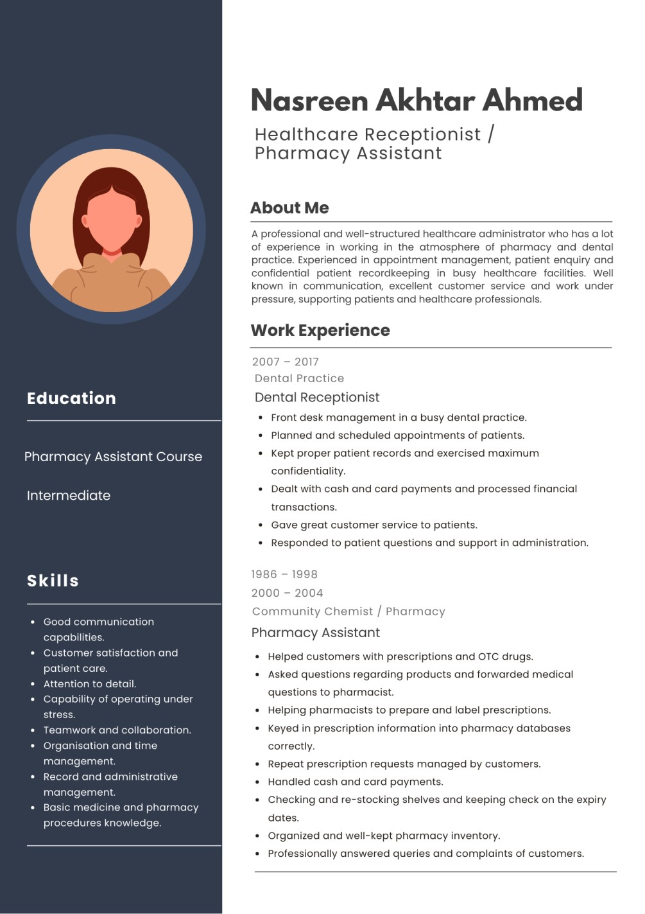
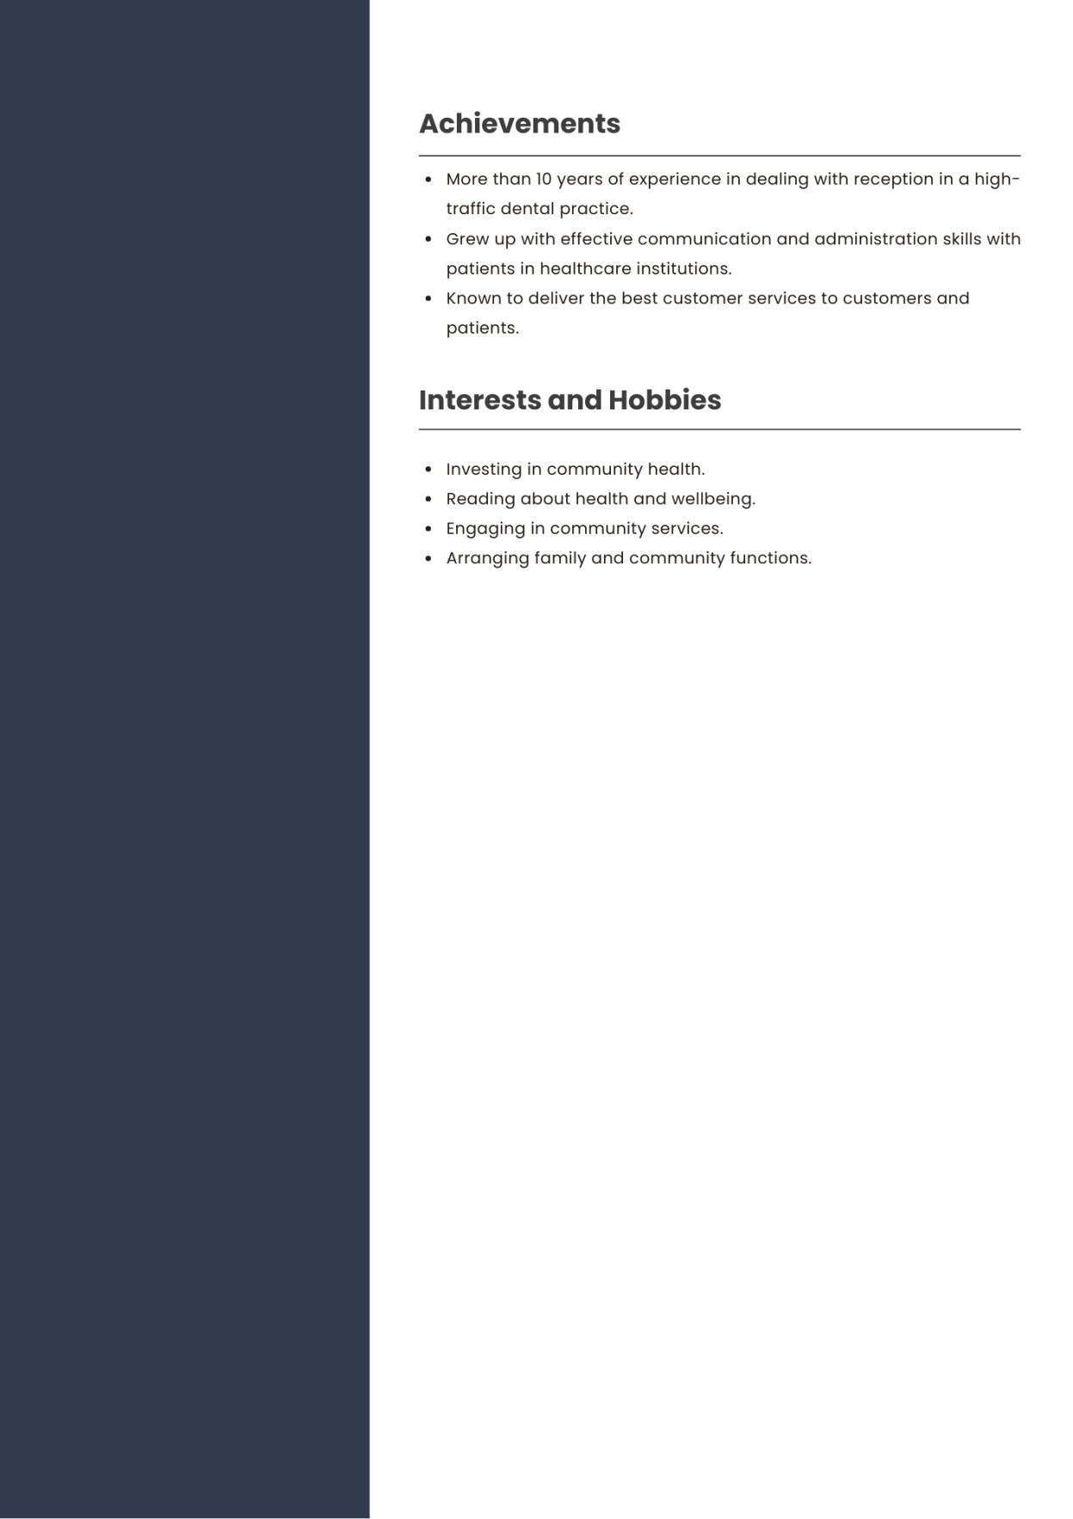

Task 02: Personal Statement
I am a qualified healthcare administrator who has a good foundation in the pharmacy and dental practice setting. I am seeking employment in the health and social care industry as I am very keen on helping patients and being a contributor to the successful provision of health care services. My career goal is to keep advancing my skills and knowledge and perform the job in the area where I will be able to assist patients with compassion and professionalism and help healthcare teams to offer high-quality customer services.
I have been working in a healthcare setting extensively and have accumulated a lot of experience in my career. I was a Pharmacy Assistant at a local chemist, and I had spent some years there and assisted clients with prescriptions and over the counter drugs and answered their questions about the product and referred them to the pharmacists where necessary. In this position, I also assisted the pharmacists in preparing and labeling prescriptions, inputting prescription data into pharmacy systems and handling repeat prescription requests. Furthermore, I made payments, arranged stock, and paid attention to expiry dates of the products to guarantee the safety of patients and effective work of the pharmacy.
I also served as a Dental Receptionist in a busy dental practice over a period of ten years. Here, I oversaw the front desk and assisted in the effective operation of the practice. It was my duty to make bookings of patient appointments, keep patient records accurate and confidential, take payments, and ensure that I responded to patient requests. This job involved good organisational skills, attention and effective communication with patients and healthcare specialists.
The result of my work experience and health and social care education has enabled me to acquire several transferable skills that employees would find useful in the healthcare industry. These are good communication skills, good customer service, teamwork and the ability to be calm and professional in an overcrowded setting. I am also very organized and determined to keep confidentiality of the patients and upholding professional standards of healthcare.
I think my direct interaction with patients, my understanding of healthcare administration, and my good interpersonal skills would enable me to positively impact any healthcare organization. I feel inspired to remain learning and growing in the health and social care field and I am determined to assist patients and health practitioners in delivering safe, effective, and caring services.

Task 3a: Personal SWOT Analysis
SWOT analysis assists in determining individual strengths, weaknesses, opportunities and threats which could affect career development in the health care and social care industry (Antoniadou and Kanellopoulou, 2024). The consideration of these factors will help me realize my capabilities and weaknesses more clearly as I aim to occupy a job like a Healthcare Assistant.
- Strengths:
My great experience in healthcare settings is one of my strengths. Working as pharmacy assistant and dental receptionist, I had to interact with patients regularly and assist healthcare professionals. The roles contributed to my building of effective communication and customer service skills which are vital in the health and social care environment. I am also well-structured and can deal with administration work including patient records, appointments and confidential information. My attention to detail would be a guarantee that patient information and healthcare procedures are handled in an accurate and professional way. Moreover, I can operate effectively under pressure and stay composed when handling a busy work environment or patients.
- Weaknesses:
Despite the experience I have in healthcare settings, most of my prior jobs were administrative and not direct patient care. Thus, I might require an additional training in order to attain practical caregiving skills that are necessary in certain health and social care professions. It is also possible that I will have to refresh my information on the current healthcare policy, safeguarding process and the contemporary healthcare system to meet the current industry standard.
Opportunities:
The health and social care sector has numerous opportunities of professional development. The new knowledge and understanding of patient care, safeguarding and practice I will acquire with my current studies in Health and Social Care will help me develop my skills in the field. I will also be able to stay updated with other training programs (first aid, training on safeguarding, training on healthcare support, etc.) that will enhance my employability and skills.
- Threats:
The possibility of intense competition of jobs in the healthcare industry can be regarded as one of the threats. Employers might favor applicants that have clinical experience that is more recent. Besides this, health care settings may be stress-inducing and strenuous, and one should be physically and emotionally strong. Nevertheless, I will be able to transcend such challenges by furthering my studies and acquiring new skills that will advance my career opportunities.

Task 3b: Personal Development Plan (PDP)
Personal Development Plan (PDP) assists one in setting objectives and activities that are required to enhance his or her work capabilities and advancement in his or her preferred profession (Romiszowski, 2024). In the case of a job in the health and social care sector, it is crucial to have continuous learning and professional development to provide high-quality care and work as a team. According to my career objectives, I have come up with three major areas of development that I would wish to advance in the next two years.
- Goal 1: Acquire Practical Patient Care Skills.
Despite having the experience of working in some healthcare settings as a pharmacy assistant and dental receptionist, my past experience was primarily in administration rather than direct patient care. This is why my initial objective is to acquire applicable patient care skills necessary in working in positions like a Healthcare Assistant (Baillie, 2022). This will be accomplished by undertaking training programs which include first aid training, safeguarding training, and basic healthcare support training. These courses will make me know the patient needs, safety practices, and the proper practices of care. I will accomplish these courses in the coming twelve months. My performance will be evaluated by receiving training program certificates and implementing the acquired knowledge in real healthcare facilities.
- Goal 2: Enhance the Understanding of Health and Social Care Practices.
The second aim of mine is to enhance my knowledge of professional practices, policies and standards in the health and social care field. In my present course of study in Health and Social Care, I will still need to be informed about the aspects of safeguarding, patient rights, communication measures, and professional responsibility (Perry et al., 2024). Within the following two years, I will work hard on my studies, visit lectures and do assignments that will enhance my theoretical background. I will measure my progress by looking at my academic performance and the comment generated by lecturers to ensure that I keep on acquiring more knowledge about the subject.
- Goal 3: Enhance the Skills in Communication and Team Work.
Communication and teamwork are some of the skills needed in the healthcare environment. By collaborating with other staff and engaging professionally with patients, I am planning to enhance these competencies further. These skills will be developed through group learning processes, attending communication skills workshops, and getting additional experience in healthcare settings. I will keep myself track by assessing my interactions with patients and colleagues and requesting input of my supervisors or mentors.
By accomplishing all these in the next two years, I will keep on enhancing my professional skills and become more ready to be successful in my career in the field of health and social care (Townsend, 2023).

Task 04: Critical Reflection (Gibbs Model)
Reflection is a significant practice that can help one to analyze his/her experience, comprehend his/her strengths and weaknesses, and enhance his/her future performance. The Reflective Cycle (2008) by Gibbs is a systematic approach to the process of reflection, and it has six steps, which are description, feelings, evaluation, analysis, conclusion, and action plan (Ahmadpour et al.,
2025). This reflection is dedicated to my presentation assessment of my LCHS4009 Component 1 and my experience, performance, and improvement areas.
- Description:
In the Component 1 assessment, I gave a presentation, which concerned health and social care. The purpose of the presentation was to show that I devoted time to studying the selected topic and was able to convey the information to the listeners in an understandable way. I made slides which described the main concepts and supporting details. The presentation was delivered through speech, and I outlined the key points, as well as tried to capture the audience. Organization, confidence, and effective communication were needed in the presentation. I got verbal responses to my performance after doing the presentation through the feedback provided to me by my lecturer (Mukhanova and Seitimova, 2025).
- Feelings:
I was a bit nervous before the presentation as it can be a difficult task to speak in front of people. Nevertheless, I also felt ready since I have done research on my topic and prepared my slides in advance. As the presentation went on, I gained confidence in myself as I proceeded talking. I was happy that I managed to articulate my ideas. I was motivated since my lecturer provided me with feedback where some positive sides of my presentation were identified. Meanwhile, I realized that there were aspects in which I could better my presentation skills.
- Evaluation:
Generally, the presentation was both strong and weak. The good thing was that I could structure the presentation logically and bringing up the pertinent information concerning the matter. My slides aided in explaining and allowed me to make the explanation easier. Moreover, I attempted to exercise a professional tone in my speech and tried to make sure that my presentation was properly structured. Based on the feedback provided by the lecturer, my content indicated that I had a good grasp of the topic.
Nevertheless, there were spaces that could be strengthened as well. I found that I could be more confident while talking to an audience. I sometimes used my notes excessively and had to speak more naturally. The lecturer also proposed the idea that to increase my interaction with the audience, I should pay more attention to eye contact and speak with more confidence.
- Analysis:
Looking back at my experience, I realize that I need practice and confidence in presentation skills. Although I was well informed on the topic, I was nervous and this influenced my delivery. This demonstrates that good presentations do not necessarily mean knowledge, but also communication expertise and the ability to engage the audience. The preparation assisted me in organizing the information and I can do better by rehearsing on my presentation more before presenting it. Drilling would make one less nervous and more fluent when talking. According to the feedback of the lecturer, confidence, eye contact, and engaging the audience are important in making a good presentation.
- Conclusion:
To sum up, learning through this presentation was fruitful. It enabled me to showcase my learning of the topic besides enhancing my communication and presentation abilities. In my opinion, my strengths were the ability to organize the content and the familiarity with the topic. Nevertheless, I understand that I still have to work on my confidence, presentation, and communication with the audience. The retrospective about this experience has allowed me to determine areas that I should improve.
- Action Plan:
As a way of enhancing my presentation skills in the future, I will practice speaking more frequently in front of people. To gain confidence and lessen the use of notes, I will go through presentations multiple times before delivering them to customers. I will also concentrate in enhancing eye contact and speaking more articulately when presenting. Moreover, I shall also consult lecturers and peers to enable me to keep on honing my communication skills. Through such enhancements, I would like to present more confident and effective presentations in future.

Bibliography
Ahmadpour, N., Shariati, A. and Moghadam, M.P., (2025). Effect of narrative writing based on Gibbs’ reflective model on the empathy and communication skills of nursing students. BMC Medical Education, 25(1), p.10.
Antoniadou, M. and Kanellopoulou, A., (2024). Educational approach: application of SWOT analysis for assessing entrepreneurial goals in senior dental students. European Journal of Investigation in Health, Psychology and Education, 14(3), pp.753-766.
Baillie, L., (2022). Practical nursing skills: a caring approach. In Developing practical nursing skills (pp. 1-36). Routledge.
Mukhanova, A. and Seitimova, A., (2025). Reimagining Differentiation: A Reflective Inquiry Using Gibbs’ Model.
Perry, A.G., Potter, P.A., Ostendorf, W.R. and Laplante, N., (2024). Clinical nursing skills and Techniques-E-Book: clinical nursing skills and Techniques-E-Book. Elsevier Health Sciences.
Romiszowski, A.J., (2024). Producing instructional systems: Lesson planning for individualized and group learning activities. Routledge.
Townsend, J., (2023). Philosophy of state development Planning. In The Impact of Oil Revenues on Arab Gulf Development (pp. 35-53). Routledge.

Appendices
1. CV.

