

BMMB7026 – Managing Marketing Change
Assignment 2
Printed Name: AL AMIN
Signature: AL AMIN
Student ID: 2506610
Selected Organisation: Amazon

Table of Contents
Executive Summary 3
1.0 Introduction 4
2.0 Evaluation of Amazon’s Marketing Activity 5
2.1 Concept and Importance of Marketing 5
2.2 Macro and Micro Marketing Environment of Amazon 5
2.2.1 Macro Marketing Environment (PESTEL Analysis) 5
2.2.2 Micro Marketing Environment (SWOT Analysis) 8
2.3 Target Markets 11
2.3.1 Market Segmentation 11
2.3.2 Targeting 11
2.3.3 Differentiation and Positioning 12
2.3.4 Marketing Mix 12
2.4 Selection of Media 14
2.5 Measuring Success 15
2.5.1 Effectiveness of Marketing Activities 15
2.5.2 Integration and Innovation 16
3.0 Conclusion of Addressing the Shortcomings of Amazon’s Marketing Strategy 19
4.0 Recommendations for Amazon’s Marketing Strategy Improvement 20
Reference List 21

Executive Summary
This report is a critical e valuation of the role and effectiveness of the marketing activities of Amazon in a very competitive global environment. It also looks at the ways in which Amazon leverages data analytics, artificial intelligence, and integrated marketing communications to appeal to customers, influence participation and maintain a competitive edge. The areas that are taken into consideration in the analysis of the company are the macro and micro marketing environment, segmentation of the target market, marketing mix, choice of media and performance measurement. The results show that the marketing strategy used by Amazon is mostly successful because of its customer-focused orientation, solid brand equity, and well-developed possibilities of personalization. Nevertheless, the analysis also reveals multiple weaknesses, such as privacy of data, excessive use of automation, ethical risks, and difficulties with ensuring differentiation during the time when the competition takes place at a blistering pace. The report based on this finding gives practical and viable recommendations based on the factors of balancing automation and creativity, enhancing ethical governance, and developing skills, as well as improving trust-based marketing practises. The following recommendations are expected to help Amazon to be marketing sustainably and strategically.

1.0 Introduction
Amazon is a massive and powerful online company that has gone into business in e-commerce, cloud computing, entertainment, and advertising. It is very much founded on the high level of marketing strategies that underline customer-centricity, data analytics, and technological innovation which help its success (Akbari, 2023). Marketing will be fundamental in the attraction of customers, greater involvement, and maintenance of the competitive impact of Amazon in extremely competitive international markets. Artificial intelligence, personalisation, and multi-channel communication are the key elements that the company uses to impact consumer behaviour and promote sales growth (Hassan et al., 2025). This report is a critical assessment of the marketing operations of Amazon through the macro and micro marketing environment, target markets and marketing mix. It also evaluates the efficiency, constraints, and further opportunities of the Amazon marketing approach in a fast-changing digital environment (Li, 2024).

2.0 Evaluation of Amazon’s Marketing Activity
Amazon is a multinational corporation that deals in e-commerce, retail, cloud computing, entertainment and advertisement. Marketing is important in customer attraction, selling and gaining a competitive edge (Akbari, 2023).

2.1 Concept and Importance of Marketing
Revenue growth, customer acquisition, and brand loyalty cannot take place without marketing (Kaufman, Horton and Soltani Far, 2023). Amazon spends a lot on marketing, namely, digital advertisements, email marketing, and personalization driven by AI (Abdullah, 2025). In 2023, Amazon incurred about $24 billion on marketing to stay visible, attract and retain customers, as well as increase market share (Hassan et al., 2025). Marketing helps in short term goal which includes sales promotion and long-term brand positioning. As an illustration, promotions such as Prime Day utilise cross-channel promotion to increase customer interest and make sales (Thiyagarajan and Sasikumar, 2025).

2.2 Macro and Micro Marketing Environment of Amazon

2.2.1 Macro Marketing Environment (PESTEL Analysis)
- Political Factors
Amazon operations and competitiveness are heavily affected by political issues in the international market. The policies by the government on e-commerce, taxation and antitrust have direct impacts on profitability and price policies (Buchanan et al., 2008). The decision of the 2018 U.S. Supreme Court that online retailers must collect sales tax decreased the previously held cost-benefit by Amazon (Pereira, 2023).
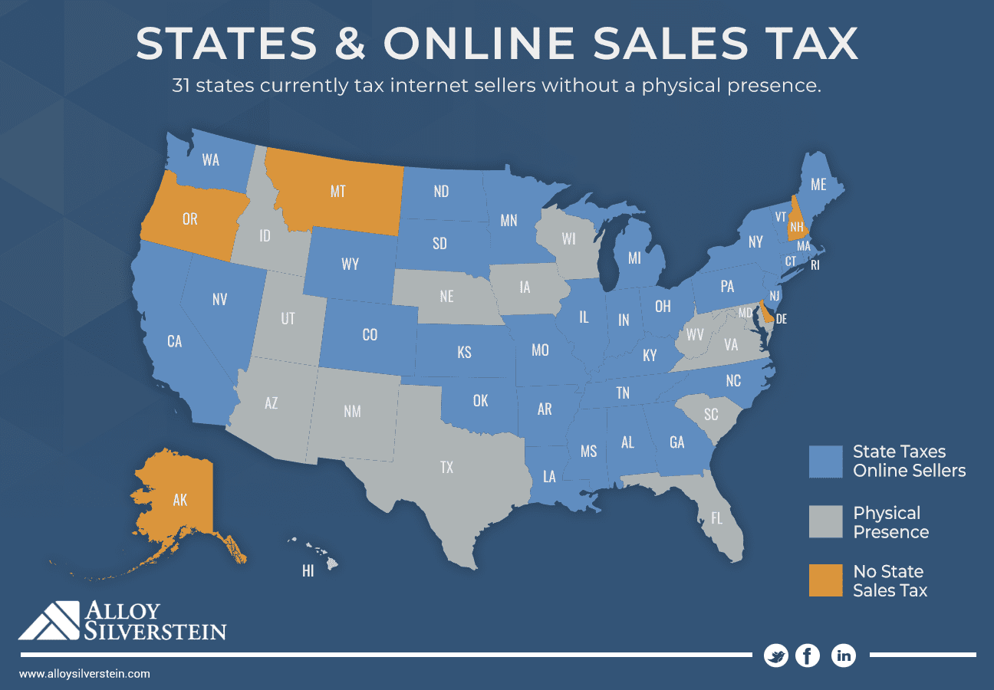
Figure 01: Till 2018 tax collection status in different states from online retailers
Source: (Reynold Cicalese III, 2018)
Cross-border supply chains of Amazon have been supported by international trade agreements like NAFTA and WTOs. Nevertheless, political opposition in markets such as China curtailed growth and compelled Amazon to withdraw out of the markets (Hassan et al., 2025).
- Economic Factors
The macroeconomic environment and consumer buying power are related issues that affect the performance of Amazon. Global supply chains also allow sourcing at a low cost and swift distribution of products (Wang, 2023). The global e-commerce market is estimated by various sources to have been between $2.5 and $3 trillion in 2023, a higher value than is projected to be the 2024 nominal gross domestic product at current prices of such countries as Brazil, Italy, Canada or Russia (Zandt, 2024). Amazon can be deemed as the most significant player in the market by far with a net income of $30 billion annually and revenues of $575 billion in 2023.
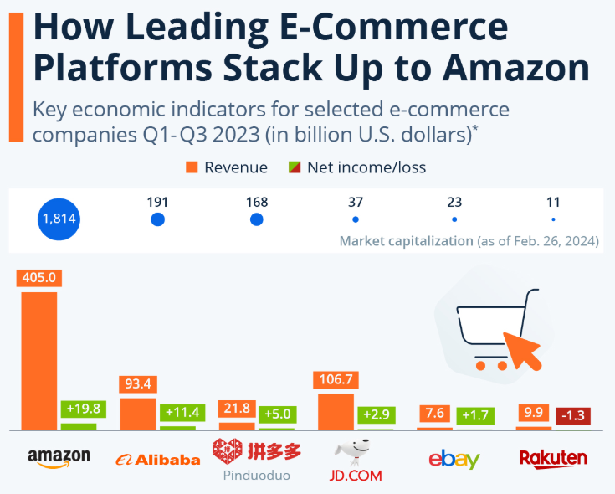
Figure 02: How Leading E-Commerce Platforms Stack Up to Amazon
Source: (Zandt, 2024)
- Social Factors
A change in consumer lifestyles and the use of digital are significant factors in favour of the growth of Amazon. The growing popularity of convenience, online shopping, and rapid delivery is in line with the value proposition of Amazon. The shifting consumer values focus on sustainability, ethical sourcing, and data privacy (Khamoushi, 2024). The cultural differences will affect the likes of products, modes of payment and marketing communication strategies. Nevertheless, the creation of jobs, low prices, and access to the platform by small sellers are positively impacting society at Amazon (Li, 2024).
- Technological Factors
In Amazon, personalised recommendations, dynamic pricing, and demand forecasting are supported by artificial intelligence (Burnes, 2014). Robotics and automation enhance the efficiency of the warehouse and deal with the shortage of labour. Alexa, Amazon Go, and drone delivery innovations are used to improve customer experience. The blockchain constant technological development makes Amazon more scalable and innovative (Dadwal et al., 2025).
- Legal Factors
Amazon is a company with complicated legal structures in various jurisdictions. The operational compliance is developed based on antitrust scrutiny, intellectual property protection, and cybersecurity laws (Yang et al., 2021). Legislation, including GDPR, COPPA, and HIPAA, makes data protection obligations and compliance expenses higher (Pereira, 2023). Minimum wage policies and labour laws have an influence on workforce costs and pricing flexibility.
- Environmental Factors
The aspect of environmental sustainability is influencing the strategy and image of Amazon more and more. The climate commitment is the Climate Pledge that leaves Amazon with zero carbon emissions by 2040 (Bhardwaj et al., 2023). This is assisted by investing in electric delivery vehicles and sustainable packaging. Severe weather conditions create logistic disruptions and increases the operational expenses. The waste mitigation programmes enhance the environmental performance and raise capital expenditure. Balancing sustainability and efficiency is a long term issue (Srivastava, 2025).

2.2.2 Micro Marketing Environment (SWOT Analysis)
The micro environment entails customers, competitors, suppliers as well as intermediaries (Akbari, 2023). Competitors of Amazon such as Walmart, Alibaba, and Flipkart pose a high level of competition as they affect prices, promotional strategies, and product assortment strategies (Kotter, 2009). The customers are becoming more and more interested in convenience, personalization, and ethical marketing (Sharma, 2024).
- Strengths
The most competitive strength of Amazon is its universally known brand that is related to convenience, trust, and quick delivery. Good brand equity facilitates customer satisfaction and traffic volumes in the different regions (Li, 2024). Customer-centric culture of Amazon is set on the low prices, a broad range of products and efficient service. Services like Amazon Prime reinforce repeat purchase and protracted interaction (Soumya et al., 2025). Another strength in the form of innovation is brought about by the artificial intelligence, the personalisation and automation in marketing and operations (Abdullah, 2025). Economies of scale, digital infrastructure and advanced logistics systems are sources of cost leadership to Amazon (Gupta, 2025).
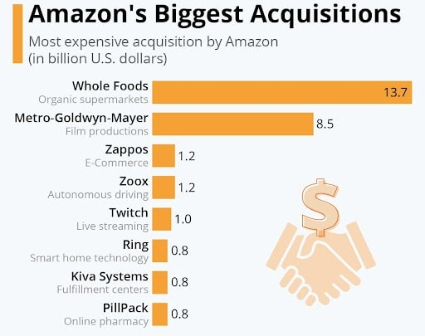
Figure 03: Amazon’s Biggest Acquisitions
Source: (Gupta, 2025)
- Weaknesses
Although it is a large-scale company, Amazon is experiencing low profit margins in most of its retail sectors. Competitive markets that are unfavourable in terms of profitability due to aggressive prices and high fulfilment costs (Kaufman, Horton and Soltanifar, 2023). There is a low physical retailing presence, which inhibits access to customers who enjoy shopping in stores. Moreover, the complaints on difficult working conditions and dissatisfaction of the employees will have a negative impact on the brand reputation and the image of the employers (Li, 2024). Lack of control to quality and safety over millions of third-party products is also a continuous weakness in the operations (Wang, 2023).
- Opportunities
Amazon has a good growth potential in the emerging markets where the internet penetration and the use of e-commerce is increasing (Soumya et al., 2025). The increase in the number of the own-label brands, including Amazon Basics, enables the organisation to satisfy the augmenting demand of low-end products when the economy faces an inflationary trend. In the case of digital healthcare like Amazon Clinic, there is a potential for diversification to high-driven areas (Dadwal et al., 2025). Long-term growth potential is also present in AWS as more people around the world have been demanding cloud computing and data services (Srivastava, 2025). The world cloud market is estimated to reach $300 billion by the year 2024 and an astonishing 21% CAGR (Gupta, 2025). Amazon Web Services controls the cloud market valued at $200B+, with a market share of 31, although the competitors are gaining ground.
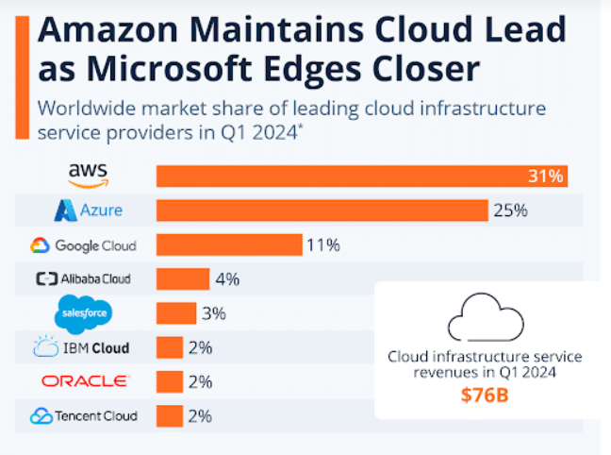
Figure 04: Amazon’s Cloud Market
Source: (Gupta, 2025)
- Threats
Amazon is experiencing a growing regulatory and legal risk in terms of competition, data privacy, and consumer protection. The adherence to regulations, like GDPR and CCPA, increases the complexity of operations and costs (Bhardwaj et al., 2023). Threats to market share and pricing power are posed by intense competition among the world in terms of retailers and technology companies. Customers may lose trust in the company due to cybersecurity threats, unrealistic reviews, and fake products (Hassan et al., 2025).

2.3 Target Markets
Amazon has a very diverse customer base globally and proper identification of the target market is vital in maintaining growth and competitive advantage. The level of sophistication of segmentation, targeting and positioning strategies allow Amazon to match the needs of the diverse customers but also to strengthen its customer-focused philosophy.

2.3.1 Market Segmentation
Amazon employs multi-dimensional market segmentation which is mostly based on the demographic, geographic, psychographic and behavioural variables. Amazon is demographically focused on the age group of young adults and middle-aged consumers with different income levels (Li, 2024). Nevertheless, a segment of middle-to high-income earners constitutes a core segment because they have greater purchasing power and subscribe to Amazon Prime. Geographically, Amazon divides the market according to region and country, and customises product assortments, prices, delivery speed and payment methods to be used locally (Danciu, 2013).
Psychographic segmentation targets the consumers who cherish convenience, time saving and digital lives. These clients are fond of web shopping, expedited delivery and digital conveniences. Amazon is of particular relevance to behavioural segmentation because it applies data analytics and artificial intelligence to examine browsing history (Sharma, 2024), purchase behaviour, and preferences. It allows individualised recommendations, dynamic pricing, and tailored promotions, improving the level of customer satisfaction and retention (Foreman et al., 2014).

2.3.2 Targeting
Amazon uses differentiated targeting as the main approach as it targets a variety of segments of the market with customised products. Its low-end strategy targets ordinary consumers who are interested in cheap prices, broad product range, and convenience (Hassan et al., 2025). Amazon Prime subscribers are a target segment of a strategic value since they already exhibit a higher level of purchase frequency, brand loyalty, and lifetime value.
Amazon serves the business client base via Amazon Business which provides the bulk purchasing, business prices, and procurement services. The Amazon Web Services, (AWS) caters to technology-driven parts that serve enterprises, start-ups and governments that need scalable cloud computing services. Other niche markets, including healthcare consumers (Amazon Clinic), entertainment audiences (Prime Video and Amazon Music), also exemplify how Amazon has targeted diversely. Such wide but narrow targeting allows Amazon to cover the market as much as possible at the same time, staying relevant to various industries and categories of customers (Danciu, 2013).

2.3.3 Differentiation and Positioning
Amazon has positioned itself by providing a powerful value chain that focuses on customer obsession, operational excellence, and technology. Among the aspects of differentiation are pricing (competitive), a wide range of products, expedited and dependable shipping (Thiyagararajan and Sasikumar, 2025), and a high level of personalisation based on the artificial intelligence. Purchasing that can be made with a single click, delivery in the same day, easy returns and services can contribute to the perceived value and convenience.
Regarding positioning, Amazon is marketed as a one-stop, customer-focused online market, which focuses on convenience, trust and affordability. This place corresponds to the ideas of brand personality presented by Aaker (2015) since Amazon is regarded as efficient, dependable, and innovative. Through the continuous reinforcement of this stance in the markets and the platforms, Amazon maintains a high brand equity and competitive advantage in the global marketplace over the long-term.

2.3.4 Marketing Mix
A marketing mix is a combination of four elements namely product, price, place and promotion. A combination of these factors creates value to the target customers and fulfils marketing goals (Sushmith, 2019). Amazon uses the 4Ps in a way that helps in the organisation of its data-driven and customer-focused marketing strategy.

Figure 04: Amazon Marketing Mix
Source: (Sushmith, 2019)
Product: Amazon started as an internet bookstore, but has grown up to be a multi-category international market. It currently provides products in electronics, home appliances, books, fashion, grocery and digital products. Seller marketing and AI-based product proposals contribute to this growth and provide more relevance to the assortment and customer satisfaction (Wang, 2023). The broad product offer enables Amazon to be positioned as a shopping platform that is one-stop.
Price: Amazon offers competitive and dynamic pricing strategy to target price-sensitive customers. The prices are usually adjusted depending on the activities of competitors, demand, and consumer behaviour. It is cost effective and guarantees coverage at the same time (Kaufman, Horton and Soltanifar, 2023). Pricing based on data analytics and discount allows boosting traffic and purchasing impulsively. The cross-selling suggestions also boost the basket value after the customers deal with discounted items (Thiyagarajan and Sasikumar, 2025).
Place: The main distribution channel of Amazon is its online marketplace that is supported by a global logistics and fulfillments network (Akbari, 2023). Given the accessibility and convenience associated with services like Amazon Global, international shopping is now possible. The availability of the fast delivery service (the same-day and the next-day delivery) contributes to better customer trust and desire to buy (Li, 2024). Availability in digital format is guaranteed by web, mobile applications, and voice commerce.
Promotion: Amazon has implemented a combination of both digital and traditional media promotional strategy. Online platforms consist of email marketing, social media, search engine optimisation, pay per click advertising, and influencer marketing. Amazon PPC campaigns enable the sellers to gain product visibility, with paid search placements. Brand awareness on a large scale is supported by traditional media including television, billboards, and print media (Azzah Wanajma, 2024).

2.4 Selection of Media
Amazon has a very integrated and data-driven media approach which it uses through various digital communication channels to attract, engage and maintain its customers (Dadwal et al., 2025). The choice of media is very consistent with the customer-focused business approach of Amazon, its international scope, and the focus on personalisation through technologies.
Paid Search Advertising and Search Engine Optimisation: Some of the most vital marketing communication channels used by Amazon include search engine marketing (SEM) and search engine optimisation (SEO). Most customers start their buying experience by searching the products online and Amazon provides a high visibility of products with a list of optimised products and paid search advertisements (Hassan et al., 2025). These are especially good channels since they reach consumers who have high purchase intentions and this translates to high conversion rates and effective utilisation of marketing budgets. Since Amazon has a broad product line, SEO and paid search are very suitable in promoting the traffic and sales (Kingsnorth, 2019).
Email Marketing and Individualised Communication: Email marketing is critical in retaining and loyalty building of customers. Amazon applies data analytics and artificial intelligence to customise emails depending on the browsing history, purchase history and customer taste (Azzah Wanajma, 2024). Promotional messages of exclusive Prime offers, personalised recommendation, and big sales events like the Prime Day are encouraged via emails. This channel is efficient because it is cheap, reaches to the audience directly and can be used to send personalised messages that enhance repeat purchases and customer lifetime value (Abdullah, 2025).
Social Media and Online Networking Sites: Amazon actively utilises such social media as Facebook, Instagram, X (Twitter), Tik Tok and YouTube to target customers and create stronger brand awareness. Prime Video, new services, and sustainability-related announcements are the primary promotional campaigns, entertainment content, and influencer collaborations conducted on these platforms. Although social media does not yield as many direct sales, as compared to search-based channels, it works well in creating brand personality, trust, and engagement, particularly with younger audiences (Akin, 2024).
On-Platform Advertising, Programmatic and Display: A highly effective channel of communication is Amazon Ads such as sponsored product listing, display ads, and programmatic advertising. With first-party data, Amazon will be able to provide accurate targeting and retargeting to its ecosystem customers. Such advertisements affect buying behaviour at the point of purchase, which makes them especially appropriate in the case of Amazon and third-party vendors (Wang, 2023).

2.5 Measuring Success
Marketing outcomes can be measured through such metrics as ROI, conversion rates, customer acquisition cost (CAC) as well as customer lifetime value (CLV) (Akbari, 2023). One can use web analytics to monitor user behaviour and A/B testing to evaluate the performance of a campaign (Sharma, 2024). The measures of social media engagement grant access to the awareness of the brand and the interaction with the audience. The campaigns during the Prime Day will be evaluated concerning the number of sales, traffic, and feedback from customers and will be assessed in a holistic manner. The AI-based recommendations and predictive analytics maximize the product visibility, personalization and campaign efficiency (Akin, 2024). Marketing control entails tracking the performance relative to the objectives and redirection of resources in order to maximise impact (Khamoushi, 2024). The use of continuous feedback loops allows Amazon to change the campaigns depending on performance information.

2.5.1 Effectiveness of Marketing Activities
The marketing practises of Amazon are quite efficient. The intensive usage of digital channels, AI, and data analytics has boosted customer interaction, sales and brand loyalty. The campaigns are responsive, targeted, and data-driven and have a high ROI (Thiyagarajan and Sasikumar, 2025). Prime Day raises billions of moneys, which is the indication of the effectiveness of integrated campaigns (Sharma, 2024). Brand credibility is enhanced by social media interactions, partnerships with influential people, and word of mouth. Although the marketing approaches are strong and dynamic (Bhardwaj et al., 2023), the marketing tactics face issues such as privacy issues and limitations of artificial intelligence.
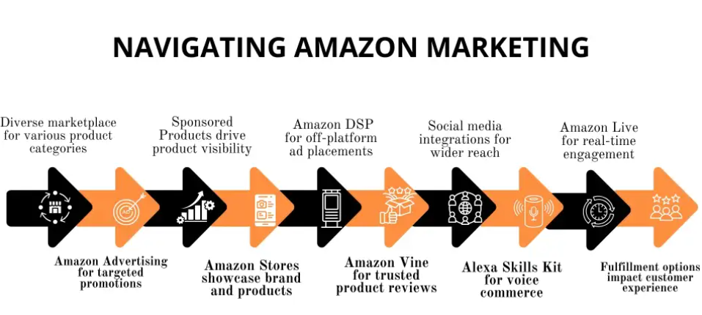
Figure 05: Amazon Marketing Strategy
Source: (Sushmith, 2019)
For example, the case of Prime Day is an example of a successful multi-channel marketing on the part of Amazon. The high visibility and urgency are generated through email, social media advertisement, banners on websites and influencer promotion (Thiyagarajan and Sasikumar, 2025). Product recommendation and dynamic pricing boost conversions, which are AI-driven (Abdullah, 2025). The reviews by users and the content created by them create a sense of trust and authenticity (Khamoushi, 2024).

2.5.2 Integration and Innovation
Unity and efficiency Amazon coordinates marketing activities in channels (Kaufman, Horton and Soltanifar, 2023). The ability of AI, CRM systems and analytics to coordinate email, digital advertisements, and social media campaigns seamlessly is possible (Kingsnorth, 2019). A comprehensive customer experience is offered with the help of dynamic pricing, inventory control, and tailored communication (Azzah Wanajma, 2024). This combination strategy has the best effect of the campaign and supports the brand message. The United Kingdom is the second leading European location of Amazon in terms of the number of fulfilment services. The company has its supply chain and logistics business in the UK under Amazon UK Services Ltd., where it has an income of more than 155 million British pounds by December 2022. Nevertheless, e-commerce meltdown of 2022 impacted the global operations of Amazon, and the UK branch was not an exception (Ou, 2025). The e-commerce giant declared the first layoffs in early 2023 because of the shutdown of a number of warehouses in the country. In the same year, Amazon closed down Book Depository which it had acquired earlier. The history of the latest retail business indicated that the Amazon Fresh business seemed to be rather unpredictable (Li, 2024). Also, with the three more Amazon Fresh stores being closed down in the Wandsworth, East Sheen, and Ealing neighbourhoods of London, and the new store in Notting Hill being opened, in the year 2023.

Figure 06: UK innovations over the past 25 years
Source: (Amazon, 2023)
Amazon honours most renowned innovation in the UK to honour 25th anniversary. Innovations Since 1998 Explore the most popular innovations, whether it be the development of fantastic streaming services to its customers or the limits it has pushed in AI and voice assistants (Bhardwaj et al., 2023). Amazon is among the top 10 employers in the UK in the private sector and it employs approximately 75,000 individuals in the UK that assist in the innovation of customers on its behalf on a daily basis. This encompasses over 2700 employees in the development centres in the UK such as Cambridge, Edinburgh, London and Swansea and are engaged in initiatives like Prime video, Alexa and customised shopping experience on the online stores (Abdullah, 2025). The UK-based small and medium-sized sellers (SMEs) that sell their products in Amazon stores around the globe are now over 100,000 in number. More than two-thirds of these businesses made their sales to external UK customers last year with a total volume of above £3.3 billion in export sales (Amazon, 2023). In the survey conducted in September 2023, 44% of the surveyed brand and agency marketers in the United Kingdom (UK) (Navarro, 2025). That said, one of the advantages of using artificial intelligence (AI) and machine learning (ML) in digital advertising was relevant advertising or creatives to clients. The manner of the most-mentioned benefit among the UK-based respondents.
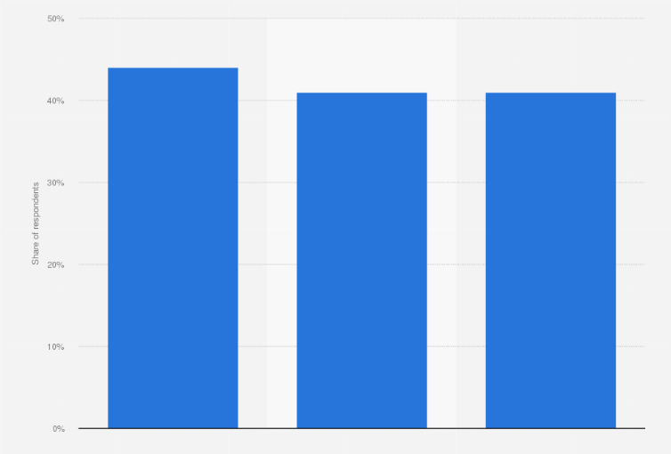
Figure 07: Benefits of AI use in marketing in the UK 2023
Source: (Navarro, 2025)

3.0 Conclusion of Addressing the Shortcomings of Amazon’s Marketing Strategy
This analysis concludes that the marketing strategy of Amazon is quite effective and not lacking significant constraints. Data analytics, artificial intelligence, and multi-channel promotion have been highly utilised by the business to guarantee customer engagement and domination of the market (Hassan et al., 2025). Nevertheless, also the same strengths that result in success lead to strategic weaknesses that need to be handled with care. There were problems associated with privacy, excessive automation, and regulatory pressure that surfaced on a regular basis during the analysis (Bhardwaj et al., 2023).
One of the weaknesses is the over reliance of Amazon on customer data to do personalization and targeting. Even though it makes them more relevant and improves conversion rates, it also exposes them to privacy risks and consumer distrust (Dadwal et al., 2025). The adherence to policies like GDPR and CCPA increases the complexity of operations and constrains the flexibility in marketing practises based on data (Li, 2024). These limitations limit the freedom of Amazon to use data on a massive scale without reputational or legal implications.
The other most important challenge is over-automating marketing activities. Artificial intelligence pricing, suggestions, and content optimisation are more efficient, yet at the risk of creating less emotional appeal and a narrative about the brand (Khamoushi, 2024). Overdependence on algorithms can decrease creativity and differentiation, particularly in the long-term, when the user is matched by the opponents (Hassan et al., 2025). This lessens the competitiveness sustainability of Amazon.
Marketing is also influenced by organisational and strategic constraints. Advanced analytics lack of skills in marketing teams can slow the implementation of AI unless it is accompanied by proper training and change management (Cameron et al., 2015). Furthermore, the increasing regulatory and antitrust attention limits the promotional campaigns and the prevalence of platforms (Akbari, 2023). Such pressures demand that Amazon juggle innovation and ethical governance and transparency.

4.0 Recommendations for Amazon’s Marketing Strategy Improvement
According to the findings, ethical data governance is recommended to enhance privacy issues in Amazon in order to retain consumer confidence. Marketing communications should also be incorporated with transparent policies of data use and a better-defined system of consent (Bhardwaj et al., 2023). Such actions can be undertaken considering the highly developed compliance framework and international legal support of Amazon (Akbari, 2023). Developed transparency will help to increase the confidence of customers without decreasing the effectiveness of personalization.
Amazon ought to strike a balance between automation and human ingenuity to cushion emotional brand connexion. Although AI enhances performance, creative teams must not lose the authority over the tell of the story, the voice of the message, and the ideas of the campaigns (Li, 2024). The authenticity and differentiation would be guaranteed by hybrid marketing teams comprised of data scientists and creative experts (Khamoushi, 2024). This strategy is pragmatic and consistent with the current cross-functional team of Amazon.
To minimise imitation by the competitors Amazon ought to invest in purpose-oriented and experiential marketing programmes. A focus on sustainability, support to the local community, and customer empowerment can enhance the brand meaning over functional advantages (Yang et al., 2021). Competitors can hardly duplicate such positioning and it builds long-term loyalty. Such campaigns can be a part of the old campaigns with minimal budgetary adjustments.
Another focus is improvement of performance measurement frameworks. To enhance the attribution models, Amazon needs to improve the multi-touch customer journey (Kingsnorth, 2019). Quantitative analytics paired with qualitative feedback can be used to improve the accuracy of decision-making.
Lastly, Amazon must take the initiative to lobby regulators and policymakers. The initial cooperation may minimise the legal risks and promote sustainable innovation (Dadwal et al., 2025). All in all, these suggestions are viable and resource-effective as well as it fits the strategic capabilities of Amazon. They facilitate ethical development, increased differentiation and effective long-term marketing.

Reference List
Abdullah, S. abbas (2025). Artificial intelligence (AI) techniques: a game-changer in Digital marketing for shop. [online] arXiv.org. Available at: https://arxiv.org/abs/2508.11705?utm [Accessed 25 Dec. 2025].
Akbari, D.A. (2023). Marketing Management: Integrating Traditional and Digital Strategy. 1st ed. [online] Amazon Kindle Direct Publishing. Available at: https://www.researchgate.net/publication/387668602_Marketing_Management_Integrating_Traditional_and_Digital_Strategies [Accessed 26 Dec. 2025].
Akin, M.S. (2024). Enhancing e-commerce competitiveness: A comprehensive analysis of customer experiences and strategies in the turkish market. Journal of Open Innovation: Technology, Market, and Complexity, 10(1), p.100222. doi:https://doi.org/10.1016/j.joitmc.2024.100222.
Amazon (2023). Amazon innovation timeline in the UK. [online] About Amazon UK. Available at: https://www.aboutamazon.co.uk/news/innovation/amazon-innovations-timeline# [Accessed 25 Dec. 2025].
Azzah Wanajma, E. (2024). Innovation and Technology Based Digital Marketing Strategy in Increasing E-Commerce Business Sustainability. Economic and Business Horizon, [online] 3(3), pp.108–113. Available at: https://journal.lifescifi.com/index.php/ebh/article/view/511?utm [Accessed 25 Dec. 2025].
Bhardwaj, S., Nair, K., Tariq, M.U., Ahmad, A. and Chitnis, A. (2023). The State of Research in Green Marketing: A Bibliometric Review from 2005 to 2022. Sustainability, [online] 15(4), p.2988. Available at: https://www.mdpi.com/2071-1050/15/4/2988?utm [Accessed 25 Dec. 2025].
Buchanan, D. A. and Badham, R.J. (2008). Power, Politics and Organisational Change, 2nd edn., London: Sage Publications.
Burnes, B. (2014). Managing Change, 6th edn.Harlow: Pearson
Cameron, E. and Green, M. (2015). Making Sense of Change Management: A Complete Guide to the Models, Tools and Techniques of Organisational Change, 4th edn. London: Kogan Page.
Dadwal, S., Kumar, P., Verma, R. and Kumar, S. (2025). Digital Transformation for Business Sustainability and Growth in Emerging Markets. 1st ed. Emerald Group Publishing.
Danciu, V. (2013). The future of marketing: an appropriate response to the environment changes. Theoretical and Applied Economics, 20(5), pp. 33-52.
Foreman, J. et al (2014). The performance implications of planning, implementation, and evolution of firms’ customer and competitor orientations, Journal of Marketing Theory and Practice, 22(4), pp.349-366.
Gupta, S.K. (2025). SWOT analysis of Amazon. [online] Business Strategy Hub. Available at: https://bstrategyhub.com/swot-analysis-of-amazon-amazon-swot/ [Accessed 26 Dec. 2025].
Hassan, S., Liu, A., Niazi, R., Ahmed, M.A., Aali, E.A., Ochieng Stella Anyango, Ayoub, A., Moustafa, M.A., Ali, A. and Moataz Eliw (2025). Assessing the impact of Amazon’s marketing strategies on consumer behavior in the food sector. Frontiers in Sustainable Food Systems, [online] 9. Available at: https://www.frontiersin.org/journals/sustainable-food-systems/articles/10.3389/fsufs.2025.1594613/full?utm [Accessed 25 Dec. 2025].
Hayes, J. (2014). The Theory and Practice of Change Management, 4th edn. Basingstoke: Palgrave Macmillan
Kaufman, I., Horton, C. and Soltanifar, M. (2023). Digital Marketing Integrating Strategy, Sustainability, and Purpose. 2nd ed. New York: Routledge. doi:https://doi.org/10.4324/9781351019187.
Khamoushi, E. (2024). AI in Food Marketing from Personalized Recommendations to Predictive Analytics: Comparing Traditional Advertising Techniques with AI-Driven Strategies. [online] arXiv.org. Available at: https://arxiv.org/abs/2410.01815?utm [Accessed 25 Dec. 2025].
Kingsnorth, S. (2019). Digital marketing strategy: an integrated approach to online marketing. 2nd ed. London: Koganpage.
Kotter, J. P. (2009). Leading Change, Mass: Harvard Business Essentials
Li, X. (2024). The External and Internal Environment Analysis of Amazon. Highlights in Business, Economics and Management, 30, pp.23–28. doi:https://doi.org/10.54097/0ar88r48.
Navarro, J.G. (2025). Benefits of AI in digital advertising in UK 2023. [online] Statista. Available at: https://www.statista.com/statistics/1394311/benefits-use-ai-marketing-uk/ [Accessed 26 Dec. 2025].
Ou, X. (2025). Amazon in the UK. [online] Statista. Available at: https://www.statista.com/topics/5592/amazon-in-the-uk/?srsltid=AfmBOop0mh-wkkJ2qo8iTEexdIwtvxlFQLV5WG_KpHiQqGSkh5Bhtfyw#topicOverview [Accessed 25 Dec. 2025].
Pereira, D. (2023). Amazon PESTLE Analysis (2025). [online] Business Model Analyst. Available at: https://businessmodelanalyst.com/amazon-pestle-analysis/?srsltid=AfmBOoqqk_MiwhSTqpoCGCiaTeSHlmgCkmDgpAgK8FpWGN-o_wK5IoYj [Accessed 25 Dec. 2025].
Sharma, A. (2024). Content Marketing in the Digital Transformation Era: Trends and Best Practices. Proceedings, [online] 101(1), p.7. Available at: https://www.mdpi.com/2504-3900/101/1/7 [Accessed 11 May 2024].
Soumya, Dr., Devendra, Prof.Dr.M., Udupa, Dr.P.N., Srivastava, D.A., Halaswamy , Dr., Kaur, H. and Maheswari, Dr.M.V. (2025). Emerging Paradigms in Knowledge Integration and Academic Research. 1st ed. RED UNICORN PUBLISHING.
Srivastava, A. (2025). Marketing in digital age. Marketing Strategy Journal, [online] 3, p.100009. doi:https://doi.org/10.1016/j.msj.2025.100009.
Sushmith (2019). Amazon Marketing Strategy – A Marketing Mix strategy. [online] Sprintzeal.com. Available at: http://sprintzeal.com/blog/amazon-marketing-strategy [Accessed 25 Dec. 2025].
Thiyagarajan, N. and Sasikumar , P. (2025). Digital Marketing Strategies And Their Effect On Consumer Behaviour Toward Electronic Products On Amazon. Journal of Neonatal Surgery , [online] 14(23S), pp.1126–31. Available at: https://jneonatalsurg.com/index.php/jns/article/view/6300?utm [Accessed 25 Dec. 2025].
Wang, J. (2023). Research on the Current Development and Optimization of Amazon’s Digital Marketing Strategy. Highlights in Business, Economics and Management, 23, pp.213–219. doi:https://doi.org/10.54097/mwg3pw30.
Yang, X., Liao, S. and Li, R. (2021). The evolution of new ventures’ behavioral strategies and the role played by governments in the green entrepreneurship context: an evolutionary game theory perspective. Environmental Science and Pollution Research, 28(24), pp.31479–31496. doi:https://doi.org/10.1007/s11356-021-12748-6.
Zandt, F. (2024). Infographic: How Leading E-Commerce Platforms Stack Up to Amazon E-commerce. [online] Statista Daily Data. Available at: https://www.statista.com/chart/31820/key-economic-indicators-for-selected-e-commerce-companies/ [Accessed 26 Dec. 2025].

