NAME: OANA ELIESCU
STUDENT NUMBER: 1809525
MOODLE TITLE: INTRODUCING IN THE MODERN WORKPLACE
LECTURER NAME: HUSAM HELMI
ASSIGNMENT TITLE:
Kellogg's in Europe
Table of Contents
INTRODUCTION 3
STRUCTURE 4
CULTURE 5
HOFSTEDE 5
PEOPLE 6
PERFORMANCE 7
RECOMMENDATION 7
CONCLUSION 8
REFERENCE 9

INTRODUCTION
Culture is the major characteristics and knowledge of the particular group of the people, encompassing language, religion, cuisine, social habits, music and arts. It is used in special sense in anthropology and sociology. It is mainly refers to the sum of human beings life way, their behaviour, belief, feelings and thoughts (Zhu and Engels, 2018). In organisational context, culture is both internal as well as external environment of the business firm which is bind by the defined core values, vision, mission and also purpose behind operation. In case of the implementation of culture, first of all core values, idea, vision or mission is need to be defined and should behaviour of the people in order to develop the culture accordingly. Cultural is highly focused to develop core competencies of the firm such as re-establishment of an individual vision or values, sustaining of a prioritised idea or objectives and application of the defined ethics. Importance of the culture is to assist in development of the vibrant workforce, sustainable environment to perform and brought up of the ethical consideration in an organisation. Moreover, purpose of the culture is to brings about harmony and organisational faith of the people into an entire system of the business firm.
Kellogg was founded as the Sanitas food company in 1900 by the brother W.K Kellogg and John H Kellogg, further who has developed tasty and also crunchy and flavoured grains for the people who loves eating grain in their breakfast. It is an American leading multi-national food manufacturing company headquartered in the Battle Creek, Michigan. They are engaged in producing cereals and convenience foods, including cookies, crackers and toaster pastries as well as all these products are manufactured or marketed in almost 180 countries. Employee strength of the Kellogg is approx. 32944 employees. Moreover, Kellogg annual revenue was lastly recorded in year 2018 at $12.923 billion dollar. This leading corn-flakes brand is operates in the USA, Canada Australia, England, Mexico, Japan, India and more. Kellogg is currently using Laissez faire leadership style and have supported management. Using this Laissez faire style of the leadership, employee takes share their idea or vision to other people or employee and then tries to structure decisions by their own (Winnubst, 2017). Furthermore, decision will be taken by senior authorities. But, if impact could be reverse of the expected one, entire blame game is going to be headed to the senior personnel. In order to bring harmony, reorganisation of the, or new leadership style is required to be implemented.

STRUCTURE
Organisational structure is the set of model which deals with defining hierarchy & stages of the operational function in an organisation. It is a set of system that helps to assign how set of the activities are focused to accomplishes the goals of an organisation (Jasimuddin and Hasan, 2015). If talks in context of the business, there are different types of business or organisational structure are as follows:
Functional structure is critically based on the organisation being divided into smaller groups with the specific task or notes. In this, each department has a manager whether finance, operational, marketing and HR.
Divisional structure which allows for much more autonomy among different group within an organisation (Körner et. al., 2015). In this structure, each division is essential to operates as their own firm, controlling resources and have a dramatic regulation of a business function.
Matrix is the blend of different functional structure of the organisation and prioritised organisational structure. In the matrix structure, employees can report to two or more bosses which mainly depends on the situation or any project under the project.
Sources: Functional organisation structure, 2019
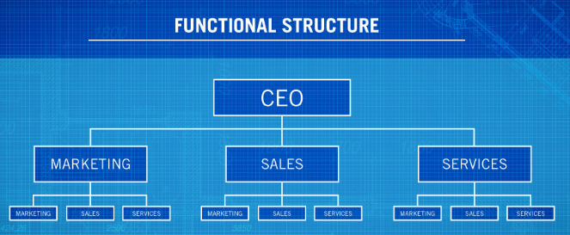Illustration 1: Functional organisation structure

If talks in context of the Kellogg, firm uses functional organisational structure in region of the Europe to operates. Kellogg is the perfect example of product line organisation that helpful to enables business organisation to incentivize employee's efforts by using pay for performance mechanism that involves less noise than those used in the functional organisation (Hogan and Coote, 2014). Hence, due to this organisational structure, Kellogg is very much capable to manages the operational aspect on the region of the Europe. With help of this organisational structure, firm has collateral reach to its customers and also led compulsive services on the global platform.

CULTURE
Culture is defined as an environment, in which core values, idea or vision of both single people or group body is applicable, so as the desired goals or objectives. Culture are of two types: collectivism and individualism. At the organisational level, they are in priority to follow individualism culture, in which individuals are given high priority to do their task and informed to senior executives. Apart from this, culture is of two types: informal and formal. In formal, organisation types in which job of each and every member is clearly defined. Plus authorities, responsibilities and accountability are also fixed. Formal culture of an organisation is mainly controlled by the top management and also has eye on each & every function or working. On the other side, informal organisation is mainly consists of culture formed within the organisation as a network of an interpersonal relationship, when an individual with each-other. This is something in the causal manner.
In response to this, Kellogg uses formal culture which is originally based on formal goals and which are controlled by the top management. In addition to this, certain issues has founds such as irregular working, lack of the positive influences, loss of the motivation, ineffective leadership, biasses for the compensation etc. (Heritage et. al., 2014). Laissez faire comes under the category of the ineffective leadership which is needs to be overcome in lesser point of time. Due to the Unfair compensation, moral of an employee is literally brought down. In addition to this, lack of the creativity and innovation is missing to maintain working curriculum in the Kellogg. Also, lack of the diversity and lack of being having equal-ism is also major concern for Kellogg. Due to lack of equality and diversity, firm has continuously faced critical regulation of the human regulation or empowerment at the major side of the business.

HOFSTEDE
Hofstede's model of the cultural dimension is one of the essential model which is clearly based on national culture of the UK. In context of the Kellogg, it consists of the dimension of the individualism vs collectivism. This indicates the extent of the degree to which people in an organisation or any established society are integrated into the groups. Individualism means when the person represents himself or herself to do any defined task and goals. Also, individualism indicates greater importance on accomplishment of the personal goals or objectives. It is mainly denoted by the letter “I”. If in case, high score is gathering in context of an individualism, it simply means firm is giving higher importance to attain personal goals or objectives. On other side, collectivism indicates that there is the greater importance on accomplishment of achieving goals or well being of a group (Denison et. al., 2014). It is mainly indicated by the words called as “We”. If society or any business firm is following collectivism, it means that they are capable to accomplishes goals or objectives with help of the defined team group. People of the UK are collectively calls them as citizen, it means that they are right on their national culture which says that people must be combined and works as a team.
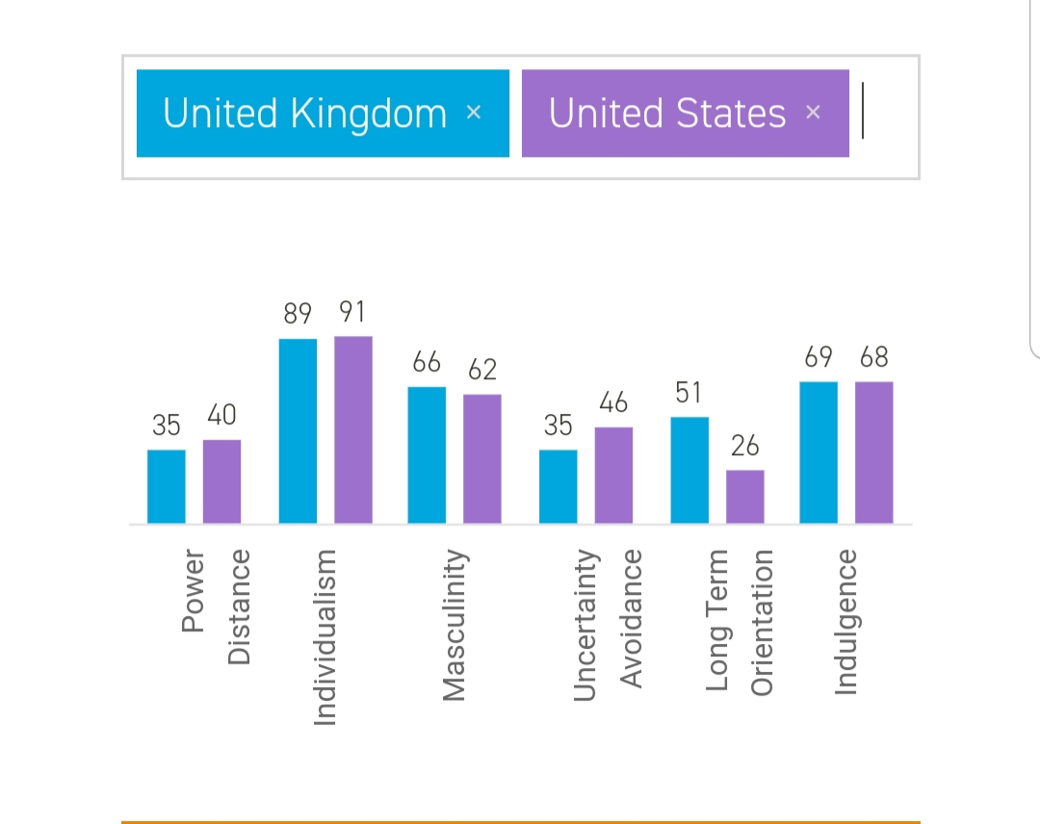
Collectivism is the part of UK national culture and also Kellogg’s is operates in the UK and it will be beneficial for them to follow collectivism culture. It is helpful to bring support of each and every employee so as to accomplishes organisational goals as well as objectives.

( Hofstede Insights, 2019)

PEOPLE
In this assessment, most probably Maslow theory of the need hierarchy will be used. Maslow hierarchy theory is the part of motivation theory which consist of five needs fulfilment of each lower need motivate the individual to fulfil higher need as well. Application of such need can help the employee to remain satisfied and pushes their capability to gain better position.
The first level is of Physiological need where human look for the satisfaction if their biological requirement (Chang et. al., 2015). Physiological needs includes air, food, drinks, water, oxygen etc., which is necessary to survive. With help of such needs, Kellogg’s company will surely involves their workforce by listening as well as evaluating their need moreover either offering them sufficient remuneration on the basis of their work.
The second need is Safety need where the Kellogg’s company can clearly depict their insurance and pension scheme so that every one will remain feel secure. These needs involves security, order, law, freedom etc.
The third level of hierarchy is Belongingness need where the staff of respective company share informal relation like friendship and affection that tie them together.
Esteem need is the fourth need where the employee wants to build their renowned image and maintain the reputation of company.
The last need is Self Actualisation need where the manger of Kellogg’s company provide the platform to their employee to achieve their target and sound position.

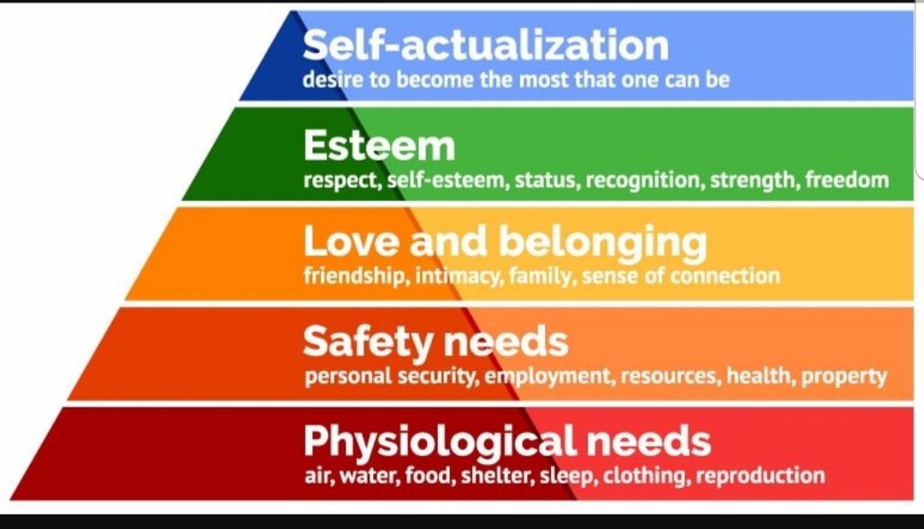

( Google Image, 2019)

PERFORMANCE
As the culture and structure of overall organisation vary from one to another that directly impact the performance of employee by motivating the employee to gain the most desirable position. Herein, Kellogg’s company follows task culture where the motive of whole team leader is to encourage the whole team and promote cooperation instead of competition. This help the overall organisation to achieve the organisational success (Brett et. al., 2015). Along with that divisional structure help the company to divide the work on the basis of specialisation where each member have deep understand and knowledge of their task. This pushes their overall effort to remain competitive and achieve the objective successfully. If talks in the perspective of the performance, its highly suggestible for Kellogg’s to conduct performance appraisal such as 360 degree in order to evaluate performance of an employees, rise their potential & motivation and achieves its contribution in favour of productive development of the structure and culture. If culture is positive and also in which employee's are collectively contributing to each-other task or work, in response that culture majorly influencing internal structure of the firm and also that will be proved as support to backup to increase performance of the Kellogg’s and will proves growth oriented in the future.

RECOMMENDATION
From above discussion, it is highly recommendable that Kellogg’s houldn’t put its focus on adaptation of the democratic leadership in conversion of the Laissez faire style plus they also starts using of the collectivism cultural, in which society or people of this organisation must be work into the defined group or as a compete team. Democratic leadership is mainly consists of sharing or gathering of the individual idea, opinion or view, so as to develops the well defined decision making and brings stability into structure or culture of the Kellogg’s. Plus, it is also stated to the top management of the Kellogg’s to understand their employee's needs and satisfied them accordingly.

CONCLUSION
From the above report, it is concluded that structure or culture of the business firm plays necessary role to represents an organisation proactively. It is also said that democratic leadership is seen as right option so as to bring effective leadership to the organisation so that employee would be proved themselves as right to share their views or idea and proves as right to develops structure and culture of an organisation in very relevant. Also, there must be co-operation among employees of an organisation so that harmony and collective working will be brought up in the Kellogg.

REFERENCE
Books and Journals
Alvesson, M. and Sveningsson, S., 2015. Changing organizational culture: Cultural change work in progress. Routledge.
Brettel, M., and et. al., 2015. How organizational culture influences innovativeness, proactiveness, and risk‐taking: Fostering entrepreneurial orientation in SMEs. Journal of Small Business Management. 53(4). pp.868-885.
Chang, C. L. H. and et. al., 2015. The role of organizational culture in the knowledge management process. Journal of Knowledge management. 19(3). pp.433-455.
Denison, D., and et. al., 2014. Diagnosing organizational cultures: A conceptual and empirical review of culture effectiveness surveys. European Journal of Work and Organizational Psychology. 23(1). pp.145-161.
Heritage, B., and et. al., 2014. Validation of the organizational culture assessment instrument. PloS one. 9(3). p.e92879.
Hogan, S. J. and Coote, L. V., 2014. Organizational culture, innovation, and performance: A test of Schein's model. Journal of Business Research. 67(8). pp.1609-1621.
Islam, M. Z., Jasimuddin, S. M. and Hasan, I., 2015. Organizational culture, structure, technology infrastructure and knowledge sharing: Empirical evidence from MNCs based in Malaysia. Vine. 45(1). pp.67-88.
Körner and. et. al., 2015. Relationship of organizational culture, teamwork and job satisfaction in interprofessional teams. BMC health services research. 15(1). p.243.
Winnubst, J., 2017. Organizational structure, social support, and burnout. In Professional burnout (pp. 151-162). Routledge.
Zhu, C. and Engels, N., 2014. Organizational culture and instructional innovations in higher education: Perceptions and reactions of teachers and students. Educational Management Administration & Leadership. 42(1). pp.136-158.

Hofstede Insights.(2019).Home-Hofstede Insights.[online]Available at: https://www.hofstede-insights.com/[Accessed 16.Aug.2019)
ThoughtCo.(2019), Maslow's Hierarchy of Needs Explained[online] Available at: https://www.thoughco.com/maslows-hierarchy-of-needs-4582571/ (Accessed 16.Aug.2019)

