Sophia Hinds
2435098
LCHS4003
Introduction to Health and Social Care
Dr Raheela Sheikh
Portfolio – Two Tasks

26/10/2025
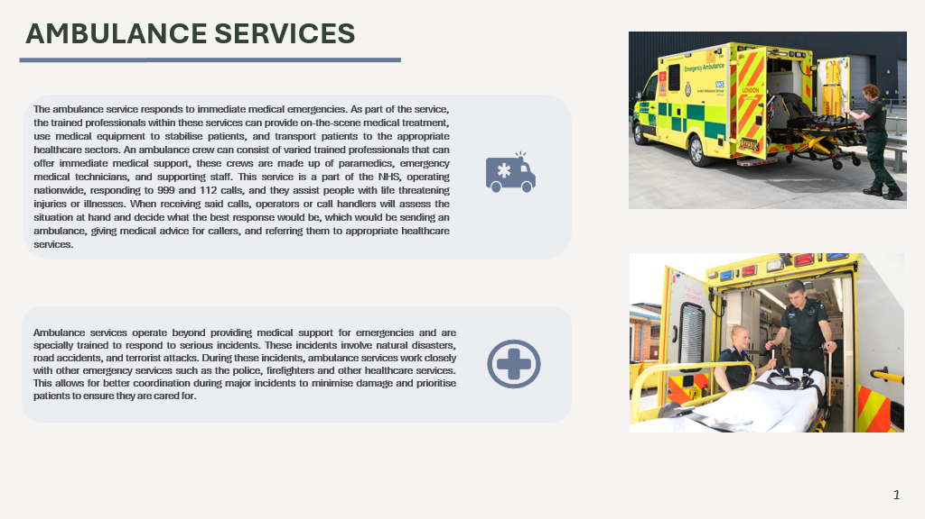
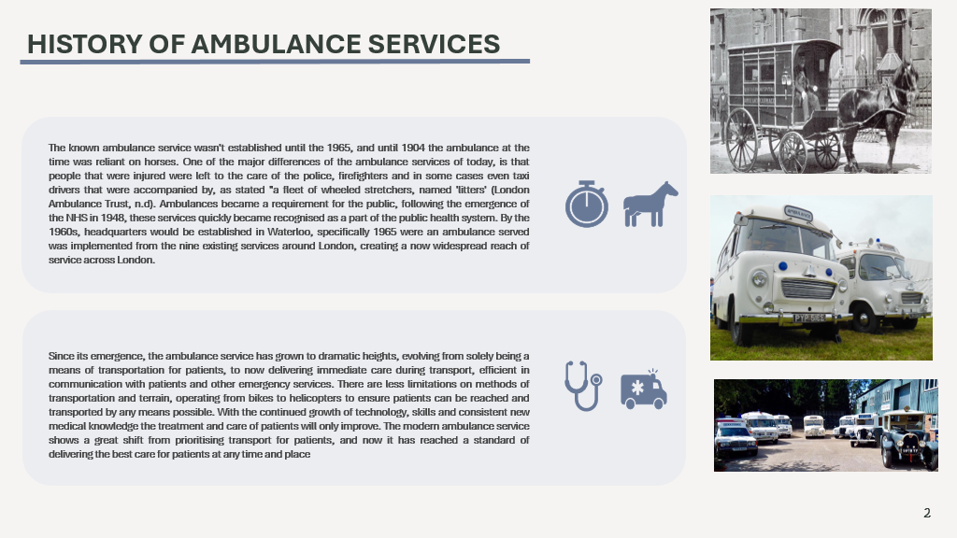
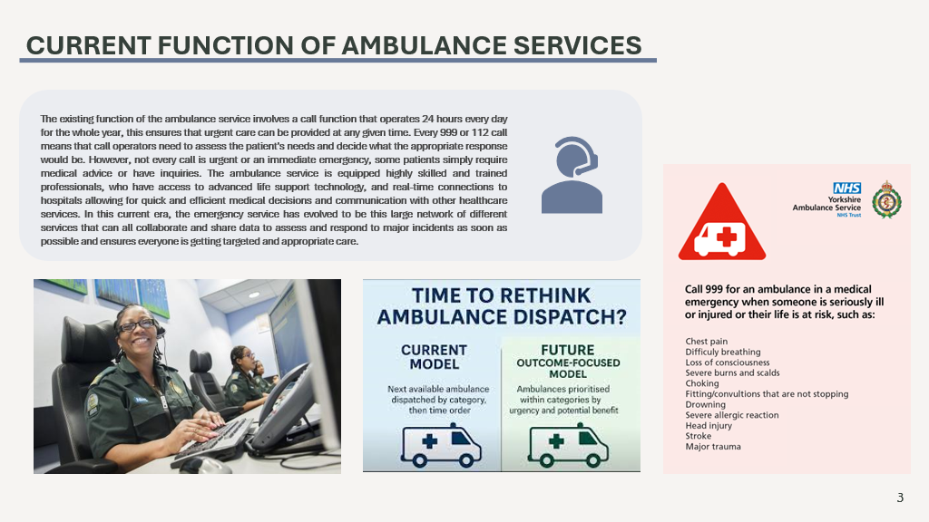
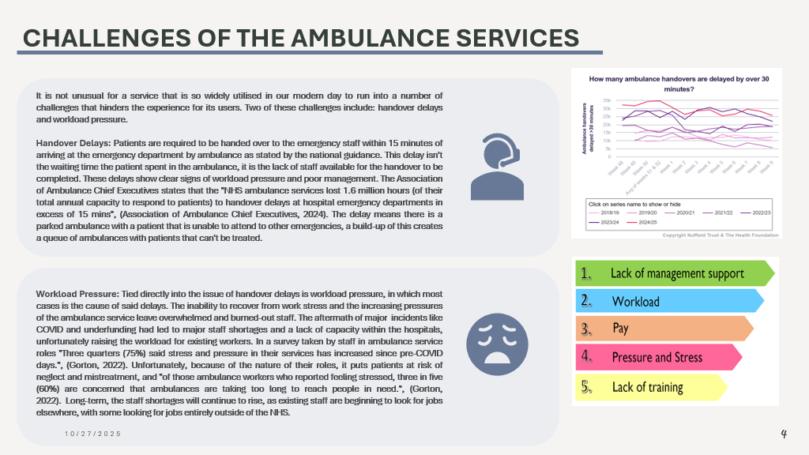
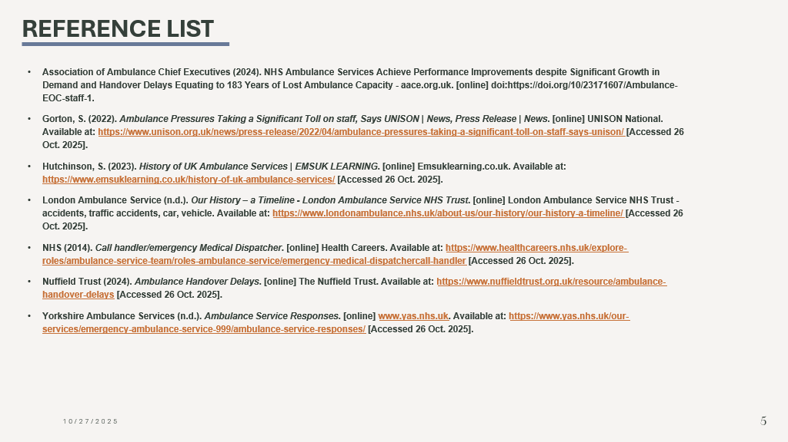

The NHS began in 1948, formed around the principles of the ‘Beveridge Report’ that aimed, “to combat the five great evils of society: want, disease, ignorance, squalor and idleness.” (Flyn, 2018). The NHS was designed to provide accessible healthcare for all citizens regardless of class and income. The unified system created from the aftermath of the Second World War allowed the people to see the good that could emerge from such a system. During this time, the government took control of healthcare services to enable and properly distribute care for civilians and soldiers. Stood at the foundation for the NHS was Aneurin Bevan, who was the Minister of Health and aimed to create a healthcare service that prided itself on accessibility, unity, and prioritising reach. Before its emergence, healthcare in this age of Britain was unequal, and mostly provided by municipal hospitals or voluntary hospitals. The general practitioners charged fees that were above what most working-class families could afford, which, in Aneurin’s belief, was wrong. He vouched for state ownership of said hospitals, ensuring that those who needed treatment could receive it, opposed to a system that relied on your ability to pay for those services.

Regardless of the promise that the NHS has shown, there has remained resistance to this plan. The idea of a united health system implied that many doctors would lose control and independence of their own healthcare services. Aneurin offered those who opposed favourable terms to ensure that they would conform to his plan. In time, the NHS became a staple of Britain, revolutionising access to healthcare for everyone, improving medical treatment across Britain, and ultimately reducing mortality and disease rates.

In today’s time, the NHS remains rooted in the principles it was built on, but naturally, due to societal, political, and economic pressures, the structure and function of the whole system have changed. The Department of Health and Social Care oversees the NHS, with the NHS managing the everyday funding of services. Reforms have been introduced by the government to create a freer atmosphere in the NHS, allowing patients to have more choice, also making the NHS more efficient. For example, the 2012 Health and Social Care Act increased the number of providers, whether private or voluntary, creating a Clinical Commissioning Group (CCG), which gives doctors the reins to manage local budgets. In 2022, these groups were replaced by the Integrated Care Systems, abolishing the CCG to introduce a more unified structure that brings in the NHS, the local government and other partners to deliver services across different geographical locations.

The NHS challenge of today that threatens its longevity, these challenges include staff shortages, funding issues, and an increased population that puts extenuating pressure on the services available. Handover and waiting times for treatment and responding to emergencies are at an all-time high, which was only catalysed by the emergence of the COVID pandemic. The system has become less efficient, and while the Integrated Care System hopes to allow more streamlined collaboration between services, the NHS still struggles with coordination, causing mass confusion between each service. There is also a growing use of private healthcare, which threatens the sustainability of the NHS, showing how Aneurin’s ideals are now being disputed. Despite these challenges, the NHS still stands above most in their quality of care at their low cost compared to other countries and remains with a dedicated workforce and public support.

Overall, the NHS is still a respected and valued system within Britain, and still holds itself to standards of quality, affordability, and ease of access. However, with rising changes comes rising demand for staff, funding, and service coordination. Facing these challenges, the NHS will have to adapt to the changing world while standing firm with the very principles that built it.

Reference List

Charles, A. (2022). Integrated Care Systems Explained. [online] The King’s Fund. Available at: https://www.kingsfund.org.uk/insight-and-analysis/long-reads/integrated-care-systems-explained [Accessed 26 Oct. 2025].

Flyn, C. (2018). The birth of Britain’s National Health Service. [online] Wellcome Collection. Available at: https://wellcomecollection.org/stories/the-birth-of-britain-s-national-health-service [Accessed 26 Oct. 2025].

Lafond , S. and Charlesworth, A. (2016). A Perfect storm: an Impossible Climate for NHS Providers’ finances? [online] The Health Foundation. Available at: https://www.health.org.uk/reports-and-analysis/reports/a-perfect-storm-an-impossible-climate-for-nhs-providers-finances [Accessed 26 Oct. 2025].

Mclaren, S. (n.d.). History of the NHS | Inner Temple Library. [online] www.innertemplelibrary.org.uk. Available at: https://www.innertemplelibrary.org.uk/timeline/history-of-the-nhs/ [Accessed 26 Oct. 2025].

National Archives (2023). The foundation of the NHS. [online] The National Archives. Available at: https://www.nationalarchives.gov.uk/explore-the-collection/stories/the-foundation-of-the-nhs/ [Accessed 26 Oct. 2025].

Parkin, E., Harker, R. and Powell, T. (2020). The structure of the NHS in England. commonslibrary.parliament.uk. [online] Available at: https://commonslibrary.parliament.uk/research-briefings/cbp-7206/ [Accessed 26 Oct. 2025].

