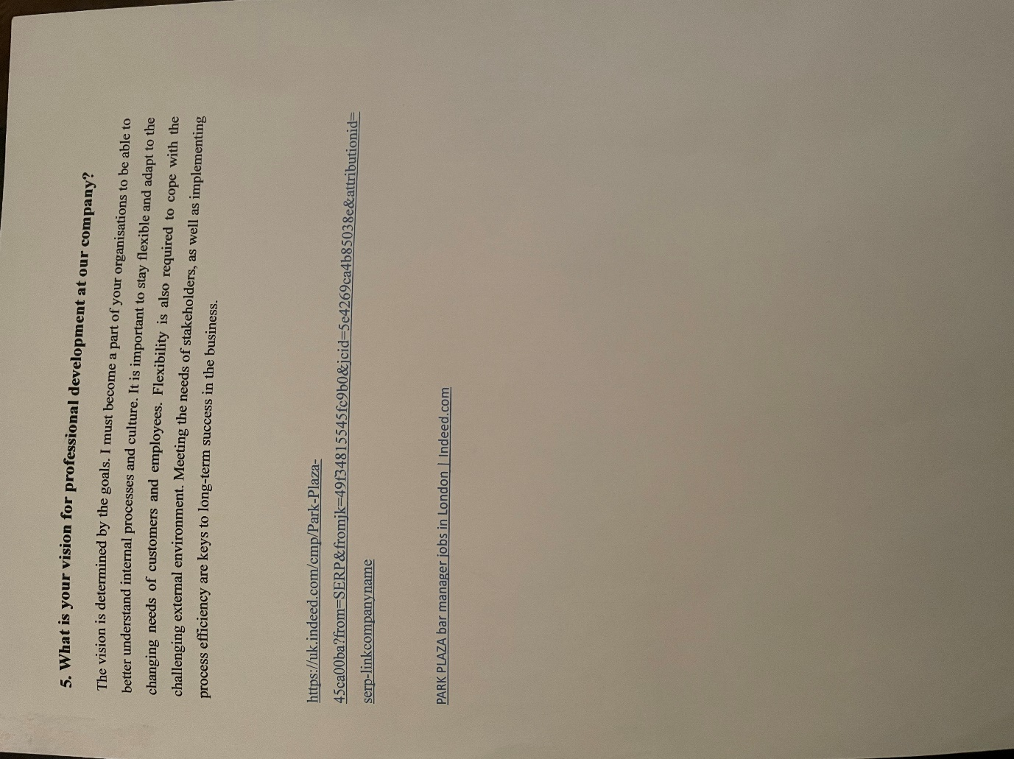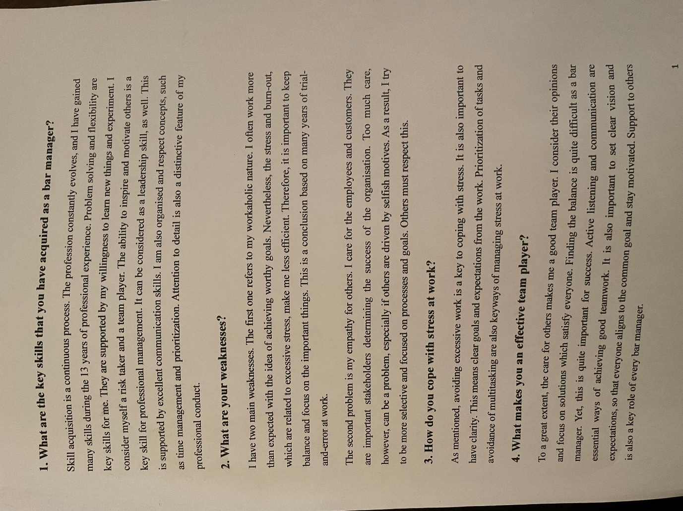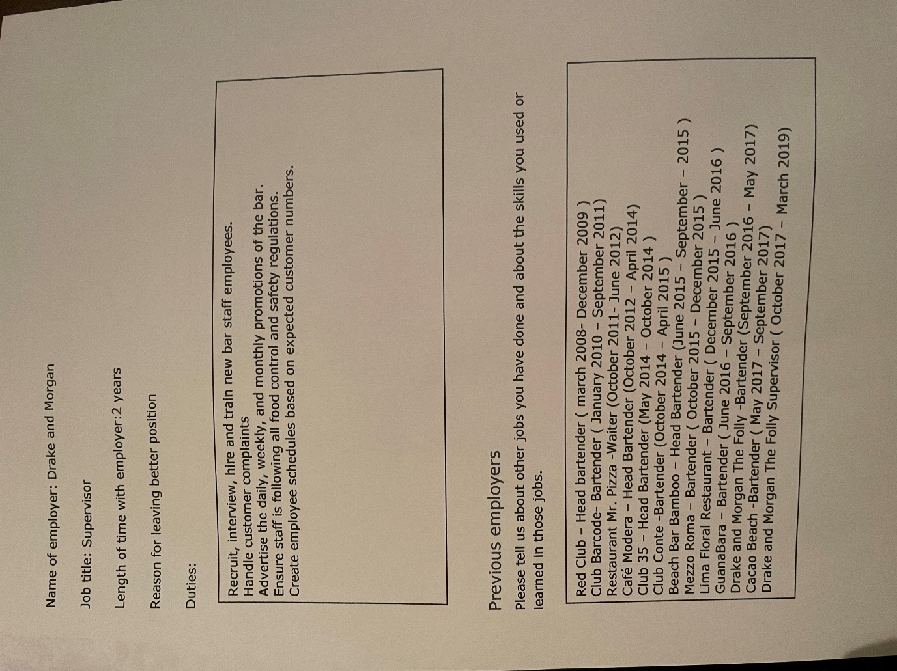
Professional Career Development
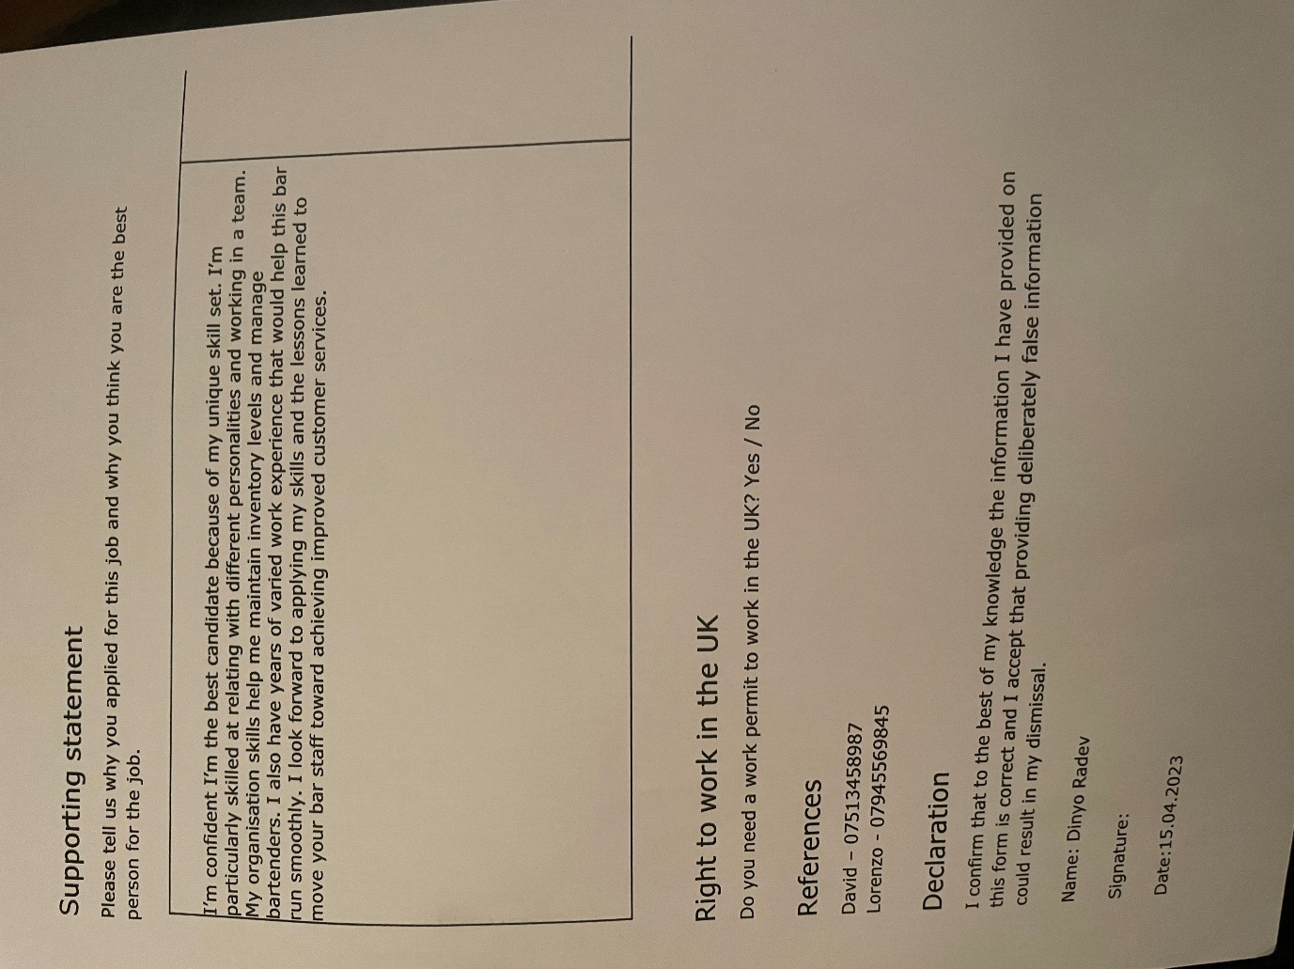 BMSW4005

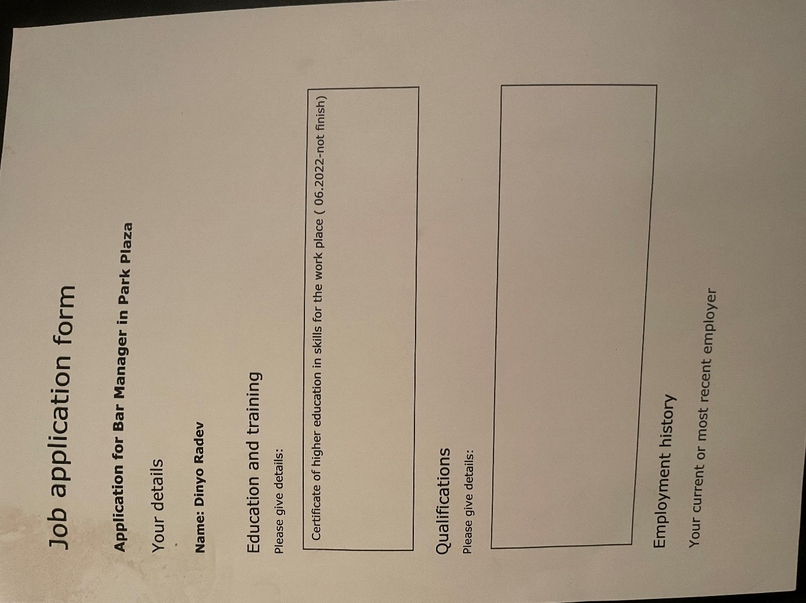

Dinyo Radev
Student ID 2129750
Task 2 Written Report

Table of Contents
Introduction 3
Recruitment and selection role play reflection 4
Assessment of personal strengths, weaknesses, skills and knowledge 5
Employment goals and development plan 7
Conclusion 8
References 9

Introduction
Learning through reflection is very important, as it allows a person to think about the contribution and value of different experiences, as well as the ways through which they can be improved if occurring again in the future. I must admit that I am not used to reflecting regularly on my academic and other experiences, which is something I want to improve. Therefore, I am quite motivated by the fact that I can practice reflection in this report. I believe that people learn best through experience, and this is the main reason why I want to improve my reflective skills.
To the current assignment, I will use the structured debriefing model of Gibbs and his reflective cycle which is graphically presented on the figure below. It includes six main steps in assessing an experience, including describing it, analysing the reactions and feelings evoked, evaluating what was good and what was bad about it, thinking about what the overall value of the experience was, evaluating what has been learned from it and planning on future areas for improvement (University of Cumbria, 2022). The reflective report analyses the contribution of the role play task to developing my skills, as well as an assessment of my own current capabilities and future goals regarding employment.
Figure 1 – Gibbs' reflective cycle
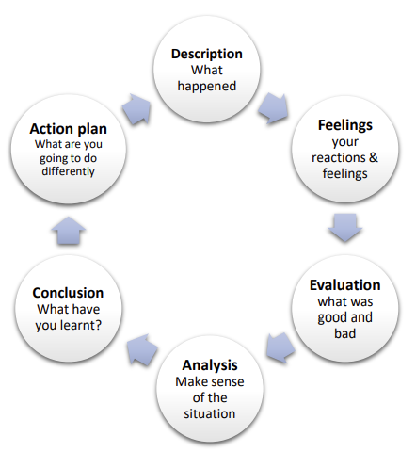
Source: University of Cumbria (2022)
Based on the model, it is possible to conduct a structured approach to reflection which is suggested to improve the quality and validity of findings.

Recruitment and selection role play reflection
Reflecting on the role play is, according to me, as important as the task itself. This has been the first time I practice a real-life scenario job interview and it made me understand that I need to put more efforts into preparing for such discussions in the future. The role play was based on a job offer listed by Park Plaza – one of the popular hotel brands regionally. As I am pursuing a career in hotels & resorts industry, practicing this job interview has been extremely valuable and effective in providing me with better understanding of what employers search for and how to address their expectations.
The role play scenario I have developed included five main discussion topics, including key skills acquired as a bar manager, weaknesses currently faced, coping with stress at work, the characteristics I possess which make me an effective team player and my vision for professional development at the company. I have emphasised on these five areas after a thorough research of industry trends and recruitment patterns in the sector. The question regarding key skills acquired as a bar manager helped me think about my development so far and own capabilities that contribute most to my employability in this industry sector. If I have to choose just a few skills to focus on, these will include problem solving, flexibility, willingness to learn and experiment, as well as being a risk-taker and a good team player.
In terms of weaknesses identified, during the role play I have focused on my workaholic nature and my strong empathy for others which, sometimes, is a disadvantage. When thinking about it now, I would also add time management skills that need to be improved. Practicing the interview during the role play made me realise that I need a lot of time thinking about the ‘most appropriate’ answer that would give me the highest credibility and advantage as perceived by the employer. This, however, is not good in real-life scenario and should be improved based on a more extensive practice in the future.
Apart from that, I believe I performed well during the role play assignment. It has been extremely valuable, as it made me think about my ‘assets’ in terms of skills which can give me a competitive advantage on the labour market, as well as ‘drawbacks’ which I must improve on a continuous basis. If I have to point out something that I would do differently, this would be the need to obtain more industry and recruitment reports to assess trends and priorities of employers in the sector, so that I can prepare better in terms of the ways to fulfil their demands. Overall, this has been an extremely valuable experience and I am planning to organise something similar again by myself, but exploring more potential questions and answers that can pop up on a real job interview.

Assessment of personal strengths, weaknesses, skills and knowledge
As already mentioned, some of the main strengths that I have are problem solving skills, flexibility, willingness to learn and experiment, being a risk-taker and teamwork skills.
Problem solving skills mean that an individual can determine an issue, locate the source of the problem, choose the best course of action in the given context and assess the complexity of each alternative (Saluja, 2023). The nature of hospitality industry suggests that it is very dynamic and thus, can be quite complicated at times. This is one of the reasons why problem-solving skills are among the top priorities of employers when it comes to recruitment and selection. Employees with good and effective problem-solving skills are a true asset to the organisation and contribute to its improved performance and productivity (Saluja,2023).
Flexibility is also essential. In hospitality industry and bar management, this is often associated with staying past normal closing hours, leaving work early, changing shifts last second or anything else which may require adaptive action in terms of the work process or customer requests (Saluja, 2023).
Willingness to learn and experiment is also very important for the industry. As already mentioned, hospitality is changing quite fast and is a rather dynamic service sector. This suggests that the most successful employees in it would be the ones who are not only flexible and adaptive but eager to learn new things and skills, as well as develop their capabilities along with the business.
Being a good team player is also crucial, especially in a service industry where the overall value delivered to customers is the result of team effort. The ability to understand own role and contribution to overall performance within the team is a pre-requisite for success. Effective teams work together, collaborate well and learn from each other in a way, so that the outcome contribute to overall organisational performance, efficiency and productivity (Saluja, 2023).
I am extremely grateful that, during my academic experience so far, I have developed all these skills through team projects, practical assignments, in-class discussions and effective teaching and learning process. All this contribute to a significantly improved employability status and better prospects for future career development.
When thinking about my weaknesses, I would prioritise my workaholic nature, my strong empathy for others and time management skills.
My workaholic nature is something I have to improve, as it currently leads to a significant workload, higher stress levels and sufficiently deteriorated work-life balance, which is likely to result in a massive burnout.
My empathy for other should also be improved, as too much of it can become a disadvantage. Emotional intelligence is associated with the ability to understand own and others’ emotions and navigate them in the desired direction, so that they contribute to productivity and performance (HBS, 2022). The components of emotional intelligence include self-awareness, self-management, social awareness and relationship management (HBS, 2022). I believe I have to work on all of these, so that I develop a healthy emotional intelligence capacity which is a foundation for success in the workplace. I intend to do that through reading more about it and research best practices in the area. To track progress, I will make an emotional intelligence test before and after, so that I can compare results.
Time management is the ability to plan and control how much time is spend on different activities and tasks, so that productivity and efficiency are maximised (CFI, 2023). There are many befits from developing good time management skills, including stress relief, having more time for different tasks, more opportunities, ability to reach pre-planned goals and objectives and higher self-confidence and self-worth (CFI, 2023). Time management is among the top skills for employers in 2023 and this is why I really need to work more on it (Dewar, 2023). Some of the strategies and activities I would perform to build a time management habit and incorporate it in my daily routine include setting specific goals, prioritising tasks and activities. Setting a time limit for their completion, taking breaks between tasks, organising every area of my life and routine, removing non-essential tasks, eliminating distractions and planning (CFI, 2023). This would also allow me to break-down activities and track progress easier, so that I intervene if necessary to improve efficiency.

Employment goals and development plan
As already identified, I want to develop a career in bar management. A bar manager is a professional in the food and beverage sector of hospitality industry who oversees and manages all areas of bar’s operations (Indeed, 2023). In general, bar managers are responsible for ensuring customer satisfaction, advertising promotions, supervising staff performance, handle customer complaints, managing inventory and ensuring customer safety (Indeed, 2023). I truly believe that I have the required skills and competencies to be effective and successful on this position. However, I need to still pass through a process and a certain career path that would lead me to the final goal.
The first thing I need to do is to gain more work experience which is directly relevant to the job. Usually, employers require one to three years of bartending experience before applying for a managerial position (Indeed, 2023). However, to be on the safe side, I would like to gain more and diverse experience relevant to the job, so that I am sure I am up to date with current industry trends and requirements.
In addition to that, I have to develop my weak skills and competencies. The specific actions I plan to take are described in the previous section. Of course, I am willing to focus on other competencies as well and develop them too if they are also required by potential employers. For this reason, I am planning to continuously monitor industry reports and link them to an audit of my own skills and competencies.
I am also planning to take several certificates relevant to the position, for example, by completing a training course on serving beverages, leadership and personnel management, operational efficiency in hospitality and many more. This would boost my employability profile and would provide me with an additional source of competitive advantage over other applicants.
In addition to all that, I would follow the offers for online courses for developing skills relevant to my desired position, including communication, leadership, teamwork, time management, leadership, critical thinking, problem solving and many more. I will complete some of them, selected on the basis of various criteria, such as duration, work overload and relevance to job occupation.
Apart from all that, I will take all opportunities arising from my studies to develop further the skills which would increase my employability in the industry. I am very grateful for the ones I have completed so far, as I am truly confident that they have a tremendous contribution to revealing my potential.

Conclusion
In conclusion, this reflective report helped me think about my competencies and skills that can be helpful for my future professional development and for reaching my desired job occupation. Using Gibbs’ reflective cycle proved to be very effective in assessing my own strengths and weaknesses in both academic and professional context. Since I realised its value and importance, I am planning to also use this model in the future and regularly audit my skills, development and progress in terms of employability status and competencies that can make me a successful employee in hospitality industry. It is an effective tool for self-assessment which, I am confident that, will be useful in my entire professional career as well.

References
CFI (2023) Time Management, [online] Available: https://corporatefinanceinstitute.com/resources/management/time-management-list-tips/ [Accessed: 1 May 2023]
Dewar, J. (2023) The Most In-Demand Skills for 2023, [online] Available: https://www.linkedin.com/business/talent/blog/talent-strategy/linkedin-most-in-demand-hard-and-soft-skills [Accessed: 1 May 2023]
HBS (2022) What Is Emotional Intelligence? [online] Available: https://online.hbs.edu/blog/post/emotional-intelligence-in-leadership#:~:text=Emotional%20intelligence%20is%20defined%20as,popularized%20by%20psychologist%20Daniel%20Goleman. [Accessed: 1 May 2023]
Indeed (2023) How to Become a Bar Manager in 6 Steps, [online] Available: https://www.indeed.com/career-advice/finding-a-job/how-to-become-bar-manager#:~:text=Gain%20work%20experience,such%20as%20hospitality%20or%20retail. [Accessed: 1 May 2023]
Saluja, S. (2023) 10 Key Employability Skills for the Workplace in 2023, [online] Available: https://www.myamcat.com/blog/amcat-concept/10-key-employability-skills-for-the-workplace [Accessed: 1 May 2023]
University of Cumbria (2022) Gibbs’ Reflective Cycle, [online] Available: https://my.cumbria.ac.uk/media/MyCumbria/Documents/ReflectiveCycleGibbs.pdf [Accessed: 29 April 2023]

