
Developing relationships and Workplace achievement:
Essay and PDP

[Document title] | BMSW 5102  Developing relationships and workplace achievement  Zilvinas Miksys 1815997

Contents:

1.Introduction ……………………………………………………………………………………………….3
2. Brief overview…………………………………………………………………………………………….3
3. Critical discussion (Task 1):
3.1 AMAZON’s benefits of applying motivation…………………………………4-5
3.2 AMAZON’s benefits of applying performance management……….5-6
3.3 AMAZON’s benefits of applying Employee engagement………………7-8
3.4 AMAZON’s benefits of applying Training………………………………………8
4. Benefits for Amazon employees:
4.1 Benefits to individuals of receiving motivation……………………………9-10
4.2 Benefits to individuals of receiving performance management…10-11
4.3 Benefits to individuals of receiving Employee engagement……….11-12
4.4 Benefits to individuals of receiving Training………………………………12-13
5. PDP plan (Task 2)…………………………………………………………………………………….13
6. Supplementary notes………………………………………………………………………………14
7. References……………………………………………………………………………………………15-16

1. INTRODUCTION
In this essay, we will review and describe various theories related to the integration of AMAZON employees, organizational performance management, explore the benefits of employee motivation, the impact and benefits of training. The main point of this essay would be the benefits that AMAZON would derive from the successful application of these development tools. Furthermore, this essay will forecast the major advantages of the workers from AMAZON's operational infrastructure growth methods. In addition, the main application of the development tools identified in this paper would be mentioned in parallel in order to identify improvements in the performance of both AMAZON and individuals.
2. BRIEF OVERVIEW
Identifying the advantages AMAZON receives from the use of development resources such as motivation, performance management, staff engagement and training is the main focus of this article. In this essay, it has been mentioned that the development of the positive working environment during the present pandemic situation would be ensured efficiently. Then the other improvement vehicle, such as performance engagement, will support individuals by offering an improved production level at AMAZON. Relatively, it may be argued that the development vehicle of employee engagement would help the company in maintaining workers for a prolonged period of time because, with such comparable development vehicles, people would gain the core element that benefits them from staying loyal to the organization. In this article, the main issue was the recognition of the different advantages obtained by AMAZON by the use of these development vehicles in accordance with the theories that are relevant and utilized by AMAZON within the operational infrastructure to ensure that the positive elements were properly pursued. Another primary advantage expressed in this article was the creation of a professional workers base.

3. CRITICAL DISCUSSION
3.1 AMAZON’s benefits of applying motivation
According to Srivastava (2016), motivation is important because human nature requires some kind of reward, inspiration, or incentive to produce better results. Motivated workers tend to be more active than unmotivated employees. If the employee is pleased and content, he/she will do his/her job in a very impressive manner, and the outcome will be positive, on the other hand, the motivated employee will inspire other workers in the workplace. Motivation theories split into two parts: content and process theories. For a better understanding of how these theories benefit AMAZON, we will take into account one from CONTENT (MASLOW’s HIERARCHY OF NEEDS) and one from PROCESS (VROOM’s EXPECTANCY) theories.
Vroom's expectancy theory of motivation concerns the mechanism of people preferring one method of behaving over another. It says that if people believe that making an effort leads to good success and that good performance provides attractive benefits that satisfies one or more of their essential needs, then they will be encouraged to make an effort (Gaffney, 2018).
EXPECTANCY THEORY
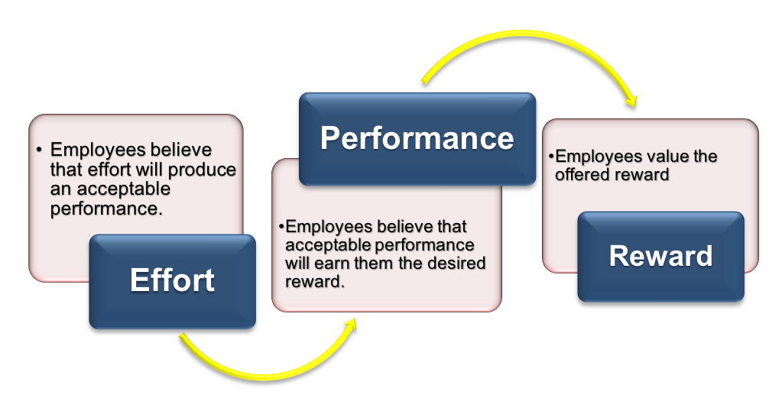
Figure 1: Expectancy theory of motivation
In the case of AMAZON, it was noticed that the Expectancy Theory amplified the participation of the staff when they understood that even small contributions were of benefit to AMAZON in achieving its objectives.
Yet speaking just about the costs of increasing salaries ignores a crucial issue: salary hikes will also improve efficiency at work. With Amazon's well-deserved credibility as a data-driven (and long-term-oriented) organization, you can bet that AMAZON'S management team did a study and found that paying workers more is more beneficial than expense from a business viewpoint. In reality, the organization was accused of being overly self-serving in its minimum wage hike—concerns emerged almost immediately after the announcement that the rise could be funded by cuts in bonuses and benefits that would make employees no better off than before. Second, higher salaries allow businesses to recruit and retain better workers. Paying wages that are above the market average (known as "efficiency wages" in economics) can also be an important driving factor for the current employee base. This adds to a wider pool of people waiting to take over as vacancies take place which making it easier to replace a slacker employee. It also means that employers have something to lose by slackening off—who cares if you are fired from a £8.20 hour job, then where else are you going to go something that pays £13 an hour?
The principle of productivity salaries is an old idea, dating back at least to Henry Ford's start of the "five dollar day" in 1914, at a time when the daily wage at manufacturing plants near his Highland Park factory was $2.30. Ford himself called it his best cost-cutting decision because of the productivity gain that followed.

3.2 AMAZON’s benefits of applying performance management
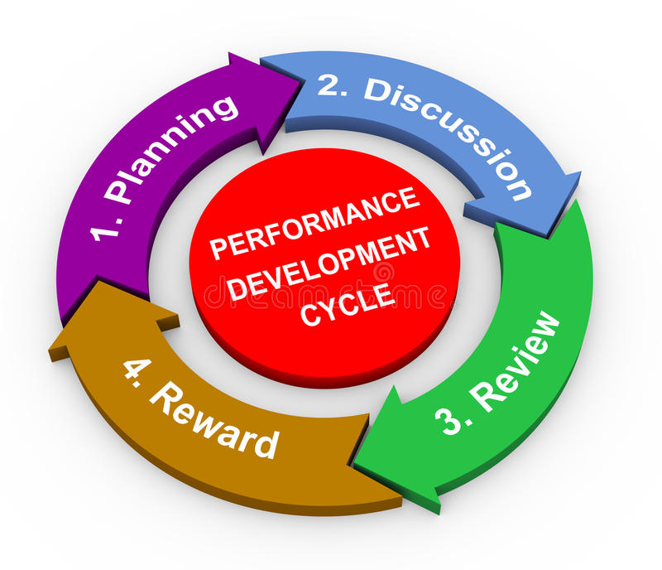
Figure 2: performance development cycle
Performance management is a corporate management technique that helps administrators track and assess the work of employees. The aim of performance management is to create an atmosphere in which individuals can perform to the best of their ability to deliver the most productive and successful work of the highest quality (Tardi, 2019). Performance management in AMAZON is different than in other companies, it able to quantify everything of its business. Often applied to its success monitoring, AMAZON conducts weekly or monthly market assessments, where each employee is held responsible for a variety of metrics. During these evaluations, workers are also tested for their understanding of these metrics. These meetings are lengthy and tedious, with the planning and discussion of the metrics taking a significant number of working hours. In the field of human resource management in the AMAZON sector, AMAZON's performance management is tailored to the needs of the company. The company's performance improvement methods help to focus on aligning results with important goals and objectives. AMAZON uses performance appraisal techniques to facilitate the right actions for employees. The organization’s policies offer staff and staff highly responsive and appropriate assistance to help them achieve the organization’s goals and priorities. AMAZON'S incentive management system helps increase employee morale and retention and increases their performance.
However, there were many leaks from the media in about the harsh handling of workers of the company (Vrchoticky, 2020). Although the accusation was kindly excited by the newspapers, AMAZON'S answer was sufficient. A proper framework for the incorporation of the democratic participation of workers within the company should be created. This will help to build a positive relationship between the workers and the management of AMAZON.

3.3 AMAZON’s benefits of applying Employee engagement
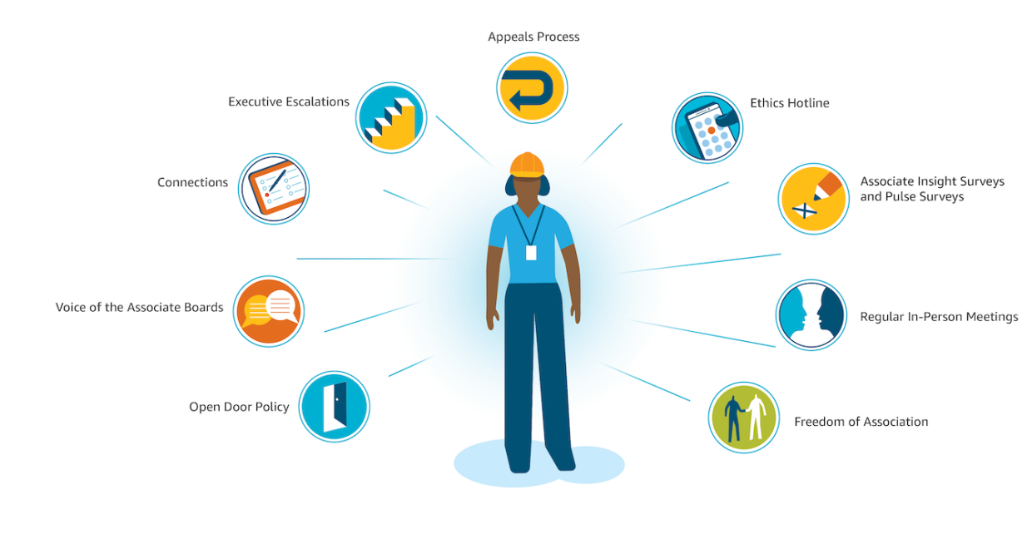
In AMAZON organization there really is a need for managers to keep in touch with their employees and educate them about what is going on around the organization. The business that employs employees is up to 202 percent more competitive than those that employ employees. Proper employee engagement includes responding to news breaks, presenting cultural initiatives such as gatherings and outings, product launches, and highlighting new company plans. It is important to disseminate this knowledge, but the tools and methods used to disseminate it are also short-lived.
The meaning that the company now gives to its employees is still unclear or it really reflects the feelings of the company. This is not obvious. There seems to be doubt as to whether AMAZON still values and cares about its health for its front-line employees. After all, AMAZON was to blame for the pandemic due to bad work practices and morale in factories.
How AMAZON handles its workers is also critical because it influences the ability of the company to maintain current employees and recruit new ones (Forbes, 2020)
Although AMAZON hired a record high during the global pandemic and employed 175,000 in the past two months, the figure will not continue and the business will inevitably return to the same talent struggle that many employers have fought against COVID-19. Employees during the crisis would certainly be affected by the wide coverage of the news. In addition, employers are reviewing sites such as Glassdoor and Indeed, and social media such as LinkedIn have created powerful forums for employees to influence the organizational expectations of future employees. Now is the moment for AMAZON to show genuine leadership in the way it engages its workforce.

3.4 AMAZON’s benefits of applying Training

AMAZON is spending £ 525 million to retrain American staff. This is a large distribution of approximately 100,000 employees - one-third of the company's American workforce. The investment will teach them the latest skills needed to work in a variety of roles in areas such as data mapping, data science and market research. The goal is to train employees to be innovative problem solvers by addressing the technical hurdles a business faces as it grows globally. AMAZON spends its millions in new internal systems to support its staff to learn how to become digital developers, operational administrators, and mechanics. The business will also expand its training and apprenticeship programmes. We can say that big companies like AMAZON have more capital than small companies, and that is really the goal. However, if we look closely at what they are doing to properly train their employees and develop their skills, something similar can be achieved with a much smaller investment. AMAZON does it not just to please new employees.

4. Benefits for Amazon employees:
4.1 Benefits to individuals of receiving motivation
The internal mechanism is motivation. it is described as a desire or need; motivation is a state within us that needs to be improved both within ourselves and in the world. Utilizing this reservoir of energy, inspiration gives a person the impetus and direction to treat the world resiliently, transparently, and boringly (Reeve, 2018). Given Maslow's hierarchy of satisfaction of needs, we can critically discuss the stimulation of personal motivation in the AMAZON organization.

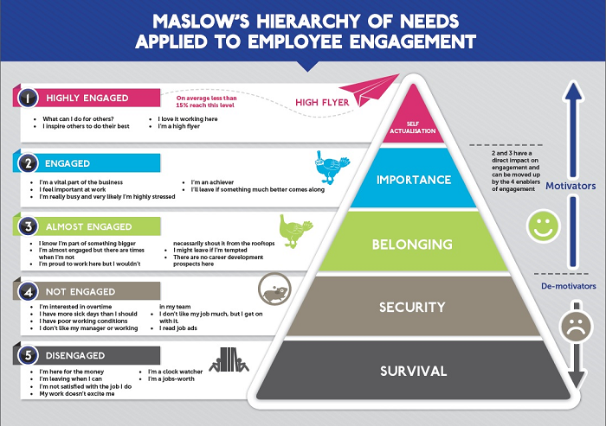

According to (Umoh, 2018) in order for Amazon to be competitive in the future, staff needed to be terrified of no longer being the best and to devote to "constant improvement, experimentation and innovation in every initiative."
“I constantly remind our employees to be afraid, to wake up every morning terrified,” (Bezos, 1999).
FEAR as a motivation in company strategies was worked well for other companies too including Tim Ferris. Ferris, the best-selling author, and host of podcasts supports anxiety-setting, a practice in which he writes down his worries, what could happen as a result of that fear, and how to avoid the worst-case scenario. He claims his greatest wins have been tied to this method, which has helped to condition himself to lose to be successful.
Former PepsiCo CEO Indra Nooyi has used the fear factor in her work practice to help guide her further steps forward. When she first took the helm of PepsiCo, Nooyi came up with new ideas, such as a focus on healthier products and a redesign of packaged goods. Nooyi’s vision helped transform the company and made it a leading business figure in the food and beverage industry.
2016 October 3 In an interview with Bloomberg, the former CEO acknowledged that the fear factor had made a significant impact on her strong work ethic and innovative business strategies.
“I’m always afraid that if I fail, I may have to go back to what I don’t want,” she said. "This fear always motivates me, so I force myself to be better and better at my job every day."(Bloomberg, 2016)

4.2 Benefits to individuals of receiving performance management

Large companies such as AMAZON, GOOGLE have replaced annual reviews with performance management. Coordinated goal setting and performance management not only saves time and time, but also attracts thousands of people who are willing and accustomed to receiving useful feedback in real time.
Employees are the key to a company’s success. Through regular and honest communication between managers and employees, employees understand management’s goals and expectations. It also helps to overcome the two main challenges facing all companies: retention levels and employee participation. The benefits of performance management are vast. Managers spend less time managing employees. Employees are more independent. Misconceptions and confusion are reduced.
Amazon CEO Jeff Bezos notes to Geek Wire: “The organization is changing its annual performance appraisal system. Bezos, who describes the current system as “radically simplified,” says it reflects employee talent, not flaws.
Bezos has long been accused of using the appraisal method to lay off workers with the lowest productivity in favour of those believed to have the greatest potential. In its start-up days, Microsoft had a similar annual assessment, but some of the more austere aspects of assessing employees have since relaxed.
Many workplaces are replacing annual performance appraisals with more traditional, more formal appraisal mechanisms. These systems focus more on the positive aspects of employee performance and provide faster feedback on success or areas for improvement. It is unclear whether Bezos plans to go with the current performance appraisal system.

4.3 Benefits to individuals of receiving Employee engagement

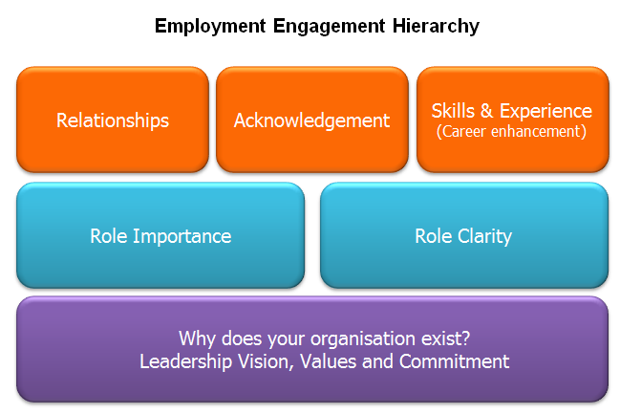
According to (Espenson, 2015) many industry experts consider the value of employee engagement. They also recognize that staff commitment on the list of management priorities is traditionally limited. That is how Amazon has become one of the funniest places since it was a very hard job.
Gallup's analysis indicates that employee motivation is one of the core aspects of revenue growth that contributes to company and employee growth. According to Gallup, staff participation lowers occupational injuries by nearly 50% and product or service failures by more than 40%. Perhaps more unexpectedly, the turnover of high-pressure firms is lowered by almost 70%. Employee participation is obviously the secret to sustaining a stable business full of proactive workers. As workers are emotionally invested and feel excited about their jobs, imagination and motivation become typical components of the company's culture. There are, however, natural obstacles to employee participation.
Amazon's heavily publicized employee retention challenges are generally very normal in the corporate world. For example, senior management frequently lacks a straightforward and succinct employee engagement plan. Instead, they take their workers for granted, and this also allows them to handle their clients in the same manner. Executives therefore ought to set a precedent by designing and communicating their communication plan with staff and the public alike.

4.4 Benefits to individuals of receiving Training

AMAZON currently has a large number of non-professional, unskilled employees. According to (aboutamazon, 2019) AMAZON will invest over $700 million to provide upskilling training programs for one in three of its employees across the U.S. Programs can allow Amazonians, from all backgrounds, to receive training and transition into highly qualified professional and non-technical positions through corporate headquarters, technology centres, regulatory centres, retail stores and transport networks, or to explore job paths beyond Amazon. For the staff at the fulfilment centre seeking to receive a diploma or degree, Amazon is committed to covering up to 95% of the tuition costs. Many of Amazon's least trained warehouse workers are predicted to be filled by robots in the next few years. When robots become workers, new jobs are developed to manage and improve them. One incentive for employers to prepare high-tech workers is to occupy these new positions. GOOGLE has also developed educational tools for individuals outside its workers. The organization began offering an IT credential in 2018, which anybody may receive, among other certification programs. Related curriculum and training benefits have since been introduced by other businesses to improve job productivity on the tight working market.

5. PDP plan (Task 2)

Objective/Area of Development | Measure | Priority | Support and Development.  Internal/External | Review Dates | Other comments
Safety | From 50 pickers of department 15 not properly wear a face mask.  10 did not keep 2m safe distance | high | Safety support will be provided from line manager(internal) and H&S department(external) | Two weeks’ time | In two weeks’, time this numbers must be decreased
Engagement | 20 pickers give feedback that after 2 months contract they did not get any cross training | high | Support will be provided from different (external) departments | One week | In one week time organize cross training for stowing and packing
Quality | 10 pickers get poor quality feedback from ICQA department | high | internal and external support | One week | In one week should provide retraining for quality measures
Fairness | “On task” rotation for 50 pickers | high | Internal support | Two days | In two days, team lead should prepare task agenda and schedule
Productivity | 15 pickers get poor productivity feedback from HR | high | Internal support | Two days | In two days, provide retraining

6. Supplementary notes
We analysed AMAZON management's main issue of building an effective workforce base, which will primarily assist the company in developing a highly profitable workforce base. This Chapter would extend the proposal in greater details so that it follows the progress goals outlined in the original section. AMAZON has remained primarily focused on making its workers highly efficient, protected from the latest pandemic and on creating a free flow supply chain by joining diverse acts within AMAZON. The critical feature of performance improvement will be reasonably compatible with the plans initiated in terms of compensation the company receives and profit earned effectively by individuals.
AMAZON's attention has been on maintaining the protection and positive working environment. Just for maintaining the danger factor of COVID-19, social distancing was thus envisaged at present. The thermal scanner used for the body temperature scanning, proper wear of face masks, retain 2m safe distance, has been designed before and during the entering and departure of the employee's centre. Consecutively, if any person has body temperature above 37.5 degree Celsius, the individual is forced to stay in the quarantine for 14 days and make covid-19 test. If the employee fails to comply with the covid-19 safety requirements he will be warned and get disciplinary note (get fired from work).

7. References

- Impraise. 2020. The Amazon Controversy: What Is Missing In Its Performance Management | Impraise. [online] Available at: <https://www.impraise.com/blog/the-amazon-controversy-what-is-missing-in-its-performance-management> [Accessed 4 October 2020].
- Tardi, C., 2019. Performance Management: Understanding A Key Corporate Tool. [online] Investopedia. Available at: <https://www.investopedia.com/terms/p/performance-management.asp> [Accessed 4 October 2020].
- Georgescu, P., 2019. Amazon Delivers For Its Employees. [online] Forbes. Available at: <https://www.forbes.com/sites/petergeorgescu/2019/12/18/amazon-delivers-for-its-employees/?sh=117fc74f6caf> [Accessed 5 October 2020].
- Yohn, D., 2020. Amazon Faces A Crucible Moment With Employees. [online] Forbes. Available at: <https://www.forbes.com/sites/deniselyohn/2020/06/02/amazon-faces-a-crucible-moment-with-employees/?sh=7c32a35e3822> [Accessed 5 October 2020].
- 2012. [online] Available at: <https://www.webershandwick.com/news/the-company-behind-the-brand-the-indivisibility-of-the-company-and-product/> [Accessed 5 October 2020].
- Tabaka, M., 2019. Amazon's 4 Keys To Success, According To Jeff Bezos. [online] Inc.com. Available at: <https://www.inc.com/marla-tabaka/jeff-bezos-says-these-4-principles-are-key-to-amazons-success-they-can-work-for-you-too.html> [Accessed 11 October 2020].
- Marks, G., 2019. Amazon Is Spending Big To Retrain Employees – And So Should You | Gene Marks. [online] the Guardian. Available at: <https://www.theguardian.com/business/2019/jul/19/amazon-retrain-employees-benefits> [Accessed 11 October 2020].
- Umoh, R., 2018. [online] Available at: <https://www.cnbc.com/2018/08/28/why-jeff-bezos-wants-amazon-employees-to-wake-up-terrified.html> [Accessed 13 October 2020].
- Hopper, E., 2020. Maslow's Hierarchy Of Needs Explained. [online] ThoughtCo. Available at: <https://www.thoughtco.com/maslows-hierarchy-of-needs-4582571> [Accessed 14 October 2020].
- Bolden-Barrett, V., 2016. Amazon Seeks To 'Radically Simplify' Its Performance Assessment Process. [online] HR Dive. Available at: <https://www.hrdive.com/news/amazon-seeks-to-radically-simplify-its-performance-assessment-process/430402/> [Accessed 14 October 2020].
- Espenson, A., 2015. Amazon's Employee Engagement System Is Making Waves. [online] Tech.co. Available at: <https://tech.co/news/amazons-employee-feedback-system-can-teach-us-employee-engagement-2015-11> [Accessed 14 October 2020].
- Gallup, I., n.d. Engage Your Employees To See High Performance And Innovation. [online] Gallup.com. Available at: <https://www.gallup.com/workplace/229424/employee-engagement.aspx> [Accessed 16 October 2020].
- Amazon Staff, A., n.d. Training. [online] UK About Amazon. Available at: <https://www.aboutamazon.co.uk/amazon-fulfilment/training> [Accessed 17 October 2020].
- Scott, A., 2019. NPR Cookie Consent And Choices. [online] Npr.org. Available at: <https://www.npr.org/2019/07/11/740660070/from-the-warehouse-to-it-amazon-offering-100-000-workers-tech-training> [Accessed 17 October 2020].
- Center, P., 2019. Amazon Pledges To Upskill 100,000 U.S. Employees For In-Demand Jobs By 2025 | Amazon.Com, Inc. - Press Room. [online] Amazon.com, Inc. - Press Room. Available at: <https://press.aboutamazon.com/news-releases/news-release-details/amazon-pledges-upskill-100000-us-employees-demand-jobs-2025> [Accessed 20 October 2020].
- Performance, C., 2020. Shadowing Programme For Leaders And Managers At All Levels | Centre For Leadership Performance. [online] Cforlp.org.uk. Available at: <https://cforlp.org.uk/products-shadowing-for-first-line-leaders.html> [Accessed 20 October 2020].
- McCabe, C., 2018. How To Get Your Amazon Account Back With A Plan Of Action. [online] ecommerceChris. Available at: <https://www.ecommercechris.com/amazon-plan-of-action/> [Accessed 4 November 2020].
- Kantor, J. and Streitfeld, D., 2015. Inside Amazon: Wrestling Big Ideas In A Bruising Workplace (Published 2015). [online] Nytimes.com. Available at: <https://www.nytimes.com/2015/08/16/technology/inside-amazon-wrestling-big-ideas-in-a-bruising-workplace.html> [Accessed 4 November 2020].
- Vrchoticky, N., 2020. The Worst Things About Being An Amazon Employee. [online] Grunge.com. Available at: <https://www.grunge.com/207782/the-worst-things-about-being-an-amazon-employee/> [Accessed 7 November 2020].
- Selyukh, A., 2020. NPR Cookie Consent And Choices. [online] Npr.org. Available at: <https://www.npr.org/2020/04/27/846438983/amazon-warehouse-safety-inadequate-n-y-attorney-general-s-office-says> [Accessed 18 November 2020].
- Selyukh, A., 2020. NPR Cookie Consent And Choices. [online] Npr.org. Available at: <https://www.npr.org/2020/04/27/846438983/amazon-warehouse-safety-inadequate-n-y-attorney-general-s-office-says> [Accessed 18 November 2020].

