

Master of Business Administration

Module Title: International Business Concepts
Module Code: LCMB7034
Company: Lamborghini Industry- Automobile
Chosen Country: India

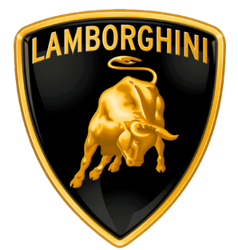
Dakshesh Narendrakumar Patel
2434255
Lecturer Name: Dr. Jean Wang
Word Count: 5072

Executive Summary
This report assesses the State of India’s automotive sector with reference to the luxury segment of the market, and to the operations of Automobili Lamborghini S.p.A. It will provide an analysis of the dynamics of the sector, the competitive positioning of firms; and the global competitiveness of the nation using Porter’s Diamond model, it also employs market analysis to analyse the attractiveness of the market. The findings suggest that India provides an environment conducive to strong growth owing to the increasing levels of wealth and aspirational consumption among its citizens. Nevertheless, there are also several significant barriers such as prohibitive duties on imported vehicles, regulatory restrictions relating to the automotive sector, and poor infrastructure that limit the ability of firms to expand their operations within India. The report concludes with a recommendation that although India represents an exciting opportunity for Lamborghini to develop sustainably over the long term, it will need to develop an adaptive strategy for continued successful and sustainable growth in India.
Table of Contents
SECTION 1: INTERNATIONAL BUSINESS REPORT 5
1. Introduction 5
2. Industry and Country Overview 5
2.1 Overview of Indian Automobile Industry 5
2.2 Luxury Car Segment in India 7
2.3 Key Players and Competitive Positioning 8
3. Porter’s Diamond Model Analysis 9
3.1 Factor Conditions 10
3.2 Demand Conditions 11
3.3 Related and Supporting Industries 11
3.4 Firm Strategy, Structure and Rivalry 11
3.5 Government Role 11
3.6 Chance Factors 12
4. Analysis of Lamborghini in India 12
4.1 Company Overview 12
4.2 Market Attractiveness Analysis 13
4.3 Entry Mode and Strategy Evaluation 17
4.4 Opportunities and Challenges 18
5. Conclusion 20
SECTION 2: REFLECTIVE ACCOUNT 21
2. Reflection using Gibbs Reflective Cycle 21
2.1 Description 21
2.2 Feelings 22
2.3 Evaluation 22
2.4 Analysis 23
2.5 Conclusion 23
2.6 Action Plan 24
Reference List 26

SECTION 1: INTERNATIONAL BUSINESS REPORT

1. Introduction
The present report discusses the car industry in India, the phenomenon of luxury supercar market and the activities of Automobili Lamborghini S.p.A. India is a fast-emerging market with strong economic growth, growth in disposable income and growth in population of high-net worth individuals, all which augurs in the growing demand of luxury goods including the high-performance cars.
The report will start by giving a background of the Indian motor industry and the competition in the luxury segment. In addition, the report evaluates critically the influence of factors that have contributed to the success of Lamborghini in India using some frameworks, including the external market analysis, evaluating the external business environment.
The aim is to find out how attractive the Indian market is to Lamborghini and analyse the viability of the current business strategy in the upcoming complex and changing international business environment.

2. Industry and Country Overview

2.1 Overview of Indian Automobile Industry
Automobile industry in India is one of the biggest and fastest growing industry in the world with a significant contribution to the development of the economy of the country (Monye et al., 2023). It takes up a significant portion of the GDP in India, and it offers millions of people work in the manufacturing, supply chains, and other side-by-side industries. The market is comprised of passenger cars, commercial cars, two-wheelers, and three-wheelers, and passenger cars have become a major driving force in the growth in the recent past (Kumar and Gehlot, 2023).
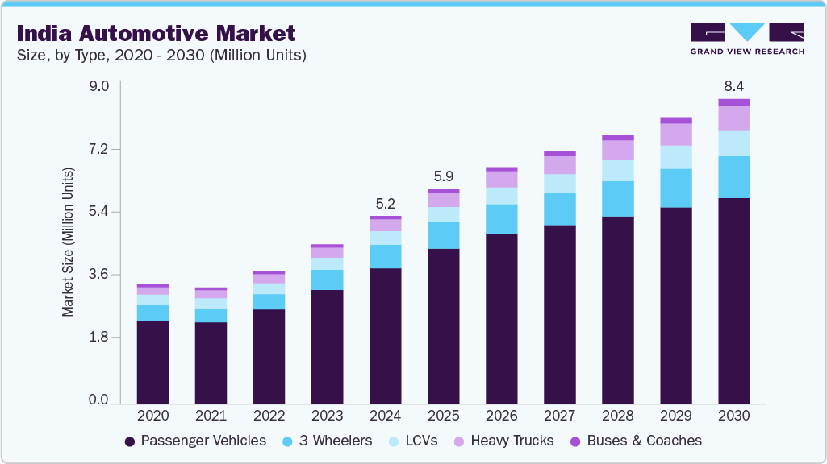
Figure 1: India Automotive Market Size and Share
(Source: Grand View Research, 2023)
The graph (figure 2) indicates that the Indian automotive market is steadily growing between 2020 and 2030, and the market is projected to grow by increasing the sales of about 3.2 million units to about 8.4 million units. During the period, passenger vehicles dominate and the growth of passenger vehicles makes the highest contribution. The three-wheelers and light commercial vehicles (LCVs) are also increasing at consistent rates indicating the need to have last-mile connection and logistics (Grand View Research, 2023). Buses and heavy trucks increase at a slower and steady rate. The market is expected to recover and grow rapidly after 2023, showing a slight decline in 2021 but a steep increase since then, which is positive evidence of post-pandemic recovery and economic growth. All in all, the industry has a good long-term growth potential due to the needs of urbanisation and mobility.
The automotive market in India has been growing steadily because of the increased urbanisation, the growth of income of middle classes in income and accessibility of financing facilities. Government programmes like “Make in India” and production-linked incentive programmes have made the local production capabilities even more vibrant and foreign investment has been drawn towards the country (Tripathy and Dastrala, 2023). Also, the developments in infrastructure, such as highways and urban networks of roads, have contributed to a higher ownership of vehicles.
The industry has been experiencing gradual sublimation of premiumisation whilst the mass-market segment also dominates in terms of volume. There is an increased demand among consumers to have vehicles with high performance, technology and brand value. This has established in place opportunity of global luxury automobile makers to have a presence in India. The market is however very sensitive in terms of pricing and other aspects like high taxation, fuel prices and regulations are still affecting buying behaviour.

2.2 Luxury Car Segment in India
The Indian luxury car market is a niche and yet fast increasing market segment in the total car industry (Hartoyo ett al., 2023). Even though its contribution in average vehicle sales is also relatively low as compared to the total sum of vehicle sales, it has high value because of high margins and brand driven demand. The Indian luxury market targets high-net-worth individuals (HNWIs), ultra-high-net-worth individuals (UHNWIs) and the rich urban consumers who are concentrated in a few city centres, namely, Mumbai, Delhi, and Bangalore (Klaus, 2022).
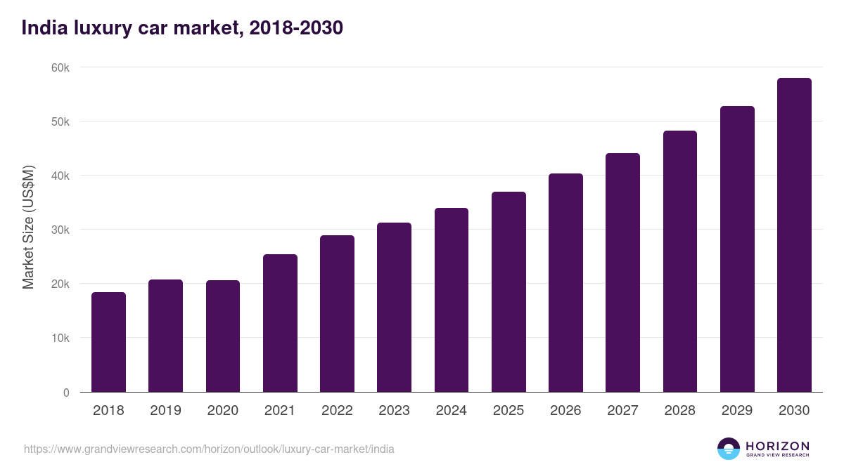
Figure 2: India Luxury Car Market Size and Outlook
(Source: Grand View Research, 2025)
It is well mentioned that increasing disposable income, shifting consumer aspirations as well as the increasing role of global lifestyles are the primary reasons behind the demand of luxury vehicles in India. Wealth is a common attribute linked to ownership of the up-end cars and as such, luxury automobiles serve as a form of identification to social status (Mya et al., 2025). Also, the younger wealthier consumers are shifting towards the experience driven consumption and preferring performance driven and technologically inclined cars.
The segment has structural problems, yet it has a growth potential. The prices of the vehicles are high and highly inaccessible by high importation rates, which reach 100% on fully constructed vehicles (CBUs). Besides, the ownership experience can be influenced by the infrastructure limits, including bad roads, insufficient service networks and others (Mazele and Amoah, 2022). However, the prospects of the long-term periods are hopeful as the wealth base is a growing one and the luxury consumption is becoming more widely accepted within the Indian society.

2.3 Key Players and Competitive Positioning
Luxury automotive market in India is intense, and many global brands have competed on a small yet profitable market. The main competitors are Ferrari N.V., Porsche AG, Mercedes-Benz Group AG, and BMW AG with different value propositions.
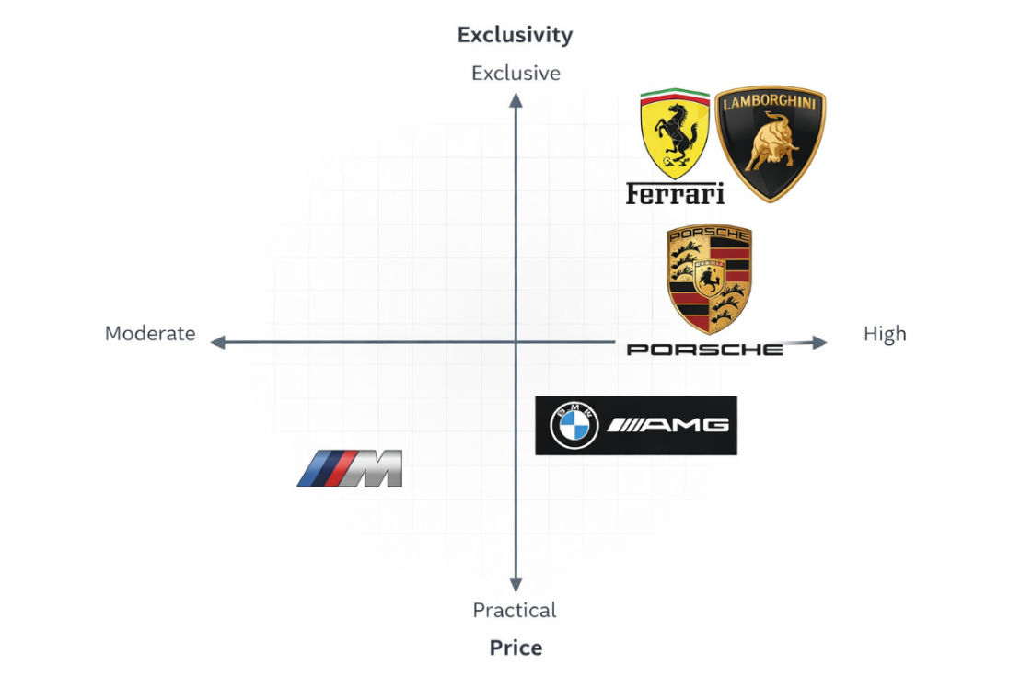
Figure 3: Perceptual Map
(Source: Self-created using Template)
Other brands like Mercedes-Benz and BMW target a more expanded luxury market where they have a variety of cars with different prices within the market, hence recording high sales volumes. Conversely, endurance, speed, and reputation over quantity, Ferrari and Lamborghini are both in the ultra-luxury segment. Automobili Lamborghini S.p.A. separates itself by violent design, engineering breakthrough and limited production, driving its reputation to the representation of a symbol of high extremeness of luxury and individuality (Villacorta et al., 2025).
Some of the factors affecting the competitive positioning in this segment include brand reputation, pricing strategy, customer experience and after sale services. Although competitors such as Porsche are also providing a performance to daily usability ratio, Lamborghini is providing a special emotional and aspirational experience.

3. Porter’s Diamond Model Analysis
Factors | Key Insights | Impact on Lamborghini
Factor Conditions | India has a large skilled workforce and developing infrastructure but lacks specialised facilities for high performance luxury vehicles (Rajendran et al., 2025). | This limits Lamborghini’s ability to rely on local production and requires continued dependence on imports.
Demand Conditions | The rising number of affluent consumers in India is increasing demand for luxury and status driven products. | This supports Lamborghini’s niche positioning and creates long term growth potential in the ultra-luxury segment.
Related and Supporting Industries | India has a strong automotive supply chain but limited specialised service networks for ultra luxury vehicles (Serohi, 2022). | This affects after sales service quality and may reduce customer satisfaction in the long term.
Firm Strategy, Structure and Rivalry | The market includes strong global competitors with varying strategies ranging from exclusivity to broader luxury offerings. | This creates competitive pressure while allowing Lamborghini to differentiate through exclusivity and performance.
Government Role | High import duties and strict regulations significantly increase the cost of luxury vehicles in India. | This acts as a major barrier to market expansion and limits Lamborghini’s sales volume.
Chance Factors | Economic fluctuations and the global shift toward electric vehicles are reshaping the automobile industry (Jagani et al., 2024). | This introduces uncertainty and requires Lamborghini to adapt its strategy toward sustainability and innovation.
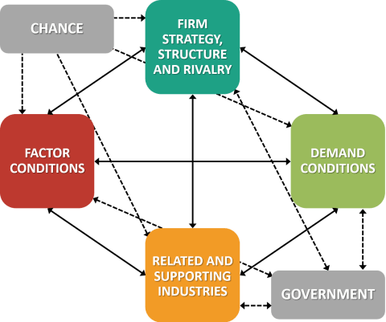
Figure 4: Porter’s Diamond Model
(Source: de Bruin, 2022)

3.1 Factor Conditions
Factor conditions are availability of production factor like labour, infrastructure and technological capabilities. India has a big pool of inexpensive labour including the qualified engineers and technicians, something that helps it to be one of the world automobile manufacturing centres (Masato and Kim, 2024). But in the case of the luxury automobile market, these are less advantageous to Lamborghini, which does not produce locally but imports fully assembled ones. There are also infrastructure issues, including variable road surface quality, and the lack of high-performance car driving conditions, which decrease the effectiveness of a supercar on the road.

3.2 Demand Conditions
Demand conditions evaluate the quality and level of domestic consumers. The increasing number of high and ultra-high-net-worth people in India has tremendously boosted the demand of the luxury products and this includes high-performance cars (Somani, 2025). In the urban environment, consumers are becoming more expressive of international trends and thus exhibit a greater preference towards high quality products that are status symbols and exclusive at the same time.

3.3 Related and Supporting Industries
Competitiveness is dependent on the availability of efficient supporting industries. The country of India has a strong network of automotive suppliers, logistics vendors, and component vendors, which provides large scale production in the mass-market segment (Martínez and Terrazas-Santamaría, 2024). Also, financial services, such as insurance and vehicle financing, are rather popular. The ultra-luxury car ecosystem is however small. For example, Lamborghini has few recognised dealerships and service centres in big cities like Mumbai and Delhi (Wakhariya, 2022). The deficient extensive specialisation maintenance infrastructure and trained specialists may have an impact on customer experience and efficiency.

3.4 Firm Strategy, Structure and Rivalry
Adequacy of domestic rivalry and corporate strategy is of essential significance in determining the competitiveness at the industry level. The intense global competitors within the Indian luxury automobile market include Ferrari N.V., Porsche AG, and Mercedes-Benz Group AG. These companies have various approaches including the exclusivity models and the volume-based luxury with luxury packages. Lamborghini distinguishes itself in terms of extreme performance, unique design, and showcased limited production something it has focused on, targeting niche customer segment (Battiston, 2025). Although the level of competition in brand prestige and customer experience is high, the general competition is balanced by the small size of the market.

3.5 Government Role
The competitiveness of the automobile industry in India is greatly dependent on government policies. The cost of luxury cars is often made to be unreachable by high importation rates on fully assembled units which sometimes goes up to more than 100%. Also, foreign companies are faced with operational complexities due to the regulatory requirements in the areas of emission, safety, and taxes (Dako et al., 2022). Although the initiatives like the Make in India are geared towards encouraging domestic manufacturing, they do not provide many benefits to those companies such as Lamborghini who depend on imports.

3.6 Chance Factors
The external events that firms and governments cannot control and that are part of chance factors are a crisis in the economy, disruption in technology, or global trends. The luxury automobile market in India can be affected by market variations in the growth of the economy, fluctuations in the exchange rate, as well as disruptions in the global supply chain (Msomi and Muzindutsi, 2025). Moreover, the world is moving towards electric cars, and Lamborghini has an opportunity to struggle with this shift and a challenge at the same time, as it has used to specialise in internal combustion engine.

4. Analysis of Lamborghini in India

4.1 Company Overview
Automobili Lamborghini S.p.A. is an Italian company that manufactures high-performance sports cars of the luxury-car segment and is based in 1963 estimating the present-day owner of the company as the Volkswagen Group (Lamborghini, 2025). The brand has a unique design and strong engines coupled with exclusivity drive and is internationally known as leading in all these aspects.
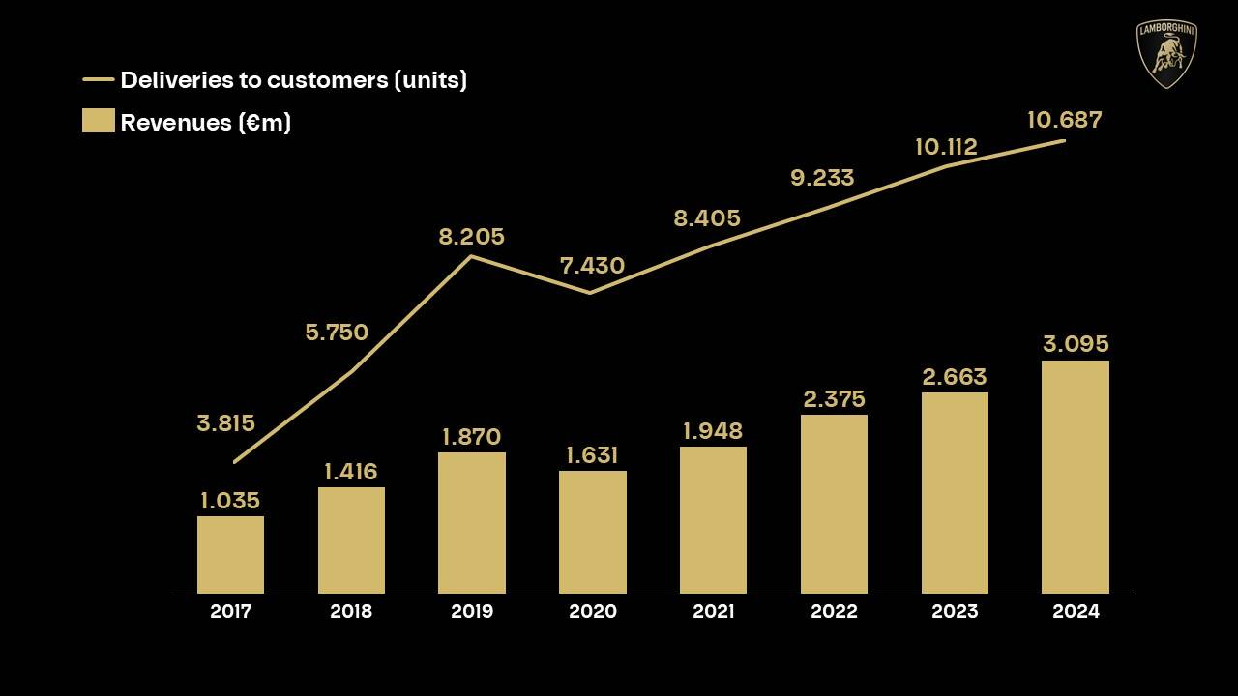
Figure 5: Financial Status of Automobili Lamborghini S.p.A.
(Source: Lamborghini, 2022)
Lamborghini had initially penetrated Indian market in the early years of 2000s and targeted ultra-high-net-worth niche of the Indian market (The Economic Times, 2025). It has operations in India which are dominated by import model whereby automobiles are imported in Completely Built Unit (CBU) form. The business has only a few licenced dealerships that are found in the key metropolitan cities like Mumbai, Delhi or Bangalore.
Its Indian strategy is exclusiveness, customer experience and brand prestige as opposed to volume sales. Lamborghini has a limited assortment of its products consisting of supercars and SUVs such as the Urus which has been a key factor in growing its sales in the Indian market. Although Lamborghini has had a small market share it has come to be known as a status-symbol and a luxury brand, serving a very narrow and well-off customer base.

4.2 Market Attractiveness Analysis
Force | Level (High/Medium/Low) | Explanation
Competitive Rivalry | Medium | High import duties (over 100%) significantly increase prices, limiting the market to a niche segment. Government initiatives like “Make in India” discourage imports. While political stability supports long-term investment, frequent policy changes create uncertainty.
Threat of Substitutes | Medium | Rising GDP and increasing wealthy population boost demand for luxury cars. However, high economic inequality restricts affordability. Alternatives such as other luxury brands or investments may substitute demand, especially during inflation or economic downturns.
Bargaining Power of Buyers (Consumers) | Medium to High | Buyers are influenced by status and aspirational value, which strengthens Lamborghini’s appeal. However, practicality concerns (road conditions, usability) and high price sensitivity in India give consumers stronger decision-making power.
Bargaining Power of Suppliers | Low to Medium | Lamborghini relies on advanced technology and global supply chains. The shift towards EVs and sustainability increases dependence on specialised suppliers. However, strong brand control and innovation reduce supplier dominance.
Threat of New Entrants | Low | Strict regulations (BS emission norms), high taxation (GST, customs duties), and homologation barriers make entry difficult. Environmental regulations and sustainability pressures further increase entry costs, protecting existing luxury brands.
Competitive Rivalry
The Indian business environment is also very applicable in determining the activities of the foreign motor company like Lamborghini. The high import duty imposed on fully assembled units is one of the most pressing problems as it may be more than 100% (Higgins, 2023). This really hikes the overall selling cost of Lamborghini cars which restricts their availability to an extremely small market number.
Also, the Indian government encourages local production by programmes like the "Make in India" that indirectly shuns the business model of importation. Market stability in India helps to providing long-term investment, but uncertainty in foreign luxury brands may be caused by almost constant changes in policies and the nature of these changes (Radha, 2025). Thus, the business setting is stable, but it offers huge costs-related impediments to Lamborghini.
Threat of Substitutes
India is among the most rapidly developing large economies, which are marked by the growing GDP, the growing disposable income and the growing wealthy population. The luxury brands including Lamborghini are the direct beneficiaries of the number of high-net-worth people in the Indian market that have been rising steadily (Ingaramo, 2022).
Nonetheless, economic disparity is still very high, which is, only a small portion of society can afford ultra-luxury cars. Moreover, the exchanges in the exchange rates also may influence pricing because Lamborghini is an imported car. The levels of economic decline or inflation can also lower discretionary budget on luxury commodities.
Bargaining Power of Consumers
The demand of luxury cars in India is mostly moulded by social and cultural reasons. The possession of luxury cars is strongly linked to social position, prosperity, and the status symbol. This predisposes Lamborghini to the high-end consumers who desire to show off and demonstrate financial prosperity and distinctive personality.
The shift in consumer behaviour especially the young affluent population has resulted in the growth of experiential and aspirational products (Klaus, 2022). The craving of global luxury brands has been further intensified by the social media and international exposure.
Nevertheless, the Indian demand of practicality and value can restrain the demand of supercar which is viewed to be not as functional on the Indian driving conditions. However, the brand image of Lamborghini cars has been able to promote demand in its niche market.
Bargaining Power of Suppliers
The world automobile market is changing under the influence of technological advancements especially with the transition of the electric vehicle (EV) and environmentally friendly movement. India is a country where the government is actively encouraging the use of EVs using policies and incentives.
In the case of Lamborghini, this proves to be a challenge and an opportunity. The brand has always been linked to high-tech internal combustion engines, which can work against the new environmental regulations and consumer demands (Villacorta et al., 2025). Nevertheless, Lamborghini has started to believe in hybrid and electric technologies in the world, and this may make it more competitive in India.
Moreover, the Indian technological system, such as digital connexion and intelligent mobility platforms, is beneficial in the expansion of high-quality automobile experiences. Yet, induced by the absence of EV charging infrastructure and performance-oriented ecosystems is still an obstacle.
Threat of New Entry
India has a legal environment characterised with strict laws pertaining to safety, emissions and taxation of vehicles. Strict adherence to Bharat Stage (BS) emission regulation laws and other forms of regulation may also pose a challenge to the importation of vehicles, as they may complicate operations.
Strict taxation with taxes imposed on luxury cars such as customs duties, Goods and Services Tax (GST) as well as registration fees make luxury cars very expensive (Mya et al., 2025). These legal restrictions make the markets less accessible and minimise the sales volume.
Also, import policies and homologation may slow the launch of the product and have an impact on business activities. Though the legal market is standardising and consumer protection is guaranteed, it presents significant obstacles on the Lamborghini importing strategy.
The issue of environmental concerns is gaining popularity in the auto industry. The Indian government is focusing on sustainability and the reduction of carbon emission, and it has resulted in the development of stricter environmental regulations.
In the case of Lamborghini, a brand that specialises in vehicles with high performance and powerful engines, it poses a strategic threat. The pressure to change into hybrid and electric models to follow the sustainability trends across the world is mounting.
Also, the issues of urban pollution and the possibility of limiting the high rates of vehicle emissions can affect the future demand (Hartoyo et al., 2023). Nevertheless, the current investments on hybrid technology by Lamborghini gives it a chance to accommodate the changes and remain relevant in the changing market.

4.3 Entry Mode and Strategy Evaluation
Automobili Lamborghini S.p.A. has been involved in India with a type of entry mode which is import based which is the sale of cars in the form of Completely Built Unities (CBUs) (Lamborghini, 2025). This plan will enable it to uphold high-quality standards and retain the level of brand image across the globe.
The company has set up a small number of dealerships in major metropolis cities, and the company offers exclusivity and personalised customer service. This strategy is in harmony with the international policy adopted by Lamborghini of concentrating on a niche market instead of trying to expand mass markets.
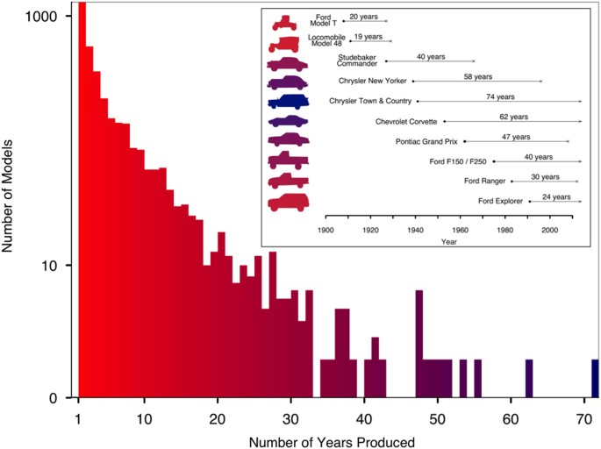
Figure 6: CBU models
(Source: Gjesfjeld, 2022)
The CBU model, however, comes with a much higher cost since import duties and taxes cause a limit of penetration in the market. Contrary to some of its competitors who have used local assembly as a means of lowering their cost, Lamborghini has preferred exclusivity, as opposed to volume.
Although such a strategy is good in keeping the brand prestigious, it might hamper long-term growth in India. Another possible option is the semi-knocked-down (SKD) or totally knocked-down (CKD) assembly which is going to cost less but would probably run a risk of diluting the exclusivity of the brand.

4.4 Opportunities and Challenges
Opportunities | Challenges | Impact on Lamborghini
The number of ultra-high net worth individuals in India is increasing, which expands the potential market for luxury automobiles. | High import duties and taxation significantly increase the cost of Lamborghini vehicles in India. | This creates strong demand potential but limits affordability, resulting in a small yet high value customer base.
The growing influence of global lifestyles and social media is increasing aspirational consumption among affluent consumers (Tripathy and Dastrala, 2023). | Infrastructure issues such as poor road conditions and traffic congestion reduce the usability of supercars. | This strengthens brand desirability but negatively affects the practical ownership experience.
The success of luxury SUVs such as the Lamborghini Urus reflects a shift toward performance combined with practicality. | Environmental regulations and the shift toward electric vehicles challenge traditional high performance combustion engines. | This creates opportunities for product diversification but requires investment in sustainable innovation.
Rapid urbanisation and concentration of wealth in metropolitan cities are driving demand for premium products. | The luxury automobile market in India remains niche and limited in size. | This allows targeted marketing strategies but restricts large scale growth and market expansion.
Increasing digital engagement enables brands to reach and influence high value customers more effectively. | Strong competition from brands offering more versatile and practical luxury vehicles affects positioning. | This enhances customer engagement but requires Lamborghini to maintain strong differentiation and exclusivity (Kumar and Gehlot, 2023).
Opportunities
The high rates of the rapid growth of the ultra-high-net-worth demographic are one of the main opportunities that Lamborghini has in India. Women are building more wealth and have more disposable incomes, which makes luxury consumption favourable.
The urbanised elite as well as increasing power of worldwide ways of life only adds to demand of luxurious brands. Also, the popularity of Lamborghini SUV car, the Lamborghini Urus is an indication that such products can be developed that will be more acceptable in Indian conditions by being luxurious and practical at the same time.
Increasing digital engagement enables brands to reach and influence high value customers more effectively. The opportunities to enhance brand engagement and increase reach in the target audience can be also achieved with the help of digital marketing and customer personalised experience.
Challenges
The Indian market has some challenges despite its potential. Taxation and high levels of importation fees cause a high price of vehicles which some consumers who are very rich cannot afford. Problems in infrastructure such as the quality of roads and the state of traffic lower the feasibility of high-performance supercars.
Furthermore, the pressure on emissions and sustainability creates long-term issues on the traditional product line of Lamborghini. The market pressure is also increasing because of the rivalry on luxurious brands that have their own vehicles which are more versatile and practical.
Strong competition from brands offering more versatile and practical luxury vehicles affects positioning. The fact that the ultra-luxury segment is limited also limits the growth available and it is not easy to attain economies of scale.

5. Conclusion
This report has evaluated the automobile market in India and the luxury supercar segment as well as the activities of the Automobili Lamborghini S.p.A. According to the findings, India is an emerging but a complicated market with high economic growth and rising affluence, changing consumer behaviour of luxury and experience-oriented products.
The industry description showed that unlike the entire automobile industry, the luxury segment is still niche and promising. The Diamond analysis by Porter found out that despite the favourable demand condition and the basic factor favourability, there are structural constraints that lead to competitiveness within ultra-luxury segment in India including high import duties, lack of developed infrastructure and supporting ecosystems.
The external analysis additionally revealed that legal (especially taxation and regulation) are also some of the greatest barriers to expansion. Nonetheless, development of the economy and trends in the society keep favouring the rise in demand of premium brands. The Indian market has the capacity to grow, and Lamborghini can utilise the current Indian market, but its current policy of exclusivity via the import-only model does not fit the global market positioning.
In general, India may be viewed as a high-numbered and high barriers market in Lamborghini. The success in the future will be determined by the capacity of the company to respond to the changes in regulatory, technological, and environmental factors without losing its brand name. Aggressive flexibility, especially concerning sustainability trends and changing customer expectations will be essential in the long-term expansion.

SECTION 2: REFLECTIVE ACCOUNT

2. Reflection using Gibbs Reflective Cycle
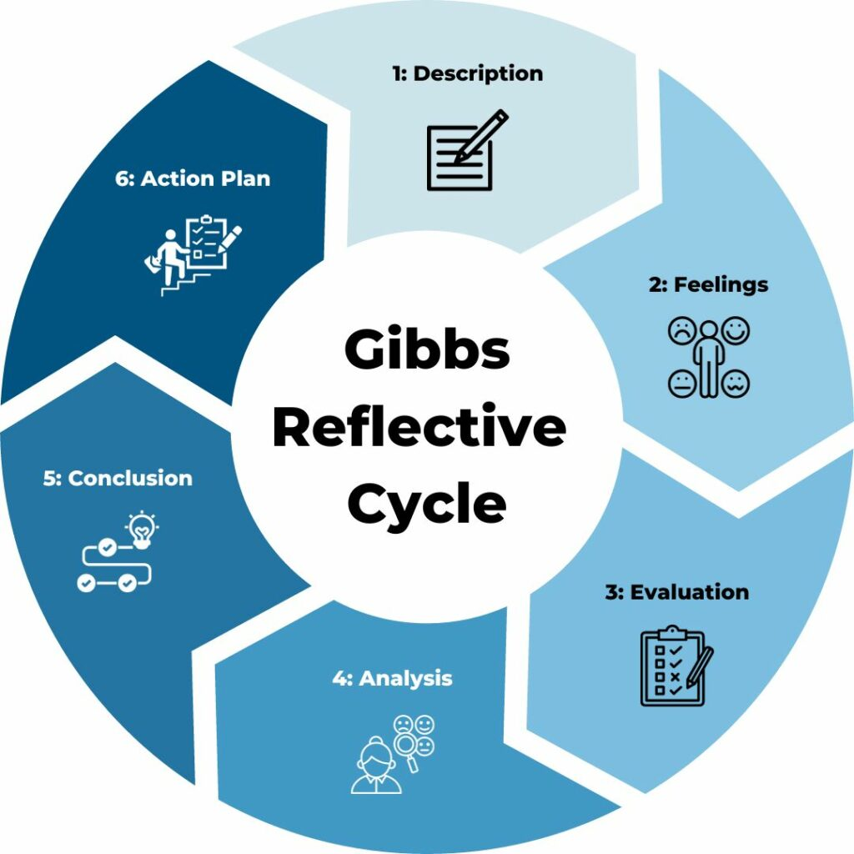
Figure 7: Gibbs Reflective Model
(Source: Channell, 2023)

2.1 Description
This assignment was a comprehensive study of the automobile business in India and more specifically, the luxury segment and how Lamborghini runs its business in India. The assignment compelled me to use different international business models, such as Porters Diamond Model Analysis, to assess the appeal of Indian market. I also looked at the competitive environment and evaluated the strategic positioning of Lamborghini in the same.
It consisted of large-scale secondary research in the form of academic journals, industry reports, and reliable internet sources. I have divided the report into various parts starting with a review of the industry and leading to a critical analysis of the business strategy of Lamborghini in India. I also related the theoretical concepts that I studied during the module to an actual organisation, and this encouraged me to overcome the gap between theory and practise.

2.2 Feelings
Initially when I started this assignment, I was confident and a bit overwhelmed. Although I was somewhat familiar with the international business concepts, I had a hard time trying to use numerous frameworks in a consistent and critical fashion. The choice of corresponding and plausible sources was also an important issue to be considered, which initially slackened my pace.
I also grew more able to examine intricate data and develop my arguments successfully as I developed. My experience in the luxury automobile segment was the most interesting to me since I gained invaluable experience on consumer behaviour and international business approaches. Nonetheless, there were also instances of frustration in my attempts to be critical but not merely describing information.

2.3 Evaluation
The capacity to use theoretical frameworks in the real world was one of my main strengths in my work. I have managed to apply the Diamond Model of Porter analysis on the Indian market, which increased the depth and applicability of my analysis. Also, I think I proved to have a good awareness of the luxury automobile industry and strategic positioning of Lamborghini.
One more positive factor was that I made attempts to use a variety of academic and industry resources, which supported the validity of my arguments. I have also formatted the report in a logical manner with a clear flow of information given between the introduction and the conclusion part.
Nonetheless, the improvement points were also present. Sometimes, I tended to get into descriptive writing instead of critical writing, especially when I was talking about the trends in the industry. I would also have learned that I could have given more comparative insights between Lamborghini and its competitors in a bid to make my assessment stronger. Another issue was time management whereby there is need to plan more on balancing research and writing.

2.4 Analysis
This assignment was a significant contribution to my knowledge about international business environments and issues of complexity in expanding the international markets. I was able to know that demand alone is not enough to sell a business in a foreign market but a mix of socio-economic factors applies. The case in point is the high importation tariffs in India which underline the direct influence by government policies on business plan and prosperity.
The use of Porters Diamond Model made appreciate the fact that the issue of national competitiveness depends on interrelated factors, but not individual ones. Likewise, external framework allowed me to examine the macro-environmental factors in an organised and methodical manner.
I also gained the ability to critically think because I critically assessed the strengths, and weaknesses of the Lamborghini strategy in India. Instead of taking business information literally, I learned to doubt and investigate the factors which hindered the decision making behind the facts of a business. This helped me to develop better arguments.
Moreover, I learned useful research skills, such as finding credible resources, synthesising information, and applying theoretical achievements of academics to practical situations. The abilities are required in postgraduate study and a career in business and management

2.5 Conclusion
To sum up, this assignment was a great learning experience that helped to improve my theoretical level of knowledge as well as practical analytical skills. I became more informed of the concepts of international business and its implementation in practical situations, specifically in the luxury automobile industry.
Although I could demonstrate effective research and analytical skills, I know that I can work on the critical evaluation and time management. The experience has made me see the role of going beyond writing descriptions and giving deeper insight and well-grounded arguments.

2.6 Action Plan
Goal | Specific | Measurable | Achievable | Relevant | Time Bound
Improve critical analysis skills | I will enhance my ability to critically evaluate academic literature by focusing on comparing arguments and identifying gaps rather than describing content. | I will demonstrate this by incorporating at least three critical arguments in each major section of future assignments. | I will use academic journals and module materials to practice critical writing techniques. | This is relevant to improving my academic performance and achieving higher grades at postgraduate level. | I will achieve this within the next two academic assignments.
Enhance time management | I will create a structured study schedule that allocates specific time for research, writing, and revision. | I will complete each stage of my assignment at least three days before the deadline. | I will use digital planning tools such as calendars and task lists to organise my work. | This is relevant to reducing stress and improving the quality of my submissions. | I will implement this plan immediately and maintain it throughout the semester.
Strengthen academic research skills | I will improve my ability to identify and use credible academic sources such as peer reviewed journals and industry reports. | I will include a minimum of fifteen high quality references in each assignment. | I will access university databases and Google Scholar to find relevant literature. | This is relevant to enhancing the credibility and depth of my academic work. | I will achieve this in all assignments for the current academic year.
Develop structured writing skills | I will improve the clarity and organisation of my writing by following a clear academic structure with logical flow. | I will ensure each section includes introduction, analysis, and conclusion elements. | I will review sample high distinction assignments and apply similar structures. | This is relevant to producing professional and well organised reports. | I will apply this approach in my next assignment submission.

Reference List
Journal Sources
Battiston, A., (2025). Redesigning the customer journey: digital technologies in the luxury automotive sector. https://gupea.ub.gu.se/bitstreams/b4798103-01d4-4483-b35a-8093224572da/download
Dako, O.F., Onalaja, T.A., Nwachukwu, P.S., Bankole, F.A. and Lateefat, T., (2022). Cross-Border Taxation and Compliance Strategies Addressing Multinational Organizations’ Operational Complexity and Regulatory Demands. https://gisrrj.com/paper/GISRRJ225426.pdf
Hartoyo, H., Manalu, E., Sumarwan, U. and Nurhayati, P., (2023). Driving success: A segmentation of customer admiration in automotive industry. Journal of Open Innovation: Technology, Market, and Complexity, 9(2), p.100031. https://www.sciencedirect.com/science/article/pii/S2199853123001336
Higgins, M.M., (2023). Closed loophole, open ports: Section 307 of the Tariff Act and the ongoing importation of goods made using forced labor. Stan. L. Rev., 75, p.917. https://review.law.stanford.edu/wp-content/uploads/sites/3/2023/04/Higgins-75-Stan.-L.-Rev.-917.pdf
Ingaramo, M.O., (2022). PREMIUM DESIGN Enhancing Synergies between Design and Business in Education and Practice. POLITECNICA. https://re.public.polimi.it/bitstream/11311/1221322/1/premium-design-enhancing-synergies-between-design-and-business-in-education-and-practice.pdf
Jagani, S., Marsillac, E. and Hong, P., (2024). The electric vehicle supply chain ecosystem: changing roles of automotive suppliers. Sustainability, 16(4), p.1570. https://www.mdpi.com/2071-1050/16/4/1570
Klaus, P.P., (2022). What matters most to ultra-high-net-worth individuals? Exploring the UHNWI luxury customer experience (ULCX). Journal of Product & Brand Management, 31(3), pp.368-376. https://www.emerald.com/jpbm/article-pdf/31/3/368/2842069/jpbm-10-2020-3164.pdf
Kumar, S. and Gehlot, D., (2023). Performance of Indian Automobile Industry: An Economic Analysis. Indian Journal of Industrial Relations, 59(2). https://search.ebscohost.com/login.aspx?direct=true&profile=ehost&scope=site&authtype=crawler&jrnl=00195286&AN=173917662&h=iTsNRE8wST1qQPYlfLRcfGwjuEX5DzTw8EAqd%2BqIVvD6ShtHL5SWvT4SYVB9ILtRTrob0uaEQgroUf3p%2BS3K%2Bg%3D%3D&crl=c
Martínez, N. and Terrazas-Santamaría, D., (2024). Beyond nearshoring: The political economy of Mexico's emerging electric vehicle industry. Energy Policy, 195, p.114385. https://papers.ssrn.com/sol3/Delivery.cfm?abstractid=4784597
Masato, D. and Kim, S.K., (2024). Global workforce challenges for the mold making and engineering industry. Sustainability, 16(1), p.346. https://www.mdpi.com/2071-1050/16/1/346?utm_campaign=releaseissue_sustainabilityutm_medium=emailutm_source=releaseissueutm_term=doilink421
Mazele, O. and Amoah, C., (2022). The causes of poor infrastructure management and maintenance in South African municipalities. Property Management, 40(2), pp.192-206. https://www.emerald.com/pm/article-pdf/40/2/192/2082862/pm-06-2021-0042.pdf
Monye, S.I., Afolalu, S.A., Lawal, S.L., Gisanrin, T.T., Oluwatoyin, O.A. and Adeyemi, A.G., (2023). Now and future challenges of the automobile industry in the developing world. In E3S Web of Conferences (Vol. 430, p. 01221). EDP Sciences. https://www.e3s-conferences.org/articles/e3sconf/pdf/2023/67/e3sconf_icmpc2023_01221.pdf
Msomi, S. and Muzindutsi, P.F., (2025). Exchange rates, supply chain activity/disruption effects, and exports. Forecasting, 7(1), p.10. https://www.mdpi.com/2571-9394/7/1/10
Mya, C.C.K.E., Bhardwaj, R., Krishnasamy, H.N., Albakri, R., Senathirajah, A.R.B.S. and Haque, R., (2025). From posts to purchases: insights into the influence of social media's influencers on retail consumers’ purchase intention. Journal of Posthumanism, 5(2), pp.1714-1739. https://www.researchgate.net/profile/Rasheedul-Haque-3/publication/390877063_From_Posts_to_Purchases_Insights_into_the_Influence_of_Social_Media's_Influencers_on_Retail_Consumers'_Purchase_Intention/links/68013528bfbe974b23ab0e5a/From-Posts-to-Purchases-Insights-into-the-Influence-of-Social-Medias-Influencers-on-Retail-Consumers-Purchase-Intention.pdf
Radha, D., (2025). Analyzing Growth Patterns-A Historical Perspective on India's Foreign Trade. https://www.academia.edu/download/124306582/04.pdf
Rajendran, S., Prakash, C., Shakir, M., Alwetaishi, M., Dhairiyasamy, R., Rajendran, P. and Lee, I.E., (2025). Enhancing competitiveness in India’s electric vehicle industry: impact of advanced manufacturing technologies and workforce development. Scientific Reports, 15(1), p.15647. https://www.nature.com/articles/s41598-025-97679-9.pdf
Serohi, A., (2022). E-mobility ecosystem innovation–impact on downstream supply chain management processes. Is India ready for inevitable change in auto sector?. Supply Chain Management: An International Journal, 27(2), pp.232-249. https://www.emerald.com/scm/article-pdf/27/2/232/2874924/scm-11-2020-0588.pdf
Somani, P.P., (2025). Crafting Desire: Real-World Insights into Luxury Marketing Strategies. In Effective Marketing and Consumer Behavior Tactics for High-End Products (pp. 249-282). IGI Global Scientific Publishing. https://www.igi-global.com/chapter/crafting-desire/380505
Tripathy, A. and Dastrala, S.M., (2023). Make in India: So far and going ahead. IIM Bangalore Research Paper, (674). https://papers.ssrn.com/sol3/Delivery.cfm?abstractid=4384039
Villacorta, A., Abuowda, O. and Larsson, A., (2025). Brand Heritage’s Affect on Brand Image in a Changing Industry: A study on Italian car brands.https://www.diva-portal.org/smash/get/diva2:1968402/FULLTEXT01.pdf
Wakhariya, M.S., (2022). New Frontiers in Technology: Can Traditional Intellectual Property Rights Laws Be Adapted and applied to NFTs?. Cath. UJL & Tech, 31, p.173. https://scholarship.law.edu/cgi/viewcontent.cgi?article=1144&context=jlt
Website Sources
Channell, M. (2023). Gibbs Reflective Cycle – How to Learn from Experience and Become a Better Leader. [online] TSW Training. Available at: https://www.tsw.co.uk/blog/leadership-and-management/gibbs-reflective-cycle/
de Bruin, L. (2022). Porter’s Diamond Model EXPLAINED with EXAMPLES | B2U. [online] B2U - Business-to-you.com. Available at: https://www.business-to-you.com/porter-diamond-model/.
Gjesfjeld, E., Chang, J., Silvestro, D., Kelty, C. and Alfaro, M. (2022). Competition and extinction explain the evolution of diversity in American automobiles. Palgrave Communications, 2(1). doi:https://doi.org/10.1057/palcomms.2016.19.
Grand View Research (2023). India Automotive Market Share & Trends Report, 2020-2027. [online] www.grandviewresearch.com. Available at: https://www.grandviewresearch.com/industry-analysis/india-automotive-market.
Grand View Research (2025). India Luxury Car Market Size & Outlook, 2030. [online] Available at: https://www.grandviewresearch.com/horizon/outlook/luxury-car-market/india.
Lamborghini (2024). Financials. [online] Available at: https://www.lamborghini.com/en-en/financials.
Lamborghini (2025). Lamborghini Automobili Spa | Lamborghini.com. [online] Available at: https://www.lamborghini.com/en-en/company.
The Economic Times (2025). Lamborghini sees demand soar among young ultra rich buyers in India. [online] Available at: https://m.economictimes.com/industry/auto/auto-news/lamborghini-sold-out-in-india-until-2027-demand-soars-among-young-ultra-rich-buyers/articleshow/119290144.cms

