CUSTOMER EXPERIENCE
  - TESCO SUPERMARKET

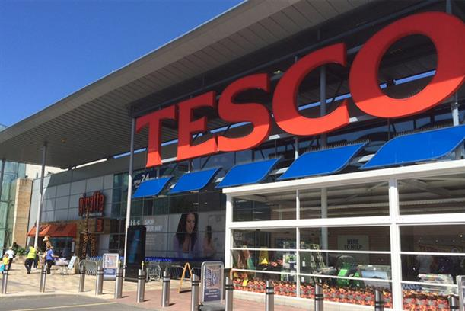
  - UNDERSTANDING AND ENGAGING IN THE CUSTOMER EXPERIENCE BMSW 5103
  - Lecturer: Dr. Kenny Tang
  - Student Id: 1813590
  - Madalina Georgiana Soreanu
  - Re-work

EXECUTIVE SUMMARY
This report has been made to enable the learner to understand how different factors affect the customer experience such as factors influencing to maximize the customer value, how the belief, attitude and value system affect the customer experience. This report had explained the overall concept of the CRM, how it affects the customer experience for the organization. This report had further used the classical management theory to understand the importance of other various factors in maximizing the customer experience.

Contents
EXECUTIVE SUMMARY 2
INTRODUCTION 4
FACTORS THAT INFLUENCE AND MAXIMIZE CUSTOMER VALUE 5
CUSTOMERS VALUE 8
CUSTOMER RELATIONSHIP MANAGEMENT 11
EVALUATION OF BELIEF, ATTITUDE AND VALUE SYSTEMS 19
MANAGEMENT THEORIES 21
CLASSICAL MANAGEMENT THEORY 21
CONTINGENCY MANAGEMENT THEORY 24
CONCLUSION 25
REFERENCES 26

INTRODUCTION
This report is made to make the learner learn about the various factors that affect the organization's ability in maximizing the customer value and satisfaction towards the products and services provided by the company. Further, this report has shown a clear understanding of effectiveness in customer requirements. It includes critical thinking through the evaluation of belief, attitude, value systems, and management theories such as classical management theory that helps in enhancing the customer experience. The main focus of this report is given to the understanding of Customer Relationship Management (CRM), this is an important approach for understanding customer experience and valuable relationship with the customers.
Tesco is the public limited company providing the super-market services with 6800 shops in different countries such as the United Kingdom, India, Malaysia, Hungary, Poland, Thailand, etc. its headquarter is in Tesco House shire park, kestrel way, Welwyn garden city, Hertfordshire and England. The chairman of Tesco is John Allan. This supermarket was founded in 1919 in Hackney, London, England by Jack Cohen.

FACTORS THAT INFLUENCE AND MAXIMIZE CUSTOMER VALUE
Customer satisfaction is the main motive that attracts the customers regarding their suppliers and products that the suppliers deliver. Several companies are operating in the worldwide aims to achieve profit, but profit is only attained when the customers purchase the products and services of the particular company, to attract the customer to buy their products and services the company must produce according to the customers' choice, satisfied customers become the loyal customers that continue buy the same products and services (Kumar and Reinartz, 2016). Customer satisfaction is the basic requirement to gin the profitability in the market. Further, some important factors affect the customer satisfaction:
The capability of the suppliers are analyzed department wise.
Technological and innovative aspects of products and services are provided.
The quality of the response provided by suppliers are analyzed.
Suppliers’ capability is analyzed to complete the deadlines.
Suppliers provide better customer services.
The complaints and feedbacks are timely solved.
The cost and quality of the products and services provided are maintained.
Suppliers maintain their etiquette and behavior.
Obstacle free operations and functions are there in the organization.
All these factors are furthers divided into two categories that is suppliers' behavior and performance of the product and services. These factors also affect the customer experience of the Tesco supermarket, the demand and supply made by the suppliers effect the price and service quality provided to the customers. These functional activities also include customer response to solve their complaints and provide the best facilities and services at a good price.
Customer satisfaction is affected by many factors including both internal and external factors such as employees, branding, accuracy of billing, and service quality provided to the customers by the company. The factors that affect customer satisfaction vary from different enterprises and to that requirement and the needs of the customers that change due to their choice, preference, trend, and comfort. The expectation level of the different customers also affects the overall customer experience. Three main factors affect the customer experience of the Tesco supermarket are:
SERVICE QUALITY
Service quality is explained as the difference between what the customer expects from the products and service and perception of what the customers receive. Customers' satisfaction is dependent upon the experience he or she receives after using of consuming the product and service. There is a proper tool used to analyze the service quality provide to the customers to identify their level of satisfaction and the gap is between the expectation and the received values to know the experience (Tripathi and Dave, 2017). The service quality is analyzed using the following dimensions:
Reliability: this shows the ability and accuracy of providing the promised services and products. The Tesco focuses on the customers’ requirement and offer them exactly what they need or better than that produced in the competitive market. The Tesco never let its customers to switch their market and are so reliable in providing the customers with valuable goods and services at the moment the customers ask for. This also helps to identify the customers’ feedback and attitude towards the Tesco’s products and services (Rosnizam et al., 2020).
Tangibility: it shows that the physical appearance of the products and services plays a crucial role in providing customer satisfaction. Tangibility for any products and services makes it more valuable, tangible products are more valuable and have the option to return or check properly whether it is the same what they needed (Saeidi et al., 2017). Tesco also provides a number of services to its customers in tangible form because tangibility brings more satisfaction like bringing the products from one place to another or improving some products like fans or watches.
Assurance: it shows the knowledge and urbanity of the employees to gain the customers’ trust and loyalty. The term assurance helps the customers and staff through effective communication to make the customers trust that the Tesco is expertise of selling quality and hygiene products and services to a large number of products and services. This helps in promoting the products and services to make the customers aware of the availability that they are providing all the required and expected facilities to make customers comfortable while making their purchase for essential items.
Empathy: this shows the sympathetic behavior towards the customers by providing them the best and useful products and services. This helps Tesco in identifying the customers’ needs and requirements as this is the most essential factor for the Tesco. The Tesco is providing its supermarket services with a wide range of products and are trying to provide the customers’ expectation through the valuable product, this they do by making proper market research.
Communication or responsiveness: the tendency and behavior to communicate with the customers should be in such a way that they understand the purpose of communication. The term responsiveness means desiring to produce the best quality products and services at less price and this is possible when the Tesco will get raw materials at low cost from the suppliers. This will further help Tesco to provide their products and services at less cost in comparison to competitors in the existing market. Receiving valuable products and services at less price makes customers highly satisfied and finally enhances the customer's value.
PERCEIVED VALUE
Perceived value is an evaluation of the customers’ experience that he or she received from the consumption of the provided goods and services. This value varies from one customer to another because different customers hold different values and perceptions and expectations from the consumption of products and services. This affects the competitive advantage in the market because to fulfill the needs and requirements of all the customers is not easy the company, therefore, makes the proper market analysis to produce and provide such products and services that provide the customers positive experience (Hussein et al., 2018).
INTERNAL CUSTOMER SATISFACTION
This gives the major focus on the satisfaction level of the employees and the workers. The employees and workers at first should be satisfied with the work and task assigned to them, when the employees and workers work efficiently the production level of the company meets the height of success. A satisfied and happy employee treats the customers in a very well manner regarding their purchasing of the goods and services. According to the Alghamdi (2016), satisfied employees work efficiently and make the maximum efforts in attaining the organizational profitable objective.
Alghamdi (2016)
All these factors whether directly or indirectly focuses on increasing the customer value by providing the best quality products and services and therefore is proved that the employees should be also motivated and encourages towards their job allotted to work and operate the organization functions to attain the maximum profit out of it and providing the best help services to the customers. The organizations like the Tesco supermarket focuses on solving the feedbacks and complaints received from the customers to attract the customers at the great level by gaining their trust and loyalty (Sinha et al., 2016).

CUSTOMERS VALUE
Providing the best quality to the customers is the main motive of the Tesco. Customer value is actually a concept that focuses on providing valuable products and services that best suits to the customers’ requirements (Ibrahim et al., 2017). This helps in improving the customer’s experience by providing better and improved services by analysing the comfort level of the customers and need as well. There are different factors of the Tesco that affects the customer value:
PRICE
The price of Tesco's consumer products and groceries of all the services are set with the intension that all the customers lying at whichever location can avail the services of the consumer products and services as the price should be made affordable for all types of customer. This increases customer value by reducing the negative effects of the price of the products.
PRODUCT
Providing best and valuable products to the customers helps in increasing customer satisfaction. Tesco focuses on identifying their targeted customers' needs and requirements and provides them accordingly or better to enhance their satisfaction level through the products and services. This helps Tesco to gain the number of customers at all the locations wherever they operate business activities or supermarket.
BRANDS
The Tesco has become a well-known brand that their customers can easily identify. The name when becomes so successful the customers become regular and by the name only they believe that the company is providing high quality, hygienic and valuable products and services. Tesco is a famous store that provides its customers with a wide variety of products and services at a reasonable price.
QUALITY
Tesco provides a huge variety of products and services in different quantities, quality, and brand. To provide the customers whatever they wish to have is the major business of Tesco and by this, they wish to make life easier and enhance the living standard of their customers. They actually focus on delivering quality and value instead of just a product or service.
TECHNOLOGY
Tesco better understands the use and advantages of the technology to make its best use in providing its customers valuable services and products at the right time and place. The Tesco gives more focus on the customers’ requirements and therefore wish to provide their customers with efficient online shopping. The Tesco changes its business styles as well according to the situation that if we talk about this current pandemic situation, COVID19 the Tesco has ensured of providing effective online ordering services with hygienic products.
BEHAVIORAL THEORY
The behavioral theory states in its study that customer satisfaction is the major focus of Tesco, as they deal with all types of consumer products and groceries to provide the customers with all their requirements under one store. Behavioral theory focuses on consumer behavior and make research on them to produce what the customers actually from the Tesco or other supermarkets. The Tesco understands this theory and implements the same within the workplace. Tesco wisely makes market research to identify the current needs and requirements of the market and provides accordingly to make a profit and provide customer satisfaction with valuable products and services.

CUSTOMER RELATIONSHIP MANAGEMENT
Customer relationship management is a tool for managing the company's relation with its existing and new customers. CRM is called as the collections of practices and strategies that a company like Tesco supermarket uses to manage and handle the customers' interaction, satisfaction, and their data towards the products and services provided. This helps in managing the overall customer's lifecycle. This management system uses the customer’s data of their purchase history to understand their choice and preferences towards their requirements. This helps the company to analyze the customer's requirements wisely, so to produce and provide accordingly. It also increases the sales of the products and services by improving and providing proper customer retention and improves the level of customer satisfaction and expectation to receive better services. Customer relationship management uses an approach to compile data using different communication mediums such as the website of the company, marketing materials, email services, and live chat and by analyzing the present era most of the communication is made through online media (Buttle and Maklan, 2019). This customer relationship management enables the companies to well identify the customers' requirements by properly targeting them and understanding their needs and demands.
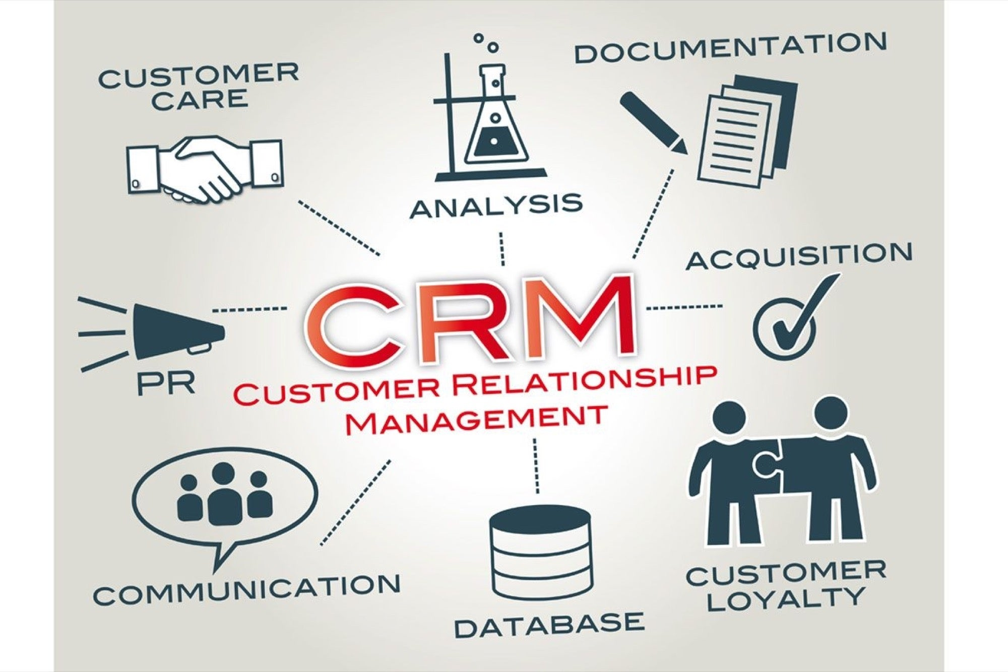

Customer relationship management
Source: (Buttle and Maklan, 2019)

COMPONENTS OF CRM
CRM software is used to combine customer information and their complete data in a company’s private database that the company can easily access and manage the overall recorded data. This software performs many functions to make the collected data more useful for a longer period. The CRM performs automation in the workflow such as managing and delegating the tasks, making the alerts, and tracking the manager's ability to analyze and identify their managing skills and capability (Rahimi, 2017). This also ensures the efficient and effective performance of all the business activities and efforts made to provide the best customer experience. Some of the CRM components are:
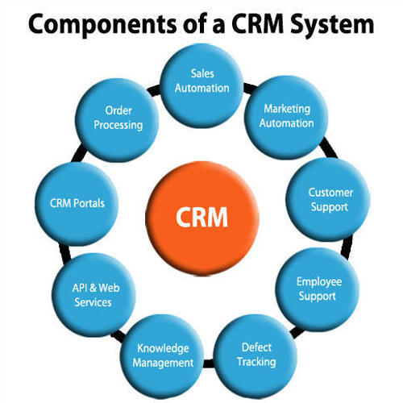

Components of CRM
Source: (Rahimi, 2017)

COMPONENTS | DESCRIPTION
MARKET AUTOMATION | In CRM the market automation helps in automatic repetitive tasks and activities to enhance the marketing efforts in the different stages of the organizational life cycle. This software or component of CRM helps in self-sending the different perspectives of marketing material to turn it into the customers' required products and services (A Al-Homery et al., 2019).
SALESFORCE AUTOMATION | Salesforce automation is an approach to identify and study different customers’ interactions to automate different business functions of the organizational sales cycle. This is also helpful in attracting new customers over existing customers in the organization to increase its sales and gain market share by providing the best services and experience to the customers.
WORKFLOW AUTOMATION | This component helps in the automatic flow of the systems in the organization to ensure the organization's efficient and effective working. This component of the customer relationship management helps in reducing the boring workloads that most employees feel in their work. They must be provided with the interesting and creative tasks that not only encourages the employees to work but also they give the better results of the work done.
ANALYTICS | This component of customer relationship management is used to enhance and create customer satisfaction. It also makes the employees to focus and analyze the collected customers' data that is collected to wisely target the customers and make the campaigns accordingly to attract the customers to buy the services and products (Nam et al., 2019).
AI | Its full form is artificial intelligence. This is a technology used to build the better customer relationship platforms to enable them to use the automatic enabled repetitive tasks. This artificial intelligence is also used to identify the customer’s buying behavior to identify the future requirements of the customers through their behaviors (Deb et al., 2018).
HUMAN RESOURCE MANAGEMENT | Customer relationship management also focuses on maintaining a good relationship with the employees of the organization because if the employees are treated well and provided with all the facilities will work happily in the organization to achieve the organizational objectives. This will also help to track the accurate information and performance review of the employees. The human resource department of an organization focuses on efficient and effective management of the organization ensuring the goal achievement for the organization (Akhondzadeh-Noughabi et al., 2016).
LEAD MANAGEMENT | Lead management is necessary to track the sales record using the customer relationship software. It helps in the analysis of the overall customer and sales data to record all in the same place for future reference to identify the customers' satisfaction level and requirements.

TYPES OF CRM TECHNOLOGY
There are four types of customer relationship management technology that are used to perform large scale functions and operations in the organization such as Tesco supermarket. The four customer relationship management technology are (Bae, 2016):
- Salesforce
- Microsoft
- SAP (System Application and Product)
- Oracle

TYPES OF THE CRM TECHNOLOGY
Source: (Bae, 2016)

ADVANTAGES OF CRM
The crucial advantage of customer relationship management is that it enhances the data of contacts in an efficient way (Naidu and Babu, 2016).
Customer relationship management is the automated process that helps in the management of the multiple teams to ensure higher management of the organization (Naidu and Babu, 2016).
Customer relationship management helps in improving and enhancing the production capacity of the employee teams.
It helps in increasing the sales by collecting the customers' accurate data.
Customer relationship management is a tool that helps in the reliable reporting of the customers as well as the employees (Naidu and Babu, 2016).
Customer relationship management helps in improving the sales metrics that result in a high level of customer satisfaction.

EFFECT OF CRM ON CUSTOMER SATISFACTION
Customer satisfaction has a great connection with the organization's economic operations because it helps in increasing customer loyalty that helps by increasing customer satisfaction by analyzing customer behavior. They wisely work upon the customer feedback and complaints to ensure the customers with outstanding facilities. This customer satisfaction approach is majorly used to identify the positive effect on customer satisfaction and the knowledge regarding the taste and preferences of the customers towards the services and products provided (Santouridis and Veraki, 2017).
This approach results in the customer benefit as the company engaged in any kind of business anyhow requires customers at the end to make their business successful. The business whether it is profit-seeking or non-profit making organizations always targets the group of customers and the after-sale service to attract the customers. There are majorly eight benefits that the company recognizes in the context of customers:
- Enhancing the target customers.
- Providing proper support to customers across different channels.
- Improving effective and efficient sales force.
- Providing a better pricing strategy.
- It provides the best products and services.
- It provides better and effective customer services.
- Makes good campaign strategies.
- Connect with customers using all the channels possible.

EVALUATION OF BELIEF, ATTITUDE AND VALUE SYSTEMS
Belief is something that makes or forces a person to trust on anything. A person beliefs on according to the probability of something to take place in reality. The belief of the customers towards the products and services also affects the customer experience. The trust and loyalty of the customers for effects according to the particular brand. It is the normal belief of the customers that any products or services of some particular or famous brand will automatically carry a high level of satisfaction and expectations of the customers (Yin et al., 2018).
Attitudes also affect the customer experience and thinking towards the products and services by a particular company or brand. There are normally five strategies that the company faces and make to change the customer's attitude towards the products and services provided. The companies, therefore, use several strategies to attract the customers and gain a positive attitude. The five strategies planned by the company are:
Enhancing the motivational functions.
Setting the products with the most admired group.
Solving the conflicts regarding the attitude of the customers.
Changing the components with multi-attribute components.
Enhancing the customers’ belief towards the products and services.
Customer relationship management is a tool used to maximize the customers' value. The companies wisely collect the data of their customers regarding their needs, demands, choice, preferences, and trends. The company wisely works on improving the necessary products and services to provide customers with better values to enhance their experience.
The organization Tesco supermarket focuses on all the required beliefs, attitudes, and value systems of the customers to provide them the products and services according to their demand and of course, affordability. The organization aims at increasing the loyal customers to gain the market share with the maximized profit by providing them the best experience. The company has also analyzed the customer's perception towards their services and has improved the services accordingly, and has especially focused on solving the customer's feedback and complaints towards the products and services provided to them.

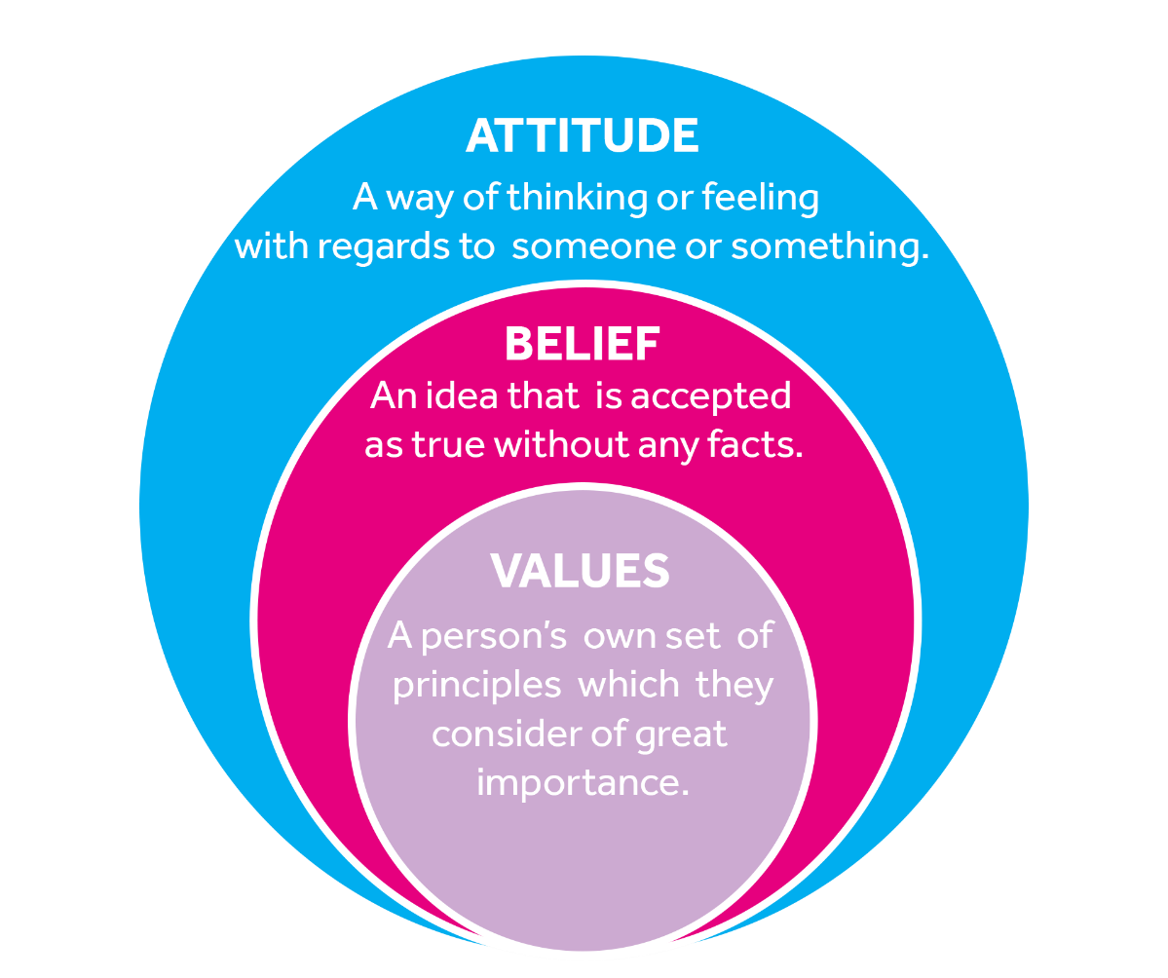

ATTITUDE, BELIEF AND VALUE SYSTEMS
Source: (Yin et al., 2018)

MANAGEMENT THEORIES
These are the conception and theories used to recommend management strategies that include using such tools and approaches such as proper guidelines and frameworks. These guidelines are used to execute in the organization to ensure success. There are many management theories that the different organizations implement in their organization to attain success and ensure the effective and efficient operations and management of the company. Customer experience is also ensured through the implementation of management theories in the organization like Tesco supermarket, Watford Branch (Friday et al., 2018).
Many management theories are used in different organizations, here classical theory is implemented in the organization. The theory is:

CLASSICAL MANAGEMENT THEORY
Classical management theory is an approach that focuses on the basic needs of the workers and employees. This theory focuses on their physical and financial needs. This doesn't include their job satisfaction, there are other needs of the workers and employees working in the company other than the profit maximization, leadership, and decision making. The theory focuses on the self-development of the workers and employees to enhance their skills and productivity (Beach and Lipshitz, 2017).
This theory further focuses on the three major concepts and structures (Kitana, 2016):
HIERARCHICAL STRUCTURE: hierarchical structure shows the three different parts of the management in classical management theory. In these three parts of the hierarchy, the topmost layers consist of the owners, executives, and board of directors who pass in the orders and tasks to the other lower department of the organization. The middle-level management of the organization delegates the responsibility and tasks according to the capacity of the employee and workers. They also supervise the teams to work efficiently for their goals assigned. The third and last level of the organization is the lowest, this level consists of the employees and workers who undertake day to day activities, and tackle all the disputes among the employees and workers to ensure the best outcome with positive results (Kitana, 2016).

SPECIALIZATION: this structure of the classical management theory consists of the different assembly lines of the workplace that task and aim to set all the organizational levels and departments to work efficiently. This level focuses on providing the specialization to make the employees easily accomplish the goal. This structure helps in increasing the productivity and efficiency level of the employees by providing them multi-task opportunities and guidance accordingly. This structure aims at specializing the employees in the task provided (Kitana, 2016).
INCENTIVES: The incentive theory of the classical management focuses on motivating the employees by paying them timely wages and remuneration. Here financial rewards are provided to increase the motivation of the employees and workers. This makes the employees to work harder and give all the necessary efforts in the completion of the tasks. This results in increased productivity, efficiency, and profit (Kitana, 2016).
The dictatorial leadership model acts as the central part of the classical management theory because according to this model there is no need to make a large group of people take any decision. Here all the required decisions are made by the single person called the leader and the superiors are asked to follow the orders made by the leader. The leader should make the required decision quickly instead of waiting for any group of people to enable the company to work effectively.
ADVANTAGES OF THE THEORY
It makes the clear structure of the company to make its proper management and functions (Terziev, 2018).
Employees and workers should be wisely divided according to their tasks assigned.
All the employees and workers should be given proper guidance for the work assigned.
The hierarchical structures of the organization are mentioned. As different management has their different roles and objectives.
Most of the decisions are taken by the leader of the company.
Although this theory is not much used in today's generation but yet carries benefits for the organization if implemented wisely. This theory focuses on the welfare of the workers and employees of the organization, because if the workers and employees are motivated and guided properly will bring the effectiveness in their work (Beach and Lipshitz, 2017).
This theory is also helpful in making the learner understand that the employees' role, work and satisfaction is also necessary to be focused by the organization like the Tesco supermarket, it is because when the employees are happy with their work will make the efforts to make the customers' satisfied with their
PRINCIPLE OF CLASSICAL MANAGEMENT THEORY
- There must be only one superior to command.
- There must be a proper scalar chain.
- There should not be any obstacles in the communication.
- The motivation should be given at all the required levels.
- Harmony must be treated as the strength.
- The work and task should be wisely delegated (Sulieman, 2019).
According to the classical management theory, the employees and workers should be given equal importance as the customers. The customers will only receive the valuable services and products from the company when the employees and workers will produce and make it available in the market. For example, the Tesco supermarket will provide its services and products to the customers only after the perfect production and the perfect and required production of the products and services will take place when then workers will do so. The employees will only work effectively and efficiently when will get all the required facilities from the organization. The happy and satisfied employees will help and guide the customers in a better way that will help in attracting the customers towards the services provided, this is very essential to make the customers loyal for the organization's products and services. This helps in the proper evaluation of the customers to provide the best facilities to enhance their experience.

CONTINGENCY MANAGEMENT THEORY
The contingency theory shows that the management of the Tesco is not fixed with a single way to manage or lead the organisation. This theory shows that the Tesco is not bounded with any single theory or way to manage its business operations, the leader and manager practices various skills and ways to manage the Tesco and provide customers with satisfying products and services to make the experience valuable (Bernstein, 2017). The manager usually practices the business strategy as per the need of the situation to bring effective and profitable results. This theory was given by Fiedler and has made further three main concepts of this theory to help the organisation like Tesco to meet their business goal and provide their customers valuable products and services to make them get a positive experience:
There is no fixed or best way to manage an organisation, this changes as per the demand of the situation
The leader and manager should be enough capable in identifying the most appropriate skills and styles to be practiced within the Tesco supermarket to help the employees achieve their business objective (Larsen et al., 2020).
Practicing the LPC scale to measure the manager's leadership orientation within the workplace to focus on the employees or workers as well intending to provide them with a secure and positive work environment.

CONCLUSION
This report is made to make the learner understand the basic factors that affect the customer experience towards the particular products and services provided by the organization. Tesco supermarket. This report has also focused on maximizing the customer value by providing them the best services and analyzing the customers' belief, attitude, and value systems towards the products and services provided. At last, this report has given the main importance in explaining customer relationship management to analyze the customer relationship and has used different management theories to understand the customer experience.

REFERENCES

A Al-Homery, H., Asharai, H. and Ahmad, A., 2019. The Core Components and Types of CRM. Pakistan Journal of Humanities and Social Sciences, 7(1), pp.121-145.
Akhondzadeh-Noughabi, E., Amin-Naseri, M.R., Albadvi, A. and Saeedi, M., 2016. Human resource performance evaluation from a CRM perspective: a two-step association rule analysis. International Journal of Business Performance Management, 17(1), pp.89-102.
Alghamdi, A.A., 2016. The impact of the service quality as a mediating variable on the relationship between internal marketing policies and internal customer satisfaction: an empirical study at Taif University. Journal of Marketing Management, 4(1), pp.104-124.
Bae, M., 2016. Effects of various types of cause-related marketing (CRM) ad appeals on consumers' visual attention, perceptions, and purchase intentions. Journal of Promotion Management, 22(6), pp.810-834.
Beach, L.R. and Lipshitz, R., 2017. Why classical decision theory is an inappropriate standard for evaluating and aiding most human decision making. Decision making in aviation, 85, pp.835-847.
Bernstein, E.S., 2017. Making transparency transparent: The evolution of observation in management theory. Academy of Management Annals, 11(1), pp.217-266.
Buttle, F. and Maklan, S., 2019. Customer relationship management: concepts and technologies. Routledge.
Deb, S.K., Jain, R. and Deb, V., 2018, January. Artificial Intelligence―Creating Automated Insights for Customer Relationship Management. In 2018 8th International Conference on Cloud Computing, Data Science & Engineering (Confluence) (pp. 758-764). IEEE.
Friday, D., Ryan, S., Sridharan, R. and Collins, D., 2018. Collaborative risk management: a systematic literature review. International Journal of Physical Distribution & Logistics Management.
Hussein, A.S., Hapsari, R.D.V. and Yulianti, I., 2018. Experience quality and hotel boutique customer loyalty: Mediating role of hotel image and perceived value. Journal of Quality Assurance in Hospitality & Tourism, 19(4), pp.442-459.
Ibrahim, A.A., Alkhawlani, M.A.A. and Al-shaghdari, F.M., 2017. Customers Desires on Marketing Mix and It’s Impacts on Tesco (Malaysia). International Sciences of Management Journal, 1(1).
Kitana, A., 2016. Overview of the managerial thoughts and theories from the history: classical management theory to modern management theory. Indian Journal of Management Science, 6(1), p.16.
Kumar, V. and Reinartz, W., 2016. Creating enduring customer value. Journal of Marketing, 80(6), pp.36-68.
Larsen, N.M., Sigurdsson, V., Breivik, J., Fagerstrøm, A. and Foxall, G.R., 2020. The marketing firm: Retailer and consumer contingencies. Managerial and Decision Economics, 41(2), pp.203-215.
Naidu, G.R. and Babu, R.H., 2016. Client Relationship Through Mobile CRM in Organized Retail Outlets. International Journal of Science Engineering and Advance Technology, 4(1), pp.100-104.
Nam, D., Lee, J. and Lee, H., 2019. Business analytics use in CRM: A nomological net from IT competence to CRM performance. International Journal of Information Management, 45, pp.233-245.
O’Brien, J., 2019. The Korean Restaurant: A Services Marketing Failure?. SAGE Publications: SAGE Business Cases Originals.
Rahimi, R., 2017. Customer relationship management (people, process and technology) and organizational culture in hotels. International Journal of Contemporary Hospitality Management.
Rosnizam, M.R.A.B., Kee, D.M.H., Akhir, M.E.H.B.M., Shahqira, M., Yusoff, M.A.H.B.M., Budiman, R.S. and Alajmi, A.M., 2020. Market Opportunities and Challenges: A Case Study of Tesco. Journal of the community development in Asia, 3(2), pp.18-27.
Saeidi, S.P., Rasli, A.B.M., Saeidi, P., Saaeidi, S.A. and Saeidi, S.P., 2017. How Service Quality Results in Customer Satisfaction of Large-Scale Retailers in Malaysia. Advanced Science Letters, 23(9), pp.9050-9054.
Santouridis, I. and Veraki, A., 2017. Customer relationship management and customer satisfaction: the mediating role of relationship quality. Total Quality Management & Business Excellence, 28(9-10), pp.1122-1133.
Sinha, M., Camgöz-Akdağ, H., İmer, H.P. and Ergin, K.N., 2016. Internal customer satisfaction improvement with QFD technique. Business Process Management Journal.
Sulieman, M.S., 2019. Roots of Organizational Knowledge in Classical Management Theories: A Literature Review. International Journal of Business and Social Science, 10(10).
Terziev, V., 2018. The active model of a social programme and its strategic advantage. Available at SSRN 3310532.
Tripathi, G. and Dave, K., 2017. Service Quality and Customer Experience: The Key to Building Sustainable Competitive Advantage in Fine Dine Restaurants. In The Indian Hospitality Industry (pp. 195-225). Apple Academic Press.
Yin, J., Qian, L. and Singhapakdi, A., 2018. Sharing sustainability: How values and ethics matter in consumers’ adoption of public bicycle-sharing scheme. Journal of Business Ethics, 149(2), pp.313-332.

