BA(Hons) Leadership and Management Skills in the Workplace
BMSW5104: Managing Projects in the Organization
Project Management Plan for Rooftop "View" Restaurant

Student Name: Sinziana Madalina Chirvasa
Student ID: 2112859
Lecturer: Nishi Ramsurrun

Executive Summary

The Rooftop "View" Restaurant blends exquisite dining and city views with culinary expertise and architectural grandeur. This includes design idea, interior refinement, procurement management, skilled workforce, and the grand opening celebration. This plan goes deeper, into each operational fragment's DNA.
This initiative carefully acknowledges and addresses stakeholders' crucial role. From the visionary project sponsor driving the financial engine to the dedicated project manager managing every move, from the specialized project team members providing expertise to the frontline employees shaping the experience, from the strategic steering committee making high-level decisions to the invaluable subcontractors providing specialized services, each stakeholder's impact and commitment is interwoven into this plan.
Work Breakdown Structure, the foundation of each successful project, is meticulously included in this plan. A complex web of tasks, subtasks, and activities, it depicts the blueprint-to-reality process. From architectural concepts to final décor, from building to final polish before the great opening, the WBS is a tribute to rigorous planning and execution.
This plan allocates resources wisely, acknowledging them as the currency of realization. Every minute, ounce, and substance is measured and qualified. The dance of monetary calculations and intangible assets enables a harmonious synergy of work and expenditure, resulting in a financially viable masterpiece.
The stormy seas of uncertainty must be addressed in every plan. Risk assessment is essential in project management's stormy seas because it predicts and guides storms. This approach mitigates and contingencies supply chain and employee turnover storms.
This Executive Summary barely scrapes the Rooftop "View" Restaurant project management plan's vast tapestry. This plan's painstaking planning, academic acumen, and strategic navigation result in a gastronomic and architectural masterpiece. The next sections examine each thread of this complicated tapestry to reveal the project's success pattern.

Table of Contents
Executive Summary. 2
Introduction 4
Project Outline / Description / Scope 4
Stakeholder Analysis 4
Progress Patron: Project Sponsor 4
Project Manager: Alignment Architect (Cote, 2023) 5
Team Members: Collaborative Craftsmen 5
Experience Engine: Employees 5
The Steering Committee: Strategic Planning Leaders 5
Subcontractors Provide Variety of Skills 5
Work Breakdown Structure (WBS) 5
Hierarchical Structure 6
Costs/Resources 6
Cost breakdown 6
Resource Allocation 6
Striking Balance 7
Resource Consideration 7
Project Schedule / Gantt Chart 8
Risk Assessment 9
Integration of Components 9
Conclusion 10
References 11

Introduction
In the dynamic landscape of the hospitality industry, the successful execution of projects is essential for achieving competitive advantage and realizing business goals. This Project Management Plan outlines a strategic roadmap for the establishment of the Rooftop "View" Restaurant, a venture aimed at redefining the dining experience through an exquisite combination of culinary excellence and breathtaking city vistas.

Project Outline / Description / Scope
The Rooftop "View" Restaurant project envisions the establishment of an iconic eatery that not only satisfies the taste senses but also provides a visual feast of the city's skyline. Architectural planning, interior design, material sourcing, human resource management, and a spectacular opening ceremony are just a few of the many tasks involved in this massive project. The mission is to combine beauty, functionality, and innovation to make the restaurant a regional and local favorite. Designing, constructing, and opening the Rooftop "View" Restaurant that offers a breathtaking vantage point over the city is part of the project. The scope of work includes architectural design, interior decoration, furniture and equipment purchasing, hiring, training, and a formal opening ceremony (Khan, 2006).

Stakeholder Analysis
In the Stakeholder Analysis section of this project management plan, the intricate network of individuals and organizations whose responsibilities, interests, and influence are crucial to the success of the Rooftop "View" Restaurant is examined. This section includes every stakeholder's perspective and recognizes their contributions, acknowledging their importance in achievement.

Progress Patron: Project Sponsor
The person or group that funds a project is called the "Project Sponsor" or "Patron of Progress."
The Project Sponsor, at the front of this ensemble, supports development. Their support is crucial to the project's success because they set the financial structure and distribute resources. Their fluid financial flow and effective resource mobilization, directed by their strategic direction, demonstrate the symbiotic relationship between their investment and project completion (Gido, and Clements, 2014).

Project Manager: Alignment Architect (Cote, 2023)
Cote (2023) states that the Project Manager is the architect of project alignment. The Project Manager acts as an architect to promote alignment, following Cote's famous article. Leaders manage resources, tasks, and collaboration to track project progress. This execution conductor ensures that the project follows set limits and finish smoothly.

Team Members: Collaborative Craftsmen
A broad set of collaborating professionals offer their specific skills to turn a concept into concrete results on this project team. Architects, interior designers, procurement specialists, chefs, and marketers work at Rooftop "View" Restaurant. This ensemble adds to the establishment's artistic vision with their unique creative skills.

Experience Engine: Employees
Staff drive the overall experience in any successful firm. Front-of-house and culinary staff work together to smooth service. Employee loyalty, productivity, and happiness build the restaurant's reputation.

The Steering Committee: Strategic Planning Leaders
Like architects shape the skyline, the Steering Committee creates project-guiding strategic outlines. This could replace the user's text: The user's text could be rearranged: The user's text could be rearranged: The user's text could be rearranged: The user's text could be rearranged: The user's text could be rearranged: The user's text could be rearranged: The user's text could be rearranged: The user's text could be rearranged: The user's text could be rearranged: The user's text could be rearranged: The user's text could be rearranged: The Rooftop "View" Restaurant has a lasting impact beyond its local environment.

Subcontractors Provide Variety of Skills
Subcontractors weave a complicated specialized knowledge network. Contractors, vendors, and event organizers each contribute to this complex mix. Their expertise is visible in the concrete constructions, material choices, and flawless execution of certain jobs, which make the culinary and architectural masterpiece (Assudani, and Kloppenborg, 2010).

Work Breakdown Structure (WBS)
Complex projects are orchestrated using the Work Breakdown Structure (WBS), which breaks down the project's goals into digestible pieces (Zecheru, and Olaru, 2016). The WBS guides the Rooftop "View" Restaurant project from concept to completion, focusing on design, structural, utilities, and finishing.

Hierarchical Structure
The WBS hierarchically segments the project into finer levels, like peeling an onion. A layer for each level of detail shows the dense tapestry of jobs that make up project completion. This hierarchical layout clarifies the Rooftop "View" Restaurant's complexities. The top layer of the WBS is design, which includes creative and architectural elements. This includes designing the restaurant's layout, architecture, interior decor, and atmosphere. Each component has subtasks that detail design development. The WBS covers construction, materials, and safety one layer below. Here, tasks include obtaining permits, procuring materials, and managing construction to ensure building integrity and safety. Plumbing, electricity, and technological integration are covered next. This layer connects the physical infrastructure with modern amenities for a smooth dining experience. Installation of water and sewage systems, electrical wiring, and technical interfaces is necessary for operation. The Rooftop "View" Restaurant's finishing touches complete the WBS. This includes installing kitchen equipment, furnishings, décor, and lighting. This includes choosing dinnerware and decorations to improve the restaurant's aesthetics and functionality.

Costs/Resources
A thorough cost-resource analysis is essential to turning the Rooftop "View" Restaurant into reality. This section addresses financial issues and resource allocation beyond money.

Cost breakdown
This project's financial foundation is a detailed cost breakdown. The anticipated hard and soft expenses are £350,000. Hard costs, totaling £250,000, include construction materials, equipment, furniture, and other major investments. Soft costs of £100,000 include permits, fees, legal services, and design consultations. This comprehensive cost estimation includes all project execution aspects, leaving no financial stone untouched.

Resource Allocation
While monetary outlays give a framework, resource allocation goes beyond pounds and pence. Time, effort, and human resources must be carefully allocated to ensure project success (Selaru, 2012). In this setting, the project manager is crucial. The project manager's involvement is deliberately allocated because time is valuable. Every minute spent planning, coordinating, and making decisions boosts the project. The project manager's time is intimately woven into the project, challenging the "zero-cost" assumption and showcasing its value.

Striking Balance
A tough task in project management is striking a careful balance between financial factors and resource utilization. This delicate balancing act is comparable to a high-stakes tightrope walk, where the expected results must perfectly match the predicted costs while resources are skillfully used to maximize efficiency. This mutually beneficial connection necessitates the careful balancing of foresight, strategic planning, and mathematical accuracy. This equilibrium's entire foundation relies around the idea of value. Every dollar spent and every resource used must finally result in consequences that can be justified. It's a dynamic interaction where the return on investment is assessed in terms of both the project's bigger goals and its monetary value. Each spend is made sure to be an investment toward the achievement of project objectives by carefully comparing the projected outputs to the financial outlays. The core of this equilibrium is resource management, which stands for the crucial intersection of strategy and execution. A project manager must deftly arrange resources to harmonize with the strategic symphony of the project, just as a conductor orchestrates a symphony. By strategically aligning all of the project's resources, whether they be human, technological, or material, the project will be successful. The likelihood of success is increased by carefully matching resource allocation to the project's strategic goals. The efficient distribution of tasks not only makes them easier to do, but it also fosters teamwork and synergy. It reflects the project's goals and serves as a physical representation of its strategic road map. However, reaching this equilibrium is a science that necessitates accuracy and computation; it is not merely a matter of intuition. When estimating and allocating resources, sophisticated tools and processes that are guided by data-driven insights are essential. Project managers may make wise decisions by using mathematical models, historical data, and predictive analytics, turning this balance from a dangerous act into a calculated undertaking (Serrat, 2015).

Resource Consideration
In the complex tapestry of project management, where resources span from tangible finances to intangible expertise, the allocation of time stands as a pivotal but often underappreciated asset. The unique nature of the Rooftop "View" Restaurant project further highlights this aspect, especially concerning the project manager's time. While this might be perceived as a cost-free contribution, this section underscores the intrinsic value of the project manager's time and the imperative of its meticulous management. The project manager's time is more than mere clock-ticking; it embodies a repository of decision-making, coordination, and strategic direction. Recognizing this, the project management plan acknowledges that, though not monetarily quantifiable, the project manager's time holds a distinct value. It holds the potential to steer the project's course, shape critical decisions, and influence outcomes. Therefore, its allocation cannot be haphazard; it necessitates a strategic approach that resonates with the project's objectives and priorities (Huemann, et al., 2007). Consequently, the project manager's time allocation is designed in alignment with the project's critical tasks. These tasks, often at the heart of the project's success, demand the project manager's hands-on involvement. Whether it's the architectural design phase, where strategic choices shape the restaurant's ambiance, or the grand opening event coordination, where the project's success is unveiled, the project manager's time is judiciously assigned. This approach acknowledges that even though the project manager's time might not entail a financial cost, its distribution plays a pivotal role in steering the project towards its envisioned triumph (Lock, 2017).

Project Schedule / Gantt Chart
In the intricate dance of project execution, time emerges as a non-renewable resource. The Project Schedule, often embodied in a Gantt Chart, becomes the compass that guides this temporal journey (Azzopardi, 2009). The Rooftop "View" Restaurant project's schedule is not just a chronology of tasks; it's a visual narrative that paints a vivid picture of task dependencies, start and finish dates, and the critical path that strings the project's elements into a synchronized symphony.
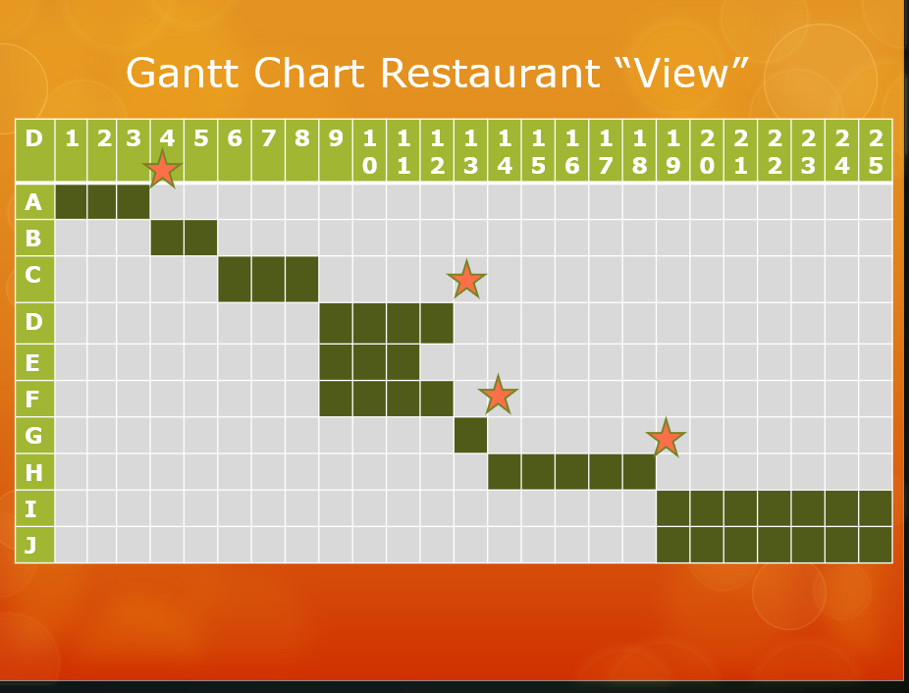

Risk Assessment
Every venture, no matter how meticulously planned, encounters uncertainties. In the context of the Rooftop "View" Restaurant project, risks may manifest as construction delays, supply chain disruptions, staff turnover, or a slower-than-expected initial customer turnout. This section of the plan doesn't merely identify these risks but goes further to assess their potential impact and probability.
The risk assessment endeavors to quantify the unpredictable and prepares to counter its effects. Through this proactive approach, mitigation strategies are formulated. Contingency planning stands poised to tackle construction delays, alternative suppliers are lined up to combat supply chain interruptions, and comprehensive staff training programs are designed to cushion against workforce turnover. This anticipatory stance ensures that the project doesn't merely react to challenges but is primed to navigate them adeptly (Radujković, and Sjekavica, 2017).

Integration of Components
A project management plan is more than the sum of its parts; it's an intricate tapestry where each component is interwoven with others, forming a cohesive narrative of success (Turner, 2016). The integration of the various facets of the Rooftop "View" Restaurant project becomes the conduit through which the plan's potency is realized. The project's scope and Work Breakdown Structure (WBS) merge harmoniously to feed into cost estimation and resource allocation. The WBS shapes the Gantt Chart, dictating task sequences, while resource allocation is inextricably linked to risk assessment. As risks are identified and strategies formulated, resource allocation is guided by the imperatives of risk mitigation. Thus, the interplay of these components resonates with the project's heartbeat, channeling its energy toward accomplishment.

Conclusion
The Rooftop "View" Restaurant project will be carried out in a seamless manner according to the current project management plan, which guarantees its successful completion. Through careful consideration of stakeholder concerns, in-depth task analysis, exact cost and resource projections, a thoughtfully constructed project schedule, and a proactive approach to risk mitigation, this meticulously designed plan serves as a roadmap, meticulously charting the path towards project completion. This combination of crucial components considerably increases the likelihood of accomplishing project goals by incorporating well-established academic frameworks and project management theories. This plan's main message emphasizes the critical significance of stakeholder engagement. The project is set up for easier progress by recognizing and resolving the different interests, expectations, and potential conflicts among stakeholders. A thorough work breakdown offers even more transparency and accountability among the project team, encouraging efficient delegation and cooperation. The financial component is taken into consideration, since accurate cost estimation and resource allocation mechanisms allow for responsible financial planning and resource allocation, which helps to control costs and stick to budgets. The cornerstone of this method is the creation of a precise project schedule. Each assignment has a clearly defined timeframe, which makes it easier to track progress and make timely adjustments as needed. Furthermore, the project's resilience is strengthened by a clever emphasis on risk management. Preemptive tactics are used to carefully identify, analyze, and minimize potential problems, avoiding disruptions and improving the overall project trajectory.

References
Assudani, R. and Kloppenborg, T.J., 2010. Managing stakeholders for project management success: an emergent model of stakeholders. Journal of general management, 35(3), pp.67-80.
Azzopardi, S., 2009. The evolution of project management-Part 2. Retrieved from.
Cote, A. (2023). How to Become a Project Manager - A Complete Guide for 2019. [online] Paymo. Available at: https://www.paymoapp.com/blog/the-complete-project-manager-guide/ [Accessed 3 Aug. 2023].
Gido, J. and Clements, J., 2014. Successful project management. Cengage Learning.
Huemann, M., Keegan, A. and Turner, J.R., 2007. Human resource management in the project-oriented company: A review. International journal of project management, 25(3), pp.315-323.
Khan, A., 2006. Project scope management. Cost engineering, 48(6), pp.12-16.
Lock, D., 2017. The essentials of project management. Routledge.
Radujković, M. and Sjekavica, M., 2017. Project management success factors. Procedia engineering, 196, pp.607-615.
Selaru, C., 2012. Resource allocation in project management. International Journal of Economic Practices and Theories, 2(4), pp.274-282.
Serrat, O., 2015. Striking a balance between physical and digital resources.
Turner, R., 2016. Gower handbook of project management. Routledge.
Winch, G.M., Morris, P. and Pinto, J., 2007. Managing project stakeholders. The Wiley guide to project, program, and portfolio management, pp.271-289.
Zecheru, V. and Olaru, B.G., 2016. Work breakdown structure (WBS) in project management. Revista de Management Comparat International, 17(1), p.61.



