MBA - Master of Business Administration
LCMB7002 FINANCIAL MANAGEMENT

Student Name: MITEN SAJANBHAI KANARA
Student ID: 2332670
Lecturer: Jia Miao
Internal Verifier: Hoang Nguyen
Due Date: 21st August 2024 by 2 PM
Table of contents
Part A: Introduction 3
Brief history of Johnson & Johnson 3
Business model 4
Marketplace and major competitors 4
Review of major recent events (Past five years) 6
Part B: Financial Performance Review 7
Financial Ratios Calculation 7
Profitability Ratios 7
Liquidity Ratios 7
Gearing Ratios (Leverage Ratios) 7
Efficiency Ratios 8
Valuation Ratios 8
Critical Evaluation of Ratios 9
Comparison to major competitors and sector average 14
Recommendations for Financial Management Improvement 19
Part C: Investment Appraisal 22
Project Evaluation and recommendation (Cash Flow Analysis) 22
Critical Discussion of Investment Appraisal Techniques 25
References 27
Appendices 32
Appendix 1: Ratios Calculation 32

Part A: Introduction

Brief history of Johnson & Johnson
Johnson & Johnson (J&J) was founded by three brothers James Wood Johnson, Robert Wood Johnson and Edward Mead Johnson in 1886, in New Brunswick, New Jersey. The company started with 14 employees and now the company is one of the most valuable companies in the world (Ourstory.jnj.com, 2021). More than 130,000 workers are working across more than 60 countries around the world. J&J provides extensive healthcare products to its customers and continuous research & development (R&D) and continuous innovation to find solutions to meet people’s medical and wellness needs. J&J is committed to providing quality health and medical products and services to cure complex diseases, provide personal solutions, and improve access and affordability (Johnson & Johnson, 2024).

Figure 1.1: Key information about J&J
(Source: Pereira, 2023)

Business model
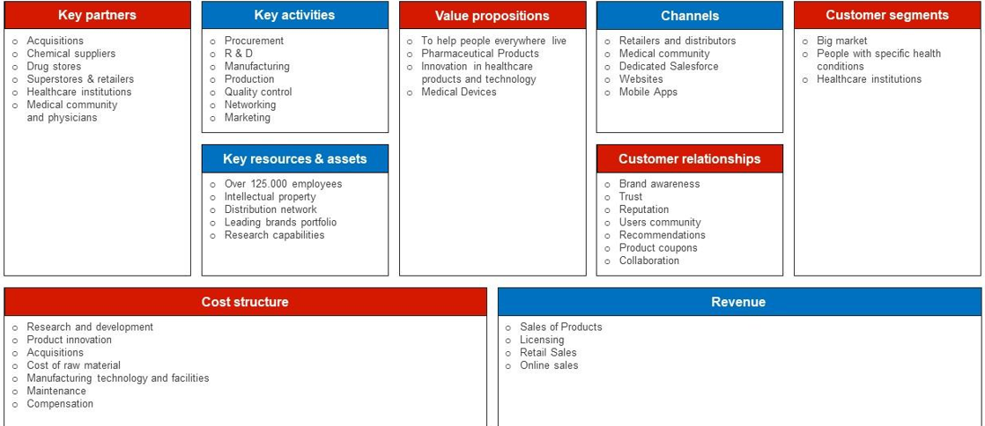
Figure 1.2: J&J Business model canvas
(Source: ‌Osterwalder et al. 2020)
J&J mainly focus on manufacturing, developing, and marketing vast medical and healthcare product ranges to customers and improving the lives and well-being of people. Starting from personal-care products to prescription drugs and medical devices J&J offer a diverse range of product portfolios to meet their business aims. Pereira (2023) stated that the commitment towards continuous development and innovation has made this organisation successful for more than 130 years in the healthcare industry. Further, embracing a customer-centric approach promotes the understanding of customer loyalty and trust in the organisation, and to achieve this J&J working hard through effective quality products & services, effective marketing initiatives and brand management tactics (Osterwalder et al. 2020).

Marketplace and major competitors
J&J remains a highly diversified global pharmaceutical leader yielding 65% areas and the rest areas are in medical devices which includes instrumental solutions, surgery, orthopaedics and many more (Bioworld.com, 2024). The company operates in more than 60 countries with a total employee of 12,500 and mainly offers its products in the US, Europe; Asia-Pacific & Africa, the Western Hemisphere (excluding the US) and Latin America (Global Data, 2022). The firm also leverages its extensive distribution networks as well as a strong brand to effectively penetrate diverse healthcare sectors worldwide.
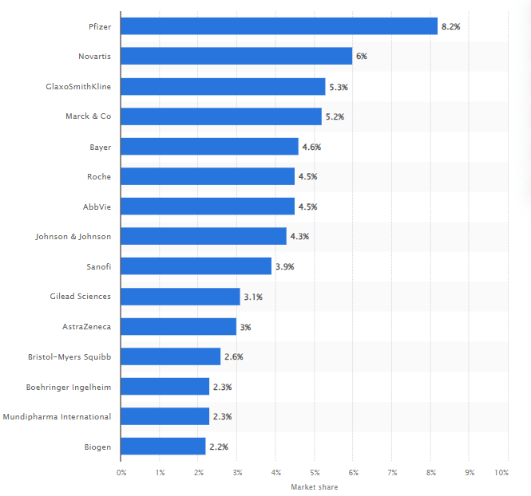
Figure 1.3: Leading pharmaceutical and healthcare companies in the UK
(Source: Statista, 2018)
This statistic displays the leading pharmaceutical companies by market share in which Pfizer topped the list with 8.2% followed by Novartis. However, considering innovative drugs and global market reach, J&J effectively compete with Pfizer along with GSK and others. In contrast, Luigi et al. (2021) claimed that in the field of consumer health, it faces serious competition from P&G which sells personal care items as well as baby care essentials. In addition, in medical devices, J&J closely competes with Medtronic focusing on both the surgical and cardiovascular implant services.

Review of major recent events (Past five years)
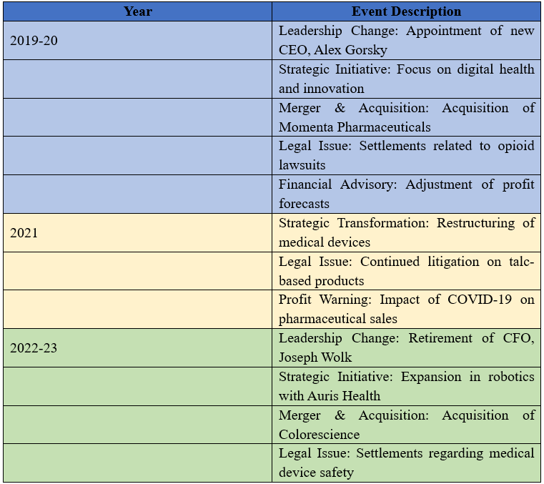
Table 1.1: Recent events in J&J in the last five years
(Source: Jnj.com, 2024)
The above description demonstrates a clear picture of the significant events that affected J&J operations as well as performance over a certain period in the healthcare and pharmaceutical sectors. The leadership position changed in the year 2022 and strategic initiatives in the form of expansion in robotics were delivered in the year 2023. On the other hand, legal issues such as sentiments related to device safety closely followed over the last two years.

Part B: Financial Performance Review

Financial Ratios Calculation

Profitability Ratios
Profitability Ratios |  | Johnson & Johnson
 | 2023 | 2022 | 2021 | 2020 | 2019 | Formulas
Gross Margin | 68.82% | 67.26% | 68.16% | 65.58% | 66.42% | “Gross Profit/Sales”
Operating Margin | 18.64% | 1.97% | 26.18% | 24.11% | 25.55% | “Operating Income/Sales”
Net Profit Margin | 41.28% | 18.90% | 22.26% | 17.82% | 18.42% | “Net Income/Sales”
Return on Equity (ROE) | 51.14% | 23.36% | 28.20% | 8.41% | 9.59% | “Net Income/Total Equity”
Return on Assets (ROA) | 20.98% | 9.57% | 11.47% | 8.41% | 9.59% | “Net Income/Total Assets”
Table 2.1: Profitability Ratios

Liquidity Ratios
Liquidity Ratios |  | Johnson & Johnson
 | 2023 | 2022 | 2021 | 2020 | 2019 | Formulas
Current Ratio | 1.16 | 0.99 | 1.35 | 1.21 | 1.26 | “Current Assets/Current Liabilities”
Quick Ratio (or Acid Test Ratio) | 0.91 | 0.77 | 1.12 | 0.99 | 1.01 | “(Current Assets-Inventories)/Current Liabilities”
Cash Ratio | 0.47 | 0.25 | 0.32 | 0.33 | 0.48 | “Cash/Current Liabilities”
Table 2.2: Liquidity Ratios

Gearing Ratios (Leverage Ratios)
Gearing Ratios (Leverage Ratios) |  | Johnson & Johnson
 | 2023 | 2022 | 2021 | 2020 | 2019 | Formulas
Debt/Equity Ratio | 0.43 | 0.35 | 1.46 | 1.76 | 1.65 | Total Debt/Total Equity
Debt/Capital Ratio | 0.30 | 0.26 | 0.59 | 0.64 | 0.62 | Total Debt/(Total Equity Total Debt)
Equity Multiplier | 2.44 | 2.44 | 2.46 | 2.76 | 2.65 | Total Assets/Total Equity
Interest Coverage Ratio | 20.56 | 6.78 | 134.14 | 99.07 | 104.33 | EBIT/Interest Expense
Table 2.3: Gearing Ratios

Efficiency Ratios
Efficiency Ratios |  | Johnson & Johnson
 | 2023 | 2022 | 2021 | 2020 | 2019 | Formulas
Inventory Days | 154 Days | 147 Days | 127 Days | 120 Days | 119 Days | “(Inventories/Cost of Sales)” x 365
Account Receivable Days | 204 Days | 190 Days | 187 Days | 174 Days | 192 Days | “(Account Receivable/Cost of Sales)” x 365
Account Payable Days | 132 Days | 137 Days | 135 Days | 122 Days | 119 Days | “(Account Payable Days/Cost of Sales)” x 365
Table 2.4: Efficiency Ratios

Valuation Ratios
Valuation Ratios |  | Johnson & Johnson
 | 2023 | 2022 | 2021 | 2020 | 2019 | Formulas
Earnings per share | 0.01 | 0.15 | 7.93 | 5.59 | 5.72 | “Earnings/Total Shares outstanding”
Price/Earnings Ratio | 25,814.82 | 968.14 | 21.18 | 28.09 | 25.37 | “Market price/Earnings per share”
Table 2.5: Valuation Ratios

Critical Evaluation of Ratios
Profitability Ratios
As stated by Bandiyono (2020), profitability ratios are important for a firm to effectively consider good profits alongside equity generation and assets return using which investors' attention can be caught easily. Using this ratio evaluation, J&J can instil confidence to make future investments in the business.
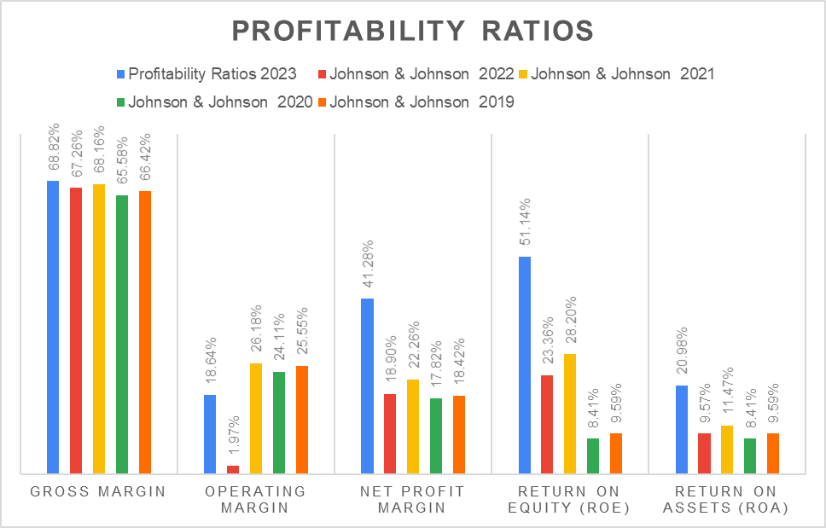
Figure 2.1: Profitability Ratios
The profitability ratio over the five-year trends depicts varying changes and the main reason behind it could be continuous shifts in efficiency as well as financial performance. As stated by Naknok (2022), a higher gross margin in a firm ultimately means more capital generation. Compared with 2019, the gross margin significantly increased from 66.4% to 68.82% in 2023 which states that effective pricing strategies are considered with valuable management of production. Moreover, the operating margin fluctuated in the last five years and declined in the year 2023, dropping to 18.64% which indicates issues faced in controlling operations expenses relative to revenue generation. However, Nariswari and Nugraha (2020) opined that net profit margin is important for a firm to consider how much profit is generated. From the chart, it is clear that it surged to 41% in 2023 and the improvement showcases that cost management is maintained in the workplace. Moreover, ROE and ROA also exhibited notable enhancement reaching a total of 51.4% and 20.98% respectively. These metrics effectively state that the firm has enhanced its profitability as compared to shareholder equity alongside total assets and accelerated resource and capital utilisation. However, true financial performance, however, can be distorted by dependence on previous data, vulnerability to manipulation through accounting techniques, and lack of context on market circumstances or outside variables. Considering this value, it can be stated that the profitability of the firm has increased over the years and that shows how well operations in the workplace are managed.
Liquidity Ratios
Stefvy and Djohan (2023) opined that for every firm in specific sectors, liquidity ratios are essential in measuring the capability of the ways the firm can pay off its short-term liabilities. Following all the ratios such as current, quick and cash ratios, J&J can execute its strategy to clear debts and avoid any payments.
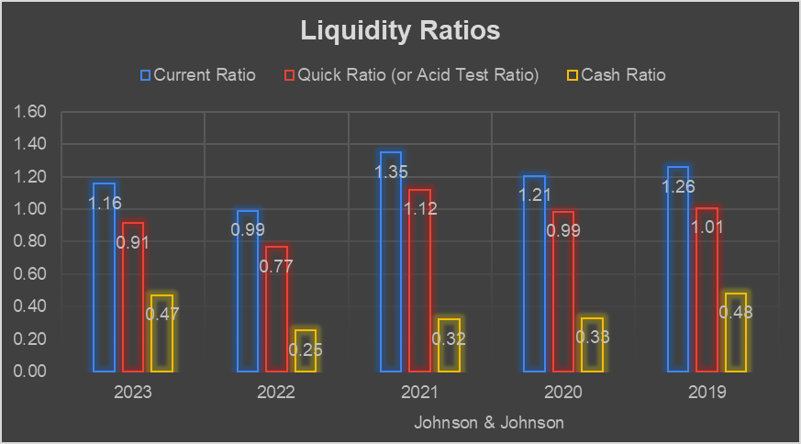
Figure 2.2: Liquidity Ratios
The above graphical trends evaluate the liquidity ratios for J&J considering that it can be stated that there are varying trends in its ability to fulfil short-term financial obligations. From the last five years, the current ratio fluctuated, as depicted; in 2022 it decreased and yielded 0.99 while in 2023 again it stands at 1.16. HRISHIKES (2021) stated the fluctuations in current assets are mainly due to factors like economic conditions and changes in the operations of a company. The rise in the current ratio states that the firm focused on inventory management as well as debt levels which ultimately impact its liquidity. However, VU et al. (2020) opined that a quick ratio of more than 1 means a firm has enough assets to manage short-term obligations. The quick ratio decreased in years 2022 and 2023 and is less than 1 which means they are more reliant on debt and face challenges in maintaining current assets. On the other hand, the cash ratio increased in 2023 amounting to 0.47 in 2023 and this suggests that there is a serious fluctuation regarding short-term obligations and ultimately influencing liquidity risk management. These trends state that J&J faces industry pressure and regulatory issues.
Gearing Ratios
Calculating the gearing ratio is important as it helps the organisation measure a company's financial performance over the years (OsazefuaImhanzenobe, 2020). It helps stakeholders make effective decisions before investing in a business organisation.
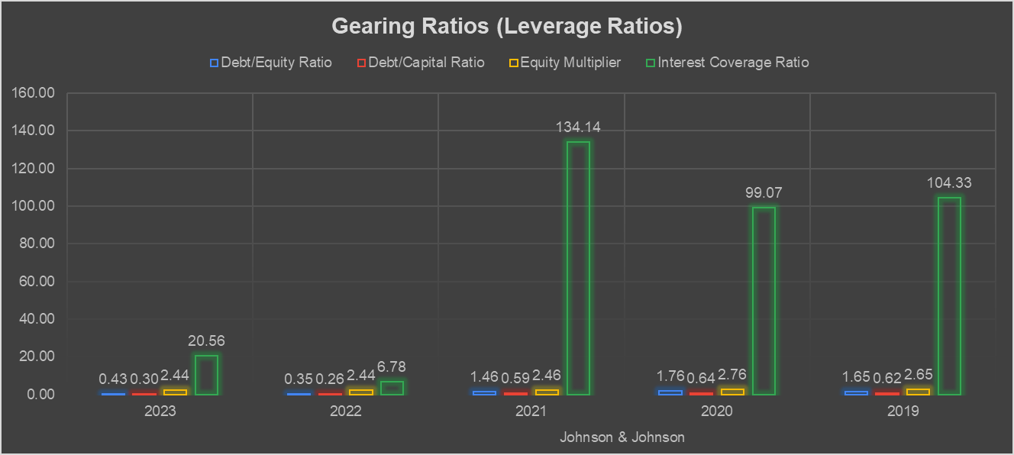
Figure 2.3: Gearing (Leverage Ratios)
The gearing ratio analysis of J&J shows organisational strategic movements to achieve stable internal rigidity. The debt/equity ratio decreased from 1.65 in 2019 to 0.43 in 2023, indicating a significant decrease in organisational reliance on debt relative to equity. However, it may also create a huge financial crisis in 2019 and 2020. However, in 2022 and 2023, J&J will maintain its positive strategic financial position, potentially by repaying increased equity. ‌Oyinloyeet al. (2020) stated that investors use a gearing ratio as a metric to determine the financial leverage of a company. The amount of money obtained through debt, or creditor loans, relative to the amount of money obtained through equity capital is known as leverage in this context.
Further, the analysis of the debt/capital ratio shows a consistent decline to 0.30 in 2023 from 0.62, indicating a decline in organisational capital structure. It is believed that a lower debt will naturally induce organisational dependency on borrowed funds, reducing financial risks and improving creditworthiness. Therefore, this also has a positive impact on organisational financial performance (Kinyua and Ochieng’, 2022). The equity multiplier remained relatively stable, ranging from 2.44 to 2.46 between 2019 and 2023, indicating consistent equity over the years. However, the interest coverage ratio improved to 20.56% in 2023 from 134.14 in 2021, indicating the organisational ability to cover interest expenses before EBIT.
Efficiency Ratios
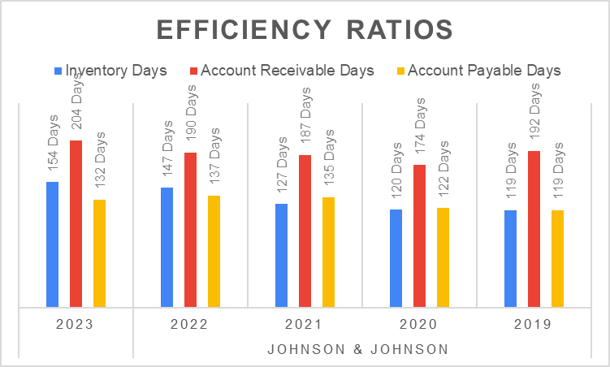
Figure 2.4: Efficiency Ratios
Overall, the efficiency ratio analysis indicates a longer duration in investments and receivables, which created challenges to main organisational operations (Albertus, 2022). For example, the inventory days could potentially increase from 119 to 154 in 2023, increasing the complexity of the inventory process. The account receivable days also increased from 192 to 204 from 2019 to 2023, indicating that it takes more time to collect due payments from customers. Further, the accounts payable days also increased from 119 in 2019 to 132 in 2023, reflecting J&J’s inability to pay its suppliers and other stakeholders on time.
Valuation Ratios
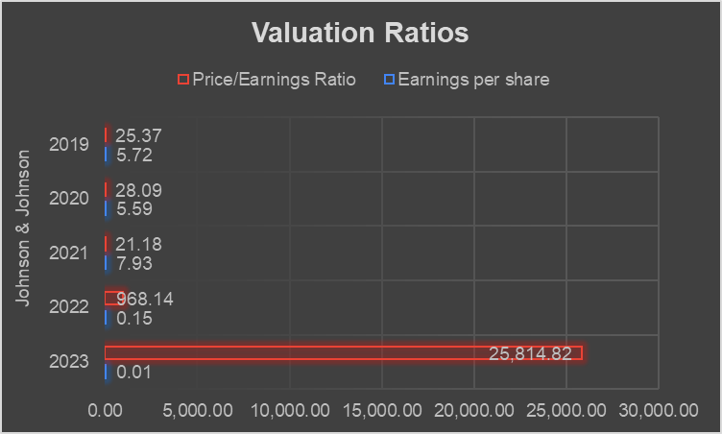
Figure 2.5: Valuation Ratios
Significant analysis of valuation ratios has helped to understand J&J’s market perceptions and earning potential (Sumrit, 2020). The earning per share ratio analysis indicates a dramatic decline to 0.01 in 2023 from 5.72 in 2019, indicating the deficiency of the organization's net profitability. However, the high EPS in 2021 could potentially indicate a profitable year for J&J. Further, the price/earnings ratio (P/E ratio) also indicates a potential inclination to 25814.82 in 2023 compared to 21.18 in 2019, which disrupts the valuation of the organisation. Thus, the overall analysis indicates that the market practice has caused difficulties in managing business profitability over the last five years.

Comparison to major competitors and sector average
Profitability Ratios
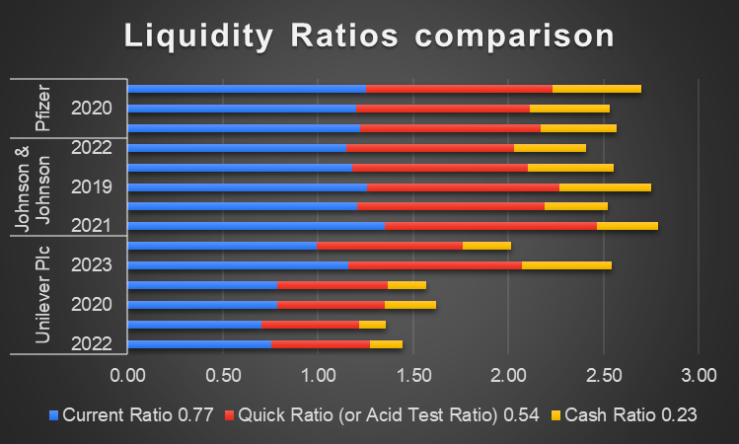
Figure 2.6: Comparison of Liquidity ratios in pharmaceutical companies
The sector average current ratios typically range between 1.5 and 2.0; the firm can maintain short-term financial obligations under this. Both the competitor’s Unilever and Pfizer current ratios are averaging around 0.70 reflecting a leaner approach to current asset management. However, J&J closely followed the industry trends and yielded robust ratios averaging around 1.20 which demonstrates that the firm has maintained better liquidity as compared to other firms. On the other hand, Effiong and Ejabu (2020) stated that the quick ratio of the pharma sector averages around 1.5 for which immediate liabilities need to be maintained. In terms of quick ratios, Unilever’s lower figure was around approximately 0.54 while both J&J and Pfizer maintained their ratios of more than 0.90 which means that the firm can cover short-term obligations without depending on inventory. In contrast, J&J's cash ratios varied from 0.24 and 0.47 and compared with competitors like Unilever, and P&G, they have maintained this and matched sector trends and the major reason behind it could be operating higher capital-intensive segments.
Liquidity Ratios
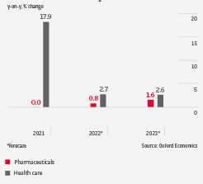
Figure 2.7: Pharmaceutical and healthcare value-added output
(Source: Atradiuscollections.com, 2022)
The statistical figure depicts that in the year 2021, health and value-added output increased a lot and yielded 17.9% which states that there is an ongoing demand for pharmaceutical products. However, considering the J&J’s gross margin ranged from 65.58% to 68.82%, shows that they have nearly touched the sector average which is 70% and influenced by strategic investments as well as periodic adjustments in operational efficiencies. Companies like P&G and Medtronic depict stable gross margins and operating margins in the sector and closely give competition to J&J which states they have focused on their operations in medical devices and consumer goods. Moreover, Tömöriet al. (2021) claimed that ROE and ROA in the pharmaceutical sector are fundamental measures that can effectively reveal the gross profit that a firm realises in areas like R&D expenditures. The ROE and ROA analysis of J&J shows that they have demonstrated valuable use of both the assets and equity to generate profits. However, companies like Pfizer, Novartis and Unilever focused on innovative drug pipelines and technological advancements which indicate superior asset utilisation.
Gearing Ratios
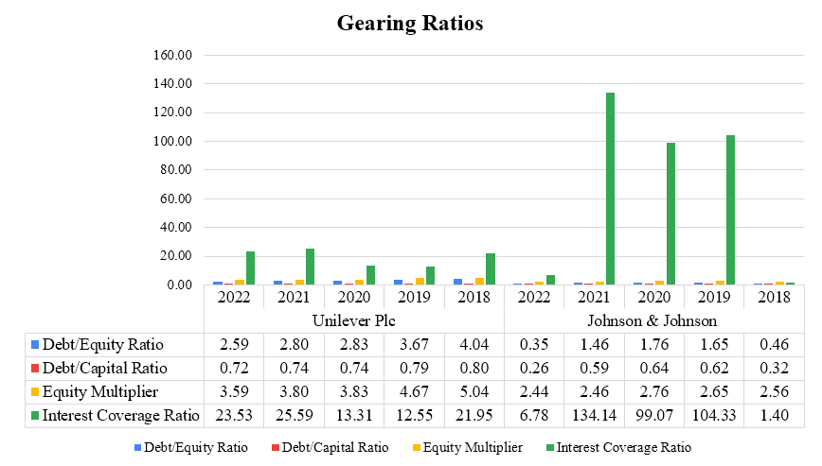
Figure 2.8: Gearing ratio comparison
The debt/equity ratio of J&J significantly decreased in 2022 to 0.35 from 1.65 in 2019. However, ‌Kinyua and Ochieng’, (2022) stated that the debt/equity ratio for the pharmaceutical industry ranges from 0.5 to 1.5; for J&J, it goes below that range, suggesting a conservative approach to organisational leverage. On the other hand, other companies' debt/equity ratios, including Unilever, were 2.59in 2022 increased from 3.67 in 2019 respectively, indicating less financial risk incurred by these organisations compared to J&J. Similarly, the debt/capital ratio needs to be between 0.3 and 0.6 to maintain a balanced financial position; in the case of J&J’s debt/capital ratio, which was 0.30 in 2023, up from 0.62 in 2019, indicates a balanced capital structure with a conservative dent approach. Thus, the gearing ratio analysts indicate a conservative leverage balance, which reduces the financial risk to competitors and maintains a competitive position in the market (Luigi et al. 2021).
Efficiency Ratios
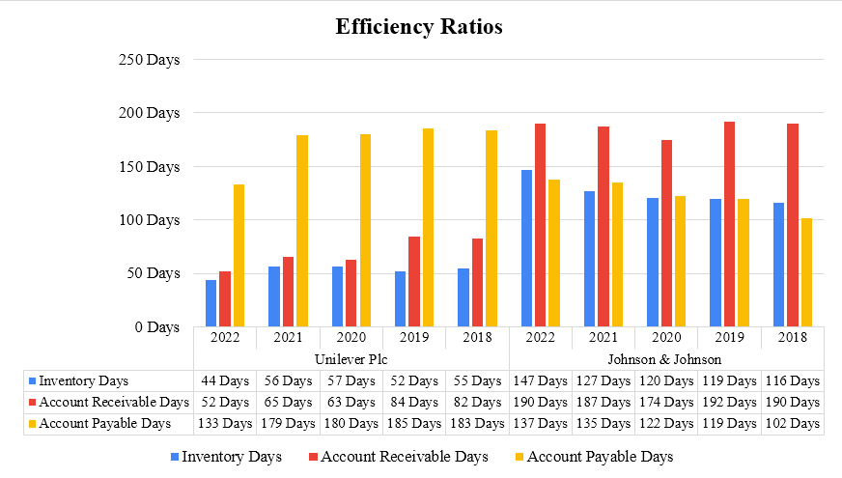
Figure 2.9: Efficiency ratio comparison
The overall efficiency ratio calculation of J&J indicates a reduced efficiency in managing organisational performance and reduced profitability. However, the inventory days for J&J increased to 147 days in 2022 from 119 days in 2019 which takes more time compared to Unilever such as 44 days in 2022 from 52 days in 2019. This also indicates that Unilever created more efficacy in managing inventories than J&J. Thus, J&J need to make an effective balance in financial decisions and manage inventories to achieve effective success (‌Oyinloyeet al. 2020).
Valuation Ratios
The financial process of estimating a company's value is called valuation and this knowledge is contextualised in relation to a company's share price using valuation ratios, which are helpful instruments for assessing investment possibilities.Enhancing market perception and value metrics can be achieved through increasing financial reporting transparency and successfully conveying strategic initiatives to investors. Stakeholder confidence can be increased by giving clear instructions on growth possibilities, capital allocation plans, and risk management techniques.
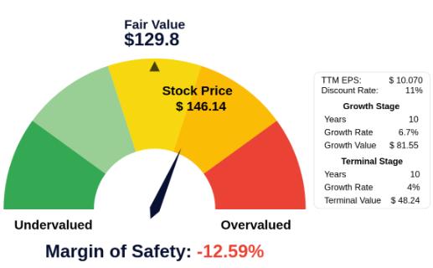
Figure 2.10: J&J’s EPS based on fair values
The analysis of the valuation ratio indicates the potentially higher market price of J&J than the fair values. Further, the analysis also reveals the complex challenges in managing financial position and reduced earnings per share compared to 2019 in 2023. However, in 2023 Pfizer a competitor of J&J generated profitability of $58.5 billion, a decrease of 41% in operational performance. Where J&J earned a profit of $35 billion indicating a competitive business position with the other market competitors (‌Statista, 2023).

Recommendations for Financial Management Improvement
It was evaluated from the profitability ratio analysis that; J&J has shown strong profitability in recent few years. However, a firm needs to optimise its product mix and pricing strategies to boost profitability more and compete with its rivals. Moreover, Amponsah-Kwatiah and Asiamah (2021) suggested that managing costs, boosting productivity and concentrating on sales efforts are other ways to boost operating and net income. For example, J&J needs to assess and promote products with higher profitability margins which can ultimately boost gross margin and ROA. In addition, Lee (2021) alludes that streamlining supply chain operations and reducing overhead costs can be also significant for improving profitability. Considering this, J&J should focus on continuous improvement tactics to guarantee sustainable profitability growth. In addition, it is essential to keep a balanced capital structure that complies with financial goals and industry norms. J&J may attain an ideal leverage ratio that supports growth objectives while sensibly managing financial risk by carefully balancing the mix of loan and equity financing.
On the contrary, the liquidity ratios fluctuated over the years which raised figures regarding liquidity risk. HRISHIKES (2021) stated that working capital management is one of the important tactics that can be crucial for enhancing liquidity ratios. For example, J&J can gain this by negotiating effectively on favourable payment terms with suppliers alongside account receivable collection. This approach can effectively boost the quick and current ratios, guaranteeing that the firm can effectively fulfil liquidity to meet short-term obligations. In addition, Pornupatham (2022) recommended that cash flow forecasting accuracy and robust cash management practices can also enhance ratios like cash ratio. Thus, putting treasury management strategies such as cash flow forecasting, cash management and enhanced cash visibility, the firm can effectively maintain liquidity.
On the other hand, based on the overall analysis, it can be recommended that J&J focus on inventory management and optimisation systems. Balkhi et al. (2022) stated the importance of implementing a just-in-time inventory management system to enhance demand forecasting and business performance. J&J can adopt this system to minimise overstocking and boost the organisational turnover rate. Further, data analytics and using sifters will help J&J maintain a better inventory management system and provide better control over business performance.
Further, to promote an effective gearing ratio J&J should implement a continuous monitoring system; it will help the organisation maintain balance in its finances and enhance investors’ confidence. Further, Kim and Lee (2021) suggested maintaining a good relationship with suppliers, which can help manage delayed payments and also enhance organisational payable efficiency. Further, it is recommended that J&J streamline business operations, invest in high-margin products, and cut unnecessary costs, which will enhance market penetration and earning potential.
On the other hand, it can be suggested to J&J to strengthen its credit policies and offer early payment discounts. This approach will influence customers’ intentions to pay the due amounts on time, and it will provide positive growth for managing receivables within the organisation (Brunnermeier and Krishnamurthy, 2020). Moreover, stated that Inventory turnover and accounts receivable turnover are two efficiency ratios that can be improved by investing in technology and automation to streamline operational procedures. Optimising resource allocation and decreasing operational inefficiencies can be achieved by implementing sophisticated analytics for inventory management and demand forecasting.Further, maintaining consistency and transparency in financial reporting will be beneficial to managing market expectations, helping stakeholders make investment decisions, and maintaining a stable P/E ratio. These recommendations are most effective as they will ultimately provide positive benefits to the organisation, enhance profitability, address business financial challenges, engage stakeholders, and maintain a competitive position in the market.

Part C: Investment Appraisal

Project Evaluation and recommendation (Cash Flow Analysis)
Payback Period (PBP) calculation
As stated by Ardiles Sinaga et al. (2023), the payback period plays a crucial role in a firm's evaluation of the investments recouping the cost of an initial investment and based on that decisions can be made. From the two given proposals, Johnson & Johnson assures the project considering such aspects.
Year | Net Cash Flow for A | Net Cash Flow for B | Cumulative Cash Flow for A | Cumulative Cash Flow for B | Payback Period (PBP) for A | (PBP) for B
0 | -80 | -75 | -80 | -75 | 3.6 | 2.7
1 | 25 | 50 | -55 | -25 | 3.6 | 2.7
2 | 25 | 20 | -30 | -5 | 3.6 | 2.7
3 | 20 | 20 | -10 | 15 | 3.6 | 2.7
4 | 55 | 20 | 45 | 35 | 3.6 | 2.7
Table 3.1: PBP calculation
From the above calculations, the PBP for project A is approximately 3.6 years while for B it yields a total of 1.7 years. Based on the financial metrics, it can be stated that Project B is more attractive for J&J, as it has a shorter payback period of only 1.7 years indicating quicker recovery of the initial investment. Imteazet al. (2021) suggested that a shorter PBP is always beneficial for a firm as it indicates less investment risk and faster profitability. Thus, as project B gives a quicker return, the firm should go with this and generate a better financial position over the project lifespan.
Accounting Rate of Return (ARR)
Aspects | For Project A | For Project B
Average Annual Profit | 31.25 | 27.50
Average Investment | 80 | 75.00
Accounting Rate of Return (ARR) | 39.06 | 36.67
 | Formula | ARR=Average Annual Profit​/Average Investment
 | Formula | Average Investment= Initial investment/ The number of years
Table 3.2: ARR calculation
(Source: Self-created)
As stated by Wang et al. (2021), ARR is effective in the firm in measuring the proper net income generated from assets compared to the initial cost of investment for any project. For Project A, the ARR amounted to 39.06% while for Project B, it stands at 36.67%. Thus, project A would be more effective for J&J as compared to Project B, as it indicates a higher return on investment and could be more profitable for the business as well when the initial outlay is optimised. On the other hand, Project B can be also taken as it is relative to the investment.
Net Present Value (NPV) calculation
Effective busts of NPV help business organisations make effective decisions to select the most profitable project. Fontalvo-Lascano et al. (2022) stated that NPV is an important financial metric used in investment analysis and capital budgeting.
Year | Cumulative Cash Flow for A | Discount Factor (1+r) ^t for A | Present Value (CF_t / (1+r) ^t) for A | NPV for A
0 | -80 | 1 | -80 | -51.4
1 | -55 | 0.91 | -50 | -51.4
2 | -30 | 0.83 | -25.07 | -51.4
3 | -10 | 0.76 | -7.64 | -51.4
4 | 45 | 0.69 | 31.31 | -51.4
Formula for NPV | The sum of Present Values - Initial Investment
Year | Cumulative Cash Flow for B | Discount Factor (1+r) ^t for B | Present Value (CF_t / (1+r) ^t) for B | NPV for B
0 | -75 | 1 | -75 | 9.68
1 | -25 | 0.91 | -22 | 9.68
2 | -5 | 0.83 | -4.18 | 9.68
3 | 15 | 0.76 | 11.45 | 9.68
4 | 35 | 0.69 | 24.41 | 9.68
Formula for NPV | The sum of Present Values - Initial Investment
Table 3.3: NPV calculations
(Source: Self-created)
Both the NPV calculations of the projects demonstrate a clear NPV. It has been determined that the NPV for Project A is -51.4, while the NPV for Project B is 9.68. Based on the gathered results, it can be said that project B can be selected by J&J, as this provides a positive value. Project A has a larger initial cash flow followed by a positive cash flow at year 4, while Project B has an initial negative cash flow, but after 2 years, this project successfully achieved positive cash flow compared to Project A. Both projects have been analysed using the same diagnostic factor of 9.75%, and based on this comparison, the NPV for Project A was -51.4 and the NPV for Project B was 9.68. Thus, project B needs to be selected as it has a more balanced cash flow, which is crucial for reducing financial risks and maintaining strong financial liquidity.
Project B has a significantly positive NPV compared to Project A, which demonstrates that Project B is more suitable and can provide a better financial return than Project A. On the other hand, project B is more capable of creating value than project A. It means project A will create additional value for J&J’s stakeholders, and this will critically align with the organisational objectives. This project will also be beneficial to maintain sustainable financial goals. Further, project B should have effective resource management practices, whereas project A would like to drain organisational resources and increase financial strain. Therefore, the selection of Project B will be an effective choice for J&J, and it will provide better financial health and liquidity.

Critical Discussion of Investment Appraisal Techniques
Advantages and shortcomings of PBP
The payback period (PBP) is an important aspect of making investment decisions; it is calculated by dividing the investment amount by the cash flows (Ardiles Sinaga et al. 2023). Choosing between projects is a common situation for business managers, financial experts, investors, and businesses. These decisions are crucial because resources are limited and management must select the best project to maximise return on investment. However, effective use of PBP makes it easy to make investment decisions. Further, PBP analysts usually provide a quick understanding of the potential investment profitability after investment, which helps organisations determine the project’s liquidity or any other type of accumulated risk. However, it has some disadvantages, including that PBP ignores the time value of money, which can lead to affected decisions when comparing projects with timelines (Imteaz et al. 2021). Further, PBP primarily focuses on the period required to get the return; it ignores cash flow after the payback period, which can create potential challenges in achieving effective profitability in the long term.
Benefits and limitations of ARR
Calculating the accounting rate of return (ARR) is important as it provides the yearly return percentage difference between assets and average net income, which helps to calculate the average capital cost. It has some benefits as it is used to understand investment projects as it takes less time to measure profitability. Further, ARR provides a broad perspective of organisational performance and analyses all the potential revenue generation and cost over the project lifecycle. Wang et al. (2021) stated that it is used when companies decide whether or not to invest in a venture, purchase, or other kind of asset by comparing the estimated future net earnings against the capital cost. Further, when it comes to making decisions, the project is appropriate if the accounting rate of return is at least that of the firm's required rate of return, meaning that the company would make a profit. At the same time, it has some limitations, such as that it also ignores the time value of money, which may create difficulties in understanding future cash flow equality (Fontalvo-Lascano et al. 2022). Additionally, it has less capability to analyse cash flow as it is solely based on accounting practices, which may decrease the decision-making ability to understand any project’s cash-generating ability.
Merits and demerits of NPV
As stated by Bazmiet al. (2021), NPV is one of the effective cash flow techniques utilised in the workplace to assess the viability of the project or any investment while considering capital budgeting. One of the main benefits of this technique is that it effectively considers the time value of money which is effective for business in earning capacity. In addition, Bulama et al. (2023) opined that it effectively guarantees a decision-making process using which businesses can consider whether the project is profit-making or loss-making in a certain period. Apart from that it offers a clear picture of profitability as well which can be effective in adding extra value to the firm. In contrast, Rekker (2024) the disadvantage of NPV includes the complex process which needs a detailed forecast and detailed knowledge regarding the financial landscape. Other demerits of such a technique include no set guidelines to track the required rate of return.
Non-Financial Factors
According to Ferreira (2022), strategic alignment is one of the effective non-financial factors that every firm wants to consider as it works with numerous terms and individuals to connect its efforts to the entire goals of the organisation. It can be stated that the project perfectly aligns with core values and mission can accelerate sustained growth and would become competitive in a sector. However, Coskun-Setirek and Tanrikulu (2021) argued and stated that projects that put innovation or any specific technology can be successive for maintaining operations and generating profit. For example, if J&J continuously invest in R&D or any advanced manufacturing process, they should competitive in the healthcare sector and may left behind companies like Pfizer. Moreover, regulatory and environmental considerations are also important for a firm as they maintain a rule in the workplace and mitigate risks regarding the environment as well. Focusing on the SDG principle and sustainability initiatives, J&J can attract investors and eco-conscious customers and deliver long-term profitability.

References
‌Albertus, R.H. (2022). THE EFFECT OF CURRENT RATIO, INVENTORY TURNOVER, DEBT TO EQUITY RATIO, AND NET PROFIT MARGIN ON THE VALUE OF COMPANIES IN THE HEALTHCARE SECTOR LISTED ON IDX 2017-2020. Strategic Management Business Journal, 2(01), pp.8–16. doi:https://doi.org/10.55751/smbj.v2i01.29.
Amponsah-Kwatiah, K.,and Asiamah, M. (2021). Working capital management and profitability of listed manufacturing firms in Ghana. International journal of productivity and performance management, 70(7), 1751-1771. https://www.emerald.com/insight/content/doi/10.1108/IJPPM-02-2020-0043/full/html
Ardiles Sinaga, Mediatrix, M., None Anggi Andini Hutasuhut, Zahara, T., None Ayu Amanda, Annisa Fitri and Muhammad, N. (2023). Comparison of capital budgeting methods: NPV, IRR, PAYBACK PERIOD. World Journal Of Advanced Research and Reviews, 19(2), pp.1078–1081. doi:https://doi.org/10.30574/wjarr.2023.19.2.1483.
Atradiuscollections.com. (2022). Pharmaceuticals Industry Trends United Kingdom - 2022 | Atradius. [online] Available at: https://atradiuscollections.com/global/reports/pharmaceuticals-industry-trends-united-kingdom-2022.html.
Balkhi, B., Alshahrani, A. and Khan, A. (2022). Just-in-Time Approach in Healthcare Inventory Management: Does It Really Work? Saudi Pharmaceutical Journal, [online] 30(12). Available at: https://www.ncbi.nlm.nih.gov/pmc/articles/PMC9805965/.
Bandiyono, A. (2020). Budget Participation and Internal Control for Better Quality Financial Statements. JurnalAkuntansi, 24(2), p.313. doi:https://doi.org/10.24912/ja.v24i2.699.
Bioworld.com. (2024). J&J splits off consumer health division | BioWorld. [online] Available at: https://www.bioworld.com/articles/513344-j-and-j-splits-off-consumer-health-division?v=preview[Accessed 13 Jul. 2024].
‌Brunnermeier, M. and Krishnamurthy, A. (2020). Corporate Debt Overhang and Credit Policy. Brookings Papers on Economic Activity, [online] 2020(2), pp.447–502. Available at: https://muse.jhu.edu/pub/11/article/787115/summary[Accessed 13 Jul. 2024].
Effiong, S.A. and Ejabu, F.E., (2020). Liquidity risk management and financial performance: are consumer goods companies involved. International Journal of Recent Technology and Engineering, 9(1), pp.580-589.
‌Fontalvo-Lascano, M.A., Alvarado-Hernández, B.B., Conde, C., Sánchez, E.J., Méndez-Piñero, M.I. and Romañach, R.J. (2022). Development and Application of a Business Case Model for a Stream Sampler in the Pharmaceutical Industry. Journal of Pharmaceutical Innovation, [online] 18(1), pp.182–194. doi:https://doi.org/10.1007/s12247-022-09634-0.
Globaldata.com. (2022). Johnson & Johnson Company Profile - Johnson & Johnson Overview - GlobalData. [online] Available at: https://www.globaldata.com/company-profile/johnson-johnson/.
HRISHIKES, B. (2021). WORKING CAPITAL MANAGEMENT : STRATEGIES AND TECHNIQUES, Fourth Edition. [online] Google Books. PHI Learning Pvt. Ltd. Available at: https://books.google.com/books?hl=en&lr=&id=jBw7EAAAQBAJ&oi=fnd&pg=PP1&dq=working+capital+management+is+one+of+the+important+tactics+that+can+be+crucial+for+enhancing+liquidity+ratios&ots=LjPomSKzWm&sig=u3MwAazhq-_vZHpODNJFXs41XLE[Accessed 13 Jul. 2024].
HRISHIKES, B. (2021). WORKING CAPITAL MANAGEMENT : STRATEGIES AND TECHNIQUES, Fourth Edition. [online] Google Books. PHI Learning Pvt. Ltd. Available at: https://books.google.com/books?hl=en&lr=&id=jBw7EAAAQBAJ&oi=fnd&pg=PP1&dq=fluctuations+in+current+assets+are+mainly+due+to+factors+like+economic+conditions+and+changes+in+the+operations+of+a+company&ots=LjPomRQt_q&sig=iGO8AbbtpqdQ6tcvU1FU2J_yZuo[Accessed 13 Jul. 2024].
Imteaz, M.A., Bayatvarkeshi, M. and Karim, Md.R. (2021). Developing Generalised Equation for the Calculation of PayBack Period for Rainwater Harvesting Systems. Sustainability, [online] 13(8), p.4266. doi:https://doi.org/10.3390/su13084266.
Jnj (2024). About Johnson & Johnson. [online] Available at: https://www.jnj.in/about-us#:~:text=Our%20over%20125%2C000%20employees%20in.
Johnson & Johnson (2024). Our credo. [online] Content Lab U.S. Available at: https://www.jnj.com/our-credo. [Accessed 13 Jul. 2024]
‌Kim, H.K. and Lee, C.W. (2021). Relationships among Healthcare Digitalization, Social Capital, and Supply Chain Performance in the Healthcare Manufacturing Industry. International Journal of Environmental Research and Public Health, 18(4), p.1417. doi:https://doi.org/10.3390/ijerph18041417.
‌Kinyua, B. and Ochieng’, D.E. (2022). Firm Characteristics, Corporate Governance and Financial Leverage: A Critical Literature Review. African Development Finance Journal, [online] 4(3), pp.78–103. Available at: http://uonjournals.uonbi.ac.ke/ojs/index.php/adfj/article/view/1321[Accessed 13 Jul. 2024].
Lee, R. (2021). The Effect of Supply Chain Management Strategy on Operational and Financial Performance. Sustainability, [online] 13(9), pp.1–18. doi:https://doi.org/10.3390/su13095138.
Luigi, B., Candidate, Y. and Shiqian (2021). Economic Analysis of the FMCG Industry In China (Fast Moving Consumer Goods). [online] Available at: https://webthesis.biblio.polito.it/secure/17759/1/tesi.pdf.
Naknok, S. (2022). Firm Performance Indicators as a Fundamental Analysis of Stocks and a Determinant of a Firm’s Operation. International Journal of Economics and Business Administration, X(Issue 1), pp.190–213. doi:https://doi.org/10.35808/ijeba/758
Nariswari, T.N. and Nugraha, N.M. (2020). Profit Growth : Impact of Net Profit Margin, Gross Profit Margin and Total Assests Turnover. International Journal of Finance & Banking Studies (2147-4486), 9(4), pp.87–96.
OsazefuaImhanzenobe, J. (2020). Managers’ financial practices and financial sustainability of Nigerian manufacturing companies: Which ratios matter most? Cogent Economics & Finance, 8(1). doi:https://doi.org/10.1080/23322039.2020.1724241.
‌Osterwalder, A., Pigneur, Y., Smith, A. and Etiemble, F., (2020). The invincible company: how to constantly reinvent your organization with inspiration from the world's best business models (Vol. 4). John Wiley & Sons.https://lup.lub.lu.se/student-papers/record/1978924/file/1978926.pdf
Ourstory.jnj.com. (2021). Our Beginning | Johnson & Johnson Our Story. [online] Available at: https://ourstory.jnj.com/our-beginning#:~:text=Early%20Male%20Workers[Accessed 13 Jul. 2024].
‌Oyinloye, L., Olaniyan, T.O. and Agbadua, B.O. (2020). Effect of financial leverage on shareholder’s returns in a dynamic business environment. Corporate Governance and Organizational Behavior Review, 4(2), pp.40–49. doi:https://doi.org/10.22495/cgobrv4i2p4.
Pereira, D. (2023). Johnson & Johnson Business Model - How Johnson & Johnson Makes Money? [online] businessmodelanalyst.com. Available at: https://businessmodelanalyst.com/johnson-johnson-business-model/.
Pornupatham, S., Tan, H.-T., Vichitsarawong, T. and Yoo, G-Song. (2022). The Effect of Cash Flow Presentation Method on Investors’ Forecast of Future Cash Flows. Management Science, 69(3). doi:https://doi.org/10.1287/mnsc.2022.4406.
Statista. (2018). Leading pharmaceutical companies in the UK 2018 by market share | Statista. [online] Available at: https://www.statista.com/statistics/956282/leading-pharmaceutical-companies-market-share-united-kingdom-uk/.
‌Statista. (2023). Johnson & Johnson net earnings 2005-2023. [online] Available at: https://www.statista.com/statistics/281389/johnson-und-johnsons-net-income/#:~:text=In%202023%2C%20Johnson%20%26%20Johnson.
Stefvy and Djohan, D. (2023). The Analysis of Liquidity Ratio as Tool to Measure Financial Position in PT. Iplug Indonesia at Medan. International Journal of Health, Economics, and Social Sciences (IJHESS), [online] 5(3), pp.322–327. doi:https://doi.org/10.56338/ijhess.v5i3.3934.
‌Sumrit, D. (2020). Supplier selection for vendor-managed inventory in healthcare using fuzzy multi-criteria decision-making approach. Decision Science Letters, [online] 9(2), pp.233–256. Available at: http://growingscience.com/beta/dsl/3660-supplier-selection-for-vendor-managed-inventory-in-healthcare-using-fuzzy-multi-criteria-decision-making-approach.html[Accessed 12 May 2020].
Tömöri, G., Lakatos, V. and Mártha, B.B. (2021). The Effect of Financial Risk Taking on Profitability in the Pharmaceutical Industry. Economies, 9(4), p.153. doi:https://doi.org/10.3390/economies9040153.
VU, T.M.T., TRUONG, T.V. and DINH, D.T. (2020). Determinants of Liquidity in Manufacturing Firms. The Journal of Asian Finance, Economics and Business, 7(12), pp.11–19. doi:https://doi.org/10.13106/jafeb.2020.vol7.no12.011.
Wang, Z., Huang, B., Tu, S., Zhang, K. and Xu, L. (2021). DeepTrader: A Deep Reinforcement Learning Approach for Risk-Return Balanced Portfolio Management with Market Conditions Embedding. Proceedings of the AAAI Conference on Artificial Intelligence, 35(1), pp.643–650. doi:https://doi.org/10.1609/aaai.v35i1.16144.

Appendices

Appendix 1: Ratios Calculation


