

University of Wales Trinity Saint David
School of Engineering
BEng Advanced Manufacturing and Operations

Independent Project:
Improving Project Management Practises at Zimmer Biomet Bridgend

Amy Evans
1909135
Module Code: ACMA6013

Abstract
Organisations need effective project management to accomplish their goals and successfully complete projects on schedule, within budget, and with high quality. To improve project outcomes and organisational performance, this report analyses Zimmer Biomet's present project management strategy, finds areas for improvement, and suggests workable remedies. Zimmer Biomet can guarantee on-time project delivery, cost effectiveness, stakeholder satisfaction, and continuous growth by optimising resource allocation, enhancing communication and collaboration, and utilising project metrics. The report also emphasises issues like inconsistent execution, ineffective resource use, poor communication, and limited metric usage. Through improved project management techniques, the suggested solutions and recommendations seek to address these issues and position Zimmer Biomet as a leader in the medical device sector.

Acknowledgements
I would like to take this opportunity to express my deepest gratitude and appreciation to the individuals who have played a significant role in the completion of my dissertation and academic journey.
First and foremost, I would like to extend my heartfelt thanks to the entire project team, Chris Teague, Wayne Watkins, David Evans, Lewis Francis, and Eleanor Poore who provided invaluable support throughout the entire process. Their dedication and commitment to our workshops and continuous improvement initiatives have greatly enhanced the quality and depth of my research.
I would also like to extend my sincere appreciation to Nigel Hubbard – Project Management Consultant for their invaluable advice on project management practices. Their expertise and guidance have been instrumental in shaping the direction of my research and ensuring its relevance and practicality.
Thank you to the senior management team at Zimmer Biomet for granting me the opportunity to pursue my degree. Their belief in my abilities and the investment they made in my education have been pivotal in enabling me to reach this milestone. I am grateful for their support and encouragement throughout this journey.
To my beloved family, I cannot thank you enough for your unwavering love, understanding, and patience. My daughter Matilda, for her creative mind mapping techniques that brought clarity and structure to my thoughts. My husband Guy and mum Diane, for being my pillar of strength, keeping me motivated, and providing unwavering support during the times when managing full-time work and studying seemed overwhelming. Your presence and belief in me made all the difference.
I would also like to express my gratitude to my extended family and friends for their continuous support, words of encouragement, and understanding. Your belief in my abilities and unwavering encouragement have kept me going during the most challenging times.
Finally, I would like to extend my heartfelt appreciation to my lecturers at University of Wales Trinity St David for their guidance, expertise, and support throughout my academic journey. Their commitment to excellence and their dedication to teaching have been crucial in shaping my growth and development as a student. I am grateful for their patience, insightful feedback, and mentorship.

Contents

1. Abstract 2
2. Acknowledgements 3
3. Table of Figures 8
4. Table of Tables 8
5. Introduction 9
5.1. Problem Statement 10
6. Aims and Objectives 11
7. Timing Plan 12
8. Literature Review - Project Management 13
8.1. What is a Project? 13
8.2. What is Project Management? 13
8.3. How Project Management Changes 14
8.4. Project Management Institute - Five Phases of Project Management 14
8.4.1. Initiation 15
8.4.2. Planning 15
8.4.3. Execution 15
8.4.4. Monitoring & Control 16
8.4.5. Closure 16
8.5. Project Management Methodologies – Agile Vs Waterfall 16
8.6. Agile 17
8.7. Waterfall 18
8.8. Limitations of Agile and Waterfall 20
9. Zimmer Biomet Project Management Structure 22
9.1. Feasibility Phase 23
9.1.1. Project Charter Part A – Benefits Vs Effort 24
9.1.2. Project Charter Part B 25
9.2. Planning Phase 25
9.3. Execution Phase 26
9.4. Closure Phase 26
9.5. Project Metrics & Reporting 26
9.5.1. Project Status Report 26
9.5.2. Milestone Adherence 27
9.5.3. Budget 27
9.5.4. Project Status Meetings 27
9.5.5. Project Management Office (PMO) 28
9.5.6. Post Project - Lessons Learned 28
10. Water System - Project Background 29
10.1. Biomet & Zimmer Merger 29
10.2. Total Hip Replacement Manufacturing Process 29
10.3. Water Quality Within the Medical Device Industry 30
10.4. Final Clean Line Wash Demand 31
10.5. Project Objectives 31
11. Water System – Reverse Osmosis Process 33
11.1. Reverse Osmosis & Water Purification 33
11.2. Orion Purified Water System 33
11.3. Stage 1 – Pre-Treatment 35
11.4. Stage 2 – Generation System 36
11.5. Stage 3 – Distribution System 38
12. Project Analysis 40
12.1. Ishikawa Analysis 40
12.1.1. Manpower 41
12.1.2. Machine 43
12.1.3. Material 44
12.1.4. Method 45
12.1.5. Measure 46
12.1.6. Environment 46
12.2. Return on Investment Analysis 48
12.3. Quality and Scrap Improvements Analysis 48
12.4. Sustainability Improvements Analysis 49
12.5. Safety Improvements Analysis 50
12.6. Project Analysis Conclusion 51
13. Project Management Analysis Workshop 52
13.1. Workshop Team 52
13.2. Project Team Issues - Brainstorming & Evaluation 53
14. How Other Companies Run Projects? 56
14.1. Medtronic 56
14.2. General Electric (GE) 57
14.3. IBM 58
15. Project Management Improvement Proposal 59
15.1. New Project Team Structure 59
15.2. Project Management Procedure (UKP038) 60
15.3. Implementation of New Project Management Methodology 61
15.4. Process Flow Guideline Improvements 62
15.5. Initiation Phase 62
15.5.1. Preliminary GMP 62
15.6. Feasibility 63
15.6.1. Feasibility / Concept Study 63
15.7. Planning 64
15.8. Improved Requirements Analysis 64
15.8.1. Design Review 64
15.8.2. User Requirement Specification 65
15.9. Execution 65
15.9.1. Scrum Master 65
15.10. Implementation of Monitor & Control Phase 66
15.10.1. Improved Metrics Reporting 66
15.11. Closure Improvement 68
15.11.1. Improved Project Performance Analysis 68
15.12. Project Management Skills 69
15.13. Change Management 69
16. Conclusion 71
17. Recommendations 72
17.1. Immediate Recommendations 72
17.2. Short-term Recommendations 72
17.3. Long-term Recommendations 72
18. References 74
19. Appendices 79
19.1. Project Status Report 80
19.2. Proposed Project Management Structure 81
19.3. Improved Process Flow 82
19.4. Project Engineering Monthly Summary Reporting 83
19.5. RACI Chart 84
19.6. Fisher Clinical URS 85

Table of Figures
Figure 1 - Timing Plan 12
Figure 2 - 5 Phases of Project Management 15
Figure 3 - Agile Framework 17
Figure 4 - Waterfall Framework 19
Figure 5 - ZB UKP038 - Project Phases 23
Figure 6 – Total Hip Replacement Taperloc 29
Figure 7 - Water System Project Objectives 32
Figure 8 - Water System Process Flow 34
Figure 9 - Pre-Treatment 35
Figure 10 - Pre-Treatment Process 35
Figure 11 – Generation System 36
Figure 12 - Generation - Carbon Softeners Process 36
Figure 13 - Semi-Permeable Membrane Flow 37
Figure 14 – Generation - Reverse Osmosis Process 37
Figure 15 - Generation - Degasser and CEDI Process 38
Figure 16 - Distribution System 38
Figure 17 - Distribution Loop Process 39
Figure 18 - Ishikawa / Fishbone Diagram 40
Figure 19 - Compressor 44
Figure 20 - Endotoxin Filter 44
Figure 21 - Purified Water Storage Tanks 47
Figure 22 - Trolley for Salt Transportation 47
Figure 23 - Proposed Project Management Structure (see appendix 19.3) 60
Figure 24 - UKP038 Process Flow Guideline (see appendix 19.3) 62
Figure 25 - Project Engineering Monthly Summary Reporting (see appendix 19.4) 67

Table of Tables
Table 1 - Timing Plan 12
Table 2 - Waterfall Vs Agile Comparison 20
Table 3 - Project Objectives Vs Outcome 40
Table 4 - Project Team Evaluation 54

Introduction
Efficient project management is vital for organisations to achieve their objectives and successfully deliver projects on time, within budget, and with high quality. Zimmer Biomet (ZB), a prominent player in the medical device industry, recognises the significance of effective project management and aims to improve its project management practices. This report endeavours to analyse the existing project management approach at ZB, identify areas for improvement, and propose practical solutions to improve project outcomes and enhance organisational effectiveness.
Project management involves the application of structured methodologies, processes, and tools to plan, execute, monitor, and control projects. It encompasses various stages, from project initiation to closure, and requires effective leadership, communication, collaboration, and resource management. By implementing effective project management practices, organisations can optimise resource allocation, mitigate risks, foster stakeholder engagement, and ensure the successful completion of projects.
The objective of this report is to conduct a comprehensive analysis of ZB's current project management approach, evaluating its strengths and weaknesses. This analysis will be supported by a thorough review of relevant literature on project management concepts, methodologies, and best practices.
Furthermore, this report seeks to propose actionable solutions to address the identified challenges and improve project management at ZB. These solutions will focus on enhancing project planning, execution, monitoring, control, and closure phases. Additionally, they will aim to improve resource allocation, communication, collaboration, and the utilisation of project metrics and reporting.
The goal of these proposed improvements is to enable ZB to ensure timely project delivery, optimise costs, enhance stakeholder satisfaction, and drive organisational growth. By establishing a more robust and efficient project management framework, ZB will be better equipped to adapt to dynamic market conditions, meet customer expectations, and maintain a competitive edge in the medical device industry.

Problem Statement
Despite its reputable status in the industry, ZB Bridgend faces challenges in its project management practices. In 2022, with only 25% of their projects being completed against a target of over 75% per year. These challenges, if left unaddressed, can hinder the company's ability to effectively deliver projects and achieve desired outcomes. One of the common challenges faced by ZB in project management include inconsistencies in project execution, resulting in variations in project quality and performance. This can lead to delays in project delivery, causing potential setbacks and missed opportunities for the organisation.
Another significant challenge lies in inefficient resource allocation, where resources may not be optimally utilised across different projects. This can result in wasted time, effort, and financial resources, impacting the overall profitability of projects. In addition, ZB may encounter issues related to communication and collaboration, where effective information sharing and coordination between project team members and stakeholders may be lacking. This can lead to misunderstandings, rework, and delays in decision-making, further impacting project timelines.
Furthermore, ZB's limited use of project metrics and reporting poses a challenge in terms of monitoring and controlling project progress. Without robust metrics and reporting mechanisms, it becomes difficult for the organisation to have clear visibility into project performance, identify potential risks, and make informed decisions. This can hinder the company's ability to proactively address issues and ensure project success.

Aims and Objectives
- Explore relevant literature on project management concepts, methodologies, and best practices.
- Conduct a comprehensive analysis of the current project management approach.
- Identify strengths and weaknesses in the project management processes.
- Propose actionable solutions to address the identified challenges and improve project management.
- Enhance project planning, execution, monitoring, control, and closure phases.
- Improve resource allocation, communication, collaboration, and use of project metrics and reporting.
- Ensure timely delivery of projects, cost efficiency, and stakeholder satisfaction.
- Contribute to the overall success and growth through enhanced project management practices.

Timing Plan
Figure 1 - Timing Plan
Table 1 - Timing Plan
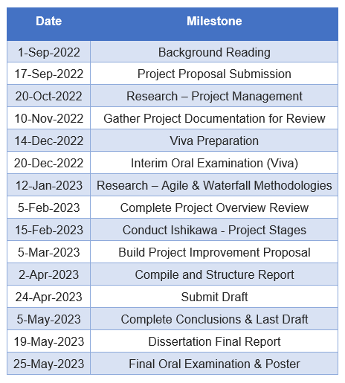

Literature Review - Project Management

What is a Project?
A project is a short-term endeavour with a predetermined start and end date to accomplish a particular goal or objective (Project Management Institute, 2017). According to (Tuman, 1983), a project is a group of individuals working towards a common goal or objective. Usually, projects are characterised by their significant scale, excessive cost, unique nature, or high level of risk, and must be completed within a specified timeframe, budget, and performance standard. At the very least, all projects must have clearly defined objectives and adequate resources to successfully accomplish all necessary tasks
Projects include the construction of buildings, the implementation of software systems, and the introduction of new product lines. Unique and complex projects need a committed team and resources to manage and complete. Planning, organising, and controlling resources to achieve project goals while balancing constraints like time, cost, and scope are all part of the project management process (Kerzner, 2013). High-quality projects that satisfy the needs of stakeholders must be delivered with effective project management.

What is Project Management?
Project management involves using predetermined principles, practises, and policies to direct a project from conception through to completion. These best practises are used in project management to make sure that a project is finished in a way that fulfils all stated outcomes, from spending constraints to end-goal objectives.
Each project component must go through phases of initiation, planning, and execution before an outcome is realised. The project management lifecycle is this procedure, and it is what makes projects successful. Additionally, this cycle enables project managers to carefully plan each task and activity to maximise success chances (Project Management Institute, 2023).

How Project Management Changes
While projects in general share similarities in terms of their objectives of organising, planning, and controlling resources to achieve specific goals within a defined timeline, there are significant differences depending on what the project encompasses. For example, (Kerzner, 2013) exhibits how, Engineering Project Management primarily focuses on structural building design and construction, as well as the development of new products or technologies. However, an engineering project is not only limited to this, but engineering projects can also be utilised for process improvement by integrating new equipment or technology into existing processes.
Some projects have a high level of technical complexity, requiring specialised knowledge and technical expertise, making the project more focused on technical planning, design, and implementation than traditional project management, making it necessary to ensure that the project meets the required technical and regulatory standards (Turner & Muller, 2017). For example, fields that requires this type of project management would be industries that are particularly stringent on risk, quality, and regulations.
Due to the potential risks to safety and the environment, such projects are known to carry more risk compared to other project types. Consequently, successful project management requires effective risk management and mitigation strategies when the regulations are strict, and the consequences impact the wellbeing of others. It is essential that the project team has the technical knowledge and expertise to identify, assess, and manage project risks efficiently. Risk management is a critical aspect of the project management process, especially where safety and environmental impacts need to be carefully considered and addressed (Bansal, 2007).

Project Management Institute - Five Phases of Project Management
An international organisation for project managers based in Pennsylvania, USA, is the Project Management Institute (PMI). The Project Management Professional (PMP) certification is one of the most well-known project management credentials in the world. PMI, which was founded in 1969, offers a variety of tools and certifications for project managers. Through lobbying, instruction, and research, PMI aims to advance the project management profession. The Project Management Body of Knowledge (PMBOK), which was created by PMI acts as a standard for the industry and is a reference for best practises in project management.
A project is said to have five phases Figure 2, according to the Project Management Institute: initiation, planning, execution, monitoring and control, and closure. Project managers can use these stages as a framework for project management and as a list of specific actions to take to ensure the achievement of their projects.

Figure 2 - 5 Phases of Project Management

Initiation
The first stage of the project management process is initiation. During this phase, the project is specified, and its feasibility is reviewed. A project plan is created once the project's goals, boundaries, and restrictions are determined. Also, the stakeholders are named, and their expectations are outlined. The Project Management Institute (PMI) states that the success of a project depends on its initiation since it establishes its framework and ensures that all stakeholders are aware of its objectives (Project Management Institute, 2017).

Planning
The second stage of the project management process is planning. A thorough project plan, complete with tasks, deadlines, costs, resources, and risks, is created at this phase. The project team is formed, and their tasks are assigned. All participants involved in the project assess and approve the project plan. Planning is essential because it ensures that the undertaking concludes on time, within budget, and to the required quality standards (Project Management Institute, 2017).

Execution
The third stage of the project management process is execution. The project plan is implemented during this stage. The tasks listed in the plan are carried out by the project team, and progress is tracked against the plan. The project manager is responsible for managing the team, ensuring that the project stays on schedule, and making sure that it satisfies all the stakeholders' needs. According to the PMI, Execution is crucial since it is where the project's actual work is done, and project managers are responsible for ensuring that the project stays on schedule (Project Management Institute, 2017).

Monitoring & Control
The fourth stage of the project management process is monitoring and control. Progress is checked against the plan during this phase, and any deviations are found and fixed. Risks, adjustments, and ensuring that the project is still feasible and will satisfy stakeholders' expectations are all things that the project manager must manage. The PMI asserts that monitoring and control are essential because they enable project managers to keep track of the project and make sure it stays on course (Project Management Institute, 2017).

Closure
The project management process ends with closure. The project team provides the finished project to the stakeholders during this phase, which marks the completion of the project. The project is assessed, and the lessons learned are recorded. The project is finished, and the project team is broken up. Closure is crucial for project managers, according to the PMI, since it enables them to properly close out the project, make sure that all stakeholders are satisfied, and record the lessons learned (Project Management Institute, 2017).

Project Management Methodologies – Agile Vs Waterfall
There are numerous project management approaches that are used to ensure that project goals are met on time, within budget, and with high quality. Popular project methodologies include Agile, Waterfall, Scrum, Lean, and PRINCE2. These methodologies have their differences and choosing the right one depends on factors such as project requirements, team size and composition, and stakeholder expectations. The two most widely used project management methodologies are Waterfall and Agile. While Waterfall is a traditional and sequential approach, Agile is a more flexible and iterative approach. This literature review aims to compare the two approaches and provide insights into the advantages and disadvantages of each methodology.

Agile
Agile project management is a flexible, iterative process with the goal of providing value to customers through continuous delivery and constant adjustment to shifting conditions. It started in the software development sector, but since then, it has expanded to other sectors like manufacturing, healthcare, and education (Sutherland & Schwaber, 2011). The ideals of the methodology are outlined in The Agile Manifesto, which was written in 2001 by a group of software developers. It places an emphasis on the value of collaboration, flexibility, and client satisfaction (Agile Alliance, 2023).
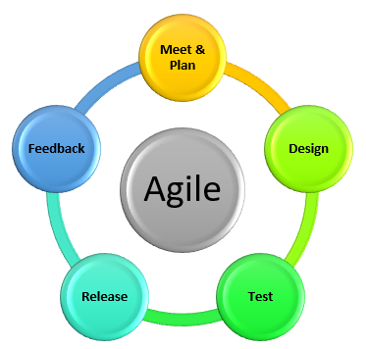
Agile project management is built on the iterative creation of small functional units, known as user stories, which are created and delivered over brief periods of time known as sprints Figure 3. Agile methodology places a strong emphasis on flexibility, emphasising the delivery of the most crucial features first and being willing to adjust requirements and objectives as necessary (Cohn, 2006). The methodology promotes the active involvement of customers and stakeholders throughout the project and places a higher value on project outcomes and customer satisfaction than extensive documentation and processes (Highsmith, 2001).
Figure 3 - Agile Framework
Agile project management relies heavily on self-organising and cross-functional teams, which are empowered to make decisions and take ownership of the project. The team works together to define the project scope, develop user stories, and estimate the effort required to complete each story (Schwaber, 2004). The team also holds regular meetings, such as daily stand-up meetings and sprint retrospectives, to ensure that everyone is aligned, and the project is on track.

Several frameworks have been developed to support Agile project management, including Scrum, Kanban, and Lean. Scrum is the most widely used framework, and it involves dividing the project into sprints, daily stand-up meetings, and frequent reviews to ensure that the team is aligned and delivering value (Sutherland & Schwaber, 2011). Kanban, on the other hand, is a visual management tool that helps teams manage their work and workflow. It emphasises the importance of limiting work in progress and continuously improving the process (Anderson, 2010). Lean is a framework that focuses on eliminating waste and maximising value, and it can be applied to both manufacturing and service industries (Poppendieck, 2003).
Overall, Agile methodology has been praised for its ability to adapt to changing circumstances and deliver value to customers quickly and efficiently. However, it has also been criticised for its lack of emphasis on documentation and its reliance on self-organising teams, which can lead to issues with communication and coordination (Larman & Basili, 2003). Nonetheless, the methodology continues to gain popularity in industries beyond software development and has shown promising results in terms of customer satisfaction and project success rates (Boehm & Turner, 2005).

Waterfall
The waterfall methodology is a linear and sequential approach to project management that is often used in software development, engineering, and construction. It is called "waterfall" because each phase of the project flows sequentially into the next phase, like a waterfall Figure 4. The phases include requirements gathering, design, implementation, testing, and maintenance (Royce, 1970).
The waterfall methodology is often used when the project requirements are well-defined, and the scope is stable. It emphasises thorough planning, documentation, and a structured approach to development. Each phase of the project must be completed before moving on to the next, which can help ensure that the project stays on track and on budget (Boehm, 1988).

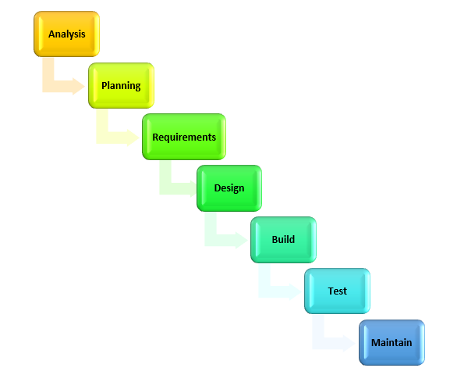
One of the advantages of the waterfall methodology is that it provides a clear structure for the project, which can make it easier to manage and monitor progress. It also emphasises documentation, which can help ensure that the project meets its requirements and can be maintained over time. Additionally, the waterfall methodology is well-suited to projects with a stable scope, where the requirements are unlikely to change significantly over the course of the project (Kendall & Kendall, 2006).
Figure 4 - Waterfall Framework
However, the waterfall methodology has been criticised for being inflexible and slow to adapt to changing requirements. Because each phase of the project must be completed before moving on to the next, there is little opportunity to adjust the project based on new information or feedback. Additionally, the waterfall methodology can be less efficient than other methodologies, as the project team must wait for each phase to be completed before beginning the next phase (Gillenson & Hwang, 1995).
Despite these criticisms, the waterfall methodology remains popular in many industries, particularly in construction and engineering. It provides a structured and well-documented approach to project management, which can be beneficial in projects with stable requirements. However, it may not be well-suited to projects with changing requirements or where flexibility is important (Royce, 1970).
Table 2 - Waterfall Vs Agile Comparison shows the differences between the two methodologies.

Table 2 - Waterfall Vs Agile Comparison
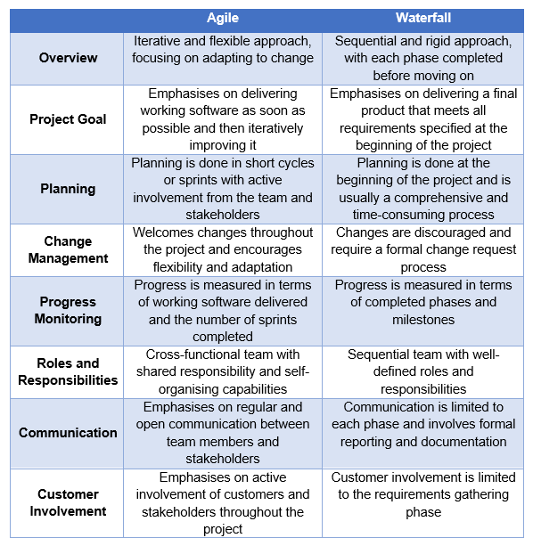

Limitations of Agile and Waterfall
The review demonstrates that both Agile and Waterfall approaches offer advantages, but it is important to understand the scenarios in which they can fail. according to (Kettunen, et al., 2017). Agile may face issues such as inadequate documentation, trouble predicting project schedule and expenditures, and restricted visibility for stakeholders. Agile's emphasis on working software over detailed documentation might cause issues in highly regulated or structured industries (Kettunen, et al., 2017). Agile's iterative nature can make it difficult to precisely predict project schedules and costs, leading to uncertainty for stakeholders (Müller & Händel, 2020). Furthermore, because Agile is dynamic and fluid, stakeholders outside the project team may have less visibility and comprehension of project progress (Conforto, et al., 2014). In a study of Agile adoption in the healthcare sector, researchers discovered that the organisation struggled to adapt to the culture change required for Agile to be successful. The study discovered that the organisation's culture was hierarchical and bureaucratic, making it difficult for the Agile method to be completely accepted (El Amrani, et al., 2018).
Waterfall, on the other hand, has limitations such as a lack of flexibility, decreased customer interaction, and a larger likelihood of late-stage failures. Its sequential and rigid character makes accommodating changes or adapting to growing project needs difficult, potentially resulting in delays or rework (Turner & Muller, 2017). Reduced customer involvement in Waterfall after the initial requirements gathering phase might lead to a mismatch between the end product and customer expectations (Kerzner, 2013). Furthermore, the linear approach of Waterfall increases the risk of discovering critical issues or defects late in the project lifecycle, making resolution more difficult and costly (Babu, et al., 2012).
Hybrid techniques that combine parts of Agile and Waterfall have gained popularity in response to the demand for flexibility and adaptation. Researchers proposed "Wagile" models and explored the concept of "Agile-Waterfall hybridisation" ( (Bannerman, et al., 2018) (Serrador & Pinto, 2018). By customising the hybrid approach to project characteristics and restrictions, these techniques strive to utilise the strengths of both methodologies while limiting their constraints.
According to the literature, in the manufacturing industry, a hybrid Agile-Waterfall strategy can achieve a balance of adaptability and structure. Organisations can profit from the combined advantages of both approaches by selectively applying Agile concepts to specific project phases, while utilising Waterfall for more stable parts. In conclusion, both Agile and Waterfall approaches have advantages and disadvantages, and they may not be universally applicable. In the manufacturing industry, organisations can consider adopting a hybrid strategy by customising it to project-specific requirements, stakeholder demands, and organisational context.

Zimmer Biomet Project Management Structure

This section provides an overview of the project management structure at ZB, specifically for Bridgend projects. The guidelines for these projects are set out in procedure UKP038 Operation Project Planning Procedure (Zimmer Biomet, 2021), which aims to provide a process for developing and executing Operation Project Plans (OPP) for large projects and A3’s for small projects. The procedure is designed to guide significant changes to the site facilities, manufacturing processes, inspection processes, or Quality System.
The medical device industry is subject to various quality, environmental, and safety regulations, which must be carefully considered and complied with during the project management process. Complying with quality regulations requires a rigorous quality management system, which includes documentation, traceability, and risk management. This can add complexity and time to a project, but it is essential for ensuring the safety and effectiveness of the final product (Rajan, 2004). The project team, therefore, requires a deep understanding of these regulations and their impact on the project. It is also the responsibility of the team to navigate the regulatory landscape and ensure that the project adheres to all applicable regulations.
The project team for Bridgend projects consists of 8 members, including an Operations Project Manager who manages the team, looks at future projects, and manages the capital budget. The Project Management Office (PMO) is responsible for defining and maintaining project standards, documenting project status and strategy, and reporting and updating the senior management team. Project Engineers are responsible for all aspects of the project from feasibility to close out.
Each project must adhere to the procedure outlined in UKP038, which is structured similarly to the waterfall methodology's framework with its linear approach and Project Management Institute (PMI), but is divided into four phases: feasibility, planning, execution, and closure Figure 5.
Figure 5 - ZB UKP038 - Project Phases

Feasibility Phase
The Feasibility Phase is the first phase of the project management process at ZB. During this phase, project charters A and B are completed. The Project Charter evaluates the benefits of the project against the effort required to complete it. This process involves analysing the potential gains that the project could bring, compared to the time, cost, and resources needed to complete it. By evaluating the benefits versus effort, the Project Charter helps to ensure that the project aligns with the organisation's strategic goals and objectives, and that it is feasible to complete within the available resources. The Project Charter is an essential document that provides a clear and concise description of the project's objectives, scope, and deliverables, as well as the roles and responsibilities of the project team.

Project Charter Part A – Benefits Vs Effort
Benefits
- Business Continuity - Does the project include any equipment / processes that will be unique to this site? Are there alternatives on site, within ZB or our existing suppliers?
- Quality/Compliance Risk Mitigation - Is this project linked to a current IE, CAPA? What is the potential impact of the project on quality and compliance risk?
- Cost Reduction - Is the project going to see any cost reductions?
- Strategic Significance - Does the project fit the site strategic plan / objectives? Is it a significant standalone project or does it form part of a programme of works?
- Capacity Uplift - Is the project going to produce capacity uplift? What is the existing and forecasted data? (Zimmer Biomet UK, 2021)
Effort
- Project Duration - What will the project duration be?
- Resource Requirements - What resources are required for the project? Will it require a small local team, full team engagement going across departments and / or sites?
- Technical Difficulty - Do we have in depth knowledge / experience on site or within ZB or is our knowledge limited or do we have no experience?
- Production Interruption - How much interruption will the project have on production?
- Total Investment - What will the required total investment be for the project, include OPEX and CAPEX detail (Zimmer Biomet UK, 2021).
After completing and approving project charter A, a decision will be made regarding the need for an Operation Project Plan (OPP) or an A3 project. The determination depends on whether the project affects a medical device or medical device manufacturing process and requires a regulatory assessment. An A3 project is suitable for smaller projects and entails reporting the problem statement, background, current conditions, root cause analysis, proposed countermeasures, implementation plan, and follow-up actions. Conversely, an OPP is intended for more significant projects that impact regulatory requirements.

Project Charter Part B
- Business Case - The reasons for project being completed and where it fits into the site strategy.
- Scope - The specific project deliverables and features. Detail what needs to be achieved to complete the project.
- Goals and Objectives - What the projects goals and objectives are.
- Risks - Identify all the risks that may affect the completion of the project.
- Milestones – Identify the key milestones of the project.
- Roles and Responsibilities – Identify the roles that will be required to complete the project and the responsibilities that they will have during the project.
- Resource Needs – Estimate how many days required per function and what resources are required to complete the project by function.
- Budget – what is the estimated budget required, including CAPEX and OPEX detail.
- Communication plan - Define the frequency of project reviews during the project and the stakeholders required.
- Steering Committee – Identify members that will provide support, guidance, and oversight of progress (Zimmer Biomet, 2022).

Planning Phase
UKP038 requires an Operation Project Plan (OPP) to be completed during the planning phase. Part 1 of the plan includes a comprehensive list of items and actions that will occur, along with relevant details for out-of-scope conditions. It also establishes the method for executing the OPP, identifies high-level project milestones, and outlines the team members required to support the project. A communication plan is also included, with regular project status meetings scheduled. If the project impacts medical devices or the medical device manufacturing process, a Regulatory Impact Assessment is required, and any related regulatory activities must be included in the project plan.

Execution Phase
UKP038 states that the execution phase of the project involves the management and direction of the project according to the established project plan and milestones. The Project Lead is responsible for acquiring resources and managing the workload and must provide monthly project status updates during project review meetings with the Project Management Office (PMO) and Senior Leadership Team (SLT). Additionally, the project leader must write any required process or machine validations, which must be approved by the validation department. This phase also includes the conduct of studies such as biocompatibility studies or product testing.

Closure Phase
After all the activities and milestones defined in the project plan have been completed and the project meets the criteria of the project scope, the project can move into the closure phase. During this phase, the team will prepare OPP Part 2 and 3, which includes a handover plan and lessons learned. The handover plan outlines the process for transitioning the project deliverables to the customer or relevant stakeholders, and the lessons learned document captures the successes and areas for improvement from the project.
Once these documents are prepared and reviewed, all project resources are released from their project responsibilities. If the project completion satisfies all stakeholders, OPP parts 1 and 2 can be approved, and the project can be closed. However, if any issues or concerns arise during the project review, further actions may be required before the project can be officially closed.

Project Metrics & Reporting

Project Status Report
Every project is monitored using a project status report (see appendix 19.1), which provides an overview of the project's progress and performance against its objectives and key metrics. The report includes information on project milestones, tasks, budgets, risks, and issues, and is used to track progress, identify trends, and make informed decisions about the project's direction and goals.

Milestone Adherence
The progress of each project is measured by tracking key milestones and individual tasks within the project, which are defined using the Gantt chart. The chart allows the project engineer to see the overall timeline of the project and the various tasks that need to be completed.
To determine the project's performance, the percentage of tasks completed versus the total number of outstanding tasks is calculated. This helps to assess whether the project is on track to meet its goals and deadlines. If any tasks are overdue or being pushed out, project engineers will escalate the issue and discuss options for getting back on track.

Budget
Budget is monitored by tracking actual expenditures against the planned budget. This involves regularly reviewing purchase orders and expenses, as well as comparing actual costs to the budgeted costs. By monitoring budget in this way, project engineer can identify any variances or deviations from the planned budget and take corrective action as needed to keep the budget on track. In addition, regular budget status reports are shared with stakeholders to ensure transparency and accountability throughout the project.

Project Status Meetings
To ensure efficient and effective completion of projects, regular status update meetings are held by the Project Management Office (PMO) with team members, and senior management, Project progress data is compiled on a generic status reporting template and reviewed during the meetings. The progress of key milestones and individual tasks is examined. Any overdue or delayed tasks are escalated, and options for getting back on track are discussed. General discussions are held about task completion and unresolved issues, as well as any issues that may impact task completion or progress, such as annual leave, production issues, or resource constraints.
During the meetings, potential risks are assessed and collaborate to eliminate them, while exploring opportunities to reduce the project's timeline or identify potential future opportunities. By closely monitoring project progress and addressing any issues that arise can ensure that the project stays on track and meets its goals while minimising the risk of delays or budget overruns.

Project Management Office (PMO)
The PMO is responsible for providing centralised oversight and support for project management activities within an organisation. This includes a variety of functions, such as developing and enforcing project management standards and methodologies and facilitating communication and collaboration between teams.
In terms of risk management, the PMO is responsible for developing and maintaining a risk management framework that enables the project engineer to identify, assess, and mitigate risks throughout the project lifecycle. By conducting risk assessments, and monitoring risks on an ongoing basis.
The PMO is also responsible for maintaining centralised information on active and closed projects within the organisation. This enables stakeholders to monitor project progress and outcomes, track resource allocation and budget utilisation, and identify opportunities for collaboration and resource sharing across projects.

Post Project - Lessons Learned
The PMO and project engineer are responsible for capturing and distributing lessons learned from past projects, to facilitate continuous improvement and knowledge sharing across the organisation. This involves developing and maintaining a lesson learned register, facilitating post-project reviews, and providing guidance and support to project teams on how to apply lessons learned to future projects.

Water System - Project Background

Biomet & Zimmer Merger
In 2015 Biomet and Zimmer merged to become the new company, Zimmer Biomet Holdings Inc, the second-largest orthopaedic device manufacturing company in the world. The merger was a huge milestone combination that brought together two major companies with a mission to lead the industry in delivering value to healthcare providers, their patients, and shareholders. Following the merger, the Bridgend site experienced a significant surge in demand. This was attributed to the doubling of sales representatives from Zimmer and Biomet's product portfolios, coupled with Bridgend's reputation for manufacturing the highly sought-after Taperloc stem, which remains one of the most acclaimed hip replacements in the industry.

Total Hip Replacement Manufacturing Process
A damaged hip joint is replaced surgically with an artificial joint in a procedure known as a total hip replacement Figure 6. Four crucial parts make up the Taperloc hip replacement, and they all work together to give the hip joint stability and mobility. The stem is the first component, and it is inserted into the femur or thigh bone to provide a secure anchor for the artificial joint. The second component is the shell or hip cup, which is inserted into the pelvic bone's hip socket. The stem and shell are both constructed from durable titanium. The third component is the ceramic ball, which fits onto the end of the stem. The liner, fourth component, which is made of polyethylene and is inserted into the hip cup to provide additional cushioning and support (Ugo Ihekweazu, MD, FAAOS, 2023).
Figure 6 – Total Hip Replacement Taperloc
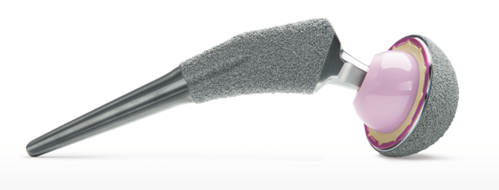
The titanium hip and shell are manufactured in several stages, including machining, polishing with polishing compounds, grit blasting, and porous coating with titanium powder. These stages, expose the parts to a variety of contaminants, necessitating a thorough cleaning process that includes in-process and final cleaning, as well as biological upgrade washing, to remove any manufacturing residues.
Furthermore, all clean line washes must use purified water to ensure that the manufactured components are clean. This adherence to cleaning protocols is critical in ensuring the safety and effectiveness of the titanium hip and shell components used in total hip replacement surgeries.

Water Quality Within the Medical Device Industry
The most frequently used raw material in the medical device industry is purified water (PW), which has a wide range of uses, including the mixing of analytical reagents, parenteral drugs, cleaning processes, and sterilisation. Ensuring the best quality or grade of water is essential to lowering patient risk depending on the manufacturing process, product need, or regulatory requirement. Poor water quality can have a significant impact on the patient, product, and process, so the purity of the water used in these processes is extremely vital.
To ensure that it is suitable for use in medical devices, purified water must meet quality standards. It is processed through a water system to remove impurities and contaminants, such as microorganisms, minerals, and chemicals. Standards for the quality level of water used in the pharmaceutical and medical device industries are set by the United States Pharmacopeia (USP) and European Pharmacopeia (EP). Water quality is critical for the safety and effectiveness of products, according to the USP (United States Pharmacopeia, 2009). The International Organization for Standardization's ISO 13485:2016 quality management system standard also specifies water quality standards that manufacturers in the medical device industry must adhere to (International Organization for Standardization, 2023).
Bacterial endotoxins are a concern in the medical device industry because they can have a wide range of negative effects on patients who are exposed to them. In addition to the risk of endotoxin exposure to patients, contaminated medical devices can cause aseptic loosening. In fact, aseptic loosening caused by endotoxins accounts for up to 8% of joint arthroplasty revisions (Lübbeke, 2013). It is characterised by the implant becoming loose from the surrounding bone, which may lead to discomfort, instability, and the need for revision surgery. Endotoxins can make this condition worse by inducing an inflammatory reaction in the tissue around them, which causes bone resorption and implant loosening (Goodman, 2007).
Medical device manufacturers must ensure efficient sterilisation and cleaning procedures to reduce the danger of aseptic loosening brought on by endotoxins. Moreover, regulatory organisations USP and EP have set standards for the management of endotoxins in medical devices. These recommendations set restrictions on the number of endotoxins that are permitted in medical devices and the water used to wash them (United States Pharmacopeia, 2009) (European Pharmacopoeia, 2021).

Final Clean Line Wash Demand
The end of line (EOL) finishing department is where all manufactured parts are washed and sterile packed before they are sent for gamma radiation. Prior to 2012 there was only two final clean lines one was for metal and the other plastic implants. Since 2012 a third final clean line has been installed and an additional in-process wash that is located on the manufacturing floor. increased the total/overall demand of purified water usage to 3000 litres per hour and therefore since the installation of the new washes the current water system generation and storage systems was performing under-capacity.

Project Objectives
In 2016, after a merger and a significant forecasted increase in demand, there was a requirement for a fourth final clean line wash and a replacement plastic wash, which increased the demand to 4500 litres per hour. This necessitated the installation of a new water system capable of meeting this increased demand. To achieve this, we have opted for a new and improved PWMEM system that not only meets the required demands but also offers better logistics, practicality, and lower running costs. The new system also maintains the highest levels of microbial control and provides better flexibility for our EOL wash lines Figure 7.
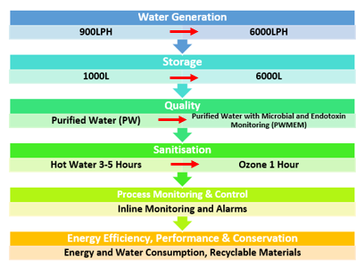
Figure 7 - Water System Project Objectives

Water System – Reverse Osmosis Process

Reverse Osmosis & Water Purification
Reverse osmosis (RO) is a water treatment process that employs a semi-permeable membrane to remove contaminants and impurities from water. This process is widely used for various applications, including drinking water purification, industrial processes, and desalination.
According to (Mulder, 1996), reverse osmosis involves applying pressure to the feed water, causing it to flow through the membrane while leaving behind dissolved solids and contaminants. The RO membrane consists of a dense polymer film with extremely small pores that allow only water molecules to pass through, effectively rejecting larger particles and impurities. The process works based on the principle of osmotic pressure, where water naturally flows from an area of lower solute concentration to an area of higher solute concentration.

Orion Purified Water System
The water system is composed of 3 stages pre-treatment, generation and distribution which distributes purified water to the EOL processes Figure 8.

Figure 8 - Water System Process Flow

Stage 1 – Pre-Treatment
The initial stage involves pre-treatment of the town's raw water, which is achieved by passing it through a 10µm cartridge filter. This process effectively eliminates impurities, solids, and any living organisms present in the raw water. Additionally, this step guarantees that the water quality remains consistent and unaffected by seasonal changes, extreme weather conditions, or industrial pollution Figure 9 and Figure 10.
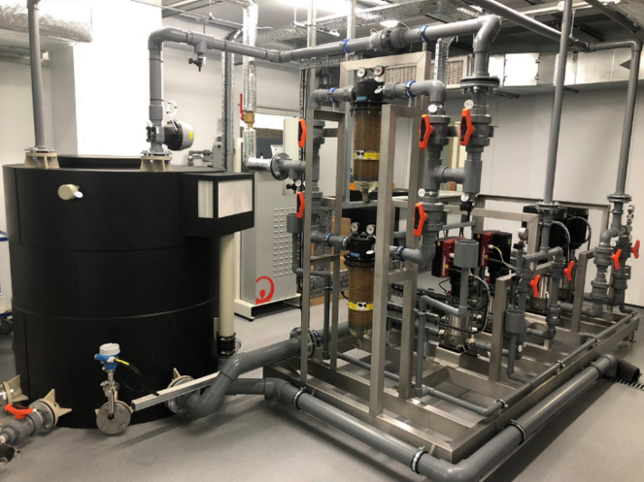
Figure 9 - Pre-Treatment
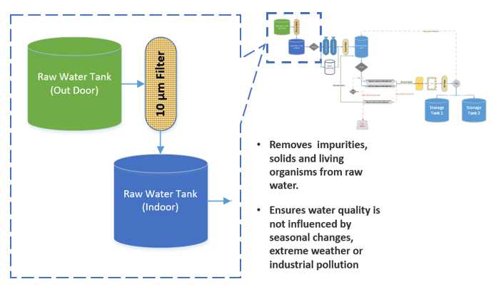
Figure 10 - Pre-Treatment Process

Stage 2 – Generation System
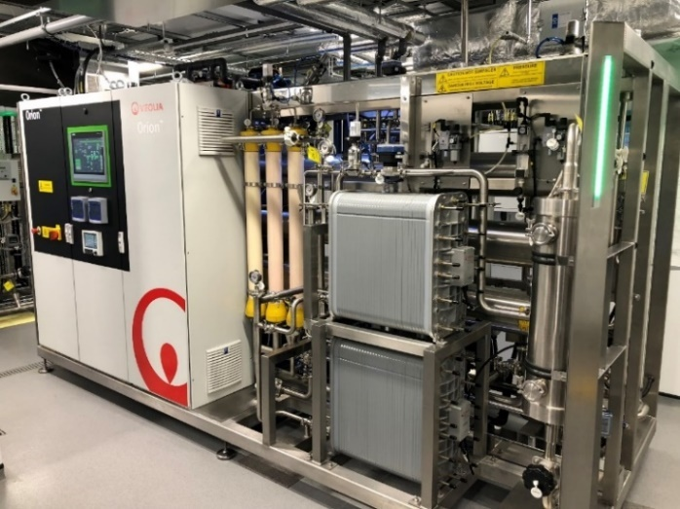
In the second stage of water purification, a Softener and activated carbon ion-exchange filtration process is employed Figure 11 & Figure 12. The Softener softens the water and exchanges calcium and magnesium ions with sodium ions to prevent precipitation when concentration occurs downstream in the reverse osmosis membranes. Meanwhile, the Carbon stage prevents scaling of the RO membranes and removes chlorine from the feed water. A 5µm carbon cartridge filter is positioned after to provide chlorine protection, as raw water typically contains chlorine, which can significantly harm the RO membranes. Once the water has undergone this process, it is directed to the RO feed tank.
Figure 11 – Generation System
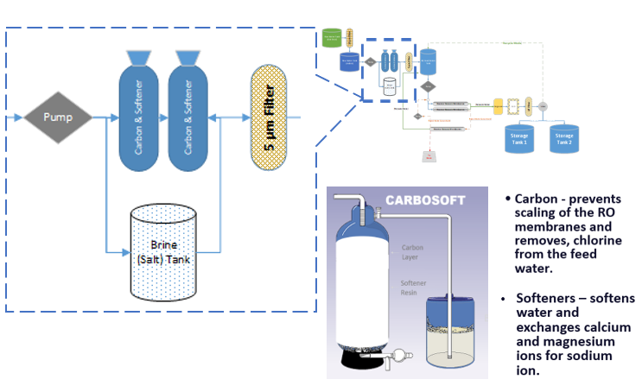
Figure 12 - Generation - Carbon Softeners Process

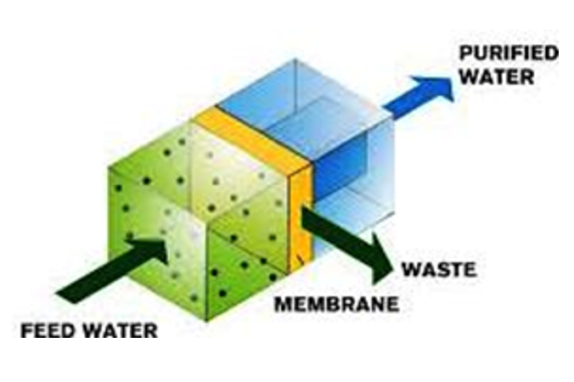
The water then passes through two high pressure vessels fitted with high performance membranes which removes >99% of ions, particulates, and biological contamination from the pre-treated water. The RO membranes have a semi-permeable layer that selectively allows water molecules to pass through while blocking larger molecules and ions Figure 13.
The ‘Permeate’ good water moves on. Reject water of the RO process is recovered and treated by a third RO membrane. The permeate/product (good water) is sent back to the RO feed water tank and is mixed with the pre-treated water going to the main RO process for second stage purification, any reject water goes to drain Figure 14.
Figure 13 - Semi-Permeable Membrane Flow
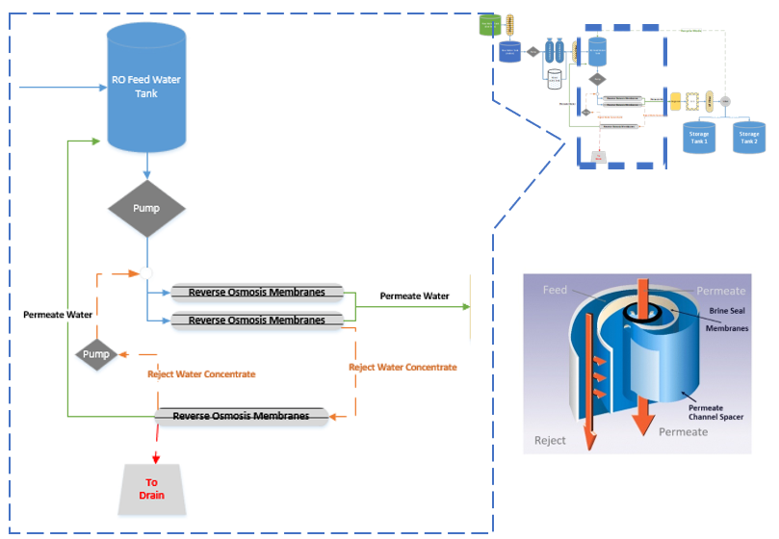
Figure 14 – Generation - Reverse Osmosis Process

The remaining ions in the RO treated water is removed by the degasser and CEDI process. The degasser removes carbon dioxide and oxygen. The capacitive deionisation (CEDI) removes charged contaminates from the water using electrical driving force. The water is then passed through a 0.05µm ultra-filter to remove the remaining particulates and biological contaminants from the water. Purified water is then fed to two storage tanks Figure 15.
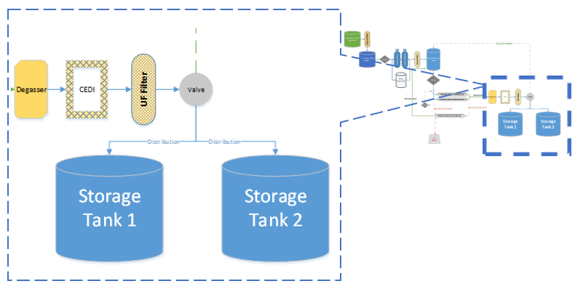
Figure 15 - Generation - Degasser and CEDI Process

Stage 3 – Distribution System
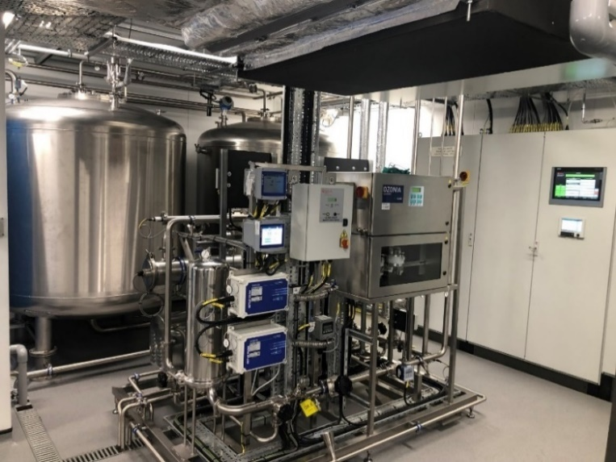
The PW generated is filled and stored in two 3,000 litre stainless steel storage tanks where it is continuously ozonated via an ozone generator to protect the PW from possible biological contamination. Ozone disinfects water and eliminates impurities by breaking down organic and inorganic materials. It is effective at removing microorganisms and organic matter, making it a popular water treatment method. Ozone is safe and eco-friendly, leaving no harmful by-products or residuals, the water then goes through Ultraviolet lamp to remove the ozone before it goes to the final purification process of ultra-filtration Figure 16. The 0.05µm ultra-filter removes possible presence of particulate and biological contaminants. After the final UF, the PW is supplied to the ring main outlet to the user points by using a high-pressure distribution pump Figure 17.
Figure 16 - Distribution System
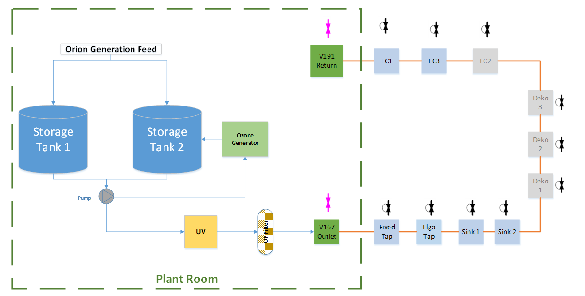
Figure 17 - Distribution Loop Process

Project Analysis
The objective of the project was to install a new improved water system to increase capacity, improve water quality, in-process monitoring and safety. Although all functional objectives were met the targeted budget and timeline were exceeded, costing £200k more and taking 12 months longer to close the project.
Table 3 - Project Objectives Vs Outcome
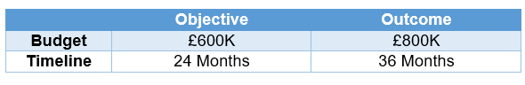
This section's aim is to evaluate how the project for the installation of the water system went using the current project management structure and to develop a proposal for improvement moving forward and assess whether the project was successful.

Ishikawa Analysis
One way to evaluate the project is to use Ishikawa analysis. An Ishikawa diagram, also known as the fishbone diagram or cause-and-effect diagram, is used to help identify the root causes of problems or defects Figure 18.
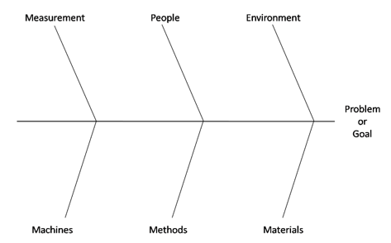
Figure 18 - Ishikawa / Fishbone Diagram

The Ishikawa diagram, consists of six elements:
- Manpower: the people involved in the process or project
- Machine: the equipment, tools, and technology used in the process or project
- Material: the raw materials, supplies, and resources used in the process or project
- Method: the procedures, processes, and systems used in the process or project
- Measure: the metrics, standards, and data used to evaluate the process or project
- Environment: the physical and cultural factors that influence the process or project.
These elements help to identify and analyse the various factors that can contribute to a problem or effect. The usefulness of the Ishikawa diagram in project management has been highlighted in several studies. For instance, (Salleh, et al., 2015) used the diagram to identify the causes of project delays in the construction industry, while (Ghasemzadeh, et al., 2012) used it to identify the factors that contribute to project success in the oil and gas industry. By considering each of these six elements and their potential impact on the problem or effect being analysed, project managers can identify the root causes of problems and develop effective strategies for improving project performance (Gupta & Gupta, 2015).
In this case, the Ishikawa is used to analyse each phase and the factors that contribute to delays in project completion, budget overspend, or quality issues.

Manpower
During the feasibility phase, a project leader was identified to oversee the initial project requirements and operations for its success. Although in UKP038 a project sponsor was not mandated, the area business leader became the sponsor due to the potential benefits for their department's future output. This was helpful as sponsors provide the necessary resources, funding, and support to ensure the project aligns with the organisation’s strategic goals. However, the failure to create a project team or assign resources resulted in several negative consequences, including project delays, missed deadlines, and poor execution of the feasibility phase.
In the planning phase, the organisation brought on board a validation and microbiologist contractor to ensure that the validation requirements and water quality were properly considered from a microbial perspective during system installation and testing. This measure helped to avert quality issues and guarantee that the system aligned with the stakeholders' requirements. Although the project manager from Veolia, the water system supplier, led the planning and installation, the absence of an internal subject matter expert on purified water systems within the organisation posed a challenge during the approval phase of the User Requirements Specification (URS) and other project documentation. The limited knowledge of the approvers caused document errors and approval delays, which eventually affected the project schedule. The lack of expertise also created doubts about the project's ability to deliver successfully, leading to additional scrutiny and questioning of the project documentation, thereby further delaying the approval process.
During the execution phase, the installation was mostly managed by Veolia, and their expertise and experience ensured that the installation ran smoothly. All installation and operational qualifications IQ and OQ were completed by them following their own protocols and reviewed and approved by ZB.
However, during this phase the project leader decided to leave the company. A new project leader was assigned, causing significant delays as there was only a two-week handover period. The new project leader not only had to comprehend the project’s structure but also learn to understand the water system with no previous experience of water systems or how the new system operated. Nevertheless, this established an excellent vendor relationship as the new leader had to spend considerable time with the supplier and reached out to other engineers outside of the organisation for guidance.
During the execution phase of the project, the project leader worked to get other departments involved to ensure a successful closure and handover phase. To achieve this, quality and process engineers were trained on the system to better understand its operation and maintenance requirements. Quality engineers were involved in the performance validation phase, which included taking water samples to ensure the system was performing to specification. Meanwhile, process engineers were responsible for running sanitisations and troubleshooting any issues with the system.
However, despite the efforts to involve other departments, there was pushback from department leaders due to a lack of resources. This resulted in no clear ownership of the system once the project entered the closure phase, leading to a lack of communication between departments. As a result, there were delays during the closure and handover phase as there was no clear department to hand the system over to. The responsibility for the system lay between maintenance, facilities, and the EOL finishing department, further complicating the situation.
To overcome these issues, a RACI (Responsible, Accountable, Consulted, Informed) chart was completed. This involved all departments in discussing their roles and responsibilities for each task. The RACI chart helped to clearly establish ownership of the system, assigning specific tasks to different departments, and clarifying who was responsible, accountable, consulted, or informed for each task (see copy of RACI chart in appendix 19.5). This helped to improve communication between departments and ensured a smooth handover and closure phase for the project.

Machine
During the feasibility phase the new water system was based on an existing water plant using a benchmarking strategy, which helped to identify milestones, cost estimates, and risk management strategies. However, funds were required to be used before year-end, resulting in utilising funds before the completion of a critical user requirements specification document. This caused issues as the URS outlines the functional and performance requirements of the system, and without it early on, misunderstandings, delays, and rework occurred.
Although the URS was approved in the planning phase, it was discovered that the new system would output water at a lower temperature range of 15-19°C compared to the existing system's temperature range of 60°C. The use of ozone treatment instead of heating the water in the distribution tank to prevent microbial growth resulted in the need for an external heater to be installed before the water could be fed to the washers to achieve the desired temperature range. This unforeseen requirement impacted the project's cost and caused delays due to the specific medical-grade specifications the heater had to meet. There were also some issues with clearly defining the demand requirements which impacted the pump and other requirements on the distribution causing an overall scope creep and budget increases.
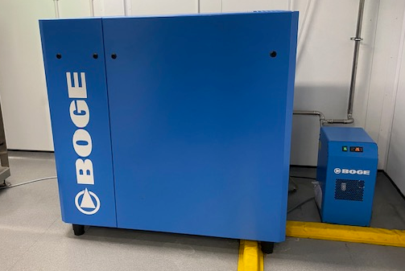
During the execution phase, the team encountered issues with utilities. The new system required medical grade compressed air to operate the plant, and it was discovered that there was not enough to cover both the generation and distribution. This led to the need for an additional compressor Figure 19, which not only added extra cost, but its footprint was not considered during the planning phase. Raw water demand was also an issue, as the demand on-site was not sufficient, requiring an additional storage tank to be installed outside of the building to act as a buffer tank. Another issue was when a major malfunction occurred with the pump on the generation side, requiring replacement. Unfortunately, the pump was not highlighted as a critical spare, resulting in a six-week wait for delivery. To prevent such occurrences in the future, a comprehensive review of the critical spare list was completed with the supplier, and the maintenance system was updated. This then initiated a maintenance contract with Veolia going forward.
Figure 19 - Compressor

Material
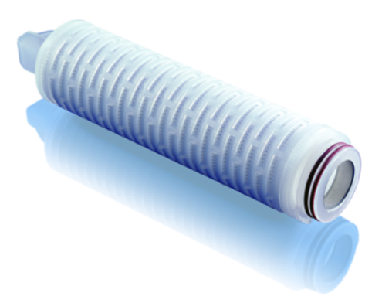
To ensure the new system met water quality specifications, materials used were considered following the ZB global specification. During IQ and OQ there was issue with the water quality output on the distribution side which was due to the endotoxin filter breaking down caused by the ozone. This was a requirement as part of the global specification however this is not a standard requirement on an ozone generated distribution system. The filter was found to be the incorrect grade, replacing this took time as finding an alternative required thorough investigation and extensive testing to ensure it was fit for purpose Figure 20.
Figure 20 - Endotoxin Filter
However, no review of lessons learned, or previous installation history had been performed, which could have identified these potential issues related to materials and helped to improve material quality and project success.

Method
The failure to complete key documents such as the project charter and feasibility study during the feasibility phase resulted in an unclear understanding of the project scope, objectives, timeline, and resource needs, leading to project failure. The absence of a feasibility study and risk management plan resulted in unexpected issues and increased costs as the project progressed.
During the planning phase, the completion of the Operation Project Plan (OPP) was a crucial step. A more detailed Gantt chart and risk assessment was required before its approval, which helped to identify potential roadblocks that were not previously identified. This analysis was essential in the planning phase as it helped uncover potential issues before they occurred, allowing the project to take necessary actions to mitigate risks and keep the project on track. By identifying roadblocks early on, the project team developed contingency plans and allocate resources accordingly.
The Performance Qualification was carried out in three phases to cover qualification and operation of the water plant under normal operating conditions. This approach was used to demonstrate system effectiveness, reproducibility, and robustness of the full integrated process. Water samples were taken weekly for six weeks from both the generation and distribution sides. However, during phase 3, the water samples showed high microbial readings, causing the validation to fail, and had to be repeated. A root cause analysis was completed, and it was identified that the sampling technique was inadequate due to the system requiring a different sampling technique compared to the existing system. Training was provided to the team to address this issue.

Measure
The initial Gantt chart with no clear timeline and budget led to ambiguity and lack of clarity in the project planning process, resulting in difficulty prioritising tasks and allocating resources effectively. As problems arose it was deemed the Gantt chart was insufficient therefore a revised chart was implemented. Additionally, the project faced unexpected costs and delays due to the lack of a clearly defined budget.
After the completion of the URS, Veolia provided a functional specification that was reviewed to ensure that the supplier could meet the customer's requirements. However, during this review, it was discovered that the estimated demand had been underestimated, resulting in alterations to the original plan. This led to scope creep, where additional requirements and features were added to the project that were not originally planned or budgeted for.
As a result of the alterations, the requirements for the water plant escalated, increasing the scope of the project, and impacting the project timeline and budget. The scope creep could have been avoided if the estimated demand had been accurately assessed during the planning phase, and if the URS had been thoroughly reviewed to identify potential issues and risks.

Environment
During the feasibility and planning phase, the failure to properly address space and utility requirements led to significant impacts on the project. The lack of clear space for installation resulted in delays and increased costs during the construction and installation, as well as frustration and dissatisfaction among stakeholders. Additionally, the inability to locate the water system with an outside wall led to issues during the execution phase, as the internal walls had to be brought down to move the tanks into the plant room Figure 21.
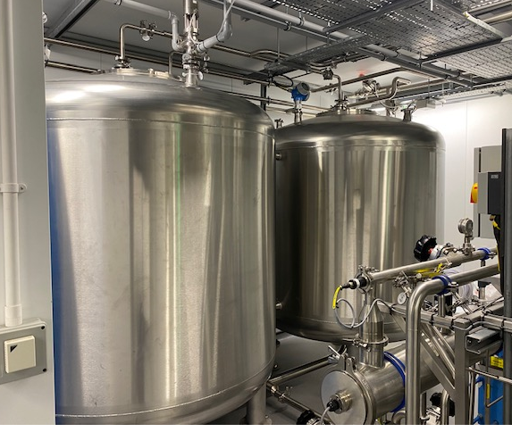
Figure 21 - Purified Water Storage Tanks
During the handover phase, further issues arose due to people going into the plant room and storing items, as well as untrained individuals attempting to fix issues outside of regular hours. This impacted the cleanliness of the system, resulting in issues with water sampling results. Restricted access was added to the plant room door and a cleaning schedule was implemented to address this.
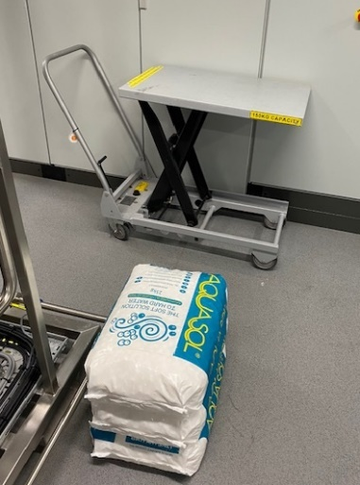
Furthermore, the water system required regular salt replenishing for the carbon softeners, and the bags of salt were stored outside. Due to the location of the plant room, facilities were required to carry the bags a long distance, resulting in strain on operators. To address this issue, a trolley was purchased to aid operators Figure 22. These issues highlight the importance of proper planning and consideration of environmental factors to ensure the success of a project.
Figure 22 - Trolley for Salt Transportation

Return on Investment Analysis
Although the project required a substantial investment and exceeded the initial budget, it also required a significant increase in operating and running costs. To capitalise on the increased capacity made possible by the water system, a new final clean wash line was purchased and installed under a different project. In total, achieving the enhanced capacity entailed an investment of £1.35 million and led to an annual increase in operational costs amounting to £151,000.
Before the implementation of the project, the current capacity of the production was 14,000 parts per week. However, with the new system in place, the capacity increased to 21,000 parts per week, resulting in an increase of 7,000 parts per week.
Considering the fixed cost per part of £113, which encompasses expenses such as utility costs, insurance, material and labour, and the sale price of £130 per part, the profit per part amounts to £17.
Therefore, with the increased capacity of 7,000 parts per week, the additional profit generated can be calculated by multiplying the profit per part by the increase in the number of parts:
Additional profit per week = 7,000 parts/week × £17/part = £119,000
Consequently, the annual additional profit can be determined by multiplying the weekly additional profit by 52 weeks:
Annual additional profit = £119,000 × 52 weeks = £6,188,000
It's important to note that while the increased capacity brings about additional profit, there is also an increase in annual operational costs amounting to £151,000.
Based on these figures, it only took approximately 2.68 months to break even and recover the overall investment (£1.35m) through the additional profit generated.

Quality and Scrap Improvements Analysis
The implementation of the new water system, despite its initial installation cost and ongoing operational expenses, has proven to be a worthwhile investment. In contrast to the previous water system that lacked alarms, the new system not only alerts users when water quality deviates from specified parameters but also prevents the distribution of out-of-specification water to user points. This improved monitoring and control has significantly mitigated the risks associated with compromised water quality.
The limitations of the previous water system are evident in the fact that it did not possess any alarms to indicate the use of water that was out of specification. This lack of monitoring and early warning resulted in 17 instances between 2018 and 2020 where the water quality fell outside acceptable limits. Consequently, the use of such substandard water in the wash systems led to the production of potentially contaminated products, necessitating costly scrap and rework procedures. The financial impact of these incidents amounted to approximately £510K in terms of scrap and rework expenses.
Since transitioning to the new water system, the organisation has experienced a considerable improvement. The implementation of alarms and preventative measures has ensured that zero instances of out-of-specification water has reached user points since 2020. This positive outcome reflects the effectiveness of the new system in maintaining water quality within acceptable limits, ultimately safeguarding the integrity of the product, and eliminating the associated costs and risks.

Sustainability Improvements Analysis
Installation of the new water system not only addressed operational requirements but also considered its environmental impact, leading to greener improvements. These enhancements include the incorporation of a Recycle Mode and the optimisation of pump efficiency, resulting in significant energy and water savings.
The Recycle Mode feature of the new system demonstrates a conscious effort to minimise waste and reduce electrical consumption. When the Distribution System reaches full capacity with no demand for water, the system automatically switches from Process Mode to Recycle Mode. In this mode, the RO Feed Pump is adjusted to produce a lower output, effectively reducing electrical usage. Moreover, the Concentrate/Reject water, which was previously discharged to drain, is now fully recirculated back to the multi-purpose tank. The sustainable approach not only eliminates water waste but also contributes to substantial utility savings.
The integration of a variable speed drive controlled by the system PLC in the RO Feed Pump significantly enhances its efficiency. The pump's frequency is regulated by the PLC to achieve a pre-set flow rate or pressure, depending on the system's operational mode. With frequency control, the pump continuously adjusts its performance to match the current requirements, thereby minimising energy consumption and the need for frequent start-ups and shutdowns. The control mechanism ensures that the pump operates optimally while conserving energy.
The impact of these greener improvements is evident in the significant energy and water savings achieved since the system's installation. On average, the organisation has reduced energy consumption by approximately 85-90 kWh per day, resulting in a total saving of over 31,300 kWh annually. This translates to a cost saving of £5K. Additionally, water consumption has been reduced by an average of 21-23m² per day, amounting to a total water saving of over 8,000m² annually, with a cost-saving of £11K.
By considering the environmental impact and implementing greener improvements, the organisation not only benefits financially but also demonstrates its commitment to sustainable practices. These energy and water savings not only reduce operating costs but also contribute to the overall reduction of carbon footprint and environmental impact.

Safety Improvements Analysis
The new water system and all equipment associated is CE marked which indicates that a product has been assessed by the manufacturer and deemed to meet EU safety, health, and environmental protection requirements (Your Europe, 2023). The system has also been installed in accordance with ISO 45001:2018 Occupational Health and Safety Management which is designed to prevent work-related injury and ill-health and to provide safe and healthy workplaces (International Organization for Standardization , 2018) and introduces significant safety considerations compared to the old system.
Several measures have been put in place to enhance safety within the plant room. For example, A bund and drainage system is installed to effectively channel water in case of a loss of containment. Level sensors are used to prevent water from reaching neighbouring equipment. Bursting disks are employed to release excessive pressure and avoid equipment failure. Chemical storage cupboards are implemented to prevent chemical reactions and spills. Restricted access is enforced to limit unauthorised entry. Lagging is applied to protect against high temperatures. Clear signage provides visual warnings to raise awareness of potential hazards. Lastly, emergency stop buttons are strategically placed to promptly halt operations during emergencies.
Since the installation of the new water system in 2020, there have been zero recorded safety incidents, highlighting the effectiveness of the safety measures implemented and their compliance with UK safety standards. These safety enhancements demonstrate a commitment to providing a safe working environment while mitigating potential risks associated with the water system.

Project Analysis Conclusion
In conclusion, the comprehensive analysis highlights the importance of taking a holistic and generic approach that goes beyond measuring task adherence, budget, and timeline when evaluating a project. By considering all factors, the organisation can enhance project efficiency, achieve objectives within resource constraints, and deliver high-quality outcomes while promoting sustainable practices. This approach involves identifying and addressing issues, learning from the evaluation process, and aligning efforts with strategic goals to establish a solid foundation for successful project execution. Additionally, evaluating improvements in key areas such as investments, quality, safety, and sustainability empowers the organisation to assess the project's overall impact and make well-informed decisions for future projects. By doing so, the organisation can ensure a path that aligns with their long-term strategic objectives and embraces a more comprehensive understanding of project evaluation.

Project Management Analysis Workshop
The engineering project team held a workshop to identify issues and potential improvements to improve project completion rates. The team is facing a significant challenge, with only 25% of their projects being completed against a target of over 75% per year. The objective of the workshop was to identify strengths, brainstorm and evaluate the root causes of missed project deadlines, and suggest potential actions to improve completion rates.
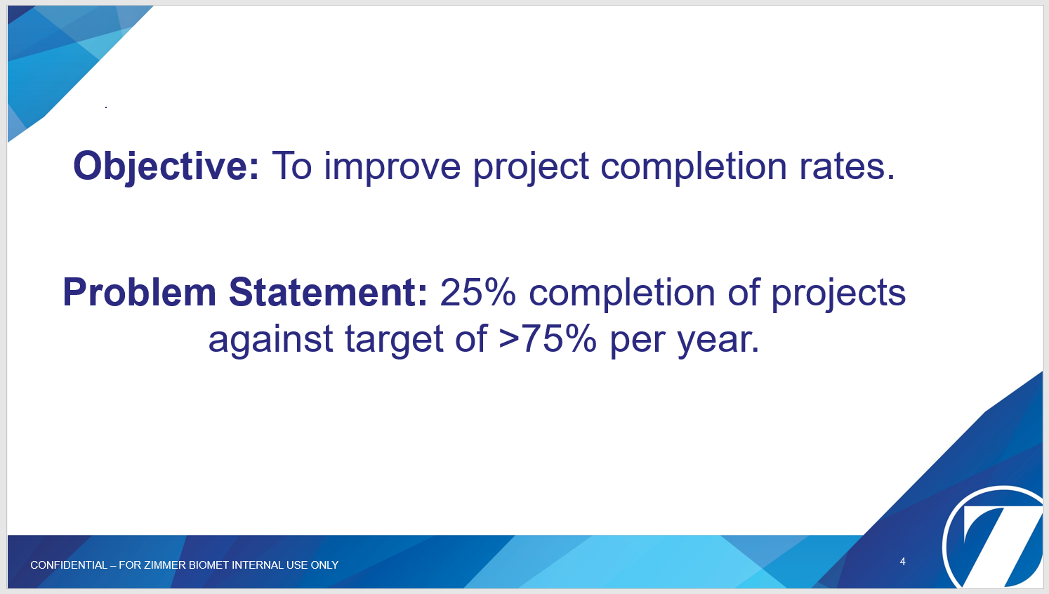

Workshop Team
The workshop team was selected for various reasons. Firstly, each team member possessed unique skills and knowledge that were essential for the success of the workshop. Additionally, the team consisted of individuals with a diverse range of experience levels, providing a mix of fresh perspectives and seasoned insights. Furthermore, each team member was assigned a specific role and responsibility that aligned with their expertise and experience, ensuring that the project ran efficiently and smoothly. The inclusion of graduate project engineers provided an opportunity for them to gain experience and develop their skills under the guidance of more experienced team members, while also offering fresh perspectives on how projects are run. Finally, the presence of a Continuous Improvement Manager as a facilitator ensured that the team used appropriate tools and techniques to optimise their work processes and outcomes, and to keep the brainstorming session focused on the right track.

Project Team Issues - Brainstorming & Evaluation
Meeting project deadlines is crucial to the success of any project. However, there are many factors that can cause delays, resulting in missed deadlines. The team conducted a brainstorming session to identify the reasons for missing project deadlines. Each engineer wrote their top 10 issues on post-it notes, and after reviewing them, the team grouped them into seven subgroups:
- Workload
- Subject Matter Experts (SME)
- Project Team Execution Structure
- Ownership
- Project Scope
- Project Management Office
They went through each subgroup to understand the issues, risks, root causes, and potential solutions for an improvement proposal. These are summarised below in Table 3 - Project Team Evaluation.

Table 4 - Project Team Evaluation
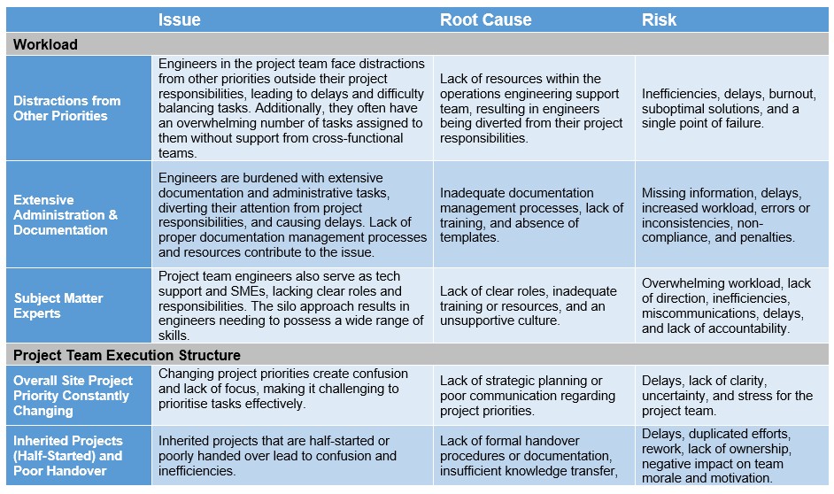
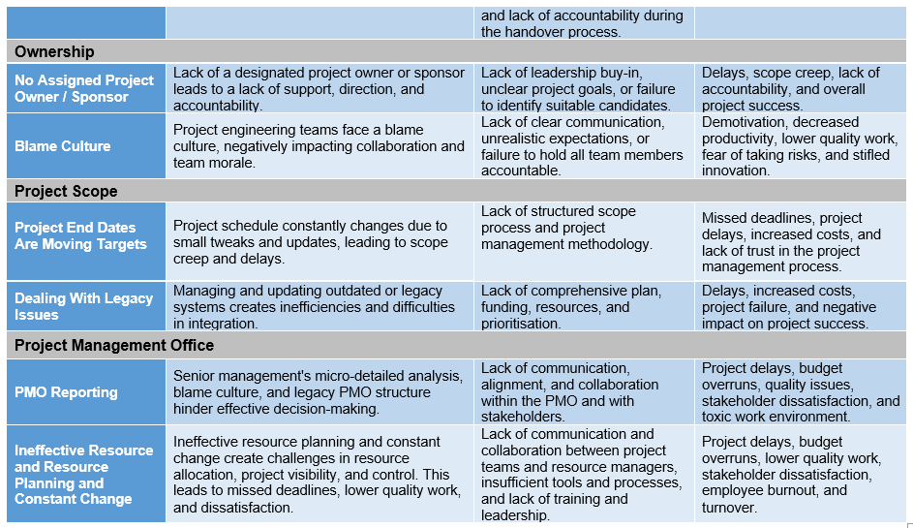

How Other Companies Run Projects?
To improve project management practices, it is important to examine how other companies organise and execute projects in various industries. One company known for its effective project management approach is Medtronic, a global healthcare company that develops medical devices and therapies for heart disease, diabetes, and neurological disorders (Medtronic, 2022).

Medtronic

Medtronic's project management approach is characterised by a focus on patient-centred innovation, quality, and collaboration. They place a high priority on understanding patient needs and designing products that meet those needs, while also adhering to strict quality standards (Medtronic, 2022).
Medtronic's project management structure is designed to ensure that projects are delivered on time, within budget, and with high quality standards (Medtronic, 2022). They employ several key techniques, including cross-functional teams, a stage-gate process, project management tools, and a strong focus on quality.
Cross-functional teams: consisting of individuals from different departments and areas of expertise to work on projects (Medtronic, 2022). This approach helps ensure that all aspects of a project are considered, and potential issues are identified early on.
Stage-gate process: for managing projects, breaking each project down into stages or phases, and evaluating progress and risks before moving to the next one (Medtronic, 2022). By using this process, Medtronic can identify and address any issues or risks early on, ensuring the project stays on track.
Project management tools: such as project charters, project plans, and risk management plans to ensure all aspects of the project are identified, tracked, and progress is reported regularly (Medtronic, 2022).
Quality: Medtronic places a strong emphasis on quality in their project management approach (Medtronic, 2022). They have a dedicated Quality function responsible for ensuring all projects adhere to strict quality standards, such as ISO 13485 and FDA regulations. This includes risk assessments, quality plans, and quality audits throughout the project lifecycle.


General Electric (GE)
Another example of a company is GE, their FastWorks methodology combines aspects of both agile and waterfall methodologies to create a hybrid approach that allows the company to manage projects efficiently while maintaining the flexibility needed to respond to changing requirements (General Electrics (GE), 2023).
Clear goals and objectives: Every project at GE start with clearly defined goals and objectives. This helps ensure that the project team is aligned on the project's purpose and understands what needs to be accomplished.
Cross-functional teams: GE uses cross-functional teams to manage projects, bringing together individuals from different departments and areas of expertise. This approach allows GE to tap into a wide range of knowledge and perspectives, ensuring that all aspects of the project are considered.
Iterative development: methodology emphasises iterative development, with small teams working in short sprints to deliver incremental progress. This approach allows the project team to respond quickly to changing requirements and adapt to new information as it becomes available.
Customer focus: approach places a strong emphasis on the customer, with customer feedback driving product development. This customer-centric approach ensures that the final product meets the needs and expectations of the target market.
Continuous improvement: The methodology also includes a continuous improvement process, with the project team reflecting on their progress at regular intervals and adjusting as needed. This helps ensure that the project stays on track and delivers the desired outcomes.

IBM

An example of a company that uses risk management in projects is IBM. IBM has a well-established project management framework that includes risk management as an integral part of the process (IBM, 2023) . Here are some details about how IBM approaches risk management in projects:
Risk identification: IBM begins by identifying possible risks that might have an impact on the project. Risks pertaining to the project's scope, plan, budget, and resources are included in this. To find possible hazards, IBM employs a range of strategies, such as risk assessment workshops and brainstorming sessions.
Assessment of risks: IBM evaluates the possibility and impact of hazards after they have been recognised. IBM utilises a risk matrix to classify hazards according to their seriousness and likelihood of happening. This enables the project team to rank risks and create effective mitigation plans.
Mitigation strategies: For each risk that is identified, IBM creates a mitigation strategy. The risk can be avoided, transferred, mitigated, or accepted using one of these ways. IBM makes ensuring that mitigation plans are realistic, doable, and affordable.
Monitoring and control: Throughout the project, IBM regularly assesses risks and changes its mitigation plans as necessary. To make sure risks are adequately managed and the project is moving forward, IBM also conducts periodic evaluations.

Project Management Improvement Proposal
Effective project management is essential for achieving success in any organisation. However, project evaluations have identified a critical problem with project management within our organisation. This issue has impacted our ability to deliver projects on time, within budget, and to the desired quality. Therefore, this proposal aims to put forward a solution to address this issue and improve project management within the organisation. By implementing a new project management structure, we aim to enhance the efficiency and effectiveness of our projects, leading to better outcomes for our organisation and our stakeholders.

New Project Team Structure
The adoption of a collaborative approach through the new project structure is a significant shift in project execution. This new structure will also help in improving points highlighted in the project management workshop. The framework has been designed to optimise project management by creating a new project leader role, responsible for overseeing either one significant project or two smaller projects Figure 23. With a clear reporting line, the project sponsor retains ownership of the project, while the project engineer is responsible for executing the technical aspects.
The creation of a resource team comprising of validation, operations, quality, and process engineers ensures that every project is handled by experts in the respective fields. This specialised approach will result in efficient project delivery and reduced turnaround time, making it possible to complete projects within a shorter timeframe.
The project leader's oversight is crucial in ensuring that every aspect of the project is managed effectively. They will take charge of all project documentation, from project initiation to closeout, and ensure that every step is executed in line with the project plan. This will not only result in a well-executed project but also reduce the chances of miscommunication and rework and facilitate a good handover process should a project lead or engineer leave the company as shown in the deficiency with the RO project.
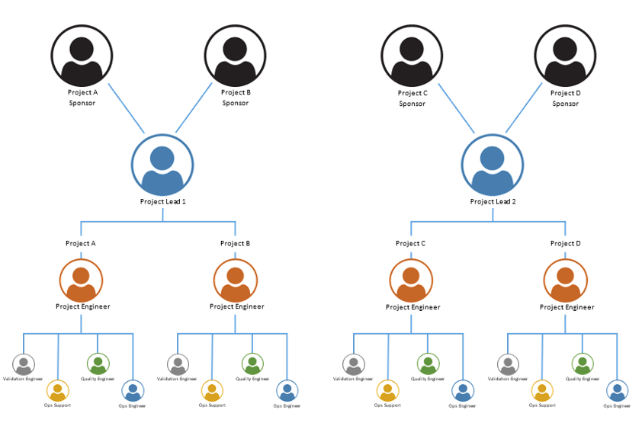
Figure 23 - Proposed Project Management Structure (see appendix 19.3)

Project Management Procedure (UKP038)
There are several ways in which procedure UKP038 can be improved regarding the ZB project management structure. The procedure is just high-level document that outlines the requirements of what a project entails but doesn’t give clear guidelines.
Project phases: the procedure defines each phase and what documents are required to be completed however it does not give detailed requirements for each phase. For example, there is no guideline on validation requirements, this could be improved by adding a checklist for each phase to ensure that all specific requirements and tasks associated with that phase have been considered/completed. Also adopted a Stage-gate process like Medtronic by evaluating progress and risks before moving to the next phase.
Clearer definition of roles and responsibilities: While the procedure outlines the roles and responsibilities of different members of the project team, there could be more clarity on specific duties and decision-making authority. This could be achieved by defining and communicating specific expectations for each role and ensuring that everyone involved understands their responsibilities but also ensuing the correct skill set is covered e.g., SME’s, technical writing.
Improved communication: The procedure emphasises the importance of communication but could provide more details on how communication will take place, what channels will be used, and what information will be shared. This could be achieved by establishing a communication plan that clearly outlines how and when information will be communicated to stakeholders.
Greater emphasis on risk management: Although the procedure mentions risk identification, there could be more emphasis on how risks will be managed throughout the project lifecycle. This could be achieved by following a similar framework to IBM, including a dedicated risk management plan that identifies potential risks, assesses their impact, and outlines mitigation strategies.
Project sponsor & Increased stakeholder involvement: The procedure could be improved by ensuring each project has an assigned project sponsor and involving stakeholders more actively throughout the project lifecycle. This could be achieved by conducting regular stakeholder meetings and ensuring that stakeholders are informed of project progress and any changes that may affect them.
More rigorous monitoring and evaluation: The procedure could be strengthened by including more rigorous monitoring and evaluation mechanisms to ensure that the project is on track and that progress is being made towards achieving project goals. This could be achieved by setting up regular checkpoints and reviews and establishing clear metrics for evaluating project performance

Implementation of New Project Management Methodology
Like GE, a hybrid methodology that combines the benefits of Agile and Waterfall approaches is gaining popularity since it enables a flexible and iterative approach to project management while still upholding the structure and discipline of Waterfall. According to (Cohn, 2006) the hybrid approach uses Agile technique for delivery and detailed planning while employing Waterfall method for high-level planning and scope defining. This strategy may lead to better teamwork, quicker delivery times, and greater customer satisfaction.
Therefore, it is recommended to introduce a hybrid Agile and Waterfall approach to the project team. Moreover, breaking down the project phases into smaller, more manageable components can help to achieve better outcomes. The following strategies can be employed to implement these recommendations.

Process Flow Guideline Improvements
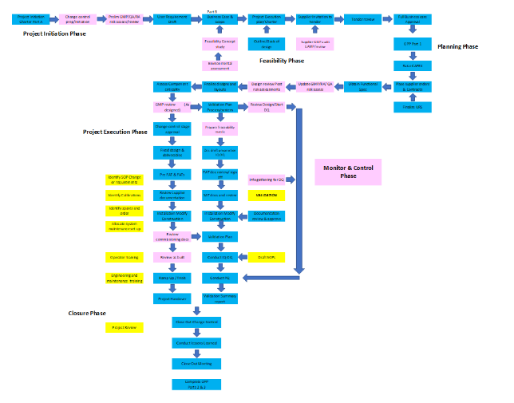
To improve the process flow detailed within procedure UKP038 and provide a more concise and comprehensive guideline for each phase, key improvements have been highlighted in pink Figure 24. The improved flow diagram not only outlines the various phases but also clearly defines the tasks involved at each stage. This structured framework will assist in effectively managing projects moving forward, starting from the initial charter and feasibility study, all the way through to the final closure and lessons learned. By following the improved guideline, all necessary steps and considerations will be diligently addressed throughout the entire project lifecycle, ensuring successful project outcomes.
Figure 24 - UKP038 Process Flow Guideline (see appendix 19.3)

Initiation Phase
The Project Charter A planning and documentation stages can initially be completed using the Waterfall method since it offers a planned and methodical approach to planning and documentation, ensuring that all important project components are rigorously evaluated and documented. This lays the groundwork for the project's later phases. This detects prospective requirements for the scope, schedule, and budget by introducing a new change control assessment. It also prevents cost overruns and delays. Additionally, it establishes a change management procedure with clear roles, standards, and a change control board. By lowering risks and issues, this promotes effective and efficient change management.

Preliminary GMP
Introducing a preliminary GMP (Good Manufacturing Practice) Quality Assurance and regulatory assessment in the project initiation phase is important because it helps to identify and address any potential regulatory or compliance issues early in the project. By conducting this assessment, the project team can identify any regulatory requirements that must be met and any potential compliance risks that may need to be mitigated. It will help to prevent costly delays and ensure that the project meets all necessary requirements and regulations. It also helps to establish a clear understanding of the regulatory landscape and any potential challenges that may need to be addressed throughout the project.

Feasibility
Agile methodology can be adopted for the feasibility assessment process. Introducing concept studies and environment assessment stages, enables continuous feedback and adjustment, reducing the risk of errors, and increasing accuracy.

Feasibility / Concept Study
A feasibility/concept study during this phase can be beneficial for many reasons. The purpose of a concept study is to determine the key objectives, requirements, and constraints of the project, and explore potential options for executing it. The study involves activities like market research, cost analysis, technical assessments, and stakeholder interviews to gather the necessary data and insights. The study typically results in a high-level plan or proposal that outlines the potential scope, schedule, budget, and risks of the project. It helps to determine the viability of the project by evaluating whether it is technically, economically, and legally feasible. It also helps to identify any potential risks and challenges that may need to be addressed before moving forward with the project ( Martinelli & Waddell, 2014) .
Some projects completed within the organisation can be impacted by various environmental factors. The addition of the environmental assessment is important in the project's feasibility phase as it helps identify potential environmental impacts and regulatory requirements. It also addresses stakeholder concerns related to the project's environmental impact.
Regulatory compliance is critical, as noncompliance with environmental standards can result in fines, legal challenges, and reputational harm. Another consideration is resource availability, since shortages, power outages, or supply chain interruptions might affect the availability and cost of natural resources needed for the project. The environmental impact is also important to consider, as potential air and water pollution, greenhouse gas emissions, and habitat destruction all have an influence on residents and ecosystems. Environmental impacts can also raise stakeholder concerns, including those from local communities, non-governmental groups, customers, and investors, potentially leading to reputational harm, legal challenges, or project delays or cancellations (Badiru, 2008).

Planning
The hybrid approach can also improve the planning phase. By breaking down the planning phase into smaller, more manageable pieces, the team can tackle it iteratively and adjust the plan as needed based on feedback and changing requirements. This approach also helps ensure that project requirements are well-defined, and that project scope is understood by all team members. For instance, the Waterfall methodology can be used to create a high-level project plan with milestones and deadlines, while Agile methodology can be employed to break down the project plan into smaller iterations and work on specific features. Regular meetings can be held to review progress and make necessary adjustments to the plan.

Improved Requirements Analysis
Many issues highlighted in the evaluation were due to management issues, but others were based on requirements not being clear initially. Analysis plays a significant role in various stages of the project lifecycle, especially in the planning phase. It helps in understanding the requirements, identifying potential risks and constraints, evaluating alternatives, and making informed decisions. Implementing a design review and improving the URS can improve the planning phase and address issues related to requirements issues.

Design Review
Before the project moves into execution, introducing a design review can assist by uncovering any design issues or areas that require improvement. In the long term, this can save time and money by avoiding costly design revisions during the execution phase. Introducing a design risk assessment into this phase can assist in identifying potential design risks and developing methods to mitigate or eliminate such risks. This can aid in completing the project safely and without problems. Post-review design qualifying involves ensuring that the design meets all the required standards and specifications. This can help ensure that the project is completed to the needed standards and that it can work properly.

User Requirement Specification
The URS holds significant importance as it serves as a comprehensive document that outlines the specific requirements and expectations for a product or system. It functions as a contractual agreement between users and the vendor / development team, ensuring that the final product aligns with the desired objectives. Moreover, the URS serves as a baseline document for vendors to provide accurate quotes and can also form the foundation for a Functional Requirements Specification during the design stage. By improving the URS process e.g., creating a template and procedure on how to perform a URS, the clarity of requirements can be significantly improved, addressing issues stemming from ambiguous or evolving requirements (Automated Production, 2023). To aid in this improvement, a URS used by Fisher Clinical Services can be a valuable resource and serve as a guideline, an extract can be found in appendix 19.6.

Execution
The hybrid approach may help ensure that the project stays on track during the execution phase by identifying defined milestones and goals that can be accomplished in short iterations. This strategy allows the team to focus on delivering value to stakeholders as quickly as feasible rather than spending too much time on a given task or feature.

Scrum Master
The team, for example, with the introduction of a project leader to the structure can step into the role of Scrum Master and adopt Agile practises by dividing the project tasks into small iterations, with each iteration concentrating on a different feature or functionality. Each iteration can include clear goals and milestones, such as completing the installation, testing, and deployment of a certain task. The team can then work on each iteration in short sprints, reviewing progress and adjusting the strategy as needed.
As a result, the hybrid approach enables the team to remain adaptable and agile while also ensuring that the project stays on track and offers value to stakeholders at every stage. Furthermore, the hybrid method aids in the early identification of any faults or blockages during the execution phase, allowing the team to take corrective measures and avoid delays or cost overruns.

Implementation of Monitor & Control Phase
The addition of the monitor and control phase is an important aspect of project management since it ensures that the project moves towards its goals. It involves regularly monitoring progress, finding deviations from the plan, and taking corrective actions to return the project to its original course. This phase also aids in the early identification of potential risks and concerns and the implementation of remedial actions to mitigate or eliminate them. This phase also includes regular reporting to stakeholders to keep them informed and enable informed decision-making.
The monitoring and control phase in the hybrid approach entails continual communication and collaboration among team members to ensure the project continues on track and issues are detected and addressed in a timely way. For example, if the project is running late, the project manager may increase team resources or change the project timeframe. Similarly, if the project goes over budget, the project manager might cut spending or change the scope of the project.
The hybrid approach lets the team stay focused on the project objectives by breaking it down into shorter iterations. It also ensures that any changes to the project plan are well-considered and in line with the overall project goals. This ensures that the project is completed on schedule and within budget, and that all specifications and quality standards are met.

Improved Metrics Reporting
To improve metrics and reporting in addition to the status report, a comprehensive approach is being implemented based on actions from the workshop. One key aspect is the development of a summary report that tracks the progress of each project engineer, encompassing both project-related tasks any day-to-day responsibilities. This report will enable the project manager to gain a holistic view of the engineers' workload, facilitating resource allocation adjustments and potential timeline modifications if needed. Additionally, it will provide insights into the number of active and closed projects, offering a snapshot of the project portfolio.
During the workshop, document approval emerged as an identified challenge. To address this issue, the monitoring of document approval processes will be integrated into the reporting framework. By tracking document approval timelines, bottlenecks can be identified and addressed promptly, ensuring smoother project progression. Moreover, the reporting system will capture task completion rates and project financials allowing for a comprehensive assessment of the team's productivity and identifying any areas that require additional support or improvement.
To ensure accurate and up-to-date data, project engineers will input their progress and relevant information into the reporting system monthly. This regular data input will enable the project manager to maintain real-time visibility into project status and make informed decisions based on the most current information available. Ultimately, this comprehensive reporting approach aims to improve project metrics, enhance communication, and enable effective project management practices Figure 25.
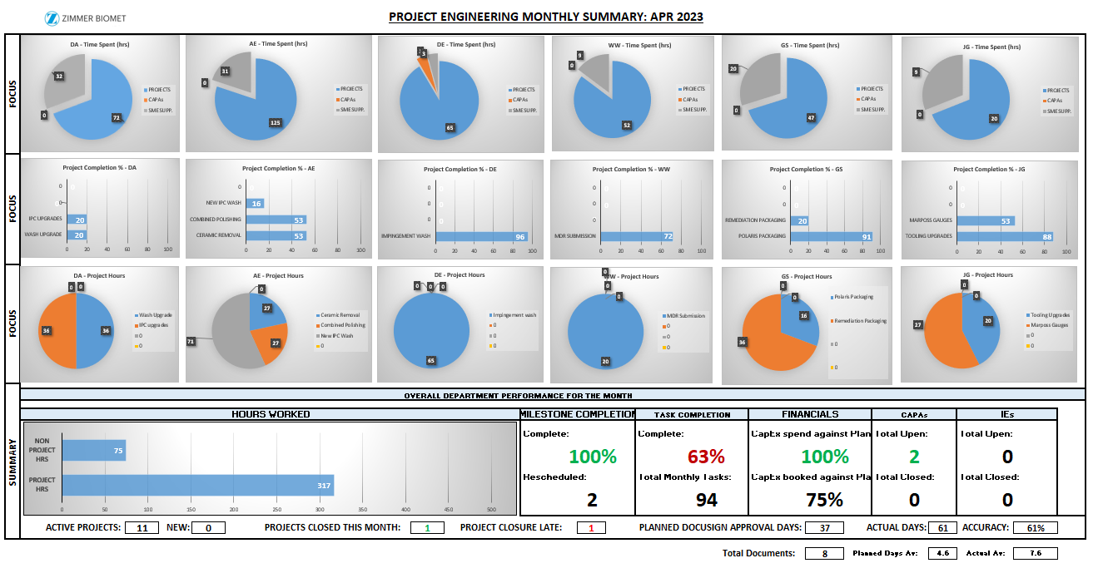
Figure 25 - Project Engineering Monthly Summary Reporting (see appendix 19.4)

Closure Improvement
Using the hybrid approach, during the closure phase, apart from analysing the project's performance and capturing lessons learned, regular meetings are held with stakeholders to review project progress and gather feedback. These meetings provide an opportunity to address any concerns, ensure alignment with stakeholder expectations, and make necessary adjustments before the project is launched.
For example, to improve handovers, engaging key production stakeholders, such as operations team, right form the initiation phase will encourage their active participation and ownership in the project, ensuring their perspectives and requirements are considered throughout the project lifecycle. Another improvement is to facilitate knowledge sharing sessions or training workshops between the project team and production team. Provide the production team with the necessary documentation, guidelines, and resources to effectively operate and maintain the delivered project. This will encourage a culture of knowledge transfer and ensure that relevant expertise is shared across teams.
To improve lessons learned, the project team can follow a structured approach during the retrospective meetings. For example, gathering data from the sprints or iterations that have been completed. Collect data and feedback from all stakeholders regarding what worked well and what challenges were faced. This can include aspects like communication, collaboration or technical issues then analyse the collected data to identify patterns, trends, and key insights. These lessons learned will be shared among the team and wider audience within the company.

Improved Project Performance Analysis
To enhance the measurement of projects during the closure phase and ensure alignment with the company’s strategic goals, it is also important to focus on all aspects of value-added elements. This can involve evaluating not only the project's adherence to budget and timeline but also its impact on various key areas. By considering factors such as, stakeholder engagement, quality improvements, risk mitigation, cost savings, health and safety and sustainability improvements, the organisation can obtain a comprehensive understanding of the project's value and its contribution to strategic objectives.

Project Management Skills
While implementing improvements in project management methodologies such as Agile and Waterfall can be beneficial, it's important to acknowledge that a one-size-fits-all approach may not be suitable for every project. A competent project management team understands the significance of considering and adapting delivery methods based on the specific objectives of each project. Therefore, a major challenge lies in acquiring the necessary skills and knowledge within the organisation to effectively utilise these methodologies.
One approach to address this challenge is through comprehensive training programs that focus on Agile, PRINCE 2, and other relevant courses. While training can be a valuable opportunity to upskill the project management team, it's essential to recognises that it may involve associated costs. To mitigate this, it would be beneficial to benchmark training options and explore cost-effective alternatives, such as online courses or workshops, that still provide valuable learning experiences.
Additionally, reaching out to sister sites within the organisation or other companies in the industry can offer valuable insights and knowledge sharing opportunities. By establishing communication and collaboration channels with these entities, project teams can exchange best practices, lessons learned, and gain practical advice on implementing Agile and Waterfall methodologies. This networking approach can prove to be cost-effective and provide a broader perspective on project management practices.

Change Management
To successfully adopt these improvements, it is important to consider change management, as highlighted in the study by (El Amrani, et al., 2018). ( Hiatt & Creasey, 2012) emphasise the importance of a structured approach to address challenges and resistance during the transition, including strong leadership support, clear communication, stakeholder engagement, and early employee involvement.
To drive adoption and address concerns, it is beneficial to have the project team serve as change agents. These individuals can play a vital role by advocating for the change, offering guidance, support, and sharing success stories to inspire confidence and enthusiasm among team members and stakeholders.
Regular communication and feedback loops are essential for maintaining transparency and addressing any resistance or misconceptions that may arise. Actively listening to the concerns and ideas of the team and stakeholders enables the project team to make necessary adjustments and provide the required support to overcome challenges.

Conclusion
This report offers an in-depth analysis of project management practices at ZB, along with practical solutions to improve project outcomes and organisational effectiveness. Key challenges faced by ZB are identified, including inconsistencies in project execution, inefficient resource allocation, communication and collaboration issues, and limited use of project metrics and reporting. To address these challenges, several solutions are proposed.
The report provides an overview of project management concepts, such as the phases of project management and the Agile and Waterfall methodologies. It highlights the significance of project metrics and reporting in tracking progress, identifying risks, and facilitating informed decisions. Furthermore, the project management structure at ZB is analysed, including the project management process, team composition, and the role of the Project Management Office (PMO). The report outlines the four phases of the project management process: feasibility, planning, execution, and closure, emphasising the importance of project metrics and reporting within ZB's project management practices.
Moreover, a project analysis of a specific project at ZB is conducted, evaluating its achievements, challenges, and return on investment. Factors contributing to delays, budget overspend, and quality issues are identified, such as inadequate resource allocation, lack of expertise, incomplete documentation, and scope creep. Despite these challenges, the project successfully achieved its functional objectives, generated additional profit, and improved water quality and scrap rates.
Additionally, a project management analysis workshop conducted by the engineering project team at ZB is described. The workshop aimed to identify issues, assess the root causes of missed project deadlines, and propose potential actions to improve completion rates. The workshop team comprised individuals with diverse skills and experience levels, ensuring a well-rounded mix of perspectives and expertise.
The report also provides insights into project management practices at other companies, including Medtronic, General Electric (GE), and IBM. These companies prioritize patient-centred innovation, quality, collaboration, and risk management in their project management approaches.
Based on the analysis and insights gained, a project management improvement proposal is presented for ZB. The proposal suggests implementing a new project team structure, improving project management procedures, and adopting a hybrid Agile and Waterfall approach to project management.
Overall, implementing the proposed improvements and incorporating best practices from other companies can enhance ZB's project management practices, overcome challenges, and achieve better project outcomes. This will contribute to the overall success and growth of the organisation.

Recommendations

Immediate Recommendations
- Implement the new project team structure with clear roles and responsibilities.
- Review and prioritise current projects and re-allocate resource.
- Enhance communication by establishing a communication plan and defining channels and information to be shared.
- Conduct regular stakeholder meetings and involve stakeholders actively throughout the project lifecycle.
- Improve the clarity of project phases and requirements by adding checklists and detailed guidelines to the project management procedure.
- Emphasise risk management by including a dedicated risk management plan.

Short-term Recommendations
- Introduce a hybrid Agile and Waterfall approach to project management.
- Break down project phases into smaller, manageable components for better outcomes.
- Conduct design reviews to identify and address potential design issues early on.
- Improve the User Requirement Specification (URS) process to ensure clear requirements.
- Implement a monitor and control phase to track progress, detect deviations, and take corrective actions.

Long-term Recommendations
- Continue using the hybrid project management methodology for flexibility and structure.
- Implement process flow improvements to provide a comprehensive guideline for each phase.
- Enhance the planning phase by breaking it down into smaller iterations and adjusting the plan based on feedback.
- Strengthen requirements analysis by implementing design reviews and improving the URS.
- Improve metrics reporting to track progress, workload, document approvals, task completion rates, and project financials.
- Focus on closure improvement by engaging production stakeholders early on, facilitating knowledge sharing sessions, and conducting structured retrospective meetings for lessons learned.

References
Camp, R. C., 2006. Benchmarking: The Search for Industry Best Practices that Lead to Superior Performance. 1st ed. s.l.:Productivity Press.
Hiatt, J. M. & Creasey, T. J., 2012. Change Management: The People Side of Change. s.l.:Prosci Research.
Martinelli, R. & Waddell, J. M., 2014. Feasibility Studies for Projects: A Guide for Project Managers. s.l.:Project Management Institute.
Agile Alliance, 2023. History: The Agile Manifesto. [Online]
Available at: https://agilemanifesto.org/history.html
Anderson, D. J., 2010. Kanban: Successful evolutionary change for your technology business. s.l.:Blue Hole Press.
Automated Production, 2023. What is a URS? Why is it Important?. [Online]
Available at: https://www.automatedproduction.co.uk/what-is-a-urs-why-is-it-important/#:~:text=The%20specification%20is%20used%20to,within%20the%20scope%20of%20supply.
[Accessed 10 May 2023].
Babu, G. M., Gupta, M. & Ramesh, A., 2012. Identification and analysis of risks in waterfall software development model. Procedia Engineering, Volume 30, pp. 661-668.
Badiru, A. B., 2008. Project Management in Manufacturing and High Technology Operations. 1nd ed. s.l.:Wiley-Interscience.
Bannerman, P. L., Moffat, J, J. & Michel, R., 2018. Wagile: A hybrid project management methodology. Journal of Systems and Software, Volume 139, pp. 62-77.
Bansal, S. P., 2007. Risk management in construction projects. Journal of Construction Engineering and Management, vol. 133, pp. 106-116.
Boehm, B., 1988. A spiral model of software development and enhancement. IEEE Computer, pp. 61-72.
Boehm, B. & Turner, R., 2005. Management challenges to implementing agile processes in traditional development organizations. IEEE Software, pp. 30-39.
Cohn, M., 2005. Agile Estimating and Planning (Robert C. Martin Series). 1st ed. s.l.:Prentice Hall.
Cohn, M., 2006. Agile estimating and planning.. s.l.:Prentice Hall Professional.
Conforto, E. C., Amaral, D. C. & Silva, S. L. D., 2014. Can agile project management be adopted by industries other than software development?. Project Management Journa, 45(3), pp. 21-34.
El Amrani, L., Almeida, J. P., Santos, M. Y. & Santana, M. A., 2018. Agile methodologies in healthcare: a case study of an emergency department. Journal of Medical Systems, 42(3), p. 42.
European Pharmacopoeia, 2021. Bacterial Endotoxins. s.l.:European Pharmacopoeia.
General Electrics (GE), 2023. FastWorks. [Online]
Available at: https://www.ge.com/news/reports/tag/fastworks
[Accessed 21 Feb 2023].
Ghasemzadeh, F., Archer, N. P. & Iyogun, P., 2012. A framework for project success evaluation. Journal of Applied Project Management, 1(1), pp. 5-14.
Gillenson, M. L. & Hwang, M. I., 1995. A systems approach to project management. 8 ed. s.l.:John Wiley & Sons.
Goodman, S. B., 2007. Wear Particles, Periprosthetic Osteolysis and the Immune System. Biomaterials, 28 , p. 5044–5048.
Gupta, A. & Gupta, D., 2015. Application of Ishikawa diagram in a manufacturing process: A case study. International Journal of Research in Engineering and Technology, 4(6), pp. 275-281.
Heagney, J., 2018. Fundamentals of project management 5th Edition. s.l.:American Management Association.
Highsmith, J., 2001. Agile software development ecosystems. s.l.: Addison-Wesley Professiona.
IBM, 2023. What is risk management?. [Online]
Available at: https://www.ibm.com/topics/risk-management
[Accessed 6 April 2023].
International Organization for Standardization , 2018. ISO 45001:2018 - Occupational health and safety management systems. [Online]
Available at: https://www.iso.org/standard/63787.html
[Accessed 13 May 2023].
International Organization for Standardization, 2023. ISO 13485:2016 Medical devices — Quality management systems — Requirements for regulatory purposes. [Online]
Available at: https://www.iso.org/standard/59752.html
Kendall, K. E. & Kendall, J. E., 2006. Systems analysis and design. 11 ed. s.l.:Pearson.
Kerzner, H., 2013. Project Management: A Systems Approach to Planning, Scheduling, and Controlling (11th edition). s.l.:John Wiley & Sons .
Kettunen, P., Kujala, J. & Lehtola, L., 2017. Agile and stage-gate hybrid model for managing new product development. Journal of Engineering and Technology Management, Volume 45, pp. 44-58.
Larman, C. & Basili, V. R., 2003. Iterative and incremental developments: A brief history. IEEE Computer, pp. 47-56..
Lübbeke, A. &. S. R., 2013. Predictors of aseptic loosening in total hip arthroplasty. EFORT Open Reviews, Volume 1, pp. 339-344.
Medtronic, 2022. About Medtronic. [Online]
Available at: https://www.medtronic.com/us-en/about.html
[Accessed 20 Feb 2023].
Medtronic, 2022. Our Approach to Innovation. [Online]
Available at: https://www.medtronic.com/us-en/about/innovation.html
[Accessed 20 Feb 2023].
Medtronic, 2022. Project Management. [Online]
Available at: https://www.medtronic.com/us-en/about/leadership/project-management.html
[Accessed 20 Feb 2023].
Medtronic, 2022. Quality and Regulatory Compliance. [Online]
Available at: https://www.medtronic.com/us-en/about/quality-regulatory-compliance.html
[Accessed 20 Feb 2023].
Medtronic, 2022. Stage-Gate Process. [Online]
Available at: https://www.medtronic.com/us-en/about/leadership/stage-gate-process.html
[Accessed 20 Feb 2023].
Mulder, M., 1996. Basic Principles of Membrane Technology. 2nd ed. s.l.:Springer.
Müller, R. & Händel, M., 2020. When agile methods encounter regulatory requirements: an exploratory study. Journal of Systems and Software, Volume 161.
Poppendieck, M. &. P. T. (. L. s. d. A. a. t., 2003. Lean software development: An agile toolkit. s.l.: Addison-Wesley Professional.
Project Management Institute, 2017. A guide to the Project Management Body of Knowledge (PMBOK guide). s.l.:Project Management Institute.
Project Management Institute, 2023. What is Project Management?. [Online]
Available at: https://www.pmi.org/about/learn-about-pmi/what-is-project-management
Rajan, S. S. R., 2004. Engineering project management: A systematic approach. International Journal of Project Management, vol. 22, pp. 141-149.
Royce, W. W., 1970. Managing the development of large software systems: Concepts and techniques.. IEEE WESCON, pp. 1-9.
Salleh, M. R., Abdullah , R. & Adnan, M. A., 2015. Salleh, The cause and effect (fishbone) diagram for identifying potential factors causing delays in Malaysian construction projects. Journal of Advanced Review on Scientific Research, 8(1), pp. 1-7.
Schwaber, K., 2004. Agile project management with Scrum. s.l.:Microsoft Press.
Serrador, P. & Pinto, J. K., 2018. Does Agile work? - A quantitative analysis of agile project success.. International Journal of Project Management, 36(1), pp. 117-126.
Sutherland, j. & Schwaber, K., 2011. The scrum guide.. s.l.:Scrum.org.
Tuman, G., 1983. Development and implementation of effective project management information and control systems. New York: Van Nostrand Reinhold Co.
Turner, J. R. & Muller, R. A., 2017. "he project manager's leadership style as a success factor on projects: A literature review. Project Management Journal, vol. 48, pp. 49-61.
Ugo Ihekweazu, MD, FAAOS, 2023. What are hip replacement implants made of?. [Online]
Available at: https://www.uiorthomd.com/blog/what-are-hip-replacement-implants-made-of
United States Pharmacopeia, 2009. <1231> Water for pharmaceutical purposes. s.l.:United States Pharmacopeia.
United States Pharmacopeia, 2009. <643> Total Organic Carbon. s.l.:United States Pharmacopeia.
United States Pharmacopeia, 2009. <645> Water Conductivity. s.l.:United States Pharmacopeia.
United States Pharmacopeia, 2009. <85> Bacterial endotoxins Test. s.l.:United States Pharmacopeia.
Your Europe, 2023. CE marking. [Online]
Available at: https://europa.eu/youreurope/business/product-requirements/labels-markings/ce-marking/index_en.htm#:~:text=CE%20marking%20indicates%20that%20a,then%20marketed%20in%20the%20EU.
[Accessed 14 May 2023].
Zimmer Biomet UK, 2021. Project Charter A Rev 2. s.l.:Zimmer Biomet.
Zimmer Biomet, 2021. UKP038 Operation Project Planning Procedure Revision 11. Bridgend: Zimmer Biomet.
Zimmer Biomet, 2022. Project Charter B Rev 3. s.l.:Zimmer Biomet.

Appendices

Project Status Report

Proposed Project Management Structure

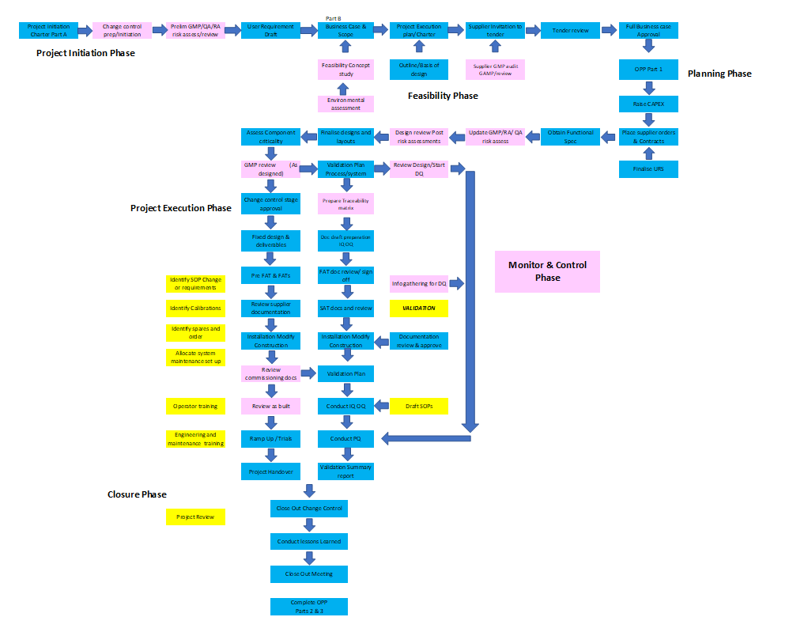
Improved Process Flow

Project Engineering Monthly Summary Reporting

RACI Chart
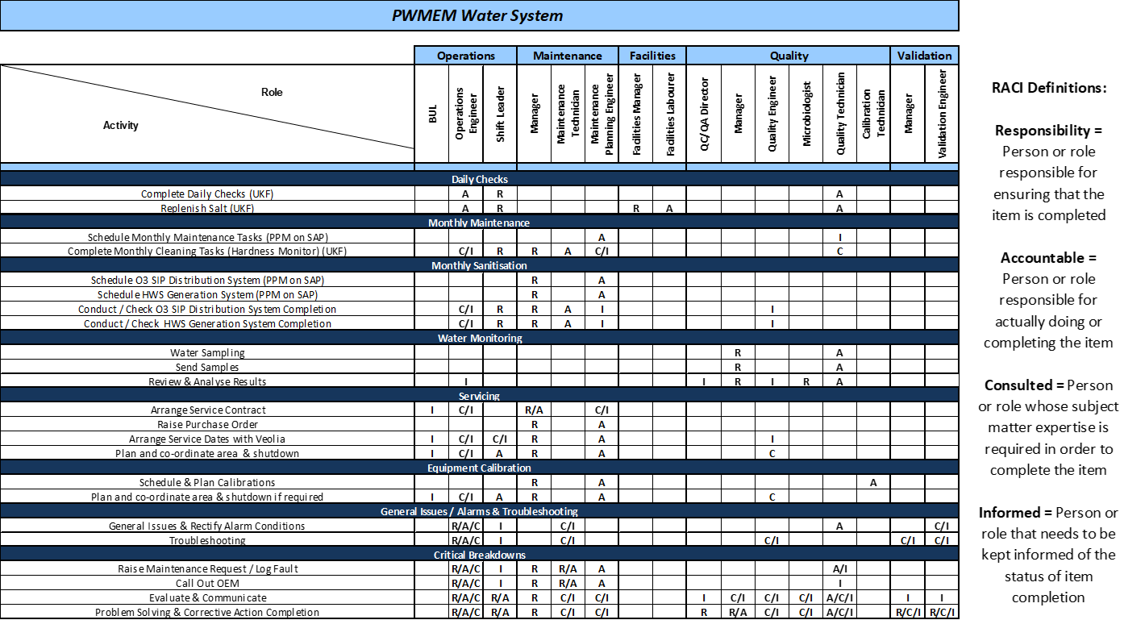

Fisher Clinical URS

