PSYCHOLOGY

CASE STUDY – MASON KABEE



Name: Natalie Tully
Student Number: 2025743
Module code: BMSW4003_BIRM
Lectures Name: Rebecca Kavanagh

Contents Page
Introduction 3
Case Analysis 3
Social identity theory (SIT) 3
What is social identity? 3
How do these link to the mason case study? 5
Theory of Planned Behaviour (TPB) 6
How do these link to the mason case study? 7
The frustration-aggression hypothesis. 8
Conclusion 9
References 10

Introduction
This report will explore and be using psychological theories, which will help to assist a team in understanding the likely explanation of Mason's behaviour. This will aid the team in developing Mason’s support strategy in the following weeks, will also use the following theories in my report: Social identity theory, Theory of Planned Behaviours, and hypothesis of frustration-aggression, as well as how these theories could apply to Mason's actions and behaviour in the case study.

Case Analysis
When reading mason’s case study, I can see some important factors to consider and look more closely in-depth. The main factors are no family supportive network, young age, association with society peers that commit crimes, this can be because of poor social learning and learned behaviours patterns from early childhood and difficult upbringing. Social learning theory looks at the individual learning process, the formation of self, and the influence of society in socializing individuals. Individuals learn to engage in crime through three factors, according to social learning theory: differential reinforcement, beliefs, and modeling. (Crossman, 2019)

Social identity theory (SIT)
This theory was developed by (Tajfel, 1978; Tajfel & Turner, 1979) devoted themselves to researching prejudice and discrimination. As its states, From the concept of Social Identity we get our self-esteem from the groups we belong to. Which helps us build a bond over similarities and beliefs.

What is social identity?
Is a person’s identity as a sense of who they are based on their group membership(s) like belonging to a group like a football team, sense of belonging to clarify as one source of pride and self-esteem, being part of a group can influence the way you think and feel, also increase our self-image by discriminating and holding prejudice views against the out-groups, (the group we don’t t belong to) for example, different football group. Social identities are most influential when individuals consider membership in a particular group to be central to their self-concept and they feel strong emotional ties to the group. (Vinney, 2018)
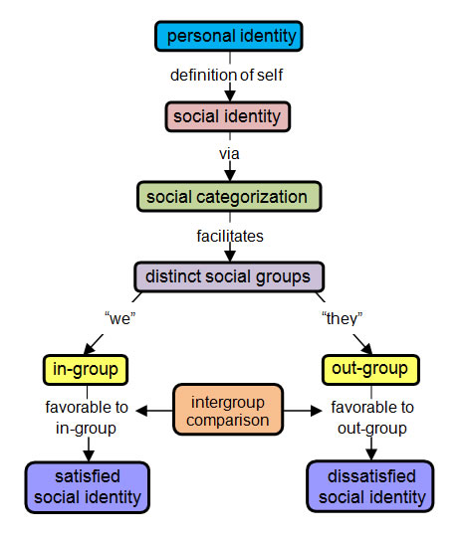
Figure 1 diagram to show the different stages of personal identity

Social identity theory groups in 3 stages
Social identity theory specifies three mental processes individuals go through to make in-group/out-group classifications
Social categorisation. This is seeing yourself as part of a group as well as a personal identity that becomes your ingroup. Everyone has a social identity group they are a part of, belonging could be basic on gender, social class, religion, school, or friends.
Social identification When you established your social identity when everyone you meet will be part of your ingroup people who share the same social identity, or people who will be in the outgroup. You will start to pay more attention to your ingroup and adopt each other values and attitudes appearance and behaviour.
Social comparison This is viewing your social identity and ingroup better than the other outgroup, this can lead to prejudice and discrimination, as it could influence the outgroup.

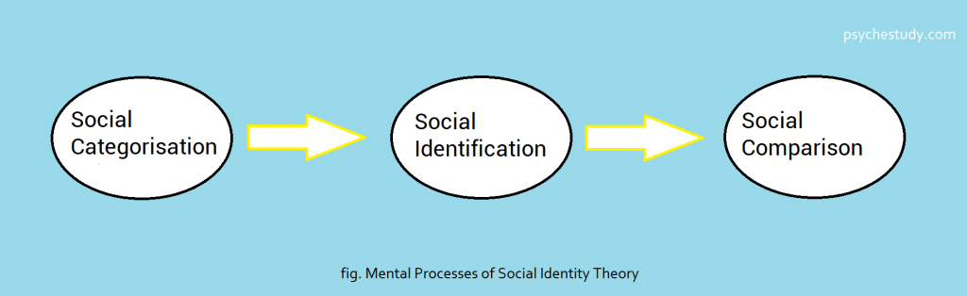
Figure 2 diagram to show 3 stages of social identity

How do these link to the mason case study?
After looking into the theories and reading the case study which can review that mason from a young age and did not have much family network around him, I feel mason has not experienced or formed positive role models throughout his life, which I assume that he didn’t have much self-belief in himself, which lead to forming a group setting with his peers which probably was from the same backgrounds and beliefs, having the same simulates I think mason feel a sense of belonging, which was influential the choices and actions he made committing the criminal sentence for possession of drugs with intent to supply, which also lead to him dropping out of college, I feel he had the support in prison to access positives groups to rehabilitate into the community into a college course to better himself, but the sense of loyally, belonging and strong emotional ties to his peer group draw him back within his group. This is important as it shapes people's social identity within groups, and social identity, in turn, influences attitudes, values, and behaviors which also links mason behaviors into a group belonging to crime, (Charness and Chen, 2020)

Theory of Planned Behaviour (TPB)
The theory of planned behavior (TPB) is a psychology theory that explains how ideas influence behavior. According to the idea, an individual's behavioral intentions are shaped by three basic components: attitude, subjective norms, and perceived behavioral control. The most proximal predictor of human social conduct, according to TPB, is behavioral intention. (Wikipedia Contributors, 2019) Icek Ajzen (1991) created the theory to increase the theory of reasoned action's predictive effectiveness by incorporating felt behavioural control. It has been used in research on the relationships between beliefs, attitudes, and behavioural intentions.
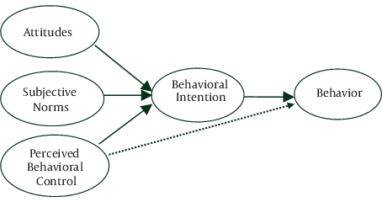
Figure 3 diagram to show 3 components of planned behaviour.

Attitude towards performing the behavior is the person's view of the behaviour’s consequence and its attractiveness.
Perceived subjective norms - the person’s perception of how relevant others would see the behaviour, how normal the behaviour is within a particular reference group, and what sort of expectation others would have for the individual to complete the behaviour.
Perceived control over the behaviour and perceived power how difficult the individual thinks the behaviour will be, how well they feel they will be able to perform the behaviour, and how much control they believe they have over the desired behaviour (Brookes, 2021)

How do these link to the mason case study?
This links to the case study as Mason was displaying his intentions to the parole board by behaving in a suitable and friendly manner. Before leaving prison, Mason accepted an opportunity to train as an apprentice at a nearby college, but after leaving custody, his behaviour altered by not attending college, and he was spotted with a previous acquaintance who was known to the police. In my opinion, I feel mason was influenced by a set procedure within the prison service to interact and follow guidelines supported by probation for his early release from prison. This is a form of planned intent behaviour, as mason understood what was expected of him but also the opportune for change for him to better himself on return to his home area Mason integrated back into the group setting of learned behaviour with known associates this is an example of subjective of norms as he feels that society see his in-group in a certain way and feels that society stereotype him for being part in-group which is involved around crime. which means there was less chance of any opportunities for Mason to achieve his goal. this is backed by. (law.jrank.org, n.d.) that states: Juveniles learn to commit crimes in the same way they learn to comply with social norms: through association with or exposure to others, according to social learning theory. Primary or personal groups, such as family and peers, have a particularly strong influence on what we learn.

The frustration-aggression hypothesis.
Aggression is caused by frustration, according to the frustration-aggression theory. Any occurrence or stimulus that stops an individual from achieving a goal, as well as the associated reinforcing quality, is referred to as frustration. (Dollard & Miller, 1939).
tFrustration is when something prevents a person from achieving their goal or aim.
Aggression is action from the cause of the interference
Displacement occurs when the source of the frustration is perceived as unapproachable, and another target becomes available

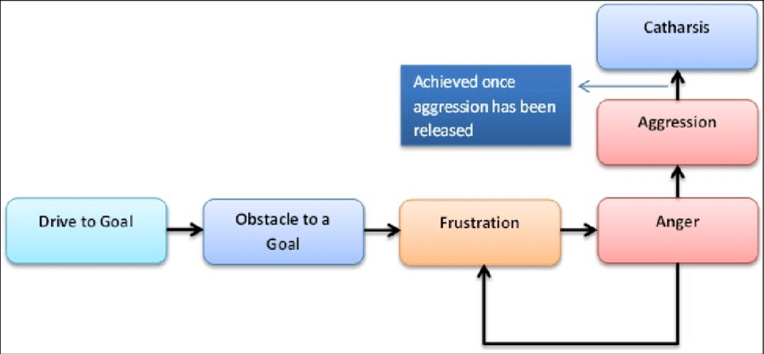
Figure 4 diagram to show the factors of FRH
They are many theories of aggression
Berkowitz (1969) argued that frustration alone was not enough to cause aggression. The aggressive cues theory states that contextual and situational factors come into play. Frustration may lead to aggression and a propensity to be aggressive, but the aggressive act is only committed if there are socially acceptable cues.

How do these link to the mason case study?
As stated in Mason’s case study When approached by the team during a probation visit Mason became verbally aggressive and stormed out of the meeting, in my opinion, I think he reacted aggressively, as he knew they would be approaching him about not attending college, which resulted in Mason putting up his guard and become unapproachable, according to the frustration-aggression hypothesis. Mason would have become frustrated before the meeting knowing he would be asked about college and interaction with his peers who are known to the police, I feel he would have felt threatened and not understood by the probation team as he would have lots of emotions from past experiences which lead him to become aggressive and scared of going back to prison. From past experiences and learned behaviours, I would assume that frustration and acting aggressively are how he used to communicate with individuals outside his group.

Conclusion
To summaries, an overall picture of the case study into Mason’s change of behaviours and how best to understand why things changed for Mason is to understand his background and beliefs, to help form better bonds within the system and out-groups to find common ground for him to relate, to understand the connection and the sense of belonging he has with former associates. considering that by learned behavouir mason could have developed an accidental identity because of past experiences during his childhood rather than a true sense of who he is to fit in or feel a sense of belonging, if this is the case could Mason be supported to change his sense of Identity? Be more aware of positives role models that relate to Mason to encourage change and promote a better outlook and opportunities. When we understand how these theories relate to Mason’s case study, we can understand why mason’s behaviours changed after coming out of prison. (Psychology Today, 2017)

References

Brookes, E. (2021). The Theory of Planned Behavior - Simply Psychology. [online] www.simplypsychology.org. Available at: https://www.simplypsychology.org/theory-of-planned-behavior.html.
‌
Crossman, A. (2019). How Social Learning Theory Explains Society’s Effect on Identity. [online] ThoughtCo. Available at: https://www.thoughtco.com/social-learning-theory-definition-3026629#:~:text=%20What%20Is%20Social%20Learning%20Theory%3F%20%201.

Charness, G. and Chen, Y. (2020). Social Identity, Group Behavior, and Teams. Annual Review of Economics, 12(1), pp.691–713.
‌ Dollard, J., Miller, N. E., Doob, L. W., Mowrer, O. H., & Sears, R. R. (1939). Frustration and aggression.
law.jrank.org. (n.d.). Crime Causation: Sociological Theories - Social Learning Theory. [online] Available at: https://law.jrank.org/pages/815/Crime-Causation-Sociological-Theories-Social-learning-theory.html#:~:text=According%20to%20social%20learning%20theory [Accessed 5 Apr. 2022].
Wikipedia Contributors (2019). Theory of planned behavior. [online] Wikipedia. Available at: https://en.wikipedia.org/wiki/Theory_of_planned_behavior.

Psychology Today. (2017). Changing Your Sense of Identity. [online] Available at: https://www.psychologytoday.com/us/blog/compassion-matters/201712/changing-your-sense-identity.

Vinney, C. (2018). Social Identity Theory and the Cognitive Processes Behind In-Group Favoritism. [online] ThoughtCo. Available at: https://www.thoughtco.com/social-identity-theory-4174315.
‌

