Task 2 :Reflection

In 1988 an American Sociologist and Psychologist Graham Gibbs published the Reflective Cycle to encourage people to reflect on an experience, so they learn and progress by understanding the need for reflection.
“Gibbs reflective cycle is arguably one of the most famous models of reflection leading you through different stages to make sense of an experience.” (The University of Edinburgh, 2019)
By referencing the Gibbs reflection cycle, I am going to be reflecting on our Poster and speaker notes whilst reflecting on my experiences as part of a team.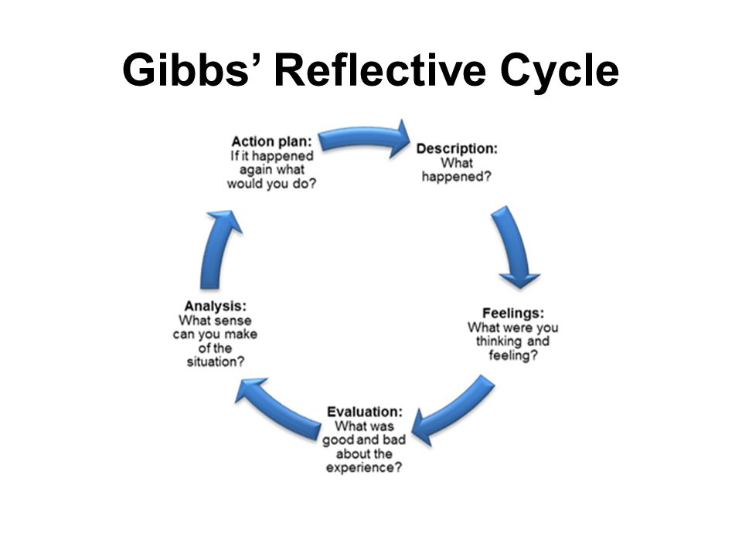(Slideplayer.com, 2019)
Description
After starting on my module Developing Workplace Critical Thinking and meeting our lecturer Shehla Khan it was decided that the class would need to be split into groups of 4-5 (our own choice) for the purpose of completing our assignments. I decide to join groups with a few other students who had completed level 4 with me the previous year.
“More hands make for lighter work.” “Two heads are better than one.” “The more the merrier.” “These adages speak to the potential groups have to be more productive, creative, and motivated than individuals on their own.” (University, 2019)
Taslima, Haslima, Kamil, and Malgorzata. Once our groups were decided we were then given our assignment which was split into 3 tasks. Task 1 was a group effort where we were to design a poster and critically assess the values, attitudes and beliefs of an organisation. Task 2 was a reflection on Task 1 and task 3 is a formal Report.
For task 1 and the poster competition we got together in class and decided to base our poster around the attitudes beliefs and values that Marks, and Spencer’s promote using various critical thinking models. We were going to design the poster using the concept of a jigsaw “puzzle piece”. Each one of us was going to answer our questions and display them onto a jigsaw piece and when all pieces connected, we would create a finished poster. For my part of the poster I was tasked with researching M&S history and finding 3 values that they are passionate about. The values chosen were
- Suggest to Steve
- Marks and Start
- Smarter Working the M&S way.
The value I was going to critically assess was Suggest to Steve using the RED Model. “Critical thinking can be taught and should be a priority in leadership and government organisations whether big or small critical thinking can help leaders with old assumptions and use different approaches in today’s realities.” (davis, 2013)
Feelings
When doing this assignment, it was quite interesting to learn more about M&S and how much they have grown since the first Penny Bazaar opened in Leeds 1884.I also learned a lot about what the company does for the community etc through learning and researching their values and how much they help and support others. I found researching M&S quite easy and writing my notes was plain sailing however the same could not be said about designing my “PUZZLE PIECE”.I was totally blind and struggling with this as there was no contact from our group we were just given a piece of card in the shape of a jigsaw piece and left to our own devices. This was very frustrating for me as we were meant to be a group but there was no communication of how we wanted it to look or if there was a theme, layout etc. I did not get to see the finished product until 09:00 am the day of the deadline so was totally relieved that it came together nicely.
Evaluate
What I enjoyed about this task is how much I enjoyed researching M&S and then trying to prove whether the information was true or not. It was a lot harder than I thought it was going to be to critically assess Suggest to Steve as there was nowhere I could research any positive or negative feedback as there were no external companies people involved only M&S personnel which made it harder for me to assess. I also thought it was good that we got to choose our own groups as this was our first group task of the year, so we got to see how others worked as well. The poster competition was also very informative as we also got to see how the other groups worked together and appreciate how different individuals have different ideas and thoughts on the same topics.
Analysis
From this task I have learned that although I enjoy teamwork, I find it easier to work alone as I can sometimes expect too much from others. I also didn’t realise how much I needed to have a plan and structure to complete my work. I also learned that since completing level 4 my organisational skills and time management have improved greatly which helped me to complete this work in a timely manner when I was feeling like I was the only one in the group wanting to work together
Action plan
After doing a lot of reflection over the last few weeks I would definitely try to talk to my group about my worries and stress and if that doesn’t resolve anything, I would consider changing groups as I cannot work that way and leave everything last minute. I would seek to be on a different group as well as I feel my current group was lacking organization, structure and communication which are all skills needed to have a successful team. In the future when participating in any team/group work I would also seek to have timeline (gantt chart) to ensure we can monitor each other’s progress and also to have regular meetings to ensure there is complete understanding of the end goal and no confusion along the way.
I do believe that it takes time to form a great team and maybe after this module we will of learned a lot about ourselves and team workers so that in the future we will be aware of our strengths and weaknesses and can target them to make ourselves a great team. Therefore I believe it will be beneficial for all if we were to follow the Tuckman Theory of teamwork which can help us from the early stages of forming right through to performing and adjourning.” The model initially consisted of four distinct stages of group formation: forming, storming, norming and performing. Later, a fifth stage was added, called ‘adjourning’ or ‘mourning’. They represent the necessary and inevitable stages from facing challenges, tackling problems, finding solutions and planning work to ultimately delivering results as a team.” (Mspguide.org, 2019)
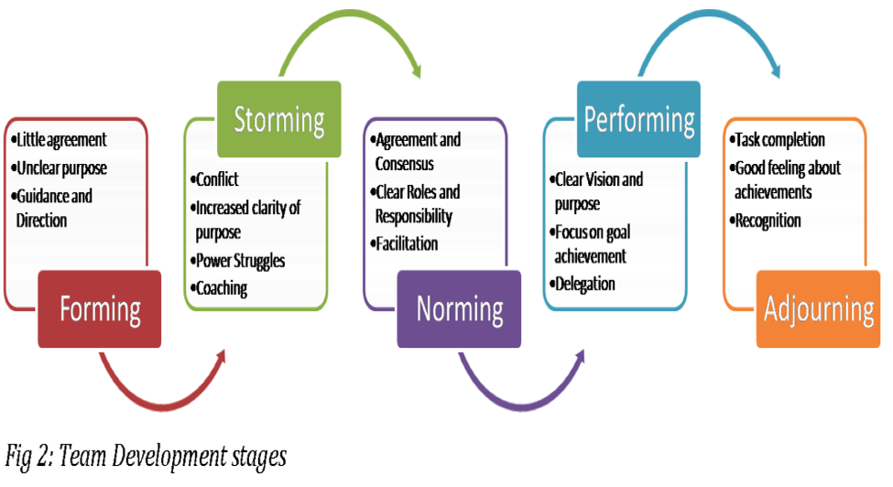
Source: Okpalad, based on Tuckman and Jensen (1977)

References
The University of Edinburgh. (2019). Gibbs' reflective cycle. [online] Available at: https://www.ed.ac.uk/reflection/reflectors-toolkit/reflecting-on-experience/gibbs-reflective-cycle [Accessed 24 Nov. 2019].
Slideplayer.com. (2019). [online] Available at: http://slideplayer.com/slide/5709122/18/images/52/Gibbs%E2%80%99+Reflective+Cycle.jpg [Accessed 23 Nov. 2019].
Davis, s. (2013). How the R.E.D Model Can Make You a Better Leader (and Thinker). [online] Government Executive. Available at: https://www.govexec.com/management/2013/07/how-red-model-can-make-you-better-leader-and-thinker/67301/ [Accessed 25 Nov.2019]
University, C. (2019). What are the benefits of group work? - Eberly Center - Carnegie Mellon University. [online] Cmu.edu. Available at: https://www.cmu.edu/teaching/designteach/design/instructionalstrategies/groupprojects/benefits.html [Accessed 25 Nov. 2019].
Mspguide.org. (2019). Tuckman (forming, norming, storming, performing) | Multi-Stakeholder Partnerships. [online] Available at: http://www.mspguide.org/tool/tuckman-forming-norming-storming-performing [Accessed 28 Nov. 2019].

