University of Wales Trinity Saint David

BSc Ordnance, Munitions and Explosives



Analysis of Shotgun pellet penetrating titanium plate
Computer Aided Engineering (ACDB5007)

Albie Willett

2030850

Date: 28/04/2023

Lecturer: Andrew Noble

Table of Contents Page Number

1.0 Introduction 3

1.1 Aim & Objectives 3
2.0 Background information 4

2.1 Summary of Shotguns and input values 4

2.2 Previous studies 7

2.3 Previous CAE of bullet penetration 8

3.0 Methodology 9

4.0 Validation 10

4.1 Mesh Convergence 13

5.0 Results and analysis 15

6.0 Conclusion 18

7.0 Reference List 20

Introduction
This report intends to summarise the CAE process and its limitations while applying it in real world situations.
Starting at the CAD modelling used to construct the test items then importing these into finite element analysis software to model the interaction between the two test items.
Validation of the models and how the mesh will affect the results will also be investigated throughout this report.

Aims & Objectives
This report will investigate how the thickness of titanium plate will affect penetration of a dragon breath style shotgun pellet fired from 10m away from the target. The methodology used for this investigation will be examined throughout followed by validation to ensure the results acquired can be justified. The results from the kinematic analysis will be evaluated and limitations of this modelling will be highlighted. Potential improvements/solutions to these limitations will be explored as well as the positives of CAE and why it is used over other methods of engineering design.
Before this can be completed the report will investigate the background information and data need to input into the CAE testing to achieve representative results. This information will include data from Shotguns and how they work to give a greater understanding of the whole system.

Background Information

This section will explain the design of the two test items and their material properties. While also looking at previous investigations into this subject matter.

2.1 Summary of shotgun’s and input values

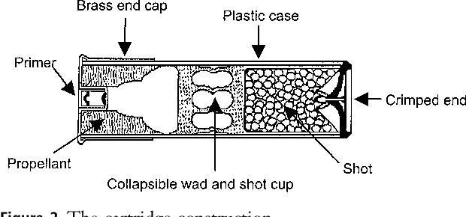 [1]
For a greater understanding of the Pellet used in this investigation the underlying workings in a shotgun and shotgun cartridge need to be understood. First the makeup of a shotgun cartridge and what is contained within:
As seen in Figure 1 the Cartridge consists of a Primer, End Cap, Propellant, Wad, Shot, Case and a crimped end to contain the shot.
The Primer is what initiates the propellant. There are many different designs for primers the most common used in shotguns are Berdan primers these consist of 2 parts the case/cup which has an integrated anvil as well as the ignition compound which is made up of a mixture of lead styphnate, antimony sulfide, barium nitrate and other chemicals.
The primer is seated within the brass end cap which is used to: provide rear obturation, provide support for the case material due to the high pressure exerted outwards during the firing process as well as positioning the round within the chamber.
Inside the brass End Cap is the plastic case this is used to keep all the internal parts of the ammunition together and in the right position. Once loaded into the gun the case provide rear obturation like the End Cap.
Inside the Case next to the primer is the propellant this is what propels the wadding and shot forward. This consists of Nitrocellulose and varying amounts of nitroglycerine this propellant has replaced the outdated black powder compositions due to its ability to produce less smoke and solid particles during consumption and produces less hygroscopic materials that rust the gun barrel. There was also an increase in performance.
Next in the case is the Wadding this provides the forward obturation and allows for the gasses to push against the shot without large loss of pressure due the gaps around the shot. This wadding can be made of a range of materials usually plastic however alternatives such as cork can be used when environmental considerations are a priority.
After the wadding is the Shot this is what this report will be looking at modelling so will be explored in further detail. In the design of a shotgun shell this is where there is most variation. Depending on the use, the size, quantity and material can be changed. For this investigation the chosen material to investigate was Magnesium this can be found in “Dragonbreath” shells that ignite the magnesium shot to increase damage and set the target on fire upon impact. The size of these pellets are 1.6mm in diameter similar to that of birdshot. This is on the smaller spectrum of this type of ammunition but due to other limitations discussed later in the report the small size was chosen. The difficulty is selecting a size for this type of ammunition is from the burning of the shot which decreases the diameter throughout the flight.

The rounds are then contained with a crimped end to stop the shot from falling out.
As well as the round the gun is needed for the rounds to function properly.
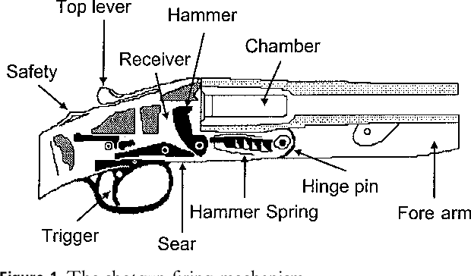

[1]
Figure 2

As seen in figure 2 there are many parts in the gun which are required for it to function. This report will only look at the Hammer, Chamber and Barrel. The reasoning behind this is that only these 3 affect performance of the round which is what this report is trying to investigate.
The hammer hitting the Primer of the Cartridge initiates the round inside the Chamber. The Chamber then contains the build-up of pressure formed from the combustion of the propellant. Throughout the loading and firing process the chamber keeps the shell in position allowing for the wading and shot to be projected through the gun barrel.

The Gun barrel greatly affects performance of the round. For this investigation a 12 gauge gun has been used for reference. This refers to the diameter of the chamber a 12 gauge shotgun refers to a bore that fits a spherical ball of 1/12th of pound of lead. A higher gauge has a smaller diameter and conversely the lower the gauge has a larger diameter. The barrel length affects the spread of the shot a shorter barrel produces a wider spread of shot and lower velocities while a longer barrel is more accurate and produces higher velocities. For this investigation the velocity data found was that of an average 12 gauge shotgun which has a barrel length of 26”.
Another consideration with the barrel is the Choke or potentially the lack of a choke which affects the spread of the pellets. A Cylinder Bore is the equivalent to having no choke this produces a larger spread of pellets. Alternatively the most extreme choke is a full choke which is where the end of the barrel constricts reducing the diameter of the barrel hence reduces the spread and increase the range. The Choke has no influence on the initial velocity of the pellets leaving the gun Barrel but the pellets will slow down slower with a full Choke. [2]
The large variation for the design of the shotgun mean that there is a large variation of muzzle velocities additionally how quickly the pellets slowdown is especially hard to calculate.
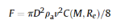
Calculating the impact velocity of the pellets onto the plate. There are three forces that act on a free falling pellet: The main force is the air resistance in the opposite direction to the motion of the pellet; the air resistance of any crosswinds and the gravity acting on the pellet. The drag can be calculated first with Newton’s second law using ma = -F where m is mass of pellet and a is acceleration the –F is the drag force on the pellet which can be calculated for a spherical sphere using [3] Once this has been completed the gravity and crosswind considerations can be applied. These equations are used in many Shotgun ballistics tables and many ballistic programs an example of which is seen below:
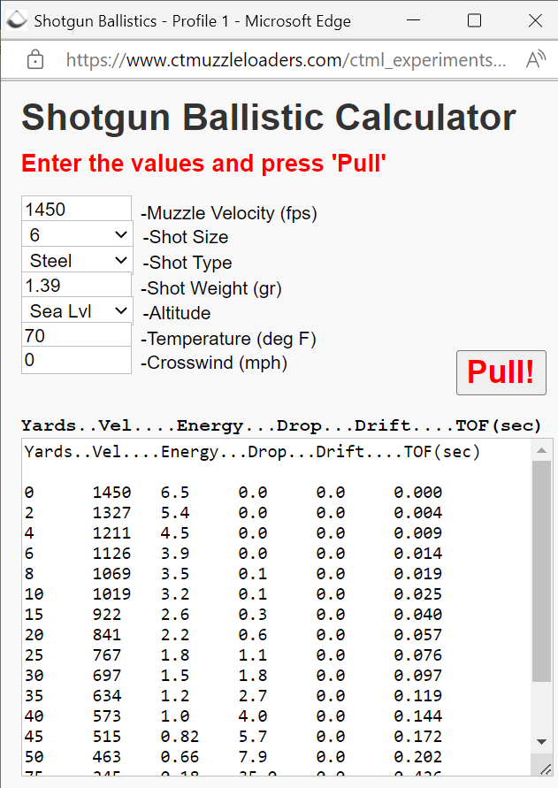
Figure 3 [3]
As seen in figure 3 the Muzzle velocity of an average size shot is 1450fps or 442m/s the rate this slows down over certain intervals is plotted above. For the purpose of this investigation the distance chosen was to investigate a pellet penetrating a 5 metres. This is chosen due to the speed of the pellets slowing down the penetration of the pellets is only a great concern when the gun is fired nearby. The closest velocities to 5 metres on the above table give values of 1211fps and 1126fps the chosen value for this report was 1150fps or 350m/s.

The second part to this simulation is the titanium plate that the pellet is penetrating through.
This has been chosen due to its use in body armour the investigation looks into how thin this plate needs to be before it fails and allows penetration. Unlike body armour the titanium plate is the only target material and does not have a Kevlar layer in front which has a large influence on the impact velocities of the pellet. Additionally the purpose of body armour is to stop a large variety of projectiles not just a singular shotgun pellet. Recurring impacts at the same point are also not considered in the simulations. This report is to demonstrate how a piece of body armour or metal plate can be evaluated for the purpose of stopping projectile penetration.
There are a range of titanium/ titanium alloy body armour on the market of which there is also a range of thicknesses of the plate inside varying from 1.5mm to 8mm. this body armour is design to prevent penetration of handgun ammunition.

2.2 Previous studies
There is a large collection of studies investigating the penetration of handgun and rifle ammunition through titanium plate. There is less studies into the penetration of shotgun pellets into titanium plate due to the minimal penetration power of shotgun pellets.
Previous studies into the evaluation of titanium alloys into handgun ammunition by John Fanning use physical test and evaluation processes to produce results for analysis rather than using CAE tools. None the less the methods used help guide the direction of this following report. In this report the investigation looks at how different: projectile shapes, thicknesses of plate and alloy properties of plate affect penetration. The main focus is on the thicknesses and test methodology which can be transferred to this CAE evaluation report.
The investigation uses a sheet 4.1mm thick of each material and then measures how far the bullets penetrates for each material. The test was completed to a Military standard this allows for repeatability of results if the test procedure was carried out correctly. To achieve these results photoelectric screens alongside chronographs were used to calculate projectile velocities at a zero degree obliquity and at ambient conditions with a relative humidity of between 35% - 75%. A witness plate was also fitted behind the armour plate to allow an easier way to distinguish between success and failure as the purpose of an armour plate is to prevent the other side of the plate from getting damaged and not just the failure of the plate completely allowing for the projectile to pass through.

Failure modes are a large part of this investigation these can be split into failure modes of the projectile and the failure modes of the armour plate. The main failure mode of the projectile is the gross plastic deformation from hitting the plate and not passing through the plate. Before the investigation the expected results were that the hardness and strength of the bullet material would be the primary attribute to penetration. Upon the investigation it was found that other properties have a greater influence on the penetration distance, hardness can sometimes reduce penetration performance. [5]
Materials with greater hardness can improve penetration resistance of the plate however may also have properties that lead to shattering which could then penetrate the person or item being protected by the armour plate. This also occurs when a HESH round hits a tank and produces a Scab as seen in figure. [5]
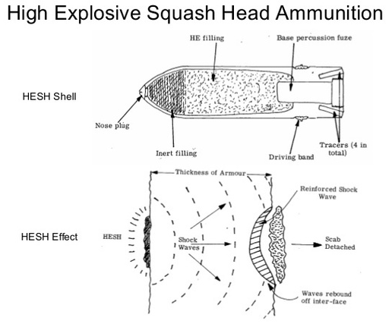
Figure 4 [5]
Despite the round not penetrating through the armour plate the armour plate itself becomes a projectile and can cause damage. The shotgun pellet does not contain any explosives so what is seen in figure 4 cannot happen however shattering of the plate could still happen.

2.3 Previous CAE of bullet penetration
This section explores an Explicit Dynamics simulation of bullet penetration through Composite bullet proof vests that has been completed.[7] In this investigation the Author looked into how different composite materials and the combination of them affect bullet penetration in bullet proof vests using Ansys. The report begins with looking at the design of the armour plate and the different plate designs being tested. Then the Projectile is designed Following this the investigation reasons a methodology for the investigation. This explains how the Items have been designed and by what tools. Then what solver was used on Ansys which was explicit dynamics the relevant material properties for this solver then need to be submitted as well as the initial conditions such as velocities, fix points and duration.
Results of the investigation include the total and directional deformation of each of the different armour plate designs and presenting them with an image imported from Ansys showing the deformation of the plate using a scale, red being the most deformed and blue being the least. The maximum deformations are also stated highlighting which plates were the most successful at preventing bullet penetration. The Results concluded that thickness increase improved performance of the armour and the best performing materials were a combination of Kevlar and Carbon fibre.

3.0 Methodology

This section will detail the methodology used throughout this investigation and explain how the results were achieved.
First the CAD designs of the objects were made on Solidworks for its user friendly interface. This is split into two parts the metal plate which was constructed by extruding a rectangular 2d shape to the desired depth; the shotgun pellet which used a revolution extrude around a semi-circle.
These designs were then imported into Ansys 21 which has a better solver for explicit dynamics than Solidworks. After importing the designs the solver type was selected. A Mesh convergence study was completed alongside a range of validation models to verify that the solver type selected was correct and providing representative results that could be seen in the real environment.
The material properties were found in the library of material properties already on Ansys these were then assigned to the corresponding items. Once assigned Constraints were added to the plate fixing it in position and initial conditions were provided to the Pellet of an initial velocity of 350m/s as discussed in the earlier part of the report. The duration of the model was also defined to determine how long it would run so that the Pellet could penetrate through the plate but no more to reduce the time need to run the simulation.
The Simulation was then ready to be solved. The issues encountered while running the solver are explored in the Validation and Conclusion section of this report.

4.0 Validation
This section explains how the methodology used can be justified. There are many potential models that can be applied to this testing selecting the correct one at the right time will impact the test results. The differences will be explored between models and how material properties influenced these results.
A validation model uses a simple model using the same solver to justify the selection of the model and the results. A loaded beam was chosen for this validation model with plastic deformation properties given to the materials as the Shotgun Pellet hitting the Plate will exceed the yield strength of the material. This was then solved with both a static model and an explicit dynamics model to find the correct solver and then followed by a mesh convergence study.
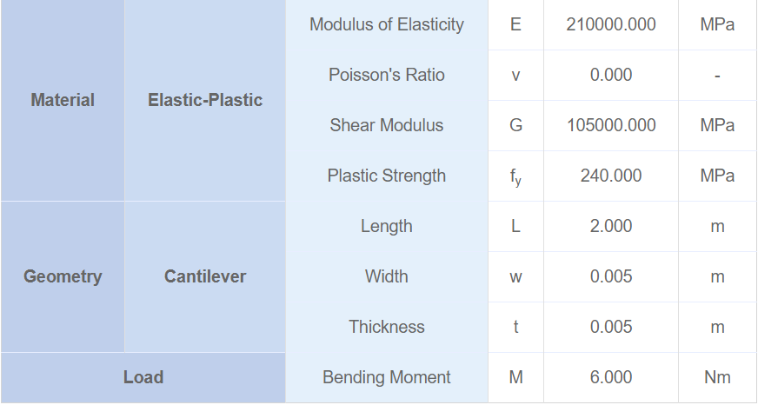
Table 1 [8]
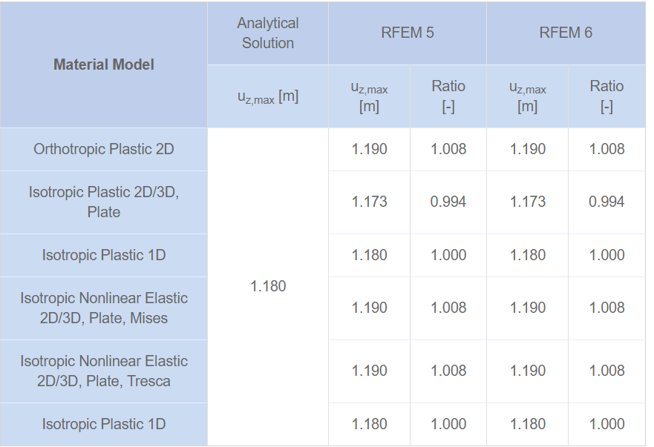
Table 2 [8]
As seen in Table 1 the input parameter for the Non Elastic material followed by the calculated results and the expected deformation in Table 2. This can be compared to the results gathered from Ansys.

As seen in the Figure 5-7 the simulation was ran 3 times with varying meshes the finest of which achieved a total deformation of 1.0664m which was 90.4% of the expected value this is an acceptable tolerance to the actual result due to incomplete material parameters and initial conditions like duration. This results could also be closer if the mesh was finer however this increases the time taken for processing the solution. Too larger mesh also is detrimental to the results acquired and can lead to failure of the model to run as seen in figure 7.

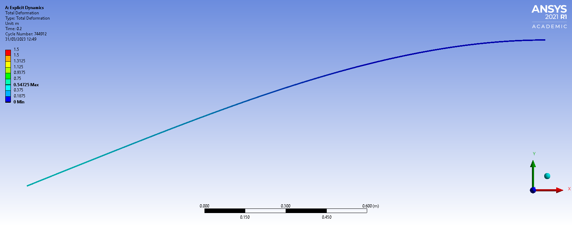
0.0025m Mesh
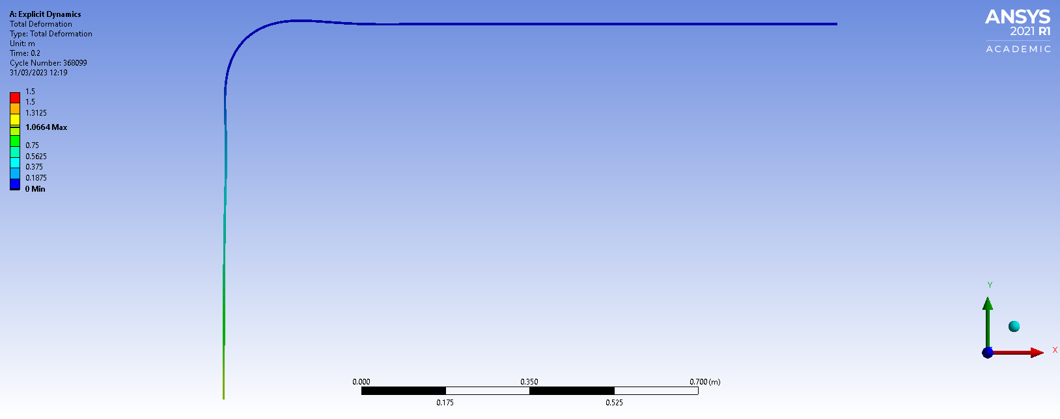
Figure 5
0.005m Mesh
Figure 6
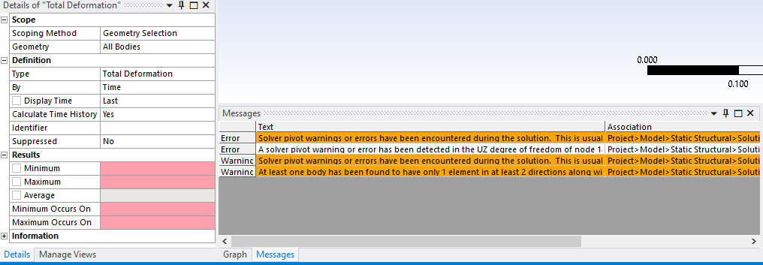
Figure 7
0.05m Mesh

4.1 Mesh Convergence
As well as validating the model used a Mesh convergence study can find the best mesh for the Model too finer mesh can cause unnecessary processing time which causes unwanted delays as well as compounding issues. Too larger mesh may mean the model cannot run and may miss high point of stress which can have unwanted consequences in real life. This creates the need to complete a mesh convergence study that finds the optimal mesh. An example of a mesh convergence study can be seen in Figures 8-12.
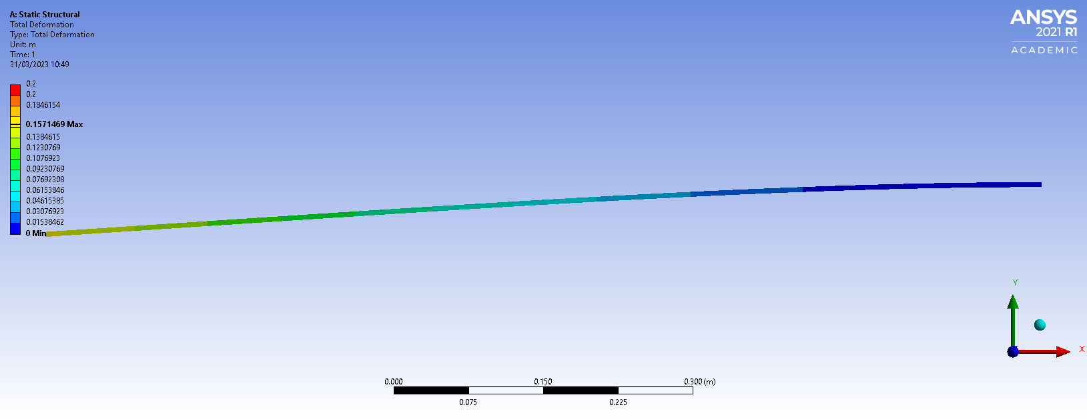
1mm Mesh

Figure 8
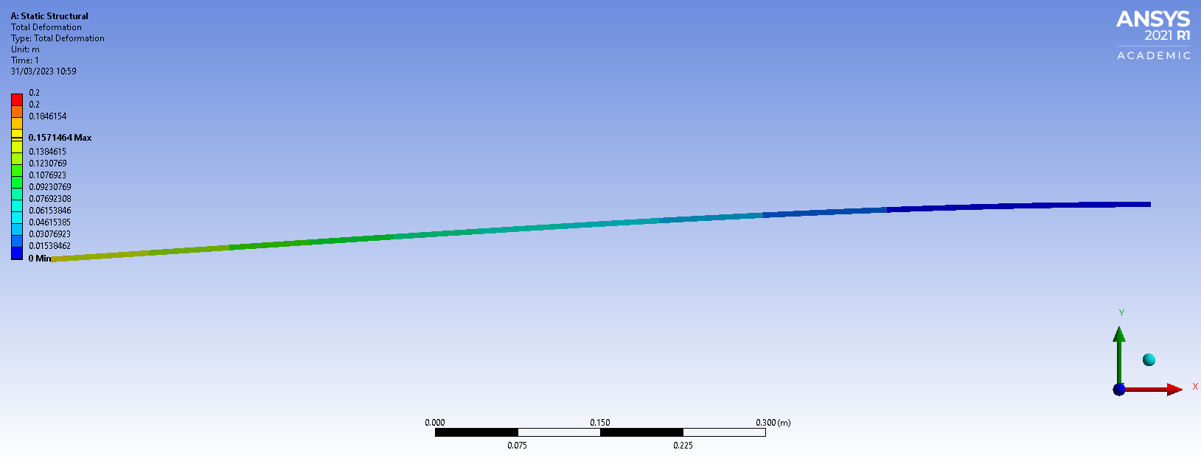
5mm Mesh

Figure 9

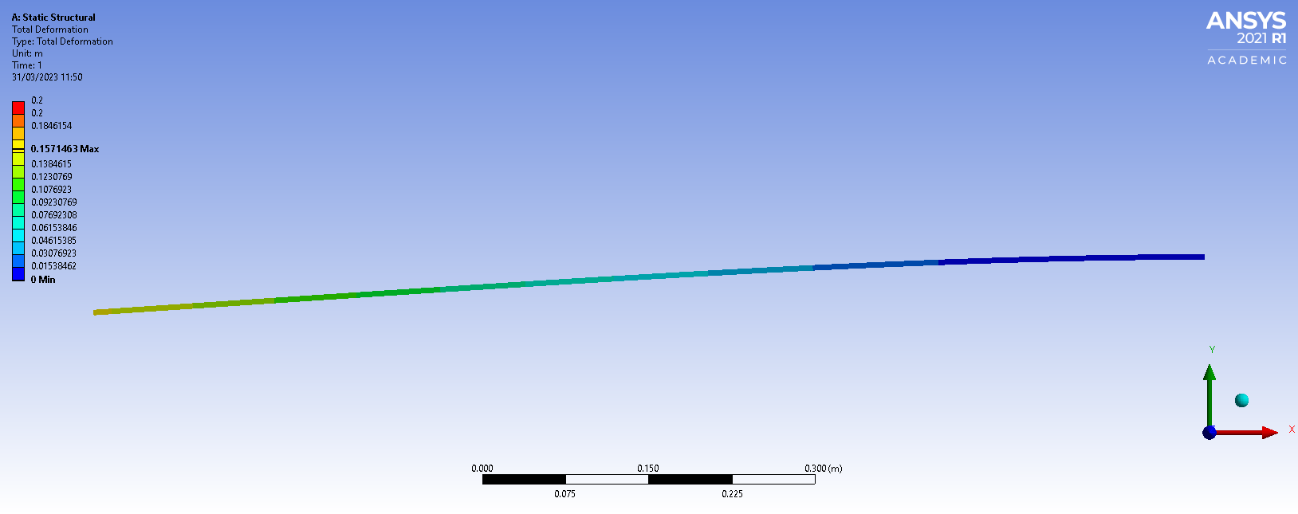
10mm Mesh

Figure 10
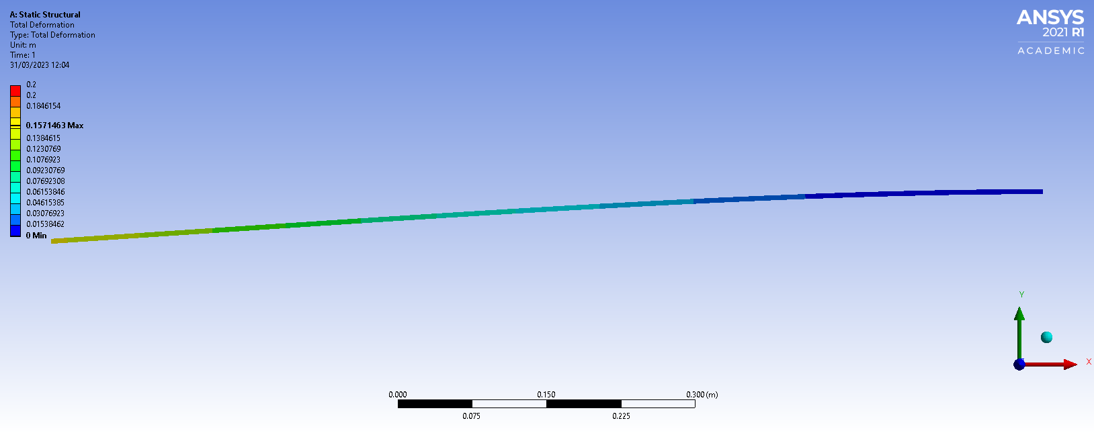
25mm Mesh

Figure 11
50mm Mesh

Figure 12
Figure Number | Deformation
8 | 0.1571469
9 | 0.1571464
10 | 0.1571463
11 | 0.1571463
12 | Unsolvable

Table 3
Table 3 summarises results from the Figure 8-12 showing how figure 8 with the finest mesh has a larger result which is closer to the actual value of deformation however also shown in the Table 3 is the differences between the meshes is so minor that in many situations a sacrifice can be made for time savings which relate to cost. The study above helped show how a larger mesh will give sufficient results in many situations and allows for more simulations to be completed in a given time. This was the case in the simulations in this report.

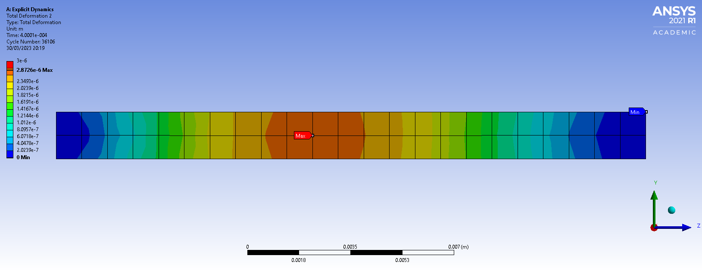
5.0 Results & Analysis
1.6mm Plate
Figure 13
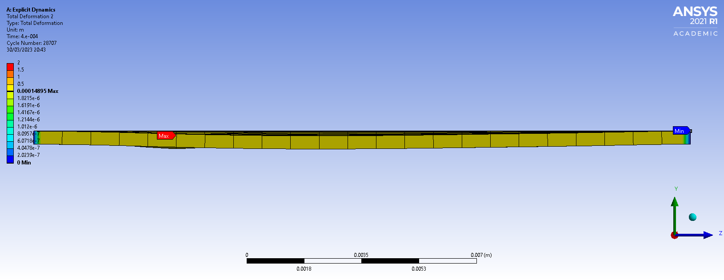
0.4mm Plate

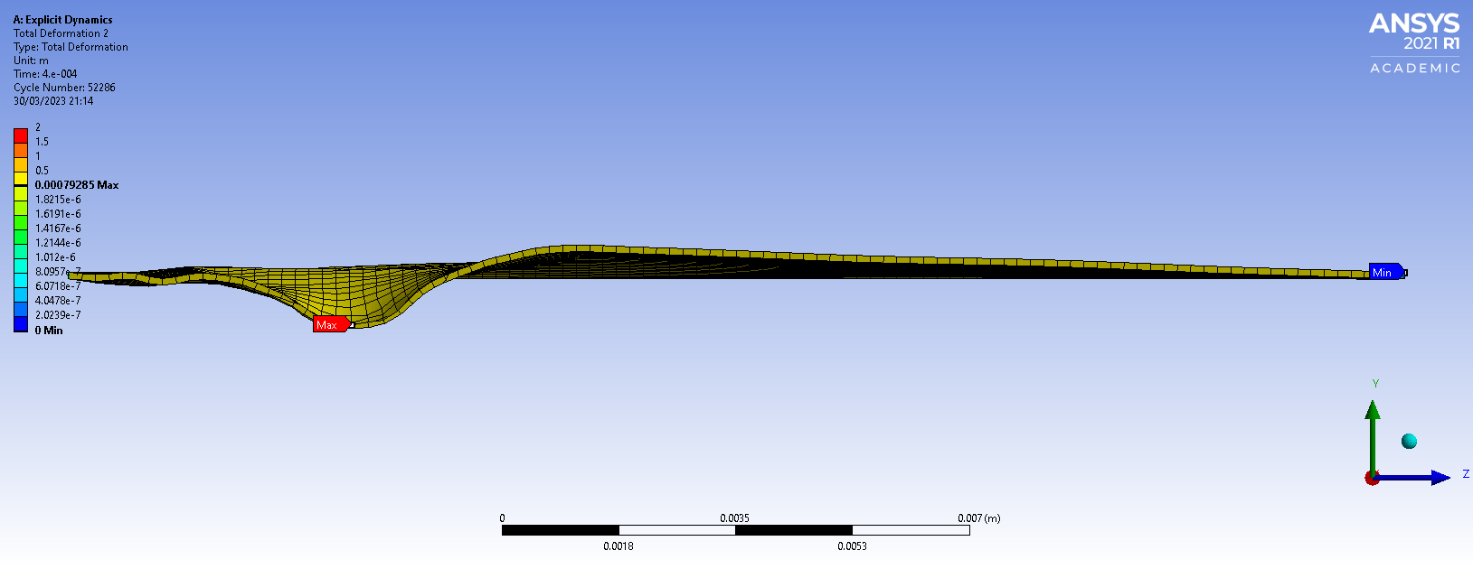
Figure 14
0.1mm Plate

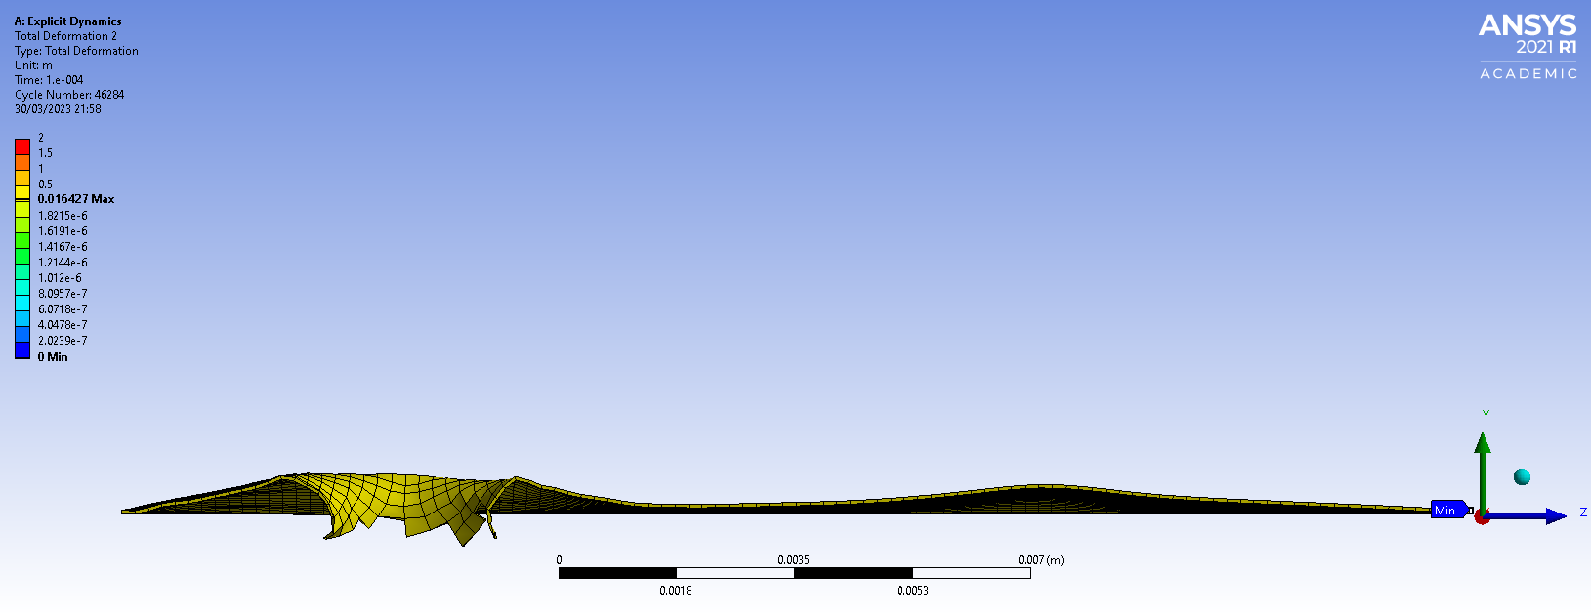
Figure 15
0.05mm Plate

Figure 16

The Results from the Simulations are seen in Figures 13-16 from highest thickness plate to the thinnest. The Figures are showing a cross sectional view of the Total deformation of the Plate.
The first simulation completed was the 1.6mm plate this was used as an initial starting point as it is the thickness of plates found in commercial body armour. As seen in Figure 13 there was no penetration and minimal deformation of 2.87 x 10^-6 m. This was to be expected as this is intended to stop higher velocity larger ammunition from handguns and rifles.

The next simulation used a plate thickness of 0.4mm this also had a minimal deformation of 1.49 x 10^-4 m. This result confirms that the thinner the plate the deformations increases non-linearly with the deformation being around 52 times greater than that of a plate 4 times thicker.

The next simulation was of a plate 0.1mm thick this still prevented penetration of the pellet with a deformation of 7.93 x 10^-4 m this performed greater than expected as this too was 4 times thinner than the previous design however the penetration was only 5 times greater.

The final simulation ran with a plate of 0.05mm. This allowed the pellet to penetrate the deformation is obsolete for this simulation as the pellet will exceed that of the plate causing damage to whatever is behind.

Throughout the study a magnesium pellet was used to simulate that of “Dragonbreath” rounds which consist of burning magnesium. Due to incomplete material properties on the Ansys and the difficulty in finding data for the thermal study as well as the explicit dynamic study it was decided to only simulate the explicit dynamics of the pellet hitting the titanium plate.

A thermal study ideally would have been completed before running the dynamic study as the increase in temperature would have affected the penetrating ability of the pellet. Additionally the combustion of the pellet is extremely hard to model on Ansys.

This study looks at stopping the penetration of the pellet through the plate however the purpose of the plate is to stop someone or something getting injured or damaged. The pellet could still penetrate the plate but cause no damage to the object behind depending on the exit velocity of the pellet.

6.0 Conclusion
The limitations of this study include the lack of a thermal study for the magnesium pellet, the course mesh used for the modelling to allow for the simulations to complete, an unknown size of the pellet and the rate at which it decreases in size while burning, other environmental conditions such as crosswinds and incomplete combustion of the magnesium pellets.

Despite this the report still met the initial requirements set out of finding a weight reduction in the design of an item and implementing CAE methods to find a solution. This conclusion section of the report will also evaluate the pros and cons of using CAE tools to help design a system.
Cons of using CAE:
Input parameters are required and one incorrect parameter can drastically affect results,
Processing time for complex models,
Initial cost of equipment and software,
Hardware failure can lead to loss of data,
Throughout the simulation part of this report the above issue were encountered leading to additional time attempting more simulations with more representative parameters and simpler meshes.
Pros of using CAE:
Cost and time savings over physical testing,
Reduces errors in the design process,
Easy to change parameters,
Safer over testing live ammunition

The advantages out way the disadvantages. To complete this investigation without CAE would require using a gun range with the suitable licenses; to have a competent user of a shotgun and set up a rig to hold the plate and shotgun in position. Furthermore any changes to the design would take long durations to complete as a new metal plate would have to be made.
Ideally a combination of CAE and real world testing can be completed to verify that the results found in the CAE are correct and that no other parameters that may have been ignored or unknown do not influence the penetration power of the pellet. Human error is one of the main causes of variation in testing which CAE cannot replicate. This is usually a positive as it allows for repeatable results however when designing items for safety the worst case scenario has to be applied to the asset.

7.0 Reference List
Bibliography

[1] | R. T. A. B. R Davidson, “Computational modelling of the shot pattern of a sporting shotgun,” Sports Engineering, vol. 5, no. 1, 2002.
[2] | Hunter 2023, “Shotgun Choke,” Beasafehunter, 11 November 2022. [Online]. Available: https://www.youtube.com/watch?v=7x016KHYwQw. [Accessed 04 April 2023].
[3] | E.J.Allen, “Approximate ballistics formulas for spherical pellets in free flight,” Defence Technology ELSEVIER, vol. 1, no. 14, pp. 1-2, 2018.
[4] | S.Wardlaw, “CTMuzzleloaders,” AvaHost.net, 03 February 2015. [Online]. Available: http://www.ctmuzzleloaders.com/ctml_experiments/shot-ballistics/shot-ballistics.html. [Accessed 24 April 2023].
[5] | the Japan Institue of Metals, “Ballistic Evaluation of Titanium Alloys Against Handgun Ammunition,” Ti-2007 Science and Technology, vol. 1, no. 1, pp. 487-491, 2007.
[6] | Ontario Regiment RCAC Regimental Museum, “ontrmuseum,” The Ontario Regiment RCAC Museum. , [Online]. Available: https://www.ontrmuseum.ca/tankmuseum/blog-post/modern-anti-tank-ammunition/#:~:text=A%20HESH%20round%20is%20a,the%20fuse%20hits%20the%20armour.. [Accessed 27 April 2023].
[7] | B. T. Narendiranath, A. P. Singh, N. S. Reddy and D. Murpani, “SIMULATION OF BALLISTIC IMPACT ON DIFFERENT COMPOSITE SAMPLES OF BULLET PROOF VEST,” IOP Conference Series. Materials Science and Engineering, vol. 1123, no. 1, pp. 1-11, 2021.

