Appendices
Appendix 1: Ethics form
APPLICATION FOR ETHICAL APPROVAL

RESEARCH STUDENTS
This form is to be completed by the student within SIX months for full-time students and TWELVE months for part time students, after the commencement of the research degree or following progression to Part Two of your course.

Once complete, submit this form via the MyTSD Doctoral College Portal at (https://mytsd.uwtsd.ac.uk).

This document is also available in Welsh.

RESEARCH STAFF ONLY
All communications relating to this application during its processing must be in writing and emailed to pgresearch@uwtsd.ac.uk , with the title ‘Ethical Approval’ followed by your name.

STUDENTS ON UNDERGRADUATE OR TAUGHT MASTERS PROGRAMMES should submit this form (and receive the outcome) via systems explained to you by the supervisor/module leader.

In order for research to result in benefit and minimise risk of harm, it must be conducted ethically. A researcher may not be covered by the University’s insurance if ethical approval has not been obtained prior to commencement.

The University follows the OECD Frascati manual definition of research activity: “creative work undertaken on a systematic basis in order to increase the stock of knowledge, including knowledge of man, culture and society, and the use of this stock of knowledge to devise new applications”. As such this covers activities undertaken by members of staff, postgraduate research students, and both taught postgraduate and undergraduate students working on dissertations/projects.

The individual undertaking the research activity is known as the “principal researcher”.

Ethical approval is not required for routine audits, performance reviews, quality assurance studies, testing within normal educational requirements, and literary or artistic criticism.

Please read the notes for guidance before completing ALL sections of the form.

This form must be completed and approved prior to undertaking any research activity. Please see Checklist for details of process for different categories of application.

SECTION A: About You (Principal Researcher)
1 | Full Name: |  | Michael Aslet
2 | Tick all boxes that apply: |  | Member of staff: | ☐ | Honorary research fellow: | ☐
 | Undergraduate Student | ☐ | Taught Postgraduate Student | ☒ | Postgraduate Research Student | ☐

3 | Institute/Academic Discipline/Centre: | Yr Athrofa, University of Wales Trinity Saint David
4 | Campus: | Swansea Campus
5 | E-mail address: | 2317644@student.uwtsd.ac.uk
6 | Contact Telephone Number: | 07917420656
 | For students:
7 | Student Number: | 2317644
8 | Programme of Study: | PGCE
9 | Director of Studies/Supervisor: | Lilian Martin

SECTION B: Approval for Research Activity
1 | Has the research activity received approval in principle?  (please check the Guidance Notes as to the appropriate approval process for different levels of research by different categories of individual) |  | YES | ☒ | NO | ☐
 |  |  |  |  | Date
2 | If Yes, please indicate source of approval (and date where known): Approval in principle must be obtained from the relevant source prior to seeking ethical approval | Research Degrees Committee |  | ☐
2 |  | Institute Research Committee |  | ☐
2 |  | Other (write in)  Lilian Martin |  | ☒ | 14/3/24

SECTION C: Internal and External Ethical Guidance Materials
 | Please list the core ethical guidance documents that have been referred to during the completion of this form (including any discipline-specific codes of research ethics, location-specific codes of research ethics, and also any specific ethical guidance relating to the proposed methodology). Please tick to confirm that your research proposal adheres to these codes and guidelines. You may add rows to this table if needed.
1 | UWTSD Research Ethics & Integrity Code of Practice | ☐
2 | UWTSD Research Data Management Policy | ☐
3 | BERA Ethical Guidelines for Educational Research, Fourth edition (2018) | ☒

SECTION D: External Collaborative Research Activity
If there are external collaborators then you should gain consent from the contact persons to share their personal data with the university. If there are no external collaborators then leave this section blank and continue to section E.
1 | Institution
2 | Contact person name
3 | Contact person e-mail address
4 | Is your research externally funded? |  | YES | ☐ | NO |  | ☐
5 | Are you in receipt of a KESS scholarship? |  | YES | ☐ | NO |  | ☐
6 | Are you specifically employed to undertake this research in either a paid or voluntary capacity? | Voluntary | YES | ☐ | NO | ☐
7 |  | Employed | YES | ☐ | NO | ☐
8 | Is the research being undertaken within an existing UWTSD Athrofa Professional Learning Partnership (APLP)? | If YES then the permission question below does not need to be answered. | YES | ☐ | NO |  | ☐
9 | Has permission to undertake the research has been provided by the partner organisation? | (If YES attach copy)  If NO the application cannot continue | YES | ☐ | NO |  | ☐

Where research activity is carried out in collaboration with an external organisation
10 | Does this organisation have its own ethics approval system? | YES | ☐ | NO | ☐
 | If Yes, please attach a copy of any final approval (or interim approval) from the organisation (this may be a copy of an email if appropriate).

SECTION E: Details of Research Activity
1 | Indicative title: | What are the perceptions and engagement of year 1 and 2 students on extrinsic motivation regarding carousel activities?
2 | Proposed start date: | 14/03/24 | Proposed end date: | 31/06/24
Introduction to the Research (maximum 300 words per section)
Ensure that you write for a Non-Specialist Audience when outlining your response to the points below:
- Purpose of Research Activity
- Proposed Research Question
- Aims of Research Activity
- Objectives of Research Activity
Demonstrate, briefly, how Existing Research has informed the proposed activity and explain
- What the research activity will add to the body of knowledge
- How it addresses an area of importance.
3 | Purpose of Research Activity  To find out if the perception of extrinsic motivation can help improve engagement levels in carousel activities..  (this box should expand as you type)
4 | Research Question  What are the perceptions and engagement of year 1 and 2 students on extrinsic motivation regarding carousel activities?  (this box should expand as you type)
5 | Aims of Research Activity  The aim of this research is to explore the perceptions and engagement of year 1 and 2 students on extrinsic rewards in relation to carousel activities within the classroom.  (this box should expand as you type)
6 | Objectives of Research Activity  I will be sending out consent forms to parents/carers and then assent forms to the participants both with an added information sheet. I will then have observation sheets for each participant (with consent and assent) from the chosen group, selected by the systematic randomised sampling system and observe them for one single session of activities. On the same day I will then hold a focus group session with 5 different participants chosen by a stratified random sample. Throughout the study I will be reminded all participants that they can withdraw at any time without consequences. All this data will then be correlated and analysed and then the headlines of the research will be shared on request.  (this box should expand as you type)
Proposed methods (maximum 600 words)
Provide a brief summary of all the methods that may be used in the research activity, making it clear what specific techniques may be used. If methods other than those listed in this section are deemed appropriate later, additional ethical approval for those methods will be needed. You do not need to justify the methods here, but should instead describe how you intend to collect the data necessary for you to complete your project.
7 | The methods that will be used to collect data will be observations and the use of focus groups. Consent and accent will be provided before the start of the research. Observations by means of an observation sheet that uses the Leuven scale to measure engagement in the activities as this is key to exploring the student’s perceptions of the extrinsic reward gained for completion of the carousel activities. This has also been chosen as its very effective with early years learners, puts the focus on the learners and is less time consuming as time availability will be a factor within this research. Focus groups will be used to attain extra verbal perspectives from the students and to limit researcher bias.  (this box should expand as you type)
Location of research activity
Identify all locations where research activity will take place.
8 | A Primary School year 1 and 2 split classroom in the Swansea area.  (this box should expand as you type)
Research activity outside of the UK
If research activity will take place overseas, you are responsible for ensuring that local ethical considerations are complied with and that the relevant permissions are sought. Specify any local guidelines (e.g. from local professional associations/learned societies/universities) that exist and whether these involve any ethical stipulations beyond those usual in the UK (provide details of any licenses or permissions required). Also specify whether there are any specific ethical issues raised by the local context in which the research activity is taking place, for example, particular cultural and/or legal sensitivities or vulnerabilities of participants. If you live in the country where you will do the research then please state this.
9 | I live in the country that the research will be carried out in.  (this box should expand as you type)

10 | Use of documentation not in the public domain: Are any documents NOT publicly available? | NO | ☒
10 |  | YES | ☐
11 | If Yes, please provide details here of how you will gain access to specific documentation that is not in the public domain and that this is in accordance with the current data protection law of the country in question and that of England and Wales.  (this box should expand as you type)

 | Does your research relate to one or more of the seven aims of the Well-being of Future Generations (Wales) Act 2015? | YES | NO
12 | A prosperous Wales | ☐ | ☒
13 | A resilient Wales | ☐ | ☒
14 | A healthier Wales | ☐ | ☒
15 | A more equal Wales | ☐ | ☒
16 | A Wales of cohesive communities | ☐ | ☒
17 | A Wales of vibrant culture and thriving Welsh language | ☐ | ☒
18 | A globally responsible Wales | ☐ | ☒
19 | If YES to any of the above, please give details:
 | (this box should expand as you type)

SECTION F: Scope of Research Activity
 | Will the research activity include: | YES | NO
1 | Use of a questionnaire or similar research instrument? | ☐ | ☒
2 | Use of interviews? | ☐ | ☒
3 | Use of focus groups? | ☒ | ☐
4 | Use of participant diaries? | ☐ | ☒
5 | Use of video or audio recording? | ☐ | ☒
6 | Use of computer-generated log files? | ☐ | ☒
7 | Participant observation with their knowledge? | ☒ | ☐
8 | Participant observation without their knowledge? | ☐ | ☒
9 | Access to personal or confidential information without the participants’ specific consent? | ☐ | ☒
10 | Administration of any questions, test stimuli, presentation that may be experienced as physically, mentally or emotionally harmful / offensive? | ☐ | ☒
11 | Performance of any acts which may cause embarrassment or affect self-esteem? | ☐ | ☒
12 | Investigation of participants involved in illegal activities? | ☐ | ☒
13 | Use of procedures that involve deception? | ☐ | ☒
14 | Administration of any substance, agent or placebo? | ☐ | ☒
15 | Working with live vertebrate animals? | ☐ | ☒
16 | Procedures that may have a negative impact on the environment? | ☐ | ☒
17 | Other primary data collection methods. Please indicate the type of data collection method(s) below. | ☐ | ☒
 | Details of any other primary data collection method:  (this box should expand as you type) | ☐ | ☒
If NO to every question, then the research activity is (ethically) low risk and may be exempt from some of the following sections (please refer to Guidance Notes).

If YES to any question, then no research activity should be undertaken until full ethical approval has been obtained.

SECTION G: Intended Participants
If there are no participants then do not complete this section, but go directly to section H.

 | Who are the intended participants: | YES | NO
1 | Students or staff at the University? | ☐ | ☒
2 | Adults (over the age of 18 and competent to give consent)? | ☐ | ☒
3 | Vulnerable adults? | ☐ | ☒
4 | Children and Young People under the age of 18? (Consent from Parent, Carer or Guardian will be required) | ☒ | ☐
5 | Prisoners? | ☐ | ☒
6 | Young offenders? | ☐ | ☒
7 | Those who could be considered to have a particularly dependent relationship with the investigator or a gatekeeper? | ☐ | ☒
8 | People engaged in illegal activities? | ☐ | ☒
9 | Others. Please indicate the participants below, and specifically any group who may be unable to give consent. | ☐ | ☒
 | Details of any other participant groups:  (this box should expand as you type) | ☐ | ☒

Participant numbers and source
Provide an estimate of the expected number of participants. How will you identify participants and how will they be recruited?
10 | How many participants are expected? | Observations will be as a systematic random sample of identified group of 5 or 6 learners ranging from year 1 to year 2 (Dependent on which group is chosen), this will be chosen from the ability groups that have already been pre-determined by the school before the research project (those who have given consent and assent). Focus group will be a stratified random sample of 5 participants within the class (2 year 1’s and 3 year 2’s).  (this box should expand as you type)
11 | Who will the participants be? | The participants will be a pre-determined ability group of learners (by the school) from the year 1 and 2 split class.  (this box should expand as you type)
12 | How will you identify the participants? | The participants will be a systematic random sample from pre-determined class ability groups for the observation and a stratified random sample for the focus groups.  (this box should expand as you type)

 | Information for participants: | YES | NO | N/A
13 | Will you describe the main research procedures to participants in advance, so that they are informed about what to expect? | ☒ | ☐ | ☐
14 | Will you tell participants that their participation is voluntary? | ☒ | ☐ | ☐
15 | Will you obtain written consent for participation? | ☒ | ☐ | ☐
16 | Will you explain to participants that refusal to participate in the research will not affect their treatment or education (if relevant)? | ☒ | ☐ | ☐
17 | If the research is observational, will you ask participants for their consent to being observed? | ☒ | ☐ | ☐
18 | Will you tell participants that they may withdraw from the research at any time and for any reason? | ☒ | ☐ | ☐
19 | With questionnaires, will you give participants the option of omitting questions they do not want to answer? | ☐ | ☐ | ☒
20 | Will you tell participants that their data will be treated with full confidentiality and that, if published, it will not be identifiable as theirs? | ☒ | ☐ | ☐
21 | Will you debrief participants at the end of their participation, in a way appropriate to the type of research undertaken? | ☒ | ☐ | ☐
22 | If NO to any of above questions, please give an explanation
 | (this box should expand as you type)

 | Information for participants: | YES | NO | N/A
24 | Will participants be paid? | ☐ | ☒ | ☐
25 | Is specialist electrical or other equipment to be used with participants? | ☐ | ☒ | ☐
26 | Are there any financial or other interests to the investigator or University arising from this study? | ☐ | ☒ | ☐
27 | Will the research activity involve deliberately misleading participants in any way, or the partial or full concealment of the specific study aims? | ☐ | ☒ | ☐
28 | If YES to any question, please provide full details
 | (this box should expand as you type)

SECTION H: Anticipated Risks

Outline any anticipated risks that may adversely affect any of the participants, the researchers and/or the University, and the steps that will be taken to address them.

If you have completed a full risk assessment (for example as required by a laboratory, or external research collaborator) you may append that to this form.
1 | Full risk assessment completed and appended? |  | Yes | ☐
1 |  |  | No | ☒
2 | Risks to participants  For example: sector-specific health & safety, emotional distress, financial disclosure, physical harm, transfer of personal data, sensitive organisational information
 | Risk to participants:  - Risk of power dynamics, i.e. the learners may wish to please and may feel uncomfortable sharing.  - Learners may forget or feel that they may get in trouble for not participating in the research.  - The learners are not old enough to give consent.  - Risk of confidential data being leaked.  (this box should expand as you type) | How you will mitigate the risk to participants:  - Remind learners to be honest and that their voices will be heard and that they will be able to withdraw at any time without consequences.  - Make sure the learners are aware from the start of the research that they can leave the research study at any time without consequences and keep reminding them throughout.  - Consent forms will be given to parents/carers and assent forms will be given to all participants.  - All data will be recorded on a password protected laptop and one drive (cloud) and the raw data will not be shared with any external people.  (this box should expand as you type)
3 | If research activity may include sensitive, embarrassing or upsetting topics (e.g. sexual activity, drug use) or issues likely to disclose information requiring further action (e.g. criminal activity), give details of the procedures to deal with these issues, including any support/advice (e.g. helpline numbers) to be offered to participants. Note that where applicable, consent procedures should make it clear that if something potentially or actually illegal is discovered in the course of a project, it may need to be disclosed to the proper authorities
 | (this box should expand as you type)
4 | Risks to the investigator  For example: personal health & safety, physical harm, emotional distress, risk of accusation of harm/impropriety, conflict of interest
 | - Allegations while conducting interviews  - Accusations of fabrication or falsification of data  - Concerns of coercion  - Participants may wish to withdraw  - A confidentiality breach due to data being released accidentally  - Risks relating to the possibility of unexpected negative emotions of the interviewees  (this box should expand as you type) | - Ensure access to a suitable space that secures the confidentiality of the of the participant contributions, whilst also being visible to other colleagues.  - Clarify with participants regarding access to transcripts of interviews or field notes. Ensure debriefing with participants to include recapping on and clarifying where necessary the contributions that they have made.  - It will be made explicit that participants are free to disengage and that in that event, this will not impact on assessment or outcomes of their programme of study  - In the case of withdrawal from the student group, discussions would be conducted with the remaining participants and new participants will be recruited, if necessary, who will be fully briefed, and whose informed consent and assents will be sought.  - The research will be stored on a password protected laptop and one drive.  - Be cautious about the places to have interview and choose quiet and public places. The participants are assured that all the personal data of the participants are securely stored in the safe place such as the password protected laptop and personal one drive. All the related laws and regulations should be carefully studied before the research activities to avoid unintentional misconduct that arouse suspicion and antagonism from authorities.  (this box should expand as you type)
5 | University/institutional risks  For example: adverse publicity, financial loss, data protection
 | - Reputational damage (Potential complaint against the researcher for causing emotional distress or embarrassment that could cause reputational damage  (this box should expand as you type) | - Ensure adherence to the UWTSD code of ethics and research standards and commonly agreed standards of good practice. Ensure compliance with data storage regulations and university guidelines and security procedures. Ensure that research methodology is robust and that methods are appropriate. Adhere to the UWTSD code of conduct and the BERA (2018) document. Establish clarity regarding procedures on reporting of disclosures throughout the research.  (this box should expand as you type)
6 | Environmental risks  For example: accidental spillage of pollutants, damage to local ecosystems
 | Risk to the environment:  - Use of paper  (this box should expand as you type) | How you will mitigate the risk to environment:  - This research activity will mostly use electronic systems reducing the need for paper  (this box should expand as you type)

 | Disclosure and Barring Service
 | If the research activity involves children or vulnerable adults, a Disclosure and Barring Service (DBS) certificate must be obtained before any contact with such participants. | YES | NO | N/A
7 | Does your research require you to hold a current DBS Certificate? | ☒ | ☐ | ☐
8 | If YES, please give the certificate number. If the certificate number is not available please write “Pending”; in this case any ethical approval will be subject to providing the appropriate certificate number. | 001846116837

SECTION I: Feedback, Consent and Confidentiality

1 | Feedback  What de-briefing and feedback will be provided to participants, how will this be done and when?
On requests I will be able to share the headlines of this research.

(this box should expand as you type)
2 | Informed consent  Describe the arrangements to inform potential participants, before providing consent, of what is involved in participating. Describe the arrangements for participants to provide full consent before data collection begins. If gaining consent in this way is inappropriate, explain how consent will be obtained and recorded in accordance with prevailing data protection legislation.
I will send a consent form to parents/carers. Accent forms will be given to the participants as they are under the age of consent.

(this box should expand as you type)
3 | Confidentiality / Anonymity  Set out how anonymity of participants and confidentiality will be ensured in any outputs. If anonymity is not being offered, explain why this is the case.
All data will be anonymous and all participants will be names as participant 1, 2, 3, 4, 5 or 6.

(this box should expand as you type)

SECTION J: Data Protection and Storage

 | Does the research activity involve personal data (as defined by the General Data Protection Regulation 2016 “GDPR” and the Data Protection Act 2018 “DPA”)? | YES | NO
1 | “Personal data” means any information relating to an identified or identifiable natural person (‘data subject’). An identifiable natural person is one who can be identified, directly or indirectly, in particular by reference to an identifier such as a name, an identification number, location data, an online identifier or to one or more factors specific to the physical, physiological, genetic, mental, economic, cultural or social identity of that natural person. Any video or audio recordings of participants is considered to be personal data. | ☐ | x
 | If YES, provide a description of the data and explain why this data needs to be collected:
2 | (this box should expand as you type)
 | Does it involve special category data (as defined by the GDPR)? | YES | NO
3 | “Special category data” means sensitive personal data consisting of information as to the data subjects’ –  (a) racial or ethnic origin,  (b) political opinions,  (c ) religious beliefs or other beliefs of a similar nature,  (d) membership of a trade union (within the meaning of the Trade Union and Labour Relations (Consolidation) Act 1992),  (e) physical or mental health or condition,  (f) sexual life,  (g) genetics,  (h) biometric data (as used for ID purposes), | ☐ | x
 | If YES, provide a description of the special category data and explain why this data needs to be collected:
4 | (this box should expand as you type)

 | Will data from the research activity (collected data, drafts of the thesis, or materials for publication) be stored in any of the following ways? | YES | NO
5 | Manual files (i.e. in paper form)? | ☐ | ☒
6 | University computers? | ☐ | ☒
7 | Private company computers? | ☐ | ☒
8 | Home or other personal computers? | ☐ | ☒
9 | Laptop computers/ CDs/ Portable disk-drives/ memory sticks? | ☒ | ☐
10 | “Cloud” storage or websites? | ☐ | ☒
11 | Other – specify: | ☐ | ☒
12 | For all stored data, explain the measures in place to ensure the security of the data collected, data confidentiality, including details of backup procedures, password protection, encryption, anonymisation and pseudonymisation:
All data will be stored on a personal password protected Laptop and my password protected one drive (cloud).

(this box should expand as you type)

 | Data Protection
 | Will the research activity involve any of the following activities: | YES | NO
13 | Electronic transfer of data in any form? | ☐ | ☒
14 | Sharing of data with others at the University outside of the immediate research team? | ☐ | ☒
15 | Sharing of data with other organisations? | ☐ | ☒
16 | Export of data outside the UK or importing of data from outside the UK? | ☐ | ☒
17 | Use of personal addresses, postcodes, faxes, emails or telephone numbers? | ☐ | ☒
18 | Publication of data that might allow identification of individuals? | ☐ | ☒
19 | Use of data management system? | ☐ | ☒
20 | Data archiving? | ☐ | ☒
21 | If YES to any question, please provide full details, explaining how this will be conducted in accordance with the GDPR and Data Protection Act (2018) (and any international equivalents, where appropriate):
 | (this box should expand as you type)
22 | List all who will have access to the data generated by the research activity:
Me as the researcher will be the only person with access to the raw data collected.

(this box should expand as you type)
23 | List who will have control of, and act as custodian(s) for, data generated by the research activity:
Me as the researcher will be the only person with control of the raw data collected.

(this box should expand as you type)
24 | Give details of data storage arrangements, including security measures in place to protect the data, where data will be stored, how long for, and in what form. Will data be archived – if so how and if not why not.
All data will be stored on a password protected laptop and one drive (cloud)

(this box should expand as you type)
25 | Please indicate if your data will be stored in the UWTSD Research Data Repository (see https://researchdata.uwtsd.ac.uk/ ). If so please explain. (Most relevant to academic staff)
No, it will not be stored anywhere other than my personal password protected laptop and my password protected one drive (cloud).

(this box should expand as you type)
26 | Confirm that you have read the UWTSD guidance on data management (see https://www.uwtsd.ac.uk/library/research-data-management/) | YES | ☒
27 | Confirm that you are aware that you need to keep all data until after your research has completed or the end of your funding | YES | ☒

SECTION K: Declaration
The information which I have provided is correct and complete to the best of my knowledge. I have attempted to identify any risks and issues related to the research activity and acknowledge my obligations and the rights of the participants.

In submitting this application I hereby confirm that I undertake to ensure that the above named research activity will meet the University’s Research Ethics and Integrity Code of Practice which is published on the website: https://www.uwtsd.ac.uk/research/research-ethics/
1 | Signature of applicant: | Michael Aslet | Date:  14/03/24

For STUDENT Submissions:
2 | Director of Studies/Supervisor: | Lilian Martin | Date:  14/3/24
3 | Signature: | LYL Martin | Date:  14/3/24

For STAFF Submissions:
4 | Academic Director/ Assistant Dean: |  | Date:
5 | Signature: |  | Date:

Checklist: Please complete the checklist below to ensure that you have completed the form according to the guidelines and attached any required documentation:
☒ | I have read the guidance notes supplied before completing the form.
☒ | I have completed ALL RELEVANT sections of the form in full.
☒ | I confirm that the research activity has received approval in principle
☐ | I have attached a copy of final/interim approval from external organisation (where appropriate)
☐ | I have attached a full risk assessment (where appropriate) ONLY TICK IF YOU HAVE ATTACHED A FULL RISK ASSESSMENT
☒ | I understand that it is my responsibility to ensure that the above named research activity will meet the University’s Research Ethics and Integrity Code of Practice.
☒ | I understand that before commencing data collection all documents aimed at respondents (including information sheets, consent forms, questionnaires, interview schedules etc.) must be confirmed by the DoS/Supervisor, module tutor or Academic Director.

RESEARCH STUDENTS ONLY
Once complete, submit this form via the MyTSD Doctoral College Portal at (https://mytsd.uwtsd.ac.uk).

RESEARCH STAFF ONLY
All communications relating to this application during its processing must be in writing and emailed to pgresearch@uwtsd.ac.uk , with the title ‘Ethical Approval’ followed by your name.

STUDENTS ON UNDERGRADUATE OR TAUGHT MASTERS PROGRAMMES should submit this form (and receive the outcome) via systems explained to you by the supervisor/module leader.

Appendix 2: Consent forms and information sheet.
Parental CONSENT FORM

PROJECT TITLE: What are the perceptions of year 1 and 2 students on extrinsic motivation regarding carousel activities

Name of Researcher:

Name or Researcher: Michael Aslet

Please initial box

1.I confirm that I have read and understand the information sheet dated 19/03/24 for the above study.

2. I understand that my child’s participation is voluntary and that I am free to withdraw my child from the study at any time, without giving any reason.

3. I understand that my child can choose to withdraw at any time, without giving a reason.

4. I understand that the information given by my child will be used in a university assignment.

5. I understand that my child’s name will not appear at any time.

6. I agree for my child to take part in the above study.

_____________________ _____________________________ __________
Child’s name Parent signature Date

When completed, please return to ………………. by the ……….. of …………….. (date)

Thank you.
IMPORTMATION SHEET

PROJECT TITLE: What are the perceptions of year 1 and 2 students on extrinsic motivation regarding carousel activities

Name of Researcher:

Dear Parent / Guardian,

My name is Michael Aslet and I am studying for a PGCE qualification at Yr Athrofa, University of Wales Trinity Saint David. I am currently a student teacher within Cwm Glas Primary School and am teaching in your child’s class.

I would like to invite your child to participate in my research project. The title of the project is: What are the perceptions of year 1 and 2 students on extrinsic motivation regarding carousel activities and I aim to explore the opinions of year 1 and 2 children on external rewards in relation to carousel activities within the classroom. Through your child’s participation, I hope to ascertain ways to improve your child’s learning experiences within the classroom.

I will be observing how your child interacts with the current carousel activities within the classroom and will be conductive an informal focus group to identify how they feel about the carousel activities.

All names will be kept strictly confidential and will only be known by myself and my research partner. Your child’s participation in this study is completely voluntary so you or your child can withdraw from the study at any stage. Your child will also be asked to give their assent before the beginning of the study.

After careful and precise analysis of the data obtained from the lesson observation and group interview, I would be happy to provide you with a copy of the findings at your request. The results of the research will be discussed in a university assignment that will contribute to my PGCE course. The results of this study will be stored on my personal password protected laptop, which only I have access to and all raw data will be destroyed once the assessment has been marked.

I thank you in advance for your time. If any questions do arise, feel free to contact me at your convenience.

Yours sincerely,

Michael Aslet

Appendix 3: Assent forms
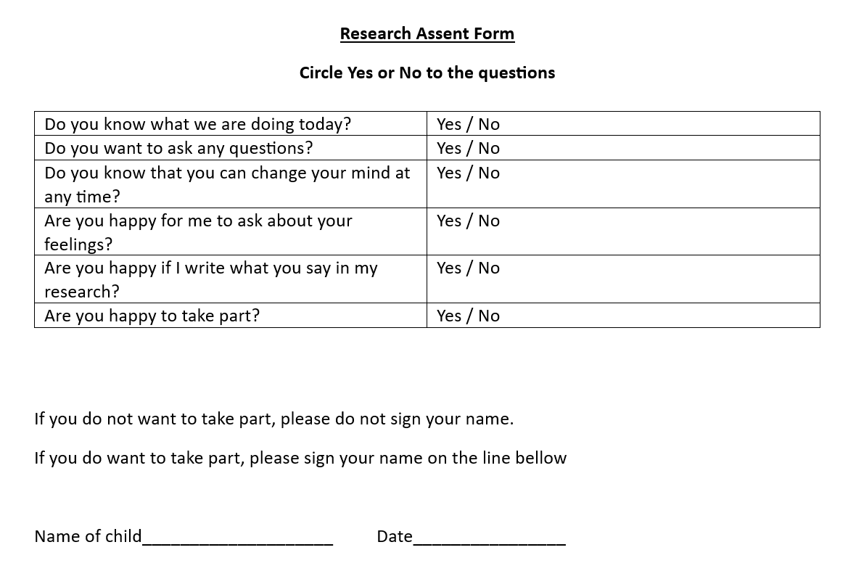

Appendix 4: Checklist used when carrying out the observations
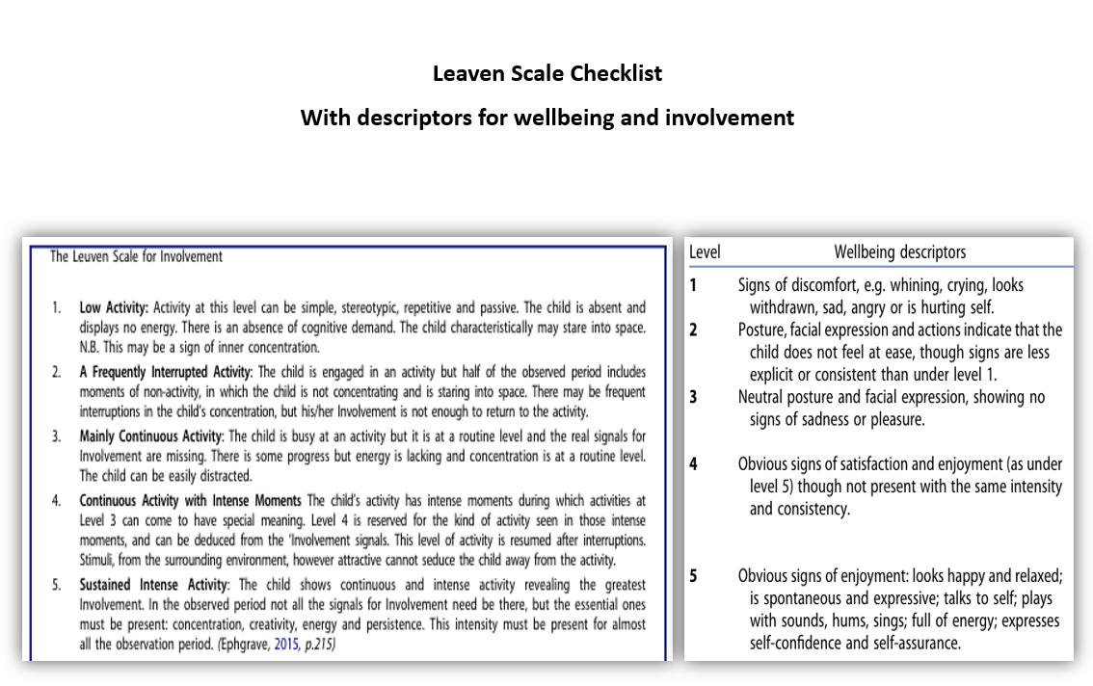
Appendix 5: Research Questions


