An Analysis of Swansea Office Supplies
Executive Summary
The examination of the Swansea Office Supplies dataset served as the basis for the report. The research uses a variety of Excel features, including IF, Pivot tables, charts, and graphs, to identify all locations with low profitability. Each function used in the report has been examined and discussed in this report. Finding the conditional analysis with the IF function is really helpful. The IF function was used as a condition to identify all of the locations with poor profitability or negative earnings. The data were then sorted using a pivot table. Summary statisticians, often known as pivot tables, provide a very useful comprehensive summary of the data. Then a bar chart was utilized to illustrate the data. We may quickly see the data summary in a bar chart. The paper then concluded with a few recommendations that highlight the limitation of these Excel functions

Table of Contents
Introduction 1
Main Findings 2
Excel 2
Conclusion 5
Recommendation 5
Reference 6

Introduction
In today's data-driven world, businesses are constantly generating and collecting massive amounts of data. However, having access to data alone is not enough; it needs to be pre-processed, analyzed, and visualized to derive meaningful insights for decision-making purposes. Microsoft Excel™ is a popular tool used by businesses worldwide for these purposes. Excel™ allows users to perform data manipulation, analysis, and visualization using a range of built-in features and functions. This report aims to explore the advantages of using Excel™ for pre-processing, analyzing and visualizing data for decision-making purposes. Excel is a tool or spreadsheet which is used to analyze data or used to visualize dataset. Microsoft excel gives the user to format, organize and calculate the dataset in a convenient way. Data analysts and other users can make information easier to examine as data is added or altered by organizing data using tools like Excel. (Guerrero, H., 2010). Some common function of MS Excel is SUM, Min and MAX, IF conditional function, Vlookup, Pivot table etc. Some of the common benefits of using MS Excel is that it gives the user easy access to store a huge data, to apply simple to advance level mathematical formulas, neat and clean visualization (Berk et al. 1998). This report has analyzed IF function, pivot table and charts that has been used to analyzed the Swansea Office Supplies data set. Their strengths and weaknesses has been analyzed.

Main Findings
This section will summarize the data from MS Excel, also each function that has been used to analyze the data and their strengths and weakness will be discussed.

Excel
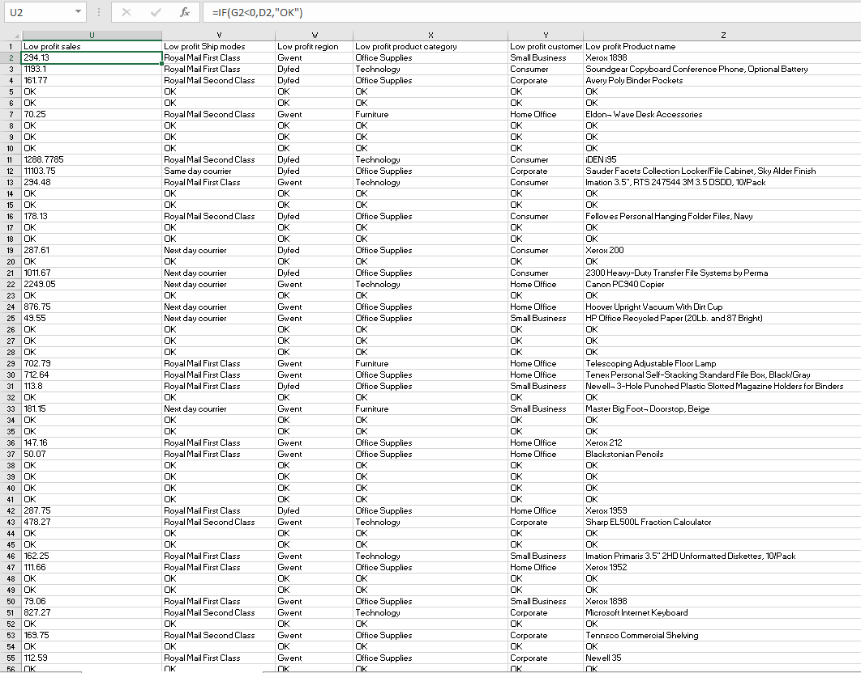

First function that was used to analyze the data was IF function. IF is a conditional function that shows logical comparisons between a value and expectations. There are two statements in IF functions (De Levie, R., 2004). If the comparison is true that will be the first result and if the comparison is false that will be second result. In the dataset, IF function has been used to find the low or negative profitability in each of the areas such as sales, ship modes, product category, profit region and product name. For example in low profit ship modes it can be seen that IF functions shows which ship modes has the low or negative profitability.
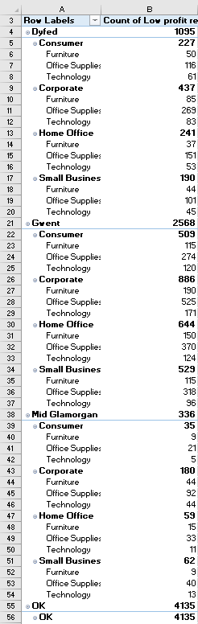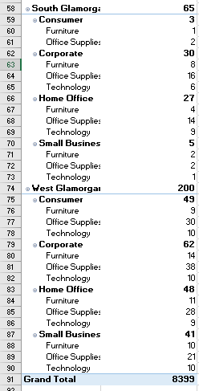The IF function is frequently used by financial analysts to review and analyze data by analyzing particular conditions. It is possible to evaluate text, values, and even mistakes using this function (Albright et al. 2014). In short it helps to summarize the data by some specific conditions. IF function organizes data with some specified criteria that helps in decision making purposes. In the data set we can see which shipping modes or which product name has low profitability. Also IF statement helps in pre-processing the data. As IF function is a conditional function that only helps to analyze the data in specific conditions. Also IF functions is not a great visualization method or summarization tool. We cannot find how many “Royal Mail First Class” ship modes have low profitability.

To summarize, sort, reorganize, count the whole data pivot table was used in the data set. A pivot table is a tool for summarizing data that is derived from larger tables (Dierenfeld et al. 2012). A pivot table's data summary may include sums, averages, or other statistics that the pivot table meaningfully groups together. The data set was sorted and summarized with a pivot table where we can see the low-profit product category count which sums up each low-profit customer segment and so on.
Pivot tables are crucial to data analysis (Daskalova) (2021). A dataset is random, uninformative data. The dataset pivot table (Kaula et al. 2018) summarized all IF function data, making data analysis easier. IF condition function reveals low or negative profit areas, yet data is fragmented. Summaries from pivot tables helped examine the data. Summary statistics help data analysts communicate a lot of information. Pivot tables condense big datasets into digestible tables (Clark et al. 2020). So from the figure, we can see the data at glance and find there are 9 pieces of furniture in the customer segment from West Glamorgan.
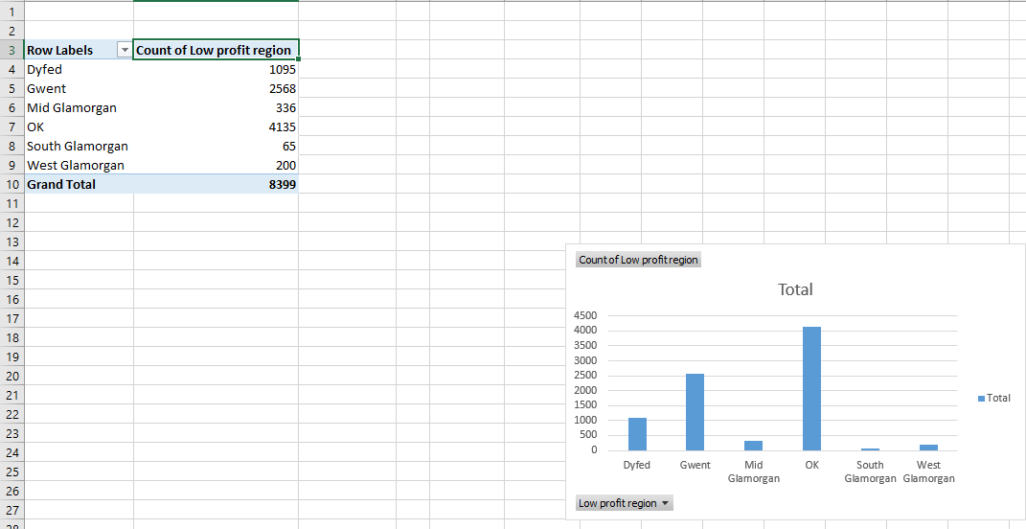

Chart is a graphical or visualization (Kumar et al. 2016) tool for any kind of data set. Low profit data region data set in shown by the chart in the figure. Chart can be multiple types such as bar chart, pie chart, line chart, scatter plot etc. In the figure bar chart has been used.
Charts can be a great way to analyze dataset (Golfarelli et al. 2020). You can compare various figures, comprehend how various components affect the overall, or examine patterns using a chart or graph. Charts and graphs can also be helpful for seeing data that deviates from what you're used to or for assisting in the understanding of group relationships. As the figure shows a bar chart (Foreman, 2013). We were able to summarize the data set as well as compare all the areas with one another. In the figure we compared the number of low profitability and profit region. We can see at a glance which area has the highest value and which has the lowest. The main weakness of this chart was that it cannot show more than two comparisons. So we cannot visualize all the areas with low profitability.

Conclusion
In conclusion, this report has highlighted the importance of data analysis in today's business environment and explored the advantages of using Microsoft Excel™ for pre-processing, analyzing, and visualizing data for decision-making purposes. Through a review of academic literature and case studies, this report has demonstrated that Excel™ is a versatile and powerful tool that can help businesses to derive meaningful insights from their data. The report has shown that Excel™'s built-in features and functions such as SUM, AVERAGE, and COUNT provide a quick and easy way to summarize and analyze data. Additionally, Excel™'s ability to perform calculations and apply functions based on specified conditions using IF functions, adds an extra layer of analysis capability. However, these functions alone cannot show everything, and businesses should also make use of other functions such as pivot tables, which provide a more flexible and powerful way to summarize data. To do the data analysis, three different functionalities of MS Excel (Swanson Church et al. 2021) were used. The IF function, a pivot table, and a chart are the three functions that are listed here. Conditional functions based on IF helped simplify the process of locating all the locations with low profitability. The data set was easily structured with the use of IF functions. The data were then restructured and categorized in a manner that was more relevant thanks to the pivot table. The pivot table provides game summary statistics that allow us to have a profound understanding of the data (Green, 2017). And finally, the last chart assisted in simplifying the visualization of the data in order to facilitate data comparison. The report has also highlighted the importance of data visualization in deriving insights from data. Visualizations such as bar charts, line charts, scatter plots, and pie charts, can help to identify patterns, trends, and relationships in the data. However, businesses should be cautious in selecting the appropriate chart type based on the nature of the data and the insights required.

Finally, the report has emphasized the importance of providing training to employees on the use of Excel™ to optimize data analysis processes. Proper training can help employees to work more efficiently and effectively, leading to more accurate and insightful data analysis. In conclusion, Microsoft Excel™ is a powerful tool that can help businesses to derive insights from their data. By following the recommendations outlined in this report, businesses can optimize their use of Excel™ and make more informed decisions based on data insights. In today's competitive business environment, the ability to make data-driven decisions is crucial, and Microsoft Excel™ is an essential tool for achieving this goal.

Recommendation
Based on the analysis and findings presented in this report, several recommendations can be made to businesses looking to optimize their use of Excel™ for data pre-processing, analysis, and visualization. Firstly, businesses should make use of Excel’s built-in functions such as SUM, AVERAGE and COUNT, as these functions provide a quick and easy way to summarize and analyze data. However, it is important to note that these functions alone cannot show everything, and businesses should also make use of other functions such as IF to show conditions. These three functions summarize the data perfectly (Carlberg, 2017). Though these functions alone cannot show everything as the IF function is great to show conditions. But IF functions cannot show any count or do not summarize the data. A pivot table is a great summarization tool, but it does not update automatically, and it also can be time-consuming to use (Fisher et al. 2012). A bar chart was used in the analysis. As bar chart only compared two kinds of variables. Secondly, businesses should consider using pivot tables for data summarization. Pivot tables provide a more powerful and flexible way to summarize large amounts of data and allow users to filter and sort data based on specific criteria. However, it is important to note that pivot tables do not update automatically, and businesses should ensure that they update their pivot tables regularly to ensure that they are accurate and up to date. Thirdly, businesses should consider using a range of chart types for data visualization. While bar charts are a useful tool for comparing two variables, they may not be suitable for all types of data. Businesses should consider using other chart types such as line charts, scatter plots, and pie charts depending on the type of data they are working with. Finally, businesses should ensure that their employees are trained in the use of Excel™ and understand how to use its features and functions effectively. Training can help employees to work more efficiently and can lead to more accurate and insightful data analysis. Excel™ is a powerful tool for data pre-processing, analysis, and visualization, and businesses can derive significant benefits from using it effectively. By following the recommendations outlined in this report, businesses can optimize their use of Excel™ and make more informed decisions based on data insights.

References list
- Albright, S.C. and Winston, W.L., 2014. Business analytics: Data analysis & decision making. Cengage Learning.
- Berk, K.N. and Carey, P., 1998. Data analysis with Microsoft excel. Pacific Grove, CA: Duxbury Press.
- Clark, D. and Clark, D., 2020. Data analysis with pivot tables and charts. Beginning Microsoft Power BI: A Practical Guide to Self-Service Data Analytics, pp.277-304.
- Carlberg, C., 2017. Predictive Analytics: Microsoft® Excel 2016. Que Publishing.
- Daskalova, D. (2021) What is a pivot table? A user-friendly guide, CareerFoundry. Available at: https://careerfoundry.com/en/blog/data-analytics/what-is-a-pivot-table/ (Accessed: January 24, 2023).
- De Levie, R., 2004. Advanced Excel for scientific data analysis. Oxford University Press, USA.
- Dierenfeld, H. and Merceron, A., 2012. Learning analytics with excel pivot tables.
- Foreman, J.W., 2013. Data smart: Using data science to transform information into insight. John Wiley & Sons.
- Green, D., 2017. The best practices to excel at people analytics. Journal of Organizational Effectiveness: People and Performance.
- Golfarelli, M. and Rizzi, S., 2020. A model-driven approach to automate data visualization in big data analytics. Information Visualization, 19(1), pp.24-47.
- Guerrero, H., 2010. Excel data analysis. Modeling and simulation.
- Kaula, R. and Kaula, R., 2018. Analyze data with excel power pivot: A tutorial. International Journal of Information, Business and Management, 10(4), pp.102-116.
- Kumar, O. and Goyal, A., 2016, February. Visualization: a novel approach for big data analytics. In 2016 Second International Conference on Computational Intelligence & Communication Technology (CICT) (pp. 121-124). IEEE.
- Swanson Church, K., Riley, J. and Schmidt, P.J., 2021. Has Excel Become a Golden Hammer: The Paradox of Data Analytics in SME Clusters. Journal of Emerging Technologies in Accounting.
- Fisher, D., DeLine, R., Czerwinski, M. and Drucker, S., 2012. Interactions with big data analytics. interactions, 19(3), pp.50-59.
- Harris, R., & Sim, B. (2020). Excel for scientists and engineers. CRC press.
- Langer, A. M. (2021). Microsoft Excel for accountants. John Wiley & Sons.
- O'Brien, J. A., & Marakas, G. M. (2017). Management information systems. McGraw-Hill Education.

