

Danielle Humphries
1910878

Module ACBA4006

Material Science and Building Services

Contents
Introduction……………………………………………………………………Page 3
The Empire State Building Structure ………………………………………Page 4
Durability……………………………………………………………………….Page 5
Advantages….….. …………………………………………………………... Page 7
Adaptability…………………………………………………………………….Page 8
56 Leonard Street……………………………………………………………..Page 8
Durability……………………………………………………………………….Page 10
Adaptability…………………………………………………………………….Page 11
Conclusion…………………………………………………………………….Page 12

Introduction
For my case study I will be researching two buildings from around the world, looking at the overall construction of both buildings and comparing & contrasting the two. One building will be constructed with steel the other with concrete.
I have decided to base my cases study on two buildings in New York City, America. I chose these buildings to compare as they both come across the same daily elements from season to season. I find this will be a good way to compare rather than using two buildings from different parts of the world that experience two completely different climates.
The steel structure I have chosen is The Empire State Building (fig.1) located on 34th Street, Midtown Manhattan and was once the world’s tallest building.
The concrete structure I have chosen is 56 Leonard Street, Tribeca Lower Manhattan (Fig.2). Known as the Jenga Building and is a residential building.

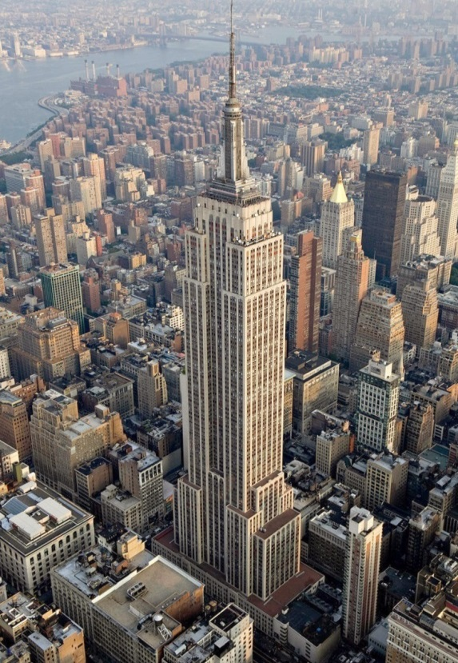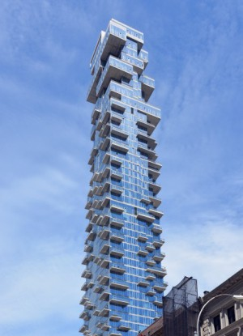
(fig.1) (fig.2)

The Empire State Building USA
Construction began on The Empire State Building in March 1930, under the watchful eye of architect’s Shreve, Lamb and Harmon Associates standing at 1495ft tall with a total of 103 floors with the framework rising by 4 ½ floors per day during construction. In 2009 the building underwent a $106 million energy efficiency retrofit project which resulted in the building becoming one of the world’s most sustainable buildings. In 2011 the building was awarded gold Leadership in Energy and Environmental Design rate certificate.
(www.designingbuildingempirestatebuilding.co.uk, 2018)
Steel Structure
The structure of The Empire State Building is made up of 60,000 tons of steel, 720 tons of Aluminium and stainless steel. Steel columns and beams form a 3D grid throughout the structure and only took 1 year and 45 days to build. (fig.40
(www.pbs.org/wgbh/buildingbig/wonder/structure/empire_state, 2001)

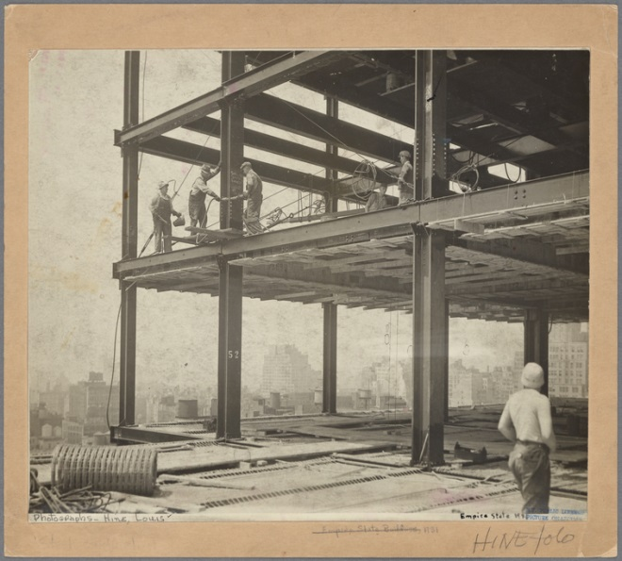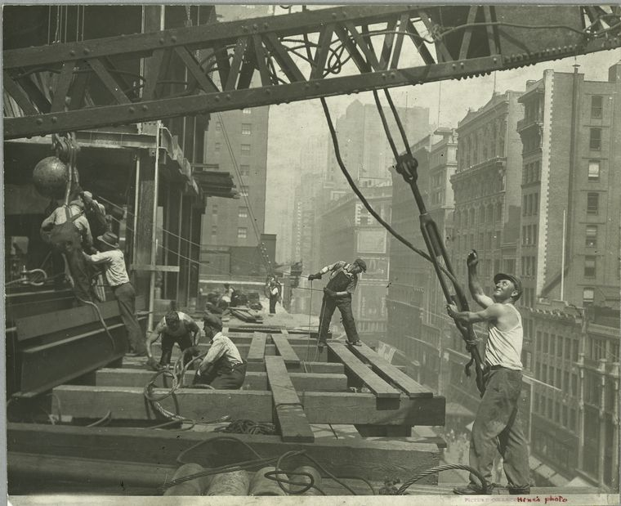(The New York Public Libuary, 2020)
(fig.3) (fig.4)
The construction of the Empire State Building was managed on a strict schedule, with 3,500 working on the building. The beams and stonework was made off site and delivered ready to be fitted by the large work force. A series of hoists and narrow-gauge tracks moved the pieces into place and from floor to floor. (Grabianowski, 2014)
The Empire State Building was one of the first to use Gantt (fig5) charting during the construction I have attached a picture below showing the actually Gantt chart used for the build.
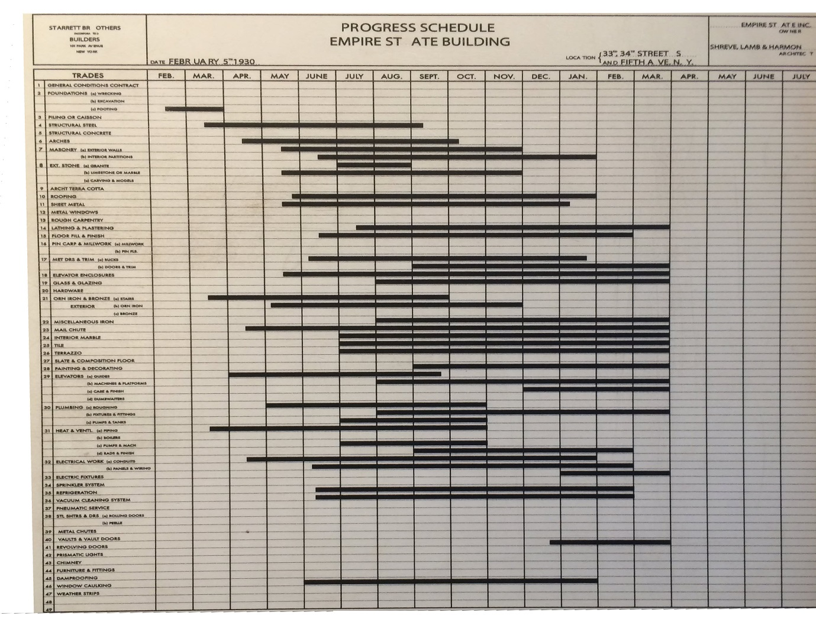
(designingbuildings, 2018) (fig.5)
Durability
The steel structure of the building consists of 60,000 tons of steel that was protected in the mill by Iron Oxide and Linseed Oil paint coat and covered with an asphalt coat to resist it from breakdown when the steel comes into contact with concrete. Cinder concrete was used around the steel meaning the building was not only strong but also fireproof. (Penafiel, 2006)
In 1945 a B-25 bomber crashed into the 78th and 79th floors while traveling at 200 miles an hour causing 18 feet wide and 20 feet high hole in the side of the building however the structural integrity was not affected by the crash. (Editors, 2019)(fig.6,7)
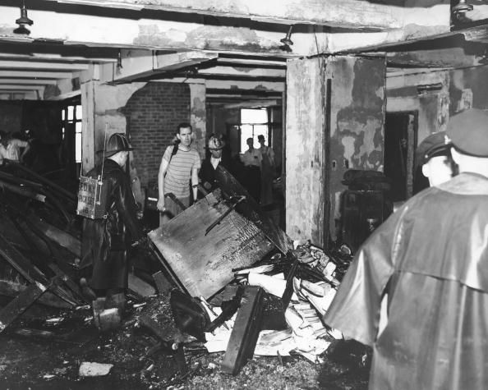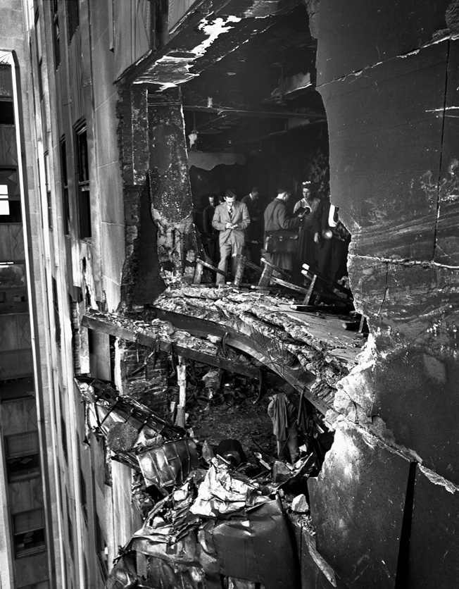
(Webb, 2019) (fig.6) (fig.7)
The plane hit the north side of the building at the 70th floor, flaming fuel poured through the entire 79th floor and down the stairwells. Although the damage was extensive and it cost nearly $1 million dollars to fix the design and structure of the building meant that the building excluding the 79th floor opened for business just 3 days after the crash.
Many people have different opinions on how long The Empire State Building will last, my research shown people to believe that the building would last anything between 100 – 1000 years. Archival material by Morris Jacks a consulting engineer who was hired to appraise the building for tax purposes. I came across a testimony that Jacks gave to the New York Supreme Court where he told the court the building wouldn’t be functioning in 60 years time however he wasn’t refereeing to the structure he was refereeing the to functionality of the building, he believed the steel would be structurally sound for well over 100 years. (Williams, 2013)
Most buildings have a design life expectancy of 50 years but it is not uncommon for larger structures to have a design life of around 100 years.
Home Insurance Building (fig.8) in Chicago was the world’s first steel structured skyscraper standing at 5 stories high but rose to 10 stories in 1891 and stood tall at 138 feet. Very small compared to the skyscraper of today however was a landmark building of its times. Built in 1884-1885 the building was then demolished 46 years later in 1931. (First Skysraper, 2020)
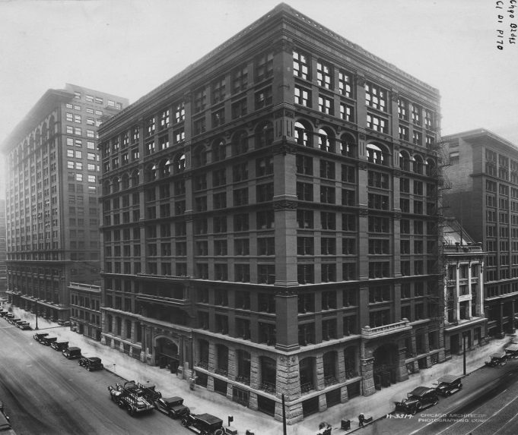 (Bellis, 2020) (fig.8)
Advantages:
- There are many benefits from using a steel structure first is the tensile strength; it has a high strength the weight ratio. Steel sections will be small and lightweight however large the overall structure.
- Can be fabricated off site and made to measure then delivered to be fitted onsite on a large scale, saving time and space onsite.
- Very flexible and can be moulded into different forms such as sheet metals or wired metal.
- Durability, steel can withstand a lot of pressure from the building itself and from the outside elements such as earthquakes, thunderstorm’s and cyclones.
- Recyclable, steel doesn’t lose quality each time it is recycled unlike other materials
Disadvantages:
- Steel is susceptible to corrosion
- Steel isn’t fireproof so needs to be fireproofed
- Can lose its properties in high temperature’s and has a high expansion rate in changing temperatures
- Possible buckling, the higher the length of the steel column the more chance you have of the steel buckling (northan welder, 2018)
- Steel conducts heat and cold so isn’t good from an insulation point
Adaptability
The Empire State Building as you know from above was constructed in a short amount of time for such a large skyscraper and in today’s times the workmen would have assess to a lot more along with new mechanical equipment used in the industry today compared to what was available in 1930. In a bid to keep the crown of Worlds Tallest skyscraper a proposed plan was put in place to demolish the 16 – story tower and replace it with a new top section to increase the height to 133 stories and 1495 feet. The idea was the dropped due to cost and concerns that this would destroy the buildings iconic look. (E, 2018)

56 Leonard Street – Jenga Tower
Anish Kapoor collaborated with Herzog & de Meuron to design this iconic building in New York’s Tribeca district. 56 Leonard Street (fig.9) is a reinforced concrete construction that stands at 830ft with 60 floors and 145 apartments including ten glass penthouse apartments.
Construction on began on the Jenga Tower in 2008 when foundations where laid however due to funding the project was put on hold. Construction restarted again in 2012 and the building was completed in 2017.
The building has a concrete core and flat-plate slabs that are supported by concrete column’s and shear walls. The reinforced concrete core acts as the main spine of the tower and is located at the centre of the building. No two consecutive floors are the same due to the shifting of volumes when stacking. Structural engineer Silvian Marcus has designed something he calls ‘walking walls’ as each floor only has 2 supporting walls between floors that transfer the load between them.
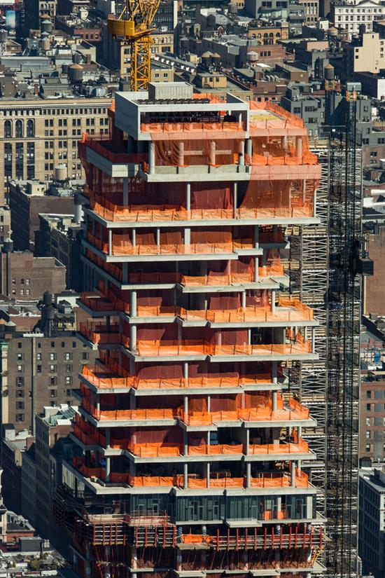 (the b1m, 2020) (fig.9)
The central core of the building is attached to the outer columns by the stabilizers 32 and 46; the top floor has a pool filled with 130,000 litres of water that acts as a buffer to temper with any movement that the building may experience during high winds. (wikiarquitectura)
The foundations of the building consist of 1,500, 24 inch diameter caissons socketed into bedrock and 180 ton end-bearing H piles, the length of these vary between 90 – 110 feet below cellar level. 5 ft deep reinforced concrete caps structurally connect these together. (Silvian Marcus, 2016)
High strength concrete of up to 12,000 psi was used for the lower parts of the tower and 7,000 psi at the top of the tower. In edition to the compressive strength, larger modulus elasticity of concrete was required to increase the lateral stiffness of the core without thickening the walls with a premium concrete with a higher compressive strength. (Silvian Marcus, 2016)

Durability
Durability and sustainability go hand in hand, you cannot have one without the other and they are now at the forefront of any building construction. We see many concrete structures from around the world that have had a long life span such as The Pantheon (fig.10) in Rome which is believed to have bee built in 113 – 125 AD and still stand today.
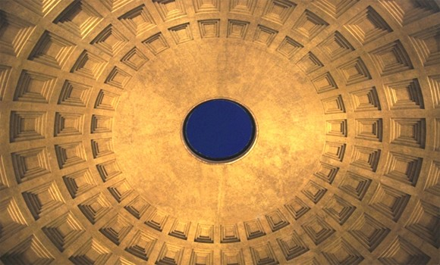 (roma, 2013) (fig.10)
Ingalls Building in Cincinnati, Ohio (fig.11) was the first ever reinforced concrete skyscraper in the world. Construction as completed in 1903 and is still in use today.
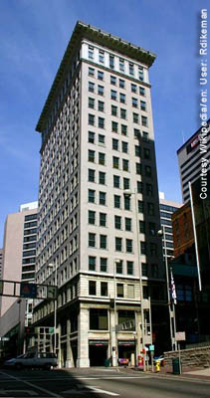 (asce, 2020) (fig.11)
When designing the Jenga building one of the main considerations was the tendency to ways due to the building being skinny, especially at higher level during high winds. Engineers increased the rigidity of the structure by connecting columns to core floors with outriggers and belt walls that wrap the perimeter and they installed a water tank containing 130,000 of water on the 56th floor to help dampen the buildings movement during high winds. (F, 2017)
Adaptability
The construction of the Jenga building was seems challenging due to the footprint of the building the many cantilever’s and significant height. The building took 9 years on total to complete this wasn’t due to the design it was due to funds. The building shows it’s structural bones and doesn’t obscure the method of the construction under any cladding. (wikiarquitectura, 2020)
The Jenga Building is build in a height restricted historic district of Manhattan surrounded by low rise buildings, the site was previously occupied by a law school and is exempt from the height regulations. While this is good for the people living in the building it does limit any future adaptions to the structure due to the footprint being small there is no scope to adapt outwards and the height restriction impacts anything higher. (Fred, 2017)

Advantages:
- Economical, concrete is inexpensive and widely available around the world and cheap to produce
- Has the ability to be cast into various shapes
- Water resistant, concrete is a good material to be used around and in water
- High temperature tolerance, concrete can withstand heat temperatures as high as 910 deg C
- Low maintenance required, does not require any protection from weather
- Naturally fireproof (P, 2016)
Disadvantages:
- Tensile strength can be low can become less ductile
- High in weight compared to its strength
- May contain soluble salt which can cause efflorescence
- Framework is required at some point whether it is reinforced or cased
- Long curing time, specified compressive strength in 28 days
- Shrinkage (CivilEngineeringTutor, 2016)
- Strick Quality Control
Conclusion
New York was the city I chose to base my assignment on. It is known as the concrete jungle.I researched the Empire State Building and the Jenga building. I decided to compare two within the same city to make sure the comparison for cost, weather conditions, time and legislation would be similar if not the same. As you can see from above the Empire State Building is in fact the most sustainable building in the world which is remarkable given its age.
As you can see there are many advantages and disadvantages when using steel and concrete in construction, even though they have different advantages and disadvantages they are both a really good choice when constructing in New York. Both buildings are sustainable; both can withstand the different weather conditions New York experiences through the 4 seasons. Cost and time of the construction are very different however this is down to the fact one was build in the 1930s and the other within the last decade meaning different Health and Safety regulations, different building regulations and the cost and availability of different materials are going to be considerably different.
So my conclusion after my research is that both concrete and steel are both as good a material when building a high rise in New York City as each other. They seem to have similar life spans and also work very well together as One World Trade Centre building shows as it is a composite building which is made up of a reinforced concrete core, steel columns and steel floor spanning. (skyscrapercentre.com)

Bibliography
(n.d.). Retrieved January 6, 2020, from wikiarquitectura: https://en.wikiarquitectura.com/building/56-leonard-street/
(2013). Retrieved January 12, 2020, from roma: https://romeonsegway.com/10-facts-about-the-pantheon/
(2018, October 23). Retrieved January 2020, 3, from designingbuildings: https://www.designingbuildings.co.uk/wiki/File:Empiregantt.jpg
(2018, January 4). Retrieved January 4, 2020, from northan welder: http://northern-weldarc.com/advantages-disadvantages-structural-steel-structures/
(2020). Retrieved January 2020, 3, from The New York Public Libuary: https://digitalcollections.nypl.org/collections/photographs-of-the-empire-state-building-under-construction#/?tab=about&scroll=15
(2020). Retrieved January 6, 2020, from the b1m: https://www.theb1m.com/video/building-56-leonard-new-york-s-jenga-tower
(2020). Retrieved Jauary 12, 2020, from asce: https://www.asce.org/project/ingalls-building/
(2020). Retrieved January 12, 2020, from wikiarquitectura: https://en.wikiarquitectura.com/building/56-leonard-street/
Bellis, M. (2020, January 10). thoughtco.com. Retrieved January 13, 2020, from thoughtco: https://www.thoughtco.com/how-skyscrapers-became-possible-1991649
CivilEngineeringTutor. (2016, October 22). Retrieved January 9, 2020, from engineeringcivil: https://engineeringcivil.org/articles/concrete/limitations-concrete-disadvantages-concrete-8-reasons/
E, A. (2018, August 22). Retrieved January 12, 2020, from history: https://www.history.com/news/10-surprising-facts-about-the-empire-state-building
Editors, H. (2019, July 28). history.com/this-day-in-history. Retrieved December 20, 2019, from History : https://www.history.com/this-day-in-history/plane-crashes-into-empire-state-building
F, M. (2017, August 2). Retrieved January 12, 2020, from theb1m: https://www.theb1m.com/video/building-56-leonard-new-york-s-jenga-tower
First Skysraper. (2020). Retrieved January 13, 2020, from guninnusesworlrecords: https://www.guinnessworldrecords.com/world-records/first-skyscraper/
Fred, M. (2017, August 2017). Retrieved January 13, 2020, from theb1m.com: https://www.theb1m.com/video/building-56-leonard-new-york-s-jenga-tower
Grabianowski, E. (2014). Retrieved January 4, 2020, from science how stuff works: https://science.howstuffworks.com/engineering/structural/empire-state-building.htm
P, A. (2016, October 20). Retrieved January 9, 2020, from civildigital: https://civildigital.com/10-advantages-concrete-construction-material-concrete/
Penafiel, K. (2006, 6 28). Retrieved January 3, 2020, from buidlings.com: https://www.buildings.com/article-details/articleid/3180/title/the-empire-state-building-an-innovative-skyscraper
Silvian Marcus, P. F. (2016, June). Retrieved January 6, 2020, from structure mag: https://www.structuremag.org/?p=10039
Webb, M. B. (2019). Retrieved January 3, 2020, from warfare history: https://warfarehistorynetwork.com/2018/12/17/the-b-25-empire-state-building-crash-tragedy-on-34th-street/
Williams, M. (2013, May 28). the shelf life of the empire state building. Retrieved January 12, 2020, from americanhistory.si.edu: https://americanhistory.si.edu/blog/2013/05/the-shelf-life-of-the-empire-state-building.html
wtc.com/about. (2019). Retrieved 12 16, 2019, from wtc.com.
www.designingbuildingempirestatebuilding.co.uk. (2018, October 24). Retrieved December 19, 2019, from www.designingbuildings.co.uk: https://www.designingbuildings.co.uk/wiki/Empire_State_Building,_New_York
www.pbs.org/wgbh/buildingbig/wonder/structure/empire_state. (2001). Retrieved December 19, 2019, from www.pbs.org: https://www.pbs.org/wgbh/buildingbig/wonder/structure/empire_state.html
www.skyscrapecenter/building/56leonard/884.com. (2019). Retrieved December 16, 2019, from www.skyscrapercenter.com.
www.wtc.com/about/buildings. (2019). Retrieved December 16, 2019, from www.wtc.com: https://www.wtc.com/about/buildings/1-world-trade-center

