Ishrat Rehman 2118374
Robert Nartowski
BMHP5014 – Birm
Changemakers: Creativity and Value Creation

Contents Page

Title Page………………………………………………………………………………1
Contents Page…………………………………………………………………………2
Elevated Pitch………………………………………………………………………….3
Explanation of Elevated Pitch………………………………………………………..4
Poster…………………………………………………………………………………...6
Explanation of Poster………………………………………………………………….7
References ……………………………………………………………………………..9

Pitch

Hello, my name is Ishrat, and I am part of the Birmingham Obesity Society – B.O.S. I would like to thank you all for your attendance, it is greatly appreciated and shows your commitment to try to eradicate a growing problem. I’m positive that we can come together and tackle a life-threatening illness that is becoming more wider and costlier by the day. I am of course talking about obesity. £6 billion pounds are spent yearly on obesity, according to Department of Health and Social Care (2022) this is set to rise to £9 billion by 2050. As well as the monetary cost, the human cost is also increasing. Public Health England (2017) have conducted research and found that obesity is responsible for over 30,000 deaths each year. Just over 1 million people who were admitted into hospital were as a result of obesity, this figure has doubled over the past five years (Holmes, 2021). Obesity, according to the World Health Organisation (2021) kills 2.8 million people worldwide each year and is a growing epidemic that needs to be eradicated. These statistics are frightening. A change needs to be made in order for the monetary and human cost to decrease. This is why today I would like to discuss our initiative – Healthy Active Lifestyle H.A.L. Having a healthy active lifestyle can significantly reduce the risk of obesity and the effects of obesity. Obesity can affect anyone from any demographic, whether they are old or young, rich, or poor, and it is also not limited to a single ethnicity group. Childhood obesity has risen significantly in recent years, NHS Digital (2017) has reported that more and more children are entering school aged 5 with early indications of obesity, roughly 1 in 3 children leave primary school aged 11 with obesity. What can be done? Well, we are here to initiate and enable a change. H.A.L will not only focus on early intervention but also work with communities to provide support for their members to make positive healthier changes to their lifestyle, this means working with people who have obesity, are at risk of obesity or those who want to use our programmes as a preventative measure. What differentiates B.O.S from other organisations? We will offer a wide range of services under one umbrella. We will offer catered programmes such as early years nutritional information, giving parents ideas of what healthy foods they can incorporate into their children’s diet. We will offer adult healthy cooking classes, exercise classes and mental health support. The different communities in our areas will be able to adapt the programmes to suit their lifestyle, making them easily accessible. The programmes will be delivered in a variety of languages, ensuring that no one is left without valuable information. Investment is greatly needed for this intervention to take place, the Local Government Association has a budget of £4.5 million which is used for obesity, we’re asking to be considered for a small yet impactful amount so that we can enable people to implement a healthy active lifestyle for a better future (LGA, 2021).
Elevated Pitch – Explanation
Marketing is essential when looking to ask for funding. A speech alone cannot guarantee monetary investment. The target audience for the pitch are members of the Local Government Association – LGA – and the Integrated Care Systems – ICSs – who allocate the healthcare budget and work in partnership with other services (NHS England, 2022). It is essential that the environment is suitable for the event, a venue central to the city will be booked for an evening casual dinner with various taster sessions. Attendees will be provided with information packs with the organisations mission statement, statistics, and a S.W.O.T analysis on obesity. How and where the funding would be allocated and spent will also be provided in a short hard copy form. Detailed information will be provided in a digital form so to not only promote sustainability but also giving a full breakdown of information with a transformation plan. Attendees will have the opportunity to engage with taster sessions of cooking classes, exercise classes and will hear how parents will be supported with instilling healthy eating habits for their children. An obesity simulation suit will be available for attendees to try on, this can give them an idea on what it is like living with obesity and how it is impactful on just daily activities, research suggests that this can lead to participants feeling empathy (Herrmann-Werner et al 2019). The benefits of the online forum will also be demonstrated.
The NHS is currently overwhelmed, the waiting times for obesity referrals are 18 weeks (NHS, 2019). The services are in demand and hard to access. The Healthy Active Lifestyle programme will cut waiting times as individuals will not require a referral from the GP, instead it will just be a matter of calling in to make an appointment. Working in partnership with other organisations can ensure better support and sustainable approaches, ensuring that the programme serves the needs of the community. Initially members will have weekly meetings, once their progress is steady and consistent, they will have fortnightly meetings. Once it has been established that individuals are successfully following the programme and having consistent weight loss, meetings will be reduced, however they will still be able to attend the drop-in sessions.
The initiative has many benefits as the strain will be reduced on the NHS. Obesity and related illnesses will be significantly reduced. Currently 3 in 5 adults are at risk of obesity related illnesses (Throup, 2022). The success of the programme will reduce the pressure on the NHS and their services. They will no longer be overwhelmed, and excess funding can be used in another target area. Costs relating to obesity will be reduced, and in the long term society will be healthier, leading to more active people, living longer but healthier, a ripple effect will be caused that can positively impact society, potentially saving the £27 billion it costs society. Related illnesses will also reduce and funding that is spent on such can be diverted. Projected outcomes will be provided to attendees that will show the positive impact the initiative can have, greatly reducing not only the human cost but also the monetary costs.

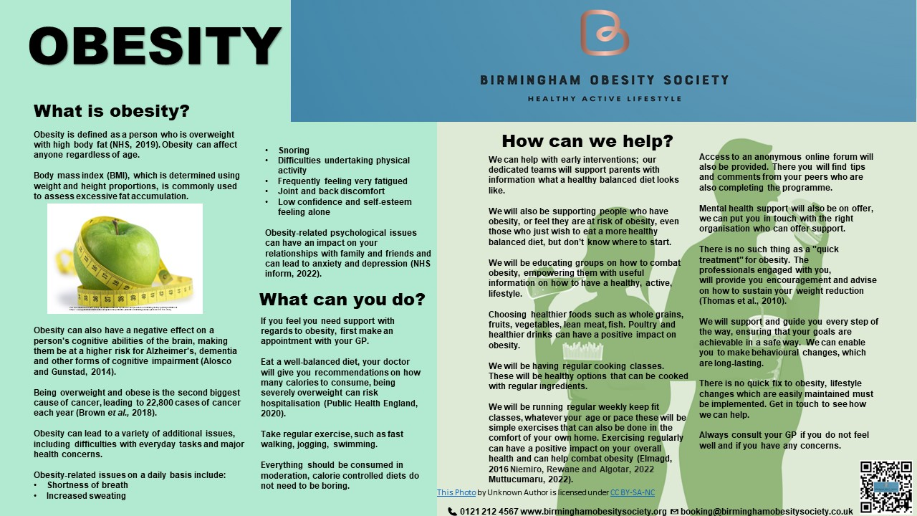
Alosco, M. L., Spitznagel, M. B., & Gunstad, J. (2014). ‘Obesity as a risk factor for poor neurocognitive outcomes in older adults with heart failure’. Heart failure reviews, 19(3), 403–411. https://doi.org/10.1007/s10741-013-9399-2 (Accessed: 6 February, 2023)
Brown, K.F., Rumgay, H., Dunlop, C., Ryan, M., Quartly, F., Cox, A., Deas, A., Elliss-Brookes, L., Gavin, A., Hounsome, L. and Huws, D. (2018). ‘The fraction of cancer attributable to modifiable risk factors in England, Wales, Scotland, Northern Ireland, and the United Kingdom in 2015’. British journal of cancer, 118(8), pp.1130-1141.
Elmagd, M. A., (2016). ‘Benefits, need and importance of daily exercise’. Int. J. Phys. Educ. Sports Health, 3(5), pp.22-27. (Accessed: February 7, 2023).
Muttucumaru, N., (2022) Lancashire Post piece posted on 15 Feb 2022, NM Health Innovations RSS. Available at: https://www.nmhealthinnovations.co.uk/News/317791cd-09a9-48b9-86cd-097d5e96910e (Accessed: February 14, 2023).
myqrcode.com. (n.d.). My QR Code - QR Code Generator. [online] Available at: https://myqrcode.com/app/editor/customize?preview=qrCode&id=a57a14e7-a1ff-44bc-8828-6b63467d7c0b (Accessed 16 Feb. 2023).
NHS Choices (2019) Obesity. NHS. Available at: https://www.nhs.uk/conditions/obesity/ (Accessed: February 7, 2023).
NHS Choices (2019) Obesity. NHS. Available at: https://www.nhs.uk/conditions/obesity/ (Accessed: February 7, 2023). ]
NHS Inform (2022) Obesity causes and treatments (2022) causes & treatments - Illnesses & conditions | NHS inform. NHS Health Scotland. Available at: https://www.nhsinform.scot/illnesses-and-conditions/nutritional/obesity/#treating-obesity (Accessed: February 14, 2023).
Niemiro GM, Rewane A, Algotar AM. (2022) Exercise and Fitness Effect On Obesity.Treasure Island (FL): StatPearls Publishing; 2022 Jan-. Available from: https://www.ncbi.nlm.nih.gov/books/NBK539893/ (Accessed: February 8, 2023).
Public Health England (2020) New voluntary calorie guidelines to help industry tackle obesity, GOV.UK. Available at: https://www.gov.uk/government/news/new-voluntary-calorie-guidelines-to-help-industry-tackle-obesity (Accessed: February 7, 2023).
Throup, M. (2022) New campaign launch reveals 6 major health benefits to losing weight, GOV.UK. Available at: https://www.gov.uk/government/news/new-campaign-launch-reveals-six-major-health-benefits-to-losing-weight (Accessed: February 14, 2023).

Leaflet Explanation
A new health initiative can only be successful if there is a good advertising campaign. Should the initiative implement a good visual and social media marketing campaign it can enable that the campaign has social impact, it will also be able to persuade the target service users to adopt a healthy lifestyle (Liao, 2020). The leaflets will be distributed to all local healthcare centres, GP surgeries, community groups and halls, and will also be provided to health visitors. A3 size posters will also be placed in areas of worship, GP surgeries, hospitals, and all local government buildings. Digital ads will be played on any screens that are available in the buildings too. Localised billboard ads with the slogan ‘healthy active lifestyle’ will be projected to the community. Locally targeted ads on Google, Instagram, Facebook and TikTok with a ‘swipe up’ feature for bookings to be made, will also be implemented, this will not only maximise the impact of the campaign but can also be sustainable. Maximising the benefits of online advertisements can be beneficial. Searches for the slogan will lead the potential services users to the website. Similarly, having a visually appealing leaflet can gain attention, leading to interest being garnered. The leaflet will be made available in a variety of languages maximising the availability. A QR code on the posters and leaflets will lead people to the slogan and a link to the website booking page, digitalising information makes it easier to access should there not be any leaflets available (Karia, Hughes, and Carr, 2019). Any organisation who requires copies of the leaflet will be able to place orders for the amount and languages they require, this will minimise wastage and promote sustainability.
GP surgeries will be asked to email the leaflet to their service users, with a link to the website, where potential users will be asked to answer several short questions and be booked in for a phone consultation with a healthcare professional. The healthcare professional will the assess the service users’ needs and requirements. Should they be successful, they will be sent out a welcome pack in their chosen language, digitally, or a hard copy. Once this process has been completed, each member will be given an individual dietary plan and dates and times of when the sessions will be held, their targets will be noted on their plans, and they will also have the opportunity to attend any extra drop-in sessions. Weigh in and measurement sessions will be conducted monthly. Individuals will have the opportunity to book in for some peer support and will also have access to an anonymous online forum chat where they can interact safely with other members. The online forum will have a moderator in place, this means that prior to any posts being added they will be monitored and approved if suitable. Each member will have their own unique log in, ensuring that only invited members are allowed access.
A new healthcare campaign that is successful can be beneficial to society and to the overall population.

References
Alosco, M. L., Spitznagel, M. B., & Gunstad, J. (2014). ‘Obesity as a risk factor for poor neurocognitive outcomes in older adults with heart failure’. Heart failure reviews, 19(3), 403–411. https://doi.org/10.1007/s10741-013-9399-2 (Accessed: 6 February 2023).
Brown, K.F., Rumgay, H., Dunlop, C., Ryan, M., Quartly, F., Cox, A., Deas, A., Elliss-Brookes, L., Gavin, A., Hounsome, L. and Huws, D. (2018). ‘The fraction of cancer attributable to modifiable risk factors in England, Wales, Scotland, Northern Ireland, and the United Kingdom in 2015’. British journal of cancer, 118(8), pp.1130-1141.
Bryan, C., Broussard, L. and Bellar, D., (2013). ‘Effective partnerships: how school nurses and physical education teachers can combat childhood obesity’. NASN School Nurse, 28(1), pp.20-23. (Accessed: 10 February 2023).
Department of Health and Social Care (2022) New obesity treatments and technology to save the NHS billions, GOV.UK. GOV.UK. Available at: https://www.gov.uk/government/news/new-obesity-treatments-and-technology-to-save-the-nhs-billions#:~:text=Obesity%20costs%20the%20NHS%20a,spent%20on%20key%20frontline%20services. (Accessed: 11 February 2023).
Elmagd, M. A., (2016). ‘Benefits, need and importance of daily exercise’. Int. J. Phys. Educ. Sports Health, 3(5), pp.22-27. (Accessed: 7 February 2023).
Gut Microbiota for Health. (2018). An update on the role of prebiotics and probiotics in controlling obesity. [online] Available at: https://www.gutmicrobiotaforhealth.com/update-role-prebiotics-probiotics-controlling-obesity/ (Accessed 14 February 2023).

Herrmann-Werner, A., Loda, T., Wiesner, L. M., Erschens, R. S., Junne, F., & Zipfel, S. (2019). Is an obesity simulation suit in an undergraduate medical communication class A valuable teaching tool? A cross-sectional proof of concept study, BMJ open. U.S. National Library of Medicine. Available at: https://www.ncbi.nlm.nih.gov/pmc/articles/PMC6688692/ (Accessed: 10 2023).
Holmes, J. (2021) Ideas that change health and care | the king's fund. Available at: https://www.kingsfund.org.uk/sites/default/files/2021-07/Tackling%20obesity.pdf (Accessed: 11 February 2023).
Karia, C.T., Hughes, A. and Carr, S., (2019). ‘Uses of quick response codes in healthcare education: a scoping review’. BMC Medical Education, 19(1), pp.1-14.
Liao, C.H., 2020. ‘Evaluating the social marketing success criteria in health promotion: a F-DEMATEL approach’. International journal of environmental research and public health, 17(17), p.6317. (Accessed: 11 February 2023).
Muttucumaru, N., (2022) Lancashire Post piece posted on 15 Feb 2022, NM Health Innovations RSS. Available at: https://www.nmhealthinnovations.co.uk/News/317791cd-09a9-48b9-86cd-097d5e96910e (Accessed: 11 February 2023).
myqrcode.com. (n.d.). My QR Code - QR Code Generator. [online] Available at: https://myqrcode.com/app/editor/customize?preview=qrCode&id=a57a14e7-a1ff-44bc-8828-6b63467d7c0b (Accessed 16 February 2023).

NHS Choices (2019) Obesity. NHS. Available at: https://www.nhs.uk/conditions/obesity/ (Accessed: 7 February 2023).
NHS England (2022) What are integrated care systems?, NHS choices. NHS. Available at: https://www.england.nhs.uk/integratedcare/what-is-integrated-care/ (Accessed: February 11, 2023). ‌
NHS Inform (2022) Obesity causes and treatments (2022) causes & treatments - Illnesses & conditions | NHS inform. NHS Health Scotland. Available at: https://www.nhsinform.scot/illnesses-and-conditions/nutritional/obesity/#treating-obesity (Accessed: February 14, 2023).
Niemiro GM, Rewane A, Algotar AM. (2022) Exercise and Fitness Effect On Obesity.Treasure Island (FL): StatPearls Publishing; 2022 Jan-. Available from: https://www.ncbi.nlm.nih.gov/books/NBK539893/ (Accessed: February 8, 2023).
Peattie, K. and Peattie, S. (2009). ‘Social marketing: A pathway to consumption reduction?’. Journal of business research, 62(2), pp.260-268.
Public Health England (2020) New voluntary calorie guidelines to help industry tackle obesity, GOV.UK. Available at: https://www.gov.uk/government/news/new-voluntary-calorie-guidelines-to-help-industry-tackle-obesity (Accessed: February 7, 2023).
Thomas, S.L. Lewis, S., Hyde, J., Castle, D. and Komesaroff, P., (2010) "the solution needs to be complex." obese adults' attitudes about the effectiveness of individual and population based interventions for Obesity, BioMed Central. BioMed Central. Available at: https://doi.org/10.1186/1471-2458-10-420 (Accessed: February 11, 2023).
Throup, M. (2022) New campaign launch reveals 6 major health benefits to losing weight, GOV.UK. Available at: https://www.gov.uk/government/news/new-campaign-launch-reveals-six-major-health-benefits-to-losing-weight (Accessed: February 14, 2023).
World Health Organization (2021). Obesity World Health Organization. Available at: https://www.who.int/news-room/facts-in-pictures/detail/6-facts-on-obesity (Accessed: February 10, 2023).

