ASSIGNMENT 2: Conference Presentation

MODULE: Contemporary Themes in the Hotel and Hospitality Sector

Module Code- BMIH6001

STUDENT NAME: Ruksana Begum

STUDENT NUMBER; 2118820

TUTOR: Dr Ernest Balutie Wavei

AI Acknowledgement: I confirm that I have not presented any AI generated text as my own work. I confirm I have copies of my drafts, notes and other resources.

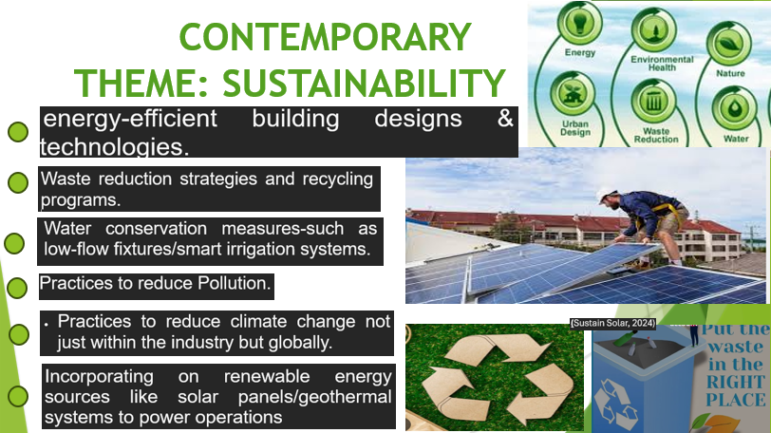

Slide 2:

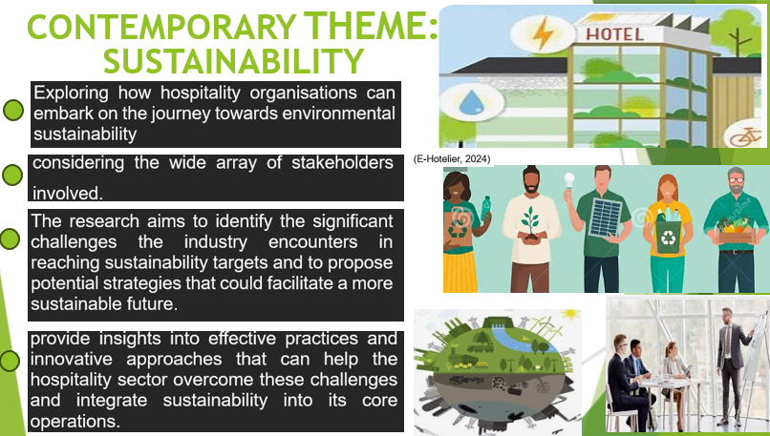

Slide 3:

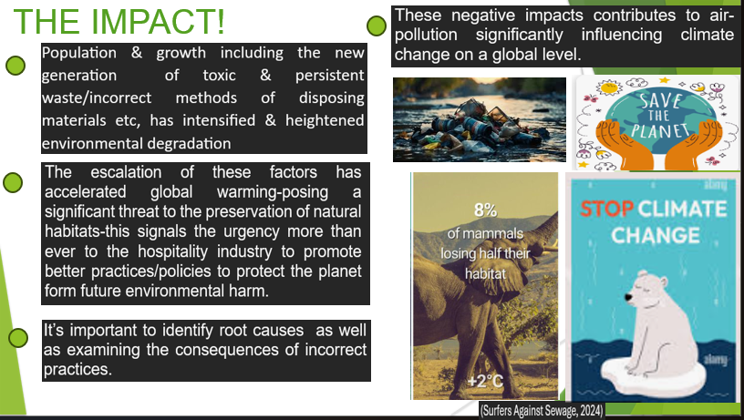

Slide 4:


Slide 5:

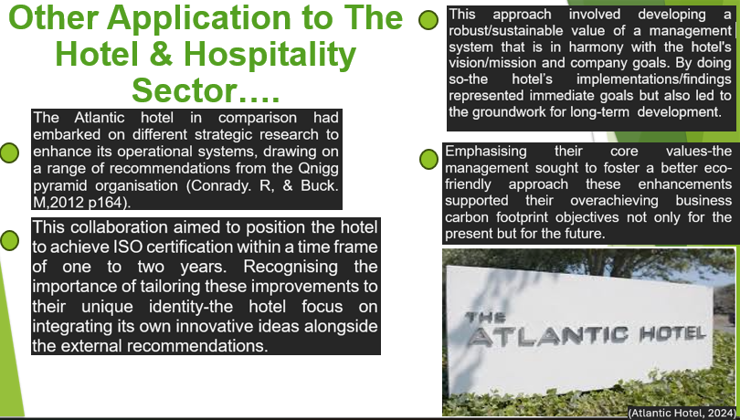

Slide 6:

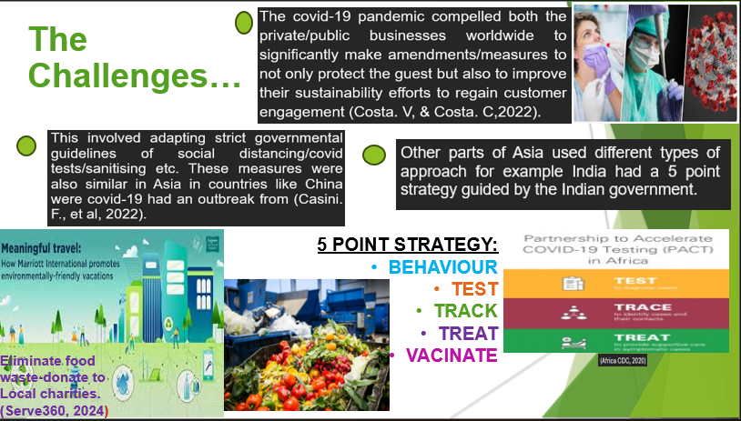
Slide 7:

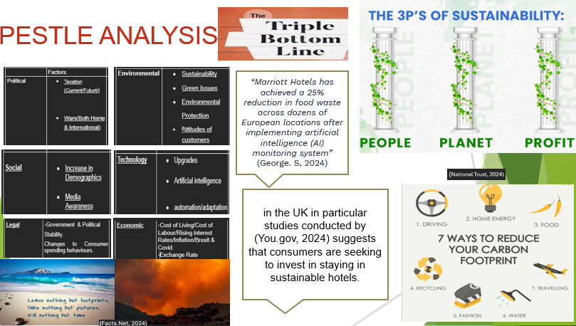

Slide 8:

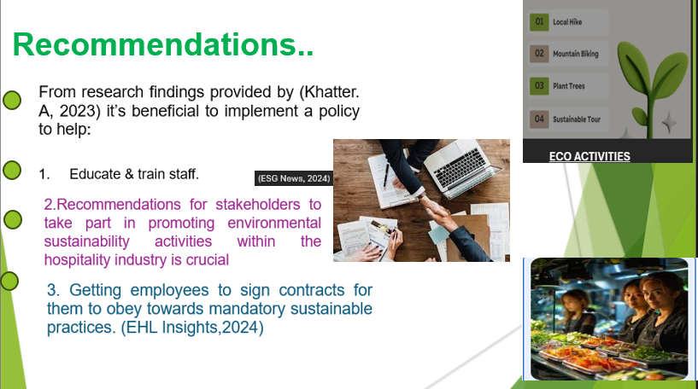
Slide 9:

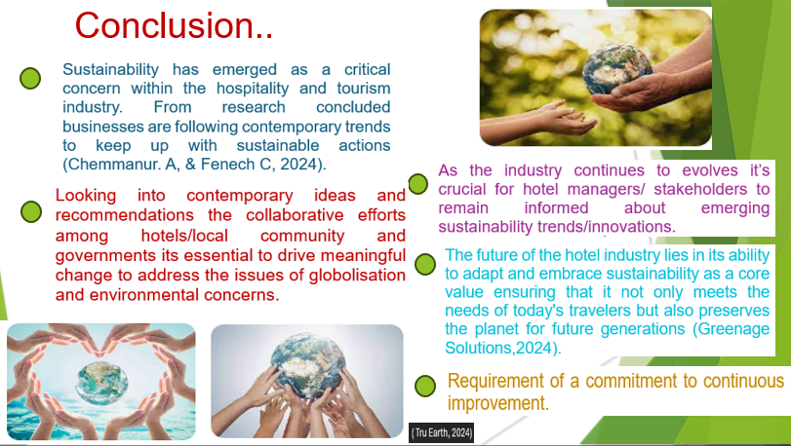

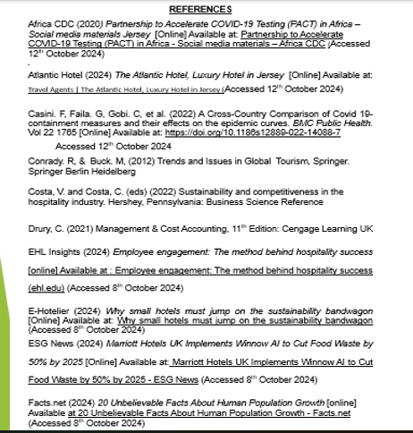

Slides 11-12:



