Kallum Doyle (2237962)
2237962@student.uwtsd.ac.uk
27/03/2026
3000 Words
Socket Programming and Concurrency Implementation
Socket Programming and Concurrency

Contents
Table of Figures 2
1. Introduction 3
1.1. Modern Network Applications 3
1.2. AIms and Objectives 3
2. Reliable Transmission and Error Control 4
2.1. TCP Mechanisms 4
2.1.1. The Sliding Window 4
2.1.2. Packet Reordering 5
2.1.3. Retransmission Amibguity 5
2.2. The Two & Byzantine Generals’ Problem 6
2.3. TCP Versus UDP 6
3. Latency, Bandwidth and Performance 7
3.1. Latency and Bandwidth Considerations 7
3.2. Congestion Control 7
3.3. Bufferbloat 8
4. Concurrency in Network Applications 9
4.1. Threads versus Events 9
4.2. Implementation of non-blocking I/O 9
4.3. Scalability, Hardware and Reliability 10
4.3.1. mCTP Utilisation 10
4.3.2. Tiara Utilisation 10
4.3.3. Analysis of the Respective Models Use Cases 10
5. Interoperability in Distributed Systems 11
5.1. Interoperability 11
5.2. Data Serialisation 11
5.3. Version Evolution 12
5.3.1. Breaking Changes 12
5.3.2. API Versioning 12
6. Conclusion and Practical Impact 13
7. References 14

Table of Figures
Figure 1 | An image showcasing the usable (segments waiting for retransmission) and outstanding (sent but not acknowledged) portions of the sliding window mechanism. Source: [27] 4
Figure 2 | An image demonstrating Bufferbloat and how AQMs can help mitigate the issue. Source: [13] 8
Figure 3 | An image showcasing how two common data formats, XML and JSON, maintain a data standard with their respective schema formatting. Source: [28] 11

Introduction

Modern Network Applications
Modern networked applications are placed in an increasingly complex environment defined by the expansion within the Distributed Computing Continuum, which consists of combining the vast available resource of cloud computing with the “heterogeneity and proximity” of edge computing. This makes the underlying infrastructure a primary consideration compared to traditional internet distributed systems. The complexity and dynamic behaviour of these systems mean a novel representation beyond the classic static computer system architectures is required in the form of an interconnected “System of Systems” perspective. This perspective is implemented to manage autonomous components and integrate these components to provide a whole view of the system, while navigating uncertainty amongst the diverse environments [26].

AIms and Objectives
The aim of this essay is to engage critically with the theory and practise of socket programming and concurrency by evaluating how different protocol choices and architectural models can impact the development of networked software. The following objectives will be addressed in the following sections to achieve this aim:
- Section 2: An analysis of the mechanisms for reliable transmission and error control within TCP and contrast these mechanisms with the best-effort delivery of UDP.
- Section 3: An examination of how latency, bandwidth and congestion control algorithms determine network performance.
- Section 4: A comparison of traditional multi-threading with event-driven and asynchronous concurrency models across different application contexts.
- Section 5: An investigation of the challenges present in maintaining interoperability and version evolution in heterogeneous distributed systems.

Reliable Transmission and Error Control

TCP Mechanisms

The Sliding Window
There are multiple mechanisms that exist within the transmission control protocol (TCP) to enable reliable transmission. One such mechanism is the sliding window mechanism, which delivers reliable and ordered data transmission and implements a control of the data flow. The window size is a component of this mechanism and provides information on the amount of data the receiver can accept. The window contains a usable and outstanding portion which details which packages have been acknowledged, and which ones need to be sent. The outstanding portion can shrink to allow new data to be sent, or the receiver can transmit a window size of zero which halts transmission in cases of small space. This mechanism exists to control the data flow, without the mechanism, a fast sender could crash the slow receiver by causing a space overflow [1]. While this mechanism prevents the receiver from being overflowed, it is important to note that separate / variant algorithms are required to manage congestion, such as TCP Reno [2].
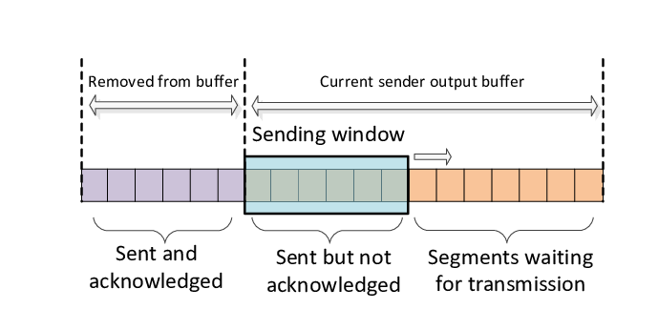
Figure 1 | An image showcasing the usable (segments waiting for retransmission) and outstanding (sent but not acknowledged) portions of the sliding window mechanism. Source: [27]

Packet Reordering
TCP must also account for instances where the network may deliver segments that becomes disordered in comparison to how it was sent, or they may drop completely. This is known as packet reordering, when data segments originate from separate paths or experience delays. If a sender transmits three segments numbered 1-3, and 2-3 get reordered by the network, the receiver will acknowledge (ACK) segment 1, but when segment 3 arrives, the receiver is designed to only acknowledge the last in order segment received (1) so a duplicate acknowledgement is generated. Performance is impacted as a result due to TCP utilising the duplicate ACKs to infer packet loss via the fast retransmission algorithm. Traditional TCP implementations wait for three duplicate ACKs before assuming packet loss and retransmitting. Persistent reordering can cause this to happen prematurely and can lead to:
- Data segments being resent that weren’t lost, which wastes network bandwidth, known as spurious retransmissions.
- Packet loss being interpreted as congestion, which causes an incorrect reduction in data transmission due to their being no real congestion.
- Bursts in transmission due to the ACK clock being interrupted. [3]

Retransmission Amibguity
Beyond these notable performance drops, these spurious retransmissions also directly lead to the retransmission ambiguity problem. An ACK will only acknowledge the receipt of a specific data segment, rather than acknowledging its specific instance. This means a sender cannot confirm if an incoming ACK corresponds to the original transmission or a retransmission and destroys the sender’s ability to measure the round-trip time (RTT) which is used by TCP to set the retransmission timeout variable. Programmers can utilise techniques such as the Karn/Patridge algorithm, which causes RTT samples from retransmitted segments to be ignored to prevent corruption of timeout calculation [7].

The Two & Byzantine Generals’ Problem
Perfect reliability is quite impossible in a network as demonstrated by the two generals’ problem, or in a more generalised format, the byzantine general’s problem. The problem is illustrated as a scenario where N number of generals are coordinating an attack on a common enemy, and they must attack at the same time, or risk defeat. The issue arises in how they coordinate this attack. Traditionally they would have to send a messenger who carries the information on the time of the attack, and in the byzantine problem, the message is delivered in a dependency format, where it is first delivered to the nearest generals before they forward it on further. This risks a corruption of the message in the scenario any of the generals are traitors, as they can change the message, which could result in contradictory or false information [4].
This contrasts with the two generals’ problem, where the scenario focuses on only two generals and an unreliable data transport link, in which the data in transit could be modified in transit or completely dropped [5]. These two problems illustrate the fundamental issues with the TCP three-way handshake, which is shown to not be able to guarantee a secure connection with 100% certainty and often other measures such as utilising security tokens to verify IP address ownership are required to increase security [6].

TCP Versus UDP
While TCP can have its reliability issues as detailed above, it is more reliable than its counterpart protocol, the User Datagram Protocol (UDP). UDP is a protocol designed with minimal protocol mechanism, meaning that it aims to achieve a best effort delivery. Unlike TCP, there is no guarantee of delivery, and there is no guarantee that duplicate packets will not arrive [8].
It is worth noting that while UDP is theoretically faster due to this design, its lack of flow control can degrade performance to a level below TCP in specific environments. UDP is best suited for transmitting larger packets at peak speed when utilised in high-speed wireless environments. Contrastingly, if UDP is utilised for sending short packets, it can cause datagrams to be dropped at the protocol level before they reach the network interface [9]
Additionally, due to the lack of throttling provided by flow control UDP can cause severe transmit buffer overruns in hardware which can cause complete controller resets. Leading to significant drops in throughput due to communication pauses. TCPs window-based flow control practically acts as a pacing mechanism, while also enabling reliability. However, on shared mediums such as 2.4GHz WLANS using CSMA/CA, synchronisation problems can occur and the ACKs used in TCP can collide with data packets and can cause TCP throughout to drop to 30% of UDPs capacity in some instances [9]. These findings showcase developers must carefully choose between TCP and UDP, basing it upon their hardware constraints and development goals. The choice between UDP and TCP is not as simple as reliability versus speed as one might think.

Latency, Bandwidth and Performance

Latency and Bandwidth Considerations
Latency and bandwidth are two primary considerations when designing an application for performance and they both target two different types of performance categories. For high scalar performance (workloads with minimal parallel tasks), minimising latency is considered most important, versus throughput for parallel (workloads running multiple tasks simultaneously) performance [9].
This contrast is observed in high Bandwidth-Delay Product (BDP) networks as they connect modern distributed systems like interconnected data centres. The physical constraint of propagation delay (latency) becomes the primary hurdle to efficiency in these environments. Standard TCP algorithms can fail to maximise the utility of the high-speed links because the expansion of the congestion window is “severely slow.” The congestion window typically only increases by one packet per RTT. Therefore, there is a possibility of a single congestion event in a high-BDP network resulting in long periods of underutilisation, sometimes requiring over 600 seconds to regain maximum throughput [10].
This showcases how latency can often be more of a significant bottleneck for modern applications than raw bandwidth, and correspondingly why it is most important to minimise latency.

Congestion Control
A crucial part of congestion control is the implementation of Congestion Control Algorithms (CCAs). They ensure network stability and high efficiency by managing the flow of data to correctly match available capacity. Originally these protocols relied on “rule-based” designs and have hard coded logic that determines how the transmission get adjusted based on the network signals. CCAs are characterised into loss-based schemes like cubic, which react to packet drops, or delay-based schemes like Vegas, which utilize RTT variations. These mathematical models are robust but can lack flexibility that is required to adapt to network environments with growing complexity [11].
Machine Learning (ML) based CCAs have been developed to address these limitations. Learning-based methods such as PCC or reinforcement learning models like indigo and aurora utilise data-driven techniques to learn the best control policies by directly interacting with the network. Moving away from static rules toward learning-based adaptability allows modern protocols to offer a more in-depth way of navigating the complexity and uncertainty of distributed systems [11].

Bufferbloat
Bufferbloat is a phenomenon in computing networks, in which large router buffers are frequently filled which results in high queueing delay and delay variation. This is caused by the implementation of oversized buffers in internet routers, which while designed to prevent packet loss, their excessive size can often cause packets to remain in long queues. This results in the end-to-end latency being increased and harms the response time of applications [12].
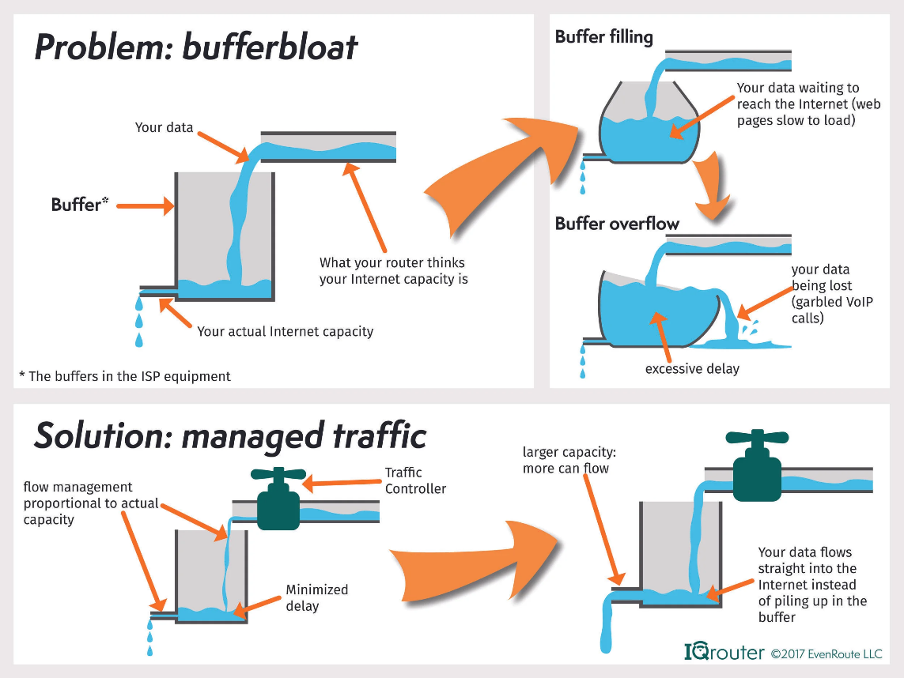
Figure 2 | An image demonstrating Bufferbloat and how AQMs can help mitigate the issue. Source: [13]
Active Queue Management (AQM) algorithms are employed to combat this latency by managing router buffers. AQMs manage router buffers and can drop, or mark packets proactively based on internal logic, which prevents the buffer from becoming completely full. A modern example is the Controlled Delay (CoDel) algorithm which maintains queuing delay at a specific target value. The proactive management of buffer occupancy means AQM mechanisms can stabilise network performance and reduce the impact of oversized router memory on the application efficiency [12].
This issue highlights that while bandwidth provides the potential for high-speed data transfer, managing the buffer remains the primary factor in preventing physical constraints of latency from degrading user experience.

Concurrency in Network Applications

Threads versus Events
Network software concurrency has two typical models: thread-per-task, or event-driven. Traditional threading provides a natural gateway to multitasking but can incur heavy overhead from switching context and memory footprints. The Staged Event-Driven Architecture (SEDA) can reduce these limitations by converting applications into stages that are connected by explicit queues. Resultingly, this enables dynamic load conditioning and can prevent committing too many resources during spikes [14].
However, there is research that suggests the weaknesses of threads can be implementation dependent, rather than being fundamental to the threaded architecture. User-level thread packages that are highly optimised can match event-driven performance while avoiding “stack ripping”, the difficult manual management of state seen in asynchronous models. Event-driven designs like SEDA offer better resource awareness for scaled concurrency, however threads can be preferred for their simplicity and effective mapping of live state [15]. Developers should weigh the strong load management of staged events against the linearity and simplicity of a threaded architecture. The strong load management may be a critical component of a high-traffic web application, however for a file transfer system the simplicity of a threaded system may be more efficient.

Implementation of non-blocking I/O
Event-driven concurrency usually focuses on the Single Process Event-Driven (SPED) model, which multiplexes numerous connections within one execution thread. This is achieved by placing all sockets into non-blocking mode and using operating system mechanisms like epoll or kqueue to identify the sockets ready for processing [16]. This architecture is well suited for network-bound tasks like chat servers that maintain a high uptime but low activity per number of connections can face significant bottlenecks with file I/O. Due to most operating systems lacking robust non-blocking file interfaces, one disk access can stall the event loop. Developers can combat this by employing specialised architecture that utilises multiple processes to ensure disk-induced blocking does not halt the entire system [16].
Contrastingly, modern threaded models try to simplify development by providing a synchronous programming method through user-level M:N threading. This model allows many user threads to be transparently mapped to a smaller pool of system threads, which in turn allows each session to be represented by a software thread within its own execution stack. “Automatic state capture” is an integral component of this stack and is a significant advantage for applications where session data must be preserved across multiple I/O interactions, such as complex web applications or file transfer systems. In contrast, event-driven models require explicit management of session states that can lead to fragmented control flow and “callback hell”. Modern runtimes can utilise the same high-performance epoll interfaces as event-driven systems but hide this complexity behind a blocking interface which is easier for developers to manage [17].

Scalability, Hardware and Reliability
Achieving true scalability in network applications is a difficult task with traditional operating system kernels struggling with short-lived TCP connections. At times, they can spend 70% to 80% of CPU cycles on internal management rather than the application itself [18].

mCTP Utilisation
A prominent modern solution is the implementation of user-level TCP stacks such as mTCP. mTCP has the potential to improve the performance of small message transactions by a significant amount; up to a factor of 25, compared to the standard Linux TCP stack. The stack can achieve this efficiency by translating multiple expensive system calls into a single shared memory reference, then performing batched packet I/O. mTCP also localises resources like flow pools and socket buffers to each core to minimise inter-core contention and utilises lock-free data structures between the application and the stack [18].

Tiara Utilisation
Environments requiring terabit-per-second throughput without a large footprint may utilise architectures like Tiara that have a three-tier hardware approach. Tiara can map memory-intensive tasks such as real-server selection to FPGAs with High-Bandwith Memory (HBM) while mapping throughput-intensive tasks like packet encapsulation to programmable switches. Tiara’s fast path (utilised for standard non-complex packets) throughput and concurrent flow capacity is scaled linearly with the number of T-NICs (Tiara FPGAs) or T-Servers (Tiara x86 Servers) utilised. This hardware accelerated approach means up to 1.6Tbps of throughput can be achieved and allows 1.8M new connections per second with less than 4 microseconds of latency in the fast path [19].

Analysis of the Respective Models Use Cases
Ultimately, these advancements showcase achieving high-performance concurrency requires a transcendence from traditional kernel centric processing in favour of hardware-software co-design which prioritises energy efficiency and linear stability to achieve millions of concurrency flows. However, such implementations might be difficult for smaller organisations to implement. The mTCP model requires manual re-implementation of kernel services like firewalls as application modules [18], while the Tiara architecture necessitates significantly longer development cycles and specialised expertise for Verilog-based FPGA programming compared to standard software [19].

Interoperability in Distributed Systems

Interoperability
Interoperability in network software is the common understanding and compatibility between systems that enables them to operate on and utilise each other’s functions. Programmers must navigate several architectural approaches to achieve interoperability. The integrated approach is reliant on the universal adoption of a single common standard / data format, such as XML or WSDL. Contrastingly, the unified approach uses a common meta-model or middleware that translates between heterogeneous formats. This strategy is exemplified by the widespread adoption of RESTful architectures [20].
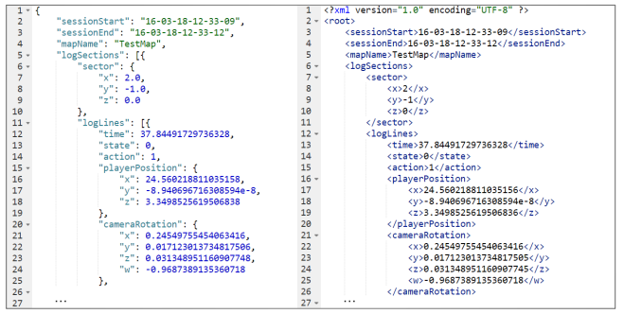
Figure 3 | An image showcasing how two common data formats, XML and JSON, maintain a data standard with their respective schema formatting. Source: [28]
However, maintaining compatibility across different platforms presents its own problems. This includes immense heterogeneity in data modelling (C1) and high engineering costs needed to modify legacy systems to meet specific standards (C2). These factors deeply impact design decisions for developers, while strict standardisation provides seamless interaction it is often impractical to achieve across large and standalone communities. A federated approach is seen as a favourable approach in modern development. This approach leverages semantic concepts to allow systems to interact effectively while preserving their own individual autonomy [20].

Data Serialisation
Data serialisation efficiency is an important consideration for the optimisation of distributed web application performance. While JSON is widely used for how well it integrates with REST services, its text-based format can introduce performance limitations as the application becomes more complex. Contrastingly, binary formats such as Protocol Buffers (Protobuf) can provide significant improvements in performance by reducing payload sizes and increasing serialisation and deserialisation speed [21].
Research suggests Protobuf can reduce payload sizes by 60% to 80% over JSON, which contributes to an estimated 80% improvement in overall response time. Further performance evaluations in microservice architectures confirm that gPRC, which utilises Protobuf, can achieve faster response times than REST and GraphQL. Additionally, GraphQL has been shown to consume higher CPU resources compared to gPRC and REST, showcasing the requirement for developers to weigh CPU utilisation in design strategies [22]. These performance metrics influence which serialisation method is best for an application’s requirements for scalability and resource optimisation.

Version Evolution

Breaking Changes
Maintaining distributed systems long term is a procedure complicated by the potential of API breaking changes. These changes occur when the continued development of an API disrupts the established standard, which results in compilation errors or behavioural changes. Large scale analysis of real-world libraries indicates approximately 14.78% of API changes are breaking, however their actual impact is relatively contained, affecting an average of 2.54% of client applications [23]. The issue is accentuated in the Android ecosystem where “evolution-induced API compatibility issues” arise as applications must deal with a wide range of system versions [24].

API Versioning
Developers frequently implement “API level checks” to handle these challenges and avoid breaking mobile applications. These checks are conditional statements to verify the systems SDK version and to provide alternative logic for certain environments [24]. However, it is important for the API developers to support the evolution process with clear versioning strategies to limit the impact of version evolution. These can be URL-based, header-based, or parameter-based versioning and serve to manage the transition between releases. Supplying each version with consistent and reliable communication via release notes or blogs and detailed documentation is an also an essential measure to enable practitioners to adjust to API changes, as the absence of clear communication and documentation is a primary reason why API changes break dependent applications [25].

Conclusion and Practical Impact
In conclusion, the development of networked software requires careful consideration of reliability, performance and concurrency. This essay shows that reliability is a managed trade-off, as while TCP offers essential guarantees its mechanisms can introduce retransmission ambiguity and performance-degrading latency. As such, programmers must decide between TCP and UDP based on specific application requirements and hardware constraints. Performance is becoming increasingly defined by latency and bandwidth, where challenges like Bufferbloat require the usage of Active Queue Management and advanced congestion control to maintain responsiveness.
A transition from traditional kernel-centric processing towards optimised concurrency models is a further requirement for scalability. Developers must evaluate the load management of event driven architectures against the simplicity of threaded models, and while hardware accelerated solutions like Tiara offer extreme throughput, the high implementation costs associated with the solution requires a justified integration and investment strategy. Additionally, achieving interoperability within the distributed systems continuum requires the adoption of efficient binary serialisation and defensive versioning strategies to handle API evolution. Ultimately, the practical impact for the modern developer is a shift towards a perspective that visualises the network as a dynamic ecosystem, ensuring stability across heterogeneous distributed systems.

References
[1] T. Goff, J. Moronski, D. S. Phatak, and V. Gupta, ‘Freeze-TCP: a true end-to-end TCP enhancement mechanism for mobile environments’, in Proceedings IEEE INFOCOM 2000. Conference on Computer Communications. Nineteenth Annual Joint Conference of the IEEE Computer and Communications Societies (Cat. No.00CH37064), Mar. 2000, pp. 1537–1545 vol.3. doi: 10.1109/INFCOM.2000.832552.
[2] A. Afanasyev, N. Tilley, P. Reiher, and L. Kleinrock, ‘Host-to-Host Congestion Control for TCP’, IEEE Communications Surveys & Tutorials, vol. 12, no. 3, pp. 304–342, 2010, doi: 10.1109/SURV.2010.042710.00114.
[3] E. Blanton and M. Allman, ‘On making TCP more robust to packet reordering’, SIGCOMM Comput. Commun. Rev., vol. 32, no. 1, pp. 20–30, Jan. 2002, doi: 10.1145/510726.510728.
[4] F. Dang, P. Zhou, Z. Li, and Y. Liu, ‘NFC-enabled attack on cyber physical systems: A practical case study’, in 2017 IEEE Conference on Computer Communications Workshops (INFOCOM WKSHPS), May 2017, pp. 289–294. doi: 10.1109/INFCOMW.2017.8116391.
[5] N. Zivic, C. Ruland, and O. Ur-Rehman, ‘Addressing Byzantine Fault Tolerance in Blockchain Technology’, in 2019 8th International Conference on Modeling Simulation and Applied Optimization (ICMSAO), Apr. 2019, pp. 1–5. doi: 10.1109/ICMSAO.2019.8880419.
[6] S. Radhakrishnan, Y. Cheng, J. Chu, A. Jain, and B. Raghavan, ‘TCP fast open’, in Proceedings of the Seventh COnference on emerging Networking EXperiments and Technologies, in CoNEXT ’11. New York, NY, USA: Association for Computing Machinery, Dec. 2011, pp. 1–12. doi: 10.1145/2079296.2079317.
[7] L. Cheng and I. Marsic, ‘Fuzzy Reasoning for Wireless Awareness’, International Journal of Wireless Information Networks, vol. 8, no. 1, pp. 15–26, Jan. 2001, doi: 10.1023/A:1011329512150.
[8] ‘User Datagram Protocol’, Internet Engineering Task Force, Request for Comments RFC 768, Aug. 1980. doi: 10.17487/RFC0768.
[9] M. A. Alrshah, M. A. Al-Maqri, and M. Othman, ‘Elastic-TCP: Flexible Congestion Control Algorithm to Adapt for High-BDP Networks’, IEEE Systems Journal, vol. 13, no. 2, pp. 1336–1346, Jun. 2019, doi: 10.1109/JSYST.2019.2896195.
[10] E. Grochowski, R. Ronen, J. Shen, and H. Wang, ‘Best of both latency and throughput’, in IEEE International Conference on Computer Design: VLSI in Computers and Processors, 2004. ICCD 2004. Proceedings., Oct. 2004, pp. 236–243. doi: 10.1109/ICCD.2004.1347928.
[11] H. Jiang et al., ‘When machine learning meets congestion control: A survey and comparison’, Computer Networks, vol. 192, p. 108033, Jun. 2021, doi: 10.1016/j.comnet.2021.108033.
[12] J. Ye, K.-C. Leung, and S. H. Low, ‘Combating Bufferbloat in Multi-Bottleneck Networks: Theory and Algorithms’, IEEE/ACM Transactions on Networking, vol. 29, no. 4, pp. 1477–1493, Aug. 2021, doi: 10.1109/TNET.2021.3066505.
[13] ‘bufferbloat’, IQrouter. [Online]. Available: https://evenroute.com/bufferbloat
[14] ‘HotOS IX — Paper’. Accessed: Mar. 22, 2026. [Online]. Available: https://www.usenix.org/legacy/events/hotos03/tech/full_papers/vonbehren/vonbehren_html/
[15] M. Welsh, D. Culler, and E. Brewer, ‘SEDA: an architecture for well-conditioned, scalable internet services’, SIGOPS Oper. Syst. Rev., vol. 35, no. 5, pp. 230–243, Oct. 2001, doi: 10.1145/502059.502057.
[16] D. Pariag, T. Brecht, A. Harji, P. Buhr, A. Shukla, and D. R. Cheriton, ‘Comparing the performance of web server architectures’, SIGOPS Oper. Syst. Rev., vol. 41, no. 3, pp. 231–243, Mar. 2007, doi: 10.1145/1272998.1273021.
[17] M. Karsten and S. Barghi, ‘User-level Threading: Have Your Cake and Eat It Too’, Proc. ACM Meas. Anal. Comput. Syst., vol. 4, no. 1, p. 17:1-17:30, May 2020, doi: 10.1145/3379483.
[18] E. Jeong, S. Woo, M. Jamshed, and H. Jeong, ‘mTCP: a Highly Scalable User-level TCP Stack for Multicore Systems’.
[19] C. Zeng et al., ‘Tiara: A Scalable and Efficient Hardware Acceleration Architecture for Stateful Layer-4 Load Balancing’.
[20] M. Sadeghi, A. Carenini, O. Corcho, M. Rossi, R. Santoro, and A. Vogelsang, ‘Interoperability of heterogeneous Systems of Systems: from requirements to a reference architecture’, J Supercomput, vol. 80, no. 7, pp. 8954–8987, May 2024, doi: 10.1007/s11227-023-05774-3.
[21] M. Niswar, R. A. Safruddin, A. Bustamin, and I. Aswad, ‘Performance Evaluation of Microservices Communication with REST, GraphQL, and gRPC’, International Journal of Electronics and Telecommunication, vol. 70, no. 2, pp. 429–436, Jun. 2024.
[22] A. Shatnawi, A. Bahri, B. Niang, and B. Verhaeghe, ‘Enhancing Data Serialization Efficiency in REST Services: Migrating from JSON to Protocol Buffers’:, in Proceedings of the 20th International Conference on Software Technologies, Bilbao, Spain: SCITEPRESS - Science and Technology Publications, 2025, pp. 193–200. doi: 10.5220/0013459500003964.
[23] S. M. Sohan, C. Anslow, and F. Maurer, ‘A Case Study of Web API Evolution’, in 2015 IEEE World Congress on Services, Jun. 2015, pp. 245–252. doi: 10.1109/SERVICES.2015.43.
[24] H. Xia et al., ‘How Android developers handle evolution-induced API compatibility issues: a large-scale study’, in Proceedings of the ACM/IEEE 42nd International Conference on Software Engineering, in ICSE ’20. New York, NY, USA: Association for Computing Machinery, Oct. 2020, pp. 886–898. doi: 10.1145/3377811.3380357.
[25] L. Xavier, A. Brito, A. Hora, and M. T. Valente, ‘Historical and impact analysis of API breaking changes: A large-scale study’, in 2017 IEEE 24th International Conference on Software Analysis, Evolution and Reengineering (SANER), Feb. 2017, pp. 138–147. doi: 10.1109/SANER.2017.7884616.
[26] V. Casamayor Pujol, A. Morichetta, I. Murturi, P. Kumar Donta, and S. Dustdar, ‘Fundamental Research Challenges for Distributed Computing Continuum Systems’, Information, vol. 14, no. 3, p. 198, Mar. 2023, doi: 10.3390/info14030198.
[27] R. Al-Saadi, G. Armitage, J. But, and P. Branch, ‘A Survey of Delay-Based and Hybrid TCP Congestion Control Algorithms’, IEEE Communications Surveys & Tutorials, vol. PP, pp. 1–1, Mar. 2019, doi: 10.1109/COMST.2019.2904994.
[28] S. Altundaş, ‘NPC AI System Based on Gameplay Recordings’, 2018. doi: 10.13140/RG.2.2.23891.89123.

