
Starbucks' Strategic Goals and challenges in China



FEBRUARY 2020
Module Name: Organisational Consultancy (M6X01422)
Student Name: Wei He
Student Number: 1900504

Table of Contents
1. Executive Summary 1
2. Introduction 2
3. Background 2
4. Strategy analysis of Starbucks 2
5. Expansion of China's inland market 3
6. Marketing strategy given by consultancy in Chinese market 4
6.1 Brand value strategy 4
6.2 Accurate market positioning 4
6.3 Product innovation 5
7. Goal completion 5
8. Problems and challenges 6
9. Fulfillment of social responsibility 7
10. Conclusion 9
11. References 10

1. Executive Summary
With the rapid development of China's economy, a coffee consumption market with great potential for development has been bred, so Starbucks has positioned the Chinese market as the most important overseas market outside its U.S. market. This report focuses on service marketing, core competitiveness theory, and customer experience. In this report, Starbucks' strategic goals and current problems in the Chinese market are figured out. Through the process of consultation, some reasonable suggestions will be given. While Starbucks is expanding rapidly, it is also facing a crisis of loss of its core competitiveness and a decline in brand value.

This report concludes that its core competitiveness is derived from its unique corporate culture and values. With the rapid development of China's economy, a large high-end market with a middle class as the major consumption group has emerged. The marketing strategy chosen by Starbucks is suitable for this part of the target market. In addition, this report analyses the combination of Starbucks marketing strategies based on the theories of service marketing and experience marketing. Starbucks' differentiated marketing strategy based on experience distinguishes itself well from other competitors. Starbucks also provides more customer experience, which brings high brand loyalty to it. The core of Starbucks' success lies in its expansion of the content of coffee culture, that is, the unique Starbucks experience. The purpose of this report is to develop a marketing strategy system for Starbucks , including the determination of target markets and marketing mix strategies.

2. Introduction
In today's market, when consumers are willing to pay more than the value of a product for a big brand, brand awareness has become a key factor for business growth(Koch, 2010). Marketing connects businesses with customers and influences consumer spending habits. So mastering the latest marketing goals and trends is conducive to achieving value-added and stable income growth, which is also the purpose of this report. Therefore, this report will focus on the strategic goals of Starbucks in the Chinese market and the analysis of its marketing strategy, which is very helpful and essential for the organization to achieve its business goals.

3. Background
Starbucks' brand positioning in China is to provide customers with a high-quality experience and is committed to selling high-quality products and services at a high price(Watson, 2018). This unique high-quality and good customer experience is the main difference between it and other coffee brands. Initially, Starbucks designed and established shop with the theme of Italian bars, providing customers with a family-like warm experience. In addition, Starbucks always adheres to the concept of customer satisfaction first, so this is the reason why customer loyalty is very high(Czepiel & Shanahan, 2014). Hence, integrating corporate communications with customers is the focus of Starbucks' customer relationship management.

4. Strategy analysis of Starbucks
In response to the fierce competition in the service industry, Starbucks has adopted an aggressive strategy to maintain its position as a market leader. Starbucks' 7P marketing mix includes: product (product), price (price), location (place), promotion (promotion), person (person), process (process), and physical(physical) environment(Thompson, 2015). But the shortcoming of this marketing mix strategy is that it focuses too much on short-term goals and ignores the company's long-term interests (Brenner, 2003). Starbucks has successfully established itself as the best coffee brand in the market by increasing the attractiveness of store design, creating a unique consumption environment, displaying elegant taste, and providing high-quality coffee beans(Arnould & Price, 2013). However, recently, Starbucks has been facing some problems such as lower growth of profits, strong competitors and lack of supply chain, which could be barriers to achieve business goals. So it is necessary to find out the problems, deliver a reasonable solution and help company to solve the problems and finally fulfil the achievement of margin increase as a part of consultancy.

5. Expansion of China's inland market
According to the official website of Starbucks, the total number of Starbucks stores in China is currently over 500, of which about 230 are in mainland China (Nicolas, 2018). Apart from this, the company adheres to the consistent global cultural traditions, actively integrates into Chinese local communities and cultures, and is committed to developing the Chinese market. Recently, Starbucks held the first global investor exchange meeting in China. At the meeting, Starbucks announced that it has set new growth targets for the Chinese mainland market (Haskova, 2015). As shown in the Figure 1, it is expected that by the end of fiscal 2022, Starbucks will enter 100 new cities in mainland China, covering a total of 230 cities (klein,2018). At the same time, the number of new stores will be increased to 600 each year, and eventually the number of stores will reach 6,000. Previously, Starbucks had set up 5,000 stores as the growth target of the Chinese market by the end of fiscal 2021 and it has achieved 3521 stores by 2018(Miller, 2019).

FIGURE A - NUMBER OF STORES IN CHINA CHART
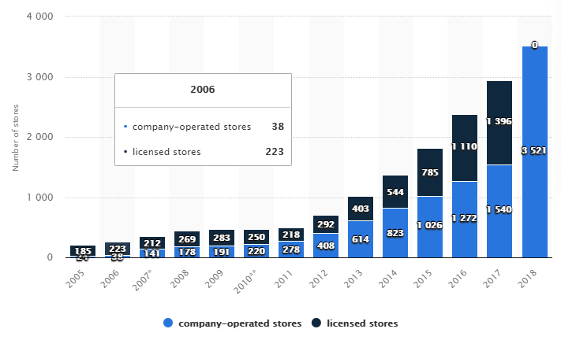
<Source from:https://www.statista.com/statistics/277795/number-of-starbucks-stores-in-china/>
These strategic guidelines are also provided to Starbucks during the consulting process in accordance with the actual situation and respond quickly. In service design or including service-oriented product design, we emphasize more on loyalty. This is why we recommend Starbucks to choose a more warm environment, as well as supporting services and excellent products, so that it is easy to turn the customer base into loyal customers. Another point suggested that Starbucks pay attention to co-creation. In addition to service providers, service consumers also need to be integrated into the process of co-creation, because consumers are highly creative, and their many suggestions and knowledge can help complete the service better. For example, Starbucks users can login a platform for voting and selection and even select background alternative music in stores. Consumer participation can also increase user loyalty.

6. Marketing strategy given by consultancy in Chinese market

6.1 Brand value strategy
Starbucks has a history of development in China for nearly two decades, occupying a leading position in the coffee industry, based on its powerful brand image and reputation, it is strongly recognized by many consumers (Dhar & Varshney, 2011). Starbucks's in-store environment, no matter tables, chairs or lights, music all create the most comfortable and beautiful consumption space for consumers, while the service staff are impressive. Undoubtedly, it increases consumer satisfaction and cultivates and builds consumer loyalty to the brand. By strengthening the charm of the brand, consumers can enjoy a better sense of taste, and at the same time, they can feel their identity is improved (Warren, 2011).

6.2 Accurate market positioning
Starbucks launched a series of beverages with tea as an ingredient, which enables more Chinese consumers to accept this brand. Starbucks' chain stores in China's consumer market are very eye-catching, and they are basically located in major bustling and busy streets (York, 2010). With a unique and attractive store decoration, many young and fashionable people who like to drink coffee will be attracted, while pedestrians passing by will also be attracted by those fashion consumer groups.

6.3 Product innovation
The success of Starbucks' operation in the Chinese market is also inseparable from the continuous innovation and efforts of Starbucks itself and Chinese localization after entering the Chinese market. For example, at the beginning of entering the Chinese market, it combined with Chinese tea culture. Later, during some traditional festivals in China, Starbucks will also launch suitable foods combined the local customs and characteristics. For instance, Starbucks launched moon cake series during the Mid-Autumn Festival (Schulze, 2018). What is more, in terms of taste and preference, Starbucks is also very humane and diversified, so that every consumer can choose their favourite and satisfied products according to their own tastes.

7.Goal completion
Starbucks' revenue has continued to increase in recent years. Although the growth rate and the previous two years have slightly decreased compared to 7.2% in 2019 and 16.5% in 2015, it has still achieved profit growth. Net profit can reach 15.4million, dominating the market steadily, which is an advantage unmatched by other competitors, while also achieving the goal of profit growth. At the same time, the goal of opening a new store in China is also being fully implemented and is expected to be achieved by 2020.
FIGURE B -STARBUCKS’ CONSOLIDATED REVENUE 2013-2019 CHART
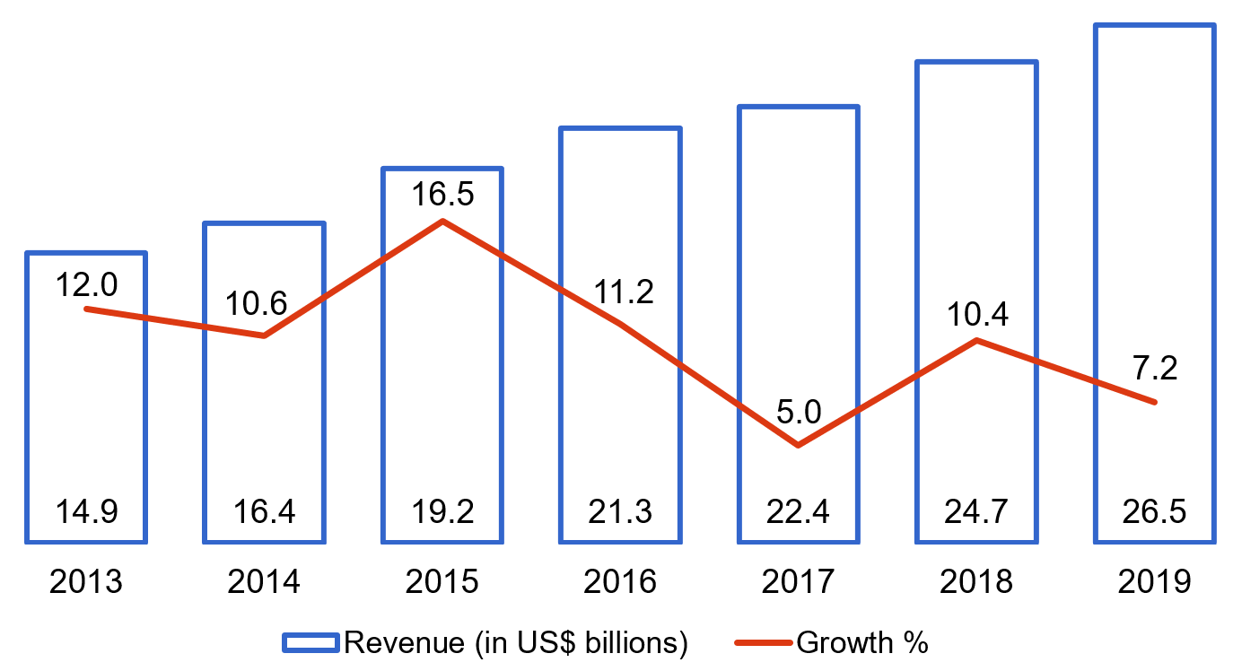
<Source from: Starbucks financial report>
FIGURE C - STARBUCKS’ OPERATING PROFIT MARGIN 2012-2019 CHART
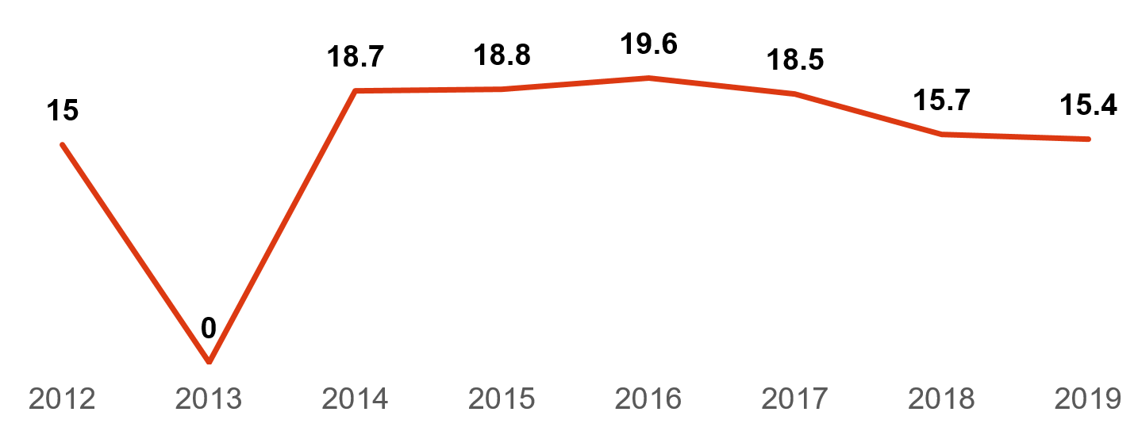
<Source from: Starbucks financial report>
In order to achieve the goal of improving customer satisfaction, Starbucks specially invested millions of dollars to establish a "Science and Technology Application Center" in order to continuously launch new products based on changes in tastes, consumer fashion, solar terms and other factors based on the main products (Rowley, 2017). In addition to this, Starbucks also collaborates with beverage companies such as Coca Cola and Pepsi to develop new products. In order to make new customers become loyal customers, Starbucks has racked its brains on improving customer satisfaction, and strives to use new products or new marketing methods to achieve value that exceeds customer expectations (Noff, 2010). Starbucks conducted extensive and in-depth market research when developing new products, and required each employee to understand the connotation of Starbucks' corporate culture when training employees.

8.Problems and challenges
In recent years, in China, the sudden emergence of Starbucks' biggest competitor, Luckin coffee, caught Starbucks by surprise. It only took 2 years as a rising star. In order to continue to acquire customers, continue to increase investment and plan to open 2500 new stores in 2019 with a total of more than 4,500 stores, catching up and overtaking Starbucks, which puts tremendous pressure on Starbucks (Öztamur, 2018). Moreover, the price of Luckin coffee products is also more lower than Starbucks. From the Figure 4, we can see that taking large Latte as an example, Starbucks is $ 4.5 while Luckin only costs $ 3.5, which is in line with the consumer needs of some young people, the ultra-high cost performance also poses a threat to Starbucks. Besides, the retail of Luckin Coffee is more convenient because it has joined the food delivery platform. Many young people in China like to buy coffee by ordering takeaway, so takeaway is indeed a shortcoming of Starbucks. Coupled with the strong investment in advertising, the name of Luckin Coffee appears more frequently in advertising, markets and social media than Starbucks (Park, 2019). Even if the annual profit is in a loss state, Luckin lost $123,000,000 while Starbucks earned $232,200,00 in 2018. Due to the fact that new stores of Luckin coffee are doing marketing widely, it is still a big threat to Starbucks.

Figure D - Numbers Of Starbucks And Luckin Chart

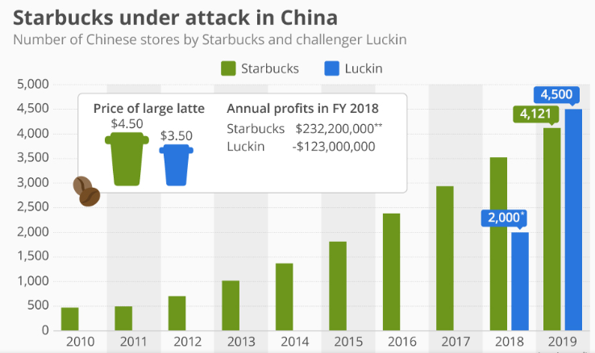
<Source from: https://www.statista.com/chart/16537/luckin-coffee-attacks-starbucks/>

9. Fulfilment of social responsibility
Starbucks established the sixth coffee support center in the worldwide and the first coffee grower in Yunnan,China which not only provided strong technical support for local farmers to grow coffee, but also injected endless vitality into the development of the coffee industry in local. Through the Coffee Growers Support Center, Starbucks has strengthened its connection with the growing community, ensuring the continuous improvement of the Starbucks high-quality coffee supply chain(Rothwell, 2017). More importantly, Starbucks has established a business model of the entire industry chain in China. Starbucks will customize coffee planting solutions for local coffee farmers, which will not only reduce the cost of coffee farmers' cultivation, but also reduce the adverse impact on the local environment. Specifically, it mainly includes three parts: seed selection, planting, and daily management. With the establishment of a coffee grower support center and a preliminary coffee processing factory in Yunnan by Starbucks(Ruiz, 2016). On the one hand, Starbucks has completed the coverage of the entire industry chain, consolidating its development in China, and on the other hand, it has brought a new opportunities for development, providing local jobs and gaining praise from the community.

Similarly, in other countries, Starbucks maintains long-lasting strategic partnerships with organizations such as Conservation International, Feeding America, and hundreds of community service partners around the world(Barnea, 2017). Starbucks takes advantage of their business scale to construct and operate the world's largest green retail business and strengthen the community, welcome everyone's participation and expand the influence of major events, and fulfill social responsibility.

10. Conclusion
To sum up, in order to help Starbucks to gain more profits and improve service and product quality in Chinese market, some key points and methods are proposed during the consultancy process. Marketing strategy of Starbucks is figure out that the core of Starbucks' marketing strategy is actually an experience marketing, and corporate values are based on customer experience. At the core, it has revolutionized and created a unique Starbucks experience, which not only meets the consumer's material needs, but also meets their emotional needs, as a value and cultural communication. We have concluded that as the world's leading coffee brand, the more competitors it faces, the unique Starbucks experience brings great success to it and determines the standards of the unprecedented coffee industry. And with the rapid expansion of Starbucks, leading to the decline of core competitiveness and loss of brand value, so that competitors have the opportunity, this crisis is also worthy of our analysis and attention.

11. References
- Czepiel, C.and Shanahan,J. (2014). The Services Challenge: Integrating for Competitive Advantage, Chicago: American Marketing Association, pp.79-84.

- Arnould, E. and Price, L. (2013). River magic: Extraordinary experience and the extended service encounter, Journal of Consumer Research, pp. 24-45.

- Thompson, C. (2015). Consumer Culture Theory (CCT): Twenty Years of Research, Journal of Consumer Research, pp. 868-882.

- Brenner, W. (2003). Knowledge enabled customer relationship management: integrating customer relationship management and knowledge management concepts, Journal of Knowledge Management, 7(5), pp. 107-123.

- Dhar, S. and Varshney, U. (2011). Challenges and business models for mobile location-based services and advertising, Communications of the ACM, 54(5), pp. 121-129.

- Watson, R.(2018). Starbucks case study strategic management, 51(3), pp. 65-69.

- Nicolas, C. (2018). Customer knowledge management and e-commerce: the role of customer perceived risk, International Journal of Information Management, 28(2), pp. 102-113.

- Miller, C.(2019). New Starbucks ads seek to recruit online fans, The New York times,[online]. [Accessed 25 Feb. 2020].Available from: http://www.nytimes.com/2019/05/19/business/media/19starbux.html

- Warren, K. (2011). Starbucks’ social media strategy, Business Review, 2 August, pp. 34-43.

- York, E.(2010). Starbucks gets its business brewing again with social media, Advertising Age, [online].[Accessed 25 Feb. 2020]. Available from: http://vandymkting.typepad.com/files/2010-2-22-advertising-age-starbuks-gets-itsbusiness-brewing-again-with-social-media.pdf. .

- Schulze, M. (2018). Organizational Knowledge creation and the generation of new product ideas: A behavioral approach Research Policy, 37(1), pp. 1742-1750.

- Rowley, B.(2017). Customer community and co-creation: A case study
Marketing Intelligence & Planning, 25 (2), pp. 136-146.

- Starbucks annual report,[online].[Accessed 25 Feb. 2020].Available from: https://s22.q4cdn.com/869488222/files/doc_financials/annual/2018/2018-Annual-Report.pdf.

- Noff, A. (2010). The Starbucks Formula for Social Media Success, The Next Web. [online].[Accessed 25 Feb. 2020].Available from: http://thenextweb.com/2010/01/11/starbucks-formula-social-media-success/.

- Öztamur, D.(2018). Exploring the Role of Social Media for SMEs: As a New Marketing Strategy Tool for the Firm Performance Perspective. Procedia-Social and Behavioral Sciences,pp. 511–520.

- Park, H.(2019). The Role of Social Network Websites in the Consumer–Brand Relationship. Journal of Retailing and Consumer Services, 21(4),pp. 460–467.

- Rothwell, J. (2017). In the Company of Others: An Introduction to Communication. New York: Oxford University Press.

- Ruiz, J. (2016). 6 Reasons Starbucks Marketing Communications Strategy is So Effective. Strategic Marketing Solutions. [online]. [Accessed 25 Feb. 2020].Available from: http://www.strategicdriven.com/marketing-insights-blog/6-reasons-starbucks-marketing-communications-strategy-is-so-effective/.

- Barnea, A.(2017). Lack of peripheral vision How Starbucks failed in Africa. Journal of Marketing Management, 3(4), pp.78-88.

- Haskova, K.(2015). Starbucks Marketing Analysis. CRIS-Bulletin of the Centre for Research and Interdisciplinary Study, 2015(1), pp.11-29.

- Koch, A.(2010). Factors influencing market and entry mode selection: developing the MEMS model. Marketing Intelligence & Planning, 19(5), pp.351-361.

- KLEIN,D.(2018).Starbucks' China Goals: A New Store Every 15 Hours for 5 Years. [online].[Accessed 26 Feb. 2020].Available from: https://www.qsrmagazine.com/fast-food/starbucks-china-goals-new-store-every-15-hours-5-years.

