
Skills for the Workplace
Module Assignment Submission
Student Name: | Nassaba Maomed Guiba-Fernandes
Student Number: | 1605896
Module No: | EMPL4011
Module Title: | Smart Technology in the Workplace

Statement of Confirmation of Authenticity
By the act of making this submission, the student declares that this is the work of the student named above. The work has not, in whole or in part, been knowingly presented elsewhere for assessment, or where assessment has been built on a previous assessment, this has been identified. Where materials have been used from other sources it has been properly acknowledged. If this statement is untrue, the student acknowledges that an assessment offence has been committed.
Attention is drawn to the plagiarism and unfair practice policies of both the University and of ILM.

Table of Contents

Introduction
Section 1-Demonstrate the ability to evaluate the appropriate use of technology (including mobile devices) to improve workplace efficiency and employability by the following means:
- Phone and Tablet
- Web based Email

Section 2-Demonstrate appropriate use of technology and it`s applications in the workplace by the means of:
- LinkedIn
- Twitter
- Facebook

Section 3-Evaluate the possibilities for communication and collaboration in the workplace that use of these social networks provides-giving examples to illustrate your research.

Conclusion

References

Introduction

Technology has become a common fixture in the modern society, independently of the economical status of a country (Gaynor, H). In the 21st century, mankind has become dependent of social media, personally and professionally, using its means to stay in contact with the outside world in their homes and workplaces. The following written assignment will focus on 2 hardware devices, social media accounts, and the ability to use these different tolls to improve a workplace and business, at the same time demonstrating how technology continuously brings countless social advancements and multiples benefits to a business. Start-ups or established businesses all need to keep on evolving consistently and having a daily presence on the technological world is the fastest way to achieve employee productivity and business expansion. The workplace example will be a Holistic Spa called Bath Haus Spa, situated in borough of Barking and Dagenham, whereas Nassaba work as a mobile Massage Therapist. This workplace, case study, will demonstrate the current relationship between mankind in business and technology.

Section 1.
The very first concept of the Smartphone appeared in the late 1970’s, however the release into the market was in 1994 by IBM,with a concept called “ Simon the personal communicator” and it was a combination between a PDA(palm top computer) and a mobile phone. This first invention has many applications such as emails, calendar, agenda, date, world clock and an on screen keyboard. (Nguyen, 2016). In 2018 the world celebrates 24 years of the existence of the amazing creation that are the Smartphone’s.
The Smartphone used in this example is the Samsung S6+ Edge. The Galaxy S6 and S6 Edge were released on 10 April 2015 in 20 countries while the S6 Edge+ was released on 21 August 2015 in 20 countries. The S6+ operating system is Android and its biggest memory available is of 256 GB. Being a Smartphone it’s very easy to carry inside the pocket, manage personal data or communicate with other people from around the world. Five and sixteen megapixels front and rear camera keeps the memories alive. The surround speakers deliver all favourite songs the memory can keep. Playback is of a very high quality as well as loud a person can also hear the bass emanating from the music, making almost difficult to notice the jump in audio quality when listening to streamed music. The S6+ is also water resistant.

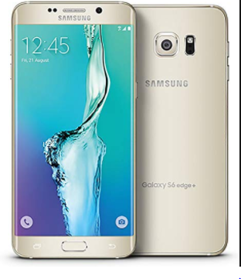
https://www.smartcellular.co.uk/samsung/galaxy/edges6+
Mobile devices are an important tool for employees and employers to access their company`s resources wherever they are. More than just working from home, mobile employees today essentially take their office with them on client visits, sales calls, at home and anywhere else where they can a signal. At the Bath Haus, all therapists are self-employed and are encouraged to use their devices, for work- related purposes, as one of the main ways to increase the employee’s productivity.

The Grid Pad was the first tablet pc released on the market by Grid Systems in 1998 and one of the earliest Silicon Valley start-ups. Firstly the tablet was used for different forms of interacting such as drawing, animation and graphics. The Gridpad was not quite the tablet inventors and people expected and wanted, because of its heavy weight (five pounds) and bulk. The screen was barely capable of displaying in grayscale, which was a far cry from the million-pixel benchmark that Kay had previously set forth, still with its limitations, the Gridpad, it was widely picked up by large companies and government agencies that used it to help streaming record and data keeping.
22 years later, Bill Gates released the first true tablet, the Microsoft Tablet PC. It was the size of a legal notepad and half the weight of today’s laptop PC's. This Tablet PC is full-powered, full feature PC, runs Windows XP, and combines the power of a desktop computing with the versatility, flexibility and portability of a pen on a paper notepad. (Hill, 2013).

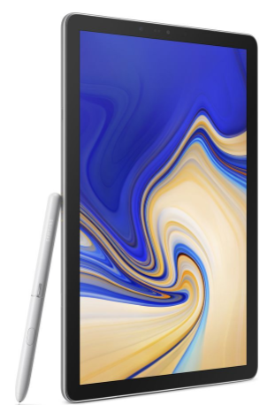
https//www.smartcellular.co.uk/samasung/Tab/S4
Samsung Galaxy Tab S4 is the latest release and the youngest of all the tablets of this particular family. UK pre-orders for the Tab S4 have begun on 9 of August 2018.
The Samsung Galaxy Tb S4 is been considered the best Android tablet to date , according to Nguyen, headlined by an HDR ready screen, four powerful speakers and an upgraded S Pen. This tablet transforms in look and potential with the included S pen and keyboard attachment, which make the must have accessories to unlock the full potential of this 2-1 tablet. Despite the fact the S6+ immense memory capacity, the Samsung Galaxy S4 Tab can be extended to 256 GB with the use of a memory card. The display of this tablet is bigger than the Smartphone and it can also be used in different ways helped by the S Pen, like presenting projects and watching videos, although heavier and bigger than a Smartphone, it can be carried in a small bag or suitcase. Both devices have an android operating system which has a week security system, making challenging to manage its software.
At the Bath Haus Spa the mobile phone and tablets are the primary devices use to conduct business on a daily basis. The tablet has an app called “Mind n Body” where all the appointments are logged in, the therapists add their availability and the clients can book directly on the app at any time. Is on the Mind n body app that all appointments are a managed, the clients details are logged and securely locked away under a password, which is changed every 3 months. All mobile devices have access to the app, giving the therapists constant access with their bookings and facilitating their self employer status.
Web based email
Gmail and Hotmail are both email programs chosen for this section and with similar functionality and features as listed below:
-Filters; enables the user to organize their emails in a variety of ways, including sending emails directly to the trash making the email inbox easier to sort through.
-Keyboard Shortcuts; has its own and once the keyboard shortcuts are memorized, the user will able to go through their email much quicker.
-Priority Inbox
-Multiple accounts accessed by granted access; relates to business related accounts and it grants access to a colleague
-Mute conversations; with this feature the user is able to mute conversations whilst in use
-HTTPS; this is a beneficial security setting providing the user, once selected the option, a more secure connection when using Gmail mobile applications, such as in internet cafe
-Video chat
-Canned Responses; another way to cut down the amount of time spending on checking emails, on a daily basis, once the user creates this feature by selecting the right settings.
-Offline Gmail; giving the alternative to access the email account off line.
-Empty message without the prompt
-SMS from Gmail
-Access Email from other online accounts
-Gmail Security Checklist

Section 2
- LinkedIn
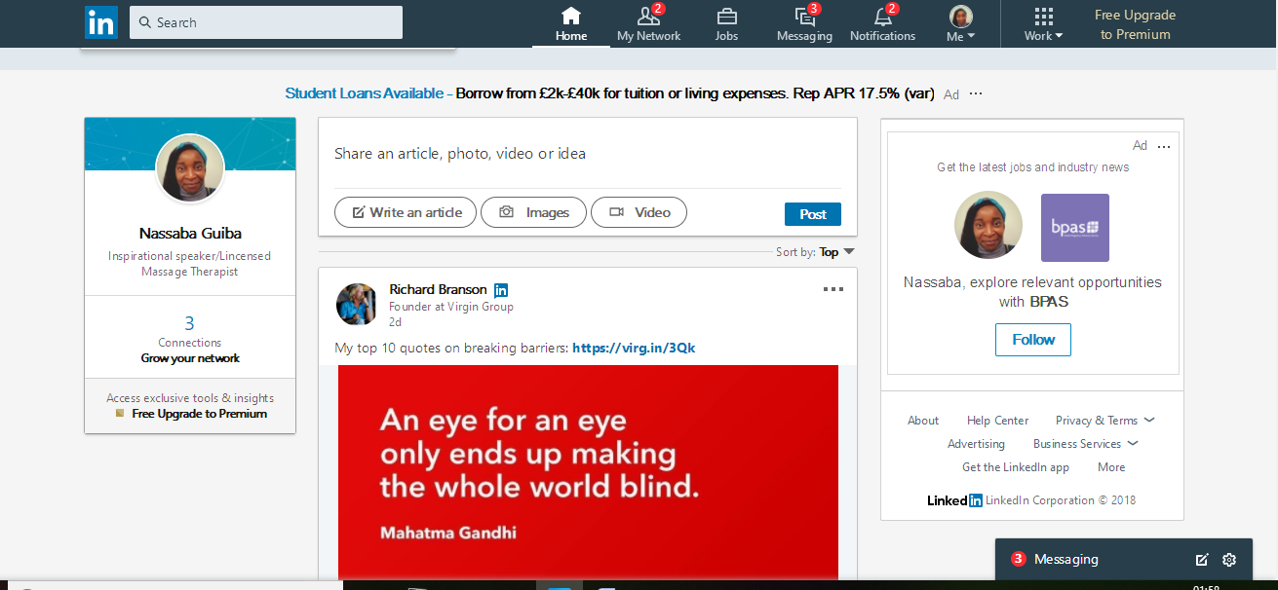
As Nassaba is a self-employer Massage therapist, the use of LinkedIn helps her to promote her own business and to advertise her skills as a verified, qualified and insured professional therapist. The LinkedIn account helps her to make new connections to people in the same type of business and to learn on how to manage her business, by following the steps of successful entrepreneurs in the dame filed. Networking is an essential part of any business and needs to be checked on a daily basis.
- Twitter
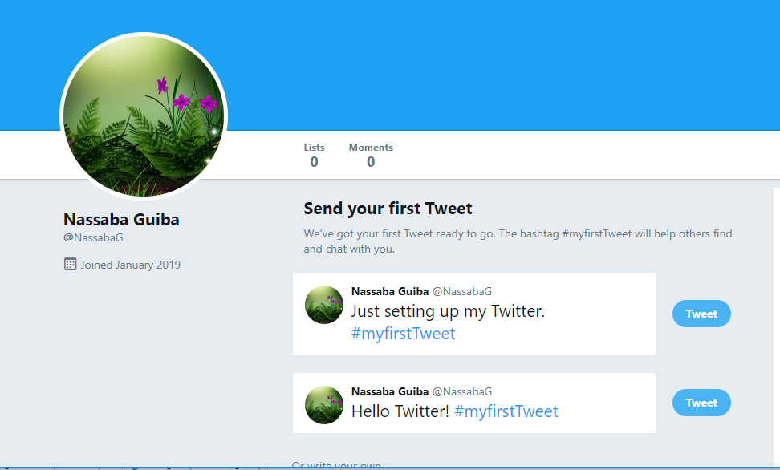
Being present in Twitter is another form of networking, yet once up and running there’s the option of becoming verified ,which can be completed by providing extra documents and according to Twitter ,it will add accountability and stability to the users account.

- Business Facebook Page Naturalis@Wellbeingbooster
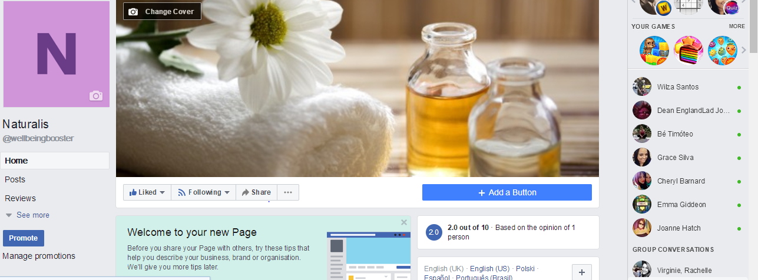
Naturalis@wellbeingbooster is an extra idea to create awareness to empower people to go back to basics in the use of natural and day to day ingredients to improve skincare and ultimately health. It’s a brand new business and in early days. The mission statement of Naturalis is “To be your natural self” by sharing naturalistic ways of living free of chemicals and to educate people on the old art of recycle organic ingredients back into a person organism in the form of skincare and aromatherapy. This idea is also being practise in the Bath Haus Spa in forms of workshops and Nassaba id the one delivering the content for the pilot workshops.
Section 3.
The working place is The Bath Haus Spa and holistic centre where the writer works as part of team of spa and massage therapists. This particular Spa uses a Pc and a Tablet to get access to an app called mind body. Mind body use is to insert, record and keep safe clients details database, to create appointments and to send automated emails and texts as reminders 48 hours previous to the client’s appointments. This app alone improves the workplace efficiency by saving time and to give each member quick access to the daily timetable as well has been environmental friendly with the electronic database which is under a password, that is changed on a weekly basis.
The Bath Haus Spa is on various social media accounts such as Face book, LinkedIn and Instagram to enable the company to communicate, advertise and to market with the existent clients as well as reaching out to potential new clients, all free of charge. All the social media account is under passwords and the tablet and Pc have an antivirus and firewall programs to keep the company details safe online.
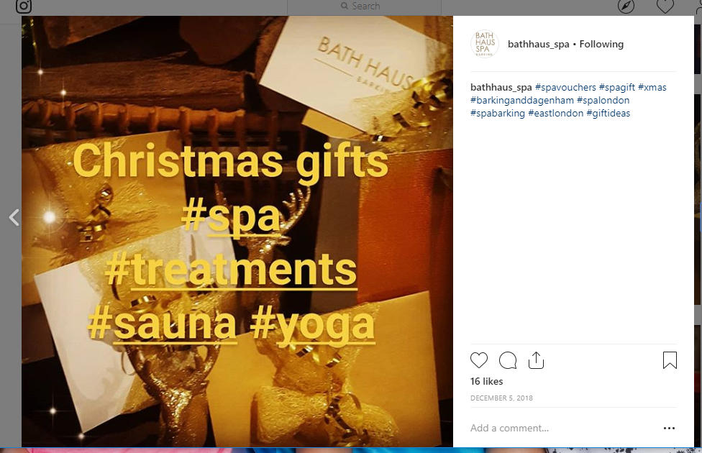
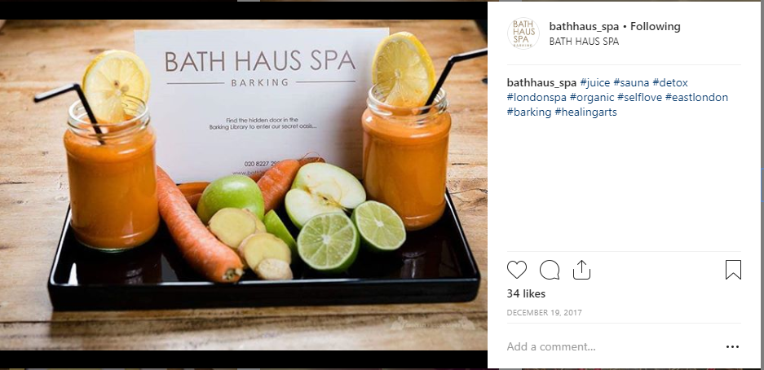
https://www.instagram/bathhauspa.co.uk

Conclusion
Technology undoubtedly makes everyone lifes easier and it’s helping multitudes of people to improve their skills. Promoting life stories which inspire others to be more adventurous in the world of business (Twiss, B.). Everything people do, in the current day an age, is based on technology. The case study provided by The Bath Haus Spa give a real inside on the existent relationship between mankind and technology and it raises the question: Will technology ever substitute mankind personal touch? According to the therapists at the Bath Haus Spa, the human touch is what clients want, so the answer is not in a near future. The only other risen aspect of this research is mankind becoming too dependent on technology and struggle without it. Either way the findings are very clear; technology has become mankind best business partner and with its evolution at its pick and more inventions arising every day business and technology will be side by side for as long as man exits.

References
Twiss, B. (1974) Managing Technological Innovation (1st edition)
Gaynor, G. (1996) Handbook of Technology Management (2nd edition)
Rooth, A. (2008) Managing the Modern Workplace (3rd edition)

Pears, R. & Shields, G. Cite Them Right. Basingstoke: Palgrave MacMillan, 2011.

Cottrell, S. (2010) Skills for Success: The Personal Development Planning Handbook (2nd edition). Hampshire: Palgrave MacMillan.

Levin, P. (2004) Write Great Essays. Maidenhead: Open University Press.

Mercer, N. (2006) The Guided Construction of Knowledge: talk amongst teachers and learners. Clevedon: Multilingual Matters Ltd.

Pritchards, A. M. (2008) Studying and Learning at University: Vital Skills for Success in your Degree. London: Sage Publications.

Seely, J. (2005) Oxford Guide to Effective Writing and Speaking (2nd edition). Oxford: Open University Press.

Van Emden, J. & Becker, L. (2010) Presentation Skills for Students (2nd edition). Palgrave Macmillan.
Ebooks
Hind, D. and Moss, S. (2011) Employability Skills, Business Education Publishers Ltd; 2nded.

Marsh, R. (2012) Skills for Employability Part One: Moving into Employment, Christal Pub.

Web links

https://www.smartcellular.co.uk/samsung/galaxy/edge6+

https://www.smartcellular.co.uk/samsung/tab/s4

https://www.linkedin.co.uk

htpps://www.facebook.co.uk

https://www.twitter/co/uk

https://www.instragram/bathhausspa.co.uk
www.inlandrevenue.gov.uk
https://jobs.theguardian.com/ - Guardian Jobs
https://www.indeed.co.uk/ - Indeed Jobs

