Name: Jon Morgan

Student Number: 2501590
__________________________________________________________

WORKSHEET 1 – TESTING (Using Variables)

- Original code:
print("Enter your surname: ")
surname = input()

print("Enter your national insurance number (e.g PE253412B): ")
nationalinsurance = str(input())

print("Enter your age: ")
age = int(input())

print("Number of working hours per week: ")
workinghours= int(input())

if workinghours > 48:
print("working hours exceeds legal limit")
else:
print("Thank you")

- Code Testing

For each test below, run your code and enter the values provided. Present a screenshot of the programme running. Did the programme behave correctly or did it do something unexpected, and if so, why?

Surname:
- Enter JONES
- Leave blank
- Enter A
- Enter 123

National Insurance Number:
- Enter PE534121B
- Leave blank
- Enter AB11223344556677 (ie too long for National Insurance number format)
- Enter 22PE4088A (ie wrong format)

Age
- Enter 34
- Enter 150
- Enter -4
- Enter a letter

Number of working hours per week:
- Enter 37.5
- Enter 150
- Enter 0
- Enter -2

Fill in a box for each test above. You should present 16 separate boxes, 1 for each test. (Note: the first two boxes are provided as a template)

Test:
Surname i. Enter JONES

Screenshot(s) of output:
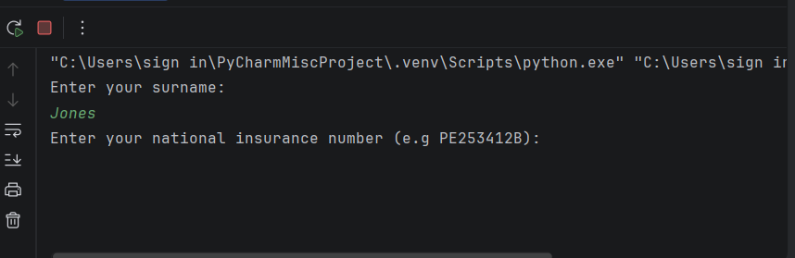
Result: The program in this scenario behaved as expected by displaying the message the user has input into the program. The Surname entered was a fitting answer, meaning it was taken successfully.

Test:
Surname ii Leave blank

Screenshot(s) of output:
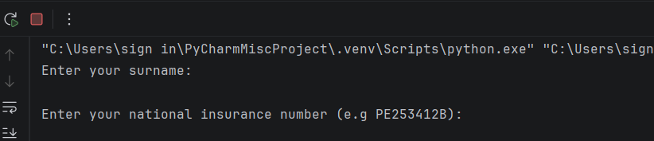
Result: The program acceptance of the blank entry means this test has proven that the code has not operated correctly. The program should not have accepted a blank answer, and instead should have prompted the user to enter a correct surname.

Continue the rest of the tests below. (Copy and paste a box for each one)

Test:
Surname iii Enter ‘A’

Screenshot(s) of output:
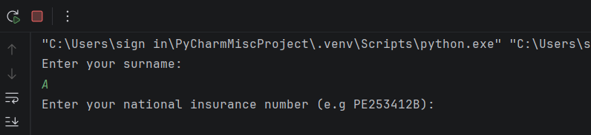
Result: The program behaved correctly by accepting the answer and displaying it on the screen.

Test:
Surname iv enter ‘123’

Screenshot(s) of output:

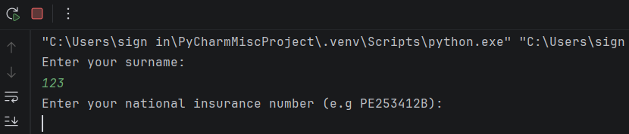
Result: The program did not behave correctly and accepted the numbers instead of rejecting them and requesting the user to enter a valid surname.

Test:
National insurance number i. enter ‘PE534121B’

Screenshot(s) of output:

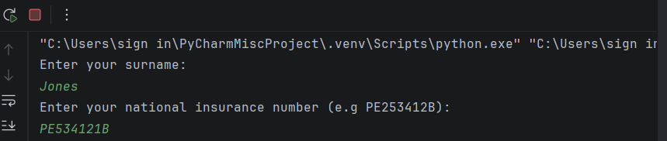
Result: This test was successful as the code was able to accept the national insurance number, as it was correct.

Test:
National insurance number ii. ‘Leave blank’

Screenshot(s) of output:

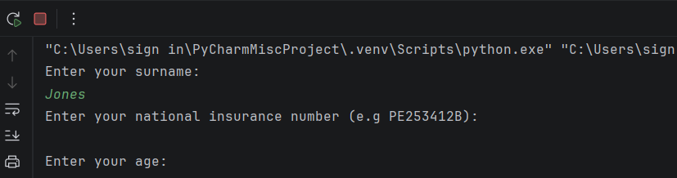
Result:
These results are not sufficient as the program has accepted a blank input for the national insurance number.

Test:
National insurance number iii. ‘AB11223344556677’

Screenshot(s) of output:

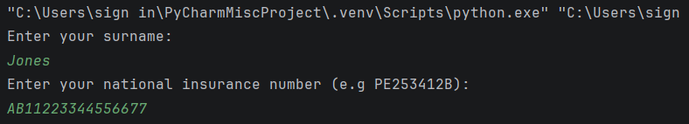
Result: Code did not perform correctly, accepted an answer that was too long.

Test:
National insurance number iv. Enter ‘22PE4088A’

Screenshot(s) of output:

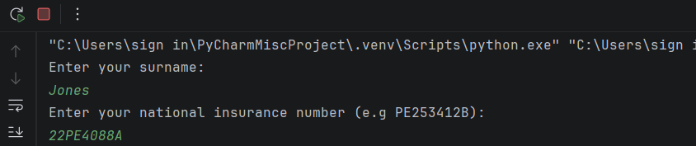
Result: Code did not perform correctly, accepted a national insurance that was in an incorrect format.

Test:
Age i. enter ‘34’

Screenshot(s) of output:

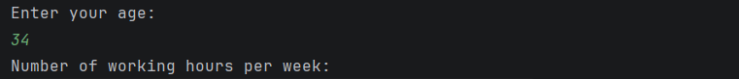
Result: Code performed successfully by accepting the code and displaying the input entered by the user.

Test:
Age ii. enter ‘150’

Screenshot(s) of output:

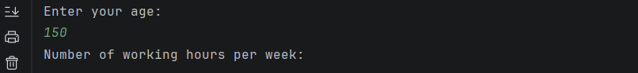
Result: The program has not performed as expected as the age 150 is typically not realistic and the user would not be that old. The program should have prompted the user to put a correct age in.

Test:
Age iii. enter ‘-4’

Screenshot(s) of output:

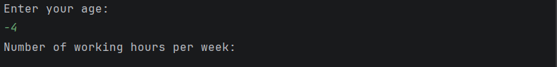
Result: The program has not performed as expected as the age -4 is not possible.

Test:
Age iv. enter a letter

Screenshot(s) of output:

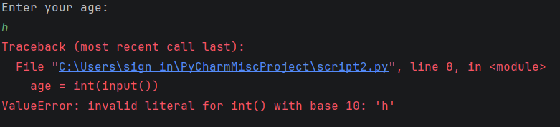
Result: The program performed properly by refusing the invalid input ‘h’ typed by the user.

Test:
Number of working hours per week, i. enter ’37.5’

Screenshot(s) of output:

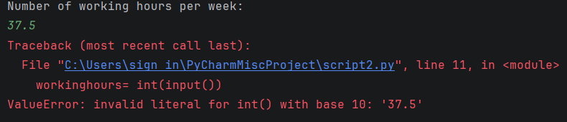
Result: The program didn’t perform correctly as it didn’t accept the input correctly.

Test:
Number of working hours per week, ii. enter ’150’

Screenshot(s) of output:

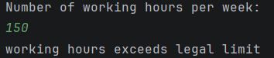
Result: The program performed correctly by displaying the working hours exceeds the legal limit.

Test:
Number of working hours per week, iii. enter ’0’

Screenshot(s) of output:

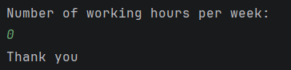
Result: The program responded correctly as the user could be unemployed.

Test:
Number of working hours per week, iv. enter ’-2’

Screenshot(s) of output:

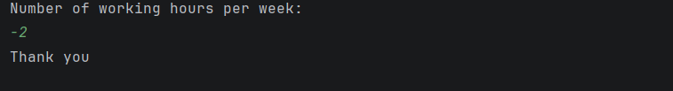
Result: The program did not perform correctly as it accepted the input of -2, instead of prompting the user to re enter their working hours.

- Consider the results of the above tests and revisit your code in order to solve the problems. (Note: you may not be able to solve all of them, but solve as many as you can.)

Paste your revised code here:

surname = input("Enter your surname:")
while not surname.isalpha():
print("Please enter a valid surname by using letters only.")
surname = input("Enter your surname:")
nationalinsurance = input("Enter your national insurance number (e.g PE253412B): ")
while not (len(nationalinsurance) == 9 and nationalinsurance.isalnum()):
print("Invalid. it must be exactly 9 characters.")
nationalinsurance = input("Enter your national insurance number: ")
age = int(input("Print your age: "))
while age <= 0:
print("Your age cannot be zero or less")
age = int(input("Enter your age: "))
while age > 120:
print("Your age cannot be more than 120")
age = int(input("Enter your age: "))
print("Number of working hours per week: ")
workinghours= int(input())
if workinghours > 48:
print("working hours exceeds legal limit")
workinghours = int(input("Enter your working hours: "))
if workinghours < 0:
print("working hours cannot be negative")
workinghours = int(input("Enter your working hours: "))
print("End of program, thank you!")

