

Dissertation
Assessing the Environmental Impacts of Tesla’s Electric Vehicle Production: A Case Study

Lecturer: Dr. Faizu Edu

Student name & ID:
Alina-Paula Manolache- 2114609
Abstract
The purpose of this report is to analyze the environmental impact of Tesla, one of the leading EV manufacturers in the globe. The paper carries the purpose of assessing the environmental impact of Tesla’s electric vehicle production through a life cycle assessment (LCA) approach. The paper analyses different aspects like carbon footprint, usage of water, mineral depletion, and toxicity level that are associated with Tesla’s EV production process. In this context, irrespective of the high demand for electric vehicles and their effectiveness in reducing carbon compared to motorized vehicles. There are certain concerns like higher public charging station development and emission from the lithium-ion battery that is a key concern to the industry. The production process of EVs is associated with a reduced carbon footprint, which has helped to reduce the negative environmental impact. Tesla has also focused on reduced water consumption from its operation and a cascade rising system is used for washing the car batteries. The manufacturing activities are associated with sustainable business operations and improving the quality of EVs.
The research work is conducted to examine the effectiveness of the strategic practice of Tesla while continuing its EV production-related practice in terms of environmental impact management which is met following an empirical approach. Secondary data containing 60 samples for different environmental impact-related variables or metrics like material composition, energy consumption and CO₂ emission is collected. The sourced secondary data is analyzed using quantitative techniques using the SPSS tool along with functions including inferential statistics, correlation and hypothesis tests.
The paper investigated the environmental influence of Tesla's EV production procedure using a quantitative life cycle assessment (LCA) method. Moreover, the research work also evaluates the data collected through employee surveys and secondary sources effectively. The study focused on quantifying energy usage, material consumption, waste generation, CO2 emissions, and water usage related to Tesla's EV production. The paper also inspected the correlation between factors and tested the hypothesis that Tesla's production practices affect waste decreases and CO2 emission decreases.

Table of Contents
Chapter 1: Introduction 6
1.1 Overview 6
1.2 Aims and objectives 6
1.3 Significance of the study 6
1.4 Research questions 7
1.5 Limitations 7
1.6 Background of the business 7
1.7 Summary 8
Chapter 2: Literature Review 9
2.1 Introduction 9
2.2 Origin of electric vehicles (EVs) 9
2.3 Reason for selecting Tesla 9
2.4 Ways Tesla’s EV production process is associated with carbon footprint 10
2.5 The relationship between the production process in Tesla and water consumption and mineral depletion 10
2.6 A comparison of the lifestyle of Tesla’s EVs and the “Internal Combustion Engine Vehicles (ICEVs)” 11
2.7 Areas of improvement in Tesla 12
2.8 Literature Gap 12
2.9 Summary 12
Chapter 3: Research Methodology 14
3.1 Introduction 14
3.2 Philosophical Position of the Research 14
3.3 Paradigm Position 14
3.4 Research Approach 15
3.5 Methodology Stance 15
3.6 Research Strategy and Design 16
3.7 Research Sample and Population 16
3.8 Data Collection and Data Analysis Tool 16
3.9 Ethical Consideration 17
3.10 Summary 17
Chapter 4: Findings and Discussion 18
4.1 Overview 18
4.2 Findings 18
4.2.1 Descriptive Statistics 18
4.2.2 Correlation 22
4.2.3 Hypothesis Analysis 23
4.3 Discussion 25
4.4 Summary 26
Chapter 5: Conclusion and Recommendation 27
5.1 Conclusion 27
5.2 Recommendation 28
5.3 Limitation 28
5.4 Scope of Future Research 29
References 30
Appendices 35
Questionnaire 35
Dataset 35

List of Figures
Figure 1: Graphical Representation of the Association between Energy Consumption and Co2 Emission; Source: Self-made; 20
Figure 2: Correlation Analysis of the relationship between Environmental Impact and Production Practices of Tesla; Source: Self-made; 21
Figure 3: Hypothesis Test; Source: Self-made; 22
Figure 4: Hypothesis Test; Source: Self-made; 22

Chapter 1: Introduction

Overview
The production procedure of different electric vehicles has been a key concern to the auto industry and the transition coming in the industry. Irrespective of the impact of electric vehicles on reducing the emission of carbon or GHG, it is identified that activities like public charging and supply chain operations to collect lithium and batteries are contributing to environmental pollution (Guo et al., 2020). Recently, Tesla has been criticized for not focusing on environmental-related concerns and lagging behind the industry, competitors in terms of lowering carbon emissions and GHG emissions. It has not been efficient enough to publish the environmental action-related disclosure, which has contributed to the criticism it faces for not following eco-friendly procedures. For example, a leading rival in the industry, Ford achieved a grade A in climate-related action disclosure, whereas Tesla only managed to receive an F grade (Calma, 2023).

Aims and objectives
Aim
The research aims to assess the environmental impacts of Tesla’s electric vehicle production through a life cycle assessment (LCA) approach.
Objectives
- To quantify the carbon footprint, water usage, mineral depletion, and toxicity impacts associated with Tesla’s EV production process.
- To compare the lifecycle impacts of Tesla’s EVs with equivalent internal combustion engine vehicles (ICEVs).
- To identify environmental hotspots in Tesla’s EV supply chain and opportunities for impact reduction.

Significance of the study
Electric vehicles have been the key transition in the automobile industry in recent times, which have mainly been designed and planned to decrease the pollution level in the environment, caused by motorized cars. Therefore, this research is rational as it not only discusses the effectiveness of electric vehicles but also identifies the pollution level caused by such cars and in different stages of the life cycle of such vehicles and how pollutant generation has been a key concern. Additionally, the research discusses the production activities of Tesla and how it has faced criticism for contributing to environmental pollution. As this business is considered one of the leading organizations in the electric vehicle manufacturing industry, the primary information collected from the respondents associated with the Tesla products makes the discussion rational as the first information found about the product life cycle of Tesla.

Research questions
1. How does the lifecycle carbon footprint of a Tesla EV compare with an equivalent ICEV( Internal combustion engine vehicle)?
2. What are the major environmental hotspots in Tesla’s EV supply chain?
3. How can the environmental impacts from Tesla’s EV manufacturing be minimized?

Limitations
The study is based on primary data collection and a survey has been conducted to collect quantitative data. Therefore, the research is associated with a limitation of not including extensive qualitative information collected from either literature sources or people working in managerial positions at Tesla. The inclusion of literary resources in the research would increase the quality of theoretical explanations and framework to be included in the paper to increase the authenticity or consistency of the information presented. Moreover, a qualitative data collection process following the primary data collection method might have increased the quality of the research as it would support gathering information from people responsible for developing strategies in Tesla for reducing its contribution to environmental pollution. Therefore, it would also support to collection of data that is more authentic.

Background of the business
This is one of the leading electric car manufacturers and it is appreciated for the most advanced electric vehicles like Model Three and model which has been the key reason for the transition of the automobile industry into electric vehicle development (Lu et al., 2022). The business was founded in 2003 in California. Tesla has been successful in generating a yearly revenue of 94.74 billion USD in 2024, which shows the financial stability of the business (Macro Trends, 2024). Due to the effective transformational leadership of Elon Musk and the focus on continually improving the features of electric vehicles, it has been successful in enhancing the business into the global automobile market by expanding the business from the native American market

Summary
It is summarized that the research is rational as it discusses the contribution of electric vehicles, manufacturing and the product life cycle on environmental pollution. Additionally, it is summarized that collecting primary data for the research delivers scope to identify the measures taken by the management to control such concerns.

Chapter 2: Literature Review

Introduction
This portion of the presentation focuses on delivering information about how electric vehicles have transformed the automobile industry in recent times and the history of electric vehicles. In addition to this, the portion of the research discusses the reason the Test was selected as the case study organization in this business-related study. More discussion has been presented against the effectiveness and shortcomings followed in the production process of Tesla and the improvement areas. The business has where it should focus on to improve the overall product life cycle.

Origin of electric vehicles (EVs)
In 1831, a carriage was transformed into an electric vehicle. In 1859, the idea of electric vehicles became more viable and in 1884, Thomas Parker applied for an electric vehicle. In modern times, the Ford Model T has been the most acknowledged and fast electric vehicle since 1908 (Barkenbus, 2020). The first sports car run by Electric came out in 1992, which was able to reach 60 mph in below four seconds. Tesla was the first organization to start production of the most advanced kind of electric vehicles in 2008 with the first-generation EB titled Roadster. Using proprietary drivetrain technology, Tesla was the fastest-to-run electric vehicle that was dependent on licensed AC propulsion and reductive charging machines. In 2010, it was able to manufacture cars that had a 200-mile driving range and included lithium batteries in the cars (Rosenberger et al., 2024). The business was able to manufacture and sell more than 2400 units of electric vehicles within four years, which ensured the transition of electric vehicles into the modern era (Rosenberger et al., 2024).

Reason for selecting Tesla
Tesla has been selected in the study for the case as it has been the most renowned and popular business among electric vehicle manufacturers globally. The business has been successful in selling the greatest number of units of electric vehicles. In recent times their production process is the most, discussed matter in the EV industry. Therefore, the selection of the business has been justified as it has developed a chance to investigate the production process as well as the life cycle of the EVs made by Tesla. Moreover, Tesla has been selected as the case study organization in the study as it has been often criticized for its impact on the environment through inefficient production and supply chain management. Apart from that, the business has been identified and criticized for not disclosing its initiatives to control waste generation and GHG generation within the production or any other stages of the product life cycle. Therefore, the primary data collection process has been selected for this organization only to identify the relevance or truthfulness of such criticism.
In addition to that, Tesla has been selected for the business-related study as it has been one of the most successful businesses in the automobile industry in recent times. For example, in 2023, Tesla was able to deliver 484,000 electric vehicles (Tesla, 2024). Additionally, the production of the business has been highly efficient as it was able to manufacture 495,000 vehicles in the fourth quarter of the year (Tesla, 2024). Therefore, the organization has been considered as the study business in this paper to identify the way it has accomplished success irrespective of the criticism it faced for not maintaining certain qualities in manufacturing or supply chain management.

Ways Tesla’s EV production process is associated with carbon footprint
The EV production of Tesla is associated with the carbon footprint in various ways in terms of supply chain emissions, aluminum emissions, battery emissions and many more. As per the statement of Fox, (2023), an electric vehicle has a smaller carbon footprint than other cars which are gas-powered. The manufacturing process of Tesla’s EV model has avoided the emissions of fossil fuel and recycling the batteries which can recover 70% of the carbon. However, the manufacture of batteries for EVs can produce 7000 to 35,000 Ibs of carbon dioxide (Tesla, 2024). On the other hand, as per the report of Tesla the supply chain emission accounted for 30.7 million tons of carbon dioxide including the services in fuel-related activities, third-party vendors, upstream transportation, uses of products, waste distributions and others. In this context, Alejandro (2021) stated that the batteries of the S model of Tesla have an additional carbon dioxide footprint however it is smaller than the large cars and the footprint of the Tesla’s S model is equal to 80.000 kilometers of diesel compared to the other large cars. Therefore, the actual footprint is significant which has a negative environmental impact.

The relationship between the production process in Tesla and water consumption and mineral depletion
Tesla uses less water for producing its electric vehicles compared to the other organizations within the industry. The recently published reports of Tesla stated that it has used water as a priority issue and reduced its uses in its operation as much as possible. An initiative is adopted by the company for reducing water consumption per vehicle and it has consumed approx. 1.8 cubic meters of water per production of the vehicles. On the other hand, the Giga Texas consumes approx. 2.78 cubic meters of water per production, therefore, an average of 2.57 cubic meters of water is used by the company to produce each car (Forbes, 2024). As per the statement of Oliveri et al., (2023), the company is optimizing the water-intensive production in its operation where they have focused on reducing water consumption and mineral depletion. The company implemented the hybrid cooling towers where it introduced the cascade rising system where the potential opportunities are developed to wash the battery. On the other hand, Tesla captured 25% of its roof runoff and stored the underground water as a result the rainwater is recycled for future use in terms of manufacturing the equipment. The company has saved more than 7.5 million gallons of water each year. In this context, Padilla-Rivera et al. (2018), stated that the “cooling tower make-up” is considered one of the biggest contributors to the use of water in the car factory. The water cools the machinery and evaporates and as a result, it is the non-portable source of rainwater. This technique is used by Tesla, where it approx. 170 gallons of potable city water can be reserved each year.

A comparison of the lifestyle of Tesla’s EVs and the “Internal Combustion Engine Vehicles (ICEVs)”
The electric vehicles of Tesla have several advantages over the “internal combustion engine”. The EVs are cost-efficient and have lower maintenance costs. It does not require changes of the oil or other common gas which has also reduced the emissions of carbon dioxide and has developed a sustainable environment. Xu and Arjmandzadeh, (2023), stated that electric vehicles are expensive initially in terms of buying the products and require a complex repair process. The production of EVs also requires fewer emissions than ICE vehicles which has also contributed to air pollution. On the other hand, the production of EVs has lowered pollution compared to the ICE. High technology is used in EVs and it requires knowing the software updates to keep the cars in good condition. However, the ICE does not require the knowledge required for the software updates. Yang et al., (2021) stated that the EVs tend to have fewer maintenance costs and last longer compared to the ICEVs. However, it requires proper maintenance, and the owner needs to follow the manufacturer's instructions. Both electric vehicles and the ICE differed in various ways in terms of power source, environmental impact, maintenance requirement and many more. Tesla has focused on improving the quality of the EV batteries while the ICE vehicles have mostly used petrol or diesel for the fuel. EVs are more efficient than ICE vehicles which can convert 77% of the electric energy into power and the acceleration tends to be faster and smoother. According to Padilla-Rivera et al. (2018), there are fewer moving parts in EVs and require less maintenance compared to ICE vehicles however it is essential to replace the batteries eventually of the events and it has it can take charging time of up to eight hours whereas ICE vehicles need maximum 5 minutes for refilling.

Areas of improvement in Tesla
Tesla has adopted various ways to improve the environmental impact of its operations. According to Xu and Arjmandzadeh (2023), Tesla has reduced the water usage to produce its vehicles and also conserved rainwater for its future uses. The carbon emission is also reduced compared to the ICEVs, however, the areas that need to be improved by Tesla in terms of reducing the charging time of the batteries and recycling them. The charging time of the batteries is higher which can increase the uses of energy that needs to be focused on by it. As per the statement of Oliveri et al. (2023), investing in battery research and development can help to explore the new materials which can be used in the manufacturing process. As a result, it will improve the capacity of the energy density along with the longevity will be improved and it can create limited degradations of the product. Therefore, research in battery development should focus on Tesla which can enhance the longevity of the battery and reduce the negative environmental impact.

Literature Gap
This research has focused on gathering information related to the environmental aspects of the production of Tesla. Therefore, it has less focused on collecting data related to the other organization that produces EVs and comparing them with the production process of Tesla which is the main literature gap of this research. Comparing the data of Tesla with other organizations can help to develop better insights related to the initiatives adopted by the various organizations in this industry.

Summary
It is summarized that Tesla has focused on reducing the negative environmental impact of the production of electric vehicles which has reduced carbon emissions. Apart from that it also tried to reduce the use of water compared to the others organization that produces ICEVs. However, the company can focus on improving the battery of the electric vehicles to explore new cell designs and improve the manufacturing techniques that can enhance its capacity.

Chapter 3: Research Methodology

3.1 Introduction
The chapter is prepared to highlight the methodology which will be efficient in collecting and analysis of the data efficient in examining the environmental impact of the electric vehicle production practice of Tesla so that informed insight might be derived to improve the sustainability of the firm. The chapter details the philosophical position of the research work in the context of the collection of data efficiency in justifying the negative and positive impact of the electric vehicle production practice of Tesla in terms of environmental population which is used to find ways to improvise the position.

3.2 Philosophical Position of the Research
Positivism philosophy is considered in the research work to validate the technique through which the electric vehicle production practice of Tesla is affecting the surrounding environment, and this has been feasible because of the usage of real and subjective data to validate the assumption (Hürlimann and Hürlimann, 2019). The consideration of the chosen philosophical approach has potentially helped in aligning the data collection and analysis practice-related inference with the quantitative trait of LCA (Lifecycle Assessment technique. The alignment of the data collection practice with the LCA method has significantly assisted in gathering real information about the relationship between the environmental sustainability of Tesla and respective electric vehicle production practices which has ultimately aided in augmenting the reliability of the deliverable.

3.3 Paradigm Position
The post-positivism-related research paradigm is considered in the accomplishment of research as this significantly aided in evidencing if the electric vehicle production practice of Tesla is leaving a positive or negative influence on the surrounding environment and this has been feasible because of the respective judgmental approach. The considered paradigm position is noticed as competitive for the iterative type of the empirical approach available in the form of LCA as this has potentially helped in finding new data efficient in establishing a relationship between the electric vehicle production practice of Tesla and respective environmental impact (O’Gorman and MacIntosh, 2016). Further, the inclusion of the proposed paradigm position has potentially helped in finding the contribution which Tesla has made in limiting the negative influence on the surrounding environment which has ultimately aided in addressing the problem of the study.

3.4 Research Approach
The authentication of the influence of the electric vehicle production practice of Tesla on the respective environmental impact management capability is made following a deductive approach and this is determined because of respective competence in using the existing framework to validate the assumption. The consideration of the determined approach in the accomplishment of the research study has potentially helped in using the peer-reviewed framework and model to examine if there is a relationship between the production process and environmental sustainability which has ultimately helped in augmenting the reliability of the deliverables (Roy and Uekusa, 2020). The deployment of the proposed methodology in the research study has provided an opportunity to use the trusted insight to validate the assumption about the influence of the electric vehicle production practice of Tesla on the surrounding environment which has ultimately aided in augmenting the acceptance of the work.

3.5 Methodology Stance
The measurement of the impact of the electric vehicle production practice of Tesla on the surrounding environment is done following quantitative methodology as this has helped in validating the assumption using statistical outcome which has ultimately contributed to augmenting the reliability of the deliverable (Taherdoost, 2022). In order to examine the process through which the electric vehicle production practice of Tesla affects the surrounding environment, the LCA method is used as a quantitative technique which is further used as a tool of primary research as this has aided in increasing the probability of standardization of the insight inclusion. The consideration of the LCA technique in the research work has aided in the assessment of the environmental impact of the electric vehicle production practice of Tesla for the entire lifecycle including raw material procurement to disposal. In short, the methodology adoption has aided in enhancing the authenticity and standardization of the derivable to validate the assumption about the impact of the electric vehicle production practice of Tesla on the surrounding environment.

3.6 Research Strategy and Design
The purpose of the empirical work is met following a case study-based research strategy considering Tesla as a company dealing in the production and retailing of EV vehicles in the global automobile market. The case study-related strategy’s inclusion in the research practice has aided in collecting and using real and contemporary automobile sector-related data to evidence the influence of the production process on the ecosystem (Haase, et al., 2016). The case study strategy’s involvement in the paper has potentially assisted in the investigation of the phenomenon in the current world. The phenomenon is about the process of influence of the electric vehicle production practice of Tesla on the environment in the form of factors like pollution.

3.7 Research Sample and Population
Purposive sampling is used for testing the stimulus of the electric vehicle production practice of Tesla on the environment because of its help in including participants with expertise in the collection and usage of related data (Flick, 2018). The research practice’s goal is met by including 50 participants working in Tesla as a quality engineer in different branches of the firm while the population size of 100-110 participants is considered in the process.

3.8 Data Collection and Data Analysis Tool
The statement about the effect of the electric vehicle production practice of Tesla on the surrounding environment is justified following the primary method of data collection. In the process, a closed-ended questionnaire containing 12 diversified environmental impact-related questions is framed. The targeted representative of Tesla and other EV companies shared a closed-ended questionnaire with 50 participants (100-110 population size) to obtain data about the consumption of energy, the composition of the material and the production of waste (Lobe, et al., 2020). The quantitative analysis is used for assessing sourced primary data because of respective effectiveness in examining the environmental impact of the electric vehicle production practice of Tesla precisely in multiple perceptions. Secondary sources like peer-reviewed literature and the LCA database are used for addressing the problem of the study. The concerned data is to be examined using the SPSS application including functions of summary statistics, correlation and t-test because of respective efficiency in examining the influence of the electric vehicle production practice of Tesla on the environment in terms of factors like climate change.

3.9 Ethical Consideration
In order to ensure ethical competitiveness across the research practice, an intent letter is shared with the participants before the survey to empower them to make informed decisions before sharing their insight about the research subject (Artal and Rubenfeld, 2017). Further, the secondary sources that information is supported by at least 8 similar sources are only included in the paper to avoid any ethical conflict.

3.10 Summary
It is summarized that the quantitative methodology is appropriate for the collection and evaluation of the data appropriate for justifying if the electric vehicle production practice of Tesla has left a negative impact on the surroundings and this is because of the respective statistical evidencing traits.

Chapter 4: Findings and Discussion

4.1 Overview
The examination of the literature has confirmed the availability of the significant influence of the EV (electric vehicle) production practice of Tesla on the surrounding environment in terms of factors like waste production and Co2 emission which are accountable for the environmental damage. The Validation of the inefficiency of the decision-makers of Tesla towards mitigation of the environmental impact of its EV production-related practice is made using secondary data assessment using statistical inferences including inferential statistics, correlation and hypothesis. The result of the statistical inferences is presented in the following sections along with a discussion of the same in the context of the goal of the assessment of the environmental impact of the EV production-related practice of Tesla.

4.2 Findings

4.2.1 Descriptive Statistics
Descriptive statistics is conducted to examine the variation in the environmental impact and EV production practice-related variables of Tesla using statistical inference to find if the value changes for the entire size of the sample (60) (Baffoe-Djan and Smith, 2019). The result of the derived statistical insight is presented below-
Table 1: Descriptive Statistics of the Environmental Impact related Data for the EV production related practice of Tesla; Source: Self-made;
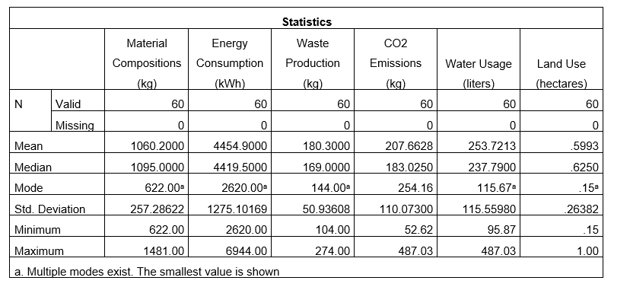
The examination of the statistical insight has confirmed that the average material composition that the team of TESLA used to produce a concerned electric vehicle is around 1060.20 kg while the minimum value for the consumption is around 622. On the other hand, the maximum material which Tesla has used for the continuation of the EV production-related practice is around 1481 which confirms significant variation in the trend of the usage of materials of different quality in the manufacturing activity. The standard deviation of the material composition-related variable is around 257.28 which confirms the moderate change in the behavior of the leaders of Tesla towards the usage of diversified materials to produce EV cars.
On the other hand, the energy which the team of Tesla is using on average while continuing the EV production-related practice is around 4, 454.90 kWh while the respective minimum and maximum consumption noticed in the concerned sample size is around 2, 620 KWh and 6, 944 kWh respectively. The standard deviation for the energy consumption variable is around 1, 275.10 which confirms the moderate variation in the energy usage of the related trait of Tesla while continuing respective EV production-related practices. It means that the team of Tesla is identified with lesser efficiency in optimization of the consumption of energy while continuing its EV production-related practice which has ultimately resulted in the form of negative environmental impact (Cooksey and Cooksey, 2020).
The average volume of waste which Tesla produces while continuing EV production-related practice is around 180 Kg while the maximum and minimum volume for the same which it generates as per the collected sample size is around 274 kg and 104 kg respectively. Apart from this, the standard deviation for the waste production variable is around 50.93 which confirms the significant variation in the waste production and management-related trait of Tesla while continuing EV production-related practice. It means that the efficiency of EV production-related practice is identified as weaker in terms of waste production and handling activity which has ultimately contributed to face a higher negative impact on the surrounding environment.
The Co2 emission which Tesla emits on average while conducting its EV production-related practice is around 207.66 Kg while the average outcome for the water usage practice is 253.72 liters. The maximum CO₂ which Tesla emits while continuing its EV production-related practice is 487.03 kg while the maximum water which the company used during the manufacturing activity is 487.03 respectively. The standard deviation of the land usage-related variable is less than 1 but the value is significantly higher for the Co2 emission and water usage activity (Mishra, et al., 2019). It means that the competence of Tesla is reduced in Co2 emission and informed water usage practice, but a moderate efficiency is identified in its land usage activity.
Table 2:Descriptive Statistics of the Environmental Impact related Data for the EV production-related practice of Tesla; Source: Self-made;
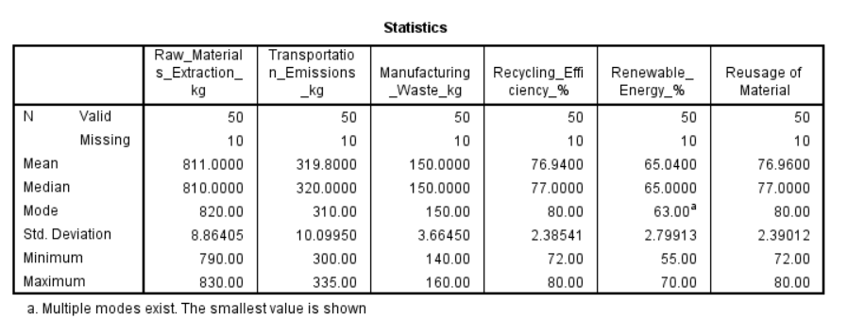
The examination of the statistical table confirms the amount of raw material which the team of Tesla extracts on an average basis while continuing the respective business practice of EV production is around 811 kg while the minimum amount for the performance metric is 790 kg. On the other hand, the maximum amount of raw material which the leaders of Tesla have extracted while continuing respective business practices is around 830 kg and this indicates significant variation in the limit of the material usage during the production of EV vehicles. The standard deviation for the raw material extraction-related trait of Tesla is around 8.86 which is significantly higher than 1 and this confirms the potential variation in the responses of the participants towards the raw material extraction-related trait of the company. In other words, the capability of the team of Tesla in the extraction of raw material during the EV production practice has differed significantly on moving from one respondent to another and this might be the result of variation in the perception of the participants towards the environmental assessment practices.
On the other hand, the examination of the statistical table has confirmed that the average amount of emission which the EV vehicle Tesla emits during transportation practice is around 319.80 while the respective minimum value noticed during strategic practice is around 300 kg. Apart from this, the maximum emission which the transportation wing of Tesla has emitted as per the responses of the participants is around 335 kg and this confirms the significant variation in the responses in terms of minimum and maximum value of the emission. The standard deviation for the transportation emission variation is around 10.09 which is significantly higher than the respective benchmark which confirms the significant deviation in the responses of the participants towards the transportation emission management capabilities of Tesla.
On the other hand, the examination of the statistical outcome validates that the average waste which the team of Tesla generated during the production of EV vehicles is around 150 kg while the minimum volume for the environmental impact is around 140 kg. The maximum waste which the team of Tesla emits during the production of EV vehicles on average as per the responses of the participants is around 160 kg and this validates the potential variation in the tendency of the manufacturing waste emission. The standard deviation for the manufacturing waste variable is around 3.66 which is significantly higher than the related benchmark and this confirms the potential variation in the waste management capability of Tesla during the manufacturing activity. It means that the respondents have been found with significant variations in the responses of the participants towards the waste minimization-related trait of Tesla.
The average recycling efficiency of Tesla as per the participant is around 76.94 while the minimum and maximum values noticed for the performance are 55 % and 70 % and this confirms significant variation in the performance of the company in terms of the adoption of a sustainable approach. The standard deviation for the recycling efficiency is 2.38 which confirms the significant variation in the recycling management-related trait of Tesla in the view of different participants. The competence of Tesla towards the Co2 emission handling is presented by depicting a relational graph for the variable against energy consumption which is presented as follows-
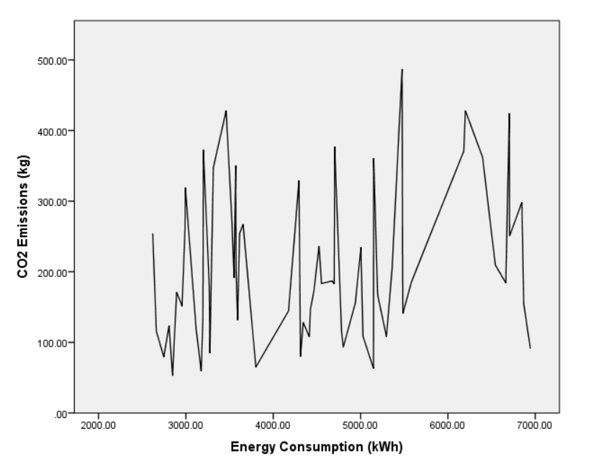
Figure 1: Graphical Representation of the Association between Energy Consumption and Co2 Emission; Source: Self-made;
The presentation highlights the significant change in the Co2 emission management-related capability of Tesla against respective energy consumption capability which is evidenced by the non-linear trend between the two variables. The graphical illustration validates on an average basis that the amount of Co2 emission is increasing and decreasing substantially at different rising points of energy consumption which confirms the inability of Tesla to optimize the non-environmentally friendly production practices in different departments. In other words, the energy consumption-related trait of Tesla hardly affects the Co2 emission management-related capability of the firm while continuing its EV production-related practice.

4.2.2 Correlation
Correlation analysis is conducted to examine the strength and direction of association between different production practices of Tesla and respective environmental impacts which is performed by calculating the correlation coefficient at a 5 % significance level.
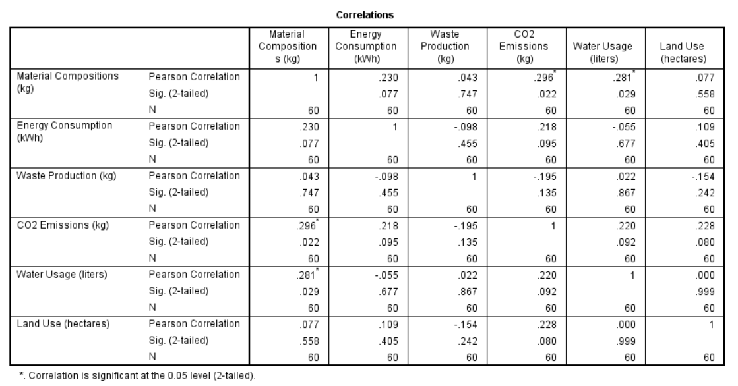
Figure 2:Correlation Analysis of the relationship between Environmental Impact and Production Practices of Tesla; Source: Self-made;
The statistical table confirms the availability of a moderate type of relationship between material consumption and Co2 emission; and water usage which is validated with a positive correlation coefficient of 0.296 and 0.281 respectively (Kafle, 2019). It means that as the inefficiency of Tesla regarding material usage will increase, the volume of Co2 emission will enhance but the variation will be noticed by only 29.60 %.

4.2.3 Hypothesis Analysis
Hypothesis 1
Ho (Null Hypothesis): there is no influence of the EV production-related practice of Tesla on the surrounding environment in terms of waste minimization.
H1 (Alternative Hypothesis): there is a vital influence of the EV production-related practice of Tesla on the surrounding environment in terms of waste minimization.
A T-test with unequal variance is estimated for the validation of the hypothesis which outcome is-
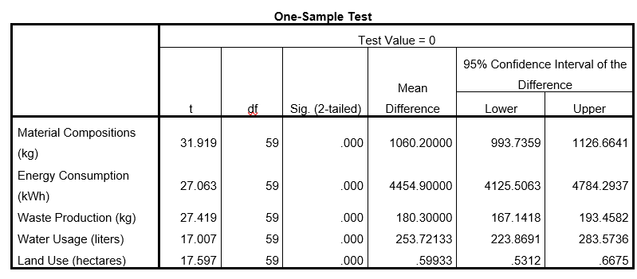
Figure 3:Hypothesis Test; Source: Self-made;
The considered H1 is true because of the lesser “2-tailed Sig” value of all related variables. It means that there is a vital influence of the EV production-related practice of Tesla on the surrounding environment in terms of waste minimization (Liu and Wang, 2021).
Hypothesis 2
Ho (Null Hypothesis): there is no influence of the EV production-related practice of Tesla on the surrounding environment in terms of Co2 emission minimization.
H1 (Alternative Hypothesis): there is a vital influence of the EV production-related practice of Tesla on the surrounding environment in terms of Co2 emission minimization.
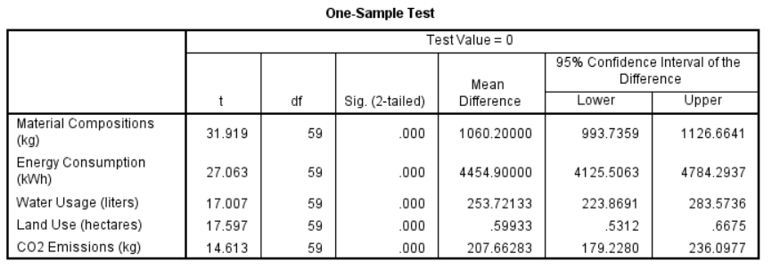
Figure 4:Hypothesis Test; Source: Self-made;
The considered H1 is true because of the lesser “2-tailed Sig” value of all related variables. It means that there is a vital influence of the EV production-related practice of Tesla on the surrounding environment in terms of Co2 emission minimization.

4.3 Discussion
It is discussed from the overall literature insights that Tesla has been a revolutionary force in the automobile industry with the effective pioneering of electric vehicles (EVs) as a more sustainable alternative to gasoline-enabled cars (Haase, et al., 2016). The possible scenario is determined in terms of ensuring the environmental impacts of Tesla’s production process that come under investigation. The considerable scenario is evaluated and discussed, where the literature examines the environmental impacts of Tesla’s EV production practices through the review of the literature and statistical insights. It is determined from the valuable analysis of the data that ensures the EV’s zero tailpipe emissions at the time of the operations. The production procedures also raise environmental concerns (Lobe, et al., 2020). The study acknowledges the smaller carbon footprint of EVs compared to gasoline vehicles. Battery production is a valuable aspect of EVs, where energy-intensive leading to significant carbon dioxide (CO2) emissions. The paper also discussed water usage, where Tesla claims an effort to diminish water consumption (Mishra, et al., 2019). The scenario also indicates the significant water usage per vehicle. The paper highlights the depletion of minerals required for battery production. The considerable insights also justify the scenario as determined in the literature review with the possible insights that evaluate the market effectiveness.
The discussion of the collected data insights from the analysis ensures a deeper into the environmental effect of Tesla’s influence on production practices through the statistical analysis. The statistical analysis examines factors such as material composition, water generation, energy consumption, CO2 emissions, land use, and water usage. The correlation analysis discusses the relationship between production practices and environmental effects. A moderate positive exists between CO2 Emissions, material consumption, and water usage. The analysis also proposes that inefficiencies in material usage led to higher emissions and water consumption. It is discussed from the hypothesis testing considering between the practices and environmental impacts indicate the scenario for clarifying the possibilities. The analytical scenario confirms that a significant influence of Tesla’s production practices on waste minimization and CO2 emission decreases. The possible scenario is determined towards identifying the statistical insights that validate the environmental impact of Tesla’s current production methods. From the overall insights of the scenario, it is determined that the focus of Tesla on the EVs as a sustainable alternative is commendable highlighting the need for additional improvements in the production practices to minimize the environmental impact.
The significant variations in the material composition are determined in terms of ensuring the energy consumption during the production of EVs. It ensures a lack of complete standardization and optimization in valuable areas. The possible scenario is also evaluated in terms of determining the descriptive statistics with the valuable determination. The considerable evaluation is also considered in terms of measuring the success, which ensures the standard deviation for the waste production and the water usage suggesting that Tesla has the possible chance of minimizing the waste and resources. A moderate positive correlation ensures the possible effectiveness towards determining the effectiveness with the proper effectiveness that ensures the inefficiencies in material usage.
The overall determination also evaluates the possible insights in terms of determining the valuable justification to represent the possible insights. The higher environmental footprint is evaluated in the scenario towards justifying the scenario that represents the CO2 emission reduction. From the overall valuation of the hypothesis, the tests confirm a significant influence of Tesla's production practices. It is discussed that the analysis highlights that while Tesla's EVs offer a cleaner alternative to traditional vehicles during operation, production procedures have environmental significance. The considerable insights also evaluate the scenario towards justifying the scenario insights with the management decision-making on the aspect that affects the situation of the business in the highly productive units.

4.4 Summary
It is summarized that the EV production-related practice that the team of Tesla performs includes excessive usage of land and water along with extensive consumption of energy. The trait has increased the ratio of emission of non-environment friendly gases in the surrounding environment which ultimately enhances the greenhouse effect.

Chapter 5: Conclusion and Recommendation

5.1 Conclusion
The research work investigated the environmental impact of Tesla’s EV production process, where a quantitative approach was used to measure the impact through the life cycle assessment (LCA). The data was collected through the survey of the Tesla employees and secondary insights. The valuable findings reveal that the EV production of Tesla has a significant impact on the environment involving material consumption, waste generation, energy usage and CO2 emissions effectively with water usage. The possible scenario is also determined in terms of considering the correlation analysis using the SPSS., the evaluation shows a moderate positive relationship between material consumption CO2 emission and water usage. Moreover, the paper also ensures hypothesis testing ensures Tesla's EV production practices significantly affect waste minimization and CO2 emission decreases.
- “To quantify the carbon footprint, water usage, mineral depletion, and toxicity impacts associated with Tesla’s EV production process.”
The carbon footprint water usage, mineral depletion, and toxicity impacts associated with Tesla’s EV production process ensure the linkage with the research objective and question. The evaluation indicates that the study measures the average amount of the materials used per vehicle and the changes across the production. The data used to determine opportunities for the reduction of materials and the research also quantified the average energy consumption during EV production. The study has a connection with the objective that represents and measures the average water consumption per vehicle. This data can be used to assess water usage efficiency within Tesla's production procedures and classify opportunities for water conservation effectively.
- “To compare the lifecycle impacts of Tesla’s EVs with equivalent internal combustion engine vehicles (ICEVs).”
The research objective has a valuable linkage with the paper that indicates that Tesla's EV production has a significant impact due to factors such as battery manufacturing, this influence is usually lower than resource removal. Tesla's EVs produce zero tailpipe emissions, providing a substantial benefit over ICEVs, which donate meaningfully to air pollution and greenhouse gas emissions. Moreover, the environmental influence of EVs during use depends deeply on the source of electricity used for accusing.
- “To identify environmental hotspots in Tesla’s EV supply chain and opportunities for impact reduction.”
The research study indicates a possible understanding that ensures the production of lithium-ion batteries for EVs is an important contributor to the overall environmental footprint effectively representing the scenario. The paper has a valuable involvement in meeting the objective that ensures the mining and processing of raw materials such as lithium, nickel, and cobalt have negative environmental penalties, involving land degradation, water pollution, and potential human rights apprehensions.

5.2 Recommendation
It is recommended that the leaders of Tesla consider the informed usage of energy across its plant while continuing its EV production-related practice as this approach will help in the minimization of the consumption of non-environment-friendly material in the operational activity. The limited consumption of non-environment-friendly materials in the production practice will assist the decision-makers of Tesla to reduce the emission of CO₂ in the surrounding environment which will ultimately contribute to gaining sustainable growth. Apart from this, the decision-makers of Tesla are suggested to use environmental impact assessment equipment within its operational framework for identifying and curbing unnecessary business practices which will ultimately contribute to environment-friendly growth in future.

5.3 Limitation
The limitation of the proposed research work is the shortage of insight of end users towards the competence of the team of Tesla in environmental impact management while carrying out its EV production-related practice. The shortage of end users’ insight towards the effectiveness of Tesla in environment impact management has reduced the reliability of the inferences from the wide audience’s perspective and this might diminish the acceptance level of the deliverables. Apart from this, the insight used in the deliverable is developed based on a limited sample only because of which the risk of diversity shortage in the inferences might be faced and this might ultimately decline the success ratio of the project.

5.4 Scope of Future Research
It is evaluated from the overall research that future research expands on the study by joining a life cycle assessment (LCA) to lengthily measure the environmental influence of Tesla's EVs throughout their complete life cycle. The research should involve investigating resource extraction and processing for battery manufacturing, raw materials, vehicle meeting, use phase (seeing the source of electricity for accusing), and end-of-life recycling and disposal effectively. Moreover, involving a broader sample size and collecting data from end-users on their perception of Tesla's environmental influence management performance would improve the generalizability and trustworthiness of the research work.

References

- Adams, J. (2014) Research Methods for Business and Social Science Students [electronic resource]. New Delhi, SAGE Publications. Available at: https://ebookcentral.proquest.com/lib/trinity/reader.action?docID=1698991 , Accessed on 18th of June 2024.
- Alejandro Vergara Blanco (2021). LA DICOTOMÍA PÚBLICO / PRIVADO:ESTADO DE LA CUESTIÓN Y SU FUNCIÓN EN DERECHO ADMINISTRATIVO. Revista de derecho, 89(250), pp.163–218. Available at: DOI: 10.29393/rd250-5dpav10005, Accessed on 18th of June 2024.
- Barkenbus, J.N. (2020). Prospects for Electric Vehicles. Sustainability, 12(14), p.5813. Available at: DOI: 10.3390/su12145813. Accessed on 24th of June 2024.
- Bauer, G., Hsu, C.W., Nicolas, M., Lutsey, N., Slowik, P. and Wappelhorst, S. (2021). Charging up America: Assessing the Growing Need for U.S. Charging Infrastructure through 2030. The International Council on Clean Transportation. Available at: https://theicct.org/publication/charging-up-america-assessing-the-growing-need-for-u-s-charging-infrastructure-through-2030/ Accessed on 8th of July 2024.
- Calma, J. (2023). Tesla’s carbon footprint is finally coming into focus, and it’s bigger than the company let on in the past. [online] The Verge. Available at: https://www.theverge.com/2023/4/26/23697746/tesla-climate-pollution-carbon-footprint-supply-chain-report. Accessed on 24th of June 2024.
- Collis, J. (2014) Business research: a practical guide for undergraduate & postgraduate students. Fourth edition. London, England, Macmillan Education., Available at: https://r2.vlereader.com/Reader?ean=9781137037480 , Accessed on 18th of June 2024.
- Dai, Q., Kelly, J.C., Gaines, L. and Wang, M. (2019). Life Cycle Analysis of Lithium-Ion Batteries for Automotive Applications. Batteries, 5(2), p.48.
- Flick, U. (2018). Triangulation in data collection. The SAGE handbook of qualitative data collection, 2(1), 527-544; Available at: DOI: 10.24986063_039871. Accessed on 24th of June 2024
- Forbes (2024). The Carbon Footprint of Tesla Manufacturing. Forbes. [online] 22 Apr. Available at: https://www.forbes.com/sites/quora/2016/04/22/the-carbon-footprint-of-tesla-manufacturing/. Accessed on 24th of June 2024.
- Fox, E. (2023). Tesla Uses Less Water per Vehicle than Industry Average. [online] Tesla Mag. Available at: https://www.tesla-mag.com/en/tesla-uses-less-water-per-vehicle-than-industry-average/#google_vignette. Accessed on 28th of June 2024.
- Guo, J., Zhang, X., Gu, F., Zhang, H. and Fan, Y. (2020). Does air pollution stimulate electric vehicle sales? Empirical evidence from twenty major cities in China. Journal of Cleaner Production, 249(1), p.119372. Available at: DOI: 10.1016/j.jclepro.2019.119372. Accessed on 28th of June 2024.
- Haase, M., Becker, I., Nill, A., Shultz, C. J., and Gentry, J. W. (2016). Male breadwinner ideology and the inclination to establish market relationships: Model development using data from Germany and a mixed-methods research strategy. Journal of Macromarketing, 36(2), 149-167; Available at: DOI: 10.1177/0276146715576202. Accessed on 28th of June 2024.
- Hürlimann, C., and Hürlimann, C. (2019). Research Philosophy and Ethics. . Valuation of Renewable Energy Investments: Practices among German and Swiss Investment Professionals, 12(1), 111-126; Available at: DOI: 10.1007/978-3-658-27469-6_3. Accessed on 2nd of July 2024.
- Intergovernmental Panel on Climate Change (2014). AR5 Climate Change 2014: Mitigation of Climate Change. Available at: https://www.ipcc.ch/report/ar5/wg3/, Accessed on 19th of July 202
- International Organization for Standardization (2006). ISO 14040:2006 Environmental Management — Life Cycle Assessment — Principles and Framework. Available at: https://www.iso.org/standard/37456.html , Accessed on 19th of July 2024.
- Katwala, A. (2018). The Spiralling Environmental Cost of Our Lithium Battery Addiction. Wired, 5 August. Available at: https://www.wired.co.uk/article/lithium-batteries-environment-impact, Accessed on 8th of July 2024.
- Katwala, A. (2018). The Spiralling Environmental Cost of Our Lithium Battery Addiction. Wired, 5 August. Available at: https://www.wired.co.uk/article/lithium-batteries-environment-impact, Accessed on 22nd of July 2024.
- Kim, H.C., Wallington, T.J., Arsenault, R., Bae, C., Ahn, S. and Lee, J. (2016). Cradle-to-Gate Emissions from a Commercial Electric Vehicle Li-Ion Battery: A Comparative Analysis. Environmental Science & Technology, 50(14), pp.7715-7722.
- Larminie, J. and Lowry, J. (2012). Electric Vehicle Technology Explained. 2nd ed. Chichester: John Wiley & Sons.
- Lobe, B., Morgan, D., and Hoffman, K. (2020). Qualitative data collection in an era of social distancing. International journal of qualitative methods, 19(1), 1609406920937875;Available at: DOI: 10.1177/1609406920937875. Accessed on 2nd of July 2024.
- Lu, Y., Wang, J., Liu, F., Liu, Y., Wang, F., Yang, N., Lu, D. and Jia, Y. (2022). Performance optimization of Tesla valve-type channel for cooling lithium-ion batteries. Applied Thermal Engineering, [online] 212(1), p.118583. Available at: DOI: 10.1016/j.applthermaleng.2022.118583. Accessed on 2nd of July 2024.
- Macro Trends (2024). Tesla Revenue 2010-2023 | TSLA. [online] www.macrotrends.net. Available at: https://www.macrotrends.net/stocks/charts/TSLA/tesla/revenue#google_vignette. Accessed on 2nd of July 2024.
- Malmgren, I. (2016). Quantifying the Societal Benefits of Electric Vehicles. World Electric Vehicle Journal, 8(4), pp.996-1007.
- Mattioli, G., Roberts, C., Steinberger, J.K. and Brown, A. (2020). The Political Economy of Car Dependence: A Systems of Provision Approach. Energy Research & Social Science, 66, p.101486.
- Moro, A. and Lonza, L. (2018). Electricity Carbon Intensity in European Member States: Impacts on GHG Emissions of Electric Vehicles. Transportation Research Part D: Transport and Environment, 64, pp.5-14.
- Nealer, R., Reichmuth, D. and Anair, D. (2015). Cleaner Cars from Cradle to Grave: How Electric Cars Beat Gasoline Cars on Lifetime Global Warming Emissions. Union of Concerned Scientists Report, pp.1-54.
- O’Gorman, K. (2015) Research methods for business & management: a guide to writing your dissertation. 2nd ed. Oxford, England:, Goodfellow Publishers Ltd., Available at: https://ebookcentral.proquest.com/lib/trinity/reader.action?docID=4531612, Accessed on: 18th of June 2024.
- O’Gorman, K., and MacIntosh, R. (2016). Research philosophy and paradigm. Research Methods for Accounting and Finance, 3(2), 59-80; Available at : DOI: 10.3163/1536-5050.103.3.011. Accessed on 2nd of July 2024.
- Oliveri, L.M., D’Urso, D., Trapani, N. and Chiacchio, F. (2023). Electrifying Green Logistics: A Comparative Life Cycle Assessment of Electric and Internal Combustion Engine Vehicles. Energies, [online] 16(23), p.7688. Available at: DOI: 10.3390/en16237688. Accessed on 2nd of July 2024.
- Padilla-Rivera, A., Amor, B. and Blanchet, P. (2018). Evaluating the Link between Low Carbon Reductions Strategies and Its Performance in the Context of Climate Change: A Carbon Footprint of a Wood-Frame Residential Building in Quebec, Canada. Sustainability, 10(8), p.2715. Available at: DOI: 10.3390/su10082715. Accessed on 6th of July 2024.
- Ricardo (2020). Transport Lifecycle Assessment Tool. Available at: https://ee.ricardo.com/tlat, Accessed on 22nd of July 2024.
- Rosenberger, N., Rosner, P., Bilfinger, P., Schöberl, J., Teichert, O., Schneider, J., Kareem Abo Gamra, Allgäuer, C., Dietermann, B., Schreiber, M., Ank, M., Kröger, T., Köhler, A. and Lienkamp, M. (2024). Quantifying the State of the Art of Electric Powertrains in Battery Electric Vehicles: Comprehensive Analysis of the Tesla Model 3 on the Vehicle Level. World electric vehicle journal, 15(6), pp.268–268. Available at: DOI: 10.3390/wevj15060268. Accessed on 6th of July 2024.
- Roy, R., and Uekusa, S. (2020). Collaborative autoethnography:“Self-reflection” as a timely alternative research approach during the global pandemic. Qualitative Research Journal, 8(1), 22-29; Available at: DOI: 10.1108/QRJ-06-2020-0054. Accessed on 6th of July 2024.
- Saunders, M., Lewis, P. and Thornhill, A. (2015). Research Methods for Business Students. 7th ed. Harlow: Pearson Education.
- Taherdoost, H. (2022). What are different research approaches? Comprehensive review of qualitative, quantitative, and mixed method research, their applications, types, and limitations. Journal of Management Science & Engineering Research, 5(1), 53-63; Available at: DOI: 10.30564/jmser.v5i1.4538. Accessed on 6th of July 2024.
- Tesla (2024). A Bit About Batteries. [online] Tesla.com. Available at: https://www.tesla.com/blog/bit-about-batteries. Accessed on 9th of July 2024.
- Tesla (2024). Tesla Vehicle Production & Deliveries and Date for Financial Results & Webcast for Fourth Quarter 2023 | Tesla Investor Relations. [online] ir.tesla.com. Available at: https://ir.tesla.com/press-release/tesla-vehicle-production-deliveries-and-date-financial-results-webcast-fourth-quarter-2023. Accessed on 8th of July 2024.
- Xu, B. and Arjmandzadeh, Z. (2023). Parametric study on thermal management system for the range of full (Tesla Model S)/ compact-size (Tesla Model 3) electric vehicles. Energy Conversion and Management, 278, p.116753. Available at: DOI: 10.1016/j.enconman.2023.116753. Accessed on 28th of June 2024.
- Yang, L., Yu, B., Yang, B., Chen, H., Malima, G. and Wei, Y.-M. (2021). Life cycle environmental assessment of electric and internal combustion engine vehicles in China. Journal of Cleaner Production, 285, p.124899. Available at: DOI: 10.1016/j.jclepro.2020.124899. Accessed on 8th of July 2024.

Appendices

Questionnaire
Q1: What are the material compositions (kg) used by Tesla?
Q2: What is the average energy consumption (kWh) of Tesla?
Q3: What is the average waste production (kg) of Tesla?
Q4: What is the average CO2 Emissions (kg) of Tesla?
Q5: What is the average Water Usage (litres) of Tesla?
Q6: What is the average Land Use (hectares) of Tesla?
Q7: what is the average raw material extracted by Tesla?
Q8: What is the average emission made by Tesla during transportation?
Q9: What is the average manufacturing waste of Tesla?
Q10: What is the average recycling efficiency of Tesla?
Q11: What is the average renewable energy usage % of Tesla?
Q12: What is the average material usage frequency of Tesla?

Dataset
Respondent | Material Compositions (kg) | Energy Consumption (kWh) | Waste Production (kg) | CO2 Emissions (kg) | Water Usage (liters) | Land Use (hectares) | Raw_Materials_Extraction_kg | Transportation_Emissions_kg | Manufacturing_Waste_kg | Recycling_Efficiency_% | Renewable_Energy_% | Reusage of Material
1 | 1209 | 4940 | 105 | 155.68 | 203.12 | 0.35 | 800 | 300 | 150 | 75 | 60 | 76
2 | 915 | 2894 | 214 | 171.35 | 185.43 | 0.94 | 820 | 310 | 140 | 72 | 65 | 78
3 | 746 | 3195 | 205 | 134.52 | 243.67 | 0.59 | 790 | 320 | 145 | 78 | 55 | 75
4 | 1335 | 6868 | 144 | 155.26 | 242.34 | 0.38 | 810 | 330 | 160 | 80 | 70 | 79
5 | 938 | 4674 | 237 | 186.99 | 225.01 | 0.9 | 830 | 315 | 150 | 77 | 62 | 80
6 | 702 | 3275 | 127 | 84.84 | 126.78 | 0.26 | 805 | 325 | 155 | 79 | 68 | 72
7 | 683 | 3592 | 169 | 131.37 | 349.67 | 0.79 | 800 | 310 | 148 | 76 | 63 | 74
8 | 622 | 2847 | 113 | 52.62 | 156.84 | 0.15 | 815 | 320 | 152 | 78 | 64 | 76
9 | 900 | 3551 | 204 | 191.31 | 233.29 | 0.45 | 810 | 330 | 149 | 75 | 67 | 77
10 | 1266 | 4426 | 143 | 147.01 | 432.84 | 0.41 | 825 | 335 | 150 | 79 | 61 | 75
11 | 793 | 4312 | 259 | 80.1 | 357.79 | 0.67 | 800 | 325 | 155 | 80 | 69 | 78
12 | 779 | 3175 | 248 | 59.38 | 168.2 | 0.47 | 810 | 300 | 145 | 72 | 66 | 74
13 | 1336 | 4802 | 144 | 93.21 | 126.62 | 0.9 | 820 | 310 | 148 | 74 | 65 | 72
14 | 1383 | 2807 | 189 | 123.68 | 181.71 | 0.93 | 805 | 330 | 150 | 76 | 70 | 80
15 | 1109 | 5195 | 149 | 167.92 | 113.72 | 0.82 | 820 | 320 | 152 | 77 | 63 | 79
16 | 697 | 4413 | 240 | 107.73 | 123.27 | 0.15 | 800 | 310 | 147 | 75 | 64 | 77
17 | 1481 | 5296 | 128 | 107.97 | 484.86 | 0.41 | 810 | 330 | 150 | 78 | 66 | 74
18 | 1406 | 4467 | 266 | 174.01 | 156.57 | 0.63 | 820 | 310 | 148 | 74 | 67 | 75
19 | 1010 | 3268 | 215 | 178.21 | 486.92 | 0.66 | 805 | 300 | 145 | 72 | 65 | 80
20 | 1251 | 6944 | 197 | 91.19 | 302.8 | 0.8 | 825 | 335 | 150 | 80 | 68 | 79
21 | 643 | 3575 | 130 | 199.14 | 104.56 | 0.79 | 815 | 325 | 155 | 79 | 69 | 76
22 | 1108 | 6663 | 104 | 184.09 | 125.4 | 0.94 | 800 | 320 | 150 | 77 | 63 | 77
23 | 700 | 3116 | 217 | 120.48 | 108.5 | 0.64 | 810 | 300 | 145 | 74 | 64 | 75
24 | 623 | 2747 | 148 | 79.23 | 138.48 | 0.72 | 820 | 310 | 148 | 75 | 65 | 80
25 | 686 | 4175 | 141 | 144.67 | 144.99 | 0.48 | 805 | 330 | 150 | 80 | 66 | 79
26 | 825 | 5148 | 274 | 62.99 | 183.01 | 0.32 | 800 | 325 | 155 | 79 | 61 | 75
27 | 963 | 4553 | 106 | 183.38 | 297.55 | 0.41 | 820 | 310 | 148 | 76 | 67 | 77
28 | 848 | 4343 | 226 | 128.25 | 127.04 | 0.43 | 810 | 320 | 150 | 77 | 64 | 80
29 | 1270 | 3801 | 247 | 64.95 | 372.99 | 0.45 | 805 | 310 | 145 | 75 | 68 | 76
30 | 1159 | 5484 | 215 | 140.87 | 173.37 | 0.26 | 825 | 335 | 150 | 80 | 63 | 74
31 | 1263 | 5028 | 267 | 108.45 | 420.38 | 0.29 | 810 | 330 | 150 | 79 | 66 | 79
32 | 1454 | 6182 | 152 | 370.87 | 95.87 | 0.95 | 820 | 310 | 148 | 75 | 67 | 80
33 | 1431 | 4295 | 235 | 329.35 | 234.62 | 0.8 | 800 | 325 | 155 | 77 | 61 | 75
34 | 902 | 2956 | 154 | 151.4 | 185.84 | 0.2 | 805 | 330 | 150 | 80 | 66 | 76
35 | 845 | 6703 | 116 | 424.48 | 250.9 | 0.94 | 820 | 310 | 148 | 76 | 63 | 79
36 | 1313 | 3461 | 157 | 428.26 | 347.3 | 0.98 | 810 | 320 | 150 | 74 | 64 | 80
37 | 1310 | 3570 | 158 | 350.38 | 234.62 | 1 | 805 | 330 | 155 | 79 | 67 | 80
38 | 1110 | 6200 | 260 | 428.17 | 362.29 | 0.15 | 820 | 325 | 150 | 80 | 68 | 75
39 | 1125 | 5150 | 123 | 360.59 | 254.16 | 0.76 | 810 | 310 | 145 | 75 | 66 | 76
40 | 1045 | 4698 | 227 | 182.67 | 372.65 | 0.59 | 800 | 320 | 148 | 76 | 65 | 75
41 | 748 | 6543 | 125 | 209.58 | 236.25 | 0.74 | 815 | 330 | 155 | 79 | 63 | 72
42 | 798 | 5583 | 120 | 185.84 | 204.28 | 0.97 | 805 | 325 | 150 | 80 | 67 | 78
43 | 1274 | 6707 | 109 | 250.9 | 298.41 | 0.72 | 820 | 330 | 155 | 80 | 68 | 80
44 | 1432 | 2662 | 174 | 115.59 | 377.16 | 0.85 | 810 | 310 | 148 | 75 | 66 | 77
45 | 759 | 3314 | 162 | 347.3 | 239.33 | 0.88 | 800 | 320 | 150 | 76 | 64 | 79
46 | 1082 | 5004 | 229 | 234.62 | 474.66 | 0.85 | 810 | 330 | 155 | 77 | 63 | 76
47 | 1042 | 6397 | 170 | 362.29 | 115.67 | 0.48 | 815 | 325 | 150 | 80 | 66 | 78
48 | 1423 | 2620 | 235 | 254.16 | 267.18 | 0.3 | 820 | 330 | 155 | 79 | 67 | 75
49 | 863 | 3200 | 150 | 372.65 | 487.03 | 0.46 | 805 | 310 | 148 | 75 | 64 | 79
50 | 1207 | 4524 | 158 | 236.25 | 319.19 | 0.9 | 820 | 320 | 150 | 76 | 63 | 80

