Exercises for Random Numbers

1. Guess my number

1a. Generate a random number and invite the user to guess what it is (use variable myGuess). Tell the user if they got it right or not.

Sample output:

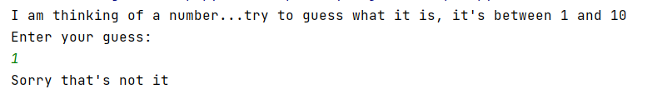

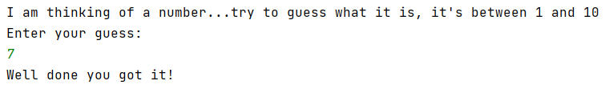

As an added extra, inform the user if their guess was out of range.

Sample output:

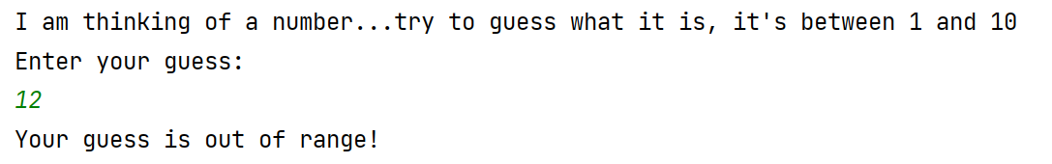

Solution:

import random
myrand = random.randint(1, 10)
print("I am thinking of a number...try to guess what it is, it's between 1 and 10")
print("Enter your guess:")
myGuess = int(input())
if myGuess == myrand:
print("Well done you got it!")
else:
print("Sorry that's not it")

Solution with added extra:

import random
myRand = random.randint(1,10)
print("I am thinking of a number...try to guess what it is, it's between 1 and 10")
print("Enter your guess:")
myGuess = int(input())
ess
if myGuess == myRand:
print("Well done you got it!")
elif myGuess > 10 or myGuess < 1:
print("Your guess is out of range!")
else:
print("Sorry that's not it")

1b. Rework the program in 1a to allow the user to make guesses until they guess right. Think back to previous classes – you will need a loop to do this. Which one?

Note: You will need to initialise guess at the top of your program Add the following line to the top of your code. I will explain why later

Sample output:

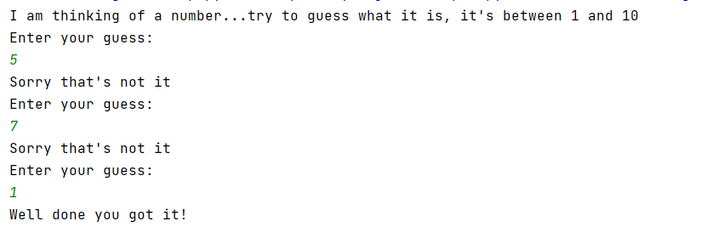

Solution:

import random
myRand = random.randint(1, 10)
myGuess = 0
print("I am thinking of a number...try to guess what it is, it's between 1 and 10")
while myGuess!=myRand:
print("Enter your guess:")
myGuess = int(input())
if myGuess == myRand:
print("Well done you got it!")
else:
print("Sorry that's not it")
2. Jackpot game

2a. Write a program that generates a lucky number for the user (between 1 and 10). There is a prize associated with each number. 5 = Jackpot, 3,4,6,7 = consolation prize (Mini Eggs), 1,2,8,9,10 = no prize. Inform the user of their prize.

Sample output:

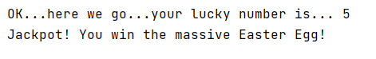.

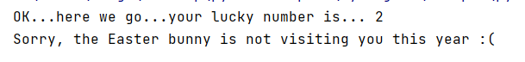

Solution:

import random
luckyNo = random.randint(1, 10)
print("OK...here we go...your lucky number is...", luckyNo)
if luckyNo == 5:
print('Jackpot! You win the massive Easter Egg!')
elif luckyNo >= 3 and luckyNo <= 7:
print("Not quite the jackpot, but you still win a packet of Cadbury's Mini Eggs!")
else:
print("Sorry, the Easter bunny is not visiting you this year :(")

2b. Extend your game from 2a above to allow the user multiple attempts (if they want):

Sample output:

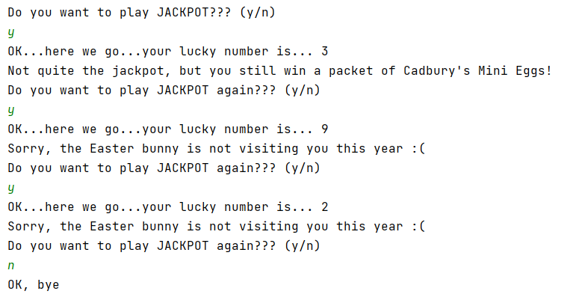

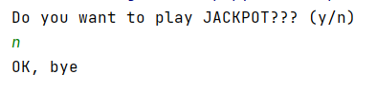

Solution:
import random
print("Do you want to play JACKPOT??? (y/n)")
choice = input()
while choice == 'y':
luckyNo = random.randint(1, 10)
print("OK...here we go...your lucky number is...", luckyNo)
if luckyNo == 5:
print('Jackpot! You win the massive Easter Egg!')
elif luckyNo >= 3 and luckyNo <= 7:
print("Not quite the jackpot, but you still win a packet of Cadbury's Mini Eggs!")
else:
print("Sorry, the Easter bunny is not visiting you this year :(")
print("Do you want to play JACKPOT again??? (y/n)")
choice = input()
print("OK, bye")

3. "Fruit" machine

3a) Generate 3 random numbers, each in the range 1 and 3 and print them on the screen.

Tell the user whether they have won (all numbers equal) or not.

Sample output:

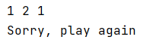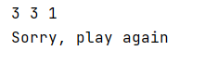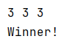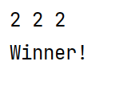

Solution:

import random
number1 = random.randint(1, 3)
number2 = random.randint(1, 3)
number3 = random.randint(1, 3)
print(number1, number2, number3)
if number1 == number2 and number2 == number3:
print("Winner!")
else:
print("Sorry, play again")

4. Lottery numbers

4a. Generate 6 lottery numbers (you could store these in individual variables, or in a list) Print your lottery numbers on the screen

Sample output:

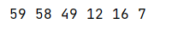

Note: Run the program a few times and you will see that duplicates appear sometimes, ignore this for now.

Solution:

import random
myLott = []
for counter in range(0, 6):
myLott.append(random.randint(1, 59))
for nextLott in myLott:
print(nextLott, end=" ")

4b Sort your lottery numbers into order. Providing you have used a list in 4a) above, this is quite easy by using the sorted() function. Code: sorted(name_of_list_here)
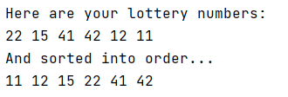
If you have not used a list, you might want to rework 4a first

Solution:
import random
myLott = []
for counter in range(0, 6):
myLott.append(random.randint(1, 59))
print("Here are your lottery numbers:")
for nextLott in myLott:
print(nextLott, end=" ")
myLott = sorted(myLott)
print("And sorted into order...")
for nextLott in myLott:
print(nextLott, end=" ")
4c. (Very challenging) Adapt your program to stop duplicates appearing in your final lottery number list

Solution:

There is more than one way to approach this problem. Here is one way, which replaces any duplicate found:

import random
myLott = []
for counter in range(0, 6):
myLott.append(random.randint(1, 59))
flag=1
while flag==1:
flag=0
for counter in range(0, 5):
for counter2 in range(counter+1, 6):
while myLott[counter]==myLott[counter2]:
myLott[counter2]=random.randint(1, 59)
flag=1 # there has been a duplicate, whole list needs re-checking
print("Here are your lottery numbers:")
for nextLott in myLott:
print(nextLott, end=" ")
myLott = sorted(myLott)
print("")
print("And sorted into order...")
for nextLott in myLott:
print(nextLott, end=" ")

