


INNOVATION AND CREATIVITY

NAME: Suraya Begum
STUDENT NUMBER: 1712135
MODULE NUMBER: BMSW6102
MODULE TITLE: Developing Innovation and Creativity for Business Advantage
LECTURER: Dr MD Nazmul Hasan

Contents
What is an Innovation product? 3
The four main types of Innovations: 3
Where my Innovation Idea came from? 4
What is the ARANET4 DEVICE? 4
My Unique Innovation Idea 5
Where and how will you sell your Product? 6
Do you have a name for your venture? 7
How do you intend to sustain your Innovation Business Proposition? 7
Who are the Competitors? 8
E-Commerce 8
Online Payment Services 9
Marketing 10
Knowing who your customers are 11
References 12

What is an Innovation product?
Product innovation involves creating new products or improving a new version of an old product or service. Its creativity thinking process that an individual or a group of people come up with which they then try and put it into reality.
Innovation is one of the most important topics concerning the long-term competitiveness of companies.
Innovation requires more creativity and more willingness to be able to take risks than the implementation of typical projects. To successfully realize innovation projects, a different mindset is needed.
There are 4 stages of innovation mindset:
- Break the rules! – challenge and explore new ideas
- Collect ideas everywhere! – new ideas are needed to tackle obstacles, change of concepts and to optimize strategies.
- Believe in the impossible! – visualize your unique idea, bring it to life believe it is possible.
- Put together an innovation team of individuals with different perspectives and thinking styles! – its always best to have more thinking hats than just one, various competencies and diverse ways of thinking.
https://innolytics-innovation.com/what-is-innovation/

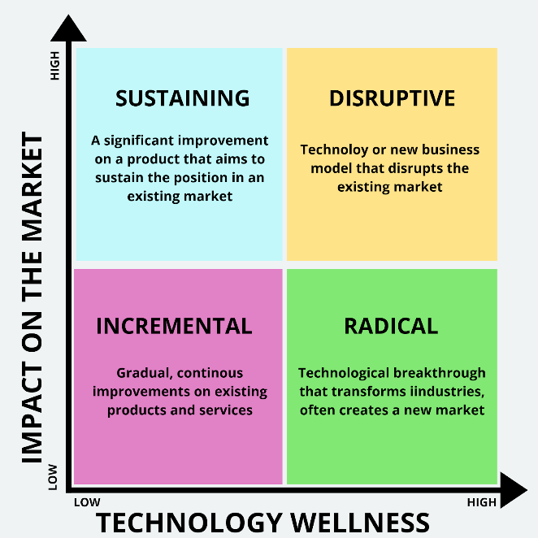
The four main types of Innovations:
Incremental Innovation – this type of innovation is increasing the current value of the product. This will make the current version a much better version of the previous one.
This will be improving the efficiency of the product while still maintaining the original core features. It mainly focuses on improving the current customer market.
Disruptive innovation – is a market disruptor, they wipe away the existing market or industries. This type of innovative strength makes a non-customer into their customer.
Sustaining Innovation- sustainable innovation is like incremental innovation. The existing market will grow while focusing on current customers. They will take small steps of innovation to build up their business.
Radical Innovation- this type of innovation is also like the disruptive innovation. This takes on extensive length of time to make disruptive changes. Though making it a rare innovation type. It brings alteration that were earlier unknown to the world of innovations for example technology, computers, mobile phones and the internet. These innovations have completely changed the way of communication in the entire world.
https://alcorfund.com/insight/innovation-models-innovation-process-models-examples/

Where my Innovation Idea came from?
Coronavirus has changed the world drastically in a way no one has thought would happen and during the 2 lockdowns it has created a huge impact on everyone’s, lives, schools, workplaces, hospitals and businesses. Basically, it has impacted everyone in lots of different ways, some have short term impacts, and some have long term impacts. It has made lives difficult in many ways specially for families not being able to do their normal day to day activities and tasks.
Being forced to stay away from your loved ones was difficult and most importantly trying to keep them safe and well.
It has affected businesses in the same way too, not being able to keep the businesses open and running, not having any revenue coming through due to the lockdowns and trying to keep your employees safe during this pandemic. Everyone has been forced to live a new life within this pandemic crisis and are trying to come to terms with this new normal where they are trying to find new ways of working and moving forward. During the lockdown a lot of innovation ideas have launched as people are desperate to keep their businesses open and looking at ways to come up with new services.
This brings me to my Unique innovation idea of an improved version of a product that is fairly New in the markets and is being used by a few organisations such as schools, offices, Doctors surgeries and homes.
The original product is called Aranet 4 which is a Wireless Indoor Air Quality Monitor.

What is the ARANET4 DEVICE?
The Aranet4 sensor Device is a battery powered CO2 meter with additional measurements of temperature, relative humidity and atmospheric pressure. The battery life is very good as it will last a very long time up to 2years. It is a device that monitors the CO2 levels in an indoor environment such as homes, schools and in offices. The device measures and detects a visual and sound notifications in case the CO2 level surpasses the high concentration level of 1400 ppm (parts per million) this poor air quality level has associated with complaints against drowsiness. The lower the number the better the air is and the higher the number the more alarming it is.
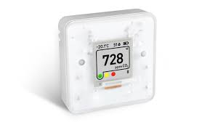
(WWW.aranet.com) 6/7/21.

Aranet4 Device (source google Image)

My Unique Innovation Idea
My Unique Innovative Product is to improve the current Aranet4 device and add an extra sensor that will not only detect poor quality air but will also detect the Coronavirus particles that’s floating around in the air. This special feature will pick up anything that is alarming in air and this will give us extra notice to take precautions.
Once the device detects the virus it will immediately set off the sounding alarm and give warning signs on the display screen letting you know how mild or strong the virus is in the air. This will give you an insight into taking immediate required actions.
This unique feature will help people to make fast decisions and act straight away in preventing the spread of the virus. You can take tests straight away and advise your work colleagues, families and customers to take a test as soon as possible to be on the safe side as the monitor has detected the virus particles in the building.
This device uses the Nondispersive infrared (NDIR) sensor to measure the concentration of CO2. We will insert a new sensor that will measure the Coronavirus particles in the same way. The virus particles will travel through the gas chamber which then gets absorbed and is measured by the sensor. The sensor will then send a message to the detector saying there’s virus particles in the air which will then set off the sounding alarm.
The less light passes through- the higher the concentration is. The gas absorbs only a specific wavelength of the light; therefore, a special filter is used where it picks up the virus.
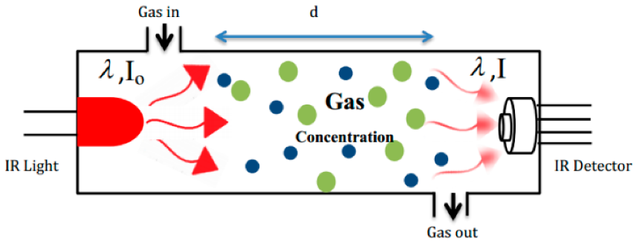

Source (Google image- Aranat4)

Having this unique technology built in the device this will be very beneficial in many ways such as it will reduce lengthy time of waiting around being unsure if you a carrier or even having to wait to develop the symptoms to know if you have the virus and then taking the test, whereas with this device once it’s detected the virus you will know exactly what to do and what actions to take. it will be the new best thing to keep safe and adds benefits for health and well-being of everyone.
This device will save a lot of time, reduce the spread of the virus, save lives and save our NHS staff and hospitals getting overwhelmed with patience.
This type of Innovation is called Incremental Innovation, it is improving a product that already exists and focuses on improving the products development efficiency, productivity and competitive differentiation. There are gains and benefits from this type of innovation, making small changes improves the productivity and performance of the company, as well as the efficiency and user experience of the products. Companies can save costs and differentiate from competitors.
“according to entrepreneur 98% of innovations are incremental” (R.Richards 17.7.21)
https://masschallenge.org/article/incremental-innovation Robbie Richards

Where and how will you sell your Product?
Currently the Aranet4 is in the market open to public and organisations to purchase and already businesses and organisation are using it in their buildings. Birmingham City Council are also using this device to monitor the air quality in their buildings. I work in Libraries and we are keeping a track on the numbers that show up on the device, once we realise the numbers are going high we then open more windows and doors to ventilate clean air into the building.
Since people are very conscious of clean air and staying safe this new improved product will sell as its unique feature can detect the virus. Once the public hear a device is innovated that picks up the virus in the air, I am certain this will sell as staying safe is all that is on people’s minds.
Businesses and organisations will also purchase this device as their main priority is keeping their colleagues and customers safe in order to keep their businesses and offices operating. The original Aranet4 device is already very popular in the market and is being used widely around homes and businesses. Therefore, adding this unique technology to improve the current device will work brilliantly and the company will benefit from the popularity. https://mightygadget.co.uk/aranet4-home-wireless-indoor-air-quality-monitor-review/(17/7/21)
The targeted market for this product will be all businesses, organisations, retails Market, schools, doctor surgeries and the general public. This improved device will be available for everyone to purchase through the website online at an affordable price under £120 to start off with, once it becomes more popular we will reassess the product price.

Do you have a name for your venture?
The Existing name for the air quality device is called Aranet4, I would like to call it with the New Improved version of the device “Cov-Air Tech 19” focusing it on the actual name of the Covid-19 Virus.

How do you intend to sustain your Innovation Business Proposition?
Since the world is concentrating on Clean air Zones and working towards reducing the pollution this device will become more and more popular.
New Researches show clean air policy making generates significant economic and health benefits. People care and want to see changes, in the UK air pollution is one kind of an issue. The public demand to see what actions are taken to clean our air as we are all building back better from the pandemic. Therefore, anything that will help us breath in clean air will be a must have gadgets in our homes, offices, schools etc. a survey commissioned by the clean air fund in 2020 showed that air pollution is one of the top three public health concerns in the UK. (R.Newton-smith 18/7/21) https://www.weforum.org/agenda/2021/04/the-uks-clean-air-zones-will-save-lives-and-money/
To grow sales and profits for exiting products and services focusing on modifying the functionality and features of existing products, the companies can keep their goods aligned with the current trends, cultural moods and evolving desires within their market.
This type of innovation strategy is a low-risk method that will strengthen the company’s existing position.

Who are the Competitors?
Incremental Innovation is an effective innovation which has become a potentially valuable way of securing competitive advantages in a firm. (Sciulli1998)
Our competitors are all those companies who are inventing air quality devices such as Aranet4. There are so many different types of devices that monitors bad quality air. The price can also be a competitive risk too, as some company will sell theirs cheaper to us. Air quality monitors are quite expensive, however there are a few alternative options which are more affordable but very few that specifically monitor CO2 and hardly any monitor Covid 19 viruses which makes us stand in a better position to other companies.
These companies are selling their Air quality monitor devices online such as Amazon, ebay and through their own company websites.

E-Commerce
It is a business model that allows businesses and Individuals to purchase and sell goods over the internet. A business model refers to a company plan of making a profit. It identifies the target market and any estimated costs. It is important for both new and established businesses as they help to develop companies attract investments, recruit talent, motivate management and staff.

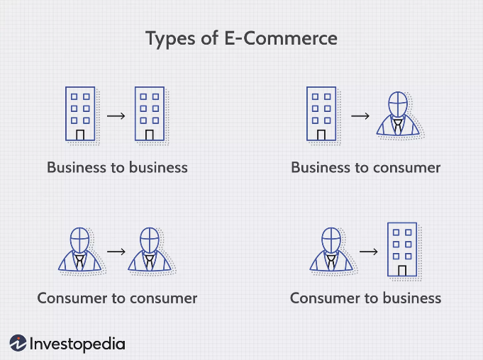
E- Commerce Operates in four major market Segments

- Business to Business
- Business to consumer
- Consumer to consumer
- Consumer to business

Image by Sabrina Jiang © Investopedia 2020
https://www.investopedia.com/terms/e/ecommerce.asp

The Aranet 4 Device is already available to purchase on Amazon so therefore I will continue to use this platform to sell my new Improved version of the Cov- air Tech 19 Device through it’s original selling platform. This service will provide other purchasers come across my New improved version of Cov-Air Tec 19 Device and this will help promote the device and eventually increase the market sales. Amazon is the largest retail platform where you can purchase wide range of products. They have reviews by other purchasers on amazon rating it out of 5 stars which will help in promoting and selling the product.
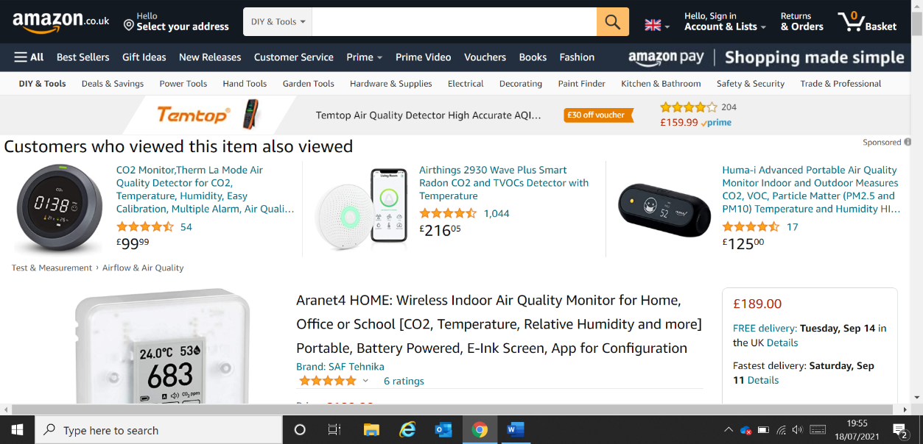
(Google, Amazon Screenshot)

Online Payment Services
Amazon has a trusted secured online payment system which allows customers to input their personal details and payment details. Once you have created your account it is saved and all you need to do on your next visit is to make a few clicks and your purchase is complete. Amazon is a world leading online retailer where your information and data is protected, and it has fraud prevention security. Selling my product through this platform will be very beneficial for the company as there is no monthly fee to pay and it’s a trusted site that gives the customers the reassurance of their data is kept safe. Hundreds and millions of Amazon customers know and trust the online payment system. 91% of Amazon customers say they would use amazon pay again, as it simplifies the checkout time and minuses clicks. https://pay.amazon.co.uk/secure-checkout
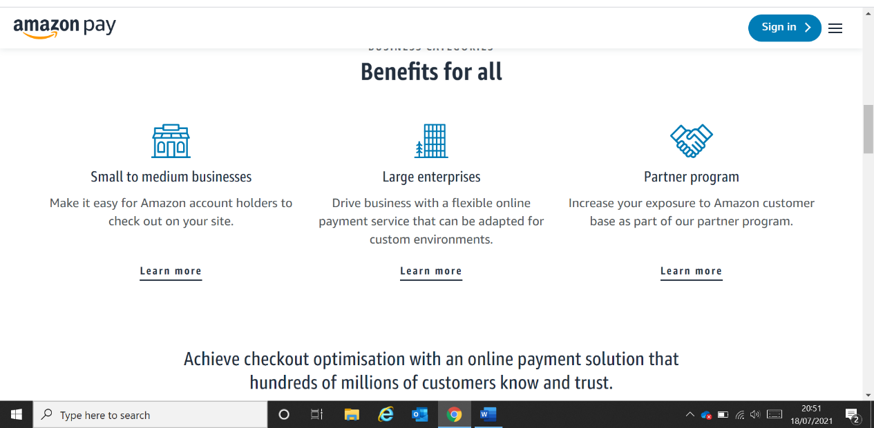

Marketing
Marketing is very important part for a business to be successful and to grow but most importantly clarity on what the innovative product is the first secret of successful innovation. Time involved at the beginning of the process to identify the areas that matter to the organisation or the customers will mainly increase the chances of innovation success. (L. Gower2015).
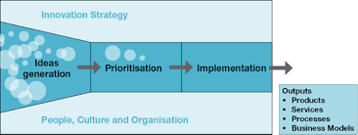

(Google Image)

It is also important to understand the marketplace, no matter how big or small the idea is, its success is dictated by how the marketplace operates. Markets are constantly changing, all at different speeds and times but it is influenced by things that are beyond our control. Therefore, it is also very important to understand the process, have patience and have a product lifecycle strategy in place.
Below is an example of a product lifecycle:
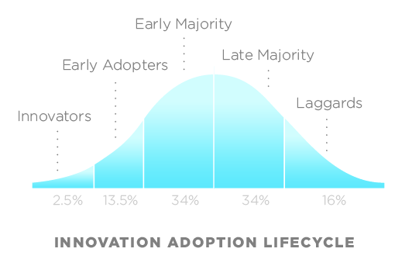

Google image (innovation lifecycle model)

The graph above shows the stages of the innovation process.
Any new product requires time to grow, since it is mainly relied on customers to become aware of the product and to recognise the value of the new product. Getting the product in the market is a big achievement and your effort doesn’t just stop there. You need to continually monitor the product performance in the marketplace. Every product has a lifecycle, not all products will be relevant for ever- even the most popular ones. (L. Gower 2015)
You have to be strong enough to take risks and be strong enough to accept failure as this is the only way you will learn and do better.

Knowing who your customers are
You need to know who your customers are, the more you learn about your customers the more you seek to understand their needs, the greater your ability will be to develop products and services. (L. Gower2015).
My target customers are everyone, families, businesses, organisations and general public. This innovation is beneficial and catered for everyone for better health and well-being. Having an insight to an accurate understanding of our customer’s needs will be the first stage of our organisation as this will be the opportunity to provide us to cater for both ours and our customers needs.
My product will be advertised in business catalogues, business websites, business suppliers, business links, business emails, tv Adverts, Gadget shops and by word of mouth etc.
We will also advertise on social media such as Facebook, Instagram, LinkedIn and twitter. Some organisations such as Birmingham city council have their own social media called yammer- which is another type of platform where the employees stay connected with other departments within the council and this will be another good way to promote the Device and can be advertised to make the organisation aware of the new improved Device Cov-Air Tech 19 has launched. Social Media is one the fastest growing platforms for small to medium sized businesses and using this platform will benefit my Innovation.

References
Online
• https://www.cambridge.org/core/journals/journal-of-management-and-organization/article/abs/innovation-adoption-process-a-multidimensional-approach/57C58BBA38794B3C215BEB9AE4F5A266. (n.d.). [Accessed Online 6/7/21]

• https://pages.amazonpayments.com/Amazon_Pay_UK.html?ld=seexukapa-APAY_Merchant_Paid_Search_UK-xxx&ref=ml_uk_ap_xx_se_psuk_xx_xx_xx_xxx&utm_adid=318198589098&utm_term=amazon%20payments-p-c&targetid=kwd-295502967486&utm_medium=paid_search&utm_source=google. (n.d.). [Accessed online 8/7/21]

- Meyer, D.J.-U. (2020). What is Innovation? Introduction and Definition for Practitioners. [online] Innolytics Innovation. Available at: https://innolytics-innovation.com/what-is-innovation/. [Accessed Online 19/7/21]

• https://www.weforum.org/agenda/2021/04/the-uks-clean-air-zones-will-save-lives-and-money/. (n.d.). [Accessed Online 8/7/21]

• https://www.eajournals.org/wp-content/uploads/Incremental-Innovation-and-Firm%e2%80%99s-Competitive-Advantage-A-Quantitative-Analysis-Approach-1.pdf. (n.d.). [Accessed Online 10/7/21]

‌ • Sciulli, L. M. (1998). Innovations in the Retail Banking Industry: The Impact of Organizational Structure and Environment on the Adoption Process. New York, NY: Garland. (n.d.). [Accessed online 12/07/21]

‌ • https://www.eajournals.org/wp-content/uploads/Incremental-Innovation-and-Firm%e2%80%99s-Competitive-Advantage-A-Quantitative-Analysis-Approach-1.pdf. (n.d.). [Accessed Online 15/07/21]

• https://alcorfund.com/insight/innovation-models-innovation-process-models-examples/. (n.d.). [|Accessed Online18/07/21]

Books
- The Innovation workout by Lucy Gower published in 2015. Publisher Pearson education limited. (n.d.).
- Brilliant start-up- how successful Entrepreneurs set up and run a brilliant business by Caspian woods. 2nd edition published 2011 -publisher pearson education limited. (n.d.).

- Innovation in Business education in Emerging Markets by Palgrave Macmillan – first published 2013. (n.d.).
‌

