  Component One: Student Journal (learning log) 750 words +/- 10%  Contribution to Overall Module Assessment: 25% | Student No: | Mihai Serban  2244688
 | Module Title: | Hotel Placement - Hotel Administration & Front Office Operations
 | Module Code: | BMIH400
 | Lecturer: | Lisa-Marie Bassler
Description:

My placement at The Talbot Hotel provided me with a unique perspective on front office operations in a setting steeped in history. Having taken responsibility for a building that dates back to the 1630s, the hotel's original structure radiates warmth and character, offering guests a peaceful retreat from the hustle and bustle of the outside world. The experience I gained from working in the front office department of this small and lovely hotel provided me with a unique insight into the challenges and responsibilities that are inherent in such an environment. Because there were limited staff due to the quiet period I was working there, I was often the sole person responsible for managing check-ins and check-outs, demonstrating the value of being flexible and resourceful in meeting the needs of guests. I was also shown how to the Booking.com system works, when to charge customers cards and how to actually communicate with customers via the Booking.com portal.

Feelings and Emotions:

In the tranquil atmosphere of The Talbot, the tasks of managing check-ins and check-outs evoked a range of emotions within me. From a profound admiration for the hotel's rich history to occasional moments of anxiety when attending to guests solo, each emotion contributed to my personal growth and resilience. There were instances of heightened pressure during unexpected rushes of guests, where I found myself juggling reception duties alongside managing the bar single-handedly. However, these challenges served as opportunities for me to cultivate confidence in my capacity to navigate various scenarios adeptly, particularly within a close-knit team environment. Through these experiences, I emerged with a newfound sense of self-assurance and adaptability, ready to tackle any challenge that comes my way.

Evaluation of Performance:

When I evaluate how I performed at the front office, I can see both my strong points and my room for improvement. Being a relatively small hotel with only 6 employees across the 24 hours, I had to demonstrate strong multitasking skills, efficiently managing various tasks simultaneously trying not to without compromise on quality. Now looking at what I need to improve, I have to say that I need to get more familiar with the area as guests often seek recommendations for local attractions, restaurants, and transportation options therefore I need to learn ore about the region around so that I can offer directions and useful advice.

Analysis:

My time working in the front office at The Talbot reinforced for me how important professionalism and communication are to ensuring that guests are happy. It became clear that being calm and controlled under pressure has a big impact on how our visitors feel about the level of service they receive at the hotel. Furthermore, I learned how important it is to be able to solve problems and multitask in the hospitality industry because these skills are constantly put to the test, particularly while handling bar and restaurant responsibilities and supervising post-cleaning room inspections as part of the front office work.

Conclusion:

It has been an enriching journey of discovery and growth for me while working at The Talbot Hotel in Stourbridge. From navigating the nuances of front office operations to embracing the hotel's rich heritage, each moment served as a stepping stone towards honing my skills and fostering a deeper understanding of hospitality's timeless allure. In addition to providing me with invaluable insights into the hospitality industry, I was able to acquire essential skills and knowledge that will help me in my future endeavours, therefore, with my newfound insights and experiences, I am prepared to embark on the next phase of my journey in the hospitality industry guided by The Talbot's legacy of excellence and warmth.

Action Plan:

My goal going forward is to improve my time management skills to better handle busy periods and prioritize tasks. Through additional training and practical experience, I will also improve my problem-solving skills. Furthermore, I aim to develop cultural sensitivity and diversity awareness in order to ensure respectful and inclusive interactions with diverse guests. By taking these proactive steps, I am confident that I will continue to grow and succeed in my hospitality career.

Component Two
Contribution to Overall Module Assessment: 25%
Trip Advisor Review Response 150 words +/-10%
Dear Chris,

Thank you for sharing your positive experience with us. We are deeply saddened to hear about your loss and extend our heartfelt condolences to you and your family during this difficult time.

It brings us immense joy to know that our team was able to provide you and your partner with a comfortable and supportive environment during your stay, particularly amidst such challenging circumstances. Ensuring your convenience and peace of mind was our top priority, and we are delighted that our efforts to accommodate your needs, from early check-in to arranging transportation, contributed to making your journey easier.

Your recommendation means a lot to us, and we look forward to welcoming you back on your next visit to Stourbridge. We're also glad that our location near local restaurants and shops added convenience to your stay.

If you need any further assistance in the future, please don't hesitate to contact us.

Warm regards,

Mihai Serban
Front Desk Officer – The Talbot Hotel

Screen shot of referenced Trip Advisor review used:

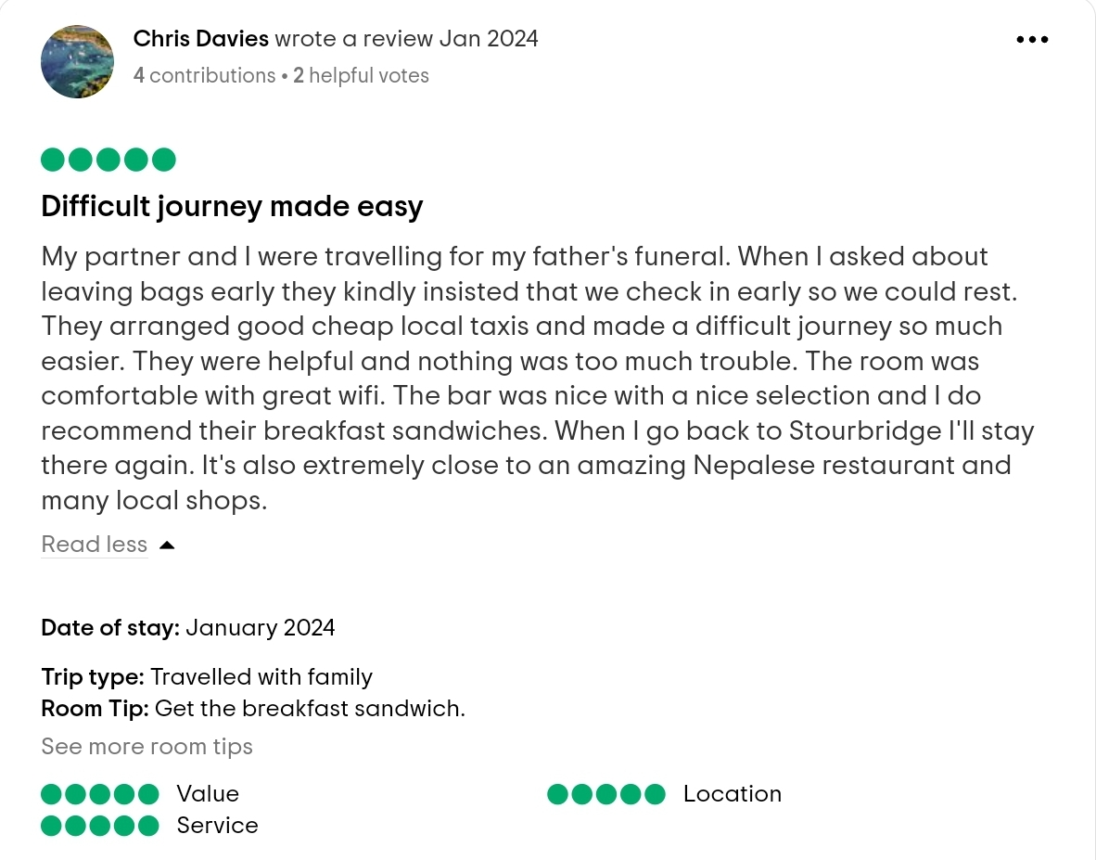
Letter of complaint response 500 words +/- 1-%
Dear Mrs. Joanna Blake,
Thank you for taking the time to write to us regarding your recent stay at our hotel. Please accept our sincerest apologies for the issues you encountered, which fell short of the high standards we strive to maintain. We understand how crucial a clean, peaceful, and welcoming environment is to our guests, especially when they rely on us for work-related activities and rest. Your feedback is invaluable to us, as it highlights areas where we can improve to ensure a better experience for all our guests.
Regarding the cleanliness of your room, this is certainly not the standard we aim to uphold. We have addressed your feedback with our housekeeping team to ensure a rigorous review and enhancement of our cleaning protocols. We are implementing additional training and spot checks to prevent such oversights in the future.
The Wi-Fi service you experienced is also below our acceptable standard. Reliable internet is a fundamental service we pride ourselves on providing, and to hear of your difficulties is concerning. We are currently working with our IT department to upgrade our network infrastructure to provide a more stable and faster internet service across the hotel. This includes assessing our current bandwidth and enhancing our support system to ensure our guests can work and communicate effectively during their stay.
Noise disruption is another area we take very seriously. We understand the importance of a good night's rest and are reviewing our current policies to better manage noise levels. This includes reinforcing our quiet hours policy and exploring additional soundproofing measures in our rooms. We are also training our staff to be more proactive in managing and preventing noise complaints to ensure all our guests have a restful stay.
The level of customer service you described is unacceptable and not indicative of our values. We are committed to providing a welcoming and supportive environment for our guests. To address this, we are initiating a comprehensive customer service training program for all staff members, focusing on responsiveness, empathy, and effective problem-solving. We aim to foster a culture where every team member feels empowered and equipped to assist our guests promptly and efficiently.
Mrs. Blake, your feedback has initiated a series of actions on our part to address and rectify the issues you've raised. We are committed to not only resolving these problems but also to ensuring they do not recur. We would appreciate the opportunity to regain your trust and would like to offer you a complimentary stay in one of our premium rooms, should you decide to give us another chance. This is with the hope that you can experience the improvements we are making firsthand.
Please contact me directly to discuss this further or if there is anything specific we can do to make amends. Your satisfaction and well-being are our top priorities, and we are dedicated to restoring your confidence in our hotel.
Thank you once again for your honest and constructive feedback. We look forward to the opportunity to welcome you back under better circumstances.
Sincerely,
Mihai Serban
Front Desk Officer
The Talbot Hotel - Stourbridge

Component Three:
Contribution to Overall Module Assessment: 50% (1000 words +/- 10%)
Writing in essay format

Key Skill 1 – Customer Service Skills

At the heart of thriving front office operations within the hotel sector lies the paramount skill of exceptional customer service. Front office staff, who often represent the first and last interaction point with guests, play a vital role in moulding the overall guest experience. Beyond merely meeting guests' needs, outstanding customer service anticipates these needs, significantly boosting guest satisfaction and fostering loyalty. According to Harris and Reynolds (2019), the capacity to connect with guests on an empathetic level, displaying patience and a proactive approach towards addressing their requirements, greatly influences a hotel's standing and financial success. The Ritz-Carlton Hotel Company stands as a sterling model of customer service supremacy. It has adopted a guiding principle, "Ladies and Gentlemen serving Ladies and Gentlemen," emphasizing the essence of treating every guest with supreme respect and regard. This core value has propelled Ritz-Carlton to achieve and sustain elevated guest satisfaction and loyalty rates (Ritz-Carlton, 2021). This ethos demonstrates that the foundation of a successful hotel operation is not just the services provided but how those services are delivered, with empathy and anticipation playing key roles in defining the quality of the guest experience.
Key Skill 2 – Communication Skills

Effective communication stands as a cornerstone skill within the arsenal of front office professionals. This multifaceted skill set extends beyond mere verbal and written exchanges; it encompasses the art of active listening and the adeptness to tailor messages suiting diverse audiences. As asserted by Kim and Jogaratnam (2019), proficiency in communication is not merely desirable but indispensable. It serves as the gateway to creating lasting positive impressions, ensuring seamless transactions, and pre-empting misunderstandings that might otherwise escalate into dissatisfactory experiences.

Delving deeper into the significance of adept communication, one finds its pivotal role in shaping the customer experience. Marriott International, a paragon in the hospitality industry, exemplifies this by prioritizing communication skills within its employee training framework. Through meticulous training initiatives, Marriott International equips its staff with the tools necessary to navigate interactions with guests hailing from myriad cultural backgrounds. Moreover, this training instills in employees the finesse required to address grievances with grace and to orchestrate seamless coordination with other departments.

In essence, effective communication emerges not merely as a desirable trait but as a fundamental pillar underpinning the edifice of exceptional service delivery. It serves as the linchpin in fostering meaningful connections, engendering trust, and ultimately elevating the overall quality of service rendered. By investing in communication training, organizations like Marriott International not only enhance the competencies of their workforce but also fortify their competitive edge in an increasingly discerning marketplace. Thus, it becomes evident that within the realm of front office operations, effective communication transcends the realm of skill; it becomes a transformative force driving unparalleled customer satisfaction and organizational success.
Key Skill 3 – Organisational Skills

In the dynamic and often fast-paced environment of the hospitality industry, the role of front office professionals cannot be overstated, particularly when it comes to the art and science of effective communication. This skill is multifaceted, involving not only the ability to convey information through clear and concise verbal and written forms but also through the nuanced skill of active listening and the adaptability to customize messages for a wide range of audiences. The importance of mastering these communication skills is highlighted by Kim and Jogaratnam (2019), who contend that the ability to communicate proficiently is not just beneficial but crucial. It lays the foundation for making a strong first impression, ensuring transactions proceed without a hitch, and mitigating the risk of misunderstandings that could lead to guest dissatisfaction.

A prime example of an organization that recognizes and champions the importance of superior communication skills is Marriott International. This global hospitality leader has made significant investments in the training and development of its employees, emphasizing the critical nature of communication abilities. Such training programs are meticulously designed to arm staff members with the necessary tools to effectively engage with guests from a multitude of cultural backgrounds, address and resolve complaints with poise and dignity, and facilitate smooth, inter-departmental coordination. The outcome of this focused training is a notable enhancement in service quality across the board (Marriott, 2020).
Key Skill 4 – Problem Solving Skills

The hotel industry is renowned for its dynamic and ever-changing nature, presenting numerous challenges and opportunities for front office staff. In order to thrive in such an environment, it is imperative for employees to possess strong problem-solving skills. This entails the ability to swiftly identify issues as they arise, delve deep into their root causes, and implement effective solutions to mitigate any negative impact on guest experiences.

Lee and Hsieh (2020) emphasize the critical role of problem-solving skills in various aspects of hotel operations, particularly in addressing guest complaints, navigating unexpected challenges, and making prompt decisions under pressure. In an industry where guest satisfaction is paramount, the ability to effectively resolve issues in a timely manner can make all the difference in maintaining a positive reputation and fostering guest loyalty.

One notable example of a hotel brand that has embraced the importance of empowering its front office staff with robust problem-solving skills is Hilton Worldwide. Through its innovative approach, Hilton has granted its employees the authority to make decisions on the spot to resolve guest issues, within certain financial limits. This empowerment not only streamlines the resolution process but also fosters a sense of ownership and accountability among employees.

By entrusting front office staff with the autonomy to address guest concerns promptly and effectively, Hilton has been able to enhance service recovery efforts and elevate overall guest satisfaction levels. This proactive approach to problem-solving not only demonstrates Hilton's commitment to delivering exceptional customer service but also sets a precedent for other players in the industry to follow suit.

Furthermore, by investing in ongoing training and development programs focused on honing problem-solving skills, hotels can ensure that their front office staff are well-equipped to tackle any challenges that may arise. Through continuous improvement and refinement of these skills, hotels can not only enhance guest satisfaction but also drive operational excellence and maintain a competitive edge in the ever-evolving hospitality landscape.

Reference List
Chris, D., 2024. Difficult journey made easy [Review]. TripAdvisor, Available at: https://www.tripadvisor.co.uk/ShowUserReviews-g616275-d1385668-r933887188-Talbot_Hotel-Stourbridge_West_Midlands_England.html [Accessed on 20th February 2024]
Four Seasons. (2021). Our approach to service. Available at: https://www.fourseasons.com/about_four_seasons/service_culture/ [Accessed on 18th February 2024].
Harris, P. & Reynolds, K., 2019. The impact of customer service on hotel guest loyalty. Journal of Hospitality and Tourism Management, 39, pp.41-52.
Hilton, 2020. Empowering Our Team Members to Make It Right. Available at: https://www.forbes.com/sites/salesforce/2020/11/05/how-hilton-uses-the-golden-rule-to-drive-commercial-success/[Accessed on 19th February 2024].
Jones, P. & Lockwood, A., 2020. Management of hotel front office operations. Journal of Hospitality and Tourism Research, 44(5), pp.789-811.
Kim, Y.K. & Jogaratnam, G., 2019. The role of communication skills in enhancing guest satisfaction in the hotel industry. Journal of Hospitality Marketing & Management, 28(7), pp.849-865.
Lee, Y. & Hsieh, A., 2020. Enhancing problem-solving skills in front office operations: A case study approach. Cornell Hospitality Quarterly, 61(4), pp.345-359.
Marriott, 2020. Marriott training program. Available at: https://www.forbes.com/sites/serenitygibbons/2020/04/30/3-things-you-can-learn-from-marriott-about-taking-care-of-employees/?sh=5f9491ef2bca [Accessed on 18th February 2024].
Ritz-Carlton, 2021. Gold Standards. Available at: https://ritzcarltonleadershipcenter.com/about-us/about-us-foundations-of-our-brand/ [Accessed on 19th February 2024].
Williams, K, Woolliams, M & Spiro, J. (2020) Reflective writing, Macmillan International, Oxford
Top of Form

