
EMPLOYEE ENGAGEMENT AT MORRISONS RETAILER
Module: Human Resource Management Code:BMMB7007


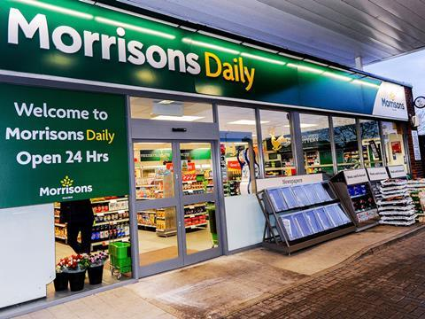
March 26, 2023
STudent: theodore toko manzambi
Lecturer: JAMES MOORE
THE UNIVERSITY OF WALES TRINITY SAINT DAVID
ID-1904060

Table of Contents
- Introduction
- Background of Wm Morrisons Supermarket

- Employee Engagement at Wm Morrisons Supermarket
  - Definition of Employee Engagement
3.2 Benefits of Employee Engagement at Morrisons Supermarket
3.2.1 Role of Wm Morrisons Supermarket’s HR and Management in Employee Engagement
3.2.2 People, Colleagues, and HR Department
3.2.2.1 Reward, A fair day’s pay for a fair day’s work
3.2.2.2 Employee relations and Policy
3.2.2.3 Internal communication & engagement
3.3 How engaged are Wm Morrisons Supermarket employees
3.4 Impact of Employees Engagement at Morrisons Supermarket
4.0 Conclusion
5.0 Recommendations

Executive Summary

1.0 Introduction
The procedures used to fulfil the "people" or human resource parts of a management role, such
as hiring, screening, training, rewarding, and evaluating employees, are referred to as human
resource management (Dessler, 2004, p. 4).
But, to negotiate ongoing disruption from digital transitions, economic uncertainty,
and political tensions, leaders must adopt a new strategy. They must continually deal with the
uncertainty that some internal and external environmental elements bring to the organisation.
According to a recent study, employee engagement and the entire employee experience, as well
as employee well-being, are currently the top two concerns for human resource and business
leaders, cited by 57% and 56%, respectively. Rosetta Stone claims that Morrisons wanted an English language training program for Manufacturing and Logistics employees because many of them were from Eastern Europe and only had rudimentary English language abilities. This was done to increase employee engagement and open doors for more opportunities within the company (Rosetta Stone, 2015).
On the other hand, it is becoming more difficult to find and keep talented employees because
people want to work for companies with strong cultures, who is caring about their well-being, and who are committed to delivering an excellent employee experience. Even though Morrison’s HR Department listens to employees' needs and expectations, learns how to make things better, and acts quickly to implement the necessary improvements, there is still criticism identified as argued by the Guardian of employees (The Guardian, 2020).
Additionally, when workers are inspired by their jobs and the objectives of the company, it is generally believed that they will perform better, contribute more, and innovate more. Also, they appear to be more content, healthy, and happy. This report will critically analyse employee engagement within Morrisons Supermarket and will demonstrate whether Morrison’s retailer is worthy to be worked in and what are the benefits and importance to Morrison’s growth. The analysis will also clarify terminology that is currently used to conflate employee experience and employee engagement, as well as their relationship to one another and, most importantly, how they affect Morrisons supermarket. The analysis's findings will then be followed by a conclusion and recommendations.
2.0 Background of Wm Morrisons Supermarket
As a vendor of eggs and butter in Rawson Market, Bradford, England, William Morrison founded Morrison in 1899 and ran it as Wm Morrison Limited.
At the age of 21, Ken Morrison, his son, took over the company in 1952. In 1958, Morrisons opened a little shop in the heart of the city. The company innovated and developed during the course of the year, going from a market stall in Bradford to the fourth supermarket in the UK, with 497 stores across the UK and 120.000 employees. However, Clayton, Dubilier & Rice purchased the business, ending the 54-year listing of the corporation on the London Stock Exchange (Annual report 2022).
The business primarily deals in the sale of food and groceries, and in a new move, it sources and prepares half of the fresh food it sells in its own warehouses and retail locations, providing it tight control over provenance and quality.
It is important to note that the business, Wm Morrison Ltd., which is a wholly-owned subsidiary of the UK's fourth-largest supermarket chain, Wm Morrison Supermarkets Limited, has a location in Hong Kong. The main responsibility of WM Morrison HK Ltd is to bring the best selection of goods to its UK stores from the several far-east Asian nations that the firm utilises as suppliers and factories, including China, Hong Kong, and many more.
Based on the post-Brexit uncertainty and mounting inflation, consumer behavior has switched in favour of cheaper options such as Aldi and Lidl.
For the first time, Aldi replaced Morrisons in fourth place in the grocery store ranking in September 2022. Aldi and Morrisons, with a combined market share of 9.1% in December 2022, were ranked in joint fourth place.
The company has a human resources department that is people-focused and cares for over 120,000 employees throughout their careers. By attracting the best talent and offering a warm welcome, lots of support, training, and development, Morrisons ensures that its employees like going to work there. To improve employee experience and digitally upgrade its HR and payroll procedures, the department teamed with Tata Consultancy Services (TCS) to overhaul its HR operations (TCS, 2022).
3.0. Employee Engagement at Wm Morrisons Supermarket
To improve employee engagement, HR executives and managers must comprehend what is important to workers, such as their well-being, work-life balance, a supportive workplace environment, and just compensation. This entails examining actions that directly affect performance, like maximising an employee's abilities, feeling protected, and being intrinsically motivated. You can determine whether your staff is capable of performing to its full potential by using these quantifiers (Luther, D. 2020).
Your company as a whole is a living thing that expands, contracts, and changes. The first step to ensuring your staff are motivated and productive is simply realising how important employee engagement is. The next stage is to determine where you, as a leader, need to take charge to make sure the best plan is in place to draw in and keep the best personnel.
3.1 Definition of Employee Engagement
Different authors have presented many definitions of employee engagement, and most organisations believe that workers work for the money they are paid.
Its meanings cover both cognitive and emotional aspects of zeal, passion, satisfaction, confidence, empowerment, and positive attitudes. It has to do with a person's "preferred self" in terms of behaviour that encourages connections with others and their place of employment.
Cook (2008) argued that employee engagement is “personified by the passion and energy employees have to give their best to the organisation to serve the customer. It is all about the willingness and ability of the employees to give sustained discretionary effort to help their organisation succeed”. In a similar vein, Ryba Kristin (2022) of Quantum Workplace emphasised that the degree of an employee's mental and emotional connection to their job, team, and organisation is known as their level of employee engagement. It gauges the satisfaction of workers with their employers. Employee engagement is more than just a sentiment. It goes beyond just satisfaction, happiness, or even enjoying a particular business. An employee may enjoy her work because she is paid well, but this does not always imply that she is actively involved in her work or committed to advancing her company.
3.2 Benefits of Employee Engagement at Morrisons Supermarket
The HR department benefits from employee engagement since it contributes to the organization's sustainability and growth in a variety of ways. Feeling involved is beneficial for workers. The majority of definitions of engagement refer to workers who are more motivated, fulfilled, and in better physical and mental health. Research has frequently proven that improved performance is correlated with engagement indicators for organisations. More generally, other studies demonstrate beneficial correlations between elements of employee engagement and other business measures, such as client happiness, productivity, innovation, staff retention, efficiency, and performance in terms of health and safety.
Yet, there are some issues with this study. The vast majority of studies just find a correlation, not cause and effect. Yet, other studies do indicate a causal link, with work engagement predicting both task performance and contextual performance, or providing additional value to the organisation outside of one's primary role. However, these associations are weak; to identify them, performance differences would need to be quantified because they are too small to be seen in normal activity.
Work engagement and performance influence one another in a somewhat reciprocal manner. So, better performance will result from more engaged employees, but better performance will also increase employee engagement.
3.2.1 Role of Wm Morrisons Supermarket’s HR and Management in Employee Engagement
Employee engagement is influenced by a variety of factors, including managerial approaches, workplace culture, and corporate communication. Managers and HR specialists both contribute significantly to the successful planning and implementation of a company's employee engagement efforts. HR professionals should have a role in establishing a culture of engagement. Designing, monitoring, and analysing policies and practises that proactively attract and keep talented individuals who have the necessary abilities to support the organization's growth and sustainability is part of this.
3.2.2 People, Colleagues, and HR Department
Morrisons' annual report for 2021/2022 claims that everything they do is centred on people, bringing in the top talent, and giving everyone a friendly welcome along with plenty of assistance, training, and growth. Additionally, they provide their managers with the training and expertise they need to guide them into the future. To ensure they act morally and treat everyone with respect, they develop policies and procedures. And they reward their colleagues' contributions with a variety of fantastic incentives to show how much they respect and value them (Annual Report 2021/2022).
Putting these claims into practice, however, has significant drawbacks and critics, and it also produces contradictions that will be thoroughly explored in the later examination, but some of them are as follows:
3.2.2.1 Reward, A fair day’s pay for a fair day’s work
Despite claims that they receive a fair day's pay for a fair day's work and plenty of extras, the Guardian revealed in 2018 that there is still a pay gap between men and women. Despite this, it has been reduced from 13% in 2021 to 10% in 2020. Furthermore, the law from Leigh Day stated that it was seeking compensation for shop workers, primarily women, who believed they were paid less than the mostly male workers in Morrisons (The Guardian, 2018). This goes against their principles when they talk about fairness, so a review should be done by
Wm HR department and improve its policy by updating its policy if it wants to maintain agents.
3.2.2.2 Employee relations and Policy
The HR department supports all of its employees, coaches managers, keeps up with changes in employment law and creates and maintains its personnel manuals, policies, and procedures.
However, it was revealed by the BBC in December 2017, The Guardian in October 2018, and Reuters in October 2018 that Wm Morrisons Supermarket had lost a Court of Appeal against a group of its employees whose personal information for about 100,000 staff members had been posted online by a former employee. Shares of the company declined following the decision and were last down 1.3 percent on the day.
3.2.2.3 Internal communication & engagement
The HR department at Wm Morrisons is passionate about encouraging employee involvement and two-way communication. They also oversee their recognition programs and ensure that everyone has a voice. To improve their business even more, they incorporate input from forums for co-workers and surveys of customer satisfaction. With various channels of communication, such as their co-worker’s Facebook group and Fresh News magazine, they keep their co-worker informed about what's happening at Morrisons.
However, the independent survey initiated by Indeed has shown that some of the departments at Morrisons Supermarket such as warehouse colleagues have declared that managers were not respecting their commencing and ending times but could not find the appropriate place to complain and decided to quit.
3.3 How engaged are Wm Morrisons Supermarket employees
Morrison's HR department works to forge strong bonds with its staff members called colleagues to preserve their loyalty and respect for the company. This goal is being achieved by the HR department by encouraging employees through performance-based awards so they can accomplish their objectives (Annual report, 2021-2022).
Although surveys are a component of the measurement to ascertain the degree of employee engagement within an organisation, there is still uncertainty in some well-established surveys and research (Good work index survey, indeed, Somerset Webservices, Forbes, Harvard Business Review, CIPD, and Gallup) on the factors that accurately ascertain the degree of employee engagement in the UK but specifically at Morrisons Supermarket.
However, studies have shown that employees in the UK recorded average engagement scores of just 45% compared to 54% in France, 56% in Australia, and 60% in the USA.
Similarly, Jobsite Breakroom c.c., which has polled over 230,000 frontline employees on their jobs since 2019, has released the grocery company rankings. The top 10 Supermarkets are then determined by factors that are important to employees, including salary, shift notice, breaks, respect, stress, and a host of other factors. In terms of a nice place to work, Wm Morrisons Supermarket came in sixth, ahead of Asda and Iceland but behind Waitrose & Partners, Aldi, Sainsbury's, Tesco, Lidl, Heron foods, and Farm foods (Somerset Apple, 2022).
3.4 Impact of Employees Engagement at Morrisons Supermarket
The expectations of employees are significantly impacted by changes in both personnel demographics and technology. For businesses to create a foundation that strengthens the reciprocal relationship between leaders and employees, it is essential to assess engagement levels to- understand employee demands.
Although there are other ways to examine engagement levels, this is how they typically appear.
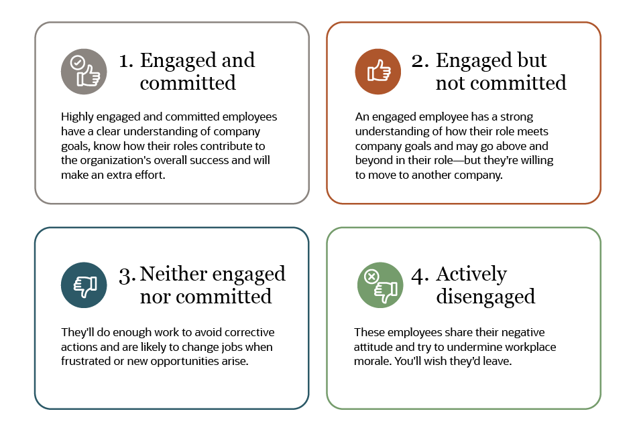
Fig1- Source: Luther, D. (2020).
To better implement and get an overall situation on the impact brought by employee engagement, the Aon Model of employee engagement has summarised the benefits of engaged employees within the organisation, customers, themselves, and the teams as drawn below:
Fig.2- AON-Hewitt Engagement Model (Aon Hewitt 2015).
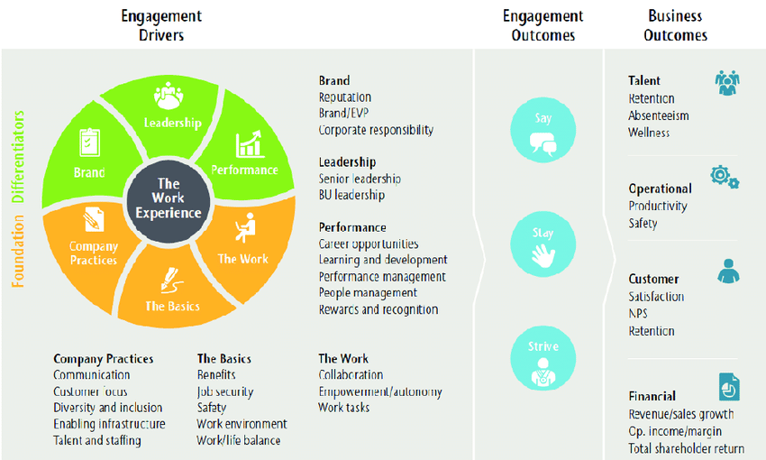
This model of employee engagement has outlined and strengthened what the company does through its HR department to increase its performance and productivity of the work experience, including the work individuals do, the people they work with, opportunities, total rewards, company procedures, and general quality of life, as Morrisons Supermarket is driven in embedding a sense of purpose with their colleagues.
4.0 Conclusions
As a result, Morrisons Supermarket's HR department has worked to maintain employee engagement and motivation as the company has risen from sixth place to among the top 10 retailers in the UK.
As previously stated, motivated personnel are prepared to advance their company, enhance their performance and productivity, but also preserve positive working relationships with one another. They also improve client retention and happiness. Progress has also been made in terms of pay rates, with Morrisons Supermarket becoming the first retailer in the UK to raise the pay rates for workers on the front lines.
A wage disparity between men and women must still be avoided or reduced, and employees in the same position must all receive the same salary to prevent resentment among coworkers. In addition, it was discovered that managers at Morrisons Supermarket lacked the necessary support and lacked the emotional intelligence that would give them a sense of belonging (life balance). Although they are committed to having their employees follow policies and regulations, they should make sure that managers and leaders are doing a good job of putting these policies and regulations into practise by conducting practical follow-ups. This will help to increase employee engagement, prevent employees from leaving the company due to unfair treatment by managers, and minimise errors.
In a nutshell, effective follow-up on engaged employees will increase engagement, have a positive effect on employees, teams, managers, and the organisation, and result in better performance, an increase in employee productivity, the accomplishment of team goals, less workplace stress, a lower risk of burnout, lower employee presenteeism, higher employee retention, lower turnover, strong employer brand, and simpler recruitment. Morrisons Supermarket placed sixth among supermarkets for better places to work, although some of the suggestions are still worthwhile to implement.
5.0 Recommendations
Given the aforementioned, the HR department at Morrisons Supermarket should introduce and improve routine training on emotional intelligence for their managers and leaders in order to better help them follow the rules and regulations and foster the development of empathy and social skills. This will stop the disclosure of crucial information in violation of the GDPR and shield Morrisons Supermarket from being penalised in court and before tribunals.
Also, reducing the pay difference between men and women for the same function always helps employees feel more a part of the company and is less frustrating.
Also, establish effective two-way communication and regular feedback to comprehend staff needs while also establishing trust and confidence that will be greatly reflected by customers and boost customer satisfaction and retention.

6.0 References
Akingbola, K., Rogers, S.E., Intindola, M. (2023). Employee Engagement: What’s the Deal? In: Employee Engagement in Nonprofit Organizations. Palgrave Macmillan, Cham. https://doi.org/10.1007/978-3-031-08469-0_1
Albrecht, S., Breidahl, E. and Marty, A., 2018. Organizational resources, organizational engagement climate, and employee engagement. Career Development International.
Bakker, A.B., Albrecht, S.L. and Leiter, M.P., 2011. Key questions regarding work engagement. European journal of work and organizational psychology, 20(1), pp.4-28.
Colleagues (Morrisons-corporate.com)
David Luther | NetSuite
Great Britain: Grocery market share 2022 | Statista
How to Improve Employee Engagement in the Workplace - Gallup
Morrisons employee reveals the things staff don't want you to know including shoppers' most annoying habits | The Sun
Morrisons employee reveals the things staff don't want you to know including shoppers' most annoying habits | The Sun (Area of improvement of HR department)
Morrisons face employment tribunal claim over equal pay | Morrisons | The Guardian
Morrisons face women's equal pay action - BBC News
Morrisons to cut 3,000 managers and take on more shop-floor staff | Morrisons | The Guardian
Morrisons' treatment of working mum is an issue facing 'thousands of women' | Diversity & Inclusion | HR Grapevine | News
Pritchard, K., 2008. Employee engagement in the UK: meeting the challenge in the public sector. Development and Learning in Organizations: An International Journal, 22(6), pp.15-17.
Published July 27, 2022, | Written By Kristin Ryba Employee engagement survey guide (and research-backed survey questions)
Shuck, B. and Wollard, K., 2010. Employee engagement and HRD: A seminal review of the foundations. Human resource development review, 9(1), pp.89-110.
Unit 18 Human Resource Management Assignment Morrisons - Locus Help (locusassignments.com)
What Is Employee Engagement? Why It's Important & How to Improve It | NetSuite
British supermarket Morrisons loses court appeal over data breach-PA | Reuters
10 Benefits of Employee Engagement, and Why It's so Important - Officevibe
Roxana, H. et Al. (2019), Factors of Employee Engagement at the Workplace. Do Years of Service Count?, VL-67, Acta Universitatis Agriculturae et Silviculturae Mendelianae Brunensis

