Report of the models of communication and the communication skills.

BMSW4002

Student: Yana Vasileva Goretsova
ID: 2021816
Lecture – Lloyd Beharry

Table of Contents
1.Introduction.......................................................... 2

2.Models of Communication................................... 3

3. Shannon and Weaver Model of Communication........................................................... 3

4. Schramm's Model of Communication .................................................................................... 4 - 5

5. Berlo's SMCR Model of Communication ................................................................................. 5 -6
6.Communicational Skills
…………………………………………………………………………….6-7
7.Verbel communication
…………………………………………………………………………….7-8
8.Non-Verbal communication
…………………………………………………………………………….7-8
9.Listening
…………………………………………………………………………….9 -10
10.Emphatic listening
…………………………………………………………………………….10
11.Conclusion
…………………………………………………………………………….10

Introduction
The word ‘communication’ come from the Latin word ‘Communis’ which means ‘common’. The meaning is communication between two or more people. They are sharing thoughts between them. Good communication can help to improve teamwork and project collaboration. It is applicable to practically every industry. Internal communication must be streamlined, which necessitates workplace communication. Effective communication keeps management and the team below them on the same page. But of course, we can always face barriers that prevent us from good communication, such as: inability to listen others, communication styles, Culture, and language etc. There are always consequences of bad communication such as: misunderstanding, missed opportunity, conflicts, mistrust, low moral etc. We will now get acquainted with the models of communication and the types of communication.

Models of Communication
- Shannon and Weaver Model of Communication
This model was created in 1948 from Shannon who was American mathematician and Weaver who was a scientist.

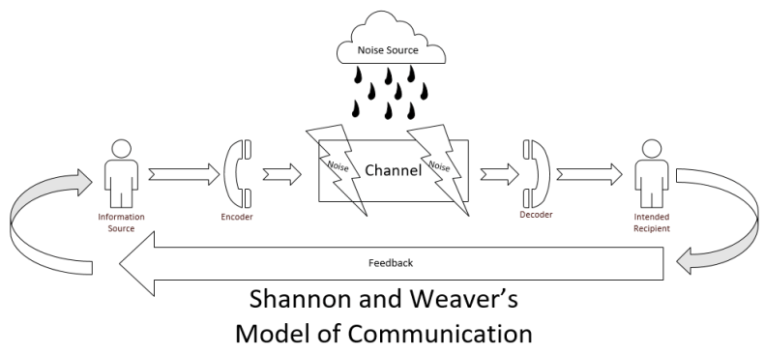

Lfcho (2019) Is Shannon and Weaver’s(1954) Model of communication complete?

The concept of the model is:
Sender (the person who send the message) ----- > Message ---> Channel (this is the way through which the message passes to reach another person) ------> Noise (this is the reason why the receiver does not understand or does not receive the full message. -----> Receiver (the person who receive the message)
This model of communication does not allow feedback and without feedback we cannot get the massage clearly.
The good example of this is the Case study of ‘Pedro and Maria’.
Because he works as a builder and his workplace is quite noisy, Pedro dose not correctly understand Maria that she asked him to get a chicken on his way home. He understands that they will meet in the kitchen, only because the two words are similar in pronunciation.

Case study:
When I used to work as a cleaner my boss called me while I was on the train. I was supposed to start my job at 09:00am.
He asked me if could go to the address 10 minutes earlier, because the customer will leave the building a little bit earlier than usual?
But because I was on the train, I lost the connection, and I did not understand what exactly the boss asked me. I decided it was nothing important and did not call him back after I was out of the tube. I was there on time, 09:00, but the customer was not, and the job was cancelled.
This could be avoided if I give him feedback once I had connection or he should send me a message which I would see for sure!

- Schramm’s Model of Communication
Wilber Schramm proposed the model of communication in 1954.
Schramm’s Model of Communication is based similar like Shannon and Weaver model of communication. How he can improve this model and then he starts talking about FEEDBACK.
Sender-- Message Chanel ReceiverFeedback (there always could be Noise).
But the difference between both models is there Schramm’s talking about Feedback. The model emphasizes that communication is not complete until the sender gets feedback from the receiver. The earlier model of communications used to end when the information was sent to the receiver.
When we are talking for a feedback, the good example is the case study of Maria and Pedro. - To avoid misunderstanding in communication, Pedro has to give Maria a feedback by phone call or text message and ask her what exactly she said ‘Kitchen’ or ‘Chicken’.
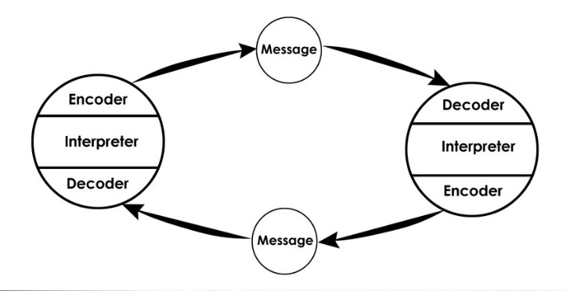
Arya Jemo (2019)

- Berlo’s SMCR Model of Communication

In 1960, David Berlo expanded on this linear communication model and created the SMCR Model of Communication.
Factors that may influence the sender are also applicable to the receiver such as:

Communication skills, Knowledge, Culture, Social system

For example, if the sender uses difficult words, which then makes it more difficult for the receiver to understand the message.
In this type of model of communication there is not feedback so the sender cannot know about the effect or the actions of the receiver. This is shown in the Case study, The Professor, and the Village People.
Case study
Because the professor has a high level of education and works at a university, he is used to use complex words in his daily communication with people. But when the fire broke out in his house late at the night, the only place he could ask for help was the nearby village where he lived and the people in it. When he went to the village to ask for help, he used too complex words to explain the people what is going on, but these words could not be understand from less educated people like these in the village, and the house burned down. The professor had to know the level of the people he would communicate, so that there would be no misunderstanding in the communication.
Personal example
When I came to England, I had a kidney problem and I had to call Emergency, but I still did not know English that well. I told that to them I have pain down the waist. They asked me to explain where exactly the pain is. I repeat again the pain is down the waist. The lady on the phone suggested me to put something warm on the spot and to keep the place warm.
So, I did what they said but because I did not know the correct word to explain where exactly the pain is, and it got worse because the kidneys are not good to warm up. I could avoid this if I had used a translation or asked someone around me to talk on the phone for me.

Communication skills
Verbal communication
This is the type of communication in which we use words to communicate to each other also and thoughts and information. These words may be both spoken and written. Passing information from one person to another is what communication is all about. This indicates that both sending and receiving the equally important. As a result, verbal communication necessitates both the transmission of the message (by a speaker or writer) and the comprehension of the message (by a listener or reader). That is why sometimes the meaning of the words which we use to send like a message by words to somebody else could not be understood. Communication styles and preferences can be influenced by a variety of social circumstances and diseases. Many of these things have an unintentional effect on the speaker.
The social factors can be:
Cultural Norms
Shyness and Anxiety Disorders
Self-Esteem and Ego
Socials Norms
The words we use in our daily lives are extremely important so we need to have some communication skills to help us and one of them could be the second element of communication – Non-Verbal communication.

Non-Verbal Communication

This type of communication includes all those ways we are not using words.
Nonverbal communication types could be: Facial expressions, posture, eye contact the tone of voice, personal space etc.
Silent Meaning the word not spoken goes not quite unheard. It lingers in the eye, in the semi-arch of brow. A gesture of the hand speaks pages more than words, The echo rests in the heart as driftwood does in sand, to be rubbed by time until it rots or shines. The word not spoken touches us as music does the mind.
en. William S. Cohen (R., Maine) ,
The New York Times
The nonverbal communication is just as important as the others, even I can say more important even than verbal one. Sometimes when we have a verbal dialogue with someone, our body language can oppose what we are saying and if the person against us has good communication skills he will understand that we do not really mean what we say. When verbal and nonverbal messages conflict, research reveals that adults tend to believe the nonverbal messages and rely on nonverbal conduct to determine another's attitudes and sentiments. (Burgoon and Guerrero, 2016 , p.3)
Body, face, voice, appearance, touch, distancing, timing, and physical surroundings all play a part in creating the total communication. A friend’s gestures, facial expressions, posture, and eye contact may signal interest. A supervisor’s vocal pitch, loudness, and tempo may signal dominance. A job candidate’s physical attractiveness, dress, and grooming may connote credibility. A lover’s proximity and touch may establish intimacy. (Burgoon and Guerrero, 2016 , p.3)
We can even sometimes convey nonverbal massages to people close to us without even a clue we are doing it. For example, when we are busy or stressed by work, school or personal problems, we may withdraw from the person next to us (could me mother, wife etc.) like a protection to focus on our problems (that is we called Distance) but they can determine that is something personal to them.
Personal example from workplace:
-Some time ago I worked as a sales consultant in a clothing store. I was very close with my manager, we always worked as a team, we were like friends, but of course we observed collegial behavior at work. One morning when we had to open the store together, she came without even saying good morning. We started the work process, and every time I asked her a work-related question, she rolled her eyes and spoke rudely to me. Naturally, I have an ego and I did not want to tolerate such an attitude, so I stopped working well the same day. We lost a lot of sales from potential customers. When she saw that I was not doing my best in the store, she asked me why I explained to her that it was because of her behavior. Then she explained and apologized to me as it had nothing to do with me.

Listening
Listening is the ability to understand properly the person against you, or on the phone who is speaking with you. Maybe this type of communication is the most important part. All good communication relies on the ability to listen properly; without it, messages are easily misunderstood.
Hearing and listening are two different things.
It is not enough to just being quiet and listen to the words of the person who is talking to you. The good listener must pay attention of what is being saying to him/her and to nonverbal communication of the speaker.

The process of listening is in 5 steps.
Receiving Understanding Remembering Evaluating Feedback

As with any type of communication, we can have noise and here (Barriers to listening). We can be distracted by anything from the environment like technology, for example if we receive a message and decide to pay attention on the phone than the speaker. We can also be distracted if we have personal problems and during the conversation, we cannot stop thinking about them, then we ca not listening effectively.
Active listening is when we really make an effort to understand what is being saying. Nonverbal factors could help us such as: eye contact – that will make us to focus on the person who talking to us. To ignore outside factors and noises, try to not think about your thoughts JUST FOCUS ON THE PERSON WHAT HE/SHE HAVE TO SAY TO YOU.
The case study of Max his client shows us how important is listening.

Case study
Max was very good at his job as an event organizer so he decided to start his own business from home but without any help because he could not afford to pay for it. He got a job from one of his previous clients to organize her parents’ anniversary. In time Max got more job to do from new clients, and he was by himself to organize everything.
The plans for the anniversary event have to be change and the client called Max to ask him if he could move the date a week earlier. But because he was busy with her event and other tasks, he forgot what they been talking about, and he doesn’t call the restaurant to change the date. The day of the event the clients went to the restaurant only to see there is not their party. All of them was so upset about the mess. Max apologised and said how sorry he was but that he had forgotten to write the new date in his diary because he had been talking to another client on the other phone and he couldn’t afford to employ anyone to help him.

It is important to have good listening skills especially at your work and pay attention of what your clients saying to you!

Empathic listening
To be good in empathic listening you have to pay attention for what is been saying to you, listen patiently and try to go through of the emotion of the speaker. Try to understand the feelings expressed by the speaker, and pay attention to the emotional content conveyed, as well as the literal meaning of the words. When you listen with empathy, control your emotions, and don't indulge in them. It is important that to understand well first the view of the speaker, evaluate later. The best way is to try to put ourselves in the situation of the person against us and we can see the point clearly and give a correct feedback.

Conclusion
The communication is the greatest importance. Can we exist without communicating? No, we cannot! Communication can go down because many communication barriers can be assigned to sender or receiver. Therefore, effective communication requires familiarity with barriers. Choosing the right communication channel is also important, because choosing the wrong medium will weaken the message. There are many associations and centers that help develop people in their communication skills. Humanity does not stop evolving in the types of communication and I believe that there is still much to learn in the future.

References:
Gulam, K., 2021. Business Communication :Basic Concepts and Skills. [Online]
Available at: https://www.uj.edu.sa/Files/1001210/Subjects/Chapter%205%20Listening%20Skills%20%20.pdf
(Accessed 15th July 2021)
Houlis, A., 2021. 7 Problems Good Communicators Are Able to Avoid. [Online]
Available at: https://fairygodboss.com/career-topics/lack-of-communication
(Accessed 30th July 2021)
Jemo, A., 2019. Robot Oral communication hybrid system using local and cloud computing. [Online]
Available at: https://www.researchgate.net/figure/Schramms-Model-of-Communication-1940_fig1_341789061
(Accessed 3rd August 2021)
Kristian, E., 2021. Social factors affecting verbal communication. [Online]
Available at: https://www.ehow.co.uk/info_8206270_social-factors-affecting-verbal-communication.html
(Accessed 5th August 2021)
mindtools, 2021. Active Listening. [Online]
Available at: https://www.mindtools.com/CommSkll/ActiveListening.htm
(Accessed 5th August 2021)
skillsyouneed, 2021. Verbal Communication Skills. [Online]
Available at: https://www.skillsyouneed.com/ips/verbal-communication.html
(Accessed 11 August 2021)

