Security Analysis Report: SteelForm Manufacturing Ltd (SFM)
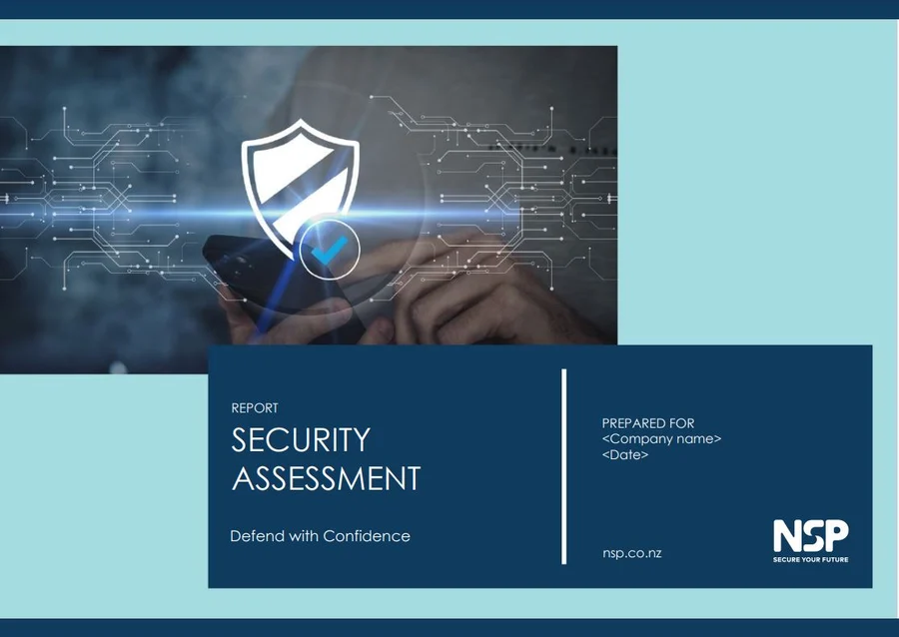

Prepared by:
Student Name: Hanzala Irshad
Student ID: 2508961
Module: Networks and Cyber Security Essentials (ACCA4024)
Date: 09 July 2026

Table of Contents
Abstract 3
1. Introduction 3
2. Task 4
2.1 Identification of Modern Threats 4
2.2 Modern Security Policies 6
2.3 Technical Mitigation Measures 7
2.4 Proactive Monitoring and Incident Response 8
2.5 Continuous Training and Awareness 9
3. Conclusion 10
4. References 10
5. Appendix 12

Abstract
SteelForm Manufacturing Ltd (SFM) is in the process of a rapid digital transformation implementing Industry 4.0 technologies like IoT (Internet of Things) and cloud computing. This may boost the efficiency of operation, but recent cyber events have exposed some critical weaknesses in the existing infrastructure. The SFM comprehensive cybersecurity and data governance strategy is summarized in this report to safeguard SFM's critical assets. With the Zero Trust approach, adhering to NIST CSF and ISO 27001 and with modern Technical Mitigations such as a strict IT/OT network segmentation and an AI-driven SIEM, SFM can effectively neutralize external and internal threats. The solution envisioned for the problem is a strong, automated incident response plan and an ongoing employee training program. These measures provide a secure, resilient environment that enables our aerospace and automotive supply chain clients to continue producing.

1. Introduction
Cybersecurity is not just a function of IT anymore; it is now a critical part of running a business and is a key driver of business resilience. In the past the manufacturing industry has depended on the concept of "air gap," which is the physical and logical separation of factory floor machines from the corporate network. But with the advent of the Internet of Things (IoT), automated robotics and cloud-based analytics, this barrier has been completely removed [1]. This digital transformation is paving the way for the convergence of Information Technology (IT) and Operational Technology (OT), fostering a comprehensive ecosystem that brings real-time insights, predictive maintenance, and significant efficiency gains to the fore.
But as it’s converging, it creates new cybersecurity problems. Current security models were developed for standalone systems and are unable to defend the vast attack surface of inter-connected sensors and edge devices [1]. Moreover, the manufacturing industry is at a completely different cultural collision with the CIA Triad (Confidentiality, Integrity and Availability). But whilst Data Confidentiality is the top priority for corporate IT, System Availability is paramount in the factory floor (OT) and even a minute's loss of availability can cost hundreds of thousands of pounds and cause disruption on a global scale.
The stakes are very high for SteelForm Manufacturing Ltd (SFM). Our data contains some incredibly sensitive proprietary designs, intellectual property, and strict just in time supply chain schedules we are a tier-one supplier to the automotive aviation industry and are highly regulated. Cyber attacks on SFM don't only lead to the loss of corporate information – they can immediately halt assembly lines, cause massive financial losses, lead to regulatory fines and irreparable reputational harm. In this report, we critically assess SFM's security landscape, explore emerging threat vectors, and develop a layered and strategic defense approach to defend our digital and physical operations while maintaining manufacturing uptime.
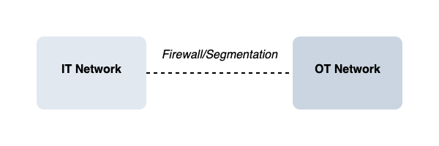
Figure 1: The intersection of Information Technology (IT) and Operational Technology (OT) and the shifting priorities of the CIA Triad in modern manufacturing.

2. Task

2.1 Identification of Modern Threats
SFM needs to grasp the nature of the adversary as well as why they target us and how they attack our hybrid landscape to create a robust defense.
Table 1: SFM Comprehensive Threat Analysis
Threat | Type | Primary Target | Impact on SFM
Ransomware (RaaS) | External | IT Servers & OT Control Systems | Total production downtime, massive financial loss, extortion, and missed client deliverables.
Phishing / Vishing | External | Employees (Procurement/HR) | Credential theft, unauthorized network access, and financial invoice fraud.
Malicious Insider | Internal | Proprietary Databases | Intellectual property theft, industrial espionage of aerospace designs, and data leakage.
Supply Chain Attack | External | Third-Party Software/Vendors | Compromise of SFM systems via trusted vendors, risking our automotive/aerospace clients.
IoT Vulnerability | Internal/External | Factory Floor Sensors | Manufacturing disruption, botnet creation, and pivot points for network-wide malware spread.
Contextualizing the Threat Landscape: The complexity and threat level of these dangers is changing quickly. Today ransomware is the dominant percentage of the total cyber losses incurred across the manufacturing portfolio [3]. Manufacturing companies are a highly attractive victim for cybercriminal syndicates as they understand that the pressure point of the manufacturing industry is the fact that it has an extremely low tolerance for downtime. The idea is that factories might be willing to pay the ransom soon to get the production lines back up and running.
In addition, the convergence of IT and OT environments makes it easy to have an attack move from a typical business network into an industrial control system if adequate separation is not put in place [1]. The infamous 2021 Colonial Pipeline ransomware attack is a real-life example of just such a situation. The attack hackers used was able to access the company's IT billing system, but due to the lack of proper segmentation between the company's IT and industrial control networks, the company had to take proactive action to close off its physical oil pipelines to stop the malware from spreading to the industrial controls.
Furthermore, many IoT devices are poorly secured and are a huge vulnerability. Manufacturers are making IoT devices as quickly as possible and rushing to release them as soon as they can, at the expense of security, where they are commonly shipped with the default password being hardcoded into their device and no provision for patching remotely [4]. These sensors are vulnerable to compromise and upon compromise can be used to provide further entry into the network, thereby directly degrading the integrity and availability of SFM's critical production data.

2.2 Modern Security Policies
To counter these advanced threats, SFM needs to get rid of the “castle and moat” thinking that is so prevalent in security. Creating more gatekeepers at the edge is no longer enough: threats can be present in the network. There is a need to develop comprehensive policies based on stronger, internationally accepted legal and industry regulations.
1. The policy for Zero Trust: Architecture is to implement a hard-line approach to ZTA at SFM. This is based on the principle of "never trust, always verify. This policy provides no trust for any user, device, application, or network packet, whether they are from the internet or from within the SFM corporate building [7]. In an industrial setting, a Zero Trust identity-centric approach can lead to a substantial boost in security. It is constantly authenticating access requests, which helps to reduce the risk of lateral spread typically seen in converged IT/OT solutions [8] and [10].
2. Alignment with ISO 27001 (ISMS): Cybersecurity is an ongoing journey. Hence, SFM shall have an Information Security Management System (ISMS) which is formally aligned with the ISO 27001. This framework requires frequent risk audits, asset management and bottom-up security governance. Full compliance with this standard (and eventual certification) will be a tangible demonstration to our aerospace and automotive clients that we treat their proprietary information with the highest level of international security [5].
3. Integration of NIST Cybersecurity Framework (CSF): The five core functions of NIST CSF (Identify, Protect, Detect, Respond and Recover) will guide our daily actions and policy. This gives our IT & Factory floor managers a repeatable methodology for managing cyber risk, and one that is specific to protecting our critical and physical infrastructure [9].
4. GDPR and Data Governance Policy: Alongside technical standards, SFM needs to have a severe data governance procedure to adhere to data security laws, like the General Data Protection Regulation (GDPR). SFM is a B2B manufacturer, but we must deal with a lot of employee data, client contact information, and possibly sensitive operational data. This policy includes the aggressive classification of data, such as "Public," "Internal," and "Confidential Aerospace IP" and the use of strong data encryption methods. With the shift towards connected physical-cyber markets [6] and the increasing volume of data being collected, keeping the risk of wrongful data collection to a minimum and avoiding the devastating consequences of privacy litigation is essential if businesses are to succeed.

2.3 Technical Mitigation Measures
Technical mitigation measures determine how we reach our security objectives, whereas policies determine what our security objectives are. The following measures are called for to be put in place at SFM as soon as possible:
- Strict IT/OT Network Segmentation: This is likely the most important physical defence. We will introduce strong industrial firewalls and Virtual Local Area Nets (VLANs) to fully isolate the IT network (where emails and HR are sent and received, internet is browsed) from the OT network (where smart machines and IoT sensors are operated). Network micro-segmentation is a key component of the Zero Trust model. Proper segmentation is like a blast door, blocking the malware movement from the accountant to the factory floor and from there to the assembly line, if the accountant opens a malicious phishing email and infects his/her computer with ransomware.
- DITAM: Multi-Factor Authentication (MFA) & Identity Access Management (IAM) – Passwords are effectively dead. Any member of staff, including executives and contractors working remotely as part of maintenance, should use MFA as a means of accessing any SFM system. MFA is a process that asks a user to enter two or more authentication factors (such as a password and a code sent to a mobile application). MFA misconfiguration or its lack is a major flaw in manufacturing processes and provides an easy means for attackers to log in via stolen credentials as consistently seen in claims data [3].
- SFM will keep off-site immutable backups to offset the devastating threat of ransomware. Immutable is a property of the data in the backup that locks it and makes it inaccessible to other people, including an administrator, for a specified amount of time, so that it cannot be changed, encrypted, or deleted. This way, our data is always available, and we can remove the infected systems and restore our production databases without having to pay a criminal syndicate's ransom.
- Risk Based Patch Management via CISA KEV: Patching operational technology (OT) can be challenging because it's costly to take a machine offline for a software update, which is why risk-based patch management is a key consideration. Hence, vulnerability scanning and patching will be given highest importance based on the Cybersecurity and Infrastructure Security Agency's (CISA) Known Exploited Vulnerabilities (KEV) catalog. This allows the IT team to spend their small window of down time on the vulnerabilities that are being exploited in the wild by hackers, and not theoretical vulnerabilities [11].

2.4 Proactive Monitoring and Incident Response
Eventually, preventative defenses will become ineffective. SFM can't just construct a wall and wait to see if we're safe, we must be actively and continuously monitoring our network for breaches and have a plan in place to quickly respond if an alert is sounded.
- Proactive Monitoring (SIEM and EDR): We will implement a centralized Security Information and Event Management (SIEM) system with AI powered Endpoint Detection and Response (EDR) systems. This SIEM serves as the brain of our security operations by gathering millions of event logs from the server, firewall and employee's laptops in our factory. This amount of data is too much for human analysis, so AI models on the edge process the network traffic and device behavior in real time. They search for subtle anomalies, like a machine trying to connect to a server it's never connected with before, which allow low-latency threat detection [2].
- Automated Incident Response Plan: Time is the most critical when a highly credible threat is detected. SFM will use Security Orchestration, Automation and Response (SOAR) technologies to implement pre-approved playbooks. This makes it possible for this system to quarantine an infected machine in milliseconds, well before a human IT worker could log on.
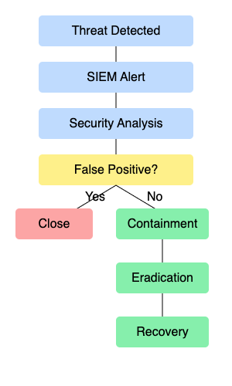
Figure 2: SFM Automated Incident Response Flowchart

2.5 Continuous Training and Awareness
The most advanced firewalls and AI detection systems in the world can be easily outsmarted by clicking a single link by one of your employees. Despite being the weakest link in cyber security, the human factor can be our greatest strength when we invest in it appropriately. SFM should encourage a culture of proactivity, away from a culture of blame, because security should be a shared responsibility.
- Continuous Phishing and Vishing Simulations: The current approach of passive "annual compliance videos" is very ineffective [12]. Awareness is helpful but it is necessary to have some active, practical approaches. SFM will conduct monthly simulated phishing (email) and vishing (voice) campaigns, which are not announced. These will simulate real attacks like fake invoice from a known supplier. Any employee clicking on the links is presented with a short, supportive, non-punitive micro-training, immediately, that clarifies what was missed.
- Role-Based Security Training: Specific training is not considered. The training should be customized to the risks encountered by a department. For instance, procurement and finance personnel will be heavily trained on recognizing Business Email Compromise (BEC), audio impersonation, and invoice fraud, among other types of scams, using the AI-generated deepfake. However, managers of the factory floors will be educated about the physical security of IoT sensors, how to detect unauthorized USB drives, and how to question unbadged people on the factory floor.
- Development of a Security Champions Program: The IT department can't be in all places at once. SFM will be looking for volunteer non-IT users in various departments such as a shift supervisor, a lead engineer to serve as "Security Champions. These will get a bit more advanced training and will serve as an easily approachable and on-the-ground advocate of secure practices closing the cultural divide between corporate IT and factory operations [12].

3. Conclusion
For the SteelForm Manufacturing (SFM) company, the implementation of smart technologies for Industry 4.0 undoubtedly has resulted in operating advantages, but also in significantly greater vulnerabilities of our critical infrastructure. To combat internal and external threats, SFM can aggressively move towards a Zero Trust architecture, apply internationally recognised ISO 27001 standards, apply non-negotiable IT/OT network segmentation and establish a culture of constant embedded security awareness.
The most obvious vulnerabilities must be mitigated immediately and enforced by a mandate: Multi-Factor Authentication (MFA) should be implemented for all local and remote accounts and a strict logical separation of IT and OT networks should be put in place within 30 days.
Future Work: The next steps are to continue scaling SFM's digital footprint, and to leverage the power of AI and its predictive threat hunting models to proactively neutralize threats before they hit our network perimeter in the form of complex supply chain attacks.

4. References
[1] Infosys, "AI AT THE EDGE: SECURING IT/OT CONVERGENCE WITH MULTI-LAYERED DEFENSE," Infosys, 2023. [Online]. Available: https://www.infosys.com/services/cyber-security/documents/multi-layered-defense.pdf. [Accessed: 05-Jul-2026].
[2] N. Kshetri, "The Colonial Pipeline Ransomware Attack," Computer, vol. 54, no. 9, pp. 116-119, Sept. 2021.
[3] Resilience, "The state of cybersecurity in manufacturing," 2026. [Online]. Available: https://4526209.fs1.hubspotusercontent-na1.net/hubfs/4526209/Manufacturing%20Report.pdf. [Accessed: 05-Jul-2026].
[4] KBR, "IoT Devices and Security: A Narrative Review," KBR, 2024. [Online]. Available: https://www.kbr.com/en/document/14356. [Accessed: 05-Jul-2026].
[5] Ryspaeva, A., Raher, R., Milanova, E., Sherbekova, A., & Kozera, L. (2026). The role of the state administration in ensuring the safety of the digital economy in France, Poland, Bulgaria and Kyrgyzstan. PA Persona e Amministrazione, 1(1), 347-380.
[6] Kwon, W. J. (2018). The insurance business in transition to the physical-cyber market: Communication, coordination and harmonization of cyber risk coverages. Coordination and Harmonization of Cyber Risk Coverages (October 15, 2018).
[7] National Institute of Standards and Technology (NIST), "Zero Trust Architecture," NIST Special Publication 800-207, 2020.
[8] GuidePoint Security, "Zero Trust in OT Environments," GuidePoint Security, 2026. [Online]. Available: https://www.guidepointsecurity.com/wp-content/uploads/2026/02/Zero_Trust_in_OT_Environments_WP.pdf. [Accessed: 06-Jul-2026].
[9] NIST, "Cybersecurity Framework," NIST.gov. [Online]. Available: https://www.nist.gov/cyberframework. [Accessed: 06-Jul-2026].
[10] S. Jiang et al., "A Zero Trust approach for the cybersecurity of Industrial Control Systems," IRIS, 2023.
[11] Cybersecurity and Infrastructure Security Agency (CISA), "Known Exploited Vulnerabilities Catalog," CISA.gov, 2024. [Online]. Available: https://www.cisa.gov/known-exploited-vulnerabilities-catalog. [Accessed: 06-Jul-2026].
[12] Intelligence and National Security Alliance (INSA), "COMPONENTS OF EFFECTIVE INSIDER THREAT TRAINING," INSA, 2022.

5. Appendix



