Research Proposal
By Rebecca Hollow

BA(hons) International Travel and Tourism Management
Cohort: September 2015
Student ID: P144700
Submission date: 20th November 2017

Dissertation
Research Proposal

An investigation to explore the motivations of UK travellers to holiday destinations, considering the impact of recent terrorist attacks.

Rebecca Hollow
P144700
Table of contents
- Introduction …………………………………..........................4
  - Research Rationale……………………………...............4
  - Contextual Background……………………………….4-5
  - Aims and objectives……………………………………..5
- Research design……………………………………………..5-8
  - Research methodology……………………………….....6
  - Philosophy….…………………………………………6-7
  - Approach………………………………………………..7
  - Strategy……………………………………………….7-8
  - Choices………………………………………………….8
  - Time horizon……………………………………………8
  - Data analysis……………………………………………8
- Resource planning…………………………………………….9
- Limitations and ethical considerations………………………..9
  - Reliability and validity………………………………9-10
- References………………………………………………..10-11

1.0 Introduction
1.1 Research rationale
The topic which is going to be investigated in this dissertation is that of international terrorism and how it has affected people’s perceptions when considering a destination. The reasoning for this research is due to the recent terrorist attacks which have occurred in many tourist destinations and have in turn led to a decrease in visitor numbers in places such as Turkey, Egypt and Tunisia, this study will attempt to find the reasons behind the decline in tourist numbers to destinations such as the ones just mentioned.
Terrorist activity has affected many UK travellers. This is because some have unfortunately been victim or have witnessed an attack which in turn has then altered their perception of certain holiday destinations. According to Sonmez and Graefe (1998), tourists compare destination alternatives according to the anticipated benefits and costs (risk of another attack). Similarly, Romagnoli (2016) also argues that risk perception, attitude and preferences are all factors in determining the destination choice for a tourist. This investigation will surface the motivations of people’s choice in destination and will further highlight if terrorism has affected them in their choice.
1.2 Contextual background
Tourism is one of the largest sectors in the world; it is also the first sector to be targeted by terrorist activity. This is due to the fact that activities undertaken within the tourism sector are responsible for housing large clusters of civilian people, who are unfortunately seen as easy targets for terrorist groups. It is important to highlight that terrorist data has been greatly valued since the terrorist attacks on September 11th, 2001. According to the Foreign and commonwealth office (2013) international terrorism still remains the highest risk to UK nationals living or travelling overseas. It is also thought that UK nationals and UK interests are most at risk from groups motivated from Iraqi and Syrian conflicts.
The issue with international terrorism is that no individual can precisely predict when an attack is going to occur, or if the same destination will fall target again. This makes it difficult for the population to decide on a ‘safe’ holiday destination. Individuals must consider several costs and benefits when selecting a destination, especially if it has been targeted before. According to Cooper et al (2008) the perception of travel related risk experienced by an individual is determined by a variety of factors; These include: the individual's perception to risk, the scale of threat and frequency, and often the media coverage of earlier events (Kozak and Andreu, 2010)
1.3 Aims and objectives
Title of research:
An investigation to explore the motivations of UK travellers to holiday destinations, considering the impact of recent terrorist attacks.
Aim:
To discover individual’s motivations in their choice of vacation destination and whether the location of recent terrorist activity has influenced them with their choice.
Objectives
- To Explore the trends in destination choice with the consideration of recent terror attacks.
- To discover the motivations in destination choice.
- To gain an insight of the impact which terrorism has inflicted upon international travel and tourism over the past five years.
2.0 Research design
According to Clark et al (1998) research may be defined in terms of a review of existing knowledge, in a particular area together with the creation of a new insight on this knowledge.
Choosing the correct research method is a vital element when conducting research. It is important to select the most appropriate method to aid the research process to gain information surrounding the subject area.
There are two main types of research; primary and secondary. Primary research is the collection of new data for the sole purpose of the topic area being discussed and secondary data is used for reanalyzing data which already exists, usually to establish or enhance an issue within the topical field which is going to be explored (Saunders et al, 2007).

2.1 Proposed research methodology:
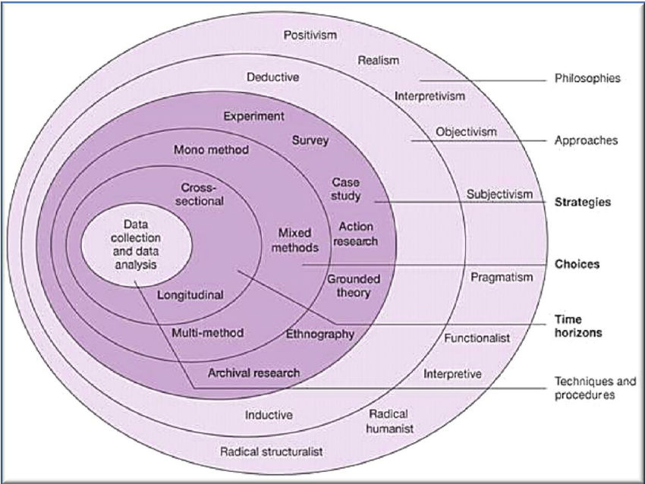
(Figure 1: Saunder’s research onion).
Saunders et el (2007) suggests that the research process is most like peeling the layers of an onion. It suggests that all research ideas begin in the middle at the data collection and data analysis stage, whilst eventually working to its exterior, ‘peeling away the layers’. During this process, a choice can be made to decide which method or methods are most appropriate for the topic area under investigation.
For this dissertation a mixed methods approach will be adopted, whereby the combination of both qualitative and quantitative research approaches will somewhat provide a more complete and sound understanding of the research problem, as opposed to just one method alone (Cresswell, 2014).
2.2 Philosophy
The philosophy of research is found on the exterior layer of the ‘onion’. Saunders et al (2007) argues that the appropriate philosophy must be adopted in order to underpin the research strategy and aid the choice in methodology. This investigation will undertake an interpretivist approach as it will encapsulate concerns around how the social world is experienced and understood in terms of people’s motivations in destination choice post terror attack (King et al, 2010). Furthermore, an interpretivist approach is most appropriate as it involves human emotions and opinions, and is not deemed a true scientific pathway with a clear and factual answer.
2.3 Approach
There are two types of research approaches, deductive, in which the research design tests the hypothesis to prove or disprove it, or inductive, whereby data is collected in order for a theory to be developed after analyzing the data (Saunders et al, 2007). Choosing the most appropriate research approach is a vital element for the researcher, it directs them in a manner whereby the researcher can decide if certain research strategies will work or not.
This investigation will be adopting an inductive approach, as data will be gathered and analyzed, to then develop theory based upon its findings.
2.4 Strategy
A research strategy’s purpose is to enable the researcher to choose the correct method in order to answer the research aim and meet its objectives (Saunders et al, 2007) This investigation will use surveys, interviews and already existing literature in an attempt to draw a conclusion from the research.
This study will contain an interview with a member from Virgin Atlantic to gain a greater understanding about the effects that terrorism has on the price of foreign holidays to certain destinations, and the procedures involved when customers demand to change destination due to an attack. Using an interview technique allows for the collection of ‘soft’ data, which is open to interpretation and allows for individual’s opinions and motivations to be explored. Interviews allow for a greater understanding of the meanings which humans attach to events (Saunders et al, 2007). This study will also consist of several other interviews with individuals in an attempt to uncover the ‘real’ motivations behind travel and tourism to destinations post terror attack.
This study will also contain a survey targeting a wide range of UK residents which will include general demographic questions and further in-depth questions about other factors which may influence in the decision-making process. The main purpose of the survey is to gather trends on destination choice and to establish whether factors such as age, gender and socioeconomic background impedes on the decision. The sample size of this survey will be between 80-100 respondents aged 18 and over. According to Mitchell and Jolley (2009) the advantage of using a survey is that they are a relatively “inexpensive method to gain greater insight into people’s attitudes, beliefs and behaviors. They allow for a large collection of data in a short period of time”.
2.5 Choice
The objectives set out in the first instance for this study will be achieved using the following methods:
- Objective one: To explore the trends in destination choice with careful consideration of recent terrorist activity; Desk research (pre-existing literature).
- Objective two: To discover the motivations in destination choice; Survey with general public, interview with industry member.
- Objective three: To gain an insight of the impact which terrorism has inflicted upon international travel and tourism over the past five years; Desk research (pre-existing literature), Survey with general public.
2.6 Time Horizon
There are two differing time horizons in which research can take place. The first being a cross sectional study, whereby data is gathered only once over a short period of time, usually within a matter of days, weeks or months. Longitudinal time horizon, however, involves collecting data several times over a longer time frame (Payne et al, 2004). Due to the nature of the dissertation and its time constraints, this study will be adopting a cross sectional time horizon.
2.7 Data analysis
Questionnaires – SPSS: Practical for entering data manually and editing data from various sources (i.e online surveys). It also allows for thorough exploration of data frequencies, means, distributions and correlations.
Excel: A widely used tool to analyse and organise data in a systematic manner. It also provides greater opportunity for analysing larger data systems (online surveys).
Interviews – Matrix tables: A key tool to display the responses from the interview conducted during the research stage. They allow for clear, and concise displays of key information collected. Helping to aid the analysis stage, when trying to determine key themes.

3.0 Resource planning
Gantt Chart (Time management action plan).
When planning to conduct any research, it is important to plan the distribution of time in a systematic way, to enable effectiveness and efficiency.
4.0 Limitations and Ethical considerations
It is highly important to consider ethics and morality when conducting a research project. Regardless of the research design, social research should take account for four broad ethical principles (Kimmel, 1989).
The ethical principles which need to be considered during social research include:
- Voluntary participation.
- Informed consent.
- No harm to participants.
- Anonymity and confidentiality.
4.1 Reliability and validity
Reliability refers to the designator which consistently comes up with the same quantification. A reliable measure is one which gives the same ‘reading’ when utilized on reiterated occasions. Unreliability can stem from several different sources, including:
- Insufficient question design.
- Varied interviewers can interpret different answers from an interviewee.
- Questions which require no opinion.
- Questions which require too precise of an answer.
The factors above can lead to unreliable data.
Validity is an important consideration. Whilst a study may have good internal validity, the findings of the research may only represent the sample involved within the research process, therefore the results cannot be generalized beyond the particular study. This may ultimately decrease the representation on a wider scale (Vaus, 2001).
5.0 References
Clark, M, Riley. M, Wilkie, E and Wood. C.R. (1998). Part 1: getting started; What is research for and what does it involve. In: Researching and writing dissertations in hospitality and tourism. London: International Thomson Business Press. p5-71.
Cooper, C., Fletcher, J., Fyall, A., Gilbert, D. and Wanhill, S. (2008) Tourism: Principles and Practice, 4th ed. Essex: Pearson Education Limited.
Cresswell, W.J. (2014). Part 1: Preliminary considerations. In: Research design: qualitative, quantitative and mixed methods approaches. 4th ed. New York: SAGE. p1-21.
Foreign and commonwealth office. (2013). Reduce your risk from terrorism whilst abroad. Available: https://www.gov.uk/guidance/reduce-your-risk-from-terrorism-while-abroad. Last accessed 14.11.17.
Kimmel, A (1989). Ethics and values in applied social research. 3rd ed. London: SAGE. p26- 42.
King, N and Horrocks, C. (2010). Chapter 2: philosophical assumptions. In: Interviews in qualitative research. New York: SAGE. p8-24.
Kozak, M and Andreu, L.A. (2010). Advances in tourism destination. London: Routledge. P118-160.
Mitchell, L.M and Jolley, M.J (2009). Research design explained. London: Cengage Learning. p263.
Payne, G and Payne, J (2004). Key concepts in social research. London: SAGE. p143-147.
Romagnoli, M. (2016). The effects of terrorism on tourism: (inter) relations, motives & risks. Almatourism. 7 (5), p125-133.
Saunders, M., Lewis, P. and Thornhill, A. (2007). Research methods for business students. 4th ed. Harlow. Pearson Education limited.
Sonmez, S. F. and Graefe, A. R. (1998). Influence of terrorism risk on foreign tourism decisions. Annals of Tourism Research. 25 (1). P112-144. Cited in: Morgan, D and Fluker, M. (2006). 9: Risk management for Australian commercial adventure tourism operations. In: Mansfield, Y and Pizam, A Tourism, security and safety. London: Routledge. P153-280.
Vaus, D. (2001). Issues in experimental design. In: Research design in social research. London: SAGE. p83-88.

