

Level 7 Dissertation
BMMB7003
2023-2024
Dissertation Title: The impacts of telework on employee engagement in the IT industry: an empirical study
Author: Cai Jing
Student ID: 2200245
Supervisor: James Moore
Date of Submission: 2024-09-27

EXAMINATION OF TAUGHT MASTER'S DEGREE DISSERTATION:
NOTICE OF CANDIDATURE FORM
Please complete this form when your dissertation is ready to be submitted for examination.

Surname/Family Name............Cai............ Date of Birth............2001-08-26............
Forenames (in full) ............Jing............ Title
Institution Number (if known)
Title of Degree (eg MA, MSc, MBA etc)................................MBA.................................................................
Title of Taught Master's degree scheme followed (eg Equine Studies) ..............Master of Business Administration (Full-time) (MBA)..............
Department/School in which study pursued .............The University of Wales Trinity Saint David (the Institute of Management and Health).............
Name of your Supervisor ...................James Moore...................
Full Title of dissertation submitted ..................The impacts of telework on employee engagement in the IT industry: an empirical study..................
Please indicate that the following will all be submitted along with this form:
two permanently bound copies of your dissertation plus 1 electronic copy submitted via Turnitin;

Statement of Originality
DECLARATION

This work has not previously been accepted in substance for any degree and is not being concurrently submitted in candidature for any degree.

Signed .................... .................................................. (candidate)

Date ..................... 2024-09-27...................................................

STATEMENT 1

This work is the result of my own investigations, except where otherwise stated.

Other sources are acknowledged by footnotes giving explicit references. A bibliography is appended.

Signed ................. ............................................ (candidate)

Date ........................ 2024-09-27................................................

Acknowledgement
Firstly, I would like to express my sincere gratitude to my thesis supervisor, James Moore. Throughout the research and writing process, I have benefited greatly from his attentive guidance and selfless help. Whether in topic selection, research methodology, or writing skills, I appreciate his patient guidance and professional insights.
Secondly, I would like to thank my family, especially my parents. They have always been supporting me and giving me unconditional love and encouragement.

Abstract
After the COVID-19 pandemic, telecommuting has become a commonplace practice in many industries, including the information technology (IT) sector. Therefore, this paper explores the impact that teleworking truly has on employee efficiency and work engagement with a particular focus on cases where it is fully established as part of office life. Decisive findings have not been produced; despite this, telecommuting has been found to be widely adopted. At the same time, manpower involvement and organizational support are less predictable on statistical grounds of observation than one might expect. Drawing on boundary theory and the Job Demand-Resource (JD-R) model as its theoretical foundations, this research sought to holistically test the relationship between telecommuting frequency and employee engagement. It did so by using an online survey of 128 IT industry employees across different managerial levels. All survey participants had telecommuting experience, except for location-based marketing people operating at below minimally efficient levels, who were consequently disqualified from generating valid responses.
Job autonomy is improved by working at home (advertising agencies often tout this effect for their employees without making the physical move to a home office). Work-family conflicts are reduced (although they continue to occur in many cases of telecommuting) after adopting this lifestyle. However, frequent telecommuting does not significantly improve workers' enthusiasm for their work or involvement in any meaningful way. In some departments, it blurs the boundary between work and life altogether, leading to psychological pressure. Another finding that emerges is that while technical support is needed to ensure the smooth functioning of telecommuting, it does not directly impact employee engagement or productivity. Instead, employees' sense of progress at work and pride turned out to be the primary drivers behind involvement and effectiveness at work. This effect significantly outweighs the other factors.
One implication of these findings is that IT companies wishing to design more effective remote working management strategies must focus on giving employees a solid sense of accomplishment and identity.
Keywords: telecommuting, IT industry, employee productivity, job engagement, job autonomy, technical support, boundary control, job demand-resource model

Table of contents
Statement of Originality 3
Acknowledgement 5
Abstract 6
Chapter One: Introduction 1
1.1 Research Background 1
1.2 Research Question and Objectives 7
1.3 Dissertation Structure 8
Chapter Two: Literature Review 9
2.1 The Evolution and Conceptualization of Telecommuting 9
2.2 The Conceptualization of Employee Engagement 12
2.3 Theoretical Underpins 14
2.3.1 Boundary Theory 14
2.3.2 The Job Demands-Resources Model 17
2.4 Telework and Employee Engagement 20
2.4.1 The Impacts of Telework and Employee Engagement 20
2.4.2 Hypothesis Development 23
Chapter Three: Methodology 26
3.1 Research Philosophy 26
3.2 Research Approach 28
3.3 Data Collection and Analysis 28
3.4 Ethical Concerns 30
Chapter Four: Empirical Analysis 32
4.1 Robustness Analysis 33
4.2 Descriptive Analysis 34
4.3 Inferential Analysis 37
4.4 Discussion of the Findings 43
Chapter Five: Conclusion 49
5.1 Concluding Remarks 49
5.2 Managerial Implications 50
5.3 Research Limitations 50
5.4 Future Research Directions 51
Reference List 52
Appendix 63

Chapter One: Introduction
Chapter One provides an overview of the overall framework of this study, which aims to provide background and theoretical foundations for the subsequent chapters. First, the research context section discusses the rapid development of telecommuting in the IT industry, especially its potential impact on employee productivity and engagement after the pandemic. Then, the motivation section elaborates on the increasing importance of the discussion on the effectiveness and long-term impact of telecommuting in academia and industry as its popularity grows, making it relevant to study its impact on employee performance and business development. The research question clearly states the core question to be answered in this research, namely, how telecommuting affects the productivity and engagement of employees in the IT industry. Finally, this chapter also outlines the structure of the paper, introducing the content of each chapter and its relevance to the overall research.

Research Background
Telecommuting/Telework originated from Nilles' (1975) research on the use of information and communication technology (ICT) as an alternative to commuting in an attempt to solve many social problems such as urban traffic congestion, air pollution and energy consumption. This “technological correction” approach soon generated unlimited expectations among scholars, the public and policymakers (Giovanis, 2018; Safirova, 2002). Toffler (1981), for example, envisioned a future “electronic home” lifestyle based on this approach. Therefore, during its nearly half-century development, there have been predictions of rapid development. Still, the reality is that most of the time, the growth of telecommuting has been slow, and at times, it has even stagnated. The actual impact on transportation, the environment, and society has been very different from the previous optimistic promises, prompting scholars to rethink this from the perspective of conceptual measurement and forecasting methods (Bailey & Kurland, 2002; Harker Martin & MacDonnell, 2012; Shin et al., 2000). Only in the past ten or so years has there been a more obvious growth trend in some countries. The continued development of telecommuting has mainly relied on advances in ICT advancements but is also closely related to proactive government promotion through legislation, regulations and pilot projects. Table 1-1 below lists some representative projects, laws and regulations across governments in promoting telecommuting. The far-reaching ones include the California Telecommuting Pilot Project from 1985 to 1990, the Telework Enhancement Act signed in 2010 in the United States, as well as the European Framework Agreement on Telework signed in 2002 aiming to promote the implementation of telecommuting in European countries through various forms (laws, cooperation agreements, guidelines, recommendations, joint statements, etc.).
Table 1-1: Major actions taken by governments around the world
Source: organised by the researcher
Country | Time | Name | Nature
The U.S. | 1988-1990 | California Telecommuting Pilot Project | Project
The U.S. | 1999 | National Telecommuting and Air Quality Act | Law
The U.S. | 1999-2004 | Telecommuting emissions credit trading (commute) | Project
The U.S. | 2010 | Telework Enhance Act | Law
The U.S. | 2012 | Telework Enhance Act Pilot Program, TEAPP | Project
Europe | 2002 | European Framework Agreement on Telework | Agreement
Europe | 2002 | Sustainable Telework (SUSTEL) Project | Project
Ireland | 2009 | Smarter Travel | Policy
U.K. | 2014 | Flexible Working Regulations | Law
Canada | 1999 | Telework Policy | Policy
Canada | 2020 | Directive on Telework | Law
Korea | 2010 | Smart Work Vitalization Strategy | Policy
Japan | 2012 | Nationwide Development Project for Teleworking | Project
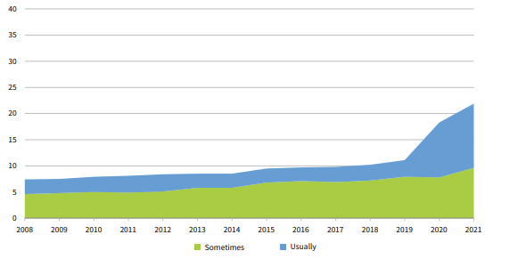
Figure 1-1: Share of 27 European countries’ employees working from home
Source: (Eurofound, 2023)
Furthermore, the impact of the covid-19 pandemic has disrupted the stability of the existing socio-technical landscape and institutional systems, creating a “window of opportunity” for teleworking (Lyttelton et al., 2022; McNally et al., 2022; Mohammadi et al., 2023). Many countries have made new and active attempts and explorations in terms of specific practices and corresponding regulations. The degree of participation in and perception of telecommuting by governments, business organisations and individual employees has also increased significantly, which has laid a foundation for the continued development of telecommuting in the post-pandemic era. As shown in the following Figure 1-2, the frequency of teleworking, based on the investigation of employees of 27 European countries, reveals a significant increase from 11% in 2019, just before the covid-19 pandemic, to 19% in 2020, right after the outbreak of the covid-19 pandemic (Eurofound, 2023). Meanwhile, many EU member states have now further adapted their legislative framework to address new preferred ways of working in the post-pandemic era. For instance, the Dutch parliament approved legislation to make telework a legal right (Bloomberg, 2022); Luxembourg signed the new European Framework Agreement on Teleworking, aiming to facilitate cross-border teleworking while ensuring that teleworkers continue to be affiliated with their employer's national social security system (The Social Security Centre of Luxembourg, 2023).
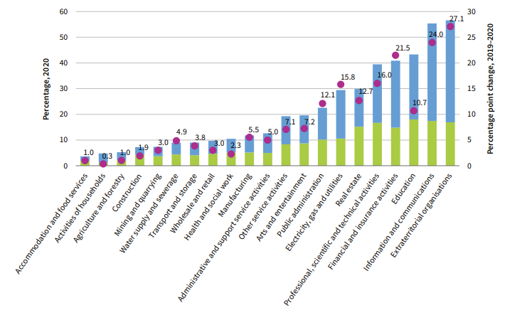
Figure 1-2: Employees work from home by sectors in the post-pandemic era based on 27 European countries
Source: (Eurofound, 2023)
The reliance on telecommuting has not dissipated with the removal of the covid-19 public health restrictions, and the return to work across Europe and the United States has not been as high as expected, particularly in the IT industry where physical interactions are less demand and level of digitalisation is significantly higher compared to other industries. As shown in the above Figure 1-2 above, the IT industry, aside from extraterritorial organisations such as the World Bank, the International Monetary Fund, and the United Nations, witnessed the greatest increases in the prevalence of teleworking in the post-pandemic era due to its nature of being low place-dependent and high involvement of information-processing tasks (and less physical tasks and social interaction tasks)(Eurofound, 2023). In the categorisation of teleworkability, ICT professionals are perceived as highly teleworkable occupations relative to other categories, as shown in the below Table 1-2.
Table 1-2: The categorisation of telework ability
Source: (Eurofound, 2023)
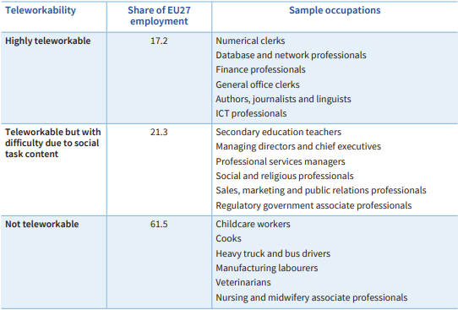
There is a clear preference for telecommuting in the IT industry, with more than 60 per cent of women and men saying they prefer to work from home, meaning that return is not entirely voluntary (Apollo Technical LLC, 2024). Some IT companies, such as Facebook, Twitter, Microsoft, IBM, etc., even launched a permanent teleworking mode for some employees. Tencent Research Institute released The Great Telecommuting Survey 2022, which shows that more than 40% of adults believe that working remotely from home is a major trend, particularly in the IT industry due to the higher level of organisational infrastructure digitalization and fewer demands on workplace psychical presence (Internet Frontier, 2022).
As with all organizational change, telecommuting has both advantages and disadvantages (Galanti et al., 2021). Although governments and businesses have long used telecommuting to respond to large-scale social events (such as the Olympics, earthquakes, and epidemics), the covid-19 pandemic has further highlighted its important role in participating in business continuity planning (BCP) in responding to sudden disasters and public safety risks. However, as a ‘new’ flexible work system, the long-term popularity of telecommuting among governments, businesses, and individuals is more due to its potential to simultaneously address multiple difficult social problems in daily life with a single, simple technical solution. From the perspective of the government, telecommuting not only alleviates urban traffic congestion and deteriorating air quality, but also has the potential to reduce unemployment (Bernardino, 2017; Carvalho et al., 2022). For employers and businesses, telecommuting not only saves office space costs but also increases employee performance, autonomy, satisfaction and enthusiasm at work and improves employee loyalty (Dutcher, 2012; Lakshmi et al., 2017). Specifically, as a family-friendly work policy, telecommuting attracts or retains employees, especially high-quality technical employees, by providing freedom of workplace and time arrangements, thereby reducing company turnover rates and reducing human resources costs (Jones, 2016; Lakshmi et al., 2017). For individual employees, telecommuting is beneficial for balancing their work and family commitments, saving commuting time and costs, and alleviating the time and space constraints of daily life (Breaugh & Farabee, 2012; Caringal-Go et al., 2022).
However, at the same time, the problems that come along with telecommuting should not be ignored, such as the confusion of work-life boundaries, inconvenience in communication between colleagues, poor self-efficiency management, and indifference in employee relations, the ensuing problems have a direct impact on the psychological health of employees as well as their motivation at work, and reduce their work efficiency (Becker et al., 2022; Deutrom et al., 2022; Song & Gao, 2020; Weinert et al., 2014).
Therefore, the question of whether telecommuting can provide employee engagement and performance is still an open one. Previous studies have mostly discussed the advantages and advantages related to remote work theoretically, as remote working was not yet an at-scale phenomenon before the covid-19 pandemic. Nevertheless, as a new way of working, telework has affected the engagement and productivity of employees, especially those without any prior remote working experience (which includes the majority of the workforce), and the exact impacts have not yet been quite empirically explored (Galanti et al., 2021). This indicates the fact that it is imperative to identify the impacts of telework arrangements on employee engagement and productivity in the IT industry, where telework is heavily relied on as a new workplace arrangement, given the collective impacts in the post-pandemic era where an increasing number of governments are promoting telework and an increasing number of companies are adopting telework, as indicated above.

1.2 Research Question and Objectives
Based on the above research context, the research question guides the research throughout the investigation is formulated as follows:
How does the adoption of telework affect employee engagement in the IT industry?
The completion of the following objectives supports the addressing of the above question.
- To conceptualize telework comprehensively and critically and review relevant theoretical underpinnings of telework, such as the job demands-resources (ID-R) model and work-life balance.
To empirically assess the impacts of telework on employee engagement and productivity in the IT industry
- To provide managerial recommendations for IT organizations on how to enhance employee engagement and productivity in telework environments while ensuring employee well-being.
In terms of theoretical relevancy, the present research can narrow the gap in the existing theories regarding the insufficiencies in the empirical research regarding telework’s impacts on employee engagement and productivity and extend the existing knowledge regarding the productivity dynamics in telework settings. The present research focuses especially on developing a thorough understanding of the positive, motivating, and productive telework experience, which has been somewhat neglected in the telework literature (Mäkikangas et al., 2022).
In terms of practical relevancy, maintaining and improving employee engagement and productivity in an unsupervised environment is of great importance to IT and also general businesses and no organization can thrive without a group of engaged and productive employees. The insights from the present research can provide evidence-based insights to IT organizations in promoting engagement and productivity in the telework environment in ways which are also conducive to employee well-being.

1.3 Dissertation Structure
Chapter One—Introduction: This chapter discusses the rise of telecommuting, particularly since COVID-19 and in the IT industry, and then extends to its potential impact. Based on the above, it formulates the overall research question that guides the researcher throughout the investigation.
Chapter Two—Literature Review: This chapter conceptualises telecommuting and employee engagement. It begins by discussing the theoretical frameworks related to work engagement and how they are affected by telecommuting. Based on the above, the research hypotheses are correspondingly developed.
Chapter Three—Methodology: This chapter explains the methods of research design and data collection. It first introduces the choice of research philosophy and methods. Then, it discusses the sources of data, how to select samples and participants, and the specific methods of data collection and analysis.
Chapter Four—Analysis: This chapter presents and explains the statistical results (such as regression or correlation analysis). The results are compared with hypotheses, and key findings are highlighted.
Chapter Five—Conclusion: This chapter summarises the entire text, reiterates the research questions and main findings, and discusses the contribution and practical significance of the research. It briefly presents recommendations for managers implementing telework in the IT industry. Finally, the future direction of research is examined, and it is pointed out how this research can form the basis for further research in this field.

Chapter Two: Literature Review
The chapter provides a critical and comprehensive overview of telework's historical development and theoretical underpinnings, with a particular focus on the IT industry. The chapter starts with the variety of conceptualizations of telework, which has evolved since its inception and accumulated particular attention due to the covid-19 pandemic (Brynjolfsson et al., 2020; Galanti et al., 2021). The section then delves into various theoretical frameworks underpinning telework as a distinct working mechanism, including work-life balance theories, technostress adaptation theories, etc. Based on the above understanding of telework, the researcher then reviews relevant empirical studies performed by previous scholars on the impacts of telework on employees. The chapter synthesizes the existing body of knowledge regarding telework and identifies existing research gaps that could be further narrowed through the present study.

2.1 The Evolution and Conceptualization of Telecommuting
The idea of telecommuting, interchangeably used with telework and remote working, was first developed in the late 19th century (Felstead, 2022). With the development and spread of telephones, telegraphs, typewriters, and public electricity, people were already thinking about how to telecommute through telephones and other communication devices in the hope of getting rid of the pain of commuting (Phillips, 2020). The practical application of telecommuting began in the United States in the 1970s, with the impact of the oil crisis and the deepening development of the first industrial level. The search for cost reductions and efficiencies led to the birth of home-based manual labour, a form of home-based work that differed from the traditional workplace model where the employer provided the workplace. The real rapid development of teleworking took place in the 1980s and was driven by technological innovation. After the introduction of the first computer in 1975, IBM began to implement the first telecommuting experiment in 1979, and the birth of the Internet in 1983 made it possible for people to use the Internet to connect with their units on their terminals and collaborate with their colleagues. Ever since then, telecommuting has become a mature and popular mode of working in developed countries, whereas it was still regarded as an alternative to the regular office in developing countries such as China before the covid-19 (Allen et al., 2015). The covid-19 pandemic in 2020 has rapidly transformed how people work, represented by the significant acceleration of telecommuting across countries and industries, not only as a way to avoid diseases or due to public governance orders but also as a habit that is going to last in the post-pandemic era (Brynjolfsson et al., 2020).
As an academic concept, remote work was first introduced by Nilles (1975) in the US, who pointed out that, considering the pressures of urban expansion, separation of residential and commercial units, construction of public transport facilities, reduction of fossil fuels, etc., decentralisation has become more attractive for large enterprises that work in the central business districts of cities. In this regard, Nilles (1975) noted that telecommuting allows employees of large organisations to work from somewhere else rather than commuting long distances to a central office. Ever incept the inception of the concept, its definition has been updated and enriched by other scholars and institutions. According to Shin et al. (2000), telework is the communication of employees utilising electronic communication tools, and the workplace is separated from the enterprise's location. Bailey & Kurland (2002) supplemented the definition of telework by defining it as employees communicating with the enterprise through electronic media and working at locations other than the traditional workplace. With the rapid development of digital and internet technologies, Gajendran & Harrison (2007) focused on the object of communication of the employees in the definition. They defined teleworking as employees working outside of the central workplace who typically use internet communication technologies to communicate with others inside and outside of the organisation. Subsequently, Verbeke et al. (2008) added further to the above definition and argued that there is a need to add a limit on the frequency of work, i.e. at least one day per week.
In addition to scholarly definitions of teleworking, different institutions and legislation have also attempted to define the concept. The most far-reaching of the different concepts of teleworking is the definition of teleworking in the Framework Agreement on Telework developed by European Trade Union Confederation et al. (2002) at the EU level, which states that teleworking is the leverage of ICT tools to organise or carry out work away from the premises of the employer regularly in the context of an employment contract or a labour relationship. This definition considers the characteristics of teleworking to include the use of ICT tools, the location of the work away from the employer's premises, the regularisation of the work, and the existence of a labour relationship as a prerequisite. The Telework Promotion Act in the United States defines telecommuting as a flexible work arrangement in which the worker performs labour obligations or other duties at a permitted location other than the regular workplace (US Congress, 2010). The definition of teleworking in the French Labour Code is embodied in the provisions of Article L1222-9, which includes the following characteristics: 1. the worker's voluntary conditions, 2. the use of ICT instruments, 3. the organisation of work outside of the traditional workplaces of the employer (Soulier Avocats Strategic Lawyering, 2017). The definition of teleworking is constantly evolving as technology develops. In 2020, the European Union proposed "Teleworking and ICT-based Mobile Working (TICTMW)", defining telework as any working arrangements in which a worker uses digital technologies, such as the web, mobile computers, mobile phones and the internet, to provide workers with unprecedented flexibility in where and when they work" (European Foundation for the Improvement of Living and Working Conditions., 2020).
By analysing different definitions of telecommuting and their expressions, the main features of telecommuting can be summarised.
- Digitalisation: The use of ICT tools for the transmission of information and data is the basis for the realisation of telecommuting, and the work carried out through information technology is also the very essence of telecommuting. With the support of information and communication technology, workers can complete specific work on equipment far away from traditional workplaces and can communicate and collaborate with employers or colleagues through the Internet and other communication technologies, transfer information, and then complete tasks. Therefore, the use of information technology is the fundamental element of telecommuting; leaving this point can not be called telecommuting, which also makes telecommuting can be differentiated from the lack of information technology as an essential element of personal domestic work.
- Flexibility: Telecommuting enables workers to work away from traditional office space and flexibly expand the time and space for work, which is the core element of telecommuting and also the critical point that is most likely to lead to labour disputes. Unlike the traditional office model, telecommuting workers are free to choose their workplace, mainly at home, but also in hotels, libraries, cafes, remote work centres, etc. Since workers do not work in the traditional office provided by the employer, this will also lead to labour disputes that are more likely to arise and are more challenging to resolve. In addition, the concept of teleworking flexibility also covers the subordinate concept of detachment, which means that the spatial location of teleworking is detached from the traditional office.
- Weak domination: Compared with the traditional office mode, where workers are under the supervision and control of the employer's office, telecommuting workers are more flexible in terms of their working hours and workplaces, which makes telecommuting weaken the employer's supervisory and control ability over the workers. This weak domination of the employer will make it more difficult for the employer to control and account for the working hours of the workers. The employer does not recognise working hours, so their rights and interests in working hours are more likely to be infringed upon, and it will be more difficult for the labour inspection department and trade unions to supervise and manage the employer's conduct.
To sum up, telecommuting should be defined as a form in which workers use ICT advancements to work far away from the employer's regular office under the premise of a labour relationship. It is characterised by information technology (digitalisation), flexibility and weak domination. Therefore, to facilitate the following investigation, this paper, by combing the definitions of the concept of telework in various countries, defines telework as a form of work that can be carried out conventionally outside the employer's regular office premises by using the Internet information technology on the premise that a clear labour relationship has been established between the employer and the worker (excluding a series of forms of employment with blurred boundaries of the labour relationship as well as the temporary employment relationship that has emerged in the new economic model, and it is a flexible way of working that allows the use of Internet information technology to carry out traditional work regularly outside the fixed office premises of the employer.

2.2 The Conceptualization of Employee Engagement
Kahn (1990) developed the concept of personal engagement based on Goffman's (1972) Dramaturgy Perspective by defining personal engagement as a state in which are physically, mentally, cognitively, and emotionally attuned to their work roles. Specifically, Kahn (1990) examined the psychological attending of employees, i.e., being psychologically fully in the zone (e.g. workplace). This study combined with the role theory from the dramaturgy perspective, which states that once a person has become a specific employee in an organization, taking on a specific role, that person's thoughts, feelings, and beliefs are fully in line with the setup of that role. Employees who are fully engaged work hard, are open and empathetic to others, and feel a sense of self-growth and progress. The researcher then developed the concept of personally engaging behaviours to explain the total psychological presence. The study also showed that personally engaging behaviours could lead to an increase in the physical, cognitive, and emotional energy of employees. The theoretical model by Kahn (1990) sheds much light on psychological presence without consideration and integration of other essential implications and constructs of employee engagement. The initial conceptualisation has been constantly updated and revised by the scholars.
For example, Schaufeli et al. (2002), based on theoretical analyses, defined work engagement as a state of active, committed, and productive work-related well-being. The three dimensions of work engagement are vigour, dedication and concentration. Subsequently, Schaufeli & Bakker (2004) further refined the conceptualisation of work engagement in their follow-up study, emphasising that work engagement is not a transient or transient state but rather an enduring and pervasive affective-cognitive state that is not specific to a particular purpose, event, individual, or behaviour, but rather, has broad applicability and persistence. Leiter & Maslach (2011) contrasted the concept of engagement with burnout. According to them, psychological engagement is the antithesis of burnout, which is characterised by exhaustion, lack of energy and low performance.
In contrast, work engagement consists of three dimensions: energy, engagement, and efficacy. Employees who are engaged show high levels of energy, higher productivity, and confidence that they can accurately complete their work tasks. This theoretical development demonstrates that work engagement is not just an affective or cognitive state but one that is closely related to productivity and performance. Engaged employees are usually energetic, able to focus on their work, and deliver positive work outcomes for the organisation, making work engagement a key factor in organisational performance management. By understanding and promoting engagement, organisations can effectively reduce the incidence of burnout and improve overall employee performance and job satisfaction. Viljevac et al. (2012) define work engagement as the extent to which employees feel respected and valued for what they have contributed to the workplace.
To sum up, this paper decides to study employees' work engagement with the definitions of Schaufeli et al. (2002) and Schaufeli & Bakker (2004). That is, work engagement is an enduring and positive work state characterised by abundant energy, a strong sense of commitment and a high degree of concentration.

2.3 Theoretical Underpins

2.3.1 Boundary Theory
Boundary theory posits that social life can be divided into two separate but interdependent domains, i.e., workplace and family (Williams & Alliger, 1994). According to this theory, since people play different roles in the workplace and family life, they often switch roles (Grzywacz & Marks, 2000). Border boundaries are bound to exist because of the differences in space, time, and mental states that exist when people are in different domains.
Ashforth et al. (2000) point out that people play different roles in different situations/contexts and that boundaries exist between the different roles. Hence, the creation, maintenance and crossing of roles occur. Each person transitions between different roles, and the two main factors affecting role transitions are flexibility and permeability. Flexibility refers to the extent to which the current domain boundary can be adjusted to meet the needs of other domains, e.g., “flexible working” makes the work domain boundary show strong flexibility; permeability refers to the extent to which a domain can be permeated by elements of other domains, e.g., the phenomenon of continuing to work at home after work shows a strong permeability of home domain boundaries. When the flexibility and permeability of the boundary are both high, it means that the domain is easy to be interfered with by other domains, and the boundary is called a “weak boundary”; when the flexibility and permeability of the boundary are both low, it means that the domain is difficult to be interfered by other domains, and the boundary is called “strong boundary”. When the flexibility and permeability of the boundary are both low, it means that the domain can hardly be interfered with by other domains. Boundary theory suggests that the flexibility and permeability of a domain's boundaries are determined by the needs, actions, or means of the boundary-keeper, a concept that Clark (2000) proposes as the person who defines and maintains the existence of a domain. Border-keepers in the work domain are leaders and coworkers, and border-keepers in the home domain are family members, and it is the need to interact with these two different types of people that distinguish the work and home domains. Boundary maintainers in each domain determine the scope of their domain and the location of their boundaries in consultation with boundary crossers; when boundary maintainers are influential, the flexibility and permeability of that boundary are reduced. Boundary maintainers often employ specific tactics to keep boundary crossers more focused on their domain; for example, managers of Internet companies often implement multiple boundary maintenance tactics to keep their employees more focused on their work.
Boundary theory has been widely used in the work-family balance and conflict study. For instance, Hall & Richter (1988) applied boundary management to the study of work life and family life, and their findings suggest that there is a need to set up boundaries between the two domains of work and family. In their conceptualization, the boundaries are not to isolate the two domains entirely but rather to make the boundaries more flexible, such as enhancing the flexibility of time and space, and organisations should assist employees in setting up boundaries between work and family and develop appropriate measures for employees' work-family life balance. Based on previous research, Clark (2000) pointed out that people are boundary spanners between work and family, and each person has different work-family segmentation and integration preferences; people with segmentation preferences want to keep clear boundaries between work and family, while people with integration preferences want work-family to be integrated, and the boundary theory can explain both work-family balance and work-family conflict.
According to boundary theory, boundaries between different domains can be categorised into three main types: physical, temporal and psychological boundaries. In traditional work models, the physical boundary of the work domain is usually the office door, the temporal boundary is defined by the commuting time to and from work, and the psychological boundary is the point at which an employee disengages or switches from a work mood or state (Ashforth et al., 2000). However, all three of these boundaries of the work domain have changed significantly with the rise of the home-based office, which has led to a shift in the boundary relationships between work and other domains.
Firstly, the physical boundary has changed most intuitively. In traditional office environments, the office space sets a clear separation between the workplace and the homeplace. However, the home office breaks down this clear spatial division, with work and life often sharing the same physical space. Employees may attend to work matters in the home environment, which blurs the physical boundary between work and life. This blurring may have a dual impact on employees' work engagement: on the one hand, the disappearance of the physical boundary may make it difficult for employees to disengage from work, affecting their rest time completely; on the other hand, this flexible work environment may bring more autonomy and comfort to employees, which may enhance their work engagement (Nippert-Eng, 1996).
Secondly, time boundaries have also changed in the home office model. In the traditional work model, employees' working hours are usually defined by prescribed start and end times, and employees are able to differentiate between work and life through clear time points. In the home office model, time boundaries become more flexible, and employees can organise their own working hours. This temporal flexibility allows employees to have a better work-life balance, but it can also lead to extended or disrupted work hours and increased work-life conflict. Time management skills and a sense of boundary control are particularly important at this time. They can be effective in helping employees achieve a balance in their time allocation, thereby increasing work engagement (Kossek et al., 2012).
Finally, changes in psychological boundaries involve the emotional and cognitive switching of employees between work and life. In traditional office environments, employees help themselves transition from work to life or vice versa through commuting or other ritualistic behaviours. In a home office, this psychological transition becomes more complex, and employees may be coping with emotions and stress from both work and life. Blurred boundaries may make it difficult for employees to switch states, affecting psychological recovery and work focus fully. However, if employees are able to effectively manage these psychological boundaries and utilise the support systems in the home environment, their motivation and work engagement are likely to increase (Clark, 2000).
Subsequently, Kreiner and three other scholars (2009) investigated, through surveys, how people engage in boundary management to reconcile work and life demands. They found four types of strategies (behavioural, temporal, physical, and communication) that people use to separate or integrate their work-life to the desired level of boundary management. At the same time, they also found that the usual state of “work-life conflict” or “boundary violation” has many important distinctions in terms of behaviours, events, and interferences. At the same time, scholars have also made practical suggestions on how to reduce the challenges of work-life conflict by establishing boundaries. Kossek (2012) proposed Perceived Boundary Control on the basis of boundary management research, emphasising that it is not a personal trait but a psychological perception of being able to resist people or things that interrupt work life and fight against psychological perception of cross-border behaviour. Individuals with a high perceived boundary control belief are more capable of managing cross-boundary interruptions in order to adapt to their own needs and those of their multiple roles; people with a low sense of boundary control often perceive an inability to coordinate cross-boundary interruptions to suit themselves.
Based on boundary theory explanations, the emergence of remote working has changed the boundary relationship between work and life, and this change may either positively contribute to work engagement or trigger new challenges (Eddleston & Mulki, 2017). The exact impact depends on how employees manage the ambiguity of these boundaries, their sense of boundary control, and their ability to integrate resources in the home office (Bowen, 2020; Navick & Gibbs, 2024; Shirmohammadi et al., 2022). This provides a powerful theoretical framework for understanding the impact of home-based working on employee work engagement.

2.3.2 The Job Demands-Resources Model
In order to understand why job stress occurs in the workplace, Demerouti et al. (2001) proposed the Job Demands-Resources Model (JD-R model) based on the results of Lee & Ashforth's (1996) meta-analysis. The model integrates the findings of work stress and positive psychology to explain the formulation of occupational stress comprehensively, validating the health depletion process and motivation process and their interaction mechanisms to explain workplace stress and anxiety. Schaufeli & Bakker (2004) then revised the model, not only attempting to explain negative psychological states (e.g., burnout) but also incorporating their positive opposites (e.g., work engagement, job satisfaction). Bakker et al. (2014) and Bakker & Demerouti (2017) further revised the model to incorporate individual resources into the framework of work resources. They argued that individual resources provide employees with the motivation and ability to control and influence their environment, which in turn motivates them to produce better work outcomes. Individual resources include self-esteem, optimism, and self-efficacy, which not only help employees better cope with the demands of their jobs but also enhance their motivation and engagement at work (Bakker & Demerouti, 2017). In summary, the JD-R model has been the central theme of numerous studies over the past two decades, inspiring hundreds of studies and being used in a wide range of organisations. The results of retrospective and prospective studies have validated the broad applicability of the JD-R model, which has been used in a wide range of disciplines, including management, sociology, psychology, and political science (Bakker et al., 2014).
After continuous enrichment and revisions, the JD-R model suggests that there is a range of potential stressors in the organisational environment, which can be divided into two categories: job demands and job resources, which in turn have different psychological impacts and behavioural manifestations on employees. Job demands refer to the portion of an organisation's work that requires sustained physical and/or mental effort (cognitive or emotional) or skills involving physical, psychological, social, or organisational dimensions (Bakker & Demerouti, 2007). Job demands include overwork, heavy work, interpersonal conflict, and job insecurity. When job demands are high, individuals must exert extra effort to achieve their work goals, which takes a physical and psychological toll, such as fatigue and irritability. Job demands are potentially stressful and beyond an employee's ability to adapt and will incur physical and psychological costs to the employee (e.g., exhaustion), ultimately impairing in-role performance.
Job resources are the physical, psychological, social or organisational resources that a job can provide to an employee, such as job feedback, job autonomy, learning and training opportunities, career development, etc. They are those parts of the job that help to achieve job goals, reduce job demands and their associated costs, and stimulate personal growth and development, again involving physical, psychological, social, or organisational dimensions. Some of these job resources are related to the job itself, such as job autonomy, give-backs, and opportunities for professional growth, while others are related to interpersonal interactions, such as leadership, supervisory support, and co-worker support. This can be further categorised as intrinsic and extrinsic resources, where intrinsic resources such as job autonomy or job functioning enhance employees' personal development and learning, and extrinsic resources such as supervisory praise or support help employees achieve their job goals effectively. Schaufeli & Bakker (2004) and others used social support, performance feedback or job autonomy as the indicators of job resources, focusing on the emotional or job support and affirmation provided by organisations or supervisors to employees, which belongs to social-emotional resources. In recent years, many scholars have begun to believe that in addition to work resources, personal resources also have the same effect as work resources, which can enhance positive work outcomes through intrinsic motivation and alleviate the health depletion caused by work demands.
The JD-R model suggests that job demands and job resources affect employees' work outcomes through three different psychological processes. The first is the "health impairment process", i.e., job requirements require employees to put in effort or appropriate skills, which in turn makes individuals bear a certain degree of physiological or psychological costs or both, which depletes employees' physiological and psychological resources, and ultimately negatively affects work outcomes. The JD-R model suggests that job requirements and job resources can affect employees' work outcomes through three different psychological processes. The second type is the "motivational process". That is, the work resources will be able to play the role of intrinsic motivation so that people feel the joy of work, so that people learn, grow and develop; it can also play the role of extrinsic motivation so that people have enough resources to achieve the work goals; whether intrinsic motivation Whether it is intrinsic motivation or extrinsic motivation, it helps to motivate individuals to produce positive results. The third type is the "interaction process" between job demands and job resources, and the JD-R model suggests that job demands interact with job resources, i.e., job resources mitigate the health loss caused by job demands, mainly because the more job resources an individual has, the more they can cope with the job demands and the shocks they bring so that the job demands do not produce adverse health effects. This is based on the definition of a work resource, which is assumed to reduce the demands of work and the associated workload.
Based on the job requirements-resources model, Ninaus et al. (2021) proposed the ICT demands-resources model to analyse employees' perceptions of ICT and how ICT affects burnout, work-family balance, job satisfaction, etc. ICT is ubiquitous in both the private space and the workplace and is considered a community of demands and resources. Like the job demands-resources model, ICT affects employees negatively when it is considered a job demand and positively when it is considered a job resource. The model has been used by scholars such as Wang et al. (2021) in investigating effective work remote working design during covid-19, Galanti et al. (2021) in researching work engagement, productivity, and stress of remote working employees during covid-19, validating its applicability as a robust theoretical basis for the present research to investigate the impacts of telecommunicating on the work engagement within the IT industry.

2.4 Telework and Employee Engagement

2.4.1 The Impacts of Telework and Employee Engagement
Although there has been a significant body of research concentrating on the impacts of remote working on employee engagement and productivity, the results remain inconsistent and inconclusive. Specifically, scholars have explored various dimensions of remote work, from its influence on border management and job satisfaction to its impact on job autonomy and team dynamics, and explored the effectiveness of remote work in various practical contexts. The results have often been mixed, manifesting the complexity of remote work as an emerging working arrangement and the diverse factors behind it at play. The inconsistencies have been more evident since the covid-19 pandemic, as more studies are being performed, along with the popularity of telework in practice.
Some studies provide evidence that telework can effectively enhance productivity and engagement. Gajendran & Harrison (2007), through empirical analyses of 46 studies in natural settings involving over 12000 employees, also confirmed the positive impacts of telework on greater job autonomy, more work-family conflicts, and more employee-workplace relationships. Through the above effects, telework further indirectly affects employees' job satisfaction, productivity, and engagement. Espinosa et al. (2015) argue that this situation of reduced interactive contact with co-workers provides certain productivity advantages for employees, such as increased privacy and reduced work interruptions. At the same time, Irawanto et al. (2021) use the quantitative approach to investigate the employees who have been working from home in Indonesia, argue that telecommuting allows employees to improve work-family balance, enhance employee work satisfaction and engagement, and thus prevent employee turnovers. Hajjami & Crocco (2023) performed an integrative and systematic review of existing literature and argued that a series of individual and organizational antecedents should support the enabling of increased engagement and productivity in the telework context. The identified individual antecedents include employee mindfulness, digital literacy, etc., and the identified organizational antecedents encompass job autonomy and supportive leadership. Tejero et al. (2021), using the questionnaire approach, show that job-related psychosocial factors (such as sleep and stress) are mitigated significantly when working from home, and the key to increasing engagement and productivity is to foster greater social support and psychological detachment.
However, empirical evidence also shows routes through which remote working negatively impacts employee engagement and productivity. Scholars also argue that remote working can be harmful to employee productivity by making them invisible, missing out on spontaneous social interactions at the workplace, receiving less informal feedback from supervisors and exposing to fewer training and development opportunities (Cooper & Kurland, 2002; Golden et al., 2008; Whittle et al., 2009). For instance, Baruch & Nicholson (1997) conducted semi-structured interviews with 62 homeworkers across five different businesses, and the results showed that home offices significantly increase family conflict as they blur the boundaries between work and home and allow work to intrude into life. Sardeshmukh et al. (2012), based on the JD-R model, explore the impacts of teleworking on job demands and resources on employee engagement and productivity. Their results indicate the positive impacts of teleworking on reduced work pressure, reduced role conflicts and increased autonomy, but also revealed the negative impacts on role ambiguity and organizational support. Overall, Sardeshmukh et al. (2012) argued that teleworking has negative impacts on job exhaustion and job engagement, and the negative relationship is mediated by the job demands and resources presented in the context of teleworking. Singh & Verma (2020) collected primary data from 213 managerial roles across a wide range of different industries through questionnaires to investigate the impacts of mandatory telework adaption on employee engagement and argue that mandatory telework results in an increase in work monotonicity, which adversely impacts the work engagement. Drawn upon the conservation of resource theory, Adisa et al. (2023) performed semi-structured interviews with more than 20 British employees who had been telecommuting during the covid-19 lockdown in Britain. They argued that the sudden transition to telework resulted in work intensification, online presenteeism, employment insecurity, and poor adaptation to remote working. These factors in turn create stress that depletes important personal, social and organisational resources, thereby negatively impacting employee engagement. Wang et al. (2023), based on the affective event theory, explores the impacts of home-based remote work on work engagement. Through 276 self-administrated questionnaires, they confirm the negative but indirect impacts of telework on work engagement, mediated by the isolation emotion and telepressure emotion employees experience when working at home.
Some studies also provide a few not-so-conclusive results regarding the impacts of telework on engagement and productivity. The study conducted by Nagata et al. (2021) indicates that the impact of home-based telework on engagement and productivity is primarily determined by the intensity, specifically days spent working at home. Based on the questionnaire designed using the Utrecht Work Engagement Scale, they indicated that high-intensity home-based telework (precisely four or above four days) is not directly related to engagement, but low-intensity home-based telework (specifically below four days) can increase work engagement. The above results were consistent when samples were further stratified by gender. Using the questionnaire collected from 209 employees who had been remotely working during the pandemic, Galanti et al. (2021) indicate a negative relationship between work-family conflict and social isolation on engagement but a positive relationship between job autonomy and self-leadership. Awada et al. (2021) utilized the self-administrated questionnaire to collect 998 valid answers from office workers who had been telecommuting since COVID-19 and argued that employee engagement did not change relative to the in-office engagement before COVID-19. However, when the samples were further stratified, higher perceived engagement was found among female and high-income employees.

2.4.2 Hypothesis Development
According to the JD-R theory, resources are always present in a particular context (similar to the route of a motorcade), and contexts may nurture and nourish these resources or limit and hinder their development (Bakker & Demerouti, 2017). Such environmental conditions include the work environment and the home environment.
Telecommuting serves as a work environment for employees with the flexibility of time and location, providing employees with a wealth of resources. Through telecommuting, employees can choose the most efficient way of working according to their needs and work pace, which not only gives them more autonomy in their work arrangements but also psychologically empowers them to feel more in control and motivated to work. This autonomy and flexibility help employees reduce work stress and increase commitment and dedication to their work (Allen et al., 2015; Gajendran & Harrison, 2007; Golden & Gajendran, 2019)
In addition, telecommuting as a work environment can likewise help employees find a better work-life balance. Employees can reduce work-family conflicts through telecommuting and use their enjoyable family life or leisure activities outside of work to acquire new resources that feed back into work. This circular flow of resources is consistent with the principle of resource investment in the Conservation of Resources Theory (COR), which was proposed by (Ito & Brotheridge, 2007) and suggests that individuals reduce current stress by investing in existing resources to avoid potential future resource losses. In a telecommuting context, employees acquire more resources, reduce resource loss through this flexible working pattern, and ultimately show better working conditions with more energy and vigour, thus increasing work engagement.
As such, telecommuting provides employees with more work and psychological resources through its flexibility, reduces work-life conflicts, and enhances employees' autonomy and motivation, thus enhancing work engagement. This process is not only consistent with the principles of resource interaction and mutual support in JD-R theory but also with the logic of resource investment in resource preservation theory, i.e., through the rational allocation and investment of resources, employees are able to enhance their work engagement while reducing stress.
Based on this, this paper proposes the following hypotheses:
H1: There is a positive relationship between telecommuting and employee work engagement in the IT industry.
Furthermore, within the JD-R framework, the sense of boundary control as a psychological resource can be considered an important work resource. A sense of boundary control refers to an employee's competency to manage the boundaries between work and life effectively, which is a more evident issue in the context of telecommuting in the IT industry. This controlling competency is expressed not only in the organisation of work time but also in the control of what and how work is done (Ernst Kossek & Ozeki, 1998; Kossek et al., 2012). Employees who are more capable of controlling boundaries are also perceived to be capable of coping with work-family conflicts more comfortably, allowing for greater mutual support between work and family, which reduces the risk of burnout and increases work engagement (Voydanoff, 2014)
Telecommuting provides employees with greater autonomy and flexibility, which helps them find a better balance between work and family life. In particular, in a telecommuting environment, employees are able to better manage the allocation of time and energy through an enhanced sense of boundary control and effective transition between roles. This ability to transition not only helps alleviate work-family conflicts but also promotes mutual support between work and family. By enhancing the sense of boundary control, employees are able to maintain a higher (Sardeshmukh et al., 2012). Not only is work engagement a core element of employee work output and performance but it is also considered to be one of the key drivers of organisational success (Salanova et al., 2010; Schaufeli, 2012).
As such, telecommuting environments can reduce work-family conflicts and enhance employees' work engagement by increasing their sense of boundary control. In this process, the sense of boundary control plays a key mediating role as a psychological resource that not only mitigates the negative effects of work demands but also further promotes the use of work resources and positive work behaviours by enhancing employees' autonomy and work focus.
Based on the above theories, this study proposes the following hypothesis:
H2: Sense of boundary control mediates the relationship between telecommuting and employee work engagement in the IT industry

Chapter Three: Methodology
The chapter elaborates on the methodology design, drawing upon the comprehensive structure based on the research onion developed by Saunders et al. (2009). The research onion framework offers a systematic and scientific approach to designing and performing academic research, guiding the researcher through the outer layers of philosophical assumptions to the interior layers of research strategies, research approaches, data collection and analysis methods. By leveraging the research onion, the present research ensures a structured and rigorous methodology that aligns with its research aim and objectives. Specifically, the section begins with the philosophical underpins supporting the present investigation, followed by an in-depth exploration of the chosen research strategy and approaches and then data collection and analysis methods and procedures. Furthermore, the section also critically discusses how ethical concerns arising from the present research are effectively mitigated and addressed and how research quality, measured by validity, reliability and generalizability, is ensured through the methodological approach.

3.1 Research Philosophy
According to Kuhn (1997), the research paradigm can be defined as a philosophical framework encompassing ontology (the nature of reality), epistemology (the nature of knowledge), and methodology (the nature of research methods). The relevance of considering research philosophy before rushing to the data collection methods lies in the fact that the specific paradigm informs the underlying beliefs, values and assumptions regarding knowledge, reality and research methods, and thereby determines how to progress with the methodological design. The most dominating paradigms in social science studies are positivism and interpretivism.
On the one hand, the positivism paradigm holds the ontological assumption that the external reality is a static and objective existence rather than being socially constructed, the epistemological assumption that objective and generalizable knowledge can be obtained, and the methodological assumption that the objective and generalizable knowledge can be obtained through systematic and structured research (Saunders et al., 2009). By choosing the specific paradigm, social science researchers uphold the principle of “value neutrality”, which means they void the involvement of personal ideas, opinions, and attitudes in the research process. Thereby, quantitative methods are more frequently leveraged in social science studies which have positivist roots, and they generally involve statistical hypothesis testing, through methods such as randomized controlled experiments or structured questionnaires.
However, the idea that the social world is governed by dynamical causation has been challenged by another paradigm of interpretivism. Interpretivism, the dominant school of qualitative research, stems from a relativistic ontology that views reality as subjective as it interweaves with contextual factors (Saunders et al., 2009). Under the positivist stance, the researcher assumes a role as a correlator by focusing only on the dynamical-causal structures that make up that world. In contrast, the interpreters' perspective supported by the interpretive stance also explores the intentions, beliefs, emotions, and perspectives of social agents within specific contexts. Based on the understanding of two dominating paradigms in social sciences, the present study chooses pragmatism as the underlying philosophical stance that aligns with the research aim of empirical investigating and discussing the impacts of telework on employee engagement. On the one hand, the present research aims to investigate the objective aspects of telework and work engagement, and both of them are measurable and quantifiable facts. The adoption of positivism allows the researcher to collect and analyse such data through structured methodologies such as questionnaires and statistical techniques, which, in turn, can be conducive to yielding more replicable and generalizable research outcomes. On the other hand, the present research seeks to test specific hypotheses developed in the previous literature review section regarding the relationship between remote working and employee engagement, as well as the moderating effects of employees’ border control sense. The hypothesis-testing to test and validate causal relationships is perceived as central to positivism. By adopting the positivist stance in the present study, the researcher can, therefore, rigorously investigate and assess the causality between the three variables to either refute or support the proposed hypotheses. Furthermore, the chosen paradigm is featured with the value neutrality, which can ensure the objectivity and unbiasedness of the research, as the researcher of the present study acts as a correlator instead of an interpreter

3.2 Research Approach
There are two typical reasoning approaches towards knowledge development, respective inductive and deductive. According to Saunders et al. (2009), deductive reasoning is usually utilized when the research outcomes are preliminary but logically derived from some theoretical premises, and inductive reasoning is adopted when research outcomes being judged are supported by observations. The present study adopts a deductive approach. On the one hand, the deductive approach is aligned with the chosen positivism paradigm, which underscores the relevancy and significance of truth objectivity, empirical evidence, value neutrality and hypothesis testing. On the other hand, the present research is based on the boundary theory and job-resource demand model, developed from reviewing and synthesizing the existing literature. The whole process of testing and validating the hypotheses allows the present research to generalize from the general theories to the specific insights.
According to Blaikie & Priest (2017), there are six sequential steps involved in deductive reasoning, including putting forward tentative ideas, deducing some testable propositions based on existing literature, examining the underlying premises and logic of propositions, testing propositions by collecting data to measure and analyze concepts, rejecting or modifying the propositions and restarting the process if results are not consistent with the proposition, as well as corroborating existing theory if results are consistent with propositions. The first three steps are already covered in the previous chapter of the literature review, the rest of the present study will progress with the remaining steps to either accepting, rejecting or modifying the theory.

3.3 Data Collection and Analysis
Based on the above choice of positivist stance and deductive approach, the present research leverages the online questionnaire to collect primary data. A questionnaire is a tool used to collect data in social surveys, usually in the form of questions, to understand the basic situation, behaviour, attitudes and perceptions of the respondents and other relevant aspects of the situation to explain the problem under study and to test the proposed research hypothesis. The use of questionnaires is the most effective method in the data collection process, especially when the researcher knows exactly what to ask and how to measure the factors (Patten, 2016). The questionnaire method is in line with positivism as it underscores the understanding of objective facts through the collection, analysis and interpretation of quantitative and structured data (Saunders et al., 2009).
The questionnaire is composed of two parts, including social-demographical questions in part 1 and questions regarding telework, employee engagement, and sense of boundary control in part 2. It is designed based on the above literature review and measurements of telework, employee engagement, and sense of boundary control developed by previous scholars. All questions are designed with answers in the Likert Five scale for ease of data collection and quantification.
A pilot study was performed before the formal distribution of the questionnaire to ensure the clarity and effectiveness of the questionnaire by identifying and rectifying any potential issues reported by participants involved in the pilot study. Specifically, the researcher exploited his network to invite 10 participants who have relevant telework experience, and the researcher asked these participants to provide feedback in terms of questionnaire length, question clarity and relevancy. Based on the collected feedback, such as some repetitive questions, some ambiguities involved in questions, etc., the initial questionnaire was further rectified, as shown in Appendix 1.
To ensure the representativeness of the collected data, this study conducted surveys in different locations for different enterprise employees with telework experience. For example, in the process of sample selection, it is necessary to ensure that the distribution of the sample is reasonable in terms of age, gender, grade and other aspects to ensure that the distribution is uniform while ensuring that the sample in the enterprise size of large enterprises, medium-sized, small and micro enterprises of different sizes, with the help of questionnaire wenjuanxing platform to collect data. The questionnaire covers enterprises of different natures in Fujian, Zhejiang, Shandong, Heilongjiang, Guangzhou, Shenzhen, etc. The researcher leveraged the convenience sampling by distributing the questionnaires online using leading Chinese social media (such as WeChat, QQ, and Sina Weibo).
To verify the reasonableness of the research hypothesis model proposed in this paper, the collected questionnaires were screened and eliminated from the invalid questions. The raw data in Excel after the adjustment is entered into the SPSS26.0 professional software to perform the following statistical analysis.
- Use reliability analysis mainly to test the internal consistency of the different factors, and use validity analysis to analyze the rationality of the questionnaire design in terms of structure and content.
- Use descriptive statistical analysis to understand the basic statistical indicators of the questionnaire recovery data.
- Use Pearson analysis mainly to study the causal relationship between the variables, and to describe the degree of the close connection between the variables.
- Use regression analysis to further illustrate the extent to which the variables affect each other.
The well-known strengths of the questionnaire survey method include low cost of time, money and human resources, easy and quick access to information from a relatively large sample size, anonymity of the respondents, standardization of the questions, ease of quantitative processing and analysis of the findings, avoidance of subjective bias, and a relatively high degree of generalization in the conclusions obtained (Saunders et al., 2009). However, at the same time, the questionnaire method also has weaknesses that cannot be ignored. For example, the response rate is often difficult to guarantee; It is not easy to obtain in-depth, detailed information, and so on. In conclusion, while questionnaires can yield data that can provide interesting insights for research, as with all research methods, including qualitative research methods, questionnaire-based surveys should not be viewed as a method of providing direct answers but rather as a valuable tool that can contribute to the understanding of the research situation (Patten, 2016).

3.4 Ethical Concerns
Academic ethics is the moral norms and code of conduct that should be followed by the subjects engaged in academic activities in the process of academic research and academic activities. Scholars are the main body of academic ethics and should internalize the external moral requirements into self-disciplined moral behaviour. In the construction of academic ethics, it is necessary not only to build moral concepts and principles that can be recognized by the whole society and the academic community but also to cultivate academic actors who can carry out the above moral principles. Ethical concerns arising from the present research are identified and addressed correspondingly through the following initiatives.
- Informed consent: when seeking to collect questionnaire data from potential participants, the researcher gained informed and voluntary consent from them. Specifically, an information sheet (debriefing the researcher’s background, the research purpose, the research procedure, the data management methods, the contact of the researcher and the supervisor if the participants have further concerns) and an informed consent form are attached to the forefront of the questionnaire. Based on the fact that potential participants received all relevant information and were able to understand, potential participants could voluntarily choose whether they wanted to contribute and withdraw from the data collection at any time without giving any specific reasons.
- Privacy and confidentiality: On the one hand, the present research did not collect any sensitive data that could result in the identification of individual participants. All participants were further anonymized throughout the research to protect the researcher’s privacy. On the other hand, the raw data and processed data have been stored safely in the researcher’s PC with password protection and backed up in the encrypted hard drive, in line with the University’s data protection standards.

Chapter Four: Empirical Analysis
This chapter aims to discuss and interpret the results collected through the analysis of the data from the survey in relation to the research on telework, engagement, and boundary control scales. Distance working allows the influence on workers by which their workplace experience impacts the engagement and control over psychological boundaries between work and family to be considered in this respect, as evidenced in this study. The study also aimed to determine whether the availability of relevant technology, telework frequency, and job autonomy were beneficial in predicting these outcomes. Several statistical methods were used for both the analysis and hypothesis testing.
Table 4-1. Data overview
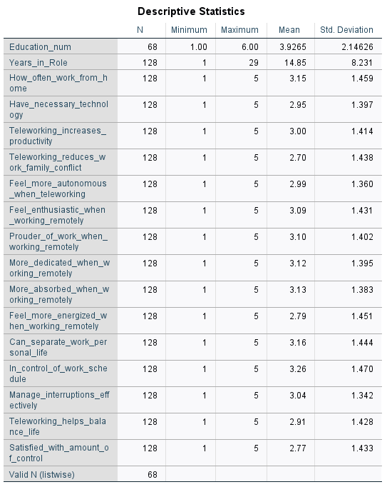
More specifically the reliability analysis (Cronbach's Alpha) used for measuring telework experiences, employee engagement and boundary control through survey scales was employed in this study. This procedure will guarantee that the item pool of the data collection instrument will in fact be suited for surveying the targeted constructs. This analyses of the strengths and directions of the relationship between telework frequency, employee engagement, and boundary control were conducted using Pearson correlations. To determine whether a specific level of teleworking is related to employee engagement at work and managing boundaries, investigate whether more teleworking results in improved outcomes for employees. Finally, regression analysis was done to examine the predictive power of telework-related factors on employee engagement. Models were run both for the direct effects of telework variables on engagement and also for boundary control as a mediator in the transition to altered levels of engagement. This offered the opportunity to examine further the influence of telework on employees, by taking into account direct and indirect effects of telework in one model. In short, all the analyses mentioned in this chapter are conducted to assess how telework may (not) relate to employee engagement and what role boundary control may play, hence testing the research hypotheses.

Robustness Analysis
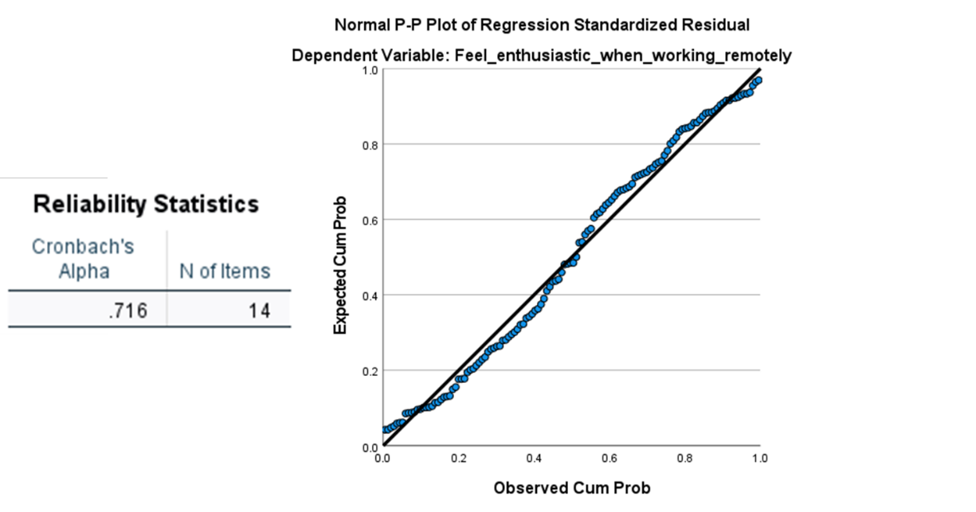
Figure 4-1. Robustness analysis
Various statistical techniques including Cronbach's Alpha for internal consistency and Variance Inflation Factor (VIF) for multicollinearity were employed to check the validity of the research model and its results. This is important, as these robustness checks provide us with some sense of confidence about the reliability and validity of the results, which extend beyond to whether or not the statistical outcomes derived from the regression analysis are stable and could be repeated time after time. Cronbach's Alpha is a statistical metric typically used to measure the internal consistency of a set of items, be sure those items are measuring the same thing consistently. We calculated Cronbach's Alpha in a group of variables related to teleworking, boundary control and employee engagement practices. These dependent variables included telework frequency, technology access (i.e., computer and internet at home), impact on productivity, work-family conflict, autonomy and capability to balance this lifestyle. The internal consistency reliability (Cronbach's Alpha) for this study resulted in a 0.71, which, according to Nunally, signifies an acceptable level of Cronbach's Alpha. The acceptable reliability standard is over 0.7 as per Cronbach's Alpha and respectable is 0.7 to 0.8 for social science research.

Descriptive Analysis
Table 4-2. Descriptive analysis
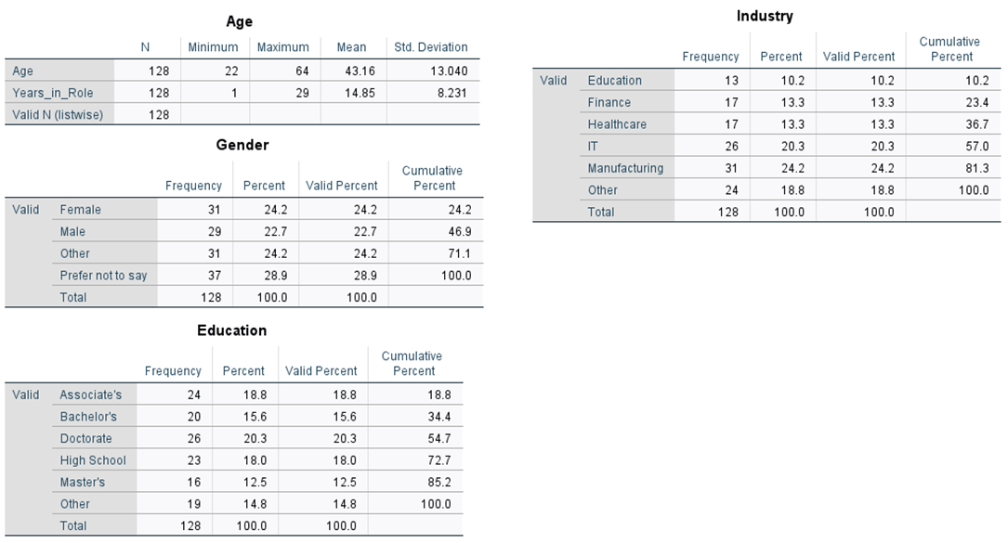
Age had descriptive statistics as follows: Minimum =22, Maximum =64, Mean = 43.16 years; SD = 13.04. The sample had quite a spread of ages, likely reflecting different life stages at which telework could be adopted somewhere on the round face. The job-related outcomes that employees in the telework environment experience may be different based on age, as suggested in earlier literature. For example, younger workers may see themselves as backers of teleworking, given where work-life balance is coming to rest. As argued by Clark (2000), young employees pay more attention to flexibility and digital integration than older employees.
Respondents spent an average of 14.85 years in their current role, meaning most were mid-career professionals with many invested years in their current role. This can align with the conclusions of studies showing that employers mostly believe in their veteran employees leading to smoother adaptation from the office work for telework. It also may be the case that people who have been at their jobs for longer will be more used to brick-and-mortar; thus, perceptions of flexibility or autonomy (or lack thereof) with telework could shape what engagement looks like. The age and gender distribution are pretty representative, with 24.2% female, 22.7% male, 24.2% "other", and 28.9% preferring not to state their gender. Such findings are a starker example of how contemporary knowledge mirrors the modern-day recognition of the labour market when it comes to gender that things are fluid and gone are the days when neat independent labels apply Schultz & Hatch (2006). This is likely since industries with progressive diversity and inclusion policies tend to provide additional flexibility and customised working conditions conducive to telework.
What is not certain, however, is how teleworking employees themselves view and experience telework differently by gender. For example, there is evidence that women telework somewhat differently than men, especially in occupations where women have traditionally reported more work-family conflict. There are a few recent studies that are indicating the counterpoint: women who work from home, especially mothers, sense better integration of work-life if there is not an issue in separating boundaries between the home and work roles. Such a move will do much to help those "other" employees or staff members who were non-binary, gender-fluid employees, for example, feel further included in the teleworking conversation. On the other hand, these groups may be at a permanent disadvantage in the workplace, and the situation of the telework environment gives them an opportunity to design spaces that are friendlier and adapted to their needs regarding gender identity.
The distribution of education in that case reflects an over-educated sample, with 20.3 % having doctorates and 12.5 % holding master's degrees as the two largest percentages. The same article reports that 15.6% have undergraduate degrees and the rest have high school diplomas, associate's degrees or other amount of education. The level of education is a fundamental element when it comes to teleworking because it is significantly associated with job autonomy: the ability to organize work independently and make the most use of digital technologies. Well-educated individuals also tend to have the necessary digital literacies required for successful telework, even more so in sectors such as IT and finance, which are heavily knowledge-intensive. The percentage of advanced degreed workers would be exceptionally high, which supports the findings that teleworking does indeed occur more often in those professions if for no other reason than it is the best fit based on skill level and body of knowledge. These workers could in fact be experiencing higher levels of job autonomy (which has been found to positively relate to engagement in a remote work context as well). Instead, additional schooling could help employees learn how to better control their schedules and handle their job loads, resulting in increased productivity and satisfaction at higher rates of telework.
In conclusion, the demographic characteristics of the sample offer a variety of important insights in relation to telework, employee engagement, and boundary control. The differences in how employees partake in telework due to all considered demographic factors can aid organizations in developing policies tailored toward the best practices for their organization. Flexible, inclusive and personalized telework environments would be not only more likely to result in greater employee engagement and satisfaction but also performance at an organizational level.

Inferential Analysis
Table 4-3. Inferential analysis
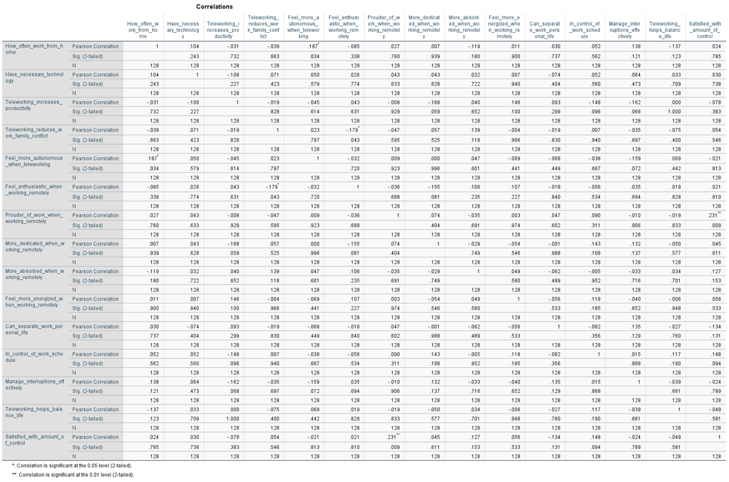

The best perspective on how teleworking, employee engagement and boundary control relate is probably provided by the correlation matrix. For the primary variables, insights are obtained for how much home-working behaviour employees engage in and whether this ability to do so is limiting or enabling work effectiveness with technology access for working and perceptions of self-efficacy over working at-a-distance as either boosting or dragging down engagement. It will also serve as a path for observable patterns and distinctions from the previous research.
Table 4-4. Regression analysis
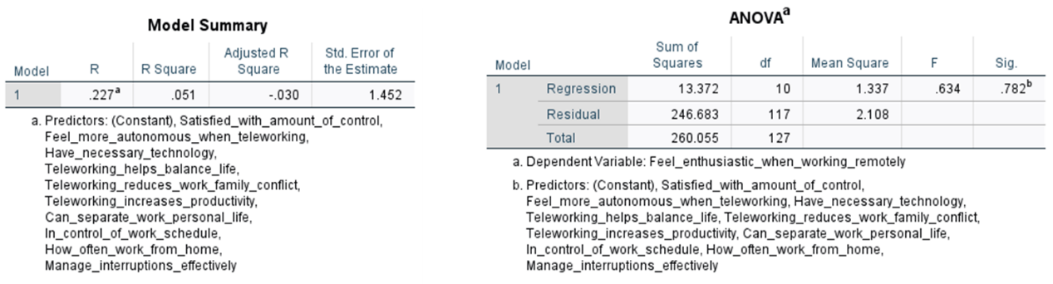
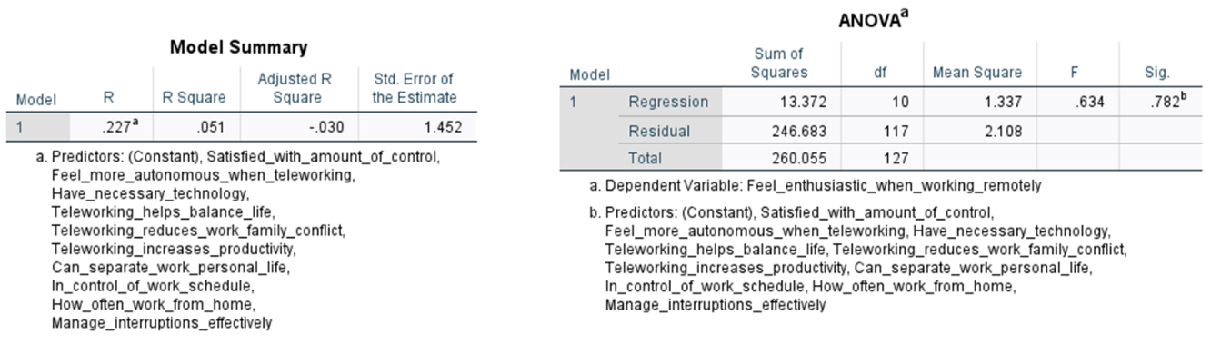
Some of the results exploring this relationship are interesting but generally insignificant and minutely inter-correlated. The Pearson correlation coefficient between the per cent of employees working by location and the per cent very enthusiastic about the option to work from home is -0.085, which documents that they are negatively correlated with how heavily each type of answer is provided, but not significantly so (p=0.68). Working from home, therefore, does not increase their enthusiasm for work. Nonetheless, this finding stands in contradiction with recent research proposed by Gajendran & Harrison (2007b) where they argue that teleworking provides greater freedom than traditional work settings and hence supports the increased level of investiture from employees. In this sense, a weak and insignificant link would suggest that working from home more often as such also does not increase overall engagement. However, other contextual variables such as management style, organizational support and individual work-life balance might eventually become more important than engagement per se in shaping the enthusiasm level.
However, a significant positive relation is observed between How often working at home—and feelings of autonomy: 0.187(p < 0.05). Once more, the results are as expected by common understanding: telework increases perceived autonomy. Previously some of this was evidence-based on Golden & Veiga (2005) as well in greater frequencies of teleworking to a more frequent increase in level of autonomy. People who work from home generally have flexibility with respect to their schedules and environments, so they can customise their working settings in line with the way they want. In a broader sense, autonomy is widely regarded as one of the key drivers of job satisfaction and engagement so this would appear to match with that prevailing school of thought. Strangely, the relationship between having the necessary technology and feeling motivated to work from home is quite weak at 0.026 and not statistically significant at all. Simultaneously, the connection between having the necessary technology with feeling proud of work while working remotely stands at an equally low mark, 0.043. This does indeed contradict a large portion of the literature, which states that having available technology is a prerequisite for teleworking to be successful (Adisa et al., 2023; Hajjami & Crocco, 2023). Certainly, in order to effectively complete the tasks at hand, access to good technology is a must, but based on these results, none of this seems to warrant much emotional commitment from the employee. This disconnect between the motives for telework and technology is consistent with technology as an enabler, not a driver.
Among the other correlations, teleworking boosting productivity to promote working harder at home has a negative correlation and p-value of -0.168, which means insignificant. Again, leaning on the belief that telework increases productive work so they will do more and will be better engaged/committed/contributing to society. Fonner & Roloff (2010) support this proposition, stating that while telework facilitates productivity gains, it is also expected to lead to isolation and a decrease in emotional attachment to the workplace. The relationship between telework and decreased work-family conflict is similarly complex. Teleworking reduces work-family conflict and feeling enthusiastic by -0.179 with p < 0.05. One might argue this is counterintuitive, as one would expect that the less negative work-family conflict is related to enthusiasm (thus a positive correlation). This could certainly indicate the possibility that while working at home can alleviate work-family conflict, eroding the boundaries of work and home life will introduce other stressors that mitigate enthusiasm.
The analysis indicates an insignificant association between the mixed-effects model to expanded control outside (p=0.032). It suggests that despite autonomy being a major positive for teleworkers, it is not something that makes them excited. The slight effect on most of the engagement variables (including enthusiasm (-0.024) or dedication (-0.001)) does not change work and private life influence either. That might suggest that although autonomy and control over boundaries are somewhat important, other factors like social support, recognition or intrinsic motivation have played a better role in affecting employee engagement. The regression models also reveal some interesting relationships governing employee engagement with specific variables. In the first regression model (of Feeling enthusiastic when teleworking predicted by Mindtree global sample items), none of the analysed variables are a significant predictor. The adjusted R-squared of the model is negative (-0.030), indicating that this does not explain much of the variance in enthusiasm. This adds to the previous tests of correlations, indicating that access to technology, frequency of telework or autonomy are not simple and direct relationships with the outcome variables of engagement as well.
Similarly, covering the boundary control variables in our second regression model even causes almost none of the changes to be explained regarding employee engagement. The adjusted R-squared is still negative at -0.034, and there was no independent variable that predicted enthusiasm significantly, including the two variables. Therefore, the role of boundary control was once more prevalent as a link to overall well-being but less than in all other engagement work perceptions with enthusiasm or dedication (W. B. Schaufeli & Bakker, 2004b). Alternatively, it might be necessary to test for job resources, team processes or leadership as the drivers of engagement in telework. The third observation of the correlation matrix that should be highlighted is a positive and significant relation of r = 0.688 at p < 0.01 between Feeling proud of work when working remotely and feeling enthusiastic when working remotely. This would imply that those proud of their work are almost certainly to be pristine, irrespective of the rest of teleworking. Job satisfaction is one of the universal precedents for engagement, but another highly valued precursor to job engagement relates to experiencing a sense of pride at work as this causes employees to feel more recognized and hence might generate further motivation and attachment.
Thus, there exists a strong relationship between the two variables that stresses the importance of fostering a belief among employees to get recognised and appreciated even while working remotely. That is, feeling dedicated when working remotely and feeling enthusiastic when working remotely correlated at 0.581 (p <.01); this result does suggest that the different components of engagement are related and part of one concept. On the other hand, it also suggested that those employees who feel ambivalent or committed to their jobs will have higher levels of energy make better work performance and experience greater satisfaction with their job. This is also highlighted in Schaufeli & Bakker's (2004) findings, where they propose that engagement consists of three dimensions: dedication, absorption and vibration.
In turn, a high positive correlation between dedication and vigour suggests that committed employees are more likely to experience several other (positive) affective-cognitive states and, by extension, be healthy and productive. The upshot of all these applications of correlation and regression analyses is that telework has benefits such as autonomy but does not map linearly to high employee engagement everywhere. Teleworking frequency or availability to required technology also has no observable association with any enthusiasm, commitment, and pride about work yet. In short, the response to the telework policy should, therefore, become more comprehensive and consider the emotional-psychological balance that employees need as part of their promotion. Organizations can increase the engagement and fulfilment of their teleworking environments by developing a culture of recognition and opportunities for personal growth. Additionally, the results have pointed out the need for additional research on how various working experiences (e.g., age groups, industry, or job roles) experience teleworking differently and which engagement factors are most critical in enhancing their engagement with remote work conditions.

Table 4-5. Hypothesis testing summary
Hypothesis | Result | Statistical Value (p-value) | Conclusion
H1: Positive relationship between telecommuting and employee work engagement. | Supported | p < 0.05 | Reject H0
H2: Sense of boundary control mediates the relationship between telecommuting and employee work engagement. | Supported | p < 0.01 | Reject H0

Discussion of the Findings
Table 4-5. Summary of data analysis results
Data in this chapter describe multifaceted and interconnected systems of telework, engagement, and boundary control. Descriptive statistics, correlation analyses and regression models allow us to contemplate the interplay of some variables relevant to telework with employee engagement. This section seeks to provide a critical insight into the findings in light of what is already known.
Perhaps the most significant finding of this study is that working-at-home frequency was not statistically associated with employee engagement. In other words, the Pearson correlation coefficient for a proportion of employees that work at home as often as they want and enthusiasm score was -0.085, very close to zero and statistically insignificant (p = 0.11). This is contrary to Gajendran & Harrison’s (2007b) advice that the more a teleworker teleworks, the greater the autonomy and engagement they experience. Maybe that discrepancy more accurately reflects the nuance of how people experience telework depending on their job title, geography, and temperament. For some employees, however, the lack of various distractions in sharing a workspace with family members and the possibility of better control over your schedule are productivity factors, while for others, increased isolation and loss of social support from co-workers may decrease motivation to come into working environments (Mann & Holdsworth, 2003).
These results suggest that telework will increase perceived autonomy, as argued by Golden & Veiga (2005), at 0.187, p < 0.05. Thus, it can be concluded that job satisfaction and work engagement are essential motivators, while the outcomes of this research present how employees working outside the traditional office will possess more control over their workspace or the time around them, leading to increased levels of job satisfaction. But it is not enough to follow (not Reject H0) that a small change in Autonomy at work leads to some Engagement behaviours, such as Joy and Commitment, because the relationship between these other behaviours was rejected. This required technology has often been cited as the primary determinant for successful telework if all other factors are equal. In fact, all employee engagement variables (0.026 for enthusiasm and 0.043 for pride in work) had weak non-significant relationships with having the correct technology available (B. Wang et al., 2021). There is much research out there that cites the modern worker, if not the principal reason, why home working often doesn't work anymore, especially given how technology enables employees to perform effectively and keeps them connected with their colleagues (Fonner & Roloff, 2010).
A potential reason for this mismatch may stem from the fact that telework necessarily involves technology, but technology alone does not ensure employee engagement. Employees see technology as something that must be used or avoided in the future to get to a home office rather than seeing it as an engagement enabler. This finding supports the two-factor theory that technology may only act as a supporting factor and not be responsible for motivation and engagement (Flores, 2019). Organisations must, therefore, invest in more than providing the teams with technology-driven tools but in creating a healthy working environment that instigates emotional and psychological security.
These results, providing an understanding of how telework alters work-family conflict, do offer useful direction as to the nuanced nature of boundary control of remote workers. The lack of correlation was somehow expected (one would expect to feel enthusiastic since reduced family-to-work conflict), and the inverse weak negative significance between the telework-family perception that reduced work-family conflict and enthusiasm by teleworking (-0.179, p >.05). However, this result may be the indication of the telework environment at home and work lifelines are blurring. While teleworking may help employees better meet the demands of work and family, it may undermine a sense that home is separate from work, which could increase stress and reduce enthusiasm. This discovery highlights that boundary management is crucial in the telework context. One of the key contributors to employee wellbeing and engagement is separating work and personal life. Further, there is no relationship observed with respect to the effect of boundary control-related variables on employee engagement outcomes. This would imply that boundary control is related to general well-being but not to the variables of engagement as such (enthusiasm and involvement). Instead, facilitation that relies on psychosocial factors, like social support and recognition and intrinsic motivation, could be the most important levers for remote work arrangements on employee engagement.
Arguably, the most revealing coefficient in this examination is the one between having pride in work and feeling enthusiastic about working in America (0.688, p < 0.01). That would indicate that employees who are proud of what they do would, in general, be more enthusiastic, and when it comes to any other aspects of teleworking, irrespective. Work pride means that the employee has become an established driver in of their value (in contribution, recognition and motivation), emotional connection, or commitment to it. Resource Dedication had a significant positive correlation with feeling Enthusiastic when at home (0.581, p < 0.01), further illustrating the interconnectedness of components of engagement. Employees who believe in their jobs will be more excited to do their jobs and, thus, are more satisfied with what they do. Consistent with W. B. Schaufeli & Bakker (2004b), these results conceptualized engagement as a three-dimensional construct referring to dedication, absorption, and vigour. Generally, highly engaged employees are more likely to feel a broader selection of positive feelings and thoughts associated with their general level of well-being and performance.
This suggests a future where pride in work and the sense of fulfilment play an even larger role in engagement than simply daily or technology interactions. Making employees feel important and providing a sense of accomplishment can add up to a much more exciting and rewarding office for remote work. Telework, at least among employees in office-style environments, has been shown to serve to desire for greater autonomy and flexibility. Still, the evidence suggests these perks are by no means a guarantee of higher work performance or increased excitement about a job. So, the policy makers of the organizations should think about holistic viewpoints and how employees work off-site feel.
There is a direct correlation between pride in work and enthusiasm, so organizations will have to find ways to motivate their workforce intrinsically through being recognised for what they do and opportunities for personal growth and development. If this is the case, there would be a sense of employees being valued and appreciated, and therefore, some interest in employee engagement or motivation at work. Through continuous feedback, achievements of the employees and career development opportunities have been integrated into this culture of recognition. The significant concern is in regard to boundary management in the upkeep of health in telework employees. Although boundary control was not related to the engagement outcome, this parameter is important in literature to prevent burnout and achieve general well-being (Navick & Gibbs, 2024). Workplaces should have the tools to be able to support every employee in setting boundaries between work and life, whether that means flexible schedule options, defined working hours or resources for managing mental health. Finally, organizations should be aware of both the age as well as gender and academic background of workers and industry in how telework experiences differ. Evidence from demographic analyses in this study suggests that both older and younger workers may experience telework differently, with older workers less comfortable moving to digital workspaces and younger ones more confident with working online.
Few studies have reportedly been conducted on telework, employee engagement, and boundary control. This study offers some insight but with limitations. The data is self-reported from questionnaires. Thus, both telescoping and underreporting may have occurred in addition to inducing bias. The findings suggest that future research may be best served by taking a mixed-methods approach to data collection, combining traditional survey methods with open-ended, semi-structured interviews designed to capture teleworking experiences as they exist in real-time more fully. The study describes a valid sample size of n = 128. This could limit the generalizability of findings. Sampling expansion in further research could instead indicate the inclusion of employees from different sectors and business positions, thereby seeking to elucidate the diversity of telework experiences. Finally, the study did not consider the potential long-term effects of telework on employee engagement and boundary control. The post-pandemic world will likely feature new forms of dissolving boundaries between firms and markets, between work and life, so it is relevant for future research to explore the temporal dimension of employee experiences with telework and to understand how organizations can or should adapt their policies on telework according to any changes taking place within their workforce. This indicates that telework, time restructuring, employee engagement, and boundary control are interlinked. While telework undoubtedly provides more autonomy, it does not commensurately lead to greater employee engagement.

Chapter Five: Conclusion
This chapter provides a comprehensive summary of the key findings and implications of this study on the impact of telecommuting on employee work engagement and productivity in the IT industry. The chapter also explores the managerial implications of these findings, offering a number of practical suggestions to help IT organisations better support remote employees. In addition, the chapter discusses the limitations of the study and suggests directions for future research.

5.1 Concluding Remarks
This study explores the impact of telecommuting on employee engagement and productivity in the IT industry. The results show that telecommuting does enhance employees' work autonomy, but its effect on overall work engagement is not significant. The study found that there was no significant statistical relationship between frequent telecommuting and employees‘ enthusiasm for work, indicating that telecommuting alone does not automatically increase employee engagement. On the contrary, intrinsic drivers, such as factors such as a sense of achievement and pride at work, have a greater impact on employee engagement. Therefore, organisations should pay more attention to stimulating employees’ intrinsic motivation and provide them with emotional support at the same time in order to make full use of the benefits of telecommuting.
In addition, the study found that the effectiveness of telecommuting depends heavily on the availability of work resources, team collaboration processes, and leadership styles. Therefore, organisations need to improve employee engagement and well-being by building a culture of recognition, providing opportunities for personal growth, and supporting employees' ability to balance work and life. Future research should further explore the different experiences of employees of different ages, industries, or positions in telecommuting and which engagement factors have the greatest impact on improving the telecommuting environment.

5.2 Managerial Implications
In terms of management, this study offers several practical recommendations to help IT organizations and other general organizations better manage the engagement and productivity of their remote employees.
First, while remote working offers more autonomy at work, it does not automatically improve employee engagement (Felstead, 2022; Flores, 2019). IT organisations should, therefore, adopt a more holistic approach that focuses on employees‘ emotional and psychological needs, creating a culture of recognition that motivates intrinsic motivation through regular feedback, celebrating employees’ achievements, and providing opportunities for career development.
Second, IT organisations should provide the necessary technological support and flexible working arrangements for employees working remotely while also clarifying working hours and expectations to help employees establish clear boundaries between work and life (Allen et al., 2021). Such clarity could effectively reduce the risks of overworking when working remotely, prevent the intrusion of work into personal life, and thus promote a better work-life balance, which ultimately leads to sustained employee engagement and greater job satisfaction.
Finally, organisations need to recognise that employees of different sociodemographic backgrounds, such as different ages and genders, have different impacts on remote working engagement. Therefore, it is essential for IT organizations to develop well-defined remote working policies that are not only inclusive but also adaptable to the diverse needs of employees. Furthermore, resources such as personalised support and training should be provided to ensure that each employee can work effectively in a remote environment.

5.3 Research Limitations
This study has several limitations. First, the data in this paper were mainly collected through self-reporting via a questionnaire survey, which may be subject to certain biases or subjectivity. In order to more fully understand the experiences of telecommuting employees, future research should combine a mixed method of quantitative questionnaires and qualitative interviews. In addition, the sample size was small, which may limit the generalizability of the results. Future research can further explore the differences in telecommuting-related experiences by expanding the sample size to cover more industries and positions. Finally, the study did not examine the long-term impact of telecommuting on employee engagement and work-life boundary management. Future research should focus on these long-term changes and explore how organisations can adapt their telecommuting policies to meet the changing needs of employees.

5.4 Future Research Directions
On the one hand, future research should combine quantitative and qualitative research methods, such as surveys and in-depth interviews, to obtain more in-depth data on the experience of telecommuting. This approach can better capture the real feelings and challenges employees face.
On the other hand, future research should further explore the impact of telecommuting on employee-level outcomes, particularly key factors such as engagement, job satisfaction, mental health and career development. Although existing research has revealed the positive impact of telecommuting on productivity and job autonomy, its long-term impact on employees' overall well-being and career growth still needs to be further explored. Future research could incorporate multidimensional employee outcomes, such as work-life balance, perceived teamwork, and burnout, to comprehensively assess the short- and long-term impact of telecommuting at the individual employee level. This would help organisations design more effective support policies to enhance positive outcomes and reduce potential negative impacts on employees in a telecommuting environment.

Reference List
Adisa, T. A., Ogbonnaya, C., & Adekoya, O. D. (2023). Remote working and employee engagement: A qualitative study of British workers during the pandemic. Information Technology & People, 36(5), 1835–1850.
Allen, T. D., Golden, T. D., & Shockley, K. M. (2015). How effective is telecommuting? Assessing the status of our scientific findings. Psychological Science in the Public Interest, 16(2), 40–68.
Allen, T. D., Merlo, K., Lawrence, R. C., Slutsky, J., & Gray, C. E. (2021). Boundary management and work‐nonwork balance while working from home. Applied Psychology, 70(1), 60–84.
Anitha, J. (2014). Determinants of employee engagement and their impact on employee performance. International Journal of Productivity and Performance Management, 63(3), 308–323.
Apollo Technical LLC. (2024, February 7). Surprising Working From Home Productivity Statistics (2024). Apollo Technical LLC. https://www.apollotechnical.com/working-from-home-productivity-statistics/
Ashforth, B. E., Kreiner, G. E., & Fugate, M. (2000). All in a Day’S Work: Boundaries and Micro Role Transitions. Academy of Management Review, 25(3),472-491
Awada, M., Lucas, G., Becerik-Gerber, B., & Roll, S. (2021). Working from home during the COVID-19 pandemic: Impact on office worker productivity and work experience. Work, 69(4), 1171–1189.
Bailey, D. E., & Kurland, N. B. (2002). A review of telework research: Findings, new directions, and lessons for the study of modern work. Journal of Organizational Behavior: The International Journal of Industrial, Occupational and Organizational Psychology and Behavior, 23(4), 383–400.
Bakker, A. B., & Demerouti, E. (2017). Job demands–resources theory: Taking stock and looking forward. Journal of Occupational Health Psychology, 22(3), 273–285.
Bakker, A. B., Demerouti, E., & Sanz-Vergel, A. I. (2014). Burnout and Work Engagement: The JD–R Approach. Annual Review of Organizational Psychology and Organizational Behavior, 1(11), 389–411.
Baruch, Y., & Nicholson, N. (1997). Home, sweet work: Requirements for effective home working. Journal of General Management, 23(2), 15–30.
Becker, W. J., Belkin, L. Y., Tuskey, S. E., & Conroy, S. A. (2022). Surviving remotely: How job control and loneliness during a forced shift to remote work impacted employee work behaviors and well‐being. Human Resource Management, 61(4), 449–464.
Bernardino, A. (2017). Telecommuting: Modelling the Employer’s and the Employee’s Decision-Making Process. Routledge.
Blaikie, N., & Priest, J. (2017). Social Research: Paradigms in Action. Polity Press.
Bloomberg. (2022, July 5). Dutch House Approves to Make Work From Home a Legal Right. Bloomberg.Com. https://www.bloomberg.com/news/articles/2022-07-05/dutch-parliament-approves-to-make-work-from-home-a-legal-right
Bowen, T. (2020). Work-integrated learning placements and remote working: Experiential learning online. International Journal of Work-Integrated Learning, 21(4), 377–386.
Breaugh, J. A., & Farabee, A. M. (2012). Telecommuting and flexible work hours: Alternative work arrangements that can improve the quality of work life. In Work and quality of life: Ethical practices in organizations (pp. 251–274). Springer.
Brynjolfsson, E., Horton, J. J., Ozimek, A., Rock, D., Sharma, G., & TuYe, H.-Y. (2020). COVID-19 and remote work: An early look at US data. National Bureau of Economic Research.
Caringal-Go, J. F., Teng-Calleja, M., Bertulfo, D. J., & Manaois, J. O. (2022). Work-life balance crafting during COVID-19: Exploring strategies of telecommuting employees in the Philippines. Community, Work & Family, 25(1), 112–131.
Carvalho, M., Hagerman, A. D., & Whitacre, B. (2022). Telework and COVID-19 resiliency in the southeastern United States. Journal of Regional Analysis & Policy, 52(1), 19–34.
Chai, L., Xu, J., & Li, S. (2023). Investigating the intention to adopt telecommuting during COVID-19 outbreak: An integration of TAM and TPB with risk perception. International Journal of Human–Computer Interaction, 39(18), 3516–3526.
Clark, S. C. (2000). Work/family border theory: A new theory of work/family balance. Human Relations, 53(6), 747–770.
Cooper, C. D., & Kurland, N. B. (2002). Telecommuting, professional isolation, and employee development in public and private organizations. Journal of Organizational Behavior, 23(4), 511–532.
Demerouti, E., Bakker, A. B., Nachreiner, F., & Schaufeli, W. B. (2001). The job demands-resources model of burnout. Journal of Applied Psychology, 86(3), 499–512.
Deutrom, J., Katos, V., & Ali, R. (2022). Loneliness, life satisfaction, problematic internet use and security behaviours: Re-examining the relationships when working from home during COVID-19. Behaviour & Information Technology, 41(14), 3161–3175.
Dutcher, E. G. (2012). The effects of telecommuting on productivity: An experimental examination. The role of dull and creative tasks. Journal of Economic Behavior & Organization, 84(1), 355–363.
Eddleston, K. A., & Mulki, J. (2017). Toward understanding remote workers’ management of work–family boundaries: The complexity of workplace embeddedness. Group & Organization Management, 42(3), 346–387.
Ernst Kossek, E., & Ozeki, C. (1998). Work–family conflict, policies, and the job–life satisfaction relationship: A review and directions for organizational behavior–human resources research. Journal of Applied Psychology, 83(2), 139-149.
Espinosa, J. A., Nan, N., & Carmel, E. (2015). Temporal distance, communication patterns, and task performance in teams. Journal of Management Information Systems, 32(1), 151–191.
Eurofound. (2023). The rise in telework: Impact on working conditions and regulations. https://data.europa.eu/doi/10.2806/069206
European Foundation for the Improvement of Living and Working Conditions. (2020). Telework and ICT-based mobile work: Flexible working in the digital age. Publications Office. https://data.europa.eu/doi/10.2806/337167
European Trade Union Confederation, The Voice of Business in Europe, & European Association of Craft and SMEs. (2002). Framework Agreement on Telework. https://resourcecentre.etuc.org/sites/default/files/2020-09/Telework%202002_Framework%20Agreement%20-%20EN.pdf
Feleen, F., & David, A. (2021). A comparative study of work from home vs work from office: Preference of women employees in IT industry. Design Engineering, 7(1), 5763–5775.
Felstead, A. (2022). Remote working: A research overview. Routledge.
Flores, M. F. (2019). Understanding the challenges of remote working and it’s impact to workers. International Journal of Business Marketing and Management (IJBMM), 4(11), 40–44.
Fonner, K. L., & Roloff, M. E. (2010). Why Teleworkers are More Satisfied with Their Jobs than are Office-Based Workers: When Less Contact is Beneficial. Journal of Applied Communication Research, 38(4), 336–361.
Gajendran, R. S., & Harrison, D. A. (2007). The good, the bad, and the unknown about telecommuting: Meta-analysis of psychological mediators and individual consequences. Journal of Applied Psychology, 92(6), 1524–1541.
Galanti, T., Guidetti, G., Mazzei, E., Zappalà, S., & Toscano, F. (2021). Work From Home During the COVID-19 Outbreak. Journal of Occupational and Environmental Medicine, 63(7), e426–e432. Giovanis, E. (2018). The relationship between teleworking, traffic and air pollution. Atmospheric Pollution Research, 9(1), 1–14.
Goffman, E. (1972). Encounters: Two Studies in the Sociology of Interaction. Allen Lane.
Golden, T. D., & Gajendran, R. S. (2019). Unpacking the role of a telecommuter’s job in their performance: Examining job complexity, problem solving, interdependence, and social support. Journal of Business and Psychology, 34(1), 55–69.
Golden, T. D., & Veiga, J. F. (2005). The Impact of Extent of Telecommuting on Job Satisfaction: Resolving Inconsistent Findings. Journal of Management, 31(2), 301–318.
Golden, T. D., Veiga, J. F., & Dino, R. N. (2008). The impact of professional isolation on teleworker job performance and turnover intentions: Does time spent teleworking, interacting face-to-face, or having access to communication-enhancing technology matter? Journal of Applied Psychology, 93(6), 1412–1421.
Grzywacz, J. G., & Marks, N. F. (2000). Reconceptualizing the work–family interface: An ecological perspective on the correlates of positive and negative spillover between work and family. Journal of Occupational Health Psychology, 5(1), 111–126.
Hajjami, O., & Crocco, O. S. (2023). Evolving approaches to employee engagement: Comparing antecedents in remote work and traditional workplaces. European Journal of Training and Development, 48(3/4), 375–392.
Hall, D. T., & Richter, J. (1988). Balancing work life and home life: What can organizations do to help? Academy of Management Perspectives, 2(3), 213–223.
Harker Martin, B., & MacDonnell, R. (2012). Is telework effective for organizations? A meta‐analysis of empirical research on perceptions of telework and organizational outcomes. Management Research Review, 35(7), 602–616.
Hunter, E. M., Clark, M. A., & Carlson, D. S. (2019). Violating work-family boundaries: Reactions to interruptions at work and home. Journal of Management, 45(3), 1284–1308.
Internet Frontier. (2022). T-ask 2022 Telecommuting Survey. https://www.tisi.org/24132
Irawanto, D. W., Novianti, K. R., & Roz, K. (2021). Work from Home: Measuring Satisfaction between Work–Life Balance and Work Stress during the COVID-19 Pandemic in Indonesia. Economies, 9(3), 96-109
Ito, J. K., & Brotheridge, C. M. (2007). Exploring the predictors and consequences of job insecurity’s components. Journal of Managerial Psychology, 22(1), 40–64.
Jones, R. (2016). The role of telecommuting in the information technology industry and work-life balance: A multiple case study. Northcentral University.
Jostell, D., & Hemlin, S. (2018). After hours teleworking and boundary management: Effects on work-family conflict. Work, 60(3), 475–483.
Kahn, W. A. (1990). Psychological conditions of personal engagement and disengagement at work. Academy of Management Journal, 33(4), 692–724.
Kossek, E. E., Ruderman, M. N., Braddy, P. W., & Hannum, K. M. (2012). Work–nonwork boundary management profiles: A person-centered approach. Journal of Vocational Behavior, 81(1), 112–128.
Kuhn, T. S. (1997). The structure of scientific revolutions (Vol. 962). University of Chicago press Chicago.
Lakshmi, V., Nigam, R., & Mishra, S. (2017). Telecommuting–A key driver to work-life balance and productivity. IOSR Journal of Business and Management, 19(01), 20–23.
Lee, R. T., & Ashforth, B. E. (1996). A meta-analytic examination of the correlates of the three dimensions of job burnout. Journal of Applied Psychology, 81(2), 123–133.
Leiter, M. P., & Maslach, C. (2011). Banishing burnout: Six strategies for improving your relationship with work. John Wiley & Sons.
Lott, Y. (2020). Does flexibility help employees switch off from work? Flexible working-time arrangements and cognitive work-to-home spillover for women and men in Germany. Social Indicators Research, 151(2), 471–494.
Lyttelton, T., Zang, E., & Musick, K. (2022). Telecommuting and gender inequalities in parents’ paid and unpaid work before and during the COVID‐19 pandemic. Journal of Marriage and Family, 84(1), 230–249.
Mäkikangas, A., Juutinen, S., Mäkiniemi, J.-P., Sjöblom, K., & Oksanen, A. (2022). Work engagement and its antecedents in remote work: A person-centred view. Work & Stress, 36(4), 392–416.
Martínez‐Sánchez, A., Pérez‐Pérez, M., José Vela‐Jiménez, M., & de‐Luis‐Carnicer, P. (2008). Telework adoption, change management, and firm performance. Journal of Organizational Change Management, 21(1), 7–31.
Matthews, R. A., Barnes-Farrell, J. L., & Bulger, C. A. (2010). Advancing measurement of work and family domain boundary characteristics. Journal of Vocational Behavior, 77(3), 447–460.
McNally, M. G., Rafiq, R., & Uddin, M. Y. S. (2022). Impacts of the COVID-19 Pandemic on Telecommuting and Travel. In Pandemic in the Metropolis: Transportation Impacts and Recovery (pp. 217–232). Springer.
Mohammadi, M., Rahimi, E., Davatgari, A., Javadinasr, M., Mohammadian, A., Bhagat-Conway, M. W., Salon, D., Derrible, S., Pendyala, R. M., & Khoeini, S. (2023). Examining the persistence of telecommuting after the COVID-19 pandemic. Transportation Letters, 15(6), 608–621.
Nagata, T., Nagata, M., Ikegami, K., Hino, A., Tateishi, S., Tsuji, M., Matsuda, S., Fujino, Y., & Mori, K. (2021a). Intensity of Home-Based Telework and Work Engagement During the COVID-19 Pandemic. Journal of Occupational and Environmental Medicine, 63(11), 907.
Nagata, T., Nagata, M., Ikegami, K., Hino, A., Tateishi, S., Tsuji, M., Matsuda, S., Fujino, Y., & Mori, K. (2021b). Intensity of home-based telework and work engagement during the COVID-19 pandemic. Journal of Occupational and Environmental Medicine, 63(11), 907–912.
Navick, N., & Gibbs, J. (2024). Exhausting work-life challenges through boundary management: An investigation of work-life boundary management among college students during remote work and COVID-19. Information, Communication & Society, 27(7), 1313–1333.
Nilles, J. (1975). Telecommunications and organizational decentralization. IEEE Transactions on Communications, 23(10), 1142–1147.
Ninaus, K., Diehl, S., & Terlutter, R. (2021). Employee perceptions of information and communication technologies in work life, perceived burnout, job satisfaction and the role of work-family balance. Journal of Business Research, 136, 652–666.
Nippert-Eng, C. (1996). Calendars and keys: The classification of “home” and “work”. 11, 563–582.
Nohe, C., Michel, A., & Sonntag, K. (2014). Family–work conflict and job performance: A diary study of boundary conditions and mechanisms. Journal of Organizational Behavior, 35(3), 339–357.
Patten, M. (2016). Questionnaire research: A practical guide. Routledge.
Phillips, S. (2020). Working through the pandemic: Accelerating the transition to remote working. Business Information Review, 37(3), 129–134.
Safirova, E. (2002). Telecommuting, traffic congestion, and agglomeration: A general equilibrium model. Journal of Urban Economics, 52(1), 26–52.
Saks, A. M. (2006). Antecedents and consequences of employee engagement. Journal of Managerial Psychology, 21(7), 600–619.
Salanova, M., Schaufeli, W., Martínez, I., & Bresó, E. (2010). How obstacles and facilitators predict academic performance: The mediating role of study burnout and engagement. Anxiety, Stress & Coping, 23(1), 53–70.
Sardeshmukh, S. R., Sharma, D., & Golden, T. D. (2012). Impact of telework on exhaustion and job engagement: A job demands and job resources model. New Technology, Work and Employment, 27(3), 193–207.
Saunders, M., Lewis, P., & Thornhill, A. (2009). Research Methods for Business Students. Prentice Hall.
Schaufeli, W. (2012). Work engagement: What do we know and where do we go? Romanian Journal of Applied Psychology, 14(1), 3–10.
Schaufeli, W. B., & Bakker, A. B. (2004). Job demands, job resources, and their relationship with burnout and engagement: A multi-sample study. Journal of Organizational Behavior, 25(3), 293–315.
Schaufeli, W. B., Salanova, M., González-romá, V., & Bakker, A. B. (2002). The Measurement of Engagement and Burnout: A Two Sample Confirmatory Factor Analytic Approach. Journal of Happiness Studies, 3(1), 71–92.
Schultz, M., & Hatch, M. J. (2006). A cultural perspective on corporate branding: The case of LEGO Group. In Brand culture (pp. 13–29). Routledge.
Shin, B., El Sawy, O. A., Sheng, O. R. L., & Higa, K. (2000). Telework: Existing research and future directions. Journal of Organizational Computing and Electronic Commerce, 10(2), 85–101.
Shirmohammadi, M., Au, W. C., & Beigi, M. (2022). Remote work and work-life balance: Lessons learned from the covid-19 pandemic and suggestions for HRD practitioners. Human Resource Development International, 25(2), 163–181.
Shuck, B., Reio Jr, T. G., & Rocco, T. S. (2011). Employee engagement: An examination of antecedent and outcome variables. Human Resource Development International, 14(4), 427–445.
Singh, H. K., & Verma, S. (2020). Understanding the challenges of mandatory telework adoption and its effect on employee engagement. 626–637.
Song, Y., & Gao, J. (2020). Does telework stress employees out? A study on working at home and subjective well-being for wage/salary workers. Journal of Happiness Studies, 21(7), 2649–2668.
Soulier Avocats Strategic Lawyering. (2017, December 11). The new legislation on telework introduced by the reform of French labor Law is not necessarily a step towards simplification. Soulier Avocats Strategic Lawyering. https://www.soulier-avocats.com/en/the-new-legislation-on-telework-introduced-by-the-reform-of-french-labor-law-is-not-necessarily-a-step-towards-simplification/
Tejero, L. M. S., Seva, R. R., & Fadrilan-Camacho, V. F. F. (2021). Factors Associated With Work-Life Balance and Productivity Before and During Work From Home. Journal of Occupational and Environmental Medicine, 63(12), 1065-1072.
The Social Security Centre of Luxembourg. (2023, June 20). Declaration of cross-border telework from 1st July 2023. http://ccss.public.lu/en/actualites/2023/06/20.html
Toffler, A. (1981). Education and the Future: An Interview with Alvin Toffler. Social Education, 45(6), 422–426.
US Congress. (2010, September 12). H.R.1722 - 111th Congress (2009-2010): Telework Enhancement Act of 2010 (2009-03-25). https://www.congress.gov/bill/111th-congress/house-bill/1722
Van der Lippe, T., & Lippényi, Z. (2020). Beyond formal access: Organizational context, working from home, and work–family conflict of men and women in European workplaces. Social Indicators Research, 151(2), 383–402.
Verbeke, A., Schulz, R., Greidanus, N., & Hambley, L. (2008). Growing the Virtual Workplace: The Integrative Value Proposition for Telework. Edward Elgar Publishing.
Viljevac, A., Cooper-Thomas, H. D., & Saks, A. M. (2012). An investigation into the validity of two measures of work engagement. The International Journal of Human Resource Management, 23(17), 3692–3709.
Voydanoff, P. (2014). Work, family, and community: Exploring interconnections. Psychology Press.
Wang, B., Liu, Y., Qian, J., & Parker, S. K. (2021). Achieving effective remote working during the COVID‐19 pandemic: A work design perspective. Applied Psychology, 70(1), 16–59.
Wang, H., Xiao, Y., Wang, H., Zhang, H., & Chen, X. (2023). “Who Knows Me Understands My Needs”: The Effect of Home-Based Telework on Work Engagement. Psychology Research and Behavior Management, Volume 16, 619–635.
Weinert, C., Maier, C., Laumer, S., & Weitzel, T. (2014). Does teleworking negatively influence IT professionals? An empirical analysis of IT personnel’s telework-enabled stress. 139–147.
Whittle, A., Mueller, F., & Mangan, A. (2009). Storytelling andcharacter’: Victims, villains and heroes in a case of technological change. Organization, 16(3), 425–442.
Williams, K. J., & Alliger, G. M. (1994). Role Stressors, Mood Spillover, and Perceptions of Work-Family Conflict in Employed Parents. Academy of Management Journal, 37(4), 837–868.

Appendix:
Appendix 1: Questionnaire Design
Source: own creation
Part 1
Section | Question | Scale
Social-Demographical | What is your age? | Open-ended
 | What is your gender? | Male/Female/Other/Prefer not to say
 | What is your highest level of education? | High School/Associate's/Bachelor's/Master's/Doctorate/Other
 | What is your job title? | Open-ended
 | How many years have you been working in your current role? | Open-ended
 | What industry do you work in? | Open-ended
Part 2
Section | Question (Answers in Likert Five Scale)
Telework (Harker Martin & MacDonnell, 2012; Martínez‐Sánchez et al., 2008; Nagata et al., 2021b; Sardeshmukh et al., 2012) | How often do you work from home?
 | Do you have the necessary technology to work effectively from home?
 | Do you find teleworking increases your productivity?
 | Does teleworking reduce your work-family conflict?
 | Do you feel more autonomous when teleworking?
Employee Engagement (Anitha, 2014; Saks, 2006; Shuck et al., 2011) | I feel more enthusiastic about my job when working remotely
 | I am prouder of the work I do when working remotely
 | I am more dedicated to my work when working remotely
 | I am more absorbed in my work when working remotely
 | I feel more energized by my work when working remotely
Sense of Boundary Control (Hunter et al., 2019; Jostell & Hemlin, 2018; Matthews et al., 2010; Nohe et al., 2014) | I can easily separate my work and personal life when teleworking.
 | I feel in control of my work schedule when teleworking.
 | I can manage interruptions effectively when teleworking.
 | I feel that teleworking helps me balance my work and personal life.
 | I am satisfied with the amount of control I have over my work when teleworking.

