My inspiration for this project originally came from speaking to my flat mate who works in the hospitality industry. It was announced that on the 24th of September 2020 that pubs, restaurants and bars would have to shut their doors and cease trading by 10pm. Through having a conversation with somebody that this directly impacted I became more aware of how this new policy might negatively affect a lot of people’s livelihoods. Less trading hours means not only will businesses struggle but employees too, with a lot of less hours for staff to split between themselves. But unlike before they reopened their doors in the Summer there is no furlough scheme available to them.

I decided to do some more of my own research into the topic and found plenty of news articles as well as a social media campaign set up and supported by hospitality professionals across the UK, encouraging people to use the hashtag #cancelthecurfew. I also watched some videos of politicians discussing the issue in Parliament. According to Ignite Economics the hospitality sector is the third biggest employer in the UK, employing 3.2 million people. I looked at a report by UKHospitality and CGA entitled “Road to Recovery” in which the data shows just how hard this industry has been affected by the pandemic. At the start of the year 83% of business leaders were confident about prospects for their business in 2020 which then dropped dramatically in April down to just 15%. As well as this 36% of venue leaders anticipated permanently closing some sites and 67% anticipated laying off some staff rather than bringing them back from furlough. Since reopening businesses have worked hard to adhere to new measures by operating at a much more limited capacity with tables distanced from each other, table service and one-way systems to walk through the venues. Staff have worn face coverings and cleaning and food hygiene procedures have had to be altered and enhanced. Despite all of this it comes as a huge blow to be plunged back into such uncertainty whilst just starting to adjust to “the new normal”.

My aim for this poster is to increase awareness of the difficulties the curfew has imposed on hospitality in the UK and to spark a discussion between people to challenge the policy and find alternative solutions. If I had been taking photographs in a bar pre lockdown I would have had a completely different outcome to now. Instead of bars being busy and lively they are quiet, and customers are scarce. I wanted to capture this change in atmosphere in my poster, so I photographed an empty seating area and lowered the vibrance of the background, stripping away a lot of the colour to symbolise the lack of life and energy. As the aim of my poster is to help people who work in this sector, I wanted a worker to be at the forefront of the poster. I added an image I took of a member of staff serving me a drink but didn’t bring the vibrance down as much as the background so that they don’t blend into it and are more of a focal point. Looking at political posters in books such as “Posters for Change” and “Make Art Not War” I noticed that many use instructive language and easy to remember slogans. I incorporated this into my own work making the text bright and eye catching in contrast with the rest of the image. I then overlayed it on to also brightly coloured rectangles, I feel this adds a subtle montage effect to my poster without diminishing the serious tone. My poster is interactive and contains links when you click on the text to take you to more information about the topic. Hannah Hoch and John Heartfield, members of the DADA movement, pioneered photomontage as a means to critique and confront the political and social conditions of their times. This is what I also hope to have achieved with my poster and have paid homage to the movement by drawing inspiration from it but creating something more contemporary.

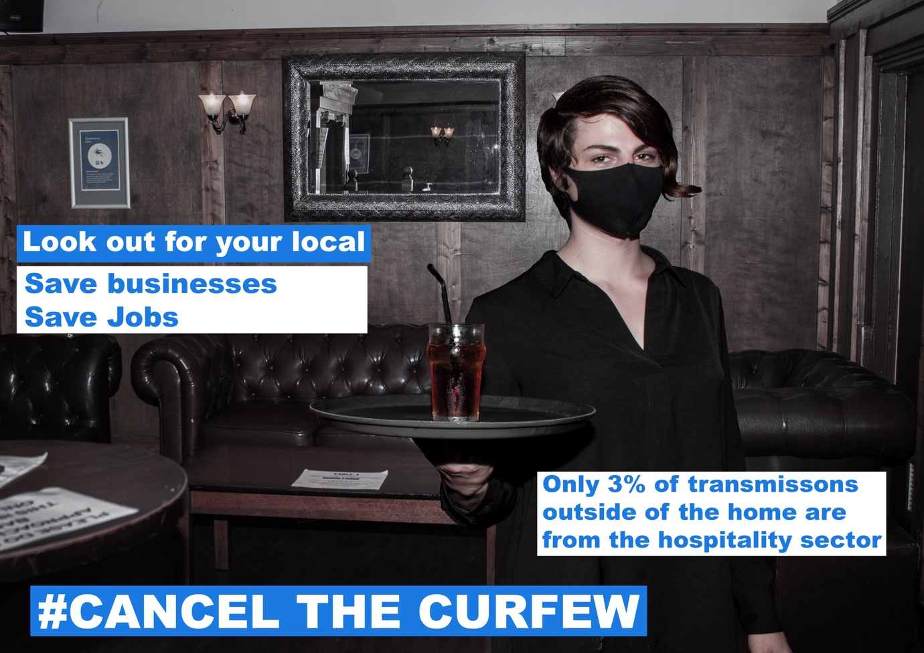

Research

UKHospitality & CGA Future Sock Report – Issue 7 – Road to Recovery
https://www.ukhospitality.org.uk/page/FutureShock-IssueSeven

https://www.bighospitality.co.uk/Article/2020/09/29/Cancel-The-Curfew-campaign-launches-to-provoke-Government-U-turn-lockdown-10pm-curfew-bars-restaurants

https://www.facebook.com/cancelcurfewuk/

https://www.facebook.com/watch/?v=714976822430310

https://www.facebook.com/117119443480805/videos/339017727169997

https://lh3.googleusercontent.com/K97-ldbWdIMFn0DR-G93npls1DuNnsiW7ziBhVAg3cJViFSv11EgCtU2QHnRwV1HVPaMvi9Zfn5DFnt9f2eF4_4Qoyf78RTH1fUyoF9e-apsGISRBNhCbCXzfzpF8gdVrnsPXW8

Make Art Not War: Political Protest Posters from the Twentieth Century – Ralph Young

Posters for Change: Tear, Paste, Protest – Princeton Architectural Press

