12/3/2018
Hannah Thomas (1703882)
University of Wales Trinity Saint David

Module code: BMPS4004
Generating Business Data and Analysis
Assignment 1
Name: Hannah Thomas
Student number: 1703882
Dr Roisin Mullins

Executive summary.
The purpose of this database design is to collect and organise data regarding a specific topic. The database that I have created for this assignment is to collect data regarding 20 different venues, then selecting which one is most appropriate for a conference. The purpose of this report is to explain the reason why I have chosen the specific venue for the conference, and how the Future Well Being of Generations Wales Act 2015 applies to the report.

Contents:

- Rationale for the chosen venue for the conference
- Analysis of the database.
- The Future Well Being of Generations Wales Act 2015.
- How the conference venue complies with one of the themes within the Well-being of Future Generations Act 2015.
- Comparison of Access and Excel.
- Benefits of Access and Excel.
- Conclusion.
- References.

Rationale for the chosen location as the conference venue.
By analysing the various venues that have been put within the database, I have decided that the most appropriate venue for the conference being held is “Parc Y Scarlets” in Carmarthen. Carmarthen is a location that is easily accessible for many people and is known to be one of the oldest towns in Wales.
Parc Y Scarlets is well known by many people, famously for its rugby. Therefore, the venue is of a large size. The venue has several conference rooms within its facilities that cater for a number of different parties. By analysing the website of this venue, you can easily book the conference room of your choice by entering how many delegate’s will be attending. Including this, by deciding which date is most appropriate for the conference you can also select if you prefer a half or full day within the venue. (Parc Y Scarlets, 2018)
For the hire of the conference room for the full day, it would total to £120. This does not include any added extras; therefore, it has additional costs.
Delegates must pay for tea and coffee, bottles of water and orange juice. If we wish to have equipment provided by the venue for the conference this will come at an extra charge. E.g. Projector and Screen = £90.
This is something that must be taken into account before booking the venue as some people may already have the appropriate equipment such as a flipchart. However, the venue does provide a television free of charge. (Parc Y Scarlets , 2018)
Regarding food for the conference, the venue does offer a range of different options. Again, this is also an additional cost. They offer options at different prices. (See the table below).
Food Option: | Price (Per Person)
Hot Buffet | £13.14
2-course sit down meal | £31.80
Sandwiches and crisps | £7.80
Finger Buffet | £17.94

The venue does have parking facilities, however there is no mention of any car parking charges.
As the venue see’s a large turnover of customers, and people from various backgrounds they have staff that are bilingual with the welsh language. This is incredibly important as the venue is under a welsh name and they are upkeeping a welsh image. It is also important as many people prefer to converse through the Welsh language.
By analysing the details of the venue from the website, I can see that it is quite costly. However, in my opinion it is the most appropriate venue for the purpose of the conference.

The creation and analysis of the Database structure.
A database is specifically used to collect and organise data and is known to be a list that is kept on an electronic platform. A database supplies key information when needed for certain things. (Refernce.com, 2018)
For the use of this database, I have collected information on a variety of venues. This includes, the counties and the towns that the venues are located in. specific details have also been stored within the database for the purpose of selecting the best for venue for the purpose of the conference.
In order to begin the creation of a database, the designer must take into consideration the:
- Planning
- Analysis
- Conceptual design
- Implementation
- Maintenance
The design of the database creation is a never-ending cycle.
The first phase of the creation of the database is to identify what data must be collected and how it implies to the information needed.
It is extremely important to focus on the main data that is required to fill the database. There are two views that are seen within the data of the database system. These two views are known as the business’s view of the data and the designers view of the data. The database must be created so that the information can be easily interoperated by the designer and the business. It is important to identify who is the audience for the database and how the data stored would be used.
To begin the creation of a database, a designer would use the “Access” platform which is known as the most popular platform for the creation, it is known as a “Relational Database” (Techopedia, 2018). However, there are other platforms that can be used for creating a database.
The first step in creating a successful database, included creating tables for different pieces of data and filling them in with the correct information. Below I have inserted a picture of a blank database with an empty table.
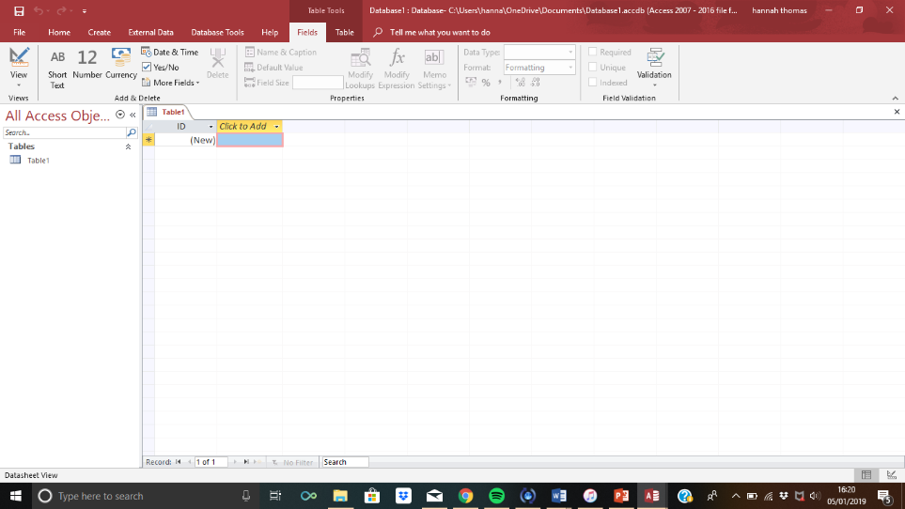

I created tables within my database for the storage of data regarding the venues and the towns and counties that the venue is located in. I have inserted a picture below demonstrating the filled tables.
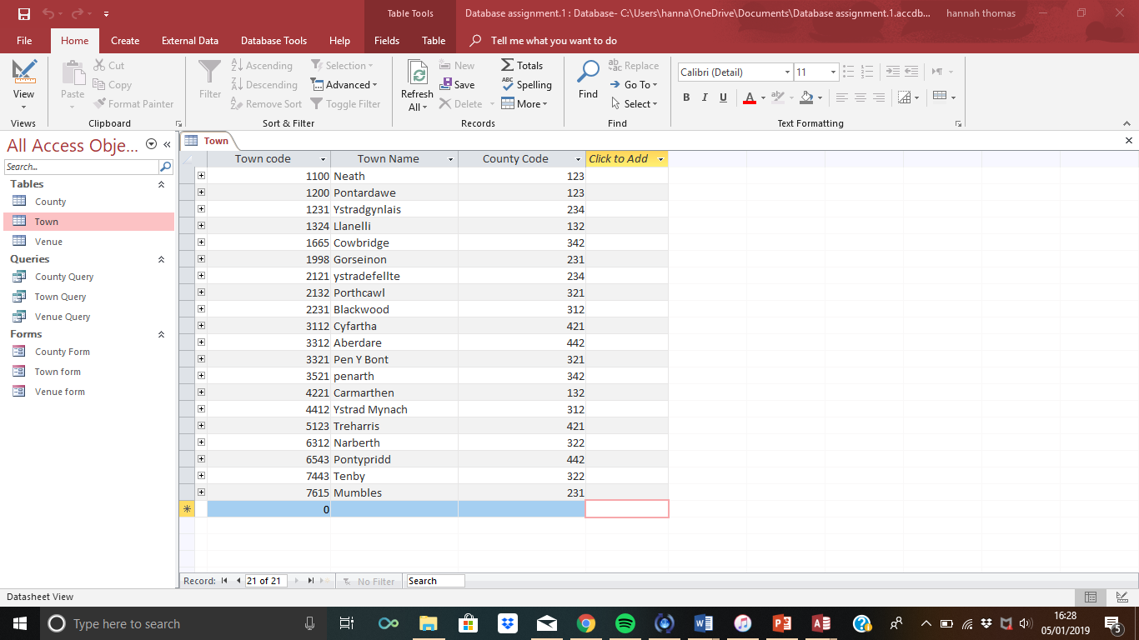

In each entity there has been a specific attribute that identifies the “Primary Key”. This is used to uniquely identify each record that’s been noted in the database.

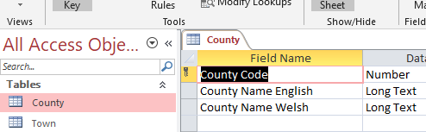

In order to decide on which venue was best for the use of the conference, and the use of the entities, I researched 10 different counties in Wales and discovered two towns in each county. This resulted in having 20 towns overall, therefore I decided to research into a venue in each town resulting in having 20 venues.
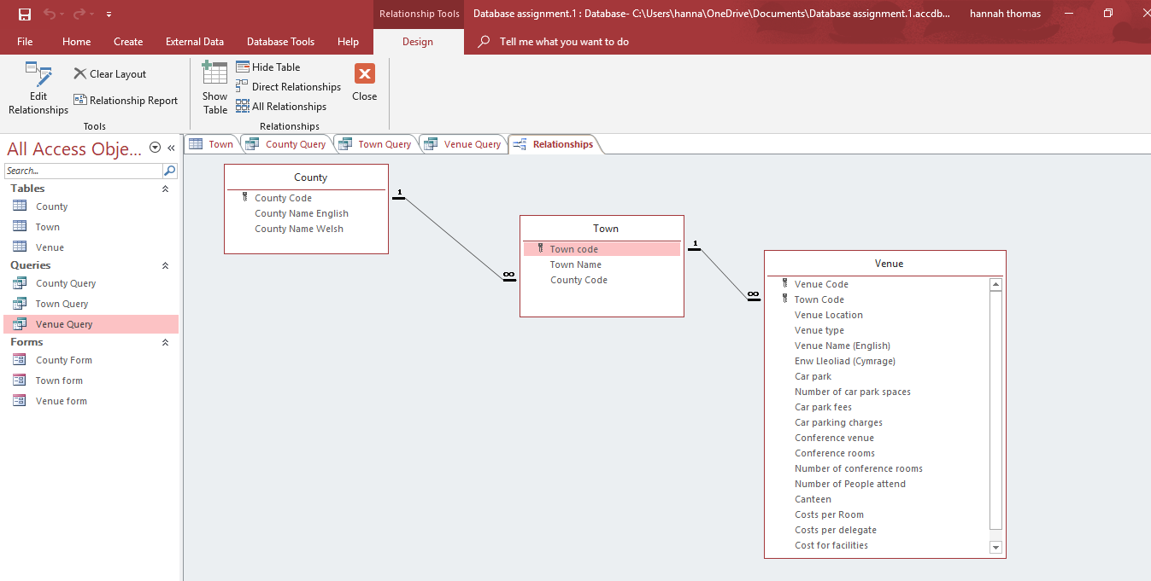
The best way to capture the data is to use the ERD, which is known as the Entity Relationship Diagram. There are three main symbols within an ERD that a used to demonstrate the relationships between the entities. Below is an image of the relationships between the three entities.

The main purpose of a relationship is to demonstrate how the entities interact with each other. There are three different types of relationships. A one to one relationship is known as a table that has no more than one relationship.
The second relationship is known as a one to many relationships, this is where a record within a table has more than one matching record within another table.
The last relationship is known as a many to many relationships, where records in both tables have more than one relationship with the opposite table.
The relationships seen in the database design that I’ve created, you can see that there is a one to many relationships.
Within the relational database, queries must be made. This is to identify data from a variation of entities within the database and then shows the results to the user. (Reference.com, 2018)
Within the database, forms are also created. Their main purpose is so that the designer can create an interface for the database application. Usually, the form is directly connected to the data stored in the database which is known as a “bound” form. Whereas, an “unbound” form doesn’t connect the data automatically. The form is made to make to data stored look nicer for the audience. (Microsoft Office , 2018)
Please see the image below for an example of a form within the database.

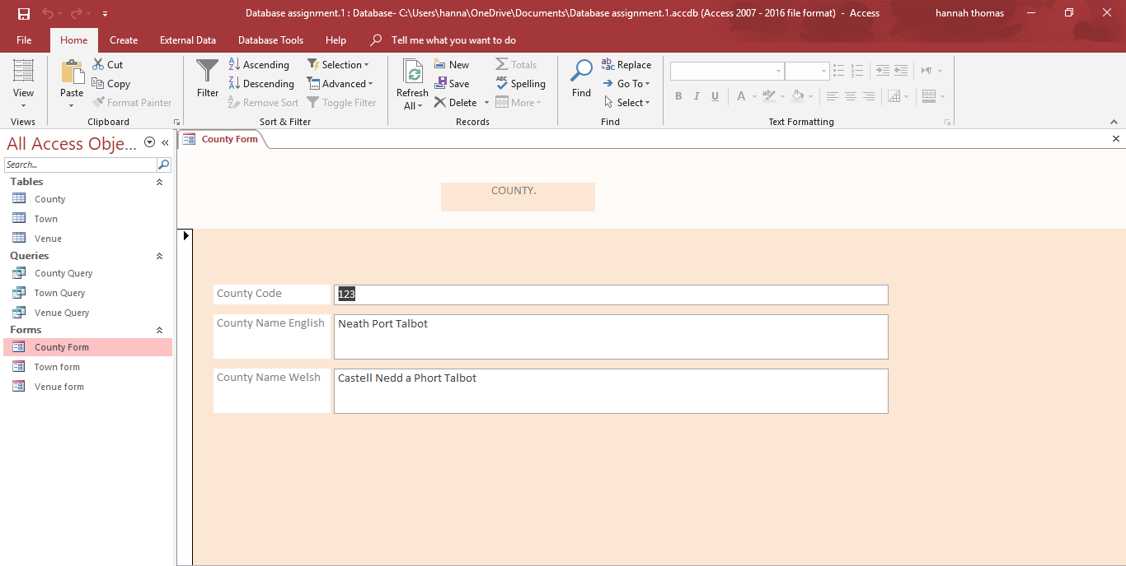

The Future Well Being of Generations Wales Act 2015
This act is unique to Wales and has been created to ensure that the people of Wales care for each other and the community. Ensuring that they combat social and environmental problems together such as poverty and climate change. This act is urging public bodies to consider the impact of their decisions and encouraging them to work better together.
Other countries have recognised what Wales is doing with this Well being act and are following suit in hopes that they can also change their communities and environment for the better. The main purpose of the Well Being of Generations Wales Act is to improve the future for future generations.
In order for the well being to be achieved, the act has put together seven different goals that must be considered. Making it clear that all seven goals must be achieved to see the best results, not just one or two.
The image below states the seven different goals that must be achieved to improve the social and environmental problems in Wales. (Future Generations, 2015)
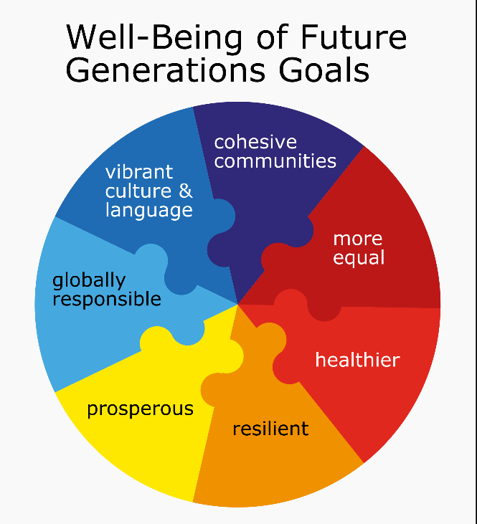

- A more equal Wales.
- A healthier Wales.
- A more resilient Wales.
- A more prosperous Wales.
- A more globally responsible Wales.
- A more vibrant Wales.
- A more cohesive Wales.

How the conference venue complies with one of the themes within the Well-being of Future Generations Act 2015.
The act has been designed with seven different themes that must be achieved to receive the best results. By analysing these different themes, I can see that my chosen venue complies best with the theme of a “More Prosperous Wales”.
“Parc Y Scarlets” is a venue that has been designed for rugby and the welsh rugby team “The Scarlets”. The venue allows people to hire out conference and event rooms for the purpose of conferences and special occasions at a charge. By doing so, this creates an extra source of income for the venue, allowing them to use the extra income to support the welsh rugby team.
The Welsh are proud and are happy to support such a thriving welsh rugby team. Therefore, by using the facilities and the venue, it creates that extra support for the venue creating a more prosperous Wales.

The difference between an Access and Excel.
There are many differences to consider between the use of access and excel. The main difference is that an access database is a relational database where as excel is mainly used for paper works mainly in an office setting.
There is also the terminology to consider when analysing the difference between both platforms.
The excel platform, you can just create a table and simply fill them in with the correct information. Whereas on access you must create the entity with the correct data and then demonstrate the relationship between them. Excel is seen to be the easier option to store data as it’s a lot easier to learn the process of creation. Whereas, with Access you must learn how to create relationships, queries and forms.
Access is a platform that is used to store data and can be accessed by several people. Access also stores data at a record level, in comparison excel stores the entire spreadsheet.
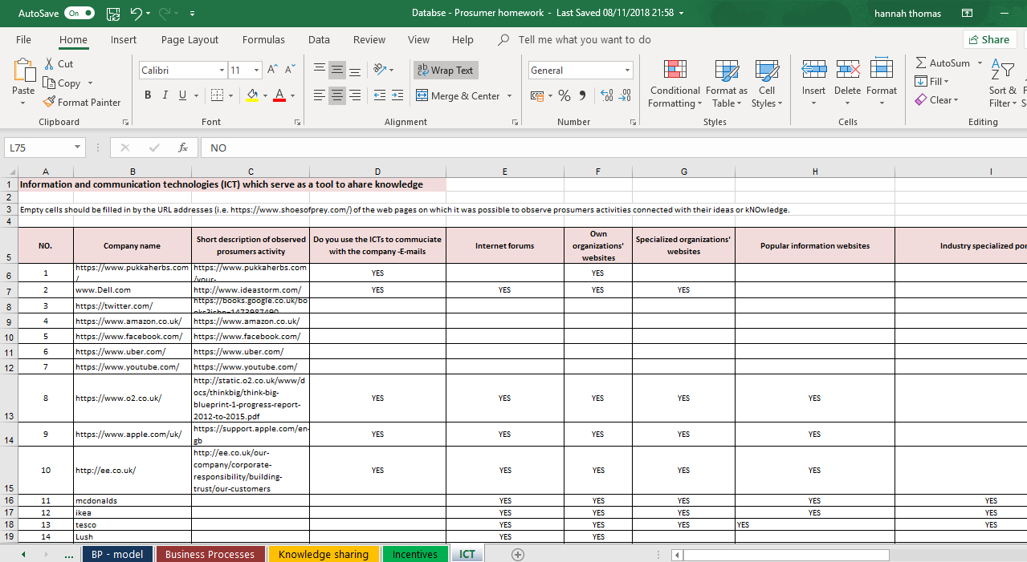

By analysing the image inserted above, you can see how that excel is a spreadsheet and not a relational database like the access platform. (DifferenceBetween, n.d.)
Benefits of using Excel.
There are many benefits to consider whilst using Excel. It supplied businesses the correct tools that are needed for them to make the most of their data, allowing them to get the most out of their resources. The use of an excel spreadsheet is to identify several trends by creating graphs and charts. As excel is a part of the Microsoft Office family, an excel spreadsheet is easily accessed on the online OneDrive allowing many people to access the file. (Blogs Business , 2018)
It is an easier platform to use in comparison to Access. It is quite self-explanatory and is easy to store information within the. This platform is used mainly in office settings, storing data that is easily accessible and easily interoperated by other people.
In order to create it, you simply name the column and enter the correct information to create the spreadsheet.
Benefits of using Access.
It is important to understand the tools correctly to use access and the create a successful database. It is a useful tool to store information in the correct attributes. Similarly, to excel, access is a part of the Microsoft Office family. Therefore, it can be saved to the OneDrive and can be accessed by other users. The use of the relational database is to store important information and to demonstrate the relationships between the attributes, making it easier for specifying relationships quicker. The use of access can teach users many IT skills for future database tasks. (MicrosoftOffice, 2018)
Its easy to add, erase and edit old data within the database. The use of an access database gives the data more protection and security in comparison to paper documents. (BBC Bitesize, 2018).
Conclusion:
By analysing the database that I have created, with all the stored information I have decided that the best venue for the conference is “Parc Y Scarlets” which is in Carmarthen. It could be quite costly to some, but it’s the best venue for this occasion. It is easily accessible for delegates via the M4. By analysing the Wellbeing of Future Generations Act 2015, I have chosen one theme out of seven and have demonstrated how it complies to my chosen venue, be creating a more prosperous Wales.
By analysing the difference between the two database platforms, access and excel, many would argue that excel is easier and it requires less skills and is less complicated. However, the use of access shows the relationships to the user between the different attributes. This makes access a better and more beneficial platform for bigger businesses. It also, presents the audience with more data that has been put in each attribute.

References
(n.d.). Retrieved from DifferenceBetween: http://www.differencebetween.net/object/difference-between-microsoft-excel-and-microsoft-access/
(2015). Retrieved from Future Generations: http://futuregenerations.wales/about-us/future-generations-act/
(2018). Retrieved from Blogs Business : https://blogs.business.microsoft.com/en-gb/2016/07/08/top-5-benefits-microsoft-excel/
(2018). Retrieved from Reference.com: https://www.reference.com/technology/purpose-query-microsoft-access-4c1f22ccdb430502
(2018). Retrieved from Microsoft Office : https://support.office.com/en-us/article/Introduction-to-forms-E8D47343-C937-44E8-A80F-B6A83A1FA3AE
(2018). Retrieved from Parc Y Scarlets: http://parcyscarlets.com/
(2018). Retrieved from Refernce.com: https://www.reference.com/technology/purpose-database-a97b31d6abd95b9e
(2018). Retrieved from Techopedia: https://www.techopedia.com/definition/1234/relational-database-rdb
2018. (n.d.). Retrieved from BBC Bitesize: https://www.bbc.com/bitesize/guides/z8yg87h/revision/4
(2018). Retrieved from BBC Bitesize: https://www.bbc.com/bitesize/guides/z8yg87h/revision/4
(2018). Retrieved from Parc Y Scarlets : http://parcyscarlets.com/conference-room-wales/
MicrosoftOffice. (2018). Retrieved from Microsoft Office: https://blogs.business.microsoft.com/en-gb/2016/07/08/top-5-benefits-microsoft-excel/

