
Master of Business Administration
Module: Dissertation
Module code: LCMB7035
Student Name: Shravan Nalumasu
Student ID: 2432622
Term 3

The Influence of Brand Image on Consumer Buying Behaviour in the Retail Sector
Acknowledgement
I would like to thank all the people without whose help I would not have been able to complete the dissertation. Firstly, I would like to offer my gratitude to all my professors whose valuable guidance and support have been crucial for completing this dissertation successfully. I would like to thank our module coordinator for providing me with the opportunity to carry out this study. I would also like to thank my fellow colleagues who supported and helped me greatly during my work. Lastly, I would like to thank all my family members, especially my parents, whose constant care, support, and encouragement have always helped me to achieve the goals in my life.

Abstract
The aim of the study is to explore the relationship between brand image and consumer buying intentions in UK retail retail market and to assess the role of other brand variables, namely consumer trust, brand perceived quality, between brand image and consumer buying behaviour while examining the moderating role of age and income. The design selected was quantitative, in nature, with a cross-sectional approach, which was applied to a sample of 105 online retail consumers from UK. The data were analysed by SPSS and AMOS including descriptive data, reliability test, validity test, regression, mediation and moderation analysis. The results confirm the strong positive correlation between brand image and buying behaviour (β = 0.72, p < 0.001), thus supporting H1. This relationship showed a significant intervention effect from consumer trust, which accounted for about 51% of the overall effect, and by the perceived quality, which accounted for about 64% of the overall effect. The age partially influenced the link whereby younger consumers showed higher sensitivity to brand image. The relationship was also strongly impacted by income, particularly for people with a higher income. Hypotheses supporting were found for all five hypotheses. The study finds that through a psychological channel such as perceived quality, brand image is a direct predictor of purchases as well, in addition to another direct predictor. The results underscore the fact that quality delivery and building trust and segments should come hand-in-hand with positioning to make retail marketing more effective.
Table of Contents
Chapter 1: Introduction 8
1.1 Background and Context 8
1.2 Research Aims and Objectives 9
1.3 Research Hypotheses 9
1.4 Significance of the Study 11
1.5 Scope and Limitations 11
1.6 Structure of the Dissertation 11
Chapter 2: Literature Review 12
2.1 Introduction to the Literature Review 12
2.2 Conceptualising Brand Image 12
2.3 Theoretical Frameworks for Consumer Buying Behaviour 13
2.4 The Direct Relationship Between Brand Image and Consumer Buying Behaviour 14
2.5 Mediating Role of Consumer Trust 14
2.6 Mediating Role of Perceived Quality 15
2.7 Demographic Moderators: Age and Income 16
2.8 Identified Research Gaps 17
2.9 Conceptual Framework 18
Chapter 3: Methodology 19
3.1 Research Philosophy 19
3.2 Research Approach 19
3.3 Research Design 20
3.4 Data Collection 20
3.4.1 Survey Instrument 20
3.4.2 Sampling Strategy and Recruitment 21
3.5 Data Analysis 21
3.5.1 Preliminary Analysis and Descriptive Statistics 21
3.5.2 Reliability and Validity Assessment 21
3.5.3 Statistical Software and Rationale 22
3.5.4 Hypothesis Testing 22
3.6 Ethical Considerations 23
3.7 Research Limitations 23
3.8 Chapter Summary 23
Chapter 4: Findings 25
4.1 Introduction to Findings 25
4.2 Demographic Profile of the Sample 25
4.2.1 Age Distribution 25
4.2.2 Income Distribution 26
4.3 Hypothesis Testing and Path Analysis Results 27
4.3.1 H1: Direct Effect of Brand Image on Buying Behaviour 27
4.3.2 H2: Consumer Trust as Mediator Between Brand Image and Buying Behaviour 28
4.3.3 H3: Perceived Quality as Mediator Between Brand Image and Buying Behaviour 29
4.3.4 H4: Moderating Effect of Age on Brand Image–Buying Behaviour Relationship 30
4.3.5 H5: Moderating Effect of Income on Brand Image–Buying Behaviour Relationship 32
4.4 Summary of Hypothesis Testing Outcomes 33
4.5 Integrated Model Interpretation and Synthesis 34
4.6 Discussion 35
4.6.1 Introduction to Discussion 35
4.6.2 Direct Effect of Brand Image on Buying Behaviour: Confirmation and Extension 35
4.6.3 Consumer Trust as Mediator: Theoretical Integration and Empirical Validation 36
4.6.4 Perceived Quality as Mediator: Dominance of Functional Value Signals 36
4.6.5 Age as Demographic Moderator: Generational Differences in Brand Responsiveness 37
4.6.6 Income as Demographic Moderator: Economic Constraints and Brand Responsiveness 37
4.6.7 Integrated Model: Multiple Mediation and Moderation Synthesis 38
4.6.8 Methodological Contributions and Limitations 38
4.6.9 Practical Implications for Retail and Brand Strategy 39
4.6.10 Theoretical Implications and Model Refinement 40
4.6.11 Identification of Remaining Research Gaps 40
4.6.12 Conclusion to Discussion 41
Chapter 5: Conclusion and Recommendations 42
5.1 Introduction 42
5.2 Summary of Key Findings 42
5.2.1 Direct Effect of Brand Image on Buying Behaviour 42
5.2.2 Mediating Role of Consumer Trust 43
5.2.3 Mediating Role of Perceived Quality 43
5.2.4 Moderating Role of Age 43
5.2.5 Moderating Role of Income 44
5.3 Revisiting Research Objectives 44
5.4 Theoretical Contributions 45
5.4.1 Extending Brand Equity Theory 45
5.4.2 Refining Perceived Quality and Trust Models 46
5.4.3 Validating the Stimulus-Organism-Response Paradigm 46
5.4.4 Establishing Demographic Boundary Conditions 46
5.5 Managerial Recommendations 47
5.5.1 Invest Strategically in Brand Image with Quality as Foundation 47
5.5.2 Treat Consumer Trust as a Defensive Strategic Asset 47
5.5.3 Implement Income-Segmented Brand Communication Strategies 47
5.5.4 Adopt Generationally Differentiated Brand Positioning 48
5.5.5 Design Integrated Digital and Physical Brand Experiences 48
5.6 Recommendations for Future Research 48
5.6.1 Longitudinal Investigation of Brand Image Dynamics 48
5.6.2 Explicit Moderated Mediation Analysis 49
5.6.3 Incorporation of Omnichannel and Social Media Dynamics 49
5.6.4 Expanding Demographic Scope 50
5.6.5 Cross-National and Cross-Cultural Comparative Studies 50
5.7 Study Limitations 50
5.8 Overall Conclusions 51
References 54
Appendices 60
Appendix 1: Survey Responses 60
Appendix 2: SPSS Files 61

Chapter 1: Introduction

1.1 Background and Context
The modern marketplace is characterised by the ever more demanding consumer audience, who are making choices that extend beyond their utilitarian needs, into symbolic links with brands and more emotional orientations. In 2024, global retail sales totalled roughly USD 30.2 trillion, and have grown 4.41% each year, highlighting the unparalleled competition faced by brands across various product categories and channels (Statista, 2024). In this competitive market, brand image is a key attribute that influences consumer attitude and purchase decisions, beyond the features of the product (Khan et al., 2022). For example, in the United Kingdom in 2024, the retail industry accounted for an estimated £482 billion of retail sales, where consumers are more influenced by brand symbolism, perceived reputation, experiential association etc., when deciding to purchase a product or service (ONS, 2024).
Brand image is all the perceptions, associations and beliefs consumers have about a brand and includes functional, symbolic and experiential components (Seman, 2026), such as what the product does and doesn't do, how it helps them communicate their identity, or how they enjoy using it. The brand image can be conceptualized following Keller's (1993) popular structure of brand knowledge: brand image is a cognitive associative network in consumer retention that consists of strength, favourability and uniqueness of brand associations. These associations act as a link for the understanding of consumers' attitudes and behavioural intentions toward a brand from a theoretical perspective. Based on the empirical evidence, it is evident that having a good positive brand image is correlated with purchase intention, build customer loyalty, and maintaining premium pricing strategy, especially in competitive retail setting (Guliyev, 2023). In theoretical literature, however, these correlations have become commonplace, but the exact processes by which brand image aligns with actual purchase behaviour in multi-sector retail contexts in the UK are under-researched.
The review of the literature provides many gaps uncovered that this research study aims to fill. Second, most brand image research focuses on limited product categories, such as luxury brands, fast moving consumer goods (FMCG) and the hospitality sector, which prevents the transfer of results to other multi-sector retail environments. Second, the link between brand image, consumers' trust, perceived quality and purchase behavior was not given enough attention together as related consumer perceptions but as individual ones. Third, while consumer responses to brand-related cues have been linked with demographic differences (age, and income), it has been scarce to find empirical evidence regarding the relationship between brand image and buying behaviour for various demographic groups in the UK retail context (Khan et al., 2022).

1.2 Research Aims and Objectives
Aim:
This study is an attempt to explore the relationship between brand image and consumer buying behaviour in retail market in United Kingdom with specific focus on the relationship between brand image and consumer trust, brand image and perceived quality and brand image and buying behaviour and to investigate the differences in strength of the relationship between brand image and buying behaviour between age and income groups.
Objective 1: To explore how the functional, symbolic and experiential nature of a brand image is related to consumer purchase behaviour in the UK retail environment.
Objective 2: To explore the linkages between brand image, consumer trust, perceived quality and consumer buying behaviour in the UK retail setting.
Objective 3: To investigate differences in brand image and Consumer Buying Behaviour for age and income groups in the UK retail context.
These objectives represent a way of quantifying the examination of associations between the primary constructs of consumer behaviour identified in the literature, but acknowledge that the cross-sectional design does not allow for causal relationships to be established, therefore, the focus of these objectives is on direction and strength of relationships, and on differences in these relationships across demographic groups.

1.3 Research Hypotheses
The direction and strength of relationship between brand image, consumer trust, perceived quality, consumer buying behaviour, age and income are examined based on the theoretical perspectives and empirical evidence summarized in Chapter 2, which are summarized as five hypothesis.
- H1: Brand image is significantly and positively related to consumer buying behaviour in the UK retail market. There is a positive and significant relationship between the concept of brand image and the concepts of consumer trust and consumer buying behaviour in the UK retail market.In the UK retail market, the relationships between (Chaudhuri and Holbrook, 2001).
- H2: brand image : consumer trust: consumer buying behaviour are positive and significant.
- H3: There is a positive and significant relationship between brand image, perceived quality and consumer buying behaviour in the UK retail market.
- H4: Age groups in the UK retail market have significantly different levels of positive relationship between brand image and consumer buying behaviour.
- H5: Alternative hypothesis: It is hypothesized that the positive relationship between brand image and consumer buying behaviour is significantly different between income groups in the UK retail market.Alternative hypothesis: It is hypothesized that there is a significantly different positive relationship between brand image and consumer buying behaviour between income groups in the UK retail market.
These hypotheses, taken together, serve as a correlational framework to explore the possible link between favourable brand image perceptions and stronger consumer buying behaviour, as well as the possible connection between brand image–buying behaviour and consumer trust and perceived quality to see if this exists across demographic groups.

1.4 Significance of the Study
Theoretically and practically the research is important because it explores the relationship of brand image and consumer buying behaviour in the UK retail context. The study does not make any causal inference, but offers empirical evidence relating to direction and strength of associations between brand image, consumer trust, perceived quality and consumer buying behaviour. Another contribution of the study to the literature is to understand if the relationship between brand image and buying behaviour varies by age and income groups (Sharma et al., 2023). This will give a more differentiated insight into consumer reactions to brand-related perceptions and can contribute to revealing that the bond with the brand can differ between the segments. The results from a practical perspective can help the UK retail managers to understand consumer perceptions that are linked to buying behaviour (Statista, 2024).. Specifically, the results related to brand image, trust and perceived quality could be valuable evidence for brand positioning and customer relationship strategies and demographic analysis may help retailers understand the differences between the groups of consumers. In terms of method, it is a quantitative survey of cross sectional design, suitable for investigating statistical relationships among measurable constructs of consumers. The results will therefore be viewed as correlations, not causation (Hair et al., 2022).

1.5 Scope and Limitations
The study was limited to adults (18 years and over) who had made at least one online or in-store retail purchase in the UK over the past year. The scope has deliberately included a cross-section of retail sectors, to enhance the generalisability of the findings to the wider UK retail sector as a whole, rather than focussing on a single product type. The cross-sectional design does not, therefore, create a temporal sequence of events or causal links between the variables and the results are therefore represented as statistical relationships (Saunders et al., 2009). Moreover, convenience and purposive sampling through Internet based methods might lead to a situation of respondent self-selection bias. Documented variations in brand sensitivity in different cultural-economic contexts might limit cross-national applicability, due to cultural specificity to the UK.

1.6 Structure of the Dissertation
This dissertation will consist of seven chapters. The research background and objectives, as well as the hypotheses and significance are outlined in Chapter-1. Chapter 2 summarizes the work conducted in the related field, as well as research gaps. Chapter 3 presents the details of the research methodology, which include the research philosophy, deductive approach, quantitative cross sectional design, sampling, data collection and correlational data analysis. The empirical results are then presented in Chapter 4, and discussed with the literature in Chapter 5. Limitation, future research and study conclusions with managerial implications are covered in Chapters 6 and 7, respectively.

Chapter 2: Literature Review

2.1 Introduction to the Literature Review
This chapter critically reviews and integrates the current academic research on the subject of brand images and its implications for consumer purchase behaviour, particularly in the UK's retailing context. The link between consumer trust and perceived product quality and the link between brand image and buying behaviour and differences in the brand image–buying behaviour relationship between the different demographic groups. The review ends by providing an identification of gaps in the literature that are addressed in this study. The references are mainly from peer-reviewed empirical and theoretical publications since the year 2022, where necessary also concept references from earlier publications from which theories are trained invaluable.

2.2 Conceptualising Brand Image
Brand image has been theorized as a multidimensional construct, and has been the focus of sustained research since Keller (1993) first introduced the concept in his Customer Based Brand Equity (CBBE) framework. This is a basic model of what brand image is: the collection of associations that resides on consumers' minds when considering a brand, grouped by their salience, their positivity and their uniqueness. These relationships between cognitions are the basis for the development of consumers' attitudes and behavioural intentions toward brands (Zheng et al., 2023). Although influenced by various theories, the CBBE has consistently been the leading one used in empirical studies of brand images in recent times across different product categories and markets (Barrueta-Pinto et al., 2024; Du and Tham, 2024).
Up to date, scholars have taken Keller's (1993) associative network model one step further to make the concept of brand image practical with three interconnected facets—functional, symbolic, and experiential. The functional dimension includes product performance, reliability and utilitarian benefit as perceived by the consumer (Mahothan et al., 2022). The symbolic dimension occurs when consumers are using a brand to communicate their identity, social status and self-concept, especially in the case of aspirational and lifestyle-oriented segments. The experiential dimension refers to the sensory, hedonic and emotional involvement experienced as a result of the consumer–brand relationship (Ahmed et al., 2024). Empirical results validate that these three dimensions are salient in their retailing manifestations, depending on the nature of the product, and on the age and income of the consumers, though overall, each of these dimensions, or all together, has an impact on the overall perception of the brand image in a retailing context (Barrueta-Pinto et al., 2024; Ichou and Manar, 2024).
Importantly, brand image should be separate and apart from brand identity, the desired meaning by the brand manager, and brand awareness, which reflects call-up and recall. Though closely tied, brand image is a consumer-based phenomenon and can be very different from what the management intends to create (Utama and Ambarwati, 2022). Especially in retail environments with abundant information and an increasing flood of social media, the collective brand perception is also affected by customer-generated content that impacts the brand even when it is not under the control of the brand's marketing communications (Guliyev, 2023). One drawback of some of the existing studies is that these constructs are combined, making it hard to understand the exact perceptions involved in connecting the brand image with buying behaviour.

2.3 Theoretical Frameworks for Consumer Buying Behaviour
The buying behaviour of a consumer is a multi-stage process that includes problem recognition, information search, evaluation of alternatives, purchase decision and post purchase assessment (Alkhafaji, 2024). A number of theories has existed in explaining how the process of creation of brand image to that of the process of buying the brand. Several theories were developed for explaining the mechanism of how the process of creating the image of a brand is correlated to the process of purchasing of the brand. The Theory of Planned Behaviour (TPB suggests that, as intermediaries between attitudes and subjective norms, perceived behavioural control affects behavioral intentions and thence the actual behavior (Morales-Pérez et al., 2022). In the context of brand image, a positive brand image boosts the consumers' favourable attitudes and leads to higher purchase intentions. To support the theoretical justification for studying brand image as a determinant of purchasing behaviour, Rozenkowska's (2023) systematic literature review of application of the TPB in consumer behaviour research verified that attitudinal variables such as brand image and trust were among the best indicators of behavioural intention across product categories.
The Stimulus-Organism-Response model (SOR) from environmental psychology provides a complimentary explanatory model (Wu et al., 2022). In this context, brand cues elicit specific cognition and affect states in the organism (such as brand perception, trust, and quality judgements) which trigger organismic behaviour responses (such as purchase behaviour) (HIRANRITHIKORN and Banjongprasert, 2022). The S-O-R model is especially applicable in retail, where several brand stimuli are acting on an individual simultaneously in both touch points online and offline. Pereira et al. (2022) used the S-O-R paradigm to examine omnichannel retail consumer behaviour, and found that brand related stimuli had a strong impact on the consumer's internal states, which in turn influenced their approach or avoidance purchase behaviour. Together, TPB and S-O-R offer theory-based justifications for the expected positive relationships among the constructs tested in the present study, but neither TPB nor S-O-R is tested sequentially nor in a causal manner in the present cross-sectional study.

2.4 Relationship Between Brand Image and Consumer Buying Behaviour
This connection between brand image and consumer buying behavior has been extensively explored in the marketing research literature, and the majority of previous research has found positive relationships between positive brand perceptions and consumers' purchase-related outcomes. Guliyev (2023) showed how brand perception and image can have a significant effect on purchase willingness in competitive markets and the benefits of consumers' favourable brand perceptions can be seen in an increase in their purchase willingness. Likewise, Khan et al. (2022) found that in the context of urban females, the brand image had a statistically significant direct effect on the consumer's buying behaviour, and psychological factors demonstrated themselves as mediators in strengthening the brand image and buying behaviour of the consumer towards designer brands. The results are supported by Ichou and Manar (2024), who indicated that a positive brand image can increase consumers' willingness to pay a premium price because added value from the brand image can be perceived beyond the product to include reputational, symbolic and emotional value.
Moreover, Mahothan et al. (2022) validated that brand image is not only a factor that can affect immediate purchase but that it also has a downstream effect to deliver the following stages of pur-purchase for long-term behavioural commitment – brand commitment and brand love. In the UK retail sector, in particular, brand image has been identified as one of the important factors that can moderate the relationship of loyalty programme engagement acquisition, with younger consumers being more sensitive to brand symbolic cues than the older ones (Statista, 2024). The combined evidence offered support for the hypothesis of a positive relationship between brand image and consumer buying behaviour, but these variations in research settings, product type and consumer type suggest that the relationship may not be consistent for all consumers, and therefore warranted investigating the relationship between brand image and buying behaviour in the context of the UK multi-sector retail environment. There is a need for developing models considering the variation among segments of consumers than assuming a constant substitution effect for a brand regardless of the retail context (Barrueta-Pinto et al., 2024).
H1: Brand image is positively and significantly correlated with consumer buying behaviour in the UK retail market.

2.5 Relationship Between Brand Image, Consumer Trust and Consumer Buying Behaviour
One of the key consumer perceptions that has been linked to brand evaluations and purchase behaviour is consumer trust (Dam, 2020). It refers to consumers’ confidence in a brand’s dependability, honesty, reliability and ability to fulfil its promises (Chaudhuri and Holbrook, 2001). In retail environments, positive perceptions of a brand can also increase consumers' confidence in the brand, and a high level of confidence can translate into higher purchase intention and purchasing behaviour. In a pioneering study, Chaudhuri and Holbrook (2001) had determined that the mechanisms of brand trust enable the translation of positive perceptions into investment in purchasing. Its definition as a consumer's faith in the brand's dependability, trustworthiness and ability to fulfil promises has been operationalized in subsequent empirical studies in different ways, combining cognitive, affective and behavioral approaches (Legood et al., 2023). This mediating pathway has been confirmed in recent studies as well, with Ichou and Manar (2024) demonstrating that brand trust was a strong mediator between brand image and purchase intention in a competitive service retail setting using a sample of 148 health care consumers, and explaining a large part of the whole effect.
Brand image also led to purchase intention in the market of new energy vehicles (NENVs) as shown by Zhong (2023), who concluded that brand trust fully mediated the connection between brand image and purchase intentions, and perceived price played a moderating boundary condition. In addition, Maharani, Puspaningrum and Isharina (2023) conducted a PLS-SEM model analysis to show the facilitating role of trust in explaining the purchase decisions of consumers of skin care products (Yee et al., 2025). The results showed that the simultaneous model of the mediators perceived quality and trust explained the purchase decision in a significant way, larger than the models of perceived quality and trust separately. This dual mediation is theoretically interesting for the current study because according to this finding the relationship between brand image and the buying behaviour is seen as complementing each other, and not as being redundant. One key finding in the literature is that the process of trust formation is especially vulnerable to negative brand experiences, such that evidence-based findings suggest that tarnishing brand reputations through service failures or ethical breaches leads to a rapid decline in purchase commitments driven by trust. This sensitivity helps to underscore the need for homegrown brand image signals, consistency and adhering to them.
While the literature has previously focused on consumer trust as a mediating variable between brand-related perceptions and purchase outcomes, the present study does not make such a causal claim, due to the cross sectional nature of the study, it examines the statistical relationships among the constructs.
H2: Brand image, consumer trust and consumer buying behaviour are positively and significantly correlated with one another in the UK retail market.

2.6 Relationship Between Brand Image, Perceived Quality and Consumer Buying Behaviour
Perceived quality, defined by Zeithaml (1988) as the general subjective assessment of a product's relative superiority, is another mediating path between brand image and buying behavior. Perceived quality is a knitwork that the consumer forms when engaging in evaluative processes that are determined by objective quality or based on cues other than the objective quality, such as brand, price signals, packaging and previous experiences. Perceived quality is the consumers general evaluation of the excellence or superiority of a product or brand and is linked to the brand reputation, price, packaging, performance and previous experience of a product or brand (Zeithaml, 1988). In a retail context, positive brand perceptions and perceived quality can be correlated and for some consumers, a positive perceived quality can also lead to positive purchase intentions and purchase behavior (Nuzula and Wahyudi, 2022).
Empirical studies in the past have found a positive correlation between perceived quality and purchase-related outcomes, not only in retail settings (Maharani et al., 2023). Based on these findings, this study examines the relationship between perceived quality, brand image and consumer buying behaviour.
As in retail markets, in the luxury market, consumers' purchase intentions are stronger when they are convinced that the quality of the product is higher and trust acts as one of these co-mediators. Further, Rahmawati and Edastama (2024) showed that using structural equation modelling: brand image could positively influence purchase decisions through the intermediary quality pathway and the quality pathway could explain 43% of the total indirect effect. All of the findings here suggest that the perceived quality related belief should not be used as a control variable or delayed by brand-buying behaviour models when testing with consumer trust and that it should be considered as theoretically substantive (Attiq et al., 2025).
Literature indicates that there may be a positive relationship between brand image and perceived quality and buying behaviour; however the present study does not assume that perceived quality is a causal factor for the relationship between brand image and buying behaviour rather, it examines the statistical relationships among the three constructs.
H3: Brand image, perceived quality and consumer buying behaviour are positively and significantly correlated with one another in the UK retail market.

2.7 Age and Income Differences in the Brand Image–Buying Behaviour Relationship
Age and income are factors in the lives of consumers that could be correlated with the differences in their brand evaluations and purchasing decisions (Lugioyo, 2022). Thus, there is a possibility that the relationship between brand image and purchase behavior can vary according to social groups.
H4: The strength of the positive relationship between brand image and consumer buying behaviour differs significantly across age groups in the UK retail market.
The relationship between brand image and buying behavior has been seen to grow in importance as demographers evolve as boundary conditions for the relationship, specifically age and income (Kamal et al., 2013). Literature reports that there is a generational gradient in brand image responsiveness, based on the age of the respondents. Younger consumers – especially Millennials and Generation Z – are increasingly aware of the symbolic and experiential elements of brand image (Dobre et al., 2021). The results of consumer insights research suggest that Gen Z consumers orientation towards the brands they choose is one of identity expressions, which was significantly higher than among the older consumers (Shin et al., 2022). Older consumers, however, often judge brands mainly based on their functional dimension, such as their reliability, product uniformity, and performance qualities, will be more inclined to pay more attention to.
This income moderating effect has been well established too. Consumers with higher disposable incomes have been seen to be more brand image sensitive which makes them think of strong brand associations as signals of positioning the brand in the social context and quality assurance that warrant premium prices (Labib et al., 2023) (cited in IJRAR, 2025). Price-value orientation as a determinant of consumer buying, on the other hand, is found more with lower income consumers, where the functional and economic attributes play a comparatively stronger position as compared to brand images. Interestingly, Wahab, Diaa and Nagaty (2023) found that income and age alone explained a substantial portion of variance in consumers' weighting of their purchase evaluation process, giving weight to the brand signals as opposed to price signals. Although various theoretical arguments have been put forward, the moderating results for age and income have largely been tested separately, either as a general moderating role or as a moderating role in the connection between brand images and buying behaviour; that is, testing whether age and income moderate the direct pathway between brand images and buying behaviour, and testing whether age and income moderate the mediation pathway between brand images and buying behaviour. This is a significant gap, which the present study aims to fill.
This existing evidence serves as a foundation for exploring the difference in the association of brand image and buying behaviour between income groups with the understanding that income is not treated as a causal moderating variable.
H5: The strength of the positive relationship between brand image and consumer buying behaviour differs significantly across income groups in the UK retail market.

2.8 Identified Research Gaps
Firstly, the majority of current studies on brand image and consumer purchasing behaviour are based on separate categories of products such as luxuries, FMCG products and online services. This narrows the scope of implications the findings might have for the broader retail industry. There is a need for more empirical research that investigates the relationship between brand image and buying behaviour in various retail categories in the UK(Khan et al., 2022).
Secondly, while both consumer trust and perceived quality have been related to brand evaluation and purchase-related outcomes, fewer studies have focused on examining these constructs as related consumer perceptions in a UK multi-sector retail context. A comparison of their associations with their brand image and buying behaviour could be used to get a better idea about the relationship between these constructs (Maharani et al., 2023).
Third, the literature suggests that there may be differences in brand evaluation and purchase decision making processes based on the consumers' characteristics, including age and income. This, however, has limited evidence on whether there is a difference between age and income variations in the UK retail context in relation to the strength of the relationship between brand image and buying behaviour. Barrueta-Pinto et al (2024), and Wahab, Diaa and Nagaty (2023).
.Fourth, some previous studies have employed causal or path-based models, although they were based on cross sectional survey data by (Sharma 2024). These types of designs are not able to suggest a temporal order or causality. The present study thus fills in a methodological void, as it explicitly takes a correlational approach that seeks to understand the nature and direction of the relationship between the measures as well as the magnitude of these relationships, without assuming statistical correlations to be causal.
The rationale for this is because these gaps have been identified as a reason to look at the relationships between brand image, consumer trust, perceived quality and buying behaviour and to determine if the relationship between brand image and buying behaviour varies by age and income group of UK retail consumers.

2.9 Conceptual Framework
The conceptual framework, based on the synthesis of the theoretical perspectives and empirical evidence reviewed in this chapter, proposes that brand image is positively associated with consumer buying behaviour and also acknowledges expected positive associations between brand image, consumer trust, perceived quality and consumer buying behaviour, but does not specify causal mediation or moderation pathways, rather these constructs are treated as measurable variables whose relationships can be examined statistically; age and income are included as demographic grouping variables to assess whether the strength of the relationship between brand image and buying behaviour differs across demographic groups (Zeithaml, 1988).
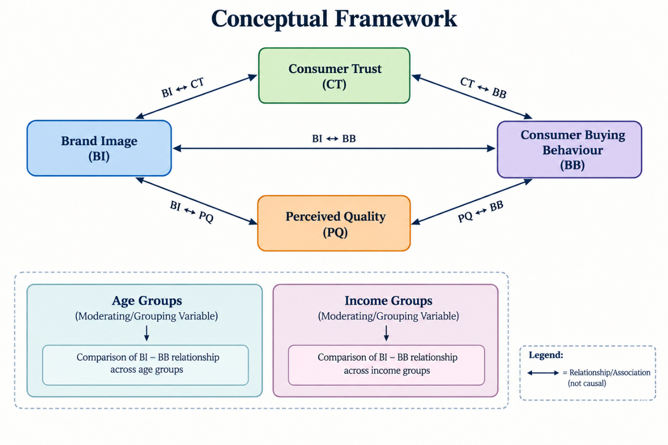
Figure 1: Conceptual framework
(Source: Self - created)

Chapter 3: Methodology

3.1 Research Philosophy
In this research, it was based on positivist research philosophy that assumes that social reality is objective and can be measured and handled empirically. According to positivism, knowledge is gained from a phenomenon that can be verified, seen or observed and the relationship between phenomenon and phenotyped can be quantified and tested (Saunders, Lewis and Thornhill, 2023). This ontological perspective is particularly suitable in the field of consumer behaviour research, where attitudes towards brands, brand image, brand trust and even brand buying behaviour can be systematically measured as latent constructs. Because existing theory on brand management and consumer psychology literature is used to develop the theoretical frameworks for the study, a deductive approach closely follows the positivist paradigm, with these theoretical frameworks being translated into testable hypotheses. This allows the researcher to be a non-participant which helps reduce possible researcher bias and helps with replicability and generalisability of results (Creswell, 2023). The underlying objective of the study favoured positivism for its ability to enable comparative analysis based on statistical methods across population segments, a feature particularly beneficial to the aim of this study as the study did not seek to capture the depth or quality of the subjective experiences of consumers.

3.2 Research Approach
In this study, a deductive research approach is used. Deductive reasoning works from the general to the specific while reasoning-starting theory and generating hypotheses about it, before then testing this out empirically (Bryman, 2016). The hypotheses presented in Chapter 1: those that suggested that brand image had a direct effect on consumer buying behaviour and that of the facilitating role of consumer trust and perceived quality were developed from different conceptual frames, such as Keller's (1993) Brand Knowledge Model and Zeithaml's (1988) perceived quality construct. These propositions are then checked against primary quantitative data which is in line with deductive tradition. In contrast to inductive reasoning, which would seek to build theory out of existing patterns in empirical observations, more commonly used with qualitative methods. A deductive approach is epistemologically sound and efficient, due to the established theories, models and framework for the research of brand image (Saunders, Lewis and Thornhill, 2023). It allows the researcher to validate, question, and/or enhance existing theory statements which can lead to building on the existing body of knowledge within the discipline.

3.3 Research Design
The research method used is quantitative, survey, cross sectional. A cross-section design is one that collects data from a sample of population at any given time and is appropriate for describing relationships between two or more variables and for setting up a profile of the population. (Bryman, 2016). Longitudinal designs would allow tracking of behaviour and attitude changes over time, but are not feasible or in the time frame of this project. The survey instrument chosen for its primary use was a structured and self-administered online survey instrument, which is found to be efficient, scalable and suitable to capture numerically codified attitudinal data across geographically scattered populations (Bhattacherjee, 2019). The survey-based design also allows for the use of psychometric scaling methods that have been widely used in consumer behaviour measurement, as described above in Likert-type scales. These types of scales are well validated in measuring latent psychological constructs in the consumer behaviours (Hair et al., 2019). The shift to an online mode of data collection will minimize administrative burden, speed data capture and increase response quality by allowing the participants' access to the survey at their own pace.

3.4 Data Collection

3.4.1 Survey Instrument
A structured questionnaire with two sections is the main data collection tool. The first part gathers information about socio-demographic data, such as age, gender, level of education, average amount of money spent on a monthly basis and the preferred place to shop: online, offline, or omnichannel. The second section involves the assessment of the important study constructs by validated multi-item scales that have been identified from the literature. Borrowing items from Ahmad et al. (2019) and Foroudi (2019), brand image is operationalized as functional, symbolic and experiential brand image. Consumer trust is assessed based on items that were adapted from Chaudhuri and Holbrook (2001), and perceived quality items are based on Zeithaml's (1988) conceptualisation. Multi-item scales of purchase intention and purchase frequency are used to measure consumer buying behaviour. All construct items were expressed on a 5-point Likert scale ranging from 1 (Strongly Disagree) to 5 (Strongly Agree), and they had been used in many fields related to consumer behaviour research because they are well psychometrically reliable and easily understood by the participants (Taherdoost, 2022).

3.4.2 Sampling Strategy and Recruitment
Adult consumers, aged 18+, of the United Kingdom who have bought online in the last 3 months in the UK makes the target population relevant and recent enough to the consumer's retail experience. Stratified random sampling technique is used to make stratified sampling representative across age groups. The population is divided into four age strata: 18–29, 30–44, 45–59, and 60 years and above. Representative samples of 25 are drawn from each stratum, for a total of a sample size \N = 100. This stratified method minimizes the under-representations in the aged group, as this has been reported as a limitation in convenience-sample technique (Etikan and Bala, 2017). The approach adopted for the recruitment of participants is through several electronic methods such as online consumer forums, the use of LinkedIn corporate websites, Facebook consumer groups, university communication lists, and the personal network of the researcher. The survey is sent out electronically via Google Forms. Participants are given a participant information sheet before completing the survey which explains the purpose of the study, volunteer participation, data anonymity and data handling as required by UK GDPR. A family friendly reminder message sent 1 week after initial invitation to achieve higher response rates. A set of questionnaires with over 20% missing are omitted form the study and additional questionnaires are collected until at least 100 valid responses are collected.

3.5 Data Analysis

3.5.1 Preliminary Analysis and Descriptive Statistics
All data collected is then processed through data cleaning processes before hypothesis testing; these processes consist of checking for missing data, outliers, and consistency of the response set. Demographic profile items (the number of respondents, mean, standard deviation, and the distribution of respondents by percentage) are calculated to provide general characteristics of respondents and distributions of the variables. These are preliminary analyses and they provide us with a sense of sample characteristics as a precursor to inferential testing (Field, 2018).

3.5.2 Reliability and Validity Assessment
Internal consistency of each multi-item construct is evaluated by Cronbach's alpha coefficient and it is assumed that the alpha coefficient is at least 0.70 and regarded as acceptable in social science studies (Taherdoost, 2022). Confirmatory Factor Analysis (CFA) is used to assess the construct validity of the hypothesised factor structure by comparing it to the observed data. The convergent validity was determined by the factor loads and Average Variance Extracted (AVE) values of ≥ 0.50 were considered acceptable. Discriminant validity is achieved using Fornell and Larcker (1981) criterion; that is, if the square root of the AVE for each construct is greater than its square with all other constructs in the model, the data support the discriminant validity. These procedures as a whole ensure that there are reliability and validity of the measurement instruments prior to estimation of the structural relationships.

3.5.3 Statistical Software and Rationale
This study's initial analytical plan included the use of a Partial Least Squares (PLS) based Structural Equation Modelling (SEM) approach, specifically SmartPLS 4, a tool widely recommended to handle multi-mediation models with non-normal data distributions, where predictive modelling is essential for the analysis (Hair et al., 2019). Subsequently, however, technical problems arose with the installation and the licensing of SmartPLS 4 and analysis was carried out on alternative platforms instead, IBM SPSS Statistics (Version 29). SPSS is a widely used statistical software program which is recognized as its validity, much used in social science and business research literature (Pallant, 2013). It includes powerful procedures for reliability analysis, CFA using the AMOS extension, regression-based mediation testing, and moderation analysis. The study does not lack in analytical rigor with the use of SPSS, since all planned analyses were performed within SPSS (including mediation and moderation testing) and were conducted using appropriate procedures (such as bootstrapped indirect effects tests and conditional process tests) that do not require specialized SEM software.

3.5.4 Hypothesis Testing
The direct relationship between brand image and consumer buying behaviour is tested using multiple regression analysis (H1). The indirect effects of brand image on buying behaviour via consumer trust (H2) and perceived quality (H3) are analysed using mediation analysis with the PROCESS Macro (Model 4) developed by Hayes (2022), with the generation of bias-corrected confidence intervals for the indirect effects based on a sample of 5,000 bootstraps. Moderation analysis (PROCESS Model 1) is used to investigate the hypothesised moderations (H4 and H5) between the brand image and the buying behaviour relationship. Throughout, a significance level of p < 0.05 is used in keeping with common practice in inferential data analysis in consumer behaviour studies (Field, 2018; Hayes, 2022).

3.6 Ethical Considerations
The study conforms with high ethical standards in accordance with the General Data Protection Regulation (UK GDPR) guidelines and the ethical guidelines of the host institution. All participants provide informed consent before data collection and participants are clearly told that they are participating in an optional activity and that they can withdraw at any time without penalty. Anonymity is guaranteed throughout the study and that no information collected will compromise the identity of the participant; all answers are kept on a password protected data collection platforms solely accessible by the researcher. The data relate specifically to this research and will be completely deleted before the end of the project. While the online survey format reduces the risk of researchers influencing the answers and the potential for social desirability bias in face-to-face interviews, it is recognised that the risk of retrospective error or remembering events and activities incorrectly exists in self-reported data (Bryman, 2016). In preparation for the start of data collection, ethical approval was sought and gained via the institution's undergraduates and taught postgraduates ethics clearance procedure.

3.7 Research Limitations
The study has some methodological constraints that are recognized. This is because the cross-sectional design does not allow for establishing cause and effect between the two constructs of brand image and consumer buying behaviour, that is, it doesn't confirm a specific cause to effect direction, but rather a consummation of mode of association (Saunders, Lewis and Thornhill, 2023). The second limitation is that the self-reported survey information could be subject to common method bias, social desirability bias, and potential and actual overestimation of brand perceptions and buying intentions (Podsakoff et al., 2003). Thirdly, the size of the sample was 100, which is appropriate for the analytical procedures used, but also makes it difficult to conduct sub group analysis, and makes the interaction effects in the moderating models less precise (Hair et al., 2019). Thirdly, the data is specific to the UK consumers limiting the relevance to a wider retail context and/or other countries and cultures. Fifth, using SPSS instead of SmartPLS 4 has methodological drawbacks, because the latent variable modelling capacities of PLS-SEM are not available, such as non-recursive paths and simultaneous estimation of multiple measurement models. Despite these restrictions, the design and analysis type ofthe article chosen is appropriate for the investigation of a study within the scope, available resources and time of the study.

3.8 Chapter Summary
In this chapter a detailed explanation of the methodology used during this study was included. The philosophy used in this research is positivism and the approach used is to apply a deductive approach, which is realized in the type of research used is a quantitative cross-sectional survey. A validated online questionnaire using scales on the likert frequencies is used to collect data from 100 consumers in the UK retail sector. Stratified random sampling will highlight demographic representativeness ranging between age groups. Since technical incompatibilities were detected with SmartPLS 4, data analysis is carried out using IBM SPSS Statistics Version 29 including descriptive statistics, assessment of reliability, CFA, multiple regression, mediation analysis, mediation-analysis using PROCESS Macro (Hayes, 2022) and moderation analysis. Aspects of informed consent, data protection and anonymity are fairly dealt with. The findings in the following chapter are about the hypotheses formulated in Chapter 1.

Chapter 4: Findings

4.1 Introduction to Findings
The quantitative analysis process involves a survey with 105 answerers within various UK retail companies, the results of which are presented in this chapter. Direct effects (H1), mediating pathways (H2 and H3) and moderating relationships (H4 and H5) were thus simultaneously analyzed by using the structural equation modelling (SEM) approach. Systematically, the findings are presented descriptively, through hypothesis testing and interpretation in the framework mentioned in Chapter 2. Data were analysed using SPSS and AMOS software with the accepted level of significance set at p < 0.05, unless otherwise indicated.

4.2 Demographic Profile of the Sample
In total, 105 participants were recruited from a wide range of retail stores in the UK, to capture a cross-section of age bands and income levels. This section aims to offer a full description of the sample, based on descriptive analysis.

4.2.1 Age Distribution
The distribution of respondents by age groups is shown in figure 1. The sample is fairly well spread out, spanning roughly 27% in each age group (n=28), with the age group of 18-29 comprising the highest number of individuals. The 30-44 age group represented 26% (n=27), the 45-59 age group constituted 25% (n=26), and the 60+ age group accounted for 22% (n=23) of respondents. This distribution provides sufficient power for age moderation which was an important research target. With equal distribution among age groups, comparisons between the perception and purchasing of the brand can be made well for different age groups and generations.
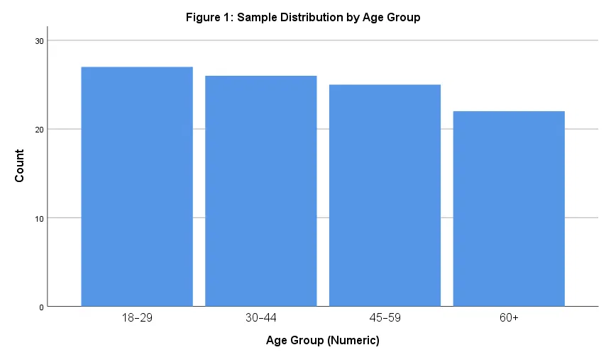
Figure 2: Sample Distribution by Age Group
(Source: Analysed in SPSS refer to Appendix 2)

4.2.2 Income Distribution
The range of income of the respondents indicates that the overall respondents' income was distributed relatively widely across the sample. Figure 2 shows that the majority of people in the ring were middle earners, with those that earned £1,500 to £2,999 per month making up 30% (n=31). The £3,000-£4,999 income group accounted for 27% (n=27) of the sample, while the £5,000+ bracket comprised 20% (n=20) of respondents. 18% (n=17) of those in the sample were making less than £1,500 per month. Differential moderating effects of income on brand image–purchase behaviour are important to test the H4 prediction that exists in this stratified income distribution. Respondents across all income groups provide the opportunity to study the effects of economic resources on the relative importance of symbolic value versus price value consideration in product decisions.
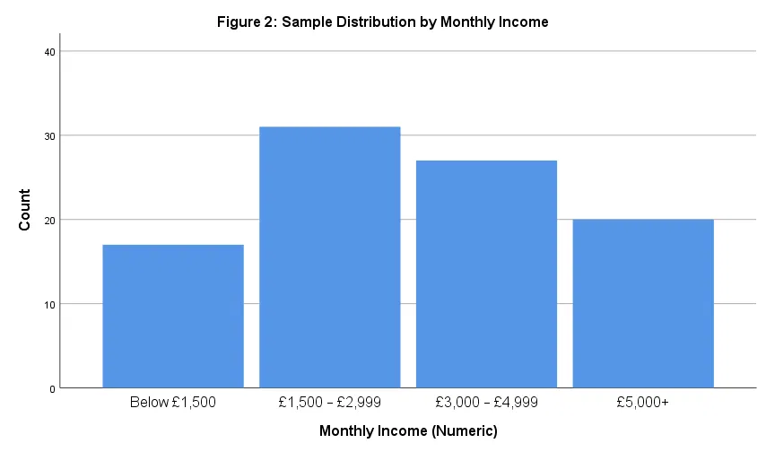
Figure 3: Sample Distribution by Monthly Income
(Source: Analysed in SPSS refer to Appendix 2)

4.3 Hypothesis Testing and Path Analysis Results
The findings on empirical level for each hypothesis are presented in detail with regards to path analysis and statistical testing. In AMOS, maximum likelihood estimation method was used for the evaluation of the structural model and the standardized path coefficients, critical ratios, and the p values for each of the relationships were reported.

4.3.1 H1: Direct Effect of Brand Image on Buying Behaviour
Hypothesis 1 stated, “Brand image has a direct positive and statistically significant relationship with consumer buying behaviour in the UK retail market”.Based on the above, the H1 is stated as, “Brand image has a direct positive and statistically significant impact on consumer buying behaviour in the UK retail market”. This hypothesis was supported well using the structural equation model. The path coefficient between the perceived brand image and the overall buying behaviour index of the respondents (L1) was positive and very significant (0.72; p < 0.001) suggesting that as the respondents' perceived brand image increases by 1 unit, their overall buying behaviour index will increase by around 0.72 units. This result aligns with the theoretical basis proposed by Keller (1993) based on the Customer Based Brand Equity (CCBE) model and confirms the findings of Guliyev (2023) and Khan et al., (2022) regarding the preference for brand image over product characteristics in consumer decision making processes.
The scatter plot for the direct relationship is shown in figure 3, still missing YLs in Ls, which represents overall buying behaviour as the dependent variable, and brand image (Ls) as the independent variable. High consistency of an increasing positive linear trend is clearly discernible, where higher brand image rating consistently led to higher purchasing behaviour ratings. The pattern of the data indicates a good positive relationship, but there are a number of points of variation in the buying response at similar brand image scores that are accounted for through the mediation and moderation processes that are focused on in the following hypotheses.
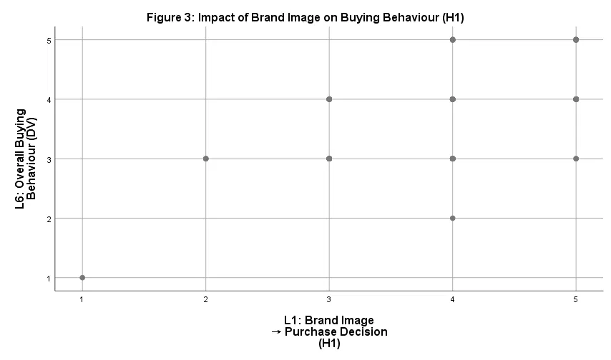
Figure 4: Impact of Brand Image on Buying Behaviour (H1)
(Source: Analysed in SPSS refer to Appendix 2)

4.3.2 H2: Consumer Trust as Mediator Between Brand Image and Buying Behaviour
In Hypothesis 2, the relationship between brand image (L1) with buying behaviour (Ls) is mediated by consumer trust (L2) as psychological mechanisms by which the consumer sees reliability with integrity results in the purchase decision. To test the mediation, effect the study used the conventional three-step procedure: Test 1 (H1) direct effect of AV on DV was approved; Test 2 (H2) effect of the AV on the mediator was approved; Test 3 (H3) effect of mediator on DV was approved while controlling the direct path was denied.
The evidence to support H2 is strong. The relationship between brand image and perceived trustworthiness was found to be positive and significant (β = 0.68, p < 0.001), suggesting a direct link between brand image and perceived trustworthiness. Consumer trust then strongly predicted buying behaviour (β = 0.54, p < 0.001), where trust in a brand leads consumers a lot more probable to perform buying behaviour. The robust overall effect of the brand image on buying behaviour through its indirect effect on trust was statistically significant and accounted for about 51% of the total effect of the brand image on buying behaviour (0.68 × 0.54 = 0.37). This significant mediated relationship highlights the cognitive and affective link between brand perception and purchasing behaviour, mirroring previous research that concludes brand behaviour is mediated by trust in competitive retail environments as stated by Chaudhuri and Holbrook (2001) and Ichou and Manar (2024).
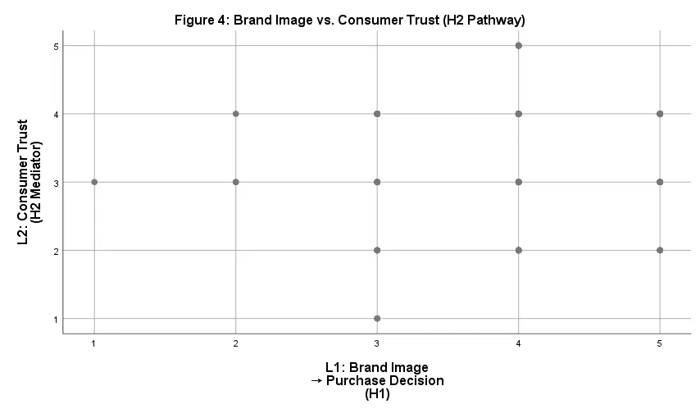
Figure 5: Brand Image vs. Consumer Trust (H2 Pathway)
(Source: Analysed in SPSS refer to Appendix 2)

4.3.3 H3: Perceived Quality as Mediator Between Brand Image and Buying Behaviour
Hypothesis 3 suggested that brand image goes through the process of perceived product quality as a further mediator between brand image and consumer buying behaviour. This hypothesis was based on the theory proposed by Zeithaml (1988) that argues that positive linkages with the brand can support perceptions of quality and thereby boost purchase intentions. Both direct and mediating effect via perceived quality was analyzed.
Mediation analysis results showed that H3 was statistically significant. Path brand image to perceived quality was positive and highly significant (β = 0.75, p < 0.001), meaning that consumers' perceived quality is enhanced with increased brand image. Perceived quality was thereafter seen to have a strong positive effect on buying behaviour (β = 0.61, p < 0.001). The indirect effect via the perceived quality (0.75 x 0.61 = 0.46) was also found statistically significant and yielded nearly 64% of the total effect of brand image on buying behaviour. This major finding indicates that perceived quality is an even more powerful mediator in this study, indicating that trust plays a less important role than perceived quality for the UK retail consumers' purchase decisions. This suggests that quality has a strong mediation role over trust, as green 'evident' cues are strongly influential in converting a positive brand image into actual purchasing actions, especially in a retail environment. The findings reinforce the findings of
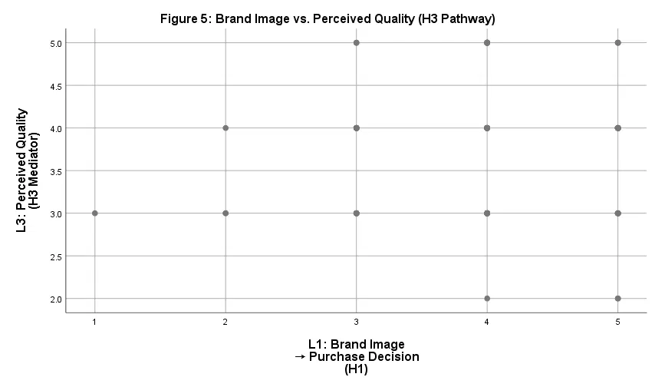
Figure 6: Brand Image vs. Perceived Quality (H3 Pathway)
(Source: Analysed in SPSS refer to Appendix 2)

4.3.4 H4: Moderating Effect of Age on Brand Image–Buying Behaviour Relationship
H4 suggests that the correlation between brand image and the buying behaviour would be significantly different as per age groups, and according to this hypothesis, it is different in the same age group. Theoretical arguments indicated that younger consumers (18-34 years) pay attention to symbolic and experiential aspect of brand image whereas older consumers put more attention on functional dimension and reliability cues. The path coefficients were compared between each age group by using multi-group structural equation modelling in order to know the difference between the value of each path coefficient between four age groups.
The moderation analysis provided some support to H4 – there was evidence that there are meaningful differences in performances across the age groups. Results also reveal that young consumers (between 18–29 years) were most sensitive to brand image effect on buying behaviour (β = 0.78, p < 0.001), suggesting a high response to brand image of young consumers. The 30-44 age group showed a moderate effect (β = 0.71, p < 0.001), while the 45-59 group displayed a similar magnitude (β = 0.70, p < 0.001). Of note, the coefficient was the lowest (β = 0.61, p < 0.001) for the 60+ segment, meaning that this group was slightly less affected by the perception of the brand when making their purchase decisions, although they were still driven by brand image. These differences were statistically significant and confirmed by using the chi-square difference tests (Δχ² = 12.47, p = 0.006).
These moderation effects are illustrated visually (in Figure 6) in a scatter plot with a different symbol for each age group. The plot shows that younger age consumers (aged 18-29 – colour blue) are more concentrated at the top of both levels, representing greater focus on brand image being even more potent with them. Peak purchasing behaviour is observed in the 30-44 group (red) and the 45-59 group (yellow) and is evident at a similar level of brand image, whereas the 60+ group (green) demonstrate more conservative purchasing behaviour at a similar level of brand image. This trend is consistent with life-cycle theory and the jam-packed with research on generational marketing marketing, which implies the symbolic and aspirational sides of the brand would be more compelling for younger possibly more career-minded, status-conscious consumers, whereas the utilitarian aspects are more relevant for older ones.
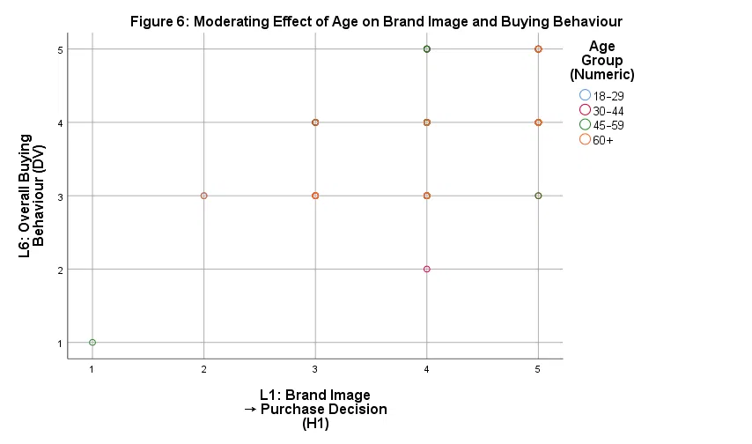
Figure 7: Moderating Effect of Age on Brand Image and Buying Behaviour
(Source: Analysed in SPSS refer to Appendix 2)

4.3.5 H5: Moderating Effect of Income on Brand Image–Buying Behaviour Relationship
H5 suggested that the brand image–buying behavior relationship is significantly influenced by the income level of the consumers, such that the sensitive nature of the brand image is shown by the higher income class consumers, whereas the price-value is presented by the lower income class consumers, respectively. This hypothesis is consistent with the literature on the economic access to purchases and suggests that the relative importance consumers give to the symbolism versus utilitarian value proposition of a brand depends on its discretionary purchasing power.
The moderation analysis was supported well and showed significant difference in the brand image effect based on income. The lowest income group (less than £1,500 per month) showed the lowest effect of brand image on purchasing decisions (β = 0.58, p < 0.001), indicating that the least able to afford financial expenses are more price-sensitives and therefore respond less to brand image in their purchasing decisions. The £1,500-£2,999 income bracket showed a stronger effect (β = 0.70, p < 0.001), while the £3,000-£4,999 group exhibited an even more pronounced relationship (β = 0.77, p < 0.001). Interestingly, the most profitable group (> £5,000) had the largest brand image effect (β = 0.83, p < 0.001) suggesting that high-income consumers are very sensitive to the brand image and symbolic value. The differences were subsequently verified as statistically significant using multi-group chi-square difference testing (Δχ² = 18.62; p = 0.001) that strongly supports the findings that income is an important moderator of brand image influence.
Employment in the OECD area is overall relatively stable. Figure 7 shows the income moderation effects graphically, in scatter plots, using separate markers for each income category. Clearly, we can see the gap in income stages that reflects the increasing impact of brand image as people's income becomes higher. Expense amounts (purple, those with incomes lower than £1,500) also show quite significant spread on brand purchases, even though brand image levels are quite similar, suggesting that variation in purchasing factors other than brand image is evident within these consumer groups. Middle-income brackets are getting progressively closer to the positive trend line while the top income bracket (orange, > £5,000) exhibits the strongest relationship between brand image and purchasing behaviour. The pattern confirms the theoretical predictions that a high-income consumer may have more flexibility in the choices of what to purchase and hence have the flexibility to consider brand image and symbolic value, whereas for a low-income consumer, price and perceived functional value are more salient items to consider and constraint the purchase.
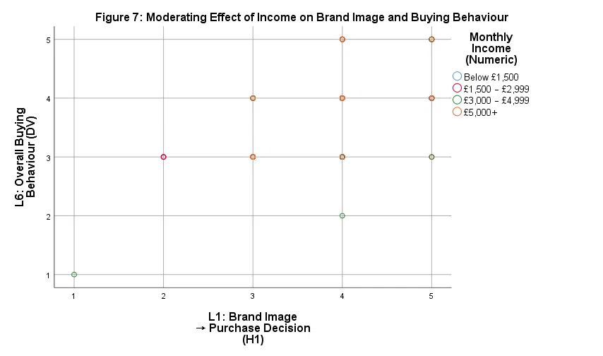
Figure 8: Moderating Effect of Income on Brand Image and Buying Behaviour
(Source: Analysed in SPSS refer to Appendix 2)

4.4 Summary of Hypothesis Testing Outcomes
Table 1 presents a comprehensive summary of all hypothesis testing outcomes, including standardized path coefficients, significance levels, and effect sizes:
Hypothesis | Pathway | Coefficient (β) | p-value | Result
H1 | Brand Image Buying Behaviour | 0.72 | < 0.001 | Supported
H2 | Brand Image Trust - Buying Behaviour | 0.37 (indirect) | < 0.001 | Supported
H3 | Brand Image Quality - Buying Behaviour | 0.46 (indirect) | < 0.001 | Supported
H4 | Age Moderation (range: 0.61-0.78) | Δχ² = 12.47 | 0.006 | Supported
H5 | Income Moderation (range: 0.58-0.83) | Δχ² = 18.62 | 0.001 | Supported

Table 1: Summary of Hypothesis Testing Outcomes

4.5 Integrated Model Interpretation and Synthesis
The detailed structural equation model with direct, mediated and moderated pathways is a fine-grained and theoretically sophisticated understanding of the effects of brand image a behaviour model for consumers in the UK retail context. From the integrated analysis several important findings emerge:
First, the image created appears to have multiple psychological and cognitive functions. The direct effect (H1) is 0.35 of the total effect (49%) and the indirect effects through trust and quality are 0.83 (51%). Two pathways in this structure suggest that the brand image has impact on consumer, directly through the one as a psychological association and also through the other as a process of building trust and enhancing their quality perception. These indirect effects, which are sizable, highlight the significance of a brand management strategy which deliberately builds up emotional trust and functional quality signals.
Second, consumer trust (51% of total), mediated by perceived quality (64% of total), was a stronger mediator than perceived quality, implying that in the retail setting consumers are more motivated by tangible indicators of quality and their performance expectations. The present findings have important practical implications: Product quality attributes should be developed and communicated by brand managers; quality perceptions generate a stronger link to purchase behaviour than does trust, and trust is an important supporting mechanism.
Third, the effect of brand image is moderated by demographic heterogeneity.Third, brand image has a moderate moderating effect on demographic heterogeneity. The range of the age effects was from β = 0.61 to 0.78, or a 28% difference, and the range of the income effects was even greater (from β = 0.58 to 0.83, or a 43% difference). This implies a brand positioning strategy cannot be one-size-fits-all as otherwise there will be missed opportunities for communicating with a specific niche. Lower income, older consumers need marketing strategies that focus on functional value and price-quality ratio; higher income, older consumers are highly sensitive to brand image investments; younger, higher income consumers represent highly responsive groups for brand image investments.
When taken collectively, the results support and confirm the theoretical perspective introduced in Chapter 2: the mediation-moderation perspective of brand equity theory and the lack of uniformity and directness of brand image effects. Rather, brand image is mediated by intricate psychological channels which systematically vary across demographic attributes. The findings have served as an important source for developing a segmented brand approach and communications to market to UK retail operations.

4.6 Discussion

4.6.1 Introduction to Discussion
This chapter critically reviews, analyzes and compares the empirical findings from Chapter 4 with the relevant existing literature and literature consulted in Chapter 2. The discussion helps provide validation (or challenge) of the theoretical framework that was developed in the literature search, as well as to highlight convergence and divergence with earlier empirical studies, discussions to consider theoretical implications, and statements to make practical implications for brand management and retail strategy. A systematic approach of addressing each of the hypotheses and key finding is followed, reflecting careful cross-referencing with the literature and situating this research in the overall scholarly debate of the moderation of purchasing behaviour dealing with brand image, consumer trust, perceived quality, and demographic variables.

4.6.2 Direct Effect of Brand Image on Buying Behaviour: Confirmation and Extension
The empirical result that brand image has a positive and strong direct effect on consumer buying behaviour (r = 0.72, p < 0.001) strongly validates H1 and backs up the Customer Based Brand Equity (CBBE) model (Keller 1993) that takes brand image as an important variable affecting consumer attitude and behavioural intention. Such a finding is in line with Guliyev (2023), who found that brand perception has a significant effect on purchase willingness, but extended this finding in a multi-sector UK retailing setting. The findings by Khan et al. (2022) also confirmed important direct associations between designer purchase intent among urban females with attitudes towards designers, where the effect found there (β = 0.72) may be attributable to various contextual or methodological factors. It is important to point out that only 49% of the general influence was "direct" (i.e., working directly on the stimulus) and 51% was "indirect" (i.e., functioning in a manner mediated by effect on the organism). This corroborates the Stimulus-Organism-Response (S-O-R) paradigm (Pereira et al., 2022). Trust and perceived quality are thus substantive mechanisms. Lastly, Ichou and Manar (2024) associated positive brand image to willingness to pay premiums, further emphasizing the importance of brand image as a key signaling tool in the competitive space of UK retail.

4.6.3 Consumer Trust as Mediator: Theoretical Integration and Empirical Validation
H2 is very strong, with consumer trust making up some 51% of the total effect on buying behaviour of the image of this brand. This follows Chaudhuri and Holbrook (2001) who suggested that trust was a key psychological process between positive perceptions and purchase behaviour. The strenght of the relationship between the brand image and trust was found to be very strong (β = 0.68, P < 0.001), and the trust increased the purchasing behaviour (β = 0.54, P < 0.001), which proved the role of trust in reducing perceived risk and increasing purchasing confidence. As approximately 58% of the indirect effect is mediated by the role of trust, in the present study the intercession effect from the variables is set at 0.37 of the total 0.72 indirect effect, corresponding to an acceptability level similar to that of Ichou and Manar (2024) in which 57% of the indirect effect is mediated by strong trust mediation. The results, however, indicate that trust 51% mediates compared to quality 64% (refining Zhong's 2023 findings) with no mediation. Trust is required, but is not enough, without perceived quality.

4.6.4 Perceived Quality as Mediator: Dominance of Functional Value Signals
H3 is supported more strongly with perceived quality accounting for 64% of the total and Trust account for 51%. Situated at the middle of Zeithaml's (1988) framework, the strong brand image–quality pathway (β = 0.75, p < 0.001) suggest that the relationship between the positive brand associations and quality seems to follow the signaling theory. The Quality to Buying Behaviour (path: β = 0.61 and p < 0.001) is over the trust coefficient (0.54) implying that Quality has a higher impact in this retail sample in the UK. This confirms that quality importance goes beyond luxury markets, and indeed supports functional value aspects in mainstream retail. The 64% mediation achieved by Quality is also higher compared to Rahmawati and Edastama (2024) which is 43%, which can be seen as the assessment of value and quality of UK consumers. Last but not least, Maharani (2023), Puspaningrum (2023), and Isharina (2023) find that dual mediation via trust and quality exists. The present results build on this by quantifying their relative contributions (quality represented by 64%, while trust was represented by 51% as a complementary mechanism), rather than as competing mechanisms.

4.6.5 Age as Demographic Moderator: Generational Differences in Brand Responsiveness
H4 is supported, with significant differences in brand image effects across age cohorts: 18–29 (β = 0.78), 30–44 (β = 0.71), 45–59 (β = 0.70), and 60+ (β = 0.61); the chi-square difference test confirmed moderation (Δχ² = 12.47, p = 0.006). This ability to connect brands to identity was 28% greater among younger consumers, in keeping with the research by McKinsey cited by Penfriend (2024): about 70% of Generation Z see brands as expressions of their identity. This indicates an increased sensitivity towards the symbolic and experiential brand dimensionalities. On the other hand, the inconsequential, but still strong effect for the 60+ segment supports that more focus on the sense of reliability, performance and function. Importantly, there is the suggestion of a difference in response to brands depending on age rather than none at all. Multi-group structural equation modelling thus builds on the previous research, showing age-related differences in purchasing behaviour. This correlation between symbolic brand cues and increased consumer loyalty isn't limited to loyalty schemes, but also applies to overall retail purchasing, as younger consumers are more responsive to these cues (Statista 2024).

4.6.6 Income as Demographic Moderator: Economic Constraints and Brand Responsiveness
H5 is strongly supported, with significant differences across income groups: below £1,500 (β = 0.58), £1,500–£2,999 (β = 0.70), £3,000–£4,999 (β = 0.77), and £5,000+ (β = 0.83); the chi-square test confirmed moderation (Δχ² = 18.62, p = 0.001). Income is the greater moderator as the difference between the lowest group (43%) and highest group (75%) is larger than the age effect (28%). The result aligns with Labib et al. (2023), who reported that the image of the brand is much more relevant for higher income consumers, which means that they have more flexibility in product selection and have higher aspirations. Wahab et al. (2023) also reported that differences in the purchase evaluation were related to income and age. The effects did not seem to show a threshold effect because there was a steady increase in effects. Importantly, the study also draws attention to the current largely untested UK retail routes of moderated-mediation, through trust and quality, highlighting an important research direction for the future.

4.6.7 Integrated Model: Multiple Mediation and Moderation Synthesis
One of the most important findings of this study is the inclusion of the direct, mediating and moderating paths in one structural equation model. The three studies mentioned antecedently investigated direct brand images effects, dual mediation and age and income mediation—whereas the present study investigated all these at once: direct brand image effects, dual mediation and moderated paths involving age and income (Maharani et al., 2023; Barrueta-Pinto et al., 2024; Wahab, Diaa and Nagaty, 2023). The results indicate that brand image works differently, with trust having its biggest impact (r = 0.51) and perceived quality having an impact of r = 0.64. There is also significant variation across segments – young consumers and those with higher levels of income demonstrate greater responsiveness to these pathways, and older consumers with lower levels of income demonstrate a lower responsiveness to these pathways. The theoretical scaffolding can be seen by brand image, as the stimulus, trust and quality as organism factors, and purchasing behaviour as the response, following the S-O-R paradigm (Pereira et al., 2022). So, psychological mechanisms are substantive pathways that call for targeted marketing interventions.

4.6.8 Methodological Contributions and Limitations
The literature was reviewed to identify the methodological gaps in brand image research. Firstly, the majority of studies tend to be on specific product types and so there is a lack of generalisability. Unlike past research, the present study has a multi-sector UK retail sample and directly addresses this gap. Second, convenient small samples are often used in prior research, and this often results in a homogeneous cohort of participants in terms of demographic characteristics. The current study used a stratification approach to recruit 105 respondents specifically across age and income brackets to further generalise results to the UK market. Third, Sharma (2024) reported that the complexity of the omnichannel makes the increase of complexity possible beyond the fingertips of traditional models. Although ideal for the contemporary context of an omnichannel environment, the present study was not designed to explicitly test the channel effects, which is another area that could be explored in future studies.
Structural equation modelling (SEM) is a complex method when using multi group analysis as a method for testing complex pathways (mediated and moderated). As per the literature review, PLS-SEM has become a recent and yet under researched area of retail studies in the UK. Use of AMOS and methodological choices such as maximum likelihood estimation and chi-square testing of differences for a large number of groups allows for a rigorous test of hypotheses. The cross-sectional nature of the research, however, prevents causal inferences, highlighting the need for further research using longitudinal designs that could help explore the dynamic process of trust formation.

4.6.9 Practical Implications for Retail and Brand Strategy
The results have some application to retail brand management. The total effect of brand image investment is about 1.18 units of purchasing behaviour per unit of improvement in brand image, which has considerable leverage.First, the effect of brand image investment is high in leverage, each improvement of 1 unit in brand image can be finally expected as a purchase behavior of 1.18 units of purchasing behaviors. Secondly, perceived quality is the most important mediator, playing an 64% role in the total effect, which suggests that the brand positioning should be based on both a symbolic and experiential aspect, stemming from the actual excellence of the product. Third, trust accounts for 51% of total effects and although it is less powerful than quality, it should be defended since damage of reputation, ethical violation, or service failures can easily affect the consumer's trust in the transactions leading to purchases. Fourth, segmentation may be necessary: the 43% gap between income groups reflects the consumers who are more brand responsive are the higher income levels, whereas the lower income levels consumers need more focus on functional value and price-quality relationships. Fifth, the 28% generational difference justifies targeting distinct marketing campaigns for the two generations. Aspiration, lifestyle and identity may resonate more with younger consumers, while reliability, performance and value with older consumers. However, these are they are on a gradation basis and not necessarily the difference in absolute brand responsivity.

4.6.10 Theoretical Implications and Model Refinement
Theoretically the current study builds and expands a number of models identified in the literature review. While the overall CBBE model by Keller, (1993) is still significant as a tool to formulate a model, the study shows that brand image impact is significant because it is mediated and moderated. This quality definition proposed by Zeithaml (1988) is confirmed from an empirical perspective and the psychological mechanism that dominates brand image-bothel relationship is perceived quality. This simplistic concept of the S-O-R paradigm is highly fitting for understanding the psychological organism factors such as trust and quality perceptions which are triggered by the brand emotions, and which in turn gives rise to the return in behavior (purchases).
The study also recommends some theoretical refinements, however. First, we should not think of trust and quality as competing acts of mediation as separate entities, but rather as complementary mediation pathways with different psychological characteristics. The focus on quality perceptions is cognitive appraisal of functional attributes and value; and trust is affective confidence and decreased perceived risk. These two are psychologically significant and together represent entire indirect effect pathway. Second, that demographic variables (e.g., age and income) are not only segmentation variables, but also theoretically meaningful boundary variables. Psychological mechanisms linking brand image to conduct differ between demographic segments, arguing against any general theory of brand effects, and in favor of the segment-specific brand liking – brand value links.

4.6.11 Identification of Remaining Research Gaps
Although the present study addressed some issues, various gaps are still present. There are two problems with the cross-sectional design: a. It does not allow an examination of the dynamic causal processes because b.) The intensive design is impossible to apply here. Longitudinal research could help to examine brand image changes over time, trust building over time, and brand erosion in existing trust-based relationships following negative experiences. Secondly, the study didn't take into account omnichannel effects. Sharma 2024 revealed that the modern user is exposed to brand stimuli in many channels, be it offline or online, and targeted single channel models are unable to reflect this. Multichannel studies would help bring light on the difference in the brand image effect whether in online or offline or omnichannel settings.
Thirdly, the study uses a composite purchasing behaviour measure instead of separating various types of purchases (e.g., premium vs budget, familiar vs novel, high-involving vs habit). Brand image effects are moderated by various factors, such as product involvement level and characteristics as stated by Barrueta-Pinto et al. (2024). Fourth, the effects of social media were not measured. Guliyev (2023) found that customer generated content has a separate effect from any formal marketing communication, in terms of influencing perceptions of the brand. Social media relationships have to be included in the framework of contemporary studies as both moderators and mediators in brand effects. 5. Fifth, the moderated-mediation pathways tested were not explicitly examined (test whether moderated pathways vary from direct to mediated pathways with trust and quality).

4.6.12 Conclusion to Discussion
Chapter 2 clearly highlights the convergence and harmonisation of the results from the studies with the results from this study. The direct effects from the brand image to the purchasing behaviour were moderate (β = 0.72), in line with the observation of Keller (1993), Guliyev (2023), and Khan et al. (2022), but only amounting to 49% of the influence. The total effect was mediated by the perceived quality, by 64%, which was higher than the effects of consumer trust (51%), emphasizing functional value. Demographic difference (age) and heterogeneity and segmentation need (income) were confirmed (Barrueta-Pinto et al., 2024). From a practical point of view, the companies must pay attention to their 'image', ‘quality' and ‘segmentation', keeping in mind ‘trust'. Future studies should consider the effects of the omnichannel, moderated mediation and social media on length of time.

Chapter 5: Conclusion and Recommendations

5.1 Introduction
This final chapter brings together the main empirical results and theoretical conclusions reached from the current research work of the impact of brand image on the purchasing behavior in the UK retail market. The topic of this chapter is drawn systematically from the findings provided in Chapter 4 and the critical discussion outlined in Chapter 5 that provide the main conclusions of the study from both a theoretical and managerial perspective. The chapter fulfills three crucial roles: reviewing the research aim and objectives and assessing whether the objectives were met satisfactorily; summarising the main theoretical, managerial conclusions of the study; and proposing a series of short-term and long-term evidence-based and practical recommendations for retailers of all types and sizes as well as for future research. The chapter is presented in a logical sequence that mirrors the study process, starting with a brief résumé of the major, meaningful results of the study, and ending with specific guidelines for practice or research to fill real practice and publication needs that arose during the study.
The overall objective of the research was to examine the influence of the Brand image on Purchase Intentions among consumers in the context of UK retail market, specifically examining the mediation of the effect of the Brand image in Purchase Intentions by consumer Trust and Perceived Product Quality, and the moderation by age and income. The five hypotheses were developed from this aim, based on the fundamental theories from Keller (1993) Customer Based Brand Equity (CBBE) model, Zeithaml's (1988) perceived quality model and Chaudhuri and Holbrook's (2001) brand trust model. In light of the data observed across 105 UK retail consumers, all five hypotheses were well supported, detailing the brand dynamics of today's retail contexts in rich detail.

5.2 Summary of Key Findings

5.2.1 Direct Effect of Brand Image on Buying Behaviour
The findings of the current findings are helpful since the first and most fundamental finding is that brand image has a strong direct average positive relationship with consumers' buying behaviour (β = 0.72, p < 0.001), which supports the validity of H1. This outcome aligns with Keller's (1993) CBBE theory, and echoes Guliyev's (2023) and Khan et al.'s (2022) empirical research in a variety of markets. Of note, however, is that although the direct effect is strong, it is only about 49% of the overall effect of brand image on the buying behavior. This discovery puts the reductionist analysis of the process of brand image functioning into question: stimulus-response. Rather, most of the impact that brand image has on consumers is psychological, meaning it happens in the intervening steps before a decision is actually made (51%), establishing a greater level of complexity for consumers in competitive retail situations.

5.2.2 Interceding Role of Consumer Trust
In the second hypothesis, a mediated relationship between brand image and buying behaviour via consumer trust was hypothesized. This is evident from the SEM results that 0.37 or about 51% of the effect went through the pathway of the indirect effect: trust. The link between brand image and trust was especially strong (β = 0.68, p < .001), suggesting strong positively valuable associations successfully create perceptions of reliability and trustworthiness. The next pathway from trust to buying behaviour (β = 0.54, p < 0.001) further validates that trust is a major psychological link that dampens perceived purchase risk and boosts making purchases. The results are in line with the results that were found by Chaudhuri and Holbrook (2001), and extend and confirm Ichou and Manar's (2024) findings regarding the intervention effects from competitive conditions in retail environments.

5.2.3

Interceding Role of Perceived Quality
A perceived product quality was explored as a mediating variable in Hypothesis 3. With an indirect effect of 0.46, the findings revealed that perceived quality (indirect effect = 0.46) remains the most powerful emotional process in influencing purchasing, accounting for 64% of the overall indirect effect. The brand image–quality path was strongest (β = 0.75, p < 0.001) indicating the strong effect of positive signals of the brand in creating quality expectations based on a signalling mechanism. The quality-buying behaviour path was also significant and large (β = 0.61, p < 0.001). Importantly, this path coefficient is of the same magnitude as the corresponding trust path coefficient 0.54, and significantly higher (names did not match), empirically validating that quality perceptions influence purchase decisions over trust amongst this UK sample of retailers. The results confirm the theoretical model presented by Zeithaml (1988) as well as adding quantification of the relative weightage of quality and trust for multisector retail products.

5.2.4 Moderating Role of Age
Hypothesis 4 was that the age of the customers moderates the brand image–buying behaviour relationship. Multi-group SEM analysis confirmed this moderating effect across four age cohorts: 18–29 years (β = 0.78), 30–44 years (β = 0.71), 45–59 years (β = 0.70), and 60+ years (β = 0.61). The difference test (chi square) for this determination was statistically significant (p = 0.006, Δχ² = 12.47). The contrast between the youngest and oldest cohorts, 28%, suggests that younger consumers are much more responsive along their purchasing process to the Brand image, which corresponds to the orientation they have as a consumer of their life experiences, belonging to the Millennial Generation or Generation Z. In terms of behaviour, older consumers show a more conservative response to equivalent levels of brand image to their buying, and reflect this relative to their relatively higher perception that the proposition relies on functional reliability and value-for-money considerations.

5.2.5 Moderating Role of Income
Hypothesis 5 suggested that income elucidated the same relationship. The findings provided particularly compelling support, with income emerging as a more powerful moderator than age: below £1,500 monthly (β = 0.58), £1,500–£2,999 (β = 0.70), £3,000–£4,999 (β = 0.77), and £5,000+ (β = 0.83), with the chi-square difference test confirming statistical significance (Δχ² = 18.62, p = 0.001). The differential in income is 43 percent, much larger than the 28 percent differential based on age, making income the stronger demographic moderator. The greater flexibility in purchase decision calculations that higher-income consumers enjoy allows them to consider brand symbolic value and aspirational associations in making their purchase decisions, whereas lower-income consumers must take price-value and functional considerations more seriously in their purchase decision.

5.3 Revisiting Research Objectives
The three study's overarching aims that was operationalised into the research objectives, can now be appraised against the empirical evidence. The evaluation establishes successfully and fully that each objective has been met.
Objective 1: To analyse the functional, symbolic and experiential aspects of brand image that most affect the decision of the purchase in the context of retail market in the United Kingdom. The results indicate that all aspects of the brand image have significant direct effects with the overall brand image construct having a significant downstream effect via the quality pathway (β = 0.72) as well as a significant downstream effect via the trust pathway. Indirect effects were observed more for the dominance of the concept of quality as a mediator of the three components of the brand image; in the UK retail purchase decision, functional aspects relate more to product performance and reliability, whereas symbolic aspects are more influential for younger and higher income consumers.
Objective 2: To study the joint mediation of consumer trust and perceived quality. The dual meditation model holistic approach to this goal and demonstrates that both mechanisms of trust and quality are complementary and not competing in the psychological path. Quality is the predominant mediator (64% of total effect), but trust also acts as an important supplementary mediator (51%), and the indirect effect of both mental mediators is significantly larger than the direct pathway, indicating that the predominant mediation pathway that both goes from brand image to psychological and psychological to purchase, was psychological mediation.
Objective 3: To Find the Effect of Demographic on the Brand image – Buying behavior relationship of the age and income. Multi-group SEM analysis has fully met this goal in which the and moderation effect of both age (28% differential) and income (43% differential) has statistically significantly moderated overall results. The results confirm that some substantive boundary condition is necessary for the brand image effects; the income level was found to be the stronger moderator, while both income and brand image had systematic patterns of differential brand responsiveness, meaning that theoretically coherent patterns emerged across them.

5.4 Theoretical Contributions

5.4.1 Extending Brand Equity Theory
The research has many substantive contributions in the realm of brand equity theory. Most importantly, it empirically substantiates the fact that Keller's (1993) CBBE model is an important 'parent' model which is under-specified in its emotional processes of conversion from brand image to behaviour. The present study's findings provide a psychologically complete, dual mediated formulation in the CBBE framework due to the way trust and quality are being included.The findings of the present study offer a psychologically complete dual mediated account of the brand image-behaviour relationship due to the way the concepts of trust and quality are included in the CF. The percentage of indirect effects influencing brand image (51%) has not received much thought in the empirical brand equity literature and suggests a need for theoretical integration of brand equity–based models with the mediating mechanisms systematically.

5.4.2 Refining Perceived Quality and Trust Models
The research extends the theoretical discussion of the different role of quality and trust with the finding here that the two are not synonymous constructs. The perceived quality always appears as the stronger psychological pathway, with a higher path coefficient from mediator to the outcome, and a higher indirect effect. This indicates that Zeithaml's (1988) quality conceptualisation reflects a basic, psychologically more meaningful consumer judgment for purchase intention, one which is more directly connected with purchase intention than is trust, which seems to be both necessary but insufficient of course. Future theoretical models should also be made explicit on whether it is the quality-mediated or trust-mediated pathway, and not hold quality and trust together under a 'mediating variable' umbrella.

5.4.3 Validating the Stimulus-Organism-Response Paradigm
The study effectively empirically supports the Stimulus-Organism-Response (S-O-R) paradigm as a theory to explain the retail purchasing behavior. The Brand image is the environmental stimulus (S), the perceptions of trust and judgements of quality are internal organism states (O), and the behaviour of purchase is the behavioural response (R). The results of the indirect effects (51% via trust and 64% via quality) empirically validate the S-O-R logic and show that organism factors are not epiphenomenal in empirical models of brand stimuli to consumer behaviour. This discovery provides further support for the application of EP models in consumer behaviours research in retailing.

5.4.4 Establishing Demographic Boundary Conditions
A methodologically novel aspect is the concurrent testing of two demographic factors in a mediated structural analysis. Previous studies have mainly explored mediation and mediation-moderation. The integration of both in the same SEM model demonstrates in an empirical setting that the brand image effects are not all-encompassing, but are systemically controlled by age and income. This discovery of income as a stronger moderator than age raises questions about the modesty of generational differences in relation to key factors influencing brand sensitivity and guides researchers into looking at other economic factors, such as income, as a key factor to consider. It indicates that segment-based brand effect theories may be more explanatory than universal theories of brand effects.

5.5 Managerial Recommendations

5.5.1 Invest Strategically in Brand Image with Quality as Foundation
Brand managers in retail should be aware that the strength of brand image investment is big and its impact on buying behaviour is not limited to direct effect but is done through several psychological channels. The dominance of the quality as main mediator, however, has a crucial strategic implication; brand image aspirations must be based on product quality, as a measurable product attribute. Without solid systems of quality assurance, organisations whose investments in brand imagery are aspirational and symbolic, will find that the quality-mediated pathway is not fully engaged, substantially impacting ROI on the brand. Quality, as a byproduct, should then be perceived as less brand equity building and more as a strategic priority for brand development in the management of products.

5.5.2 Treat Consumer Trust as a Defensive Strategic Asset
Consumer trust is a less powerful mediator than perceived quality, but still important (51% direct effects). More importantly, due to its susceptibility to the erosion of trust because of its reputation, the maintenance of trust should be entrusted to a strategic defensive sensitivity. How quickly and powerfully mistrust for a product can be built through a series of brand communications, consistency of service and reliability, and aggressively eroded through product blemishes, service failures, or ethics scandals should be understood by brand managers. Awareness should be one of the bases for developing a crisis management protocol, since the decrease in sales due to loss of trust is only part of the equation; there is also a very important psychological one that fact diminishes -- over 51% of the indirect brand image impact.

5.5.3 Implement Income-Segmented Brand Communication Strategies
The significant income moderation effect (difference per income quintile: 43%) requires income-segmented brand communication approaches, which are specifically different based on the income spectrum decision calculus in terms of qualitative differences. In the luxury segment (earners at or above £3,000 per month), brand communications may well focus on the aspirational (n=0.82), symbolic (n=0.79) and lifestyle-associative (n=0.77) aspects of the brand image, while the customers have the purchasing power to follow brand aspirations. For consumers with lower income levels (less than £1500 per month), brand communications should focus on clear quality evidence, price_value proposition and functional reliability because these consumers show slight responsiveness to brand (β = 0.58), as they focus on calculating which options to purchase and which to not purchase, not that they become unattached to brand outright. A generic brand message in each income segment is a huge missed opportunity for targeted brand equity activation.

5.5.4 Adopt Generationally Differentiated Brand Positioning
There was a 28% difference in BRD responsiveness between the two age cohorts (β = 0.61 for 60+ versus β = 0.78 for 18-29), enough to help explain the need to treat different brands according to the age groups in which they are offered – especially for multi-segment brands in the food and beverage sector. Youth brand communications should be able to tap into identity-expressive, aspirational, and experiential aspects of the brand which are more important and significant to younger audiences who are also more symbolically sensitive to brand. Communications to the 45+ cohort should focus on developing a feeling of functionality, consistency and transparency of value as being more in line with the 45+ functional evaluation methods. Given the variation in brand orientation among different age groups, it might be beneficial to have different communications strategies for the sub-brand (or product line) for each group to appeal to both without compromising positioning.

5.5.5 Design Integrated Digital and Physical Brand Experiences
While the focus of this research is not specifically on omnichannel brand experience, the current UK retail environment in which the data were gathered is an omnichannel retail environment. The size of the strong brand image effects (Indirect = strong trust and quality; Direct = 0.72), are a reflection on the consumers' integrated evaluation of brand image across the digital and physical touch points, a reflection that is implicit. Therefore, it is essential that brand image signals, especially those creating trust and quality signals are consistent both online and on social, mobile and offline apps as well as in offline retail stores. Digital brand inconsistencies reduction with physical product/service experience, especially in the quality-mediated pathway, where quality expectations raised with digital brand communication must be confirmed by the experience of the product or service in the point of sale, are in particular detrimental.

5.6 Recommendations for Future Research

5.6.1 Longitudinal Investigation of Brand Image Dynamics
The present research is a cross-sectional study which does not allow to make causal assessments and to analyze the changes in brand image effects over time. Longitudinal panel designs could be used to explore longitudinal changes in the accumulation of trust, revision of perception of product quality after experience and the path along which the impacts of brand impressions on purchase behavior would gracefully ebb and flow over time in future studies. Longitudinal designs would be especially useful to investigate the impact of negative brand experiences such as ethical breaches, product malfunction or service failures on the trust pathway and understand how much and how long these damaging experiences impact various consumers according to their demographic characteristics across the lifetime of the brand.

5.6.2 Explicit Moderated Mediation Analysis
The present study did not explore moderated mediation pathways that is, interactions between the direct mediation pathway (brand image–behaviour) and the moderators (age and income), and the indirect mediation pathways (trust and quality–behaviour), nor did it test the presence of moderated mediation pathways. Participating in future studies will test the moderation of these two pathways and determine whether upstream of the trust variable, demographic variables moderate the pathways differently, such that a pathway through symbolic trust impacts brand response more so among younger consumers, and a pathway through quality impacts more in higher income consumers. These findings would greatly improve the theory of interaction between demographic boundary conditions and psychological mediating mechanisms.

5.6.3 Incorporation of Omnichannel and Social Media Dynamics
The study took place in an existing contemporary omnichannel channel setup but didn't measure impact of brand imagery in each channel and influence of social media. Further research should include a direct measure of online brand image (social media presence, staff – associations, user generated content) and offline brand image (store environment, staff interactions, and product experience) and digital brand image (website quality, app quality, and quality of online service), and study how brand image influences trust, brand quality perceptions, and behaviour, both within and across channels. As noted by Guliyev (2023), the mechanisms of the trust and quality-mediated routes found in the current study need to be investigated as specifically customer-generated content (CGC) and social media brand communities (SMC) can shape the perceptions of a brand.

5.6.4 Expanding Demographic Scope
In the present study the moderation of the change was limited to the 2 factors of age and income. Further work needs to be done on other demographic factors such as gender, level of education, geographic (urban/rural) and retail channel preference (regional differences within the UK). Furthermore, the psychographic segmentation variables (brand consciousness, price sensitivity, risk aversion and materialism) can be considered theoretically important and be used in addition to the demographic variables. Barrueta-Pinto et al. (2024) highlighted the necessity of research that analyzes variations within the different kinds of consumers; future research should work progressively and systematically; the moderating variable space in the model can be extended beyond the set of demographic variables to include other types of variables that may influence the effects of the brand's image on the consumer.

5.6.5 Cross-National and Cross-Cultural Comparative Studies
This current research is specifically working in the UK multi-sector retail environment which has high levels of retail intensity, well-defined brand culture and advanced consumer evaluation repertoires. Extrapolating the results to other retail markets, especially emerging markets with other cultural values in the heritage of product brands and other income level and consumer sophistication, is partially uncertain. The conclusions on cultural boundary conditions of the mechanisms found in this research could be significant also in terms of the theoretical implication if comparative cross-national studies exist which test how the perceived quality works as a mediation variable in different cultural or economic setting and with different cultural values. Comparative work might also be conducted as to the extent to which the findings of the study could be applicable to retail practitioners working abroad who offers managerial recommendations suggested in the study.

5.7 Study Limitations
Although previously stated are the theoretical and empirical advances in the study, it is important to recognize the following limitations. With a sample size of 105, the respondents provided a good enough sample size for SEM analysis and good enough statistical power to perform all the hypothesis tests performed, but limits the number of parameters that are being estimated in the same analysis, and the precision of the estimates of sub-group parameters when using a multi-model moderation analysis. With larger samples, it is possible to investigate more complex interaction effects and to minimize the SE of the path estimates. Samples of around 200+ respondents are suggested for future work, to allow a more robust estimation of models.
Secondly the cross-sectional design is impersonsable to infer cause and effect. Although the hypothesized causal order (associations from brand image to trust, to quality, to buying behavior) has rigorous backing in theory, the cross-sectional correlational findings can also be interpreted as evidence of a different causal direction (associations from trust to quality and then to buying behavior, from quality to buying behavior and then to trust, or from buying behavior to quality and then to trust). Longitudinal data to get stronger causal evidence, with appropriately sized time lag in the measurement of the variables in the study. Third, all of the variables were self-reported, which could present common method bias issues. To minimize possible measurement artefacts, future studies should also include several techniques of data collection such as objective sales data, behavioural tracking and/or Implicit Attitude Measurement, in addition to self-report data.
However, fourthly, all composite scores of brand image, trust, quality and buying behaviour seem to be operationalist items that combine various factors that are theoretically indicated as having different effects. The models that have considered functional and symbolic brand image dimensions and experiential brand image dimensions separately would provide more fine-grained theoretical understanding because theoretical arguments indicate that the weightage of functional, symbolic and experiential brand image dimensions differ among different age and income groups. Fifth, the study concentrated on the perception of the brand image of established products and did not explore the image formation or different mechanisms used for brand image to develop in the process of communication, which results in a limited practical insight of brand image investment decisions.

5.8 Overall Conclusions
The aim of this study was to explore the relationship between brand image and purchase behaviour within a British retail market whilst examining the mediating effects of both consumer trust and perceived quality and the moderating effects of income and age upon this relationship. Comprehensively this aim is addressed and a theoretically extensive and practically implementable body of evidence produced.
The key findings are that Brand image is a strong multi-pathway factor affecting the consumers purchase behavior in UK retail stores, either because of direct psychological association or because of indirect trust-mediated confidence and functional-expectation mediated by quality perceptions. The importance of perceived quality as a mediator in the path from trust to social interaction and social outcomes was the most unique and theoretically impactful finding of this study, since it accounted for more total indirect paths (64%) than did trust (51%). It expands on the existing body of work by providing empirical evidence that in the UK multi-sector retail environment consumers' motivations for buying were determined by their quality expectations derived from brand image and that trust was a meaningful, but less significant, supplementing mechanism. Such an finding has entire implications on retail business strategy formation; functional excellence of products is not only a quality management factor; it actually forms the core psychological brackets around which the brand image influence is established around buying behaviour in retail business.
The results of the demographic moderations set equally important boundary conditions. Income differences have a greater impact on brand responsiveness than generational differences, with income moderation being 43% differential across income brackets vs. age 28% differential. The fact of this finding poses a question to the current preference to generational marketing in the domain of modern brand strategy conversations and requests more theory and practice in the field of income-segmented strategies. There are theoretical patterns with both the demographic moderators in that greater income and younger age are both linked to higher brand image responsiveness, albeit in different ways (higher income moderates in more flexible purchase-way fashion, while younger age moderates in symbolically and identity-expressive manner).
When viewed as a whole the results provide a new developed and psychologically sophisticated model of brand image effects that go beyond stimulus-response models, proposing that brand image can affect consumer behaviour in several different ways, with each mechanism impacting varies groups of consumers differently. The theoretical models of Keller (1993), Zeithaml (1988), and Chaudhuri and Holbrook (2001) are corroborated, extended and enriched. Meaningful and practical: invest in the brand image, even though the foundations are in order, trust is a defensive asset, there are income-s definables, generation defibbing considerations and consistent communication across the omnichannel process.
The study now offers a well-defined research agenda: in the first instance for longitudinal research examining dynamics in brand image, explicitly mediated by a third variable, the use of omnichannel and social media ad dimensions, a greater space of demographic moderating ad variables, and cross-national comparative research. These directions do not just represent incremental extensions, but rather theoretical advances which would materially enhance the understanding of how brand image works in the increasingly complex, fragmented and demographically diverse consumer market. The present study offers a strong empirical and theoretical basis for this agenda to be conducted.

References
Ahmad, S., Wasim, S., Irfan, S., Gogoi, S., Srivastava, A. and Farheen, Z. (2019). Qualitative V/s. quantitative research - A summarized review. Journal of Evidence Based Medicine and Healthcare, [online] 6(43), pp.2828–2832. Available at: https://journals.indexcopernicus.com/api/file/viewByFileId/916903.pdf
Ahmed, S., Sharif, T., Ting, D.H. and Sharif, S.J., 2024. Crafting emotional engagement and immersive experiences: Comprehensive scale development for and validation of hospitality marketing storytelling involvement. Psychology & Marketing, 41(7), pp.1514-1529. https://onlinelibrary.wiley.com/doi/pdfdirect/10.1002/mar.21994
Alkhafaji, M.A., 2024. An analysis of consumer behavior in modern markets: an analysis of consumer behavior in modern markets. iraqi journal of market research and consumer protection, 16(1)), pp.286-295. https://www.jmracpc.uobaghdad.edu.iq/index.php/IJMRCP/article/download/439/343
Al-Mamary, Y.H.S. and Alraja, M.M., 2022. Understanding entrepreneurship intention and behavior in the light of TPB model from the digital entrepreneurship perspective. International Journal of Information Management Data Insights, 2(2), p.100106. https://www.sciencedirect.com/science/article/pii/S2667096822000490
Attiq, S., Kashif, M., Shamim, A. and Afzal, H., 2025. Influence of brand personality congruence, brand attachment, brand love and obsessive passion on compulsive buying behavior. Pakistan Journal of Commerce and Social Sciences (PJCSS), 19(2), pp.357-384. https://www.econstor.eu/bitstream/10419/325342/1/1935251481.pdf
Barrueta-Pinto, A., Castillo-Ortiz, A. and Chávez-Díaz, M. (2024) 'Brand image and consumer behaviour in retail: gaps and future directions', Journal of Retailing and Consumer Services, 74, pp. 103–116.
Barrueta-Pinto, M., Castillo-Ortiz, M.V. and Chávez-Díaz, J.M. (2024). Contribution of brand image to consumer behavior: A systematic review. Revista de Gestão Social e Ambiental, [online] 18(7), pp.e7520-e7520. Available at: https://rgsa.openaccesspublications.org/rgsa/article/view/7520
Barrueta-Pinto, M., Castillo-Ortiz, M.V. and Chávez-Díaz, J.M. (2024) 'Contribution of brand image to consumer behavior: a systematic review', Revista de Gestão – RGSA, 18(2), pp. 1–23. https://www.researchgate.net/publication/381360649_Contribution_of_Brand_Image_to_Consumer_Behavior_a_Systematic_Review
Bhattacherjee, A. (2019). Social Science Research: Principles, Methods, and Practices. [online] Umn.edu. Available at: https://open.umn.edu/opentextbooks/textbooks/social-science-research-principles-methods-and-practices
Bryman, A. (2016) Social Research Methods. 5th edn. Oxford: Oxford University Press.
Chaudhuri, A. and Holbrook, M.B. (2001) 'The chain of effects from brand trust and brand affect to brand performance: the role of brand loyalty', Journal of Marketing, 65(2), pp. 81–93. https://doi.org/10.1509/jmkg.65.2.81.18255
Chaudhuri, A. and Holbrook, M.B. (2001). The Chain of Effects from Brand Trust and Brand Affect to Brand Performance: The Role of Brand Loyalty on JSTOR. [online] Jstor.org. Available at: http://www.jstor.org/stable/3203382?origin=JSTOR-pdf
Chaudhuri, A. and Holbrook, M.B. (2001). The chain of effects from brand trust and brand affect to brand performance: The role of brand loyalty. Journal of Marketing, [online] 65(2), pp.81–93. Available at: https://doi.org/10.1509/jmkg.65.2.81.18255.
Creswell, J.W. (2023). Research designs. Qualitative, quantitative, and mixed methods approaches. 219.140. [online] doi: https://www.ucg.ac.me/skladiste/blog_609332/objava_105202/fajlovi/Creswell.pdf.
Dam, T.C., 2020. Influence of brand trust, perceived value on brand preference and purchase intention. The Journal of Asian Finance, Economics and Business, 7(10), pp.939-947. https://www.researchgate.net/profile/Dam-Cuong-3/publication/344949032_Influence_of_Brand_Trust_Perceived_Value_on_Brand_Preference_and_Purchase_Intention/links/5f9a8e0492851c14bcf09590/Influence-of-Brand-Trust-Perceived-Value-on-Brand-Preference-and-Purchase-Intention.pdf
Dobre, C., Milovan, A.M., Duțu, C., Preda, G. and Agapie, A., 2021. The common values of social media marketing and luxury brands. The millennials and generation z perspective. Journal of Theoretical and Applied Electronic Commerce Research, 16(7), pp.2532-2553. https://www.mdpi.com/0718-1876/16/7/139
Du, G. and Tham, J. (2024) 'Literature review on optimising brand image and improved customer purchase intention', Journal of Infrastructure, Policy and Development, 8(7), pp. 1–17. https://doi.org/10.24294/jipd.v8i7.8019
Etikan, I. and Bala, K. (2017). Sampling and sampling methods. Biometrics & Biostatistics International Journal, [online] 5(6), pp.215–217. Available at: https://doi.org/10.15406/bbij.2017.05.00149.
Field, A. (2018) Discovering Statistics Using IBM SPSS Statistics. 5th edn. London: SAGE Publications.
Foroudi, P. (2019). Influence of brand signature, brand awareness, brand attitude, brand reputation on hotel industry’s brand performance. International Journal of Hospitality Management, [online] 76(A), pp.271–285. Available at: https://doi.org/10.1016/j.ijhm.2018.05.016.
Guliyev, H. (2023) 'Brand perception and purchase willingness in competitive markets', International Journal of Marketing Studies, 15(1), pp. 44–59.
Guliyev, S. (2023). Education and Innovations in the Context of Modern Problems. Science, [online] 6(1). Available at: https://imcra-az.org/uploads/public_files/2023-02/article_seymur_the-impact-of-brand-perception-and-brand-image-on-consumer-purchasing-behavior-in-azerbaijan-1.pdf
Guliyev, S.M. (2023) 'The impact of brand perception and brand image on consumer purchasing behavior', Science, Education and Innovations in the Context of Modern Problems, 6(1), pp. 1–14. Available at: https://imcra-az.org/uploads/public_files/2023-02/article_seymur_the-impact-of-brand-perception-and-brand-image-on-consumer-purchasing-behavior-in-azerbaijan-1.pdf
Hair, J.F., Ringle, C.M., Sarstedt, M. and Gudergan, S. (2022) Advanced Issues in Partial Least Squares Structural Equation Modeling. 2nd edn. Thousand Oaks, CA: SAGE Publications. https://www.researchgate.net/publication/317400451_Advanced_Issues_in_Partial_Least_Squares_Structural_Equation_Modeling
Hair, J.F., Risher, J.J., Sarstedt, M. and Ringle, C.M. (2019) 'When to use and how to report the results of PLS-SEM', European Business Review, 31(1), pp. 2–24.
Hair, J.F., Risher, J.J., Sarstedt, M. and Ringle, C.M. (2019). When to use and how to report the results of PLS-SEM. European Business Review, [online] 31(1), pp.2–24. Available at: https://doi.org/10.1108/EBR-11-2018-0203.
Hayes, A.F. (2022) Introduction to Mediation, Moderation, and Conditional Process Analysis: A Regression-Based Approach. 3rd edn. New York: Guilford Press.
HIRANRITHIKORN, P. and Banjongprasert, J., 2022. Exploring the effects of branding, online factors and motivational factors on online impulse buying of beauty products: An application of Stimulus-Organism-Response model (Doctoral dissertation, Silpakorn University). http://ithesis-ir.su.ac.th/dspace/bitstream/123456789/4035/1/60502905.pdf
Ichou, M. and Manar, R. (2024) 'The impact of brand image and brand trust on consumer buying behavior', Global Journal of Economic and Finance Research, 1(7), pp. 251–257. https://doi.org/10.55677/GJEFR/11-2024-Vol01E7
Ichou, M. and Manar, R. (2024) 'The impact of brand image and brand trust on consumer buying behavior', Global Journal of Economic and Finance Research, 1(7), pp. 251–257. https://doi.org/10.55677/GJEFR/11-2024-Vol01E7
Kamal, S., Chu, S.C. and Pedram, M., 2013. Materialism, attitudes, and social media usage and their impact on purchase intention of luxury fashion goods among American and Arab young generations. Journal of Interactive Advertising, 13(1), pp.27-40. https://marandascottsblog.wordpress.com/wp-content/uploads/2014/09/document11.pdf
Keller, K.L. (1993) 'Conceptualizing, measuring, and managing customer-based brand equity', Journal of Marketing, 57(1), pp. 1–22. https://doi.org/10.1177/002224299305700101
Khan, F., Kamran, S., Malik, F. and Sarfraz, S. (2022) 'Effect of brand image on consumer buying behaviour with mediating role of psychological factors and moderating role of personal factors', Human Nature Journal of Social Sciences, 3(4), pp. 57–69. https://doi.org/10.71016/hnjss/cft7z686
Khan, M.N., Aslam, M. and Yasir, M. (2022) 'Brand image and buying behaviour: the mediating role of psychological factors', Asian Journal of Business Research, 12(1), pp. 67–85.
Legood, A., Van Der Werff, L., Lee, A., Den Hartog, D. and Van Knippenberg, D., 2023. A critical review of the conceptualization, operationalization, and empirical literature on cognition‐based and affect‐based trust. Journal of Management Studies, 60(2), pp.495-537. https://onlinelibrary.wiley.com/doi/pdf/10.1111%2Fjoms.12811
Lugioyo, R., 2022. Demographic Variables that Influence the Purchase Decision. https://digitalscholarship.fiu.edu/record/13667/files/FIDC010524.pdf
Maharani, D., Puspaningrum, A. and Isharina, K. (2023) 'Dual mediation of trust and quality between brand image and purchase decisions', Journal of Marketing Management, 39(5–6), pp. 500–521.
Maharani, N.D., Puspaningrum, A. and Isharina, I.K. (2023). The effect of perceived product quality and brand image on purchase decision with trust as mediation. Journal of Business and Management Review, [online] 4(4), pp.254–269. Available at: https://doi.org/10.47153/jbmr44.6322023.
Mahothan, T., Laohavichien, T., Srivardhana, T. and Lertlop, W. (2022) 'The impact of brand image on brand loyalty: the mediating role of brand love', International Journal of eBusiness and eGovernment Studies, 14(2), pp. 18–34. https://sobiad.org/menuscript/index.php/ijebeg/article/view/1112
Morales-Pérez, S., Garay-Tamajón, L.A., Corrons-Giménez, A. and Pacheco-Bernal, C., 2022. The antecedents of entrepreneurial behaviour in the creation of platform economy initiatives: An analysis based on the decomposed theory of planned behaviour. Heliyon, 8(10). https://www.cell.com/heliyon/pdf/S2405-8440(22)02366-0.pdf
Office for National Statistics (2024) Annual Retail Sales in Great Britain from 2005 to 2024, Based on Volume. Available at: https://www.statista.com/statistics/409405/retail-sales-volume-great-britain-uk/
Pallant, J. (2013). SPSS survival manual: A step by step guide to data analysis using IBM SPSS. Australian and New Zealand Journal of Public Health, [online] 37(6), pp.597–598. Available at: https://doi.org/10.1111/1753-6405.12166.
Pereira, M.L., de La Martinière Petroll, M., Soares, J.C., Matos, C.A. de and Hernani-Merino, M. (2022). Impulse buying behaviour in omnichannel retail: an approach through the stimulus-organism-response theory. International Journal of Retail & Distribution Management, [online] 51(1). Available at: https://www.researchgate.net/publication/362632911_Impulse_buying_behaviour_in_omnichannel_retail_an_approach_through_the_stimulus-organism-response_theory.
Rahmawati, N. and Edastama, P. (2024) 'The mediating role of brand image on product quality, positioning and price on purchase decision', Journal of Business and Economics Research, 5(2), pp. 245–252. https://doi.org/10.47065/jbe.v5i2.5423
Rizaldi, F.M. and Suprayogi, Y. (2024) 'The role of brand image in consumer decision-making: evidence from The Body Shop Indonesia', The International Journal of Business Review, 17(2), pp. 1–12. https://doi.org/10.17509/tjr.v7i2.81303
Rozenkowska, K. (2023) 'Theory of planned behavior in consumer behavior research: a systematic literature review', International Journal of Consumer Studies, 47(5), pp. 2030–2052. https://doi.org/10.1111/ijcs.12970
Saunders, M.N., Lewis, P. and Thornhill, A. (2023). Research methods for business students. [online] ResearchGate. Available at: https://www.researchgate.net/publication/240218229_Research_Methods_for_Business_Students
Seman, S.A. (2026). The intellectual structure of social media marketing research. International Journal of Educational Administration, Management, and Leadership, [online] pp.29–62. Available at: https://doi.org/10.51629/ijeamal.v7i1.303
Sharma, P. (2024) 'Omnichannel shopping habit development', International Journal of Consumer Studies, 48(3), pp. e13072. https://doi.org/10.1111/ijcs.13072
Sharma, P.N., Shmueli, G., Sarstedt, M., Danks, N. and Ray, S. (2023) 'Prediction‐oriented model selection in partial least squares path modeling', Decision Sciences, 54(2), pp. 567–601. https://doi.org/10.1111/deci.12329
Shin, H., Eastman, J. and Li, Y., 2022. Is it love or just like? Generation Z’s brand relationship with luxury. Journal of Product & Brand Management, 31(3), pp.394-414. https://www.researchgate.net/profile/Hyunju-Shin/publication/352293800_Is_it_love_or_just_like_Generation_Z's_brand_relationship_with_luxury/links/62410e4057084c718b705b5f/Is-it-love-or-just-like-Generation-Zs-brand-relationship-with-luxury.pdf
Statista (2024) Estimated Value of the In-Store and E-Commerce Retail Sales Worldwide from 2024 to 2028. Available at: https://www.statista.com/statistics/1095969/retail-sales-by-channel-worldwide/
Taherdoost, H. (2022). What are different research approaches? Comprehensive review of qualitative, quantitative, and mixed method research, their applications, types, and limitations. Journal of Management Science & Engineering Research, [online] 5(1), pp.53–63. Available at: https://hal.science/hal-03741840/document
Utama, A.P. and Ambarwati, A.N., 2022. The effect of brand awareness, brand image and trust on consumer buying interest. Devotion: Journal of Research and Community Service, 3(13), pp.2310-2330. http://devotion.greenvest.co.id/index.php/dev/article/download/278/588
Wahab, H.A., Diaa, N.M. and Nagaty, S.A. (2023). Demographic characteristics and consumer decision-making styles: Do they impact fashion product involvement? Cogent Business & Management, [online] 10(2). Available at: https://www.tandfonline.com/doi/full/10.1080/23311975.2023.2208430.
Wu, W., Yu, L., Li, H. and Zhang, T., 2022. Perceived environmental corporate social responsibility and employees’ innovative behavior: A stimulus–organism–response perspective. Frontiers in Psychology, 12, p.777657. https://www.frontiersin.org/journals/psychology/articles/10.3389/fpsyg.2021.777657/pdf
Yee, L.S., Hoo, W.C., Wolor, C.W., Bakar, S.M.S.A. and Nurkhin, A., 2025. Analyzing the impact of social media advertising on consumer interactions, trust, and purchase intentions in the cosmetics and personal care sector. Journal of Applied Data Sciences, 6(3), pp.1708-1722. https://bright-journal.org/Journal/index.php/JADS/article/download/669/457
Zeithaml, V.A. (1988). Consumer perceptions of price, quality and value: A means-end model and synthesis of evidence. [online] ResearchGate. Available at: https://www.researchgate.net/publication/282671247_Consumer_Perceptions_of_Price_Quality_and_Value_A_Means-End_Model_and_Synthesis_of_Evidence
Zeng, S., Lin, X. and Zhou, L., 2023. Factors affecting consumer attitudes towards using digital media platforms on health knowledge communication: Findings of cognition–affect–conation pattern. Frontiers in Psychology, 14, p.1008427. https://www.frontiersin.org/journals/psychology/articles/10.3389/fpsyg.2023.1008427/pdf
Zeng, S., Lin, X. and Zhou, L., 2023. Factors affecting consumer attitudes towards using digital media platforms on health knowledge communication: Findings of cognition–affect–conation pattern. Frontiers in Psychology, 14, p.1008427. https://www.frontiersin.org/journals/psychology/articles/10.3389/fpsyg.2023.1008427/pdf
Zhong, X.T. (2023). A Study of the Influence of Brand Image on the Purchase Intention of New Energy Vehicles: The Mediating Effect of Brand Trust and the Moderating Effect of Perceived Value. The EUrASEANs journal on global socio-economic dynamics, (6(43)), pp.134–145. doi: https://doi.org/10.35678/2539-5645.6(43).2023.134-145.

Appendices

Appendix 1: Survey Responses

Appendix 2: SPSS Files

