 |  | RESULT:

ASSIGNMENT SPECIFICATION

Student name: | Sophie Williams |  |  | Student P number: |  | P1701487
Programme: | Contextual Practices |  |  | Faculty/School: |  | Art & Design/ Contextual Practices
Module: | Ways of Perceiving |  |  | Module Level (4, 5, 6, 7): |  | 4
Module code: | M4X01559 |  |  | Contribution to Overall  Module Assessment (%): |  | (100%) 10 credits
Lecturer: | Julia Lockheart, Rob Jones, Ryan Moule, Gwen Beynon, Simon Kilshaw, Jenn Kirby, Scott Smith, Martin Bush |  |  | Internal Verifier: |  | Rob Charters
Assignment Title: | Outcome = 1200 words, including maps and images per student + presentation of collaborative Zine. |  |  | Assignment No (x of x): |  | 1 of 1
Hand Out Date: | 30/01/18 | Submission Date: | By 10am on 08/05/18 |  | Feedback Date: |  | On 29/05/2018

Referencing: | Written coursework submissions: In the main body of your submission you must give credit to authors on whose research your work is based. Append to your submission a reference list that indicates the books, articles, etc. that you have read or quoted in order to complete this assignment (e.g. for books: surname of author and initials, year of publication, title of book, edition, publisher: place of publication). Harvard referencing systems is preferred.  Practical coursework submissions: You must give credit to designers or artists whose work you have used to inspire your own. Where specific designs or images have been used in your development work you must indicate the name of the ‘author’ and details of the source of the work (e.g. book, journal, website etc.).
Disclosure: | I declare that this assignment is all my own work and that I have acknowledged all materials used from the published or unpublished works of other people. All references have been duly cited.
Student’s Signature: | 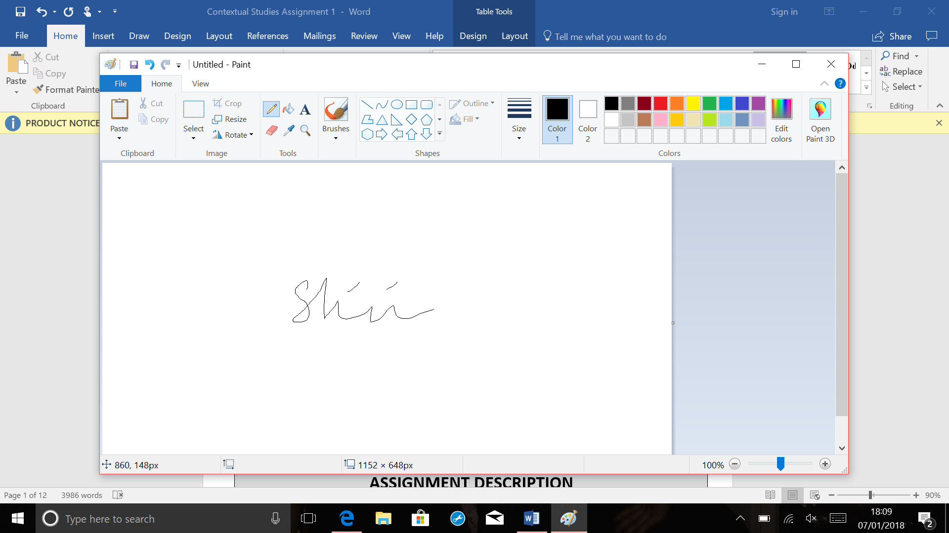 | Date of submission:
Turnitin: Lecturer to tick to indicate if an electronic version of the assignment must be submitted to Turnitin.  If both electronic and hard copy submissions are required then both versions MUST be submitted by the same deadline. No marks will be released until both submissions are received.  Note: the Turnitin version is the primary submission and acts as a proof of receipt for the student.  A paper receipt must be completed for hard copy submissions, including portfolios and other design work. |  |  | YES
 |  |  | NO
Penalties for late submission: Up to one week late, maximum mark of 40% for first attempt.
Work cannot be accepted after 1 week and will be recorded as a non-submission, 0%.

Silhouettes
In this essay I will be focusing on producing an exhibition on silhouettes. This space will be held in the Mission Gallery in Swansea because I feel the open plan layout would work best to hold my exhibition because I will be combining both structure and light in one large room. I feel that having a dim lit room will create a better effect on the shadows in the room, so the audience can relate in their own way to each shadow projected onto the walls. I intend to capture the light on the shadows of the figures more rather than the structures projecting them as I feel that we pay more attention to whatever is casting rather than the figure itself. Your silhouette is what you would see if you took the colour, texture, and other details out of yourself. It's a fundamental factor of your general look. It's also one of the most fun things to play around with which is why I wanted to fill a space with silhouettes of people represented with upcycled scrap.
Here I have made a floor plan of what I would like my exhibition to look like. I wanted the room to be very dark and shady so that the silhouettes created will be the first thing the audience will see not the rubbish structures, so the public will be surprised to see what is creating the images on the walls. I am going to arrange each silhouette on the walls differently such as using altered angles and have the scrap structures making different movements. As Poinsot (1996, p.43) states
The relative exiguity of the rooms, the manner in which their interiors were developed and the large number of exposed objects combined to present the visitor with a very linear, yet labyrinthical, passage.

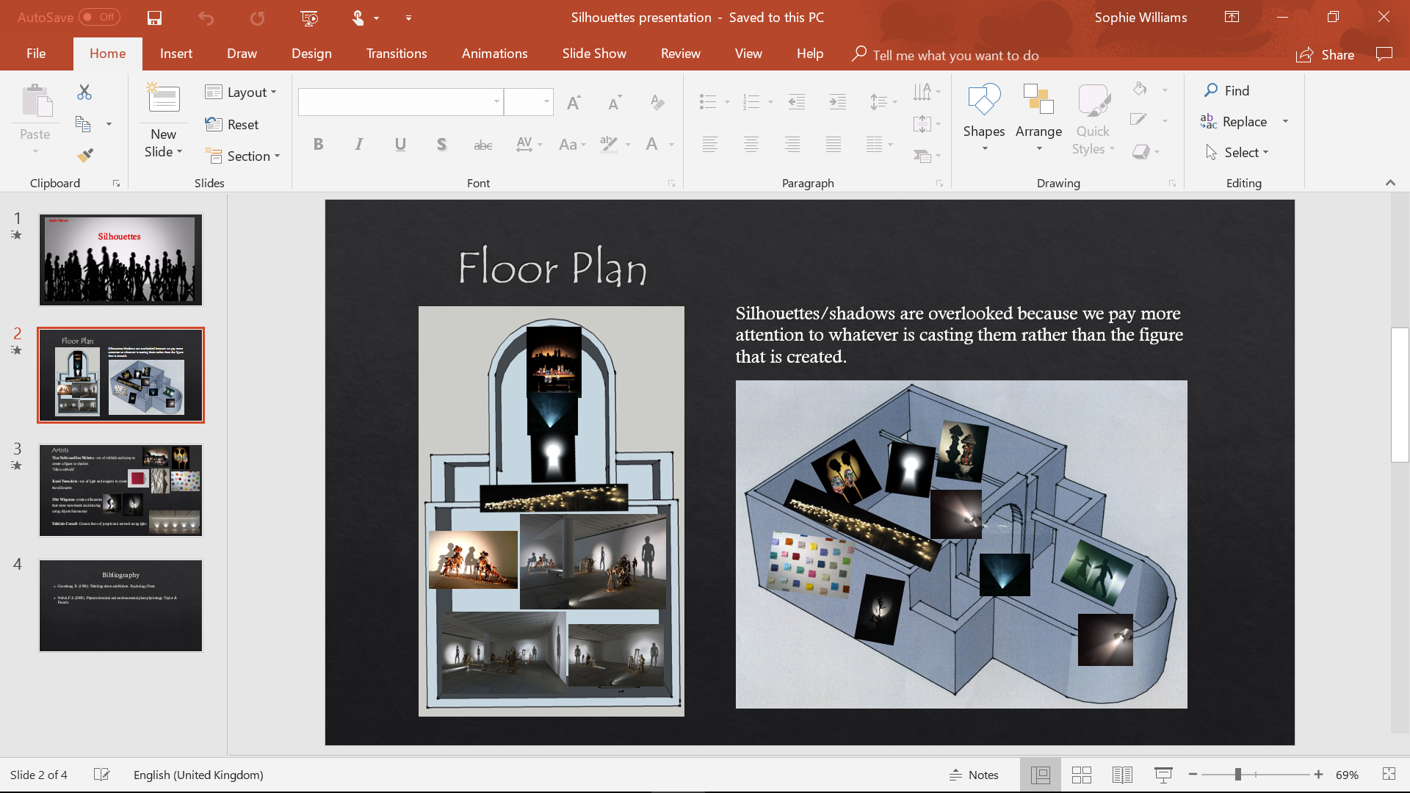
Floor Plan

I have chosen Diet Wiegman as one of my artists because of the use of creating movement in the dancers and I would like to use this idea but make the upcycled sculptures move to show the silhouette figures change position. I felt that by motorising the rubbish structures it would have more of an effect on the silhouettes if the were to have movement added to them.
Wiegman is a Dutch artist that uses a combination of figure and light to create shadow art projected onto walls. I feel that perspective is key in Wiegman’s work, so I wanted to take that and create the motorised rubbish sculptures so that they move and change the way you see the shadows as the scrap moves too. Weigman is most famous for his shadow manipulation, his manipulation with light and sculpture demonstrate reality with the illusion to create a really interesting piece of art. I like the thought of creating an illusion like Wiegman with my rubbish sculptures to show the life on the walls of human silhouettes. The meaning behind this is that I wanted to show that life is made out of man made rubbish and so I wanted to express this by using recycled objects and projecting human scenes of moving people on the walls.
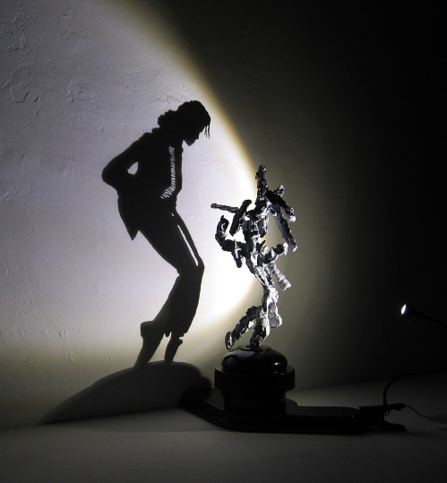

(Souppouris, 2013)

Like Wiegman I then found artist duo Tim Noble and Sue Webster who also work with light and shadow sculptures, their art seems more experimental and abstract which when you first glance just looks like piles of scrap, food and rubbish but when exposed to the light then produces a whole new piece of art. Noble and Webster ‘played with the idea of how humans perceive abstract images and define them with meaning’ (Hosmer, 2012, para. 2). This implied to me that they liked the idea of the audience having a reaction to their work which is what I wanted to achieve in my exhibition by using rubbish to create what I perceive as life, rather than having a person with their shadows in front of them I wanted to use rubbish because Noble and Sue also say “life is rubbish” so I wanted to use this statement to express what I feel life is through shadows.
The process of transformation from discarded waste to a recognizable image fascinated me that you could take something abstract to create something you see in everyday life but don’t appreciate. Noble and Webster seem familiar with how people evaluate abstract forms. Throughout their careers they have investigated the idea of how the audience perceive abstract images and define them with meaning. The result is astonishing as it redefines how abstract forms can transform into figurative ones.


(Noble and Webster, 2003)

Fabrizio Corneli makes carefully handmade projections of light. I chose him as one of my artists because I liked how his work seems like a collection of abstract figures in darkness but when there is light there are these pleasing shadow figures. Corneli’s work gives life to his very simple, geometric wall pieces with light. I was influenced also by the way he presents his artwork on the walls because he seems to keep them in rows but separated enough to differentiate each piece. This statement made me think about the perspectives of my exhibition and how the audience will view each piece of art which I believe is the main importance in my exhibition, which is the way the viewer sees it.
I feel that each piece of his work demonstrates the power of light and shadow to form silhouettes. Corneli (no date, cited in Pinar, 2014, para.1.) states ‘Light is energy which creates forms’. This statement implies to me that Corneli uses light to discover different forms and figures with his own techniques.

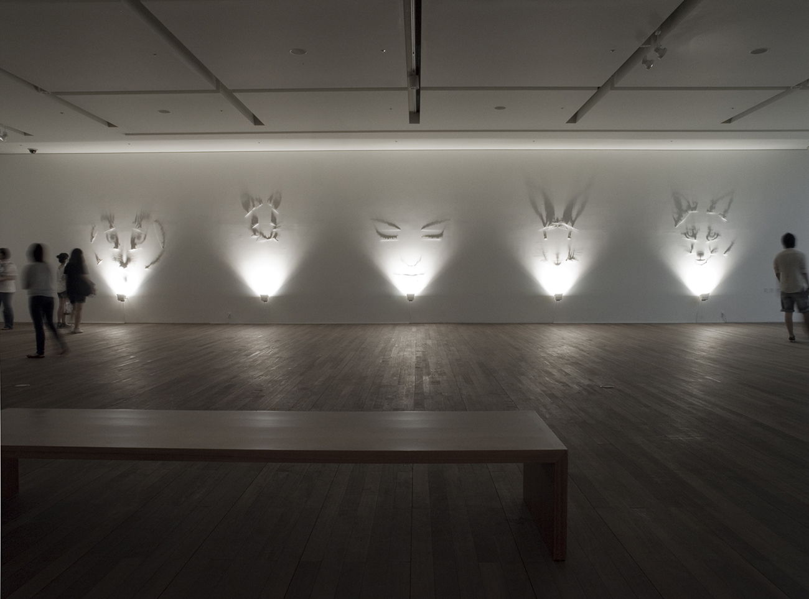
(Pinar, 2014)

Kumi Yamashita makes silhouettes using origami which I thought would link in well with my exhibition because this was what then brought me to my idea also using bit of scrap paper in the sculptures. Yamashita constructs in multiples as well as single objects and places them in relation to one light source so then her work shows both the solid objects and the light or shadow. I would like to use this idea in the space by constructing my sculptures using multiples of rubbish to display one single silhouette. Yamashita composes her pieces out of strategically-placed light along with a variation of perfectly placed objects to create shadow silhouettes. The staggering effect she develops through her exhibitions accentuates casted shadows that are cast upon the objects which are placed at certain distances from just a single light. As Gloman and LeTourneau (2005, P.129) states
Where you “place” the shadow makes a big difference. The instrument that provides the biggest clue to the location of the presumed light source is the “key light”.

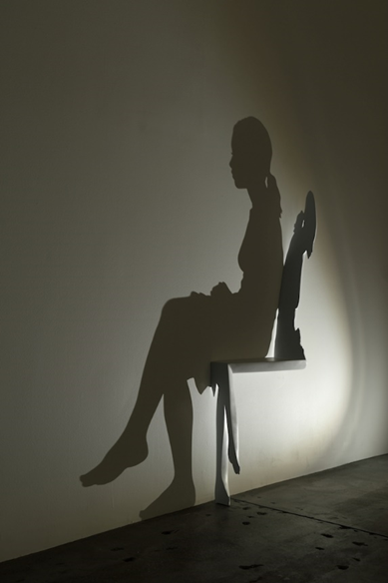

(Yamashita, 2015)

Bibliography
Gloman, C. and LeTourneau, T. (2005) Placing Shadows. Oxford: Elsevier Inc.

Hosmer, K. (2012) Mind-Boggling Shadow Art from Trash Sculptures. https://mymodernmet.com/tim-noble-sue-webster-shadow-sculptures/ (Accessed: 3rd April 2018).

Noble, T. and Webster, S. (2003) SUNSET OVER MANHATTAN. http://timnobleandsuewebster.com/sunset_manhattan_2003.html (Accessed: 5th May 2018).

Pinar (2014) Incredible Shadow Art by Fabrizio Corneli. https://mymodernmet.com/fabrizio-corneli-shadow-art/ (Accessed: 6th May 2018).

Poinsot, J. (1996) ‘Large Exhibitions: a sketch of typology’, in Greenburg, R., and Ferguson, B. and
Nairne, S. (eds) Thinking about Exhibitions. London: Routledge.

Souppouris,A. (2013) The incredible shadow-dancing light sculptures of Diet Wiegman. https://www.theverge.com/2013/3/21/4130960/the-incredible-shadow-dancing-light-sculptures-of-diet-wiegman (Accessed: 6th May 2018).

Yamashita, K. (2015) interview with artist kumi yamashita. https://www.designboom.com/art/kumi-yamashita-interview-03-05-2015/ (Accessed: 6th May 2018).

