Juwayriyah Bibi
2315837
BA Leadership and Management
Design Thinking and Innovation LCLM6002
Dian Mayasari
Words: 4111 (excluding references)

Contents
Part 1: Tesco’s Analysis and Assessment Introduction…………………………………………………………………………………………....3
Key Consumer and Industry Trends……………………………………………………………….4-5 Tesco’s Approach to Innovation……………………………………………………………….……6 Innovation Ambition Matrix application to Tesco ……………………………………….….….9 Customer Journey Mapping (Current Journey)……………………………………………….…..11
Part 2: Proposed Digital Transformation Initiative
Identifying The Core Problems………………………………………………………………….…13 Updated Customer Journey……………………………………………………………………..…14
DVF analysis…………………………………………………………………………………………..15
Defining KPI’s to Measure Success…………………………………………………………….…16
Implementation plan…………………………………………………………………………………….17
Gantt chart…………………………………………………………………………………………….18
Strategic Alignment and Competitive Advantage………………………………………………..19
Risks and mitigation……………………………………………………………………………………….20
Conclusion…………………………………………………………………………………………...21
References…………………………………………………………………………………………. 22

- Introduction
As the retail environment continues to evolve at pace, organisations are required to innovate consistently to remain competitive and achieve sustainable growth. One approach for businesses is Design Thinking, a human-centred methodology that places customer needs at the forefront of organisational problem-solving (Brown, 2008). It encourages the exploration of user experiences and challenges through ideas, trial products, and feedback, which creates creative and strategic feasibility (Carlgren et al., 2016). This makes it particularly suitable for industries such as retail, where innovation is driven by understanding and enhancing the customer journey.
This report adopts the principles of Design Thinking to critically analyse and evaluate innovation and customer journey transformation within Tesco PLC, the United Kingdom’s largest grocery retailer. Established in 1919, Tesco operates over 3,400 stores nationwide and maintains a dominant market share of approximately 27% (Statista, 2024). Its business model has evolved beyond traditional grocery retailing to include financial services, mobile telecommunications, and digital convenience channels. Tesco’s strategic emphasis on technology, convenience, and customer data analytics, particularly through its Clubcard loyalty scheme and online retail platforms demonstrates its ongoing commitment to innovation. However, the company also faces significant challenges such as competition from Aldi and Lidl. (Euromonitor, 2024). Therefore, there is a need for continuous innovation in both products and customer experience design.
The report’s aim is to critically explore Tesco’s innovation strategy and customer journey using the Innovation Ambition Matrix and Customer Journey Mapping frameworks. The application of these models will support the identification of key innovation areas, customer pain and gain points, and digital transformation opportunities. The analysis will also incorporate causal mapping and brainstorming techniques to visualise the interrelationships between customer needs, operational challenges, and innovation drivers. Subsequently, the report will propose a new digital transformation initiative designed to enhance Tesco’s customer experience, underpinned by an assessment of its desirability, feasibility, and viability. The report will conclude with a summary of findings, theoretical reflections, and practical digital based strategies and recommendations to improve Tesco’s performance and customer satisfaction.

- Key Consumer and Industry Trends
The UK grocery retail sector is currently experiencing substantial transformation due to economic pressures, digital disruption, and shifting consumer priorities, placing Tesco in an increasingly competitive market shaped by technology-driven browsing, purchasing and engagement behaviours (Deloitte, 2024). I will list some industry trends and further explain their relevance.

Digital Convenience
With a consumer demand for convenience during COVID-19, online shopping became the new norm. Online reports show approximately 11% of total grocery spending online, which is almost double pre-COVID-19 (Statista, 2024). Tesco has taken advantage of this through its strong online grocery platform and expanded fulfilment offerings such as Click & Collect and rapid delivery services. The customer can move between website, mobile app, and store seamlessly without interruption, which is referred to a term called ‘omnichannel.’ However, competition in digital convenience is escalating, particularly from Amazon Fresh and delivery-first platforms (McKinsey, 2024).
Price Sensitivity and Value
The cost-of-living crisis continues to shape consumer behaviour, with 72% of UK shoppers actively seeking price reductions or loyalty-based offers (Mintel, 2024). Discounters Aldi and Lidl have captured significant market share through competitive pricing. Tesco’s uses the Clubcard Prices strategy, delivering personalised pricing incentives and a loyalty reward system for customers (Tesco plc, 2024). While Clubcard pricing delivers immediate value, its impact is limited over time, and Tesco must diversify into digital experience-based innovation to maintain competitive advantage.
Personalisation Through Data and AI
As the largest loyalty programme in the UK, Clubcard provides Tesco with a distinctive data advantage. Data-driven personalisation is becoming an industry standard, with 83% of consumers expecting retailers to tailor products and offers to individual preferences (PwC, 2023). Using artificial intelligence to translate data into real-time, context-sensitive customer interactions represents a significant opportunity to strengthen engagement and retention. However, academic literature cautions that personalisation must be carefully designed to avoid privacy overreach or customer discomfort (Lemon and Verhoef, 2016). This creates a strategic tension in Tesco’s digital journey design: increased automation versus maintaining trust and transparency.

Experience-Led Retailing and Human-Centred Innovation
Consumers increasingly value end-to-end shopping experiences that are flexible across channels. Design thinking theory emphasises that empathy-based approaches to innovation are essential in capturing such user needs (Brown, 2008). Competitors have invested heavily in experience-centric models, for example, Amazon’s autonomous retail stores and Sainsbury’s enhanced mobile scanning. Tesco’s GetGo cashier less format represents a transformational response, aligning with a broader shift toward low-friction retail journeys. However, scale and public readiness remain uncertain, requiring careful evaluation through desirability, feasibility, and viability dimensions.
Sustainability and Ethical Consumption
Sustainability continues to influence retail strategy, with 58% of UK consumers considering environmental impact in their purchasing decisions (Kantar, 2024). Tesco has committed to net-zero operations by 2035, investing in waste reduction, recyclable packaging, and local sourcing. While these initiatives improve corporate reputation, they also impact supply chain efficiency and pricing, again highlighting a need for innovation that balances ethical performance with affordability. Digital transparency tools are emerging such as blockchain-enabled traceability, where consumers can track where the products come from and how it moved through the supply chain.
Rising Intensity of Market Competition
The UK grocery market remains one of the most competitive globally. Discounters threaten Tesco’s price leadership, while digital-native players challenge convenience and innovation dominance. Market fragmentation forces shops like Tesco to invest in continuous innovation, with design thinking guiding more customer-centric refinement (Liedtka, 2018). This competitive landscape magnifies the strategic importance of a differentiated digital journey and a balanced innovation portfolio.

Implications for Tesco’s Customer Journey and Innovation Strategy
From these trends, several needs become evident:
Trend | Customer Need | Implication for Tesco
Online convenience | Fast, frictionless shopping | Enhance digital touchpoints and rapid fulfilment
Value-driven purchasing | Low pricing without quality compromise | Data-driven loyalty innovation beyond discounts
Demand for personalisation | Relevant recommendations and tailored user experience | AI-enabled customer journey optimisation
Sustainability expectations | Transparent and ethical retail | Tech-supported traceability and circular models
Intense competition | Differentiated, engaging experiences | Transformational innovation (e.g., cashier less formats)
Table 1) trend and implications

- Tesco’s Current Approach to Innovation
Tesco has adopted a continuous innovation strategy to maintain competitive advantage within the UK grocery retail market.
A strategy of Tesco’s innovation approach is its data-driven loyalty ecosystem. Clubcard and Clubcard Prices use transactional data to deliver personalised promotions and price-led incentives (Tesco plc, 2024). Clubcard Plus extends this plan through subscription-based benefits such as monthly discounts and partner offers. Tesco’s collaboration with Dunnhumby has enabled advanced customer analytics through the Tesco Media and Insight Platform, allowing suppliers to optimise marketing spend by linking advertising exposure to both online and offline purchasing behaviour (Kantar, 2024).
In physical stores, Tesco has implemented cashier-less services such as GetGo format. This technology enables customers to enter, pick items, and leave without queueing at checkout. This aligns with consumer demand for time-efficient shopping trips (PwC, 2023). Similarly, Scan-as-You-Shop handheld devices and mobile scanning support self-service efficiency, improving independence and reducing waiting time.
Tesco Whoosh is a rapid delivery service. It is a service that offers delivery within as little as 45 minutes, responding to the growth of convenient and essential purchasing. (Statista, 2024). Orders are placed via the Tesco app or website, and customers receive real-time updates, enabling transparency and control over the delivery experience. Whoosh addresses “need-it-now” missions such as forgotten items, top-up shops, and last-minute essentials, supporting customer loyalty.
Tesco’s approach also extends into supply-side innovation. Automation within fulfilment centres and predictive inventory systems are used to improve replenishment accuracy and reduce waste (McKinsey, 2024). Additionally, Tesco’s investment through W23 Global demonstrates an initiative-taking strategy to source emerging retail technologies, supporting AI-enabled operations and sustainable packaging solutions (Independent, 2024; Tesco plc, 2024).
However, despite these advancements, Tesco’s innovation activity remains incremental, meaning there are small and continuous improvements in existing products and experiences rather than transforming the whole customer experience. Competing retailers, such as Amazon Fresh use experiential differentiation (Mintel, 2024). There remains opportunity for more personalised health guidance, transparent sustainability information, and integrated digital post-purchase support.
Overall, Tesco’s innovation strategy demonstrates strong alignment with current consumer expectations, but the balance between incremental and transformational innovation suggests further potential to differentiate in an increasingly competitive and digitally driven landscape.

Trend Impact on Customers | Strategic Implication for Tesco | Link to Customer Journey
Demand for rapid digital convenience | Enhance omnichannel experience and fulfilment solutions | Faster browsing = better delivery = real-time tracking
Price sensitivity and value demand | Personalised pricing and loyalty innovation | Relevant deals = more engagement at purchase stage
Interest in healthier lifestyles | Product innovation supported by digital nutrition guidance | Smarter substitutions = informed choices pre-purchase
Sustainability expectations | Technology-driven transparency (e.g., traceability tools) | Clear sourcing info at point of decision
Expectation of personalisation | AI-driven recommendations and customised journeys | Tailored promotions = simplified navigation
Competition from digital leaders | Differentiated branded experience | Frictionless checkout = intuitive store interactions
Table 2) link to customer journey

Part 1A: Innovation Ambition Matrix – Tesco
The Innovation Ambition Matrix (Nagasawa, 2010; Baghai et al., 1999) categorises innovation based on whether an organisation is targeting existing or new markets and influencing existing or new capabilities. Applying this framework enables a balanced assessment of Tesco’s innovation portfolio relative to both immediate customer needs and long-term strategic growth.
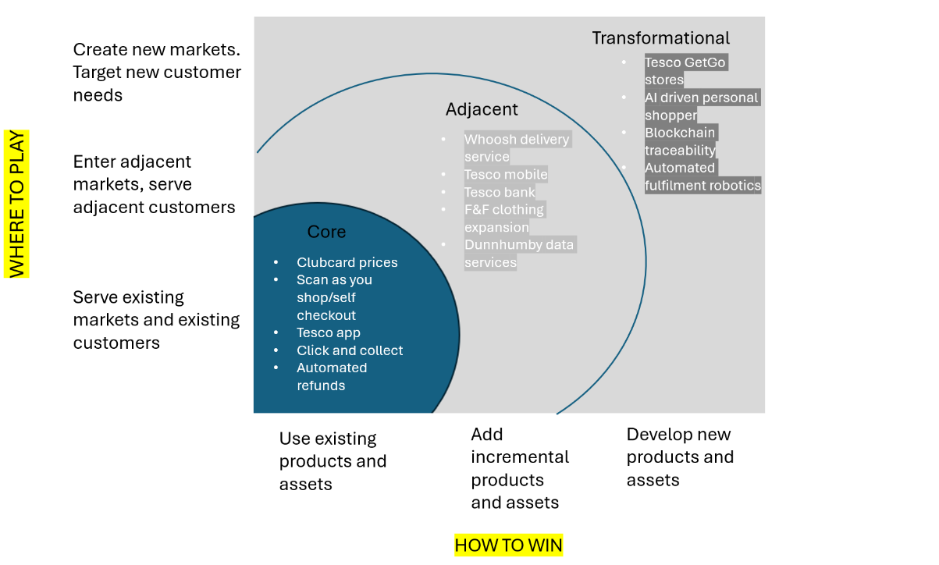

Figure 1) innovation ambition matrix
- Core Innovations – Defending Market Leadership
Core innovation focuses on improving existing offerings for current customers while using established capabilities (Baghai et al., 1999). For Tesco, these initiatives protect its dominant market share and optimise operational efficiency:
Tesco’s core innovation activity focuses on enhancing value, speed, and efficiency within existing operations. Initiatives such as Clubcard pricing, self-checkout optimisation, automated refunds, and Scan-as-You-Shop reduce friction in established behaviours while lowering operational cost and labour intensity. These innovations maintain convenience and price perception without changing the underlying retail model. However, over-reliance on pricing incentives risks short-term loyalty rather than deeper emotional engagement. Therefore, while core initiatives drive volume, they are insufficient alone against competitors such as Amazon Fresh and Aldi.
Adjacent innovation leverages Tesco’s brand, data, and planning to expand into new but related markets (Nagasawa, 2010). Whoosh rapid delivery responds to growing demand for urban convenience, while partnerships with courier platforms extend reach without significant infrastructure investment. The Tesco Media & Insight Platform monetises Clubcard data by offering targeted advertising to brands, positioning Tesco as a digital data intermediary. These initiatives increase digital touchpoints and strengthen omnichannel journeys but require strong data governance and personalisation capabilities to remain competitive.
Transformational innovation focuses on meeting new customer needs and entering future markets, often using disruptive technology (Osterwalder & Pigneur, 2010). These ideas can change Tesco’s long-term direction. Examples include GetGo cashier less stores, which remove queues and reduce labour, and blockchain traceability, which gives customers clearer information about product sourcing and sustainability. Although these innovations are more uncertain and harder to implement, they help protect Tesco against digital-first competitors. They also align with design thinking by redesigning the whole customer journey, not just improving small parts. Scaling these ideas will require cultural readiness and repeated testing to ensure desirability, feasibility, and viability.
Nagji and Tuff (2012) argue that organisations should maintain a balanced innovation portfolio across core, adjacent and transformational activity. Tesco’s current activity is weighted toward core optimisation and adjacent digital services, supporting short-term competitiveness but increasing the risk of long-term commoditisation. Strengthening transformational initiatives would differentiate the brand beyond pricing and enhance resilience against digital disruption.
Innovation Type | Strength | Strategic Risk | Implications
Core | Protects value perception and volume | Hard to differentiate long-term | Must reduce discount dependency
Adjacent | Grows share of wallet & new revenue | Complexity in service integration | Needs unified CX platform
Transformational | Future-proofs Tesco’s business model | Cost + uncertain adoption | Requires design-thinking iteration
Table 3) evaluation of innovations

5. Current Customer Journey Map (Online Delivery Customer)
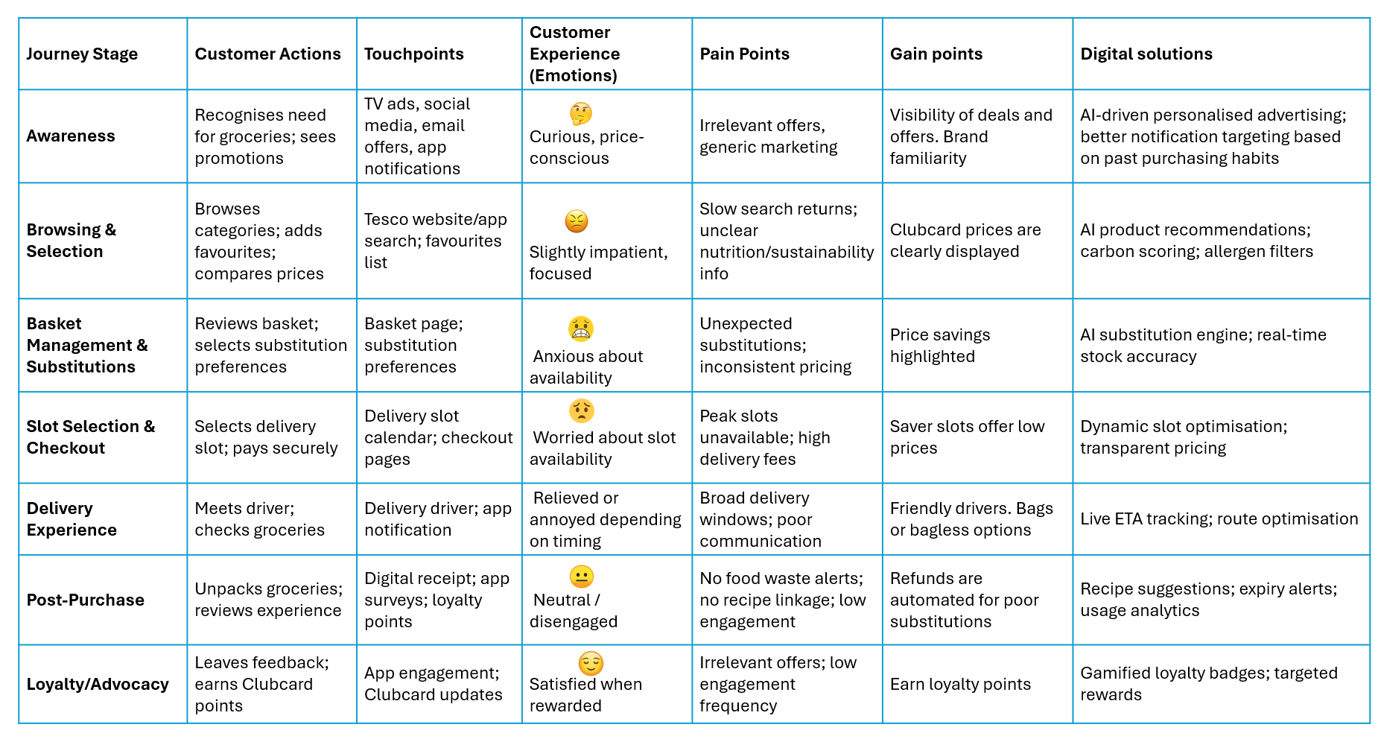
The customer journey for Tesco’s online delivery service can be broken into six stages. Each stage includes the key customer experience elements identified by Lemon and Verhoef (2016): functional interactions, emotional responses, and digital touchpoints.
Figure 2) customer journey map

Pain points
Substitution uncertainty:
Customers feel anxious when items are unavailable, and unexpected substitutions reduce trust, especially for dietary or brand-loyal shoppers.
Delivery slot scarcity and price variation:
Popular delivery slots fill quickly, and charges vary, creating frustration and sometimes basket abandonment or switching to competitors.
Limited real-time delivery visibility:
Broad delivery windows cause waiting uncertainty and inconvenience. Lack of live tracking weakens the value of online grocery.
Weak post-purchase engagement:
After checkout, Tesco’s digital touchpoints become passive. No proactive support (e.g., recipe suggestions, expiry alerts) means emotional engagement drops.
Limited nutritional and sustainability transparency:
Customers increasingly want clear health and environmental information (Kantar, 2024). Inconsistent detail creates friction at the decision stage.

Gain Points
Favourites and past purchases:
Allow quick re-ordering and reduce effort.
Clubcard prices and vouchers:
Visible savings provide emotional reward and reinforce value perception.
Automated refunds:
Fast, friction-free refunds increase trust and reduce contact centre pressure.
Positive delivery driver interaction:
Human touchpoints create strong loyalty moments and improve the overall experience.
Digital friction occurs primarily at basket management (substitution anxiety), delivery slot scheduling (scarcity frustration), and post-purchase support (slow refunds and no expiry alerts). These frictions create emotional uncertainty and reduce perceived value despite Tesco’s strong loyalty proposition. Addressing these points represents a key opportunity for digital transformation.

Part 2 Identifying Core Customer Experience Problems
Analysis of the current customer journey highlights three persistent sources of digital friction. First, substitution uncertainty during online fulfilment reduces perceived value. Second, broad delivery windows and limited tracking increase frustration at critical “moments of truth.” Third, limited post-purchase engagement represents a missed opportunity to reinforce loyalty. Additionally, inconsistent real-time stock visibility and limited personalisation reduce shopping confidence, particularly among digitally dependent customers (Lemon & Verhoef, 2016). Collectively, these issues increase churn risk and weaken Tesco’s ability to differentiate in a competitive grocery market.

- Proposed Digital Transformation Initiative
To address these challenges, this report proposes the implementation of an AI-driven Post-Purchase Companion integrated into the Tesco App. The system uses machine learning to:
• predict preferred substitutions based on past behaviour
• provide live delivery ETAs
• generate recipe suggestions from purchased items
• send expiry alerts to reduce waste
• recommend healthier alternatives
• reward sustainable choices through gamification
Extending engagement beyond checkout enhances perceived value and emotional affinity. The initiative applies design thinking by responding to latent customer needs (Brown, 2008) and reflects Service-Dominant Logic through value co-creation (Vargo & Lusch, 2004). It improves omnichannel coherence by smoothing negative “moments of truth” within the journey (Lemon & Verhoef, 2016).
Strategically, the solution differentiates Tesco from digital competitors such as Amazon Fresh through personalisation and sustainability features, while responsibly monetising existing Clubcard data and supporting Tesco’s 2025 commitments.

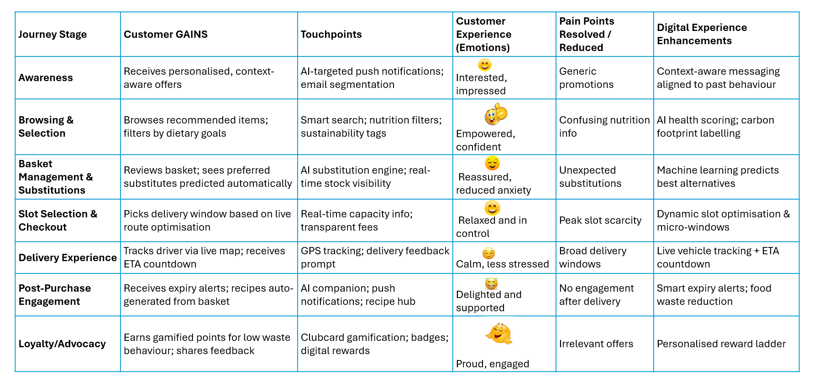
- Enhanced customer journey map
Figure 3) enhanced customer journey map.
The enhanced customer journey map demonstrates how the proposed AI-driven Post-Purchase Companion reduces friction across critical moments of truth. Emotional anxiety around substitutions and delivery uncertainty is replaced with confidence through real-time tracking and preference-based machine learning. Post-purchase value is extended via expiry alerts, recipe suggestions, and sustainability nudges, converting a historically neutral stage into an area of differentiation. The steady upward emotional slope indicates an improved experience trajectory, strengthening affective loyalty. This illustrates a shift from transactional value to ongoing service-based value creation, consistent with Service-Dominant Logic (Vargo & Lusch, 2004).

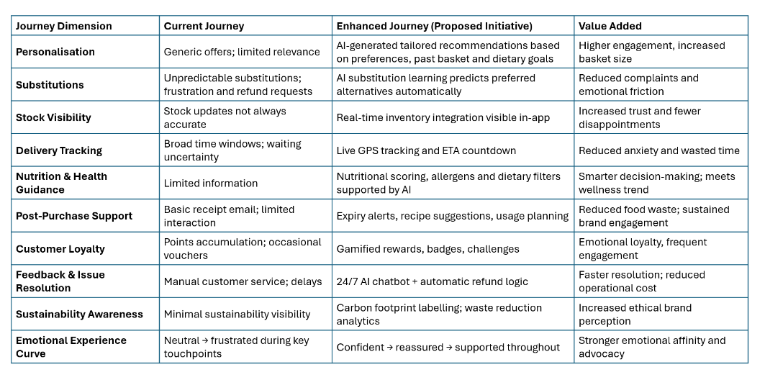
The proposed solution elevates the journey through initiative-taking support, AI-driven personalisation and post-purchase engagement, increasing both experiential and
Figure 4) comparison from old to enhanced customer journey map.
behavioural loyalty. By reducing emotional friction and extending engagement beyond checkout, the initiative improves retention, basket growth, and advocacy.

- DVF Analysis (Desirability, Viability, Feasibility)
Desirability
From a customer perspective, the AI-driven Post-Purchase Companion tackles key frustrations, including unclear substitutions, unpredictable delivery times, and the lack of support after checkout. Real-time tracking and personalised substitution preferences increase confidence at important moments, while expiry alerts and recipe suggestions add value after the purchase. Lemon and Verhoef (2016) note that positive experiences during fulfilment and post-purchase strongly influence loyalty, indicating high desirability. Rising demand for convenience and personalisation in grocery shopping further supports customer interest in these features (Mintel, 2024). By reducing effort and increasing usefulness, the initiative is likely to be welcomed by digitally active Clubcard users.
Viability
The initiative builds on Tesco’s existing data systems, loyalty base, and mobile app, making it financially viable without major new investment. Stronger personalisation can increase basket size, conversion, and customer retention, supporting revenue goals (Tesco PLC, 2024). More accurate substitutions reduce refund costs, while expiry alerts help cut food waste, improving efficiency. Emotional loyalty also reduces customer switching, increasing lifetime value in a price-sensitive market (PwC, 2023). Further revenue can be generated through anonymised insights on Tesco’s Media and Insight Platform, strengthening long-term commercial viability.
Feasibility
Feasibility is supported by Tesco’s existing strengths in machine learning and predictive analytics through Clubcard data. Integration with current delivery routing systems is achievable, as these already manage real-time updates. Because the solution runs through the app, no new hardware is required, allowing a gradual rollout. Risks around data accuracy and GDPR are manageable, as Tesco already operates strong data governance processes. A phased launch in high-density areas enables testing and improvement, reducing technical and operational risk. Staff training needs are minimal, as most interactions take place through the existing app interface.
- Success Metrics / Key Performance Indicators (KPIs)
To ensure that the proposed AI-driven Post-Purchase Companion delivers tangible value, Tesco should measure performance using a combination of customer, operational and financial KPIs.
Customer Satisfaction Score (CSAT):
Used to measure satisfaction at key journey touchpoints (delivery, substitutions, post-purchase engagement). Improvements indicate reduced friction and stronger perceptions of reliability.
Net Promoter Score (NPS):
Evaluates customers’ likelihood to recommend Tesco to others. Research suggests that personalised digital experiences positively influence advocacy (PwC, 2023).
Substitution Acceptance Rate:
Tracks whether customers accept alternative product recommendations. Higher acceptance suggests increased trust and accuracy of AI substitution logic.
Reduction in Refund Claims:
Measures decrease in refunds resulting from incorrect substitutions or damaged items. Lower refund volume indicates improved fulfilment quality and operational efficiency.
Delivery ETA Accuracy:
Measures the precision of real-time delivery tracking. Improved accuracy reduces frustration during critical “moments of truth.”
Customer Retention Rate:
Tracks repeat purchasing behaviour. Higher retention indicates strengthened emotional loyalty and reduced switching to competitors.
Food Waste Reduction Metrics:
Expiry alerts and better planning insights support Tesco’s sustainability targets. Reduced waste has both environmental and financial benefits (Kantar, 2024).

Implementation plan
The proposed AI-driven Post-Purchase Companion requires phased implementation to minimise disruption, ensure data quality and enable iterative refinement. A staged rollout approach reduces technical risk and supports organisational learning.
Phase 1: Planning (Months 1–2)
Tesco’s data, user experience and supply chain teams agree on what the system must do, how it will connect to existing systems, and how it will follow GDPR rules. The main customer problems from Part 1 are prioritised.
Phase 2: Prototype Build (Months 3–4)
A basic first version is created inside the Tesco App, including substitution preferences, delivery tracking and expiry alerts. The design is evaluated internally to check ease of use.
Phase 3: Data Connection (Months 4–6)
The system connects to Clubcard data, store stock levels, and delivery systems. Data checks are completed to ensure accuracy and privacy.
Phase 4: Pilot Test (Months 6–8)
The prototype is evaluated in busy urban areas with lots of online orders. Tesco monitors customer feedback, substitution acceptance, and delivery accuracy.
Phase 5: Improvements (Months 8–9)
Feedback is used to improve the AI, notification timing, and app layout. Any operational issues are fixed before national launch.
Phase 6: National Rollout (Months 10–12)
The final version is released across the UK. Marketing messages through Clubcard help drive adoption.
Staff Training
Only basic support is needed, as most interactions are app-based. Customer service teams are taught how to manage chatbot escalations.
This step-by-step rollout follows agile methods, allowing fast learning, reduced risk, and low-cost scaling.

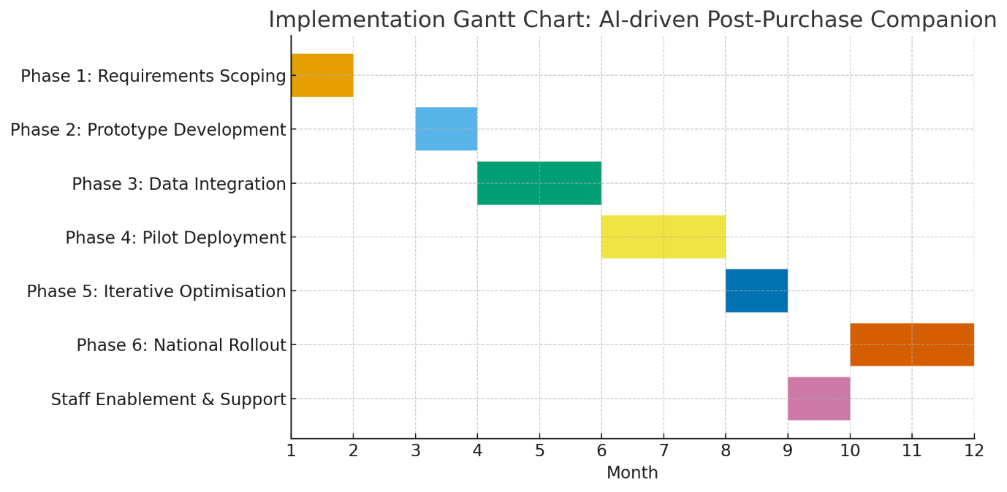
Figure 5) Tesco Gantt Chart implementation

Business impact
The AI-driven Post-Purchase Companion is expected to generate significant business impact by improving customer satisfaction, reducing operational inefficiencies, and strengthening loyalty. By increasing transparency during fulfilment, the initiative reinforces customer trust at critical “moments of truth,” which Lemon and Verhoef (2016) suggest disproportionately influence overall experience. More accurate substitution recommendations and live delivery tracking reduce frustration and encourage repeat purchasing.
Operationally, improved substitution accuracy reduces refunds and customer service intervention, lowering service costs. Predictive expiry notifications can reduce household food waste, support Tesco’s sustainability commitments while driving timely repurchase.
Commercially, personalised post-purchase recommendations can enhance average basket value, aligning with Tesco’s data-driven revenue model (Tesco PLC, 2024). Increased post-purchase engagement also improves customer lifetime value (PwC, 2023) and reduces switching intention in a highly competitive grocery environment.
Strategically, focusing on experience-led differentiation allows Tesco to compete on convenience and relevance rather than price alone. Over time, reduced cost-to-serve and improved retention make the initiative commercially attractive and scalable.

Strategic Alignment and Competitive Advantage
The proposed AI-driven Post-Purchase Companion aligns with Tesco’s strategic focus on digital personalisation, loyalty growth and seamless omnichannel integration (Tesco PLC, 2024). By extending value beyond the point of sale, it deepens customer relationships and reduces journey friction. Expiry alerts and smart substitution also support sustainability goals by reducing food waste. Competitively, the solution differentiates Tesco beyond price while strengthening digital convenience against Amazon Fresh and Ocado. Enhanced personalisation increases emotional loyalty, which is difficult to imitate and therefore strategically defensible. Leveraging existing Clubcard and app infrastructure, the initiative increases switching costs and reinforces Tesco’s leadership in data-driven retail innovation.

Risks and Mitigation Strategies
Data Accuracy and Algorithmic Bias
If substitution recommendations or expiry alerts are inaccurate, customer trust may decline. Algorithmic bias could favour certain brands or categories, leading to perceived unfairness.
Mitigation: Tesco should conduct continuous algorithm auditing using diverse datasets and feedback loops. Pilot testing with different customer segments reduces the risk of skewed outputs.
Privacy and Data Governance
The initiative relies heavily on personalised insights, which increases exposure to GDPR-related scrutiny. Customers may resist additional data tracking.
Mitigation: Clear, transparent consent mechanisms should be embedded within the app. Tesco already operates under strong data governance frameworks, which can be extended to this feature (Tesco PLC, 2024).
Technical Reliability and System Performance
Real-time tracking and stock visibility require stable infrastructure. System downtime during peak shopping periods could create negative brand moments.
Mitigation: Incremental rollout, robust load testing, and automated downtime alerts support system resilience. Redundant tracking systems ensure continuity.
Customer Adoption Resistance
Some users may prefer traditional checkout processes or avoid digital engagement entirely. Adoption failure would reduce return on investment.
Mitigation: In-app tutorials, promotional incentives (e.g., bonus Clubcard points) and clear value communication improve uptake. Staff guidance in-store also reduces apprehension.
Operational Complexity and Staff Adaptation
If staff lack clarity on escalation pathways or AI substitution logic, service quality could decline.
Mitigation: Short micro-learning modules and chatbot escalation scripts ensure consistent handling of unusual cases.
Cybersecurity Vulnerabilities
Increased data integration expands attack surface exposure, particularly around delivery tracking and payment functionality.
Mitigation: Enhanced encryption, multi-factor authentication and regular penetration testing minimise cybersecurity risk.
By addressing these risks through initiative-taking, planning, transparent communication and controlled deployment, Tesco can minimise operational disruption while maximising customer value. When effectively governed, the initiative remains strategically feasible, ethically responsible, and commercially defensible.

Strategic fit
The proposed AI-driven Post-Purchase Companion demonstrates strong strategic fit with Tesco’s existing capabilities. It builds on extensive behavioural data within the Clubcard ecosystem, leveraging current analytics infrastructure rather than requiring new systems. The initiative aligns with Tesco’s focus on convenience, loyalty and food waste reduction outlined in its 2025 roadmap (Tesco PLC, 2024). Operationally, it integrates with mature fulfilment and delivery networks, enabling incremental deployment. Cultural readiness is evidenced by adoption of scan-as-you-shop, mobile app usage and rapid delivery models. Overall, the initiative presents high internal compatibility and low implementation friction, making it strategically coherent and commercially scalable.
Conclusion
This report critically evaluated Tesco’s innovation activity using design thinking, customer journey mapping, and the Innovation Ambition Matrix. The analysis showed that, although Tesco offers strong value through loyalty pricing and multichannel convenience, recurring pain points remain in fulfilment transparency, substitution control, and post-purchase engagement.
To address these issues, the proposed AI-driven Post-Purchase Companion improves real-time communication, personalisation, and operational efficiency across digital touchpoints. Assessed through desirability, viability and feasibility, the initiative demonstrates strong customer appeal, commercial value, and organisational suitability. The enhanced customer journey map illustrates reduced friction and greater service coherence.
Strategically, the solution aligns with Tesco’s digital priorities and leverages existing analytics infrastructure, strengthening competitive position through experience-led differentiation. Overall, the initiative provides a realistic opportunity to increase customer satisfaction, loyalty, and financial performance. By applying a human-centred, iterative approach, Tesco can maintain relevance in an increasingly competitive retail environment.

References
Brown, T. (2008) ‘Design Thinking’, Harvard Business Review, 86(6), pp. 84–92.
Baghai, M., Coley, S. and White, D. (1999) The Alchemy of Growth: Practical Insights for Building the Enduring Enterprise. London: Orion Business Books.
Carlgren, L., Rauth, I. and Elmquist, M. (2016) ‘Framing Design Thinking: The Concept in Idea and Enactment’, Creativity and Innovation Management, 25(1), pp. 38–57.
Deloitte (2024) Retail trends 2024: Consumer behaviour and the future of shopping. Available at: https://www2.deloitte.com (Accessed: 29 October 2025).
Euromonitor (2024) Grocery Retailing in the United Kingdom. [online] Euromonitor International. Available at: https://www.euromonitor.com (Accessed: 3 October 2025).
Euromonitor International (2024) UK Grocery Retailing. London: Euromonitor International.
The Independent (2024) Tesco invests in W23 Global start-up venture fund. Available at: https://www.independent.co.uk (Accessed: 30 October 2025).
Kantar (2024) UK Consumer Sustainability Attitudes Tracker 2024. London: Kantar Group.
Lemon, K.N. and Verhoef, P.C. (2016) ‘Understanding customer experience throughout the customer journey’, Journal of Marketing, 80(6), pp. 69–96. Available at: https://www.journalofmarketing.org (Accessed: 03 November 2025).
Lemon, K.N. and Verhoef, P.C. (2016) ‘Understanding Customer Experience Throughout the Customer Journey’, Journal of Marketing, 80(6), pp. 69–96.
McKinsey & Company (2024) The future of grocery: Trends reshaping food retail in 2024. Available at: https://www.mckinsey.com (Accessed: 29 October 2025).
Mintel (2024) UK Grocery Shopping: Market Report. London: Mintel Group Ltd.
Nagji, B. and Tuff, G. (2012) ‘Managing your innovation portfolio’, Harvard Business Review, 90(5), pp. 66–72. Available at: https://hbr.org/2012/05/managing-your-innovation-portfolio (Accessed: 03 November 2025).
Nagasawa, S. (2010) ‘Customer experience management: A case study of an experience-oriented store’, International Journal of Business and Management, 5(7), pp. 9–16. Available at: https://www.ccsenet.org/journal/index.php/ijbm/article/view/6148 (Accessed: 03 November 2025).
Osterwalder, A. and Pigneur, Y. (2010) Business Model Generation: A Handbook for Visionaries, Game Changers, and Challengers. Hoboken, NJ: John Wiley & Sons.
PwC (2023) Customer Experience: The New Battleground for Growth. Available at: https://www.pwc.com (Accessed: 29 October 2025).
Statista (2024) Online grocery market share in the United Kingdom (UK) 2015–2024. Available at: https://www.statista.com (Accessed: 29 October 2025).
Tesco plc (2024) Annual Report and Financial Statements 2024. Welwyn Garden City: Tesco plc. Available at: https://www.tescoplc.com (Accessed: 29 October 2025).
Tesco PLC (2024) Annual Report and Financial Statements 2024. [online] Tesco PLC. Available at: https://www.tescoplc.com (Accessed: 3 October 2025).
Vargo, S.L. and Lusch, R.F. (2004) ‘Evolving to a new dominant logic for marketing’, Journal of Marketing, 68(1), pp. 1–17.
(Accessed: 03 November 2025).

