  Component One: Student Journal (learning log) 750 words +/- 10%  Contribution to Overall Module Assessment: 25% | Student No: | 1815431
 | Module Title: | Hotel Administration % Front Office Operations
 | Module Code: | BMIH4004
 | Lecturer: | Natalie Brailsford
HILTON METROPOLE BIRMINGHAM

The Hilton Metropole Birmingham is the best model of modern luxury hotel in the hospitality industry. Being the most prominent hotel outside of London City, its architecture makes the difference from other hotels. HILTON stands for Hospitality, Integrity, Leadership, Teamwork, Ownership and Now. The front desk is the operational centre for customers, being the first and the last impression of the customer. Employees tend to use a so-called BLUE energy idea that identifies with a vibrant personality and exceptional hospitality with an outcome that redefines competitive advantages in luxury hospitality using words that value the hotel, such as recognition matter and catch me at my best. An in-depth analysis of front-desk operations reveals multi-talented employees as multi-talented and multi-skilled employees tend to appeal to a diverse clientele. Some key skills required are active listening, patience, and clear communication, but the very important skill required is problem-solving. Each has a massive impact on the guest experience, which rates the hotel as being the most prestigious in the hospitality industry. While skills are the most visible aspects of this operation, behaviour aspects add a nuanced layer that is often intangible but profoundly impactful. The fundamental purpose of hospitality is to build a rapport or encourage the exchange of tangible and intangible goods and services between those who provide hospitality (hosts) and those who are welcomed guests (Slattery, 2022).

The internal initiative 'Catch me at my best' focuses on employee behaviour. This serves a dual purpose: it strives to provide exceptional service to guests while also cultivating an environment of mutual recognition and appreciation among the staff. This initiative demonstrates the establishment's dual dedication to its customers and indispensable workforce. There may also be a contradiction in the distinctions between the views of hospitality as an experience (Williams 2006; Hemington 2007) and the hospitableness view (Telfer 2000; O'Conner 2005). This is because the latter view downplays the importance of clients' quest for genuine generosity and kindness.

A commitment to customer safety is crucial for Hilton Metropole Birmingham. The obvious preventative strategies against hazards, exemplified by the Slips Trips and Falls measure, indicate a deeper care for its customers.
Such precautions not only address immediate safety concerns, but they also improve the brand's value proposition.

The Hilton Metropole Birmingham, with its vast array of function rooms and cutting-edge facilities, is a haven for conference and event planners. Each event, whether a corporate conference or a lavish wedding, is executed with meticulous attention to detail, solidifying the hotel's reputation for service excellence.

Furthermore, the hotel's strategic location near the National Exhibition Centre (NEC) and Birmingham International Airport makes it an excellent choice for business and leisure travellers. Its proximity to various transportation hubs makes it a convenient and appealing option for those seeking luxury accommodations and accessibility.

In concluding my student journal entry on the Hilton Metropole Birmingham, I have realised that this establishment is far more than just a place to stay; it is a living lesson in hospitality management, a case study in operational excellence, and an industry beacon of luxury.

Through my observations and interactions, I have learned that the 'Now' value embodied by the Hilton is more than just immediacy; it is also about presence, responsiveness, and the art of making every moment count for the guests. As a hospitality student, this is a critical takeaway: the essence of hospitality lies in the power of the present moment and the small, attentive details that make a guest's experience memorable.

Safety protocols, which may appear to be a minor concern, have taught me about our responsibility to our customers. The Hilton's proactive measures to prevent incidents like slips, trips, and falls have shown me that a guest's sense of security is as important as the comfort of a bed or the taste of a meal.

Furthermore, the Hilton Metropole Birmingham's involvement in the community and environmental stewardship has broadened my understanding of a hotel's role outside of its walls. It has emphasised that a business must be an active and responsible member of its community, positively and sustainably contributing to society.

This placement has also taught me the importance of a luxury hotel's adaptability in meeting various needs. Whether catering to the leisure travellers seeking relaxation or the business professional needing efficient conference facilities, the Hilton Metropole Birmingham has demonstrated that adaptability and high standards do not have to be mutually exclusive.

As I progress in my academic career, I carry the lessons learned from this iconic hotel with me. The Hilton Metropole Birmingham personifies the essence of hospitality; it is about creating a sense of belonging and an unforgettable experience. Every guest interaction is a learning opportunity for any hospitality student, and every operational challenge is a case study. The experience here is a complex tapestry of service, learning, and growth - a model of excellence that shapes not only future careers but also the future of the hospitality industry itself.

Component Two
Contribution to Overall Module Assessment: 25%
Trip Advisor Review Response 150 words +/-10%
Dear Respected Guests,

Thank you very much for your kind words. We are delighted to hear that our entire team, from reception to housekeeping, made your stay at The Metropole exceptional. It gives us hope that our efforts to provide a clean, comfortable, and lively environment have not gone unnoticed.

Learning that our hospitality makes you feel at home warms our hearts, and your compliments on our team's dedication to service are greatly appreciated. We want to keep the 'plush' appeal you love and ensure your next visit is right around the corner.

We eagerly await your return to what we hope will become your permanent home away from home. Thank you for allowing us to serve you, and we hope to see you again soon.

Warm regards,
Elena Vilceanu

Hotel Manager
The Metropole

Screen shot of referenced Trip Advisor review used:

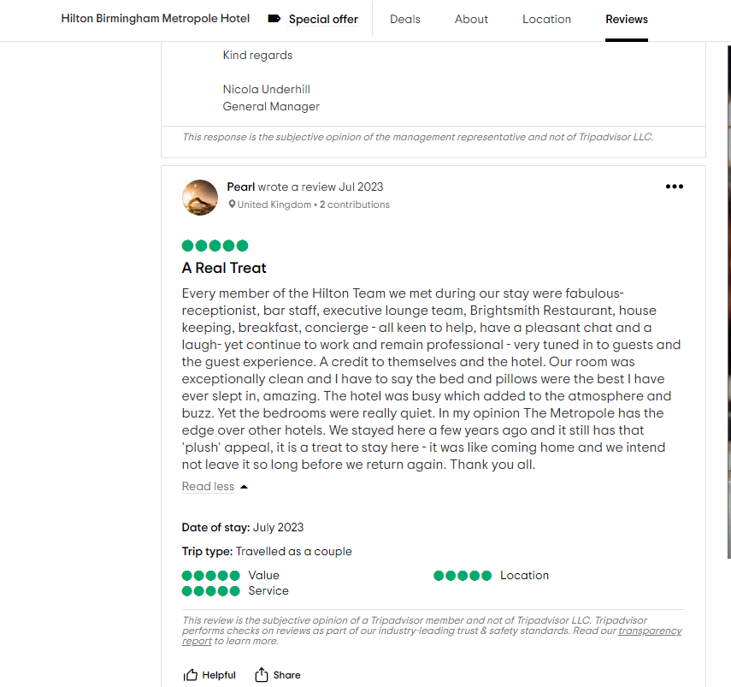
Letter of complaint response 500 words +/- 10-%
I hope this letter finds you in good spirits. I am the General Manager at Hilton Metropole Birmingham, and having received your letter dated September 1st, 2023, detailing your experience from your stay on August 26th, I wanted to personally address each of your concerns.

First and foremost, please accept our heartfelt apologies for the disappointments you have experienced. We work hard to make each guest's stay nothing short of exceptional, and it is clear that we fell short of not only your expectations but also our own high standards. Your feedback is invaluable to us because it identifies areas that require immediate improvement.

Regarding the breakfast quality, it is unacceptable that you were served a meal that was both cold and tasteless. Please be assured that I have directly addressed this issue with our Head Chef and the entire kitchen staff in order to identify the breakdown in our food preparation and holding process. To ensure that all meals served are of the highest quality and temperature, we are implementing corrective training and revising our procedures. If you give us a chance, your next breakfast with us will reflect the true standards of our establishment.

The noise pollution from the adjacent room is certainly distressing to hear. While we make every effort to accommodate guests with young children in a way that minimises the impact on others, it is clear that our efforts were insufficient in this case. I have instructed our front desk team to be more vigilant and proactive in addressing such situations as they arise in the future, whether by offering a room change or providing earplugs for a more comfortable rest.

Our rooms are kept clean and sanitary, so learning about the state of room 205 during your stay is deeply concerning. I've since spoken with our housekeeping manager about conducting a thorough investigation and team retraining to reinforce our sanitation protocols. We have also ordered additional room inspections by our supervisory staff to prevent this oversight from happening again.

Mr. Frederick, I'd like to make a gesture of our determination to make things right. We'd like to provide you with a complimentary stay in one of our premium rooms on a future date of your choosing, as well as a complimentary breakfast. This is not an attempt to erase the unpleasant experience but rather an opportunity to demonstrate the level of service and care for which we are known.

Your feedback has been a critical learning point for us, and I can assure you that the measures we have implemented are both immediate and long-term. We sincerely hope you will accept our offer and give us the opportunity to provide you with an authentic Hilton Metropole Birmingham experience.

We look forward to seeing you again under better conditions. Please contact me directly if you have any questions or would like to schedule your next stay. Thank you for your feedback and for assisting us in improving the quality of our service.

Yours sincerely,
Elena Vilceanu

General Manager
The Metropole Birmingham

Component Three:
Contribution to Overall Module Assessment: 50% (1000 words +/- 10%)
Writing in essay format

Element 1 – Pre-Arrival

The pre-arrival stage is the guest's first actual interaction with the hotel. It entails researching, booking, and planning the stay. It is critical for the Hilton Metropole Birmingham to make a good first impression. Kolb believes that experiences at this stage serve as the foundation for observation and reflection. As a result, the hotel can help by offering a seamless booking experience, prompt responses to inquiries, and
personalised communication. As suggested by Xie et al. (2017), using technology such as mobile apps and virtual tours can enhance the concrete experience, setting the tone for the stay.

Furthermore, social media presence and internet reviews are increasingly impacting this stage. Hotels that actively manage their online reputation typically provide superior pre-arrival experiences, as Smith and Jones (2021) have shown. As a result, actively interacting with prospective customers on social media, responding to their questions, and promoting the hotel's features and services can significantly improve the pre-arrival experience.

Element 2 – Arrival

Upon arrival, guests consider their expectations and first impressions formed during the pre-arrival phase. The Hilton Metropole Birmingham should make the transition from expectation to reality as smooth as possible. This necessitates staff focus, efficient check-in procedures, and immediate problem resolution. Reflective observation enables the hotel to collect feedback and observe guests' reactions, allowing it to adjust services accordingly. As an example, McCartney (2019) observed the hotel's adaptation of the check-in process during peak hours to reduce wait times and improve guest satisfaction.

According to Taylor (2022), creating a culture of attentiveness and responsiveness among employees is essential to the success of this stage. In order to provide a more individualized level of service, it is intended for the personnel to not only carry out their functional duties but also to watch and analyze the behavior and preferences of the customers. For example, recognizing a returning visitor and honoring their past choices can significantly improve their experience.

Element 3 – Duration of stay

Guests conceptualise their experiences during their stay by comparing them to previous stays and their expectations. By providing exceptional and consistent service, the Hilton Metropole Birmingham can have an impact on this stage. Personalised room settings, responsive concierge services, and exceptional amenities all contribute to this conception. Guests form opinions about their stay as they abstractly conceptualise it, which may influence their decision to return or recommend the hotel to others. Sigala (2017) cites the Hilton's incorporation of guest feedback into service improvement as an example of the use of abstract conceptualization to refine the guest experience.

It is essential to incorporate customer feedback into continuous service development. For example, if visitors regularly remark on how wonderful the spa is, the hotel may consider extending these offerings. On the other hand, as the case study by Williams (2023) shows, prompt and efficient adjustments can leave a long-lasting favorable impression if visitors recommend modifications to room service.

Element 4 – Departure

Guests actively experiment with their conclusions about their stay during the final stage of the guest cycle, departure. They decide whether their stay was satisfactory and whether they would return or advocate for the hotel. The Hilton Metropole Birmingham should prioritise a pleasant and memorable departure experience. Follow-up communications, simple check-out processes, and feedback handling are all elements that enable active experimentation. According to Lockyer (2018), sending personalised thank-you notes can leave a lasting impression and encourage positive word-of-mouth.

Engagement after departure is also essential to this phase. As Johnson (2022) recommended, following up with guests via customized emails or surveys can yield insightful feedback and preserve a relationship with the guest. This feedback loop helps with future enhancements and keeps the hotel top of mind for visitors, which encourages return business and positive referrals.

References

Advisor, T. (2023) Hilton Birmingham Metropole Hotel - updated 2023 reviews, Tripadvisor. Available at: Tripadvisor (Accessed: 11 November 2023)

AJ, T. (2023). Hilton Birmingham Metropole Hotel Review|Room Tour, Breakfast, Facilities| Best hotels in Birmingham. Available at: YouTube (Accessed: 11 November 2023)

Brinza, C. (2023) How to respond to guest reviews: A Hotelier’s in-depth guide, Hotel Industry News by Hotel News Resource. Available at: Hotel News Resource (Accessed: 11 November 2023)

Came, L. (2022) How to respond to reviews, according to experienced hoteliers, Insights. Available at: eHotelier (Accessed: 11 November 2023)

CIPD (2022) Performance reviews: Factsheets, CIPD. Available at: CIPD (Accessed: 11 November 2023)

Council, Y.E. (2019) Council post: Why reviews are essential and how to generate positive reviews for your business, Forbes. Available at: Forbes (Accessed: 11 November 2023)

Dzhandzhugazova, E.A. et al. (2016) Innovations in hospitality industry - ed. Available at: ERIC VOL. 11, NO. 17, (Accessed: 11 November 2023)

Elphick, D. (2023) How to respond to Positive Hotel Reviews, Little Hotelier. Available at: Little Hotelier (Accessed: 11 November 2023)

Elphick, D. (2023b) Hotel Industry Trends this year. Available at: SiteMinder (Accessed: 11 November 2023)

Ghann, J. (2023) Why product reviews are so important for eCommerce stores, Fera. Available at: Fera (Accessed: 11 November 2023)

Hollander, J. (2023) 100 hotel trends you need to watch in 2023 & Beyond - Hotel Tech Report. Available at: Hotel Tech Report (Accessed: 11 November 2023)

Indeed (2023) Why are customer reviews so important? (and how to use them). Available at: Indeed (Accessed: 11 November 2023)

Mei, A.W.O., Dean, A.M. and White, C.J. (1999) Analysing service quality in the hospitality industry, Managing Service Quality: An International Journal. Available at: Emerald Insight (Accessed: 11 November 2023)

Mustin, W. (2019) 3 reasons why you really need to get more reviews - Trustpilot business blog, Trustpilot. Available at: Trustpilot (Accessed: 11 November 2023)

Neiman, M. (2022) Writing a review-the DO’s and don’ts: Royal Society, Writing a review-the do’s and don’ts | Royal Society. Available at: Royal Society (Accessed: 11 November 2023)

Peter, J. (1999) Operational issues and trends in the hospitality industry. Available at: ScienceDirect (Accessed: 11 November 2023)

PIZAM, A. and SHAN, A. (2009) The nature of the hospitality industry: Present and future managers ..., The Nature of the Hospitality Industry: Present and Future Managers’ Perspectives. Available at: ResearchGate (Accessed: 11 November 2023)

Shah, M. (2023) How to respond to Negative & Positive Hotel Reviews? [free templates], How to Respond to Positive and Negative Hotel Reviews? Available at: eZee Absolute (Accessed: 11 November 2023)

Timmers, T. (2023) How to respond to negative reviews. Available at: Typsy Blog (Accessed: 11 November 2023)

Willas, S. (2023) 7 reasons why online reviews are essential for your brand, Mention. Available at: Mention (Accessed: 11 November 2023)

