LCBB4004 MARKETING FUNDAMENTALS
Iulian Poenaru ID: 1817475
Ciprian Simpliceanu ID: 1817169
Andrei Ionut Balaci ID: 1714716
Volodea Craus ID: 1816780
Tutor: Tushara Balendran
Contents
Introduction 3
Background of Group Renault (Iulian Poenaru) 3
Product Description (Ciprian Simpliceanu) 4
Various Prices for Renault Cars (Andrei Ionut Balaci) 6
Places and Distribution for Renault Group Cars (Volodea Craus) 7
Promotion (Volodea Craus) 9
Group Renault Makes History in the Auto Industry 11
Reference List 13
Journals 13
Websites 14

Introduction
Marketing strategies and marketing mixes help a company to achieve success and make more growth in industry. Maximum number of companies follows 4Ps of marketing mix in their business model to offer customers products of them efficiently and beneficially. Four Ps of marketing are such as Product, Price, Place and Promotion; these four elements of business have a vast effect on products and services of a company, brand image of a company and loyalty of customers.
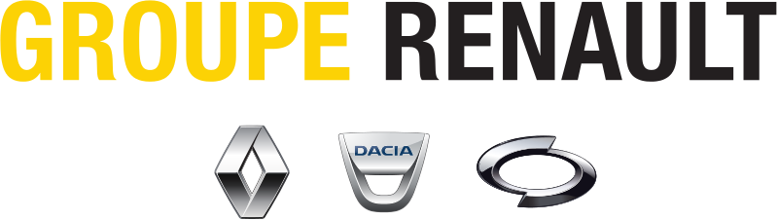In this case, a blog is made on Renault’s groups and their various automotive functions for their products. In addition, it contains a description of mobility solutions of company and customer service of the company. Renaults Group has advanced level technologies in their working system that helps them to produce excellent quality products and services to their customers. Renault Group has created a record in the year 2017; it has the highest sales of 3.76 million vehicles in that year. Sales record is mainly for systematic technology they use for their electric vehicles and those sustainable features they provide to their customers in their products. In this blog, the focus is upon communication process of company officials with consumers to increase sales and performance of the company.

Background of Group Renault (Iulian Poenaru)
Renault group is known as one of the major organizations in the automotive industry. Renault group has a great brand image in a global context, and that is because of their manufactured iconic cars with added advanced features. Renault group is made in the name of Renault marque and subsidiaries in alpine and Automobile Dacia in Romania (Group.renault.com, 2019).
Thierry Bollore is current Chief Executive Officer of company. There are thirty-nine factories, three innovation labs and six technical centres of Renault in all over the world. So many offices and warehouses of company exist all over the world, and those contain approximately one thousand eighty-three thousand employees, which can define that Renault is an internationally established company with a huge number of employees. According to records, Renault group has sold an approximate number of thirty-nine thousand vehicles in 2018 and has a revenue of approximately fifty-seven thousand million Euros in that year (Group.renault.com, 2019).

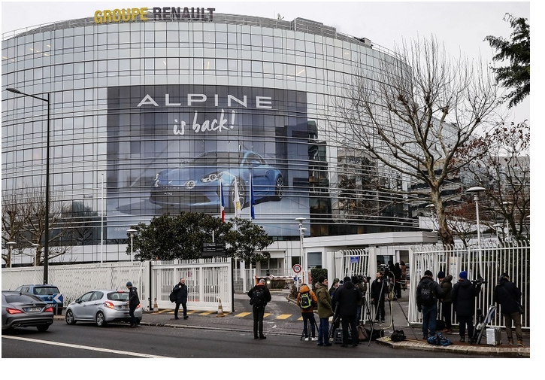
Renault has their main headquarter in Boulogne-Billancourt, France, and it has spread its business among thirty-seven countries over the world. Renault has two sub-parts of their company, such as Romanian Automobile Dacia and Korean Renault Samsung Motors. Renault brand owns many brands in their company such as; Renault Nissan Mitsubishi Alliance owns brands Mitsubishi, Infiniti and Nissan. Volkswagen group of Renault is the most popular brand of Renault among consumers, and it owns brands such as Bentley, Audi, Lamborghini, Bugatti, Volkswagen and Porsche. Toyota Motor Corporation owns Toyota and Lexus and company has its stakes Suzuki and Subaru (Group.renault.com, 2019).
According to records, in recent times, one out of four vehicles sold in Europe is a Renault car. Over the last few years, it is the number one electric vehicle manufacturing company all over the world for its practical solutions and automotive solutions.

Product Description (Ciprian Simpliceanu)
Renault has various ranges of prices of their products, and there are various types of products that Renault provide for their customers. Renault produces many varieties of cars, and they own many brands that produce different types of cars such as Renault Captur, Renault Triber, Renault Lodgy, Renault Duster, Renault KWID and many more (Group.renault.com, 2019).
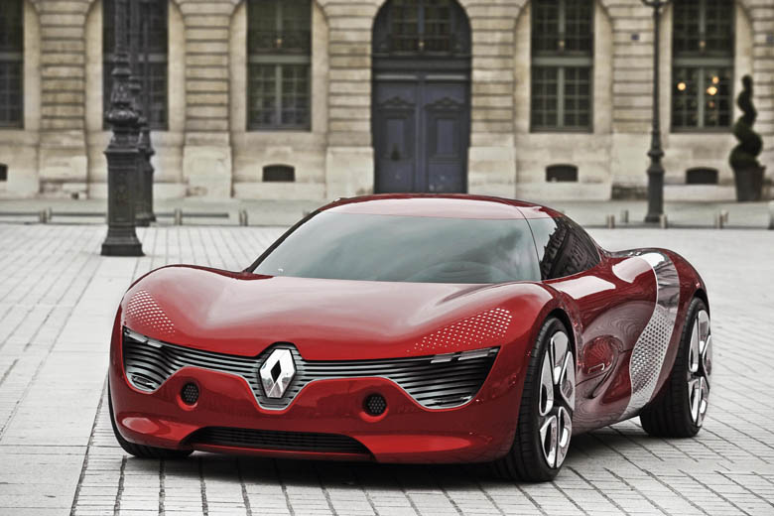Renault design and manufacture their products according to the needs of customers and growth of generation. It analyses markets and rural areas to find out the needs of customers in their area. There are various types of cars with various facilities of Renault such as autonomous cars, electric cars, robot-taxi operations car, passenger cars and many more (Hanssens and Pauwels, 2016). Features and innovations are the main aspects of Renault officials; they provide advanced features and innovations in their products for customer satisfaction and attracting more customers towards brand (Anusha, 2016). There are five unique brands of Renault that reflect products of companies such as:

- Renault,
- Dacia,
- Alpine,
- Renault Samsung Motors and
- LADA.

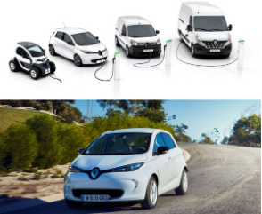
Each of brands makes products according to their uniqueness such as Renault produces cars such as KOLEOS, Dacia produces cars such as Duster. Alpine produces cars such as A110, Renault Samsung Motors produces cars such as SMG and LADA produce cars such as VESTA. There are mainly SUV cars and mini cars that are designed by company (Bartoloni and Baussola, 2016).

Various Prices for Renault Cars (Andrei Ionut Balaci)

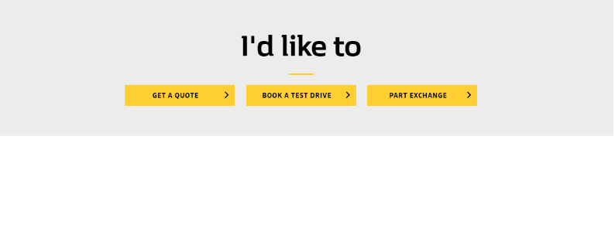
Prices of products of Renault have a reputation, and we considered as the most valuable aspect of Renaults marketing mix. Our innovative approaches and solutions provided to our customers have a vast effect on customers of company. Value for money market price makes Renault number one contender of electric vehicle company over world (Boisen et al. 2018).
Price of a product is the first choice for customers to buy a product and Renault officials keep this factor on their mind and produce products of them in the market, which has a customer-friendly price and affordable for them as well (Gunasekharan et al. 2016).
The products of Renault have many varieties, and there are varieties in their price. In addition, there are divisions of automotive cars, electric cars, fuel cars, diesel cars, cars that have high-level monitoring systems and advanced features (Datta et al. 2017).
According to our official website, there is a huge range of difference in ranges and prices of cars produced by Renault. Cars of Renaults mainly start from a range of £4,400.
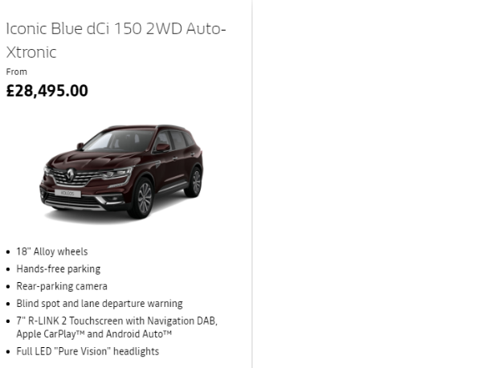
- Renault Koleos has a range of £28,495 to £45,000 in the market.
- Renault Duster has a price range of £10,995 to £16,880 in the market,
- Renault Lodgy has a price range of £8.630 to £12.110 in the market, it has features of manual controlling and consumes 1litre diesel for running 21.04 km (Shalender and Singh, 2015).
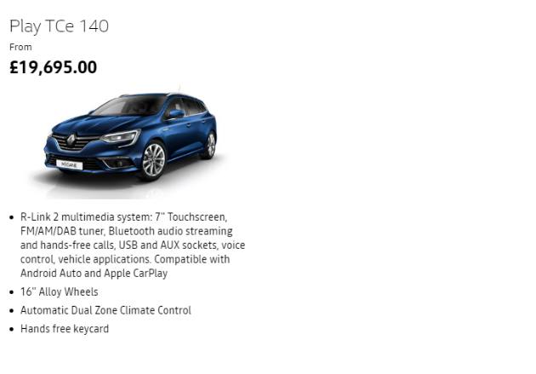
- Renaults Tourer has a price range of £19,695 to £25,000 in the market, it has features of manual control and automatic controlling and consumes one litre of petrol for running twenty to twenty-one km.
- Renault Captur has a price range of £9.490 to £12.990 in the market, it has features of manual controlling, and it consumes one litre of diesel or petrol for running thirteen to twenty-one km (Topspeed.com, 2019).

Places and Distribution for Renault Group Cars (Volodea Craus)

Places are very much significant for a company to do its business and to have an effective business in a global context; there is much importance of places for an organization. Renault Company builds a different dealership and brands stores in Europe to attract more customers towards company (Durmaz and Yaşar, 2016).
- There are many shops and stores of Renault in Europe and over world that helps to enhance customers’ availability in places where the company does business.
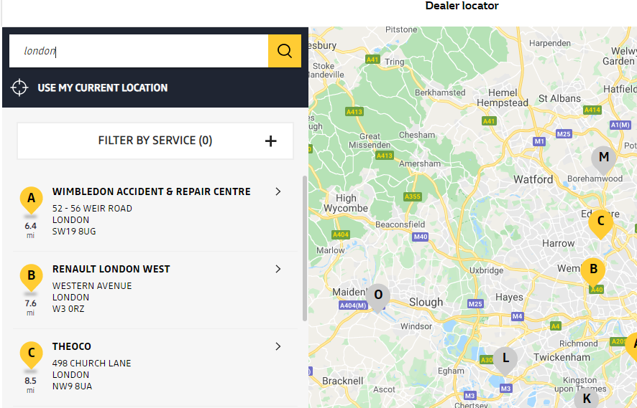
- Renault Company has online shops and facilities of online shopping in their online site, which helps to connect customers with company.
- Renaults have launched first electric automotive vehicles that are run by electric and for charging these cars Renault has built many vehicles charging platforms in Europe to help customers in their using purpose of vehicles (Išoraitė, 2016).
- This strategy of marketing of Renaults can show that Renault officials have made marketing strategies for a very long time, and there are skilled employees in the management of Renault.
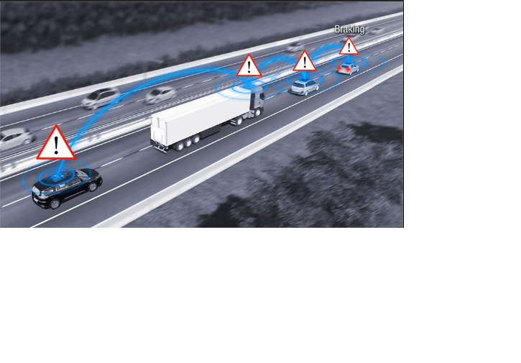
- Renault’s officials have implemented a SCOOP Project strategy for their business that helps to connect drivers to locations of area. Many local and regional area of their business is connected by these maps (Eneizan et al. 2016). Significant landmarks such as organizations, shops, institutions, universities, schools and offices are recorded in this map data, and later they are in map to help drivers to have a piece of knowledge about their arrival locations or designated locations.
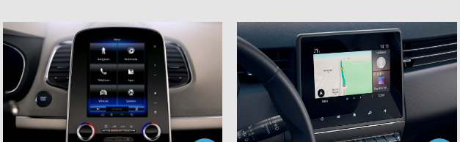
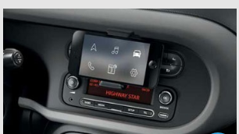
- COYOTE and WAVE technologies in display are an innovative approach and feature of Renault Company that helps driver to have more technological advancements while driving. There are features provided by Renault in their cars that provides radio frequency to compatible devices installed in cars (Grimpe et al. 2017). In addition, it provides benefits to connect multimedia devices with a car, and these features help drivers to have a piece of vast information about their locations and communicating with others (Falát and Holubčík, 2017).

Promotion (Volodea Craus)

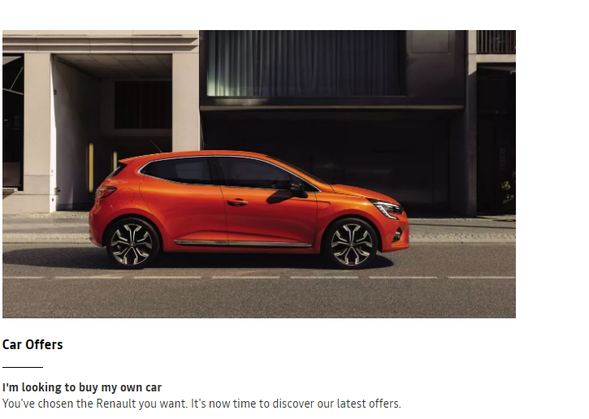
Promotion can be considered as a significant factor for those companies, which are newly established in the market and needs the support of customers to grow up in the industry (Liu et al. 2017). Renault Group is a globally established company, and there are many advantages of it in their business.

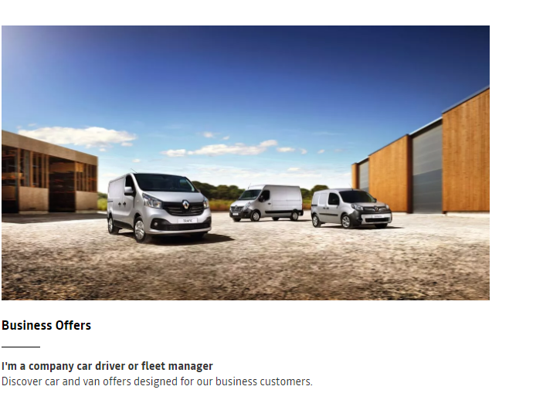
Renault Company takes huge advantages of their brand image in promotion process of marketing, and it helps company to increase its business in a global context. Promotion process of Renault is done by advertising, promotion in sales, personal selling, and making communication with customers (Mahmoud, 2018).

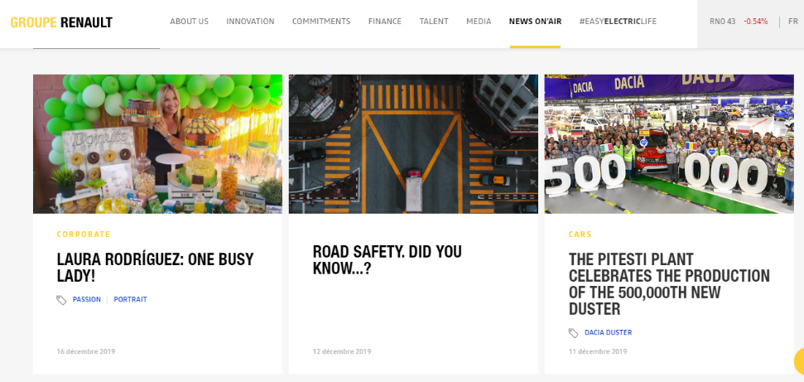
Currently, advertisement in social media is a trend of market and Renault officials follow this process of advertising very effectively to gain more customers for the company. Advertising is a great process to promote any business, and Renault Group makes use of it by using celebrities such as Benedict Cumberbatch to attract more customers towards brand (Resnick et al. 2016).

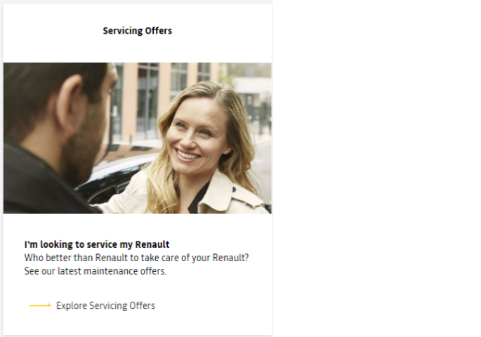
Promotion of Renault Company is looked over by the human resource management department of the company, and there are skilled employees in the human resource department of the company after analysing their promotion part of marketing mix. There is use of good promotional activities and advertisement in the promotion process of Renaults Company (Todorova, 2015). Renaults Group provides sales, offers and discounts to their customer as a promotional activity to attract more customers towards the company. In addition, Renaults Company sponsors celebrity matches, football leagues, cricket leagues and charity show as their promotional activities.

Group Renault Makes History in the Auto Industry

Renault is a renowned company in the global automotive industry, and it has an excellent brand image of it among customers over the world.

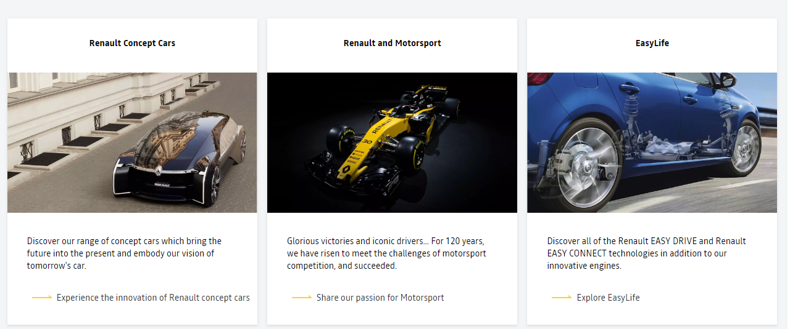The company provides many automotive features and innovative features in their products and sells them to their customers.

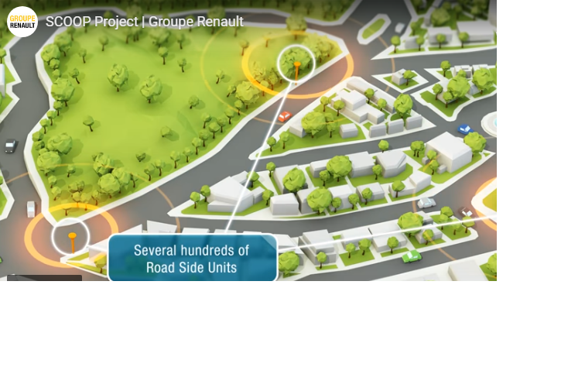
These innovative features and approaches have a massive value on customers, and it provides customer satisfaction by using products of Renault. Blog mainly sheds light on those automotive features and mobility solutions provided by company and suggest marketing mixes and marketing tools for readers to have a vast language of marketing tools and techniques.
Our group aims to become the most optimal mode of green transport and to develop a fleet of reliable cars for our customers. The future is in our hands, and for the next generations to benefit from at least a healthy experience, the concept cars that will be built within our group will allow fast travel with 0 emissions and attractive designs for all categories of customers.
We are also determined to give back to the community what we have received from the community, namely respect, help, trust and encouragement. Current and future projects propose far-reaching investments in disadvantaged communities and financial support for children profiting from these communities.
The Renault Group wants change to come from within each one and to encourage the outside world to change through innovation and exceptional organizational structure and, therefore, the transparency of our projects in the media has the effect of better synthesizing the wishes of our customers and meeting the expectations of the next generations.

Reference List

Journals
Anusha, K.S., 2016. Brand a marketing mix: a review. Journal of Global Economics, 4(3), pp.1-4.
Bartoloni, E. and Baussola, M., 2016. Does technological innovation undertaken alone have a real pivotal role? Product and marketing innovation in manufacturing firms. Economics of Innovation and New Technology, 25(2), pp.91-113.
Boisen, M., Terlouw, K., Groote, P. and Couwenberg, O., 2018. Reframing place promotion, place marketing, and place branding-moving beyond conceptual confusion. Cities, 80, pp.4-11.
Datta, H., Ailawadi, K.L. and Van Heerde, H.J., 2017. How well does consumer-based brand equity align with sales-based brand equity and marketing-mix response? Journal of Marketing, 81(3), pp.1-20.
Durmaz, Y. and Yaşar, H.V., 2016. Green Marketing and Benefits to Business. Business and Management Studies, 2(2), pp.64-71.
Eneizan, B.M., Abd-Wahab, K. and Obaid, T.F., 2016. Effects of green marketing strategy on the financial and non-financial performance of firms: A conceptual paper. Oman Chapter of Arabian Journal of Business and Management Review, 34(3796), pp.1-14.
Falát, L. and Holubčík, M., 2017. The influence of marketing communication on financial situation of the company–a case from automobile industry. Procedia engineering, 192, pp.148-153.
Grimpe, C., Sofka, W., Bhargava, M. and Chatterjee, R., 2017. R&D, marketing innovation, and new product performance: a mixed methods study. Journal of Product Innovation Management, 34(3), pp.360-383.
Gunasekharan, T., Basha, S.S. and Lakshmanna, B.C., 2016. A Study on impact of Promotion Mix Elements-Sales promotion & Direct Marketing of DTH manufactures on Customer Behaviour. ITIHAS The Journal of Indian Management, 6(1), pp.67-72.
Hanssens, D.M. and Pauwels, K.H., 2016. Demonstrating the value of marketing. Journal of Marketing, 80(6), pp.173-190.
Išoraitė, M., 2016. Marketing mix theoretical aspects. International Journal of Research–Granthaalayah, 4(6), pp.25-37.
Liu, Y., Li, K.J., Chen, H. and Balachander, S., 2017. The effects of products’ aesthetic design on demand and marketing-mix effectiveness: The role of segment prototypicality and brand consistency. Journal of Marketing, 81(1), pp.83-102.
Mahmoud, T.O., 2018. Impact of green marketing mix on purchase intention. International Journal of Advanced and Applied Sciences, 5(2), pp.127-135.
Resnick, S.M., Cheng, R., Simpson, M. and Lourenço, F., 2016. Marketing in SMEs: a “4Ps” self-branding model. International Journal of Entrepreneurial Behaviour & Research, 22(1), pp.155-174.
Shalender, K. and Singh, N., 2015. Marketing flexibility: Significance and implications for automobile industry. Global Journal of Flexible Systems Management, 16(3), pp.251-262.
Todorova, G., 2015. Marketing communication mix. Trakia Journal of sciences, 13(1), pp.368-374.

Websites
Group.renault.com, (2019) Innovation Viewed on: 20 Dec 2019 <https://group.renault.com/en/innovation-2/>
Group.renault.com, (2019) About Us Viewed on: 20 Dec 2019
<https://group.renault.com/en/our-company/>
Group.renault.com, (2019) Brands Viewed on: 20 Dec 2019
<https://group.renault.com/en/our-company/our-brands/>
Group.renault.com, (2019) Homepage Viewed on: 20 Dec 2019
<https://group.renault.com/en/>
Topspeed.com, (2019) Price Viewed on: 20 Dec 2019<https://www.topspeed.com/cars/renault/index83.html>

