ECAD4010-C: Researching the Learning – What, how and why am I teaching?
Lauren Bourne - 1902225

Targed/Target 1 | Revise use of appendices. Include any additional material that you wish to share with the reader clearly labelled in appendices.
Targed/Target 2 | In order to further develop an academic writing style, use the first person ‘I’ for reflection, but try and use the third person or impersonal form of the verb wherever else possible.

A critical analysis and evaluation of the observation research tool, ‘Leuven Scale.’

Task Description
“Compare and contrast a range of literature (journals, blogs, government reports, websites, Estyn reports) related to observation of the learning environment within a Foundation Phase (FP) class. The learning environment may include indoor or outdoor spaces and resources. Observation should focus on a small group of learners, using the Leuven scale as a tool.

You need to engage critically with the literature in making tentative conclusions about the creation of an effective learning environment. Consideration also needs to be given to the potential impact of using the Leuven scale on your own practice as an ethical researcher and the development of learners.” (Moodle, 2020).

During this assignment I intend to explore the use of observation as a research tool within a Foundation Phase learning environment, as well as evaluating the effectiveness of the Leuven Scale. As Hattie suggests (2009, p6), it is important as a teacher to consistently self-evaluate our pedagogy through research and not to rely on simply finding support to justify our actions. By conducting research in education, teachers can review their practice and explore why certain approaches work well or not so well (Griggs, 2010). Observation is a tool which can be used to assess specific approaches or environments within the classroom on a first hand basis; I will be undertaking an observation of a Foundation Phase setting.
The Foundation Phase philosophy is based on a holistic approach to child development and learning; this includes giving children a wide variety of learning experiences (Welsh Government, 2015). A typical Foundation Phase classroom will provide different learning environments for these experiences, such as a role play, outdoor or creative area to name a few. From the selection of video clips given, I chose to observe a group of children engaging in a role play activity (Department for Education, 2011), focusing on the research question: ‘To what extent does the role play environment provide opportunities for pupil involvement and learning?’ (Evans, 2020).
The Foundation Phase suggests that play is a crucial part of a young child’s development and aims to create a “balance between structured learning through child-initiated activities and those directed by practitioners.” (Welsh Government, 2015, p4). Each area of learning within the framework has a range of skills needed to achieve the outcomes set, from which the literacy and numeracy skills could be considered to be constructed in more detail than the others. This could be interpreted as the onus currently being on the more academic areas of learning, which are typically taught with direct teaching methods as opposed to child-initiated play. As founder of the Reggio Emilia approach which is predominantly child-led, Malaguzzi said that the teacher should be “sometimes the director, sometimes the set designer, sometimes the curtain and the backdrop, and sometimes the prompter.” (Rinaldi, 2006, p73). With this you could argue it is important as a teacher to assess when intervention is necessary, but it is beneficial to allow children to follow their interests and be independent where possible. Maria Montessori’s idea of ‘periods of sensitivity,’ where the children are most eager to learn and must be allowed time to pursue these sparks of interest without interruption also supports this (Pound, 2005).
The role play learning environment specifically, is considered a child-led activity as children are able to engage independently by taking turns, adopting a role, using their imaginations and exploring a variety of topics. However, it can also be used to consolidate and contextualise prior information from directed focused tasks; this is the case within my chosen video (Department for Education, 2011) where the children have been learning about the topic of Japan and travel, giving them the information needed to pretend they are at a travel agents booking a holiday to go there.
The social element of role play would be considered important by Vygotsky as children are able to learn from their more knowledgeable peers and establish the Zone of Proximal Development (Pound, 2005). The Zone of Proximal Development (ZPD) is considered important in the process of planning a curriculum that challenges their current capabilities; the notion of ‘scaffolding’ and observing the child helps to assess their level within the ZPD. In this aspect, observing and assessing children whilst they are independent within a role play environment can help to create an effective learning environment.
The Leuven Scale is an observation tool that can be used to assess a child’s wellbeing or their involvement in learning. Developed by Ferre Laevers and his colleagues at the Leuven University in Belgium while exploring Experiential Education (Laevers, 2011). It provides detailed descriptors to match with a child’s behaviour in order to categorise their level, which would prove useful in an observation. However, as with all research tools and strategies, context has an important role to play. Laevers admits that observing involvement can be subject to interpretation (Laevers, 2000, p25). Macintyre’s thoughts (2001) on observing play support this as she believes learning during play can be implicit. So the results and value of the play activity “may well depend on the understanding and observation skills of the observers!” (Macintyre, 2001, p4). The sample size or the length of the observation could also affect how reliable the information would be in a general sense, as well as the how, when and how often a recording is made.
As my research question focuses solely on pupil involvement and learning, I decided to use the Leuven Scale for Involvement in Learning only (Wells, 2015). This provided me with the basic indicators to look for during the observation. I then created an observation schedule, on which I would record a score for each child at one minute intervals for the duration of the activity – see appendix (i). The scores are based on a key included in the schedule, created with the Leuven Scale descriptors. I also created an ‘additional comments’ section so as to provide some context on the actions of the children throughout the activity. The results would therefore be mixed between qualitative and quantitative data; the score given as a result of the Leuven Scale would be quantitative as it is numerical in form, whereas the additional comments could be considered qualitative from an observational perspective.
When conducting any form of research, it is essential to consider how best to ensure the research is ethical. In this instance of an observation in a Foundation Phase setting, parental consent would be required as well as the school and class teacher giving informed consent for the research to go ahead. As the participants of the observation are under the age of 18, assent would need to be granted, meaning they express their willingness to take part. (BERA, 2018). At any point, a participant or parent can decide not to participate and so any data collected thus far should be destroyed and discarded from the research results.
The participants within any form of research have a right to privacy, especially persons under the age of 18 as stated in Article 16 of the UN Convention on the Rights of the Child (1989). For this reason, it is important to conduct research with confidentiality and anonymity in mind. Researchers should attempt to keep participants anonymous, however this is not always possible, for example, if the researcher was aware of the participants’ identities. If this is the case, confidentiality must be adhered to so that the participant is unable to be identified or traced (BERA, 2018). With my chosen video (Department for Education, 2011), I have made the assumption that all participants and their parents/guardians will have given consent and assent to be filmed. Within my observation schedule, anonymity and confidentiality were both considered as no names, ages or identifying factors were used – see appendix (ii).
In regards to the research question, ‘to what extent does the role play environment provide opportunities for pupil involvement and learning?’ (Evans, 2020) the results of my observation are positive in nature in regards to pupil involvement in learning within a role play environment. The overall modal scores for each child ranged from three to five, which showed moderate, high and extremely high levels of involvement in learning. However, as the sample size was a small group of three children, the results are unable to support a general statement regarding the Foundation Phase as a whole without further investigation. Also, in regards to Laevers point that observation is subjective to interpretation (Laevers, 2000, p25), I would agree and if carrying out the observation again, I would consider multiple observers using the same schedule and scoring key.
As stated previously, context has a strong role to play in observation; the children shown in the video (Department for Education, 2011), seemed to have good knowledge of the topic of Japan and travel as they near the end of a class theme. It is possible to argue that if the children were not as knowledgeable or as comfortable with the topic, the role play activity may not have proved successful for involvement in learning.
Within the additional notes included in my findings, it is mentioned that Learner B ‘seems shy’. If we look at this observation with her modal involvement score of three, could their level of involvement be subjective to interpretation due to their nature? All children develop socially and emotionally at different rates, and will be influenced by their individual contexts including: prior learning, genetic endowment, their environment and the quality and quantity of opportunities they have experienced (Macintyre, 2001, p34). Learner B although not as sociable as the other learners in the group, still engaged during parts of the activity and observed during other parts. As the Leuven Scale (Wells, 2015) does not give details on whether simply observing the other children merits a higher involvement score, this then perhaps had an impact on the result given. Due to this, it could be interpreted that the Leuven Scale is unable to give a credible score in relation to an individuals’ involvement in learning.
Overall, I feel measuring pupil involvement in learning is down to interpretation, however, the Leuven Scale provides a generalised score of how enthusiastic each child appears in accordance to the descriptors given (Wells, 2015). If a number of observations were to be completed by more than one observer, it may provide a more conclusive set of data in regards to general pupil involvement within a role play environment. I feel the Leuven Scale was a suitable observational tool for the question in terms of relevance; we are able to use the results to help us assess individual children’s levels of involvement, which would be beneficial for teachers to flag up pupils who may need extra support or differentiation within the activities.
Carlina Rinaldi said,
“personal and professional development, like education, should not be seen as static or unchangeable qualities, achieved once and for all, but rather as a process, an ongoing path that we follow from birth throughout our lives,” (Rinaldi, 2006, p137).
Part of the role of a professional teacher is to continue to self-evaluate their practice, and be researchers throughout their careers. As the Athrofa Research Dispositions state (Evans, 2020), being a teacher is to be part of an “inquiring profession” which actively engages with the research of others and proactively contributing to others. A topic I would like to investigate in the future is: ‘To what extent does play support the learning and social development of pupils with additional learning needs?’ After completing this observation, I would consider using the Leuven Scale in my research in the future alongside other research tools, providing the context was appropriate.

References

British Educational Research Association (BERA). (2018) Ethical Guidelines for Educational Research. 4th Ed. Available at: https://www.bera.ac.uk/publication/ethical-guidelines-for-educational-research-2018-online (Accessed on: 26/04/20).

Department for Education (2011) ‘Early Years Foundation Stage: Children playing at being travel agents’ [video] Available at: https://www.youtube.com/watch?v=yt69atPdg3I (Accessed on: 11/05/20).

Evans, A. (2020) ECAD4010C – Session Eight Available at: https://uowtsd-my.sharepoint.com/:p:/g/personal/alison_evans2_uwtsd_ac_uk/EXcGRVDT3jVJkOGPdPrWyscB9w7axVLjYVdjpG5hbUH1kw?e=tj68W8 (Accessed on: 08/05/20).

Griggs, R. (2010) Becoming an outstanding primary school teacher Essex: Pearson Education Ltd.

Hattie, J. (2009) Visible Learning: a synthesis of over 800 meta-analyses related to achievement London; New York: Routledge.

Laevers, F. (2000) ‘Forward to Basics! Deep-Level-Learning and the Experiential Approach’ Early Years, 20(2), pp. 20-29.

Laevers, F. (2011) Experiential Education: Making Care and Education More Effective Through Well-Being and Involvement Available at: http://expertisecentrum.cego.be/wp-content/uploads/2019/07/Laevers_2011_ChildEncyclopedia.pdf (Accessed on: 12/05/20).

Macintyre, C. (2001) Enhancing Learning Through Play – A Developmental Perspective for Early Years Settings London: David Fulton Publishers

Moodle. ECAD4010 Assessment Specification Available at: https://moodle.uwtsd.ac.uk/pluginfile.php/362313/mod_resource/content/1/ECAD%204010%20Assessment%2C%202020.pdf (Accessed on: 29/04/20).

Pound, L. (2005) How Children Learn. Warwickshire: Step Forward Publishing Ltd.

Rinaldi, C. (2006) In Dialogue with Reggio Emilia – Listening, researching and learning. London: Routledge.

United Nations (1989) UN Convention on the Rights of the Child. New York: United Nations.

Welsh Government (2015) Foundation Phase Framework. Cardiff: Welsh Government.

Wells, R. (2015) ‘Are your learners achieving Flow?’ EDUWELLS Education futures + learning how to learn [blog]. 28 February. Available at: https://eduwells.com/2015/02/28/can-ipads-help-achieve-a-state-of-flow/ (Accessed on: 11/05/20).

Appendix

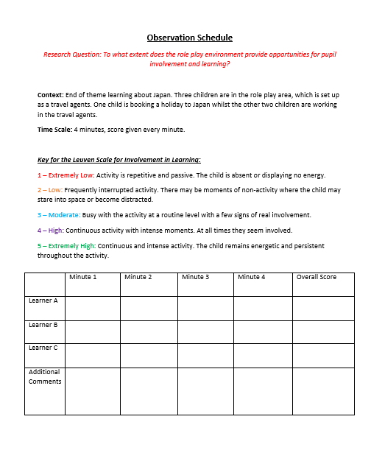
- Observation Schedule using the Leuven Scale for Involvement in Learning.

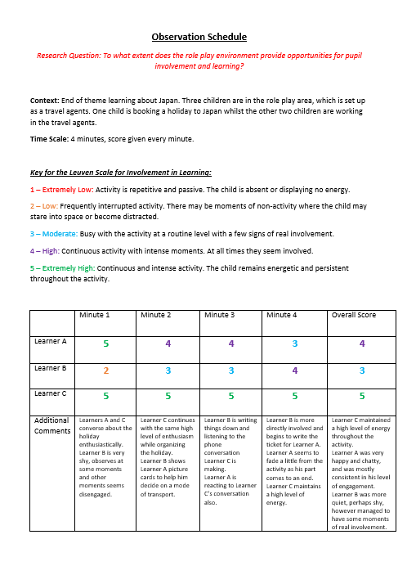
- Results of observation using the Leuven Scale for Involvement in Learning

