
business plan gelafab
Artisanal gelato shop


Corina Cernat 2019920
Managing Entreprise in the 21st Century
02.12.2021
Word count:2522

Contents
1. Name and concept 2
3. Mission statement 3
4. Business Aims 4
5. Business Objectives 4
6. Products and services 4
7. Physical location 5
Location 5
Equipment 6
8. Human Resource strategy 9
9. Marketing strategy 10
Marketing samples 10
Market research 13
10. Finance 16
11. SWOT 17
12. Cash flow 18
13. References 21

- Name and concept
I came up with the idea of a gelato shop not because there is a hole on the market that can be filled, but from passion and the love I have for Italy, and gelato.
Ice cream has always been my favourite dessert and I know it is loved by so many of us, and Italy has the best one, that is a fact. Their gelato is well known for its intense flavour, richer and silkier consistency and with 50% less fat than normal ice cream (Sacchi, et al., 2019). It contains natural ingredients and is made without preservatives and is seen as a healthier alternative to industrial ice-cream and an increase towards health consciousness among consumers is going to lead to a growing demand for artisanal gelato (Allied Market Research, 2021). It is usually served 10-15 degrees warmer than ice cream, which makes it easier to enjoy in the colder months as well and has a lower environmental impact than traditional ice cream (Konstantas, et al., 2019).
When I decided what name I should choose for my business, I encountered a few challenges. Most of the names I was thinking about have already been taken and I knew I wanted a simple name, but also representative for the products offered and the quality as well.
I have then created GelaFab, where Gela stands for gelato, and Fab comes from fabulous, which is exactly how the gelato is going to be.

- Legal identity
I have decided to operate my business as a sole trader to begin with, with the possibility to move onto a limited company after a few years.
As a sole trader I will have less bureaucracy to deal with, lower start-up costs and I will be able to manage the business myself (Morris, 2011), but also to employ people for the other roles. It will also be easier to change the structure of the business once it expands.
Some of the disadvantages are that it might be more difficult at the beginning to obtain finance, I will also have sole responsibility for everything that happens and can lose all the personal investment and acquire debts if the business is not successful.
Once the business will be growing, I can then change to a limited company, and I will be able to protect the company’s name and attract new investors easily. The personal liability will also be minimised and so will the tax contribution (Grigore & Gurau, 2017).

- Mission statement
Our mission is to provide the best artisanal gelato in town to satisfy all tastes buds, at the most attractive prices.

- Business Aims
Our aim is to offer all customers a healthier ice cream alternative and delight them with natural ingredients gelato whilst looking after the environment.
We intend to operate in a sustainable manner and source most of the prime ingredients locally, use reusable and recyclable packaging and the latest technology to lower the sugar levels whilst keeping the flavours intact.

- Business Objectives
My objectives for the first year are:
- to start making profit
- to build awareness of the brand
- employee retention
- provide excellent customer service
- target the right customers
- maintain a positive cash flow
- liaise with local food suppliers
- use recyclable and reusable package

- Products and services
The shop will focus on selling mainly gelatos and sorbets, will have a selection of the most popular gelato flavours and other classic Italian ones. I will also be selling vegan options, fat free and some sugar free flavours as well.
The UK market for ice cream, desserts and cakes consumed outside the house has seen a 16% increase in the last 5 years (Shahbandeh, 2021) with only the ice cream retail value reaching £1.32 billion in 2020.
This is no surprise if we are to analyse the answers that the people interviewed during the market research for this business plan have provided when they were asked what else they would expect to buy from a gelato shop.
From all the respondents, 61% would also buy traditional cakes, 28% would buy teas and coffees and 22% would buy pastries and other seasonal sweets like panettones (Cernat, 2021).
Based on my market research and the growing demand for these types of deserts, among the gelato flavours, I will also be selling gelato cakes (semifreddo) and traditional ones, pastries, Italian sweets like cannoli, spreadable sweet creams with chocolate, hazelnuts, pistachios, caramel and other flavours, coffees, including affogato, teas, soft drinks, and other seasonal sweets, like panettone.
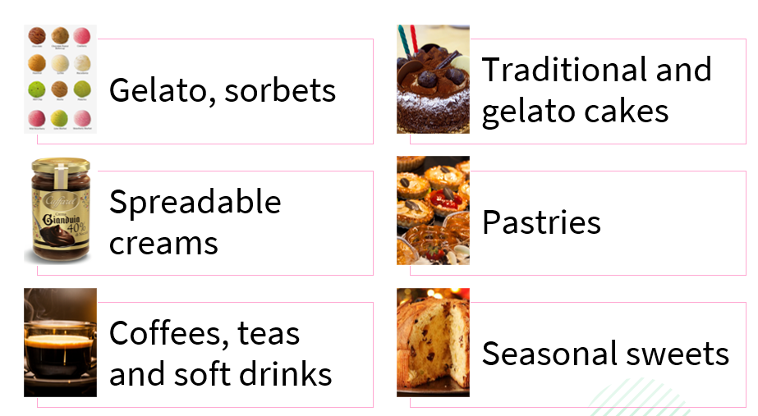
In the colder months when the demand is likely to drop, I will be introducing a new gelato concept called gelato caldo (Krystal, 2015), a combination between ice cream and parfait that is soft and creamy and feels warm on the palate.

Physical location

Location
I have decided to open a physical gelato shop in one of the most sought-after areas from Cardiff, considering that 78% of the people interviewed in my primary research live in this city. The shop will be in Penarth, on the busy Windsor Road. It is close to the beach and will have no issues in attracting customers and tourists. It will have a size of 1600 square feet and will include a display area, ordering counter, washing area, 6-8 small tables, toilet area and a laboratory where the gelato will be made every day.
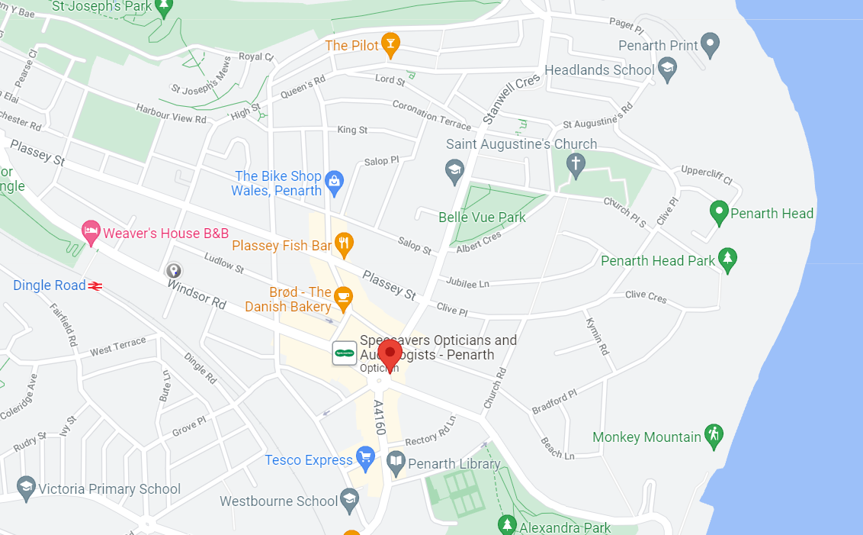

Although on an adjacent street there is a bakery and a crepe shop that sells ice cream as well, I am confident that my business will attract customers with the different products it offers. I also intend to have different opening times to theirs, as the shop will be opened from 12 PM-10 PM.

Equipment
To produce a good quality artisan gelato, I will need to follow a 5-step process (Carpigiani, 2021):

The equipment for the shop will be purchased from Carpigiani (Carpigiani, 2021), the leading manufacturer of gelato machines and the ones who have recently developed technology to create gelato and sorbets with no added sugars (Hallet, 2018).
- DOUBLE SUGAR CONES MACHINE - CAST IRON - 3000W – £1550
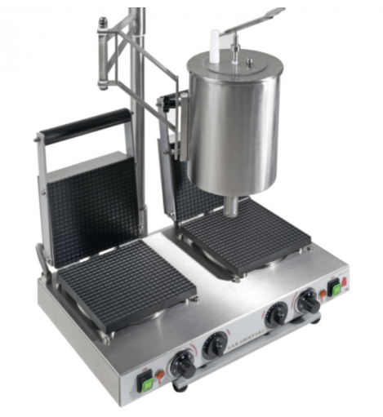
- PASTO 30 XPL Pasteuriser £2950– used for pasteurizing, storing, and aging on gelato mixes.
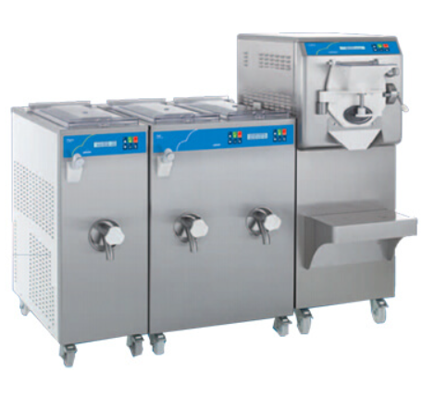

- TURBO MIX Blender £1150- used for preparation and mixes of gelato and sorbet bases
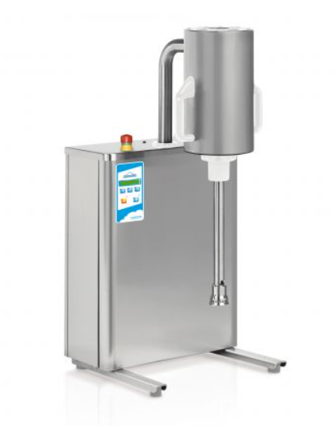
- LABO 15 60 HE Batch Freezer- £7900, floor standing batch freezer that recognize the type and quantity whilst also automatically regulating the cold and hot gas for optimal temperature
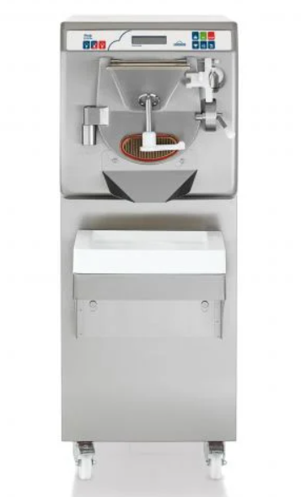
- LUNETTE Gelato Display- £2375
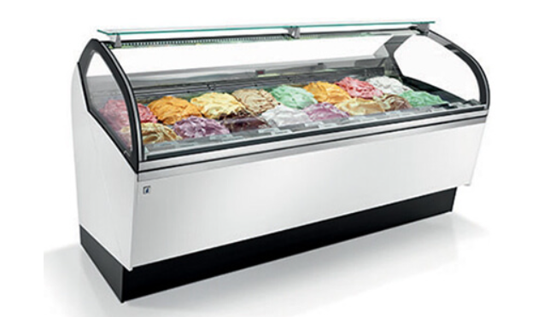

- Human Resource strategy
Once the shop will open, I will be taking the role of the manager for the business. I will be looking to employ 4 shop assistants, a supervisor, a technologist, a cook, and a supervisor. The premisses will be open every day, from 12 pm until 10 pm and these roles will be permanent and full time, apart from 2 of the shop assistants who will be on a part time contract.
I will also employ a cleaner on a part time basis who will come in a few hours a day, I will work with an accountant on a flexible basis at the end of each month and employ delivery drivers on a commission basis.
The recruitment process will be handled by myself, I will be posting the job adverts online on Indeed, Totaljobs, Studentjobs and conducting the interviews over the phone and in person.
The wages offered per year will be as follow:
Manager- £24.000
Technologist-£22.000
Cook-£22.000
Supervisor-£20.000
Shop assistant-£18.000/£10.000
Cleaner-£10.000
Delivery driver- £18.000
Accountant-£480
Organisational chart
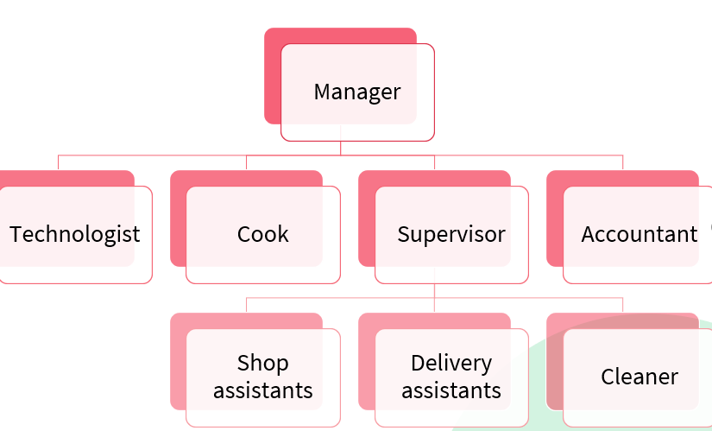

- Marketing strategy

Marketing samples
I have created a few marketing samples that I intend to use to advertise my business.
First, I have created a logo using some findings from my main market research. After analysing the answers provided to some of the questions, I concluded that the majority of those who consume gelato prefer to have it in a cone and prefer a pistachio flavour. I have therefore used a cone in my logo with the preferred flavour by my potential customers and the background is also a pastel green that resembles the pistachio colour.

Using the logo, I have then created business cards that I will keep in the shop and handle to bothy my customers and suppliers.
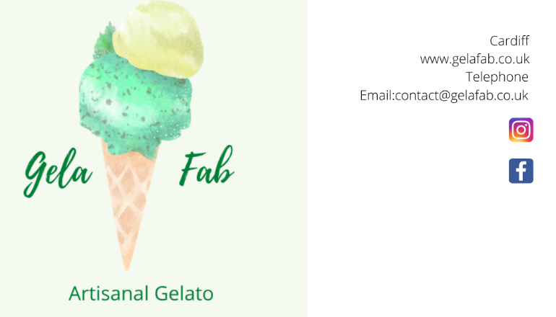
The main instrument that I intend to use for marketing purposes is going to be the website that I have developed considering the insights gathered from my primary research. The customers will be able to find out our story, our mission, and values, as well as the products we offer, will be able to subscribe to a weekly newsletter that will inform about new products and promotions, giveaways and will be viewing our contact details, email address and where to find us.

Home page
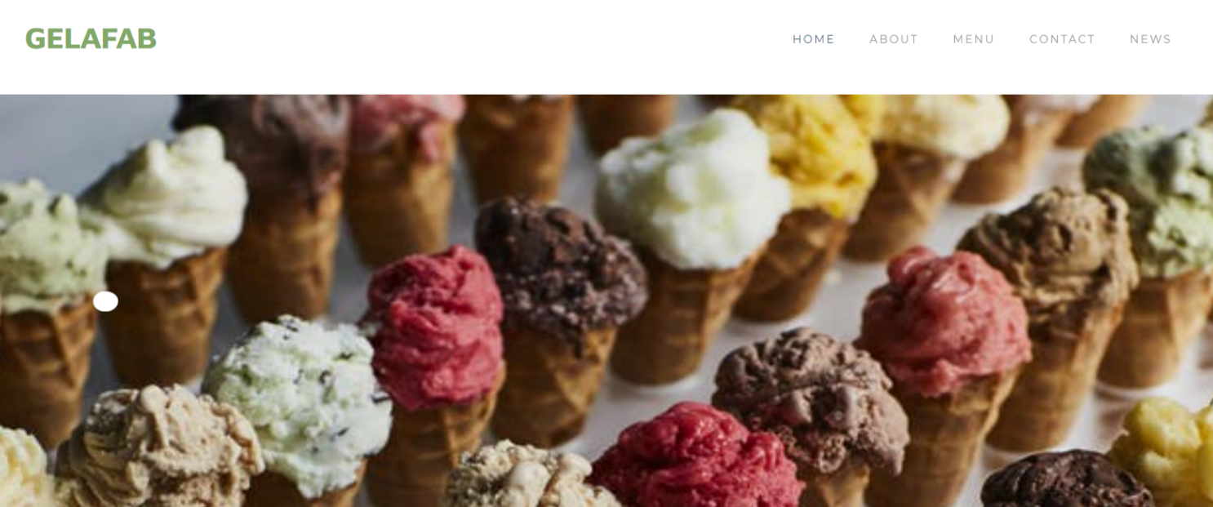

Contact page
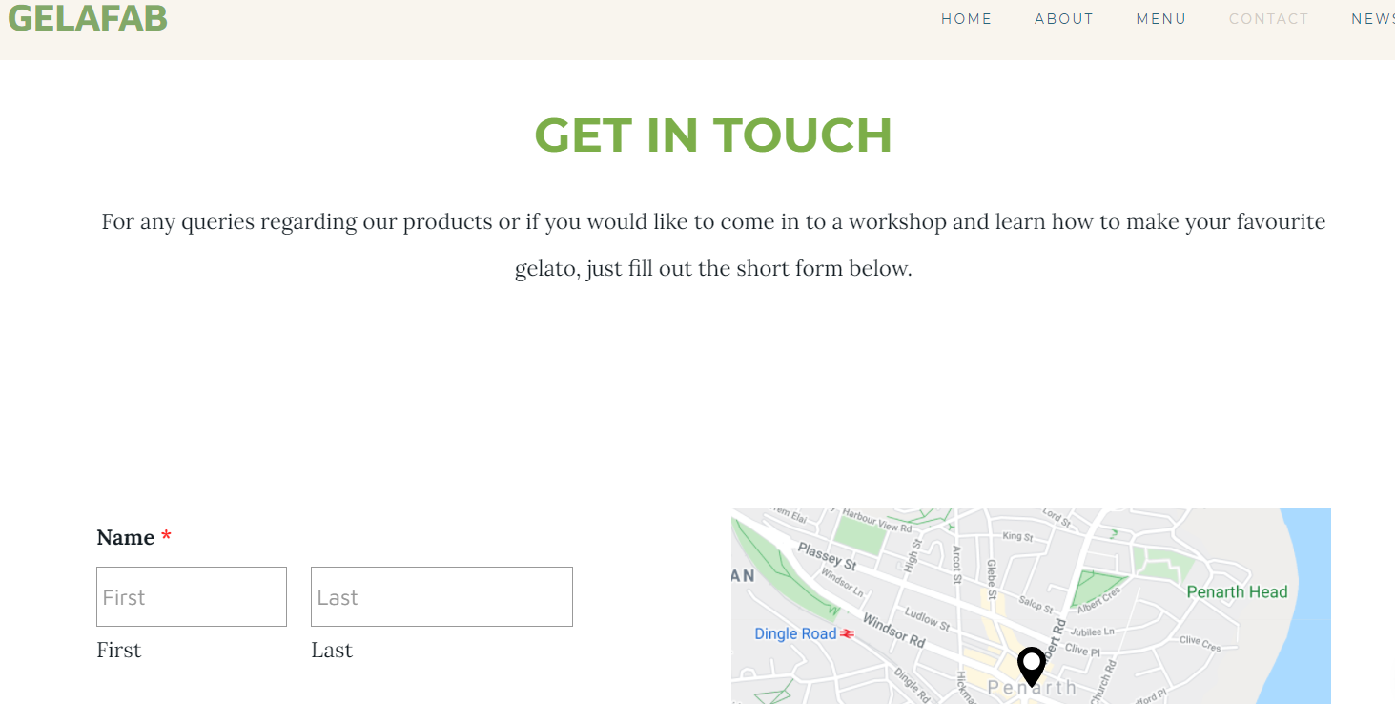
The business will also have a Facebook and Instagram page, and I am hoping the customers will contribute to increase the reach on these pages, especially on Instagram, as I intend to organize a monthly competition and offer a prize consisting in Amazon or Love2Shop vouchers to those who post a picture with their gelato and tag us on their profiles.

Facebook page
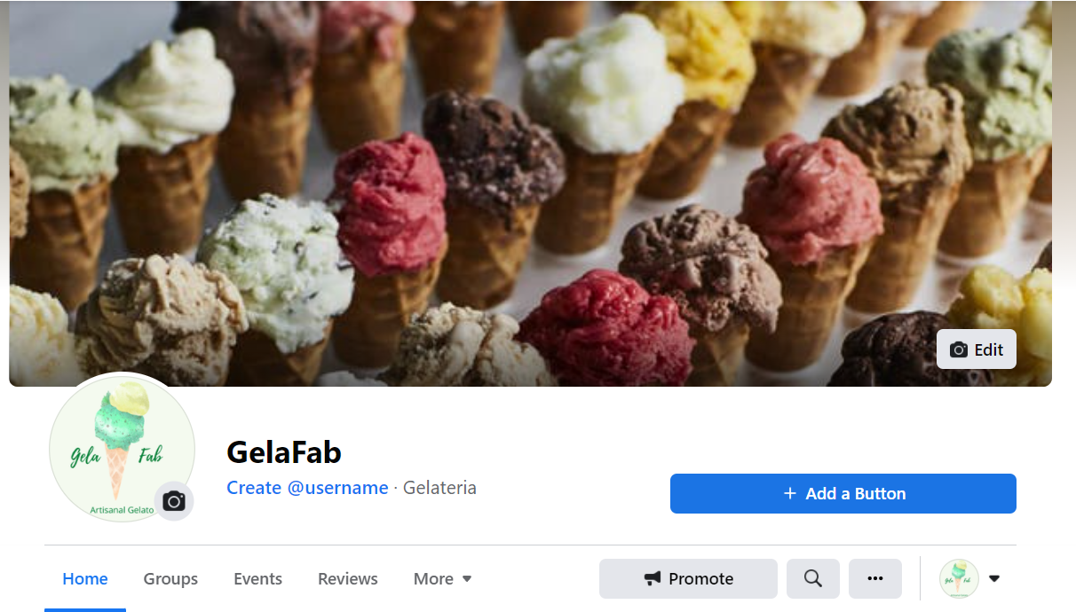

Instagram page
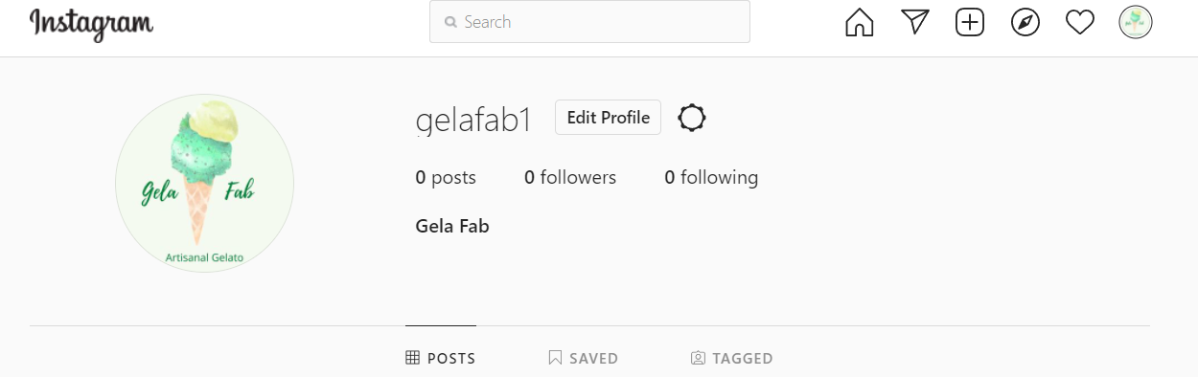
Before the opening of the store, I will be spreading leaflets in Cardiff and surrounding areas, on the leaflet there will be a voucher that the customers can bring to the shop in the first week and claim a free scoop from a selection of gelato flavours. I will also contact the local radio for an ad that will run for a few weeks once the shop is opened.

Market research
To determine my target demographics, I have conducted some primary research through a focus group and a questionnaire. The latter is the most used and cost-effective tool to gather data from a large group (Brace, 2018)and has provided valuable findings that helped me develop my website and logo for my business. From the questionnaire I have managed to find out the shopping habits that my potential customers have when it comes to how often they buy gelato, where they tend to purchase it from, favourite flavours, how much they are willing to pay and what are the most important factors in their buying decision.
The data gathered has been analysed and helped me determine my pricing strategies, what are the flavours that are likely to be selling most, what other products people expect to buy from my shop and how they prefer their gelato to be served. I have also gathered important information that will be used for my SEO strategy and creating my website, especially keywords, locations that will need to be mentioned, and pictures that will be used online.

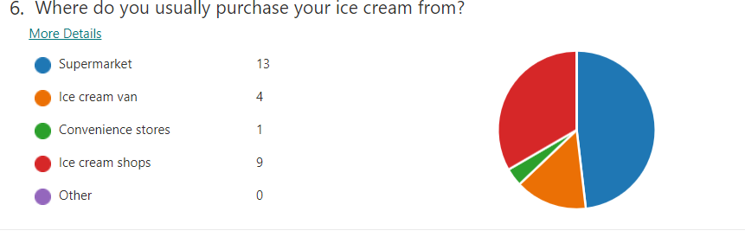
Although most respondents purchase their ice cream from the supermarket, 56% of them also buy from an ice cream shop, fact that is supported also by statistics showing the average purchase of ice cream consumed outside the home in UK in the last years, as illustrated below.
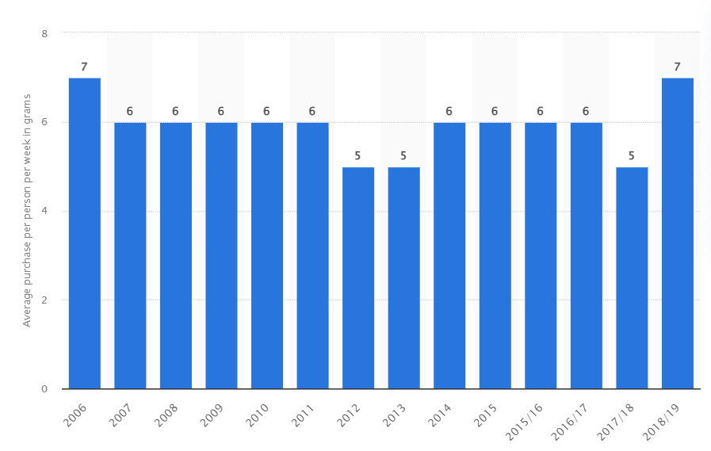
Figure 1. Average purchase per person per week of ice cream consumed outside the home in the United Kingdom (UK) from 2006 to 2018/2019 in grams (Statista, 2020)

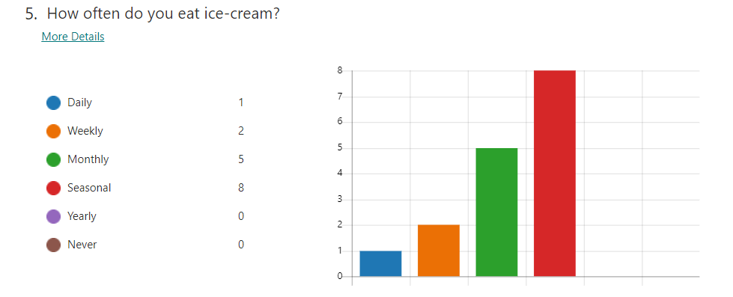
When asked how often they consume ice cream, 50% of them buy it seasonally, whereas 31% eat it monthly and 13% consume it weekly. None of the respondents said they never consume it, so this again shows that gelato is a desert enjoyed by everyone of us. It is no surprise that so many people consume this treat monthly, as in the last years the consumption of gelato outside the season has increased because of warmer weather and rising of disposable income (IbisWorld, 2021)
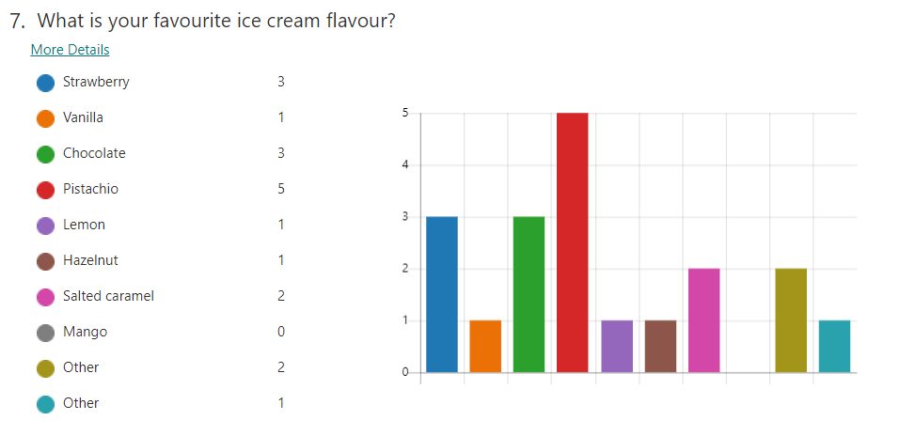
The answers provided to this question show that most potential customers prefer the pistachio flavour, and this fact has been used to create the logo of this business and helped me decide the colour theme for my website. All the flavours that were chosen by the respondents will be present in the gelato shop in bigger quantities to satisfy the demand.
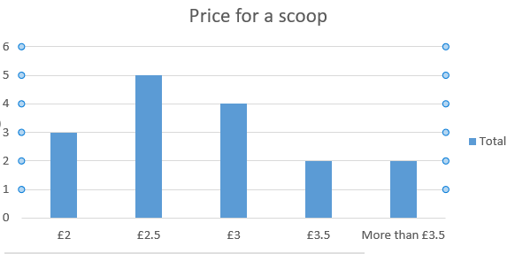
This question has been used to determine the price point for a gelato scoop and the answers provided show that the majority would pay £2.5 for it, followed by those who would pay £3 or more. The respondents have also indicated on a next question that quality of the product is more important than the price, which again shows they are willing to pay more for a premium product that uses better ingredients and offers an improved taste.
The business will target people from Cardiff and surrounding areas aged between 18-54 years old.

- Finance
For the start of the business, I intend to use my savings and apply for a micro loan from up to £50.000 from Development Bank in Wales (DBW, 2021) that will cover my start-up costs with renting the equipment and the premises, staff recruitment and training, marketing purposes and stock purchasing. To minimise the costs with wages in the first 6 months, I intend to apply for the Kickstart Scheme (Cardiff Council, 2021), a grant funded by the Department of Works and Pensions that is available for employers who create 6-month job placements for young people and gives 100% contribution for 25 hours a week. This grant will support me with the wages of the part time employees in the first half year.
Apart from the business loan and the grant, I will also be investing £15.000 from my savings.
The higher costs for the business will be allocated buying the equipment and the remaining costs will be for decoration, working capital and the inventory.

Estimated costs (£)
Equipment | 20.000
Fees and licenses | 3.000
Furniture | 10.000
Opening inventory (prime ingredients and supplies) | 5.000
Insurance | 100
Working capital (rent, wages, business rates) | 20.000
Shop design | 8000
Marketing | 1500
Stationary | 300
Total | £67.900

- SWOT
Strengths

- Locally sourced prime ingredients
- healthier option than ice cream
- large variety of gelato flavours and other sweets
- vegan options available
- prime location
- high quality products
- high demand in the summer months
- delivery options available for Cardiff and surrounding area

Weaknesses
- high start-up costs
- several competitors in Cardiff
- lack of experience
- unknown brand
- seasonal product

Opportunities
- available funding through Business for Wales
- selling gelato kits for customers to prepare at home
- high quality equipment
- offering different products, like gelato cakes, Italian sweets (cannoli), spreadable sweets, other seasonal bakes
- healthier varieties offered, like sugar free, fat free
- increase in customers who view artisanal gelato as a healthier option (Market Research Future, 2021)
- organising corporate workshops for learning how to make your own gelato

Threats
- Loss of interest during winter months
- high competition and similar products available in many locations, like supermarkets, convenience stores, restaurants
- higher import costs because of Brexit
- Local resources might be affected by increased costs or high demand
- Risk of not getting the finance

- Cash flow
To make sure my business can survive and grow in the first year, I have also created a cash flow forecast for the first 12 months that I have attached below.

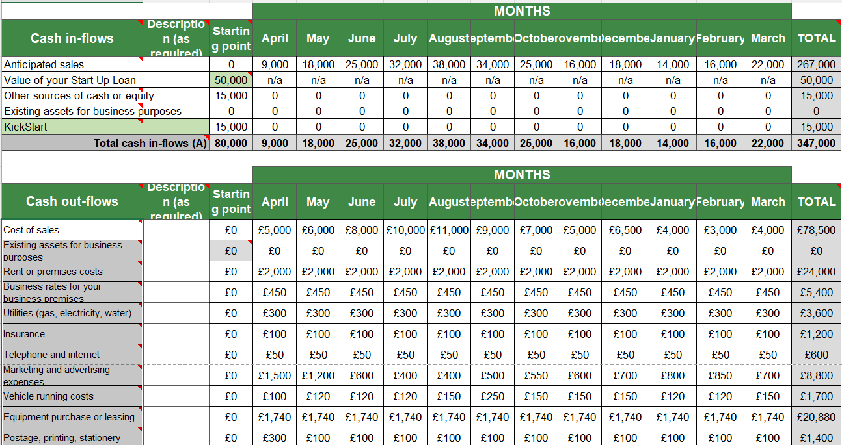

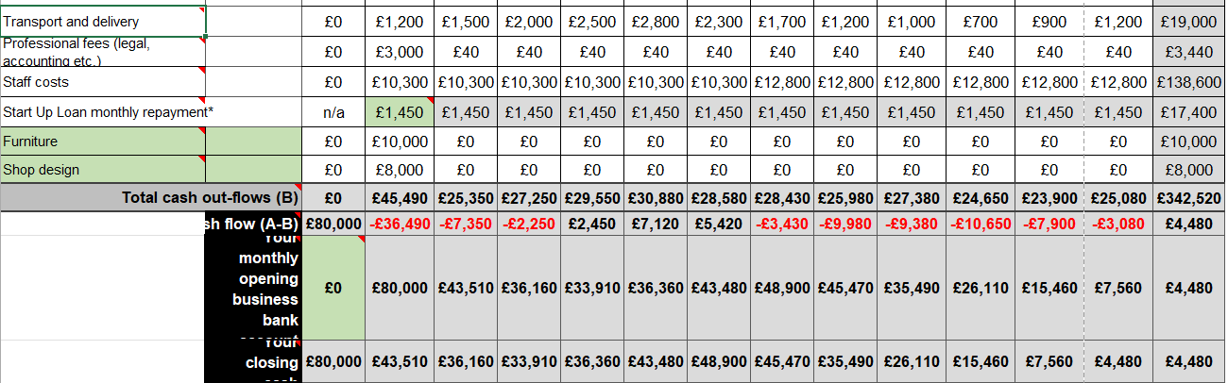

References
- Allied Market Research, 2021. Artisanal Ice cream Market. [Online]
Available at: https://www.alliedmarketresearch.com/artisanal-ice-cream-market-A06555
[Accessed 29 November 2021].
- Brace, I., 2018. Questionnaire Design: How to Plan, Structure and Write Survey Material for Effective Market Research. 3rd ed. s.l.:Kogan PAge Publishers.
- Cardiff Council, 2021. Kickstart Scheme Grant Funding Agreement: terms and conditions for employers – effective from 22 November 2021. [Online]
Available at: https://www.gov.uk/government/publications/kickstart-scheme-terms-and-conditions/kickstart-scheme-grant-funding-agreement-terms-and-conditions-for-employers-effective-from-21-june-2021#duration-and-purpose-of-the-grant
[Accessed 30 November 2021].
- Carpigiani, 2021. Artisan Gelato. [Online]
Available at: https://www.carpigiani.co.uk/artisan-gelato-overview
[Accessed 29 November 2021].
- Carpigiani, 2021. The gelato journey. [Online]
Available at: https://www.carpigiani.co.uk/artisan-gelato-overview
[Accessed 30 November 2021].
- Cernat, C., 2021. Gelato shop questionnaire. [Online]
Available at: https://forms.office.com/Pages/ResponsePage.aspx?id=-REPTm4EBUWcuNshUjEeITt1LfCI_JtGipH1e15Im7FUQUhKSDJNR0FIWEwzTkpZWEpQWjZMUDFVRC4u
[Accessed 29 November 2021].
- DBW, 2021. Small business loans in Wales. [Online]
Available at: https://developmentbank.wales/small-business-loans-wales
[Accessed 30 November 2021].
- Grigore, M. Z. & Gurau, M., 2017. Optimizing Tax Costs relating to a New Business. Global Economic Observer, 5(1), pp. 201-208.
- Hallet, V., 2018. New Technology Aims To Take The Sugar Out Of Gelato - Not The Flavor. [Online]
Available at: https://www.proquest.com/docview/1999841538?accountid=130472&pq-origsite=primo
[Accessed 29 November 2021].
- IbisWorld, 2021. Ice Cream Production in the UK - Market Research Report. [Online]
Available at: https://www.ibisworld.com/united-kingdom/market-research-reports/ice-cream-production-industry/
[Accessed 29 November 2021].
- Krystal, B., 2015. 'Hot' gelato: It's a thing, and it's pretty cool: Though it sounds like a literal hot mess, gelato caldo is perfect for D.C. summers.. The Washington Post, 8 June.
- Market Research Future, 2021. Global Artisanal Ice Cream Market: Information By Type (Conventional and Lactose-Free), By Distribution Channel (Supermarkets & Hypermarkets, Specialty Stores and Online) - Forecast till 2027, s.l.: Market Research Future.
- Michael J, M., 2011. Your business name and legal status. In: Starting a successful business. London: Kogan Page, pp. 93-101.
- Sacchi, R. et al., 2019. Sensory profile, biophenolic and volatile compounds of an artisanal ice cream (‘gelato’) functionalised using extra virgin olive oil. International Journal of Gastronomy and Food Science, Volume 18, p. 100173.
- Shahbandeh, M., 2021. Average purchase per person per week of ice cream, desserts and cake consumed outside the home in the United Kingdom (UK) from 2006 to 2018/2019. [Online]
Available at: https://www.statista.com/statistics/284686/eating-out-weekly-uk-consumption-of-ice-cream-desserts-and-cakes/
[Accessed 29 November 2021].
- Statista, 2020. Average purchase per person per week of ice cream consumed outside the home in the United Kingdom (UK) from 2006 to 2018/2019. [Online]
Available at: https://www.statista.com/statistics/375874/eating-out-weekly-uk-consumption-of-ice-cream-uk/
[Accessed 29 November 2021].

