LCHS7009 Component 1
Digital Health Promotion Blogs
Two blog entries | Existing technology and designed technology

Programme | MSc Public Health and Social Care in Practice
Module | Population Health and Digital Health Promotion
Module code | LCHS7009
Lecturer | Dr. Raheela Shaikh
Assignment title | Component 1: 2 Blogs
Student name | Mst Sharmin Sultana Mitu
Student ID number | 2524666
Submission Date | 1 July, 2026

BLOG 1: Role of Digital Technology in Dementia Management in the UK

Background
Dementia is a progressive syndrome that impairs memory, thinking, behaviour and daily functioning hence resulting in the emergence of long-term needs of safety, communication and social care supports (World Health Organization, 2025). It is estimated that approximately 982,000 people live with dementia in the UK and that the cost is going to increase to approximately £90 billion in 2040 compared to approximately 42 billion in 2024 (Alzheimer's Society and Carnall Farrar, 2024). Dementia can also be considered as a population health concern due to unpaid caregivers usually taking care of medications, appointments, nighttime care and risks related to disorientation or going out without notice (NICE, 2018; Damant et al., 2024). Effective dementia care must consequently defend autonomy devoid of disregarding dignity, assent and disparities in the digital arena (NICE, 2018; NHS England, 2023).

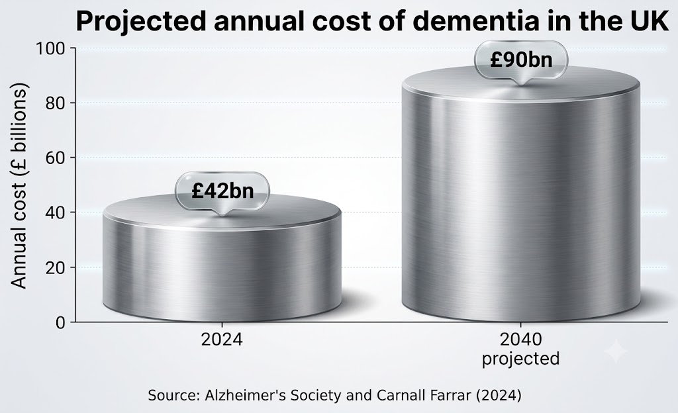
Figure 1. Projected annual cost of dementia in the UK. Source: author's own, based on Alzheimer's Society and Carnall Farrar (2024).

Role of digital technology
Digital tools in dementia treatment comprise reminder applications, video calls, information websites on the Internet about the carers, GPS watch (skilefts) and smart-home devices (Di Lorito et al., 2022; Damant et al., 2024). GPS accessories and sensors at home are helpful in that they are rather created to aid safer living at home than human attention (Doyle et al., 2024). The GPS device can also notify a carer upon an overstep on an agreed safe zone, whereas door or motion detectors can indicate atypical habit like night wandering (Doyle et al., 2024; NICE, 2018).
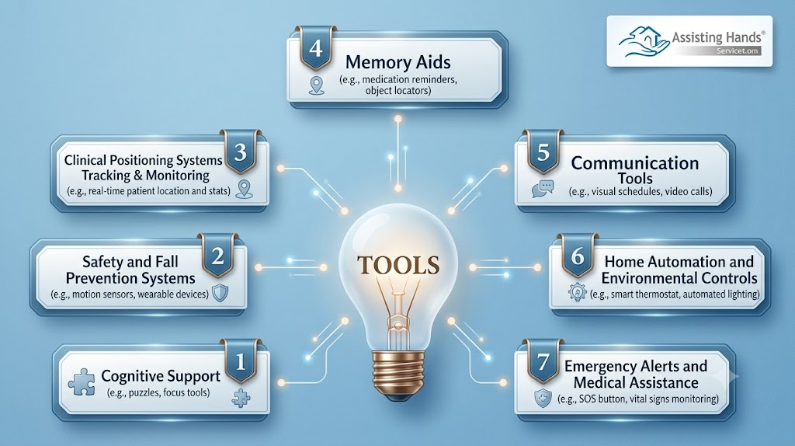
Figure 2. Digital technology pathway in dementia management. Source: author's own, based on NICE (2018), Michie, van Stralen and West (2011), Doyle et al. (2024) and NHS England (2023).

Clinical impact of digital technology
Early response is the health-promotion value since carers can intervene before the crisis turns into an emergency (Doyle et al., 2024). Remote monitoring may contribute to capability by providing more informative carers, opportunity by facilitating faster response, and motivation through alleviating anxiety which is associated with the COM-B behaviour change theory (Michie, van Stralen and West, 2011). Doyle et al. (2024) have established GPS trackers as a feasible and acceptable form of wearer-carer dyad, and the benefits of independence, safety, reassurance and decreased contact with the police force or the social services. Information access ability and communication of the carers with support networks could also be enhanced through ICT (Damant et al., 2024).

Figure 3: Dementia care often depends on family support, safety planning and person-centred daily care

Ethical issues, inequality and shortfalls
The effect is not necessarily good since monitoring may become support and surveillance (Di Lorito et al., 2022). When the unpaid carers have to pay attention to the digital systems, monitoring may appear intrusive, the false alerts may cause additional stress, and when the services fail to respond in time, the load on the already enough work may be transferred to them (Di Lorito et al., 2022; Damant et al., 2024). One of the key issues is digital exclusion since in the UK only 53 per cent of adults at the age of 75 and older have the basic foundational knowledge of digital skills (Good Things Foundation, 2024). Opt-in consent, frequent review, limited data gathering, training of carers, and use of loan devices and non-digital options should be implemented to address these gaps by local authorities and to Integrated Care Systems (NICE, 2018; NHS England, 2023; Good Things Foundation, 2024).

Resources for further study
For dementia advice and support, visit NHS Dementia: https://www.nhs.uk/conditions/dementia/
and Dementia UK: https://www.dementiauk.org/
BLOG 2: A Digital Support Tool for Dementia Care in the UK: CogniCare

Background
The prevention and support of dementia is a priority in the public health as the clinical, behavioural and social determinants of dementia risk in the life course (Livingston et al., 2024; World Health Organization, 2025). It is estimated that nearly half of the cases of dementia may be prevented or postponed by dealing with 14 risk factors that are modifiable, including hearing loss, hypertension, inactivity and isolation (Livingston et al., 2024). Family carers are also affected by dementia in the UK where most of the people who are at home rely on family support (Damant et al., 2024).

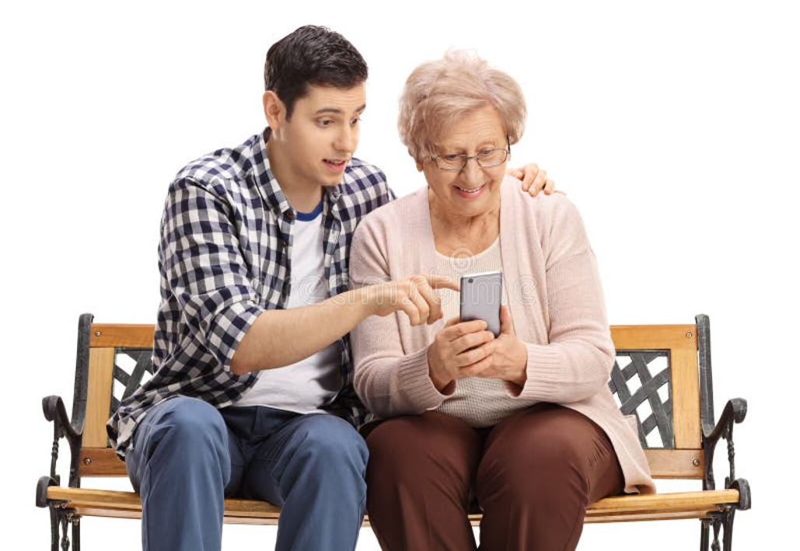
Figure 1: Digital dementia support should be simple enough for carers and older adults to use together. Author’s own illustration created for this submission

Role of CogniCare
CogniCare Ageing UK is a carer-focused mobile, web and SMS service in support of adults with early memory issues or mild dementia that has been designed around the principles of digital inclusion (NHS England, 2023). It is not a diagnostic app meaning that users would be directed to GP and NHS routes when symptoms evolve (NICE, 2018). The platform transforms brain-health types of advice to weekly activities like walking, hearing check, social interaction and appointment booking (Livingston et al., 2024; World Health Organization, 2025). The Carer Load Traffic Light is its initial feature, whereby the carers respond to four weekly questions about sleep, stress, confidence and missed tasks, via a straightforward escalation concept, which aligns with person-centred support (NICE, 2018). Green is reassuring, amber indicative of local support, and red provides an action prompt, which can be printed and given to a GP, NHS 111, carer centre or social prescriber (NICE, 2018; NHS England, 2023).
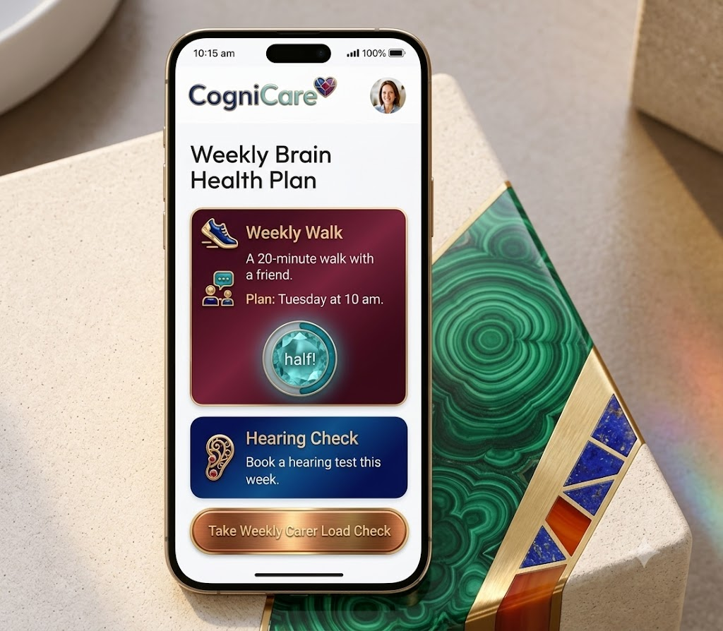
Figure 2. CogniCare Ageing UK design flow. Source: author's own, based on Michie, van Stralen and West (2011), NICE (2018) and NHS England (2023).

How it promotes health
CogniCare embraces the idea of COM-B, where all are enabled to develop through the provision of short learning cards, access to local services via localized service mapping and SMS, and induced through feedback and the shared family objectives (Michie, van Stralen and West, 2011). It might help decrease inequality through plain-English, voice services, translation, and printable plans and low-data access, which allows households with low digital literacy to use the health service (Good Things Foundation, 2024; NHS England, 2023). It may bring prevention, support and carer wellbeing into a single pathway, which reacts to fragmented support outlined in the literature on dementia and carers (Damant et al., 2024; NICE, 2018).

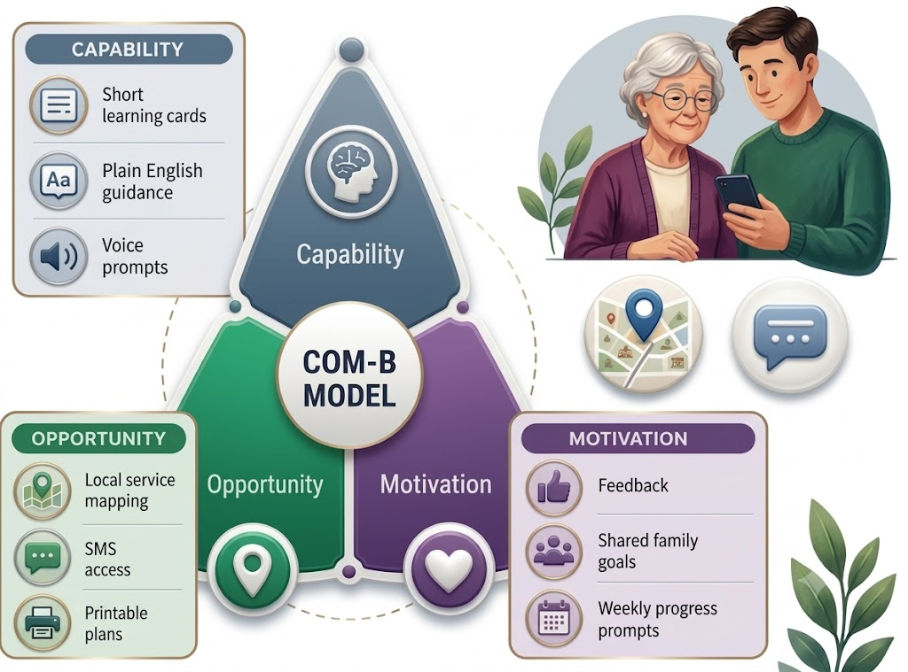
Figure 3: CogniCare applies COM-B by linking learning, access and motivation to weekly dementia-support actions. Author’s own illustration created for this submission

Risks and shortfalls
The primary risks are the invasion of privacy, excessive reliance on self-reported data on carers, additional unpaid labour and disappointment in case the local services are not able to reply (Di Lorito et al., 2022; Damant et al., 2024). These risks are important due to the frequent evidence of greater acceptability and lesser long-term outcomes of interventions of digital dementia across various groups (Di Lorito et al., 2022). CogniCare ought to be co-created with individuals with dementia, minority ethnic carers, elderly and low-income households, and require very small amounts of data, consent and human follow-up (NICE, 2018; NHS England, 2023; Damant et al., 2024). Carter burden, social participation, service referrals and usability are the success metrics that need to be used rather than downloads (Damant et al., 2024).

Resources for further study
For dementia advice and support, visit NHS Dementia: https://www.nhs.uk/conditions/dementia/
and Alzheimer's Society: https://www.alzheimers.org.uk/

References for Blog 1
Alzheimer’s Society and Carnall Farrar (2024) The economic impact of dementia. London: Alzheimer’s Society. Available at: https://www.alzheimers.org.uk/what-we-do/policy-and-influencing/economic-impact-of-dementia (Accessed: 19 June 2026).
Damant, J., Freddolino, P., Dangoor, M., Hu, B., King, D. and Wittenberg, R. (2024) ‘Unpaid carers of people with dementia and information communication technology: use, impact and ideas for the future’, Dementia, 23(5), pp. 779–799. Available at: https://doi.org/10.1177/14713012241249793.
Di Lorito, C., Bosco, A., Rai, H., Craven, M., McNally, D., Todd, C., Booth, V., Cowley, A., Howe, L. and Harwood, R. (2022) ‘A systematic literature review and meta-analysis on digital health interventions for people living with dementia and mild cognitive impairment’, International Journal of Geriatric Psychiatry, 37(6). Available at: https://doi.org/10.1002/gps.5730.
Doyle, M., Nwofe, E.S., Rooke, C., Seelam, K., Porter, J. and Bishop, D. (2024) ‘Implementing global positioning system trackers for people with dementia who are at risk of wandering’, Dementia, 23(6), pp. 964–980. Available at: https://doi.org/10.1177/14713012241248556.
Good Things Foundation (2024) Digital inclusion and health: summary of key statistics. Available at: https://www.goodthingsfoundation.org/discover/digital-inclusion-insights/digital-inclusion-insights-2024/digital-inclusion-and-health (Accessed: 19 June 2026).
Michie, S., van Stralen, M.M. and West, R. (2011) ‘The behaviour change wheel: a new method for characterising and designing behaviour change interventions’, Implementation Science, 6, article 42. Available at: https://doi.org/10.1186/1748-5908-6-42.
NHS England (2023) Inclusive digital healthcare: a framework for NHS action on digital inclusion. Available at: https://www.england.nhs.uk/long-read/inclusive-digital-healthcare-a-framework-for-nhs-action-on-digital-inclusion/ (Accessed: 19 June 2026).
NICE (2018) Dementia: assessment, management and support for people living with dementia and their carers. NICE guideline NG97. Available at: https://www.nice.org.uk/guidance/ng97 (Accessed: 19 June 2026).
World Health Organization (2025) Dementia. Available at: https://www.who.int/news-room/fact-sheets/detail/dementia (Accessed: 19 June 2026).

References for Blog 2
Damant, J., Freddolino, P., Dangoor, M., Hu, B., King, D. and Wittenberg, R. (2024) ‘Unpaid carers of people with dementia and information communication technology: use, impact and ideas for the future’, Dementia, 23(5), pp. 779–799. Available at: https://doi.org/10.1177/14713012241249793.
Di Lorito, C., Bosco, A., Rai, H., Craven, M., McNally, D., Todd, C., Booth, V., Cowley, A., Howe, L. and Harwood, R. (2022) ‘A systematic literature review and meta-analysis on digital health interventions for people living with dementia and mild cognitive impairment’, International Journal of Geriatric Psychiatry, 37(6). Available at: https://doi.org/10.1002/gps.5730.
Good Things Foundation (2024) Digital inclusion and health: summary of key statistics. Available at: https://www.goodthingsfoundation.org/discover/digital-inclusion-insights/digital-inclusion-insights-2024/digital-inclusion-and-health (Accessed: 19 June 2026).
Livingston, G., Huntley, J., Liu, K.Y., Costafreda, S.G., Selbæk, G., Alladi, S., Ames, D., Banerjee, S., Burns, A., Brayne, C. et al. (2024) ‘Dementia prevention, intervention, and care: 2024 report of the Lancet Standing Commission’, The Lancet, 404(10452), pp. 572–628. Available at: https://doi.org/10.1016/S0140-6736(24)01296-0.
Michie, S., van Stralen, M.M. and West, R. (2011) ‘The behaviour change wheel: a new method for characterising and designing behaviour change interventions’, Implementation Science, 6, article 42. Available at: https://doi.org/10.1186/1748-5908-6-42.
NHS England (2023) Inclusive digital healthcare: a framework for NHS action on digital inclusion. Available at: https://www.england.nhs.uk/long-read/inclusive-digital-healthcare-a-framework-for-nhs-action-on-digital-inclusion/ (Accessed: 19 June 2026).
NICE (2018) Dementia: assessment, management and support for people living with dementia and their carers. NICE guideline NG97. Available at: https://www.nice.org.uk/guidance/ng97 (Accessed: 19 June 2026).
World Health Organization (2025) Dementia. Available at: https://www.who.int/news-room/fact-sheets/detail/dementia (Accessed: 19 June 2026).

