Advanced Character Animation Blog
M6X02056

All the videos can be found on the blog and are included in the submission sent by email. (Links to the animations can be also found at the bottom of the document)
Blog - https://advancedcharacteranim.blogspot.com/
Introduction
This blog will document the production process of the Advanced Character Animation module. The module requires an end product of a single - or series - of self-directed animations that total to 20-30 seconds.
The plan here is to create a series of animations that fit the description of the character and present different kinds of emotion. The process will rely on understanding emotions and body language as well as implementing that information in the animation.
(Side note: this is the second version of the blog as the first one ended up getting deleted. The posts have been backed up on a Microsoft Word document and have been re-uploaded on this new blog.)

The Idea

The initial idea for this module was to create a series of facial animations portraying different emotions, this idea was meant to relate to the Major Project module and provide a better understanding of expressing emotions in animation. Going forward with the Advanced Character Animation module, this idea evolved into expressing emotion through body language rather than facial expressions. This may prove to be more of a challenge, but it fits the nature of CD-8's character better due to the fact his robot face has limitations and ties into the theme of the Major Project module. The research from module will also come in handy.

Emotions

"A strong feeling deriving from one's circumstances, mood or relationships with others." - Oxford Dictionary definition of emotion.

Humans experience emotions all the time and have different ways of expressing those emotions. Most of the time, those emotions can be picked up from facial expressions or body language. Paul Ekman's research examined six basic emotions: anger, disgust, fear, happiness, sadness and surprise. In reality there are many more emotions experienced by humans on a daily basis, but to keep things simple let's stick to the basic emotions for now.

The plan is to have a series of animations that present different emotions relying on body language, the setting of the scene will have an impact on what takes place in the animation and the animation needs to tell some kind of story.

The initial shortlist of emotions for the animation consisted of happy, surprised, shocked, scared, angry and confused. Those emotions stood out due to the fact that they could be exaggerated for animation purposes and can be easily identified. Going forward the plan was to identify emotions that would work best with the character and narrow it down to four emotions that would be used in the four animations.

Sketches of key poses helped narrow the list down and brought new options into the equation, one pose that really worked was the surprise emotion, the character had a lot of life and personality. Another pose that worked was the bored pose, the pose captured the emotion well and worked well in contrast to the surprised one. On the other hand, the confused pose ended up giving the same impression as the bored pose which didn't work. And the angry pose evolved into more of a frustrated emotion.

Reference Breakdown

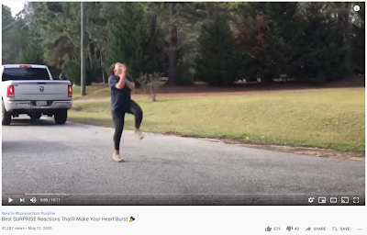
Best Surprise Reactions - https://www.youtube.com/watch?v=IZHwZwfy9W0

It's interesting to see so many different ways people act when surprised, some reactions didn't have a lot of body movement but relied a lot more facial expression, on the other hand some reactions were over the top and almost seemed exaggerated with the way people are jumping around. This shows that there isn't a single right way to act surprised rather there are many different characteristics depending on the situation and the person.

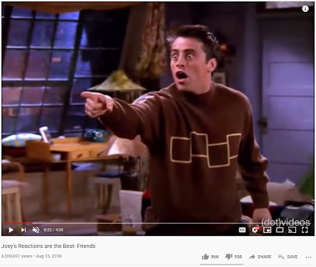
Joey's Reactions are the Best - Friends - https://www.youtube.com/watch?v=YuyrSDGk3N0

This montage of Joey's best reactions from the Friends TV show provides examples of many different emotions (some of them are exaggerated which could be useful for animating). This reference provided insight on emotions such as shocked, confused and frustrated.

Character

The process of animating a character requires a 3D character rig, the rig you use has a big impact on the animation varying from style to the functional aspect, for example you want a character rig that matches the description of your character and fits the theme of the animation. You could obviously make one yourself that matches all the criteria but in order to save time it might be worth using a free/ educational rig. The quality of the rig is the most important aspect when looking for a character rig to use, the process usually takes trial and error going through multiple of rigs. The things to look out for are whether the rig is compatible with your software, the polycount of the character mesh (don't want anything too low or too high) and finally whether the rig functions and fulfils all the needs of the animation.

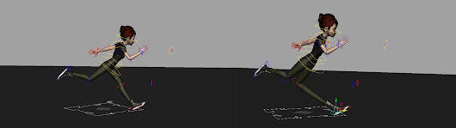
Broken "Mery" Rig from: https://www.meryproject.com/

There were many rigs taken into consideration for this animation, most of them were rejected due to crashing during the animation process, this ultimately narrowed it down to two rigs. The final two rigs were used for creating key poses for different emotions and expressions.

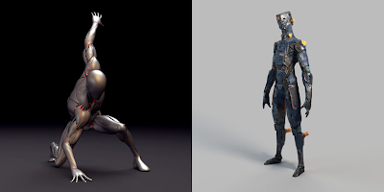
Cyborg Rig - https://gumroad.com/l/cyborgrig (Left)
RBT10 Rig - https://www.rig-it.net/product/robot-rbt10/ (Right)

Out of the Cyborg Rig and RBT10 Rig, the final rigs were both used in the process of making key poses, the RBT10 Rig was used in all of the animations due to later discovered problems with the Cyborg Rig in the animating stage.

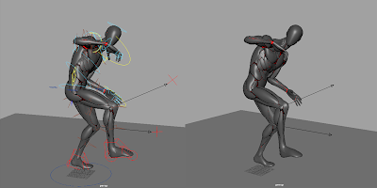
This pose was inspired by the sketches based on the Best Surprised Reactions
video - https://www.youtube.com/watch?v=IZHwZwfy9W0

The pose gives the character some personality and portrays a surprised or almost shocked emotion, the robot could've been surprised by another character or an event that took place. The pose is also lively and looks like the character had just jumped into that position, so far it seems like a good idea to have the character walk (minding his own business) and get surprised out of nowhere.

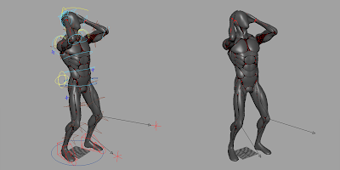
Surprised/ Shocked Pose

While working on surprised poses this pose stood out, the pose gives off a shocked emotion and inspired to work on that emotion more. The character rig used on those poses was still the Cyborg rig.

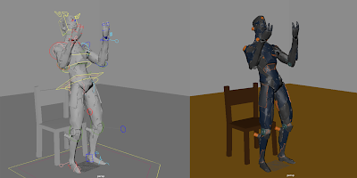
Angry Pose

The angry pose really captures the frustration of the character, to add to the emotion and impact of the animation the character could interact with the environment. The stiffness of the pose adds to the personality of the character and makes him look more like a robot. This second rig also better represents a robot character due to its design, the first rig (Cyborg) had more of a human like anatomical build.

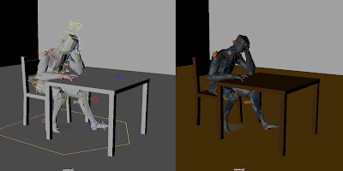
Bored Pose

This pose really adds to the identity of the character, he looks lost in his thoughts or straight up bored. The emotion really comes through and shows that the even though he isn't organic the robot has some sort of consciousnesses.

Walk Cycles

Understanding the walk cycle is a fundamental skill for animators, most human walk cycles follow the same rules of the contact method or down position method as described in The Animator's Survival Kit by Richard Williams.

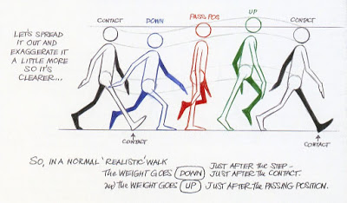
Williams, R. (2009). The animator's survival kit. London: Faber and Faber. (p.108)

While having a basic understanding of the walk cycle and pacing is crucial when it comes to animating humans, it may not be as useful when it comes to animating non-human characters such as robots or quadruped creatures. This doesn't rule out that some of the same rules apply such as the contact positions as well as the up and down positions, but some extra work would be needed.



The robot's walk is fast and snappy. He doesn't have a smooth step which makes it look mechanical. The keyframes for this walk aren't mirrored (symmetrical) which adds more of a randomness to every movement and provides some balance to the calculated mechanical style of the walk. This walk cycle could be implemented to one of the animations, for example it could work well with the surprised one ending with the character jumping into a surprised pose. If multiple animations include walk cycles they will be varied, the next one for example might be cleaner and more realistic.

Blocking Out
The blocking out stage for the walk cycle was the simplest part of this phase, the walk cycle used a similar approach to the contact method used in The Animator's Survival Kit by Richard Williams. The key difference from a normal walk cycle to this one was the simplified upper body movement, the reasoning is that humans move in an efficient aerodynamic way while robots don't necessarily have that kind of need or mannerism.

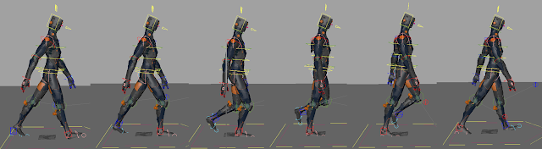

Starting off with the walk cycle blockout was a good warm up and good preparation for the animation blockout. The earlier key poses came in handy during the process.

The blockout for the angry animation focuses on all of the keyframes in the sequence. The character is sitting at a table/ desk and hits it out of frustration, the anger gets to him as he violently stands up almost knocking the chair over. As soon as he's up he grabs the table by the edge and flips it up. The motive of the animation is up to interpretation, the character could have gotten some bad news and reacted. The environment adds to the animation, the pose of the character comes off as bored but translates into angered rapidly. The character also interacts with the props which were made specifically for the animation using MAYA.

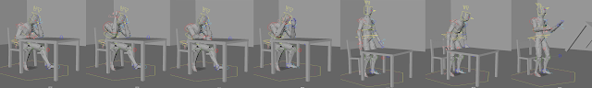

The same scenery was used in the second blockout for the bored animation. This blockout is more subtle than the angry one and relies on little details such as the finger taps which will take place between the first and third blockout.

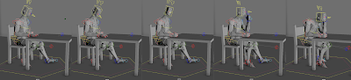

The next blockout takes a different approach with a different setting, the scene starts with a walk cycle where the character is holding a ball, while he's walking to his destination he starts to play with the ball by repeatably throwing it up and catching it. During a lapse of concentration he drops the ball which results with him being disappointed and shocked with himself. This is showing the personality of the character and shows that even though he’s a robot he isn't exempt from human error. Based on the number of key poses in this blockout this animation could be significantly longer than the other three.

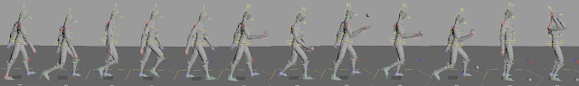

The final blockout used the original walk cycle to add variety to the animations, the poses are very exaggerated and almost cartoon like. The final pose is definitely the strongest and was referenced using earlier work on poses.

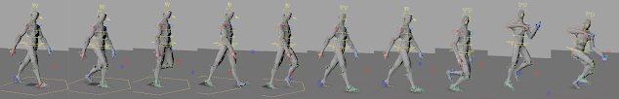

Animating
All of the work leads to this point, the animation process. The blockouts will be come in handy as main keyframes for the animation, the tricky part is getting the timing right, this usually takes a lot of revising. After setting the keyframes for the primary animation it's a good idea to spend some time on the timing of the animation and doing some cleaning up in the graph editor. Once all that is done the secondary animation comes in, this makes the animation looks smoother and adds more depth to it.

The original animation file size was too large to upload to the blog, the animation has been exported using Corel VideoStudio Pro to decrease the file size.

Bored Animation

The animation is just over five seconds long and follows the set outline, the timing in this animation is arguably the best out of the four animations. The camera in the animation starts with a close up shot of the character just above the table which later zooms out to fit the character and capture the whole animation.

Frustrated Animation

The shortest animation lasts just under four seconds which fits its fast paced theme, in this shot the camera is still and captures the action in the centre of the screen using a the rule of thirds. In this animation the character is visibly frustrated, the characters movement is fast and abrupt which complements the characters angered emotion.

Shocked Animation

At just over nine seconds long the shocked animation feels the most complete, there is a lot more going on in this animation. The walk cycle in this animation is smoother that the original walk cycle for the robot, it still gives off a rough vibe but is more symmetrical which makes it feel more mechanical. The camera is still in the shot since the character is walking on the spot which makes the animation feel like the character is moving at a steady pace. This animation also took the most work, the ball in this scene is parented to a controller in the hand which made it look like the character is actually holding the ball, when tossing it up the ball is un-parented and animated.

Surprised Animation

In this shot the character starts off with a walk cycle as planned, the character glances over his shoulder when he notices something unexpected, this makes him jump. The surprised pose was inspired by the reference from the Best Surprised Reaction video on YouTube. The camera in this scene pans across the setting at an angle following the character and comes to a stop when he jumps.

The submitted animated characters present four different emotions: bored, frustrated, shocked and surprised.

Conclusion
Inspired by human body language and the way we express emotions; the animation presents a robot character experiencing four different emotions. The goal was to get the character's personality across and present the way he emotionally handles those situations. The principles of animation applied to the character as well as the referenced real life mannerisms, the idea was to use that information and translate it into a more exaggerated final piece.

Rigs used –
https://discover.therookies.co/2020/07/15/best-websites-for-free-3d-animation-rigs/
https://rustyanimator.com/free-maya-rigs/
https://www.animationmentor.com/free-maya-rig/#terms-conditions-summary
https://www.cgtrader.com/free-3d-models/character/sci-fi/sci-fi-free-robot-bh-2
https://www.cgtrader.com/free-3d-models/character/sci-fi/rigged-body
https://www.cgtrader.com/free-3d-models/character/woman/wraith-cyber-ninja-apex-legends
https://www.rig-it.net/product/robot-rbt10/
https://gumroad.com/l/cyborgrig

All the videos can be found on the blog and are included in the submission sent by email.
Blog - https://advancedcharacteranim.blogspot.com/

Links to animations (YouTube)
Compilation - https://www.youtube.com/watch?v=Ct1lAb5VHW8&feature=youtu.be
Bored Animation - https://www.youtube.com/watch?v=OISWclXAoDw&feature=youtu.be
Frustrated Animation - https://www.youtube.com/watch?v=RVCfYZIfddQ&feature=youtu.be
Shocked Animation - https://www.youtube.com/watch?v=fAr1yY0_biQ&feature=youtu.be
Surprised Animation - https://www.youtube.com/watch?v=dE8cd-XXyFU&feature=youtu.be

