The following assignment will detail three geotechnical engineering experiments undertaken in the Laboratory and detail a full experimental write up of them
Nathan J Morris

Essay
The following three experiments will be written up containing methodology, data collection and analysis. The experiments are as follows:
- The Atterberg Limits test
- Constant head permeameter test
- Sieve analysis
Contents
1. The Atterberg limits test 2
1.1 Introduction 2
1.2 Methodology 2
1.2.1 Apparatus 2
1.3 Liquid limit 3
1.4 Plastic limit 3
1.5 Results and analysis 4
1.6 Conclusions 6
1.7 Limitations 7
2. Constant head permeameter test 8
2.1 Introduction 8
2.2 Methodology 8
2.2.1 Apparatus 9
2.3 Results and analysis 9
2.4 Conclusions 11
2.5 Recommendations 11
3. Sieve analysis 12
3.1 Introduction 12
3.2 Methodology 12
3.2.1 Apparatus 13
3.3 Results and analysis 13
3.4 Conclusions 15
3.5 Recommendations 15
References 16

Word count - 3045

The Atterberg limits test

1.1 Introduction

The Atterberg limits test is a test which measures the water content of primarily fine-grained soil such as silts and clays. The test is commonly used to identify the liquid limit and plastic limit based on the moisture content of a soil. The test is relatively easy to conduct on a well set up site with power due to its ease of use and portability and can be completed in a short space of time i.e 24hrs.
The liquid limit can be defined as the maximum water content a silt or clay can have before becoming a liquid. The liquid limit of a soil is a measure of its moisture content and displayed as a percentage of the weight of the dried soil sample. (Geoengineer.org,2022)
The plastic limit is the minimum water content at which a soil is considered to behave in a ‘plastic’ manner, i.e capable of being moulded. It is the moisture content at which a soil begins to crumble. (Mcbride,2002)
The plasticity index can be defined as the difference between the liquid limit and plastic limit and can give an indication of moisture content required to change a soil from a liquid to a semi solid state. It can be used to measure the cohesion of a soil. (Geoengineer.org,2022)
Atterberg limits are measured in a laboratory and in accordance with BS1377-2:1990. (geosynthetics.com,2022)

1.2 Methodology

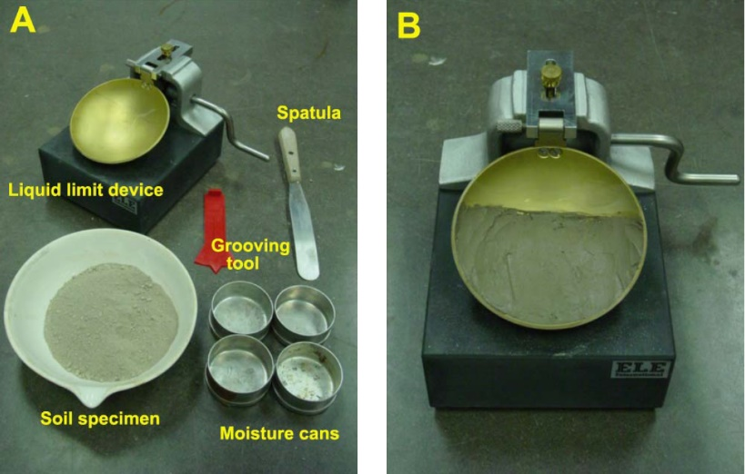
1.2.1 Apparatus
- Soil specimen
- 4 Small metal cans
- Weighing scale
- Spatula
- Distilled water
- Glass plate
- Large metal mixing bowl
- Cassagrande apparatus
- Grooving tool
- Drying oven

Figure 1 – Equipment used for test
(basiccivilngineering.com,2022)

1.3 Liquid limit

To begin the experiment, 4 metal containers were weighed, and the weights of each of these empty containers recorded. Two large soil samples were selected for the test and approximately 250g of each soil sample was placed in a large metal mixing bowl, and then 1-2ml of distilled water added while mixing thoroughly with a spatula. This was continued until a smooth paste like consistency was reached.
When the right consistency was achieved (a consistency which required at least 30-35 drops of the cassagrande apparatus) a small sample of the mix was placed into the cassagrande cup and pressed down with a spatula as flat as possible to a depth of approximately 10mm. (a few consistencies were tried to get this right). Any excess soil was put back into the large mixing bowl.
The sample was then smoothed out from back to front using the grooving tool to cut a groove right through the sample to the base of the cup.
Once the desired smooth cut sample was achieved, the drop counter was zeroed on the apparatus and the crank handle rotated at a rate of 2 turns per second and recorded the blows this took to close the 12mm gap created by the grooving tool.
Then the recorded the number of blows needed to close the gap were recorded.
After this a slice of the soil sample was removed (approximately a spatula width) and placed in small pre labelled metal tin, then weighed, and the weight recorded of the wet soil and tin.
This was then repeated four times, for four samples, gradually adding more water to the soil sample and fully mixing, the increased water content increased the moisture content slowly and reduced the number of blows required to close the gap. The range of blows roughly ranged between 35 to 15.
All samples were then placed in the oven for 24hrs at 110 degrees Celsius and recorded the dry weight of each sample to determine moisture content.
This was repeated for second soil sample.
The results were then plotted on a graph with moisture content (Y axis) against number of blows (X axis) and a line of best fit obtained, on the X axis a 25 blow mark was used to obtain the liquid limit value where this intersected our line of best fit. This can be seen in figure 2.

1.4 Plastic limit

For the plastic limit experiment, 3 metal containers were weighed and marked as per previous experiment, then the container weights recorded.
Then selected the remaining soil sample and added distilled water until the consistency allowed it to be rolled on a glass plate without sticking to the plate or hands, the sample was fully kneaded to ensure a good mix and then rolled the soil into a small ball.
The sample was then rolled into a sausage shape until small cracks started to appear on surface and divided the sample into 3 equal parts.
Each sample was then rolled to approximately 6mm in diameter and one sample selected and kept rolling it until this reached approximately 3mm in diameter. It was then rolled further, trying to maintain a uniform pressure until the sample started to crumble (shearing both longitudinally and horizontally). This crumbling point is what was recorded as the plastic limit.
At the crumbling point the sample and crumbs were placed into a metal dish and weighed (wet weight). This was repeated for each of the three samples.
The three samples were then added in their respective containers to the oven at 110 degrees for 24hrs. Then the recorded the dry weights for each sample recorded which enabled the calculation of the moisture content of the three samples, an average taken of the three to obtain mean moisture content value.
This mean moisture content value was then recorded as the plastic limit moisture content indicator.

1.5 Results and analysis

From the experiment we calculated the liquid limit, plastic limit and also the plasticity index of our samples. The raw data is displayed in figure 2 below, but a summary is as follows.
The liquid limit water content for Sample A is approximately = 26 (Can be seen in Figure 3 below)
The liquid limit water content for Sample B is approximately = 31 (Can be seen in Figure 3 below)
The Plastic limit water content for Sample A is approximately = 23.8 (Average of 22.8+26.07+22.54/3)
The Plastic limit water content for Sample B is approximately = 22.76 (Average of 23.95+22.2+22.14/3)
The Plasticity index for Sample A is approximately = 2.2 – PI=LL-PL (26-23.8)
The Plasticity index for Sample B is approximately = 8.24 – PI=LL-PL (31-22.76)

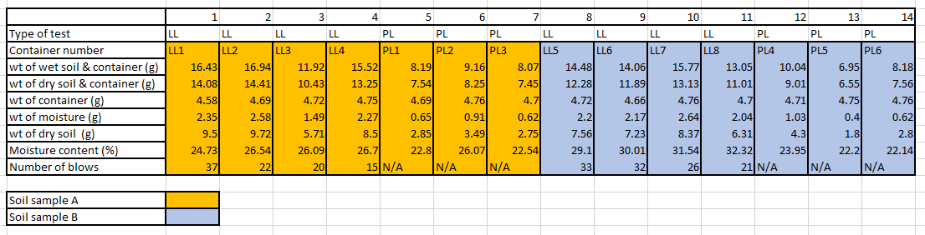

Figure 2 – Liquid and plastic determination experimental data

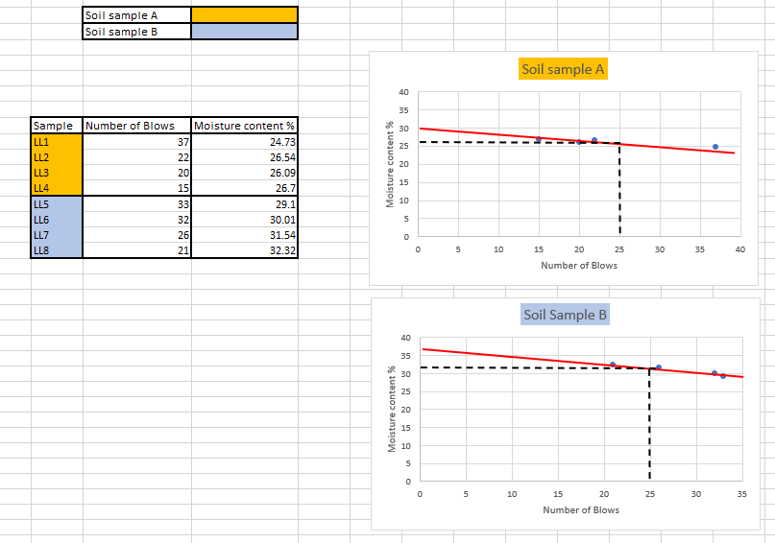
Figure 3 – Liquid limit chart

1.6 Conclusions

To conclude the experiment, the results of the Atterberg limits test indicate that the soil samples analysed can be defined as follows
Sample A
Slightly plastic – It appears on the plasticity chart in figure 3 below in the low plasticity silt classification (ML) and can be categorised as having a higher silt content as it sits below the A line (silts and organic soils). This sample would be rated as poor in slope stability due to the silty or sandy clays not having a strong cohesive bond between particles and a more rounded particle make up.
Sample B
Medium plastic - It appears on the plasticity chart in figure 3 below in the medium plasticity clay classification (CL). This sits slightly above the A line (Clayey soils) and is made up of more clay than silt and would have a more stable slope stability due to the stronger inter bonding particles within the soil sample acting as a glue to hold the plate like particles together.
Significance of liquid limit – the liquid limit is significant because it gives us an indication of the bearing capacity and prediction of consolidation in a fine grained soil, this is essential when designing foundations of a building for example. (Mcbride,2002)
Significance of plastic limit – the plastic limit helps us define the toughness of the fine grained soil and at what water content the soil can no longer be moulded before it begins to crumble. It also provides an idea of the soils consistency, shear strength and also allows us to predict settlement and bearing capacity of the soil. The plastic limit also allows us to understand what load soil can cope with before becoming permanently deformed. (Mcbride,2002)
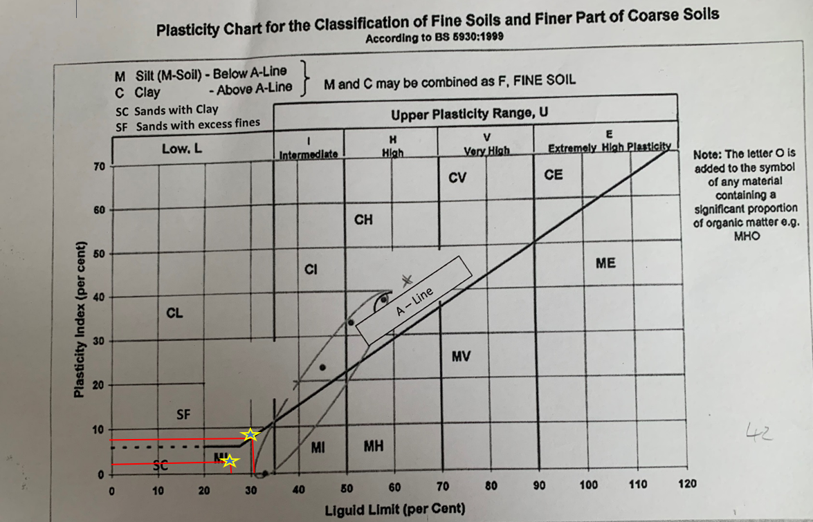
Figure 4 – Plasticity chart

1.7 Limitations
The experiment had some limitations due to the temperature of the laboratory being very warm, this impacted on both the liquid limit experiment and plastic limit experiment by drying out the samples altering the recorded moisture contents. Sample B appeared to be more of a plastic nature than the data suggests, this again may be to the drying out in the room before the samples went into the oven and also the drying out by rolling in hand to get the required shapes. If we repeated this experiment a cooler room and no delay in drying the samples this would improve experimental results.

Constant head permeameter test

2.1 Introduction

The constant head permeability test is a testing method which allows us to determine the permeability of granular soils (soils containing little or no silt). This method is best suited to sand and gravel type soils and is used on disturbed or soil samples that have been recreated in a laboratory environment. (geotechdata,2022). This test is difficult to replicate on site and requires specialist laboratory equipment.
The aim of this experiment was to calculate the coefficient of permeability for our soil sample using the following equation
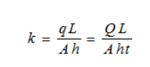
Where K is the coefficient of permeability and q= discharge, Q=total volume of water(m3), t=time (s) period, h=head causing flow (mm), L= length of specimen (mm), A= cross-sectional area (mm2).

2.2 Methodology

The test kit for the constant head permeability test was set up as per figure 5 in the appendix. To begin this experiment, a few measurements were taken to enable the input of data into the above formula. The first measurement was for the internal cross sectional area of the standpipe (using vernier callipers) which held the sample, and the result recorded to enable an area to be calculated using the formula ( $A=πr^{2}$). Then the difference in head between the Manometer tubes were measured, measuring the difference between the bubbles of air in each tube (h) using a measuring tape. This difference is the head difference between the water pressure at the top and bottom of the soil as the water passes through it. Then the difference in height of the sample within the cylinder (l) was taken and recorded. Once these measurements were taken, the experiment could begin. The experiment could begin when the outlet tube was moved from the sink to the cylinder, it was held closed and then reopened the bottom outlet to allow the water to fill up the measuring cylinder for a period of approximately 15 seconds (this was timed on a stop watch). The volume of water captured in the measuring cylinder was then recorded (Q). This was then repeated for roughly a 30s period, and again for roughly a 45s period and the volumes of water in the cylinder recorded for each time period. The data was then inputted into the above formula for each time period and 3 separate values for K obtained. Calculations are shown in figure 6.
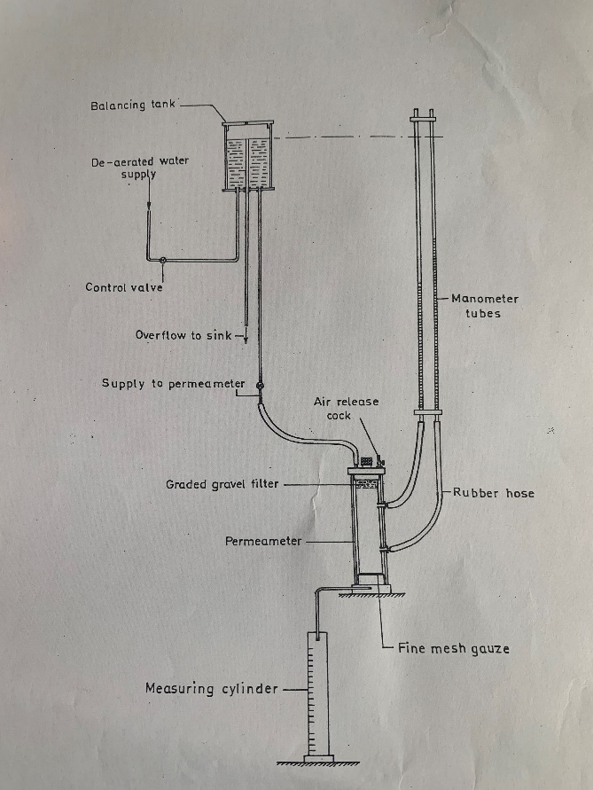

2.2.1 Apparatus

- Balancing tank
- De-aerated water supply
- Control valves
- Overflow to sink
- Supply connection to permeameter
- Manmeter tubes
- Various connection hoses
- Permeameter tube
- Measuring cylinder
- Gravel filter
- Fine mesh Gauze
- Air release valve
- Soil specimen
- Stop watch

Figure 5 – Constant head permeability apparatus (nantel,2022 – lecture handout)

2.3 Results and analysis

Data
T= time taken for water to flow into measuring cylinder
Q= volume in m3 of water collected in cylinder
The area of the permeameter tube was calculated using $A=πr^{2}$
This equalled 0.004786m2
Length (L) of sample was recorded to be 0.072m
Hydraulic grade line difference / difference in manometer tube bubbles (H) = 0.001m

T1 = 15.05, Q1 = 380 x10-6
T2 = 30, Q2 = 725 x10-6
T3 = 45.21, Q3 = 1830 x10-6
These results were then inputted into the following equation

Exact experimental data and calculations can be found below in figure 6.
Results for K for each of the three experiments were calculated and are as follows:

K1 = 0.3635 m/s
K2 = 0.3635 m/s
K3 = 0.609 m/s

The K values recorded align with the Dense and gravelly sand column in Figure 7’s table of permeability found on the next page.
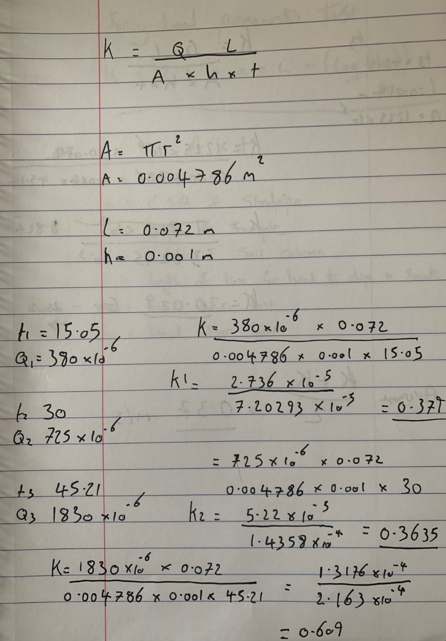
Figure 6 – experimental calculations

2.4 Conclusions

From the data obtained the soil type would be classified as dense and gravelly sand Figure 7 below) and a good soil to be used in the construction industry due to its high drainage and good bearing capacity, however the results from the test aren’t consistent due to the K values differing between all three tests. There is a significant difference between K1, K2 and K3. K1 and K2 are fairly similar which is what we would expect but K3 is almost double in value to the first 2 results. This is not what we would expect as all 3 values should be very similar due to no change in soil type or any other laboratory conditions. K values are influenced by pore size, soil structure and viscosity which have all remained the same. This variation in result could be explained by the issues we experienced in the equipment set up. There were various issues with dropping of pressure during the later parts of the experiment in the manometer tubes and visible trapped air bubbles were also visible within the system, this may have impacted the time taken for the flow of water through the media and therefore impacted our calculations and therefore results. This may have been caused by the opening and closing of the release valve between tests which may have caused surges of water pressure to the system potentially impacting the media and introducing air bubbles.

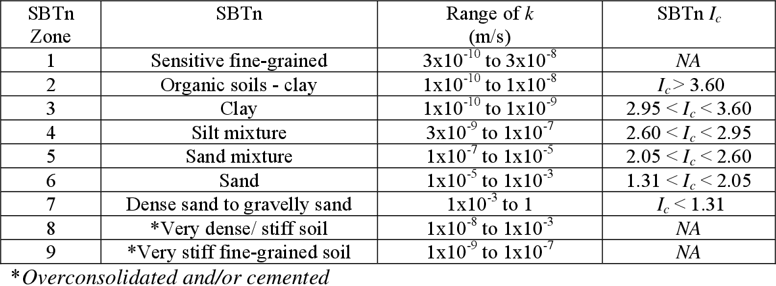
Figure 7 – Table of coefficient of permeability
(Campanella et al, 1987)

2.5 Recommendations

Equipment set up in the laboratory did not align with British standards BS1377 part 5, the manometer tubes were not reading correctly to begin with (air bubbles were below zero on one tube). There were also visible air bubbles within the system and the method of moving the outlet valve from the overflow to the cylinder was not ideal as this caused visible surges in flow back up the tube into the sample even though it was for a short period of time. The experiment should be repeated with the equipment set out to these higher standards for us to have a higher level of confidence in our results.

Sieve analysis

3.1 Introduction

Sieve analysis is a process of determining the particle size and distribution of aggregate from a sample of soil. It allows particles to be sorted by passing through varying sized hole on a series of sieves from largest to smallest and allows particles to be sized and divided as per BS1377 (chudley and greeno, 2008). This is important as it allows the soil to be graded and therefore used to assist with compliance for design requirements. The test is also very easy to do in a laboratory or even on site using manual sieving as results can be achieved in a very short period of time with minimal equipment.

3.2 Methodology

To begin the experiment, the scale pan was weighed, and this then recorded. The sample was then divided into quarters and approximately 750g of this divided sample used. This sample was then weighed, and the result recorded.
The sieves were then selected and with the largest sieve on top stacked them in size order, they were then placed onto the vibration machine and the sample poured into the top sieve and the lid placed on. It was then tightened down using the clamps on to the vibration machine stack and turned on. The vibration machine was set to run for 2 minutes. The machine was then stopped, and the lid of the top sieve removed.
The top sieve was then removed, and the contents emptied into a clean sample dish ensuring no material was lost. The sample of aggregates was then weighed from the sieve and the results recorded.
This was then repeated for each subsequent sieve ensuring all remaining particles were brushed from the sieve into their respective dish to be weighed. It was then possible to calculate the percentages of aggregate remaining on each sieve by dividing the mass passed through the sieve divided by the total mass x 100 and recorded these results. It was then possible to plot the information sieve size against percentage passing on a graph to enable us to analyse the data.

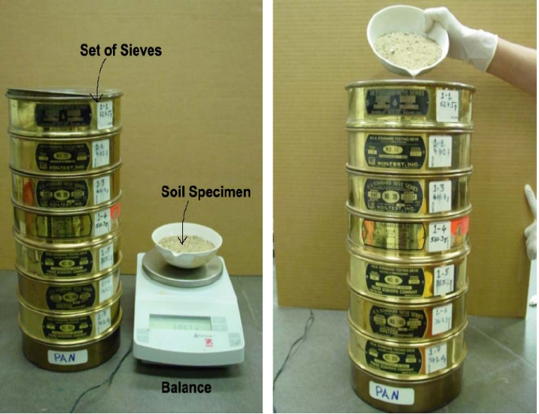
3.2.1 Apparatus

- Weighing scale
- Varying sieve sizes 2mm – 0.038mm
- Soil sample
- Metal pan
- Wire brush
- Mechanical shaker
- Trowel

Figure 8 – Sieve analysis (soil testing gradation, 2022)

3.3 Results and analysis

From the results table in figure 9 below and the particle size distribution chart in figure 10, we can see that much of the soil within this test sample falls within the category of sand, this is due to the particle size distribution primarily being 0.063mm – 2mm sieve size which is where the sand category predominately falls. There are approximately 95.03% of the sample sitting within this category, 3.08% sitting within the 0.063-0.045mm boundary for silts and only 1.89% of material falling into the 0.045 and below clay category. This enables the use of the Triangular graph of soil texture in figure 11 and plot our soil sample on to this chart, this then shows us that indeed or sample is primarily made up of sands.
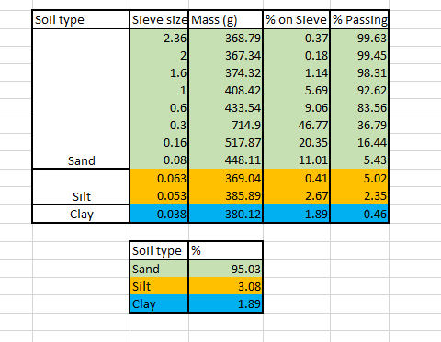
Figure 9 – Results table
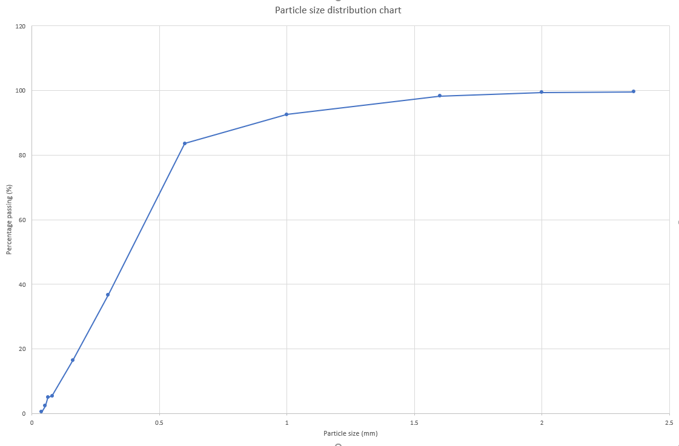
Figure 10 – particle size distribution chart

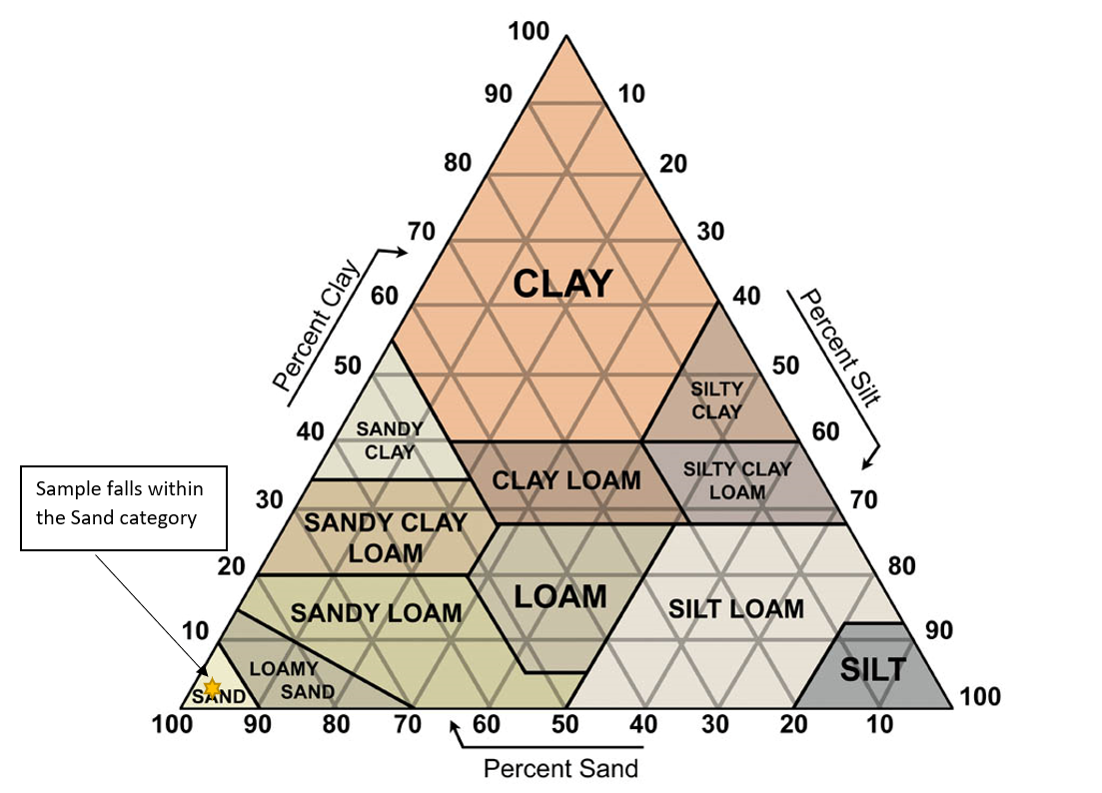
Figure 11 – Soil texture triangle for sample (soilsensor.com,2022)

3.4 Conclusions

The conclusion of the test enabled us to determine the majority of the soil sample to be predominately sand and of that the majority lying at the 0.3mm size range, this would allow us to determine that this soil sample would be considered non cohesive and would not hold much water therefore being good for drainage. It would also be a good soil to be used as an aggregate for concrete and as a reliable foundation to be built upon due to its higher bearing capacity, low settlement and high frictional properties.

3.5 Recommendations

To improve the accuracy of this experiment we could use a lower sieve size to capture finer particle sizes, enabling us to capture more of the finer clays. We could also use new sieves as some were slightly damaged and may have allowed larger materials to pass through causing inaccurate readings. Some fine materials were also lost whilst transferring sieves from the vibration machine to the pan for weighing, this lost material should be accounted for also and a more careful approach adopted.

References

ABG Geosynthetics. 2022. ABG Technical Papers | Soil Properties | Atterberg Limits. [online] Available at: <https://www.abg-geosynthetics.com/technical/soil-properties/atterberg-limits/> [Accessed 3 April 2022].
Basiccivilengineering.2022.[online]Availableat: <https://basiccivilengineering.com/2015/07/atterberg-limit-test-soil-mechanics.html> [Accessed 6 April 2022].
Becquerel Industries Pvt Ltd. 2022. Soil Testing Gradation test on soil sample. [online] Available at: <https://www.biplndt.in/latest-update/soil-testing-gradation-test-o/546> [Accessed 7 April 2022].
British standards (1990). BS1377-2:1990. British standards institute. Methods for test for soils for civil engineering purposes. [online] Available at: https://www.impact-testsets.co.uk/products/c621-bs1377-methods-of-test-for-soils-for-civil-engineering-purposes/ [Accessed 6 April 2022].
Campanella, R., Robertson, P., Gillespie, D., Laing, N. and Kurfurst, P., 1987. Seismic cone penetration testing in the near offshore of the MacKenzie Delta. Canadian Geotechnical Journal, 24(1), pp.154-159.
Geoengineer. 2022. [online] Available at: <https://www.geoengineer.org/education/laboratory-testing/atterberg-limits> [Accessed 2 April 2022].
Geotechdata. 2022. Constant head permeability test. [online] Geotechdata.info. Available at: <http://www.geotechdata.info/geotest/constant-head-permeability-test> [Accessed 6 April 2022].
McBride, R., 2018. 2.9 Atterberg Limits. SSSA Book Series, pp.389-398.
Nantel, A., 2022. Soils lecture.
SoilSensor.com.2022. SoilTextures|SoilSensor.com.[online]Availableat: <https://soilsensor.com/articles/soil-textures/> [Accessed 7 April 2022].

