Name: Shazia Begum
Student Number: 2117727
Module: Effective Teamwork and Communication
Module code: BMSW4002
Lecturers Name: Joanne Davies

Abstract
The effects of teamwork in a health and social care setting will be examined in the following report. Effective team development the hurdles to teamwork, as well as the types of roles required to form an effective team will be investigated. Pelsall Care Home’s manager Steve will be given recommendations on how to overcome these hurdles.

Contents Page
Abstract………………………………………………………………Page 2
Introduction…………………………………………………………..Page 4
Overview Of Teamwork…………………………………………… Page 4
Models Of Team Development…………………………………….Page 5
Five Stages Of Team Development……………………………….Page 5
Team Roles ………………………………………………………….Page 6
Discussion……………………………………………………………Page 8
Conclusion……………………………………………………………Page 9
References………………………………………………………… Page 10

Introduction
Pelsall Hall Care Homes manager Steve Brookes will be given advice in the following report on how to establish a successful team. Pelsall Hall does not have a consistent teamwork ethos, which may have an impact on the level of treatment provided in the home. In a Health and Social Care setting, the impact of good teamwork will be investigated, as well as any obstacles that may arise. The types of roles that are required in a successful team will also be discussed in the study. Two different group development models will be looked at in this report. Tuckman’s model (Bonebright,2010) the well-known steps of forming, storming, norming, performing, and adjourning are depicted in this model. This model has a unique history. In addition to this Wheelan’s model of team development will be mentioned in this paper According to Åkerlund, et al (2021) Wheelan developed the Integrated model of group development, which includes dependencies and inclusion, counter-dependencies and fights, trust and structure, and work and productivity. Belbin’s Team roles will also be looked at in this report.
Overview of Team Working
In a workplace setting a team is defined by a group of people who work together striving towards the same goal which they are all dedicated to . A good example of this is in a hospital setting. According to Ervin, et al (2018) ICU teams often include a physician who specialises in intensive care, a clinical pharmacist, a dietician, numerous respiratory therapists and bedside nurses, as well as other medical professionals like therapists. This indicates that in any health-care setting, successful teamwork requires everyone in different roles working toward the same goal. Teams are also defined as groups of people who work together to complete assigned responsibilities.
Effective communication, commitment to the task at hand being productive, good leadership, and direction are all aspects that contribute to effective teamwork in a health and social care setting. When everyone in an organisation is working toward the same goal, the company's aim can be achieved. In a health and social care context, teamwork is essential because no single person can ensure the success of an organisation. According to Leggat (2007) a team's success is when the members displayed a strong focus on the organisation and the values, climate and culture underlying effective interpersonal and teamwork relationships. Common issues that can arise in an ineffective team include a lack of commitment. If individuals are not committed to the task at hand, this can lead to additional issues such as a loss of productivity, which could result in the failure of the entire team. Poor communication is another aspect that can contribute to the failure of effective teamwork, as a breakdown in understanding can result from a breakdown in communication between employees. Another element that might cause problems in teams is a lack of leadership qualities. A good manager according to Belbin (2010) is an individual who understands resource management, is incredibly adaptable when it comes to people, and never loses control of a situation in addition, competent bosses keep their ability to make their own decisions based on their evaluation of what is required in practise. Furthermore, a good manager can motivate staff to perform well. Steve should take all these points into consideration if he is to achieve a highly performing team.
Models of Team Development
A team development model such as Tuckman should be considered by Steve as this model depicts the stages that teams frequently go through from the start of a project through its successful completion, as well as the areas where the team and the project may fail. Bruce Tuckman's classic approach has brought comfort and new perspectives to managers responsible with leading a team or trying to do so for four decades. Bruce Tuckman in 1965, created the forming–storming–norming–performing model of group growth, contending that these stages are all essential and unavoidable for a team to mature, deal with challenges, find solutions to issues, organise work, and produce results as stated by John Fairhurst (no date).These stages are illustrated in the diagram below.

Five Stages of Team Development 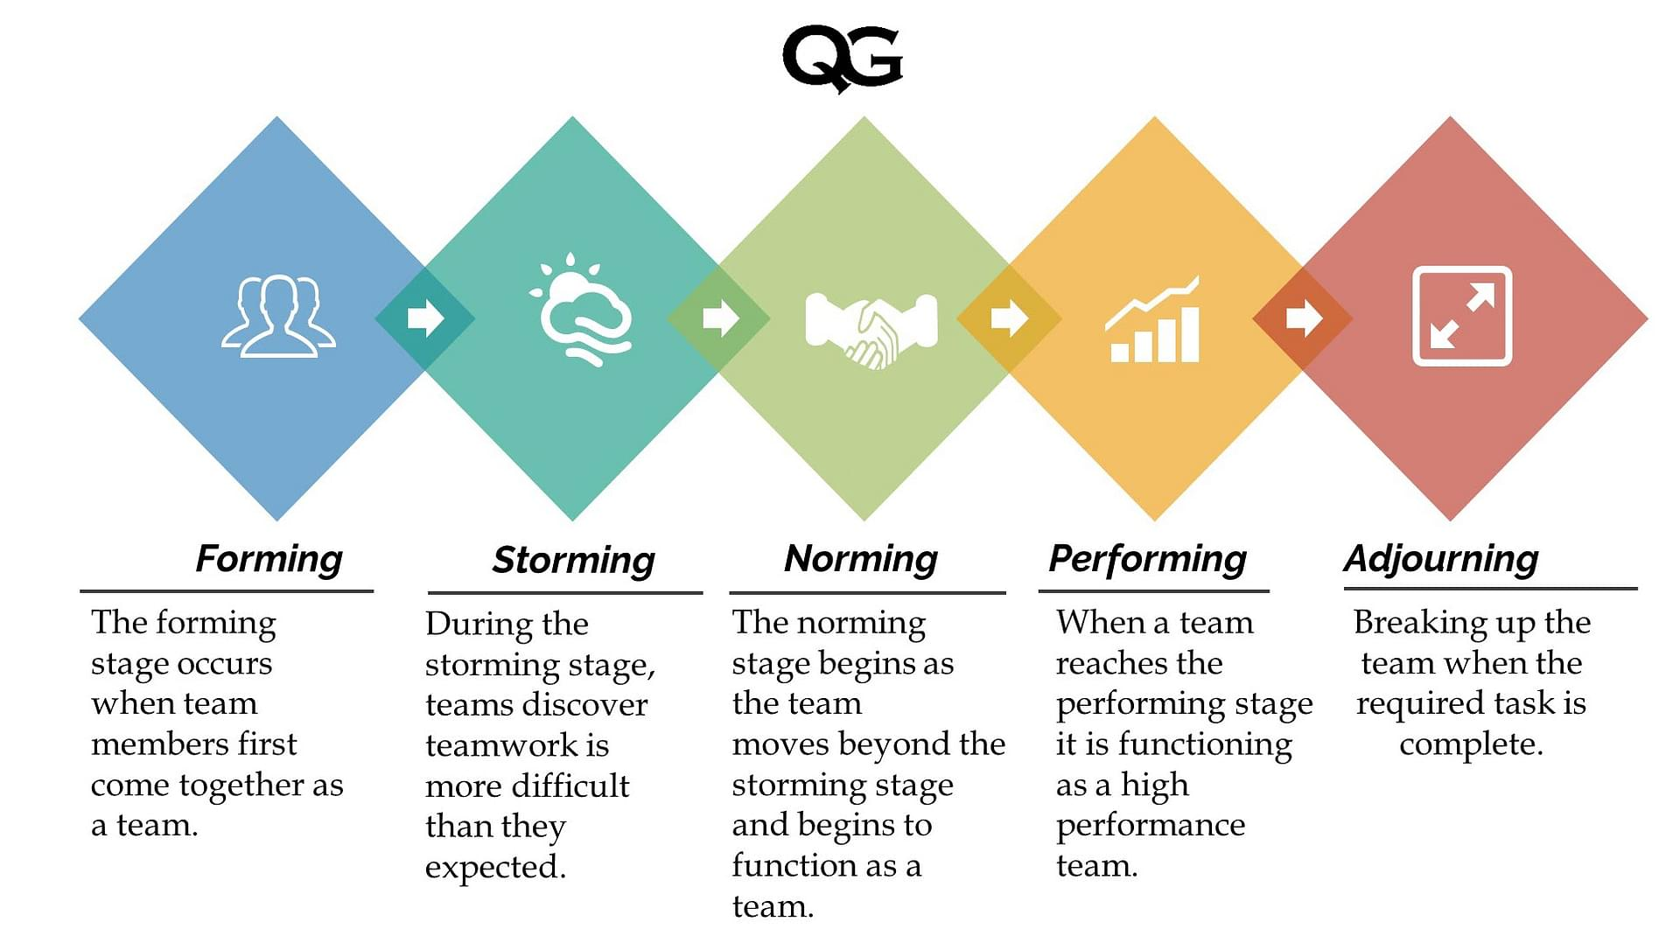
GQ, (2022)

This model is one that could be considered at Pelsall Hall Care home as it is a recognised model which is universally used all around the world in organisations, an example of this is when two separate universities were merged, and a project team was faced with the task of establishing an academic workload management system. To address any issues experienced, Natvig, et al (2016) states that Tuckman's small-group development model, together with the insights acquired from this case study, could be used to improve the overall efficacy of project teams within an organisation. This model is a good choice for health and social care teams who are looking to build better work teams. By adapting this model to Pelsall Hall, Steve could evaluate the team's dynamics as well as thinking about what must be done to get the team to the stage where they can perform. The team should be reviewed on a regular basis. Steve, as the manager, should also give positive feedback to his employees to boost the team’s moral.
In addition to Tuckman, other models such as Wheelan’s (1999) have also been explored this model encourages individuals not to blame others for group problems, encourage clarification, listen to others and be heard and balance task communication and supportive communication. According to Akerlund, et al (2021) Wheelan was a big believer in the idea that group growth is not random, and that if groups do change it happens in stages that build on previous stages in a predictable way. However, the Tuckman model is recommended for implementation at Pelsall Hall Care Home because it fits in well with the existing situation's needs and it is easy to follow.

Team Roles
Advanced teamwork will be required at Pelsall Hall Care Home because it is the most efficient approach to complete duties in a Health and social care setting. If success is to be achieved, a team must have a balance of personalities and roles. Different skills are essential in a care home as there are many roles which need to be fulfilled in this setting for the care home to have a high-quality care service . Cohesive and effective teams could be created at Pelsall Hall Care home by members on the team being able to adapt to change in there working conditions. According to Onyett (2003) teams must be able to evolve and adapt to constantly changing conditions while staying committed to their main goal. Therefore, the team should be able to adapt to change if success is to be achieved.
Pelsall Hall Care Home should consider using the Belbin’s Team Model. According to Hills, (2015) this model recognises that team tasks can assist members to develop their strengths and control their weaknesses, allowing them to contribute more effectively to the group.

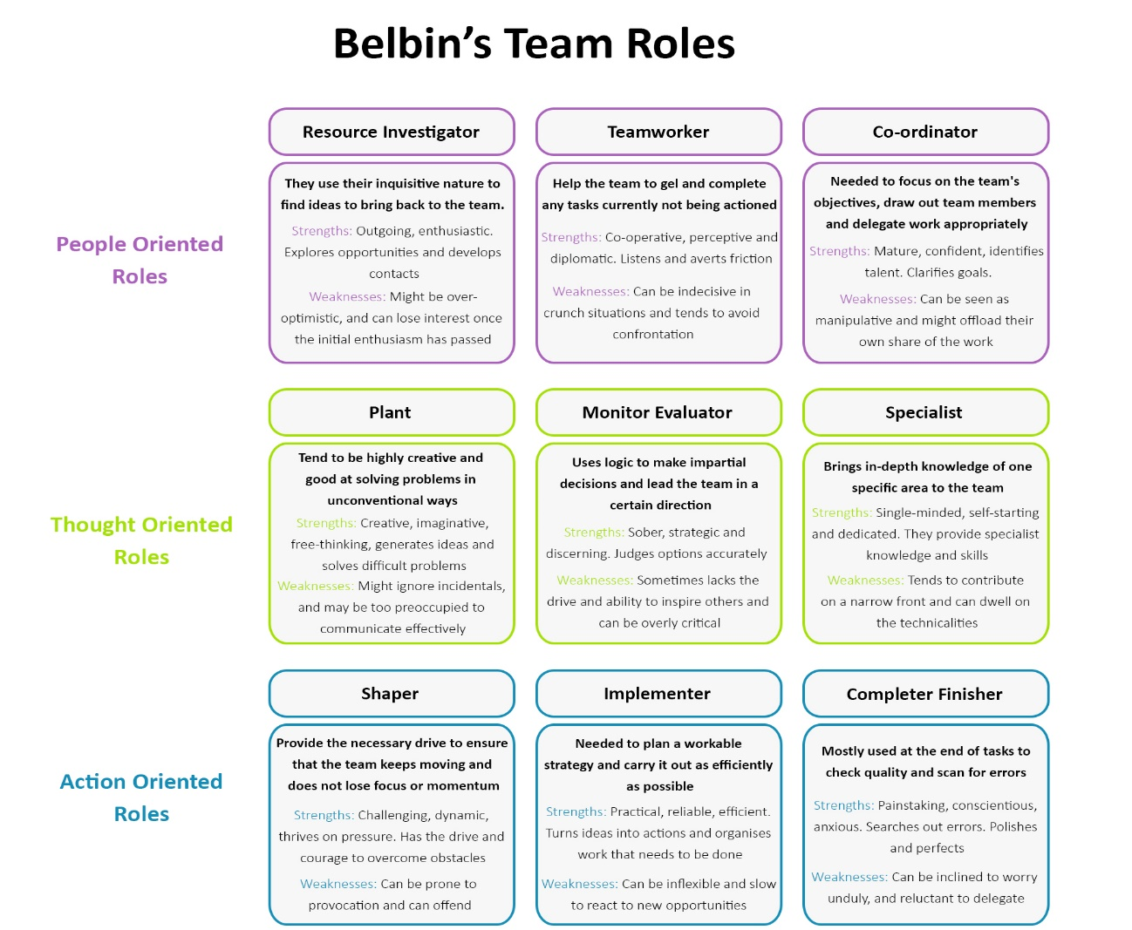
The types of people who make up a successful workforce are depicted in the image below.

(Accipio,2022)

Steve should consider this model and look for these qualities in his care facility's employees. He should use Belbin's Team model to figure out which job roles are already taken at his care home and which job roles still need to be filled for the care home to be a highly effective workforce. If there is a shortage of a certain skill, Steve could look for missing qualities as he hires new team members. When considering new members for employment, Steve should keep in mind the talent he already has on his team. Consideration should be made as to what a new member would bring to the group dynamic and what positive impact they would bring to the team. Team size should also be considered by Steve as larger teams usually need greater support. Team diversity is also an aspect which is crucial as this can bring great strengths to a health and social care team. According to Dubey (2022) In the health and social care field, it is important to put equality and diversity at the centre of your work.

DISCUSSION
According to Reeves, et al (2011) a health care team should know what each person in their team brings to their assigned role and any special skills that a team member has. Successful teams are motivated and share the same work ethos and are dedicated to the company's shared purpose. Furthermore, in a health and social care setting each member should know their roles and the roles off their co-workers.
According to Rodrigo, et al (2019) leadership is critical in motivating, persuading, and guiding others in this direction. Good leadership is crucial in building a successful team Steve, as the manager, should provide employees positive feedback because it will help them feel like they are doing an excellent job and motivate the team to continue working at a high level.
Different skills in a health and social care setting are essential. Ferlie, et al (2016) whether it is treating a diabetic patient, caring for weak and elderly patients, or overseeing the delivery of nursing care on a busy ward, health care is complicated, and this amount of complexity requires teamwork. This indicates that for Pelsall Hall to have a successful workforce, all its members must be dedicated and proactively be working as a team in their given roles to achieve the best care results at Pelsall Hall Care Home.
Pelsall Hall should be more effective in the care they provide if they work as a team and understand the role assigned to themselves. According to Hills (2015) employees who understand their team roles are better able to apply themselves, how they fit in with others, and how they may improve their performance. Individuals will also be working in a place where everyone is striving for the same goal, which is to provide the best possible care to their patients. Pelsall Hall should become a terrific place to work for if everyone pulls together and contributes. Working as a team would also ensure that the care home achieves the greatest potential results, as high-performing staff would deliver the best care to the residents.
Poor teamwork can have a negative impact on Pelsall Hall's overall success. If specific members of the team are not performing to their full potential, it can have a detrimental impact on the entire team, as it can lower morale if staff are not performing the roles they have been allocated to. Clear instructions should be given by Steve as stated by Griffith, et al (2015) misunderstandings, incorrect assumptions, honest mistakes, or aggravating factors beyond the team's control can all lead to conflict.
From undertaking this research and as someone who has worked in a leadership position, I can offer Steve the following advice based on my own experiences. Designated jobs should be made apparent. This can be done by notifying employees their roles and responsibilities for the coming week, so they are aware of their individual responsibilities. Steve may also organise a weekly staff meeting to give good feedback and address any issues that arise, as issues that are addressed early on are easier to resolve than those that are left to build resentment among the team. Steve might also arrange a coffee morning once a month as a team bonding session. These types of informal meetings can help the team bond and create an effective team. Team members who are dedicated and hardworking should be given additional praise by Steve, to ensure that they are aware they are doing an excellent job. This in turn will motivate them to continue working to the high level which they already are.

Conclusion
It has been concluded that if Pelsall Hall Care Home is to create effective teams that works well together the best results would be achieved if team members are all collaborating to achieve the aim of delivering high quality care . Everyone’s talent should be recognised and appreciated to make team members feel valued, which could lead to an overall increase in morale. Steve, as the manager should be offering positive praise, as well as using Belbin's team model, this should be used to ensure that everyone is in the appropriate work position. The Tuckman (1965) model has been recommended for use at Pelsall Hall because it best matches the current needs at the care home.

Reference Page

Accipio, (2022)Belbins Team Models Available at: https://www.accipio.com/eleadership/mod/wiki/view.php. (Accessed:17 June 2022)
Åkerlund,M. Jacobsson,C. and Tilin, F. (2021) ‘The Legacy of Susan Wheelan: Small group research’, 52(1), pp. 103–109.
Belbin, M., (2010), Team Roles at Work, eBook Collection (EBSCOhost), Routledge.
Belbin, R.M. (2010) Management teams [electronic resource] : why they succeed or fail . 3rd edn. Oxford: Butterworth-Heinemann.
Bonebright, D.A. (2010) ‘40 years of storming: a historical review of Tuckman’s model of small group development’, Human resource development international, 13(1), pp. 111–120.
Dubey, S.R., (2020). Diversity in Health care. Int. J. Nur. Edu. and Research, 8(3), pp.397-399.
Ervin, J.N. et al. (2018) ‘Teamwork in the Intensive Care Unit’, The American psychologist, 73(4), pp. 468–477.
Ferlie, E., Montgomery, K. and Reff Pedersen, A. (2016) The Oxford Handbook of Health Care Management. Oxford: Oxford University Press.
GQ (2022) Five Stages Of Team Development. Available at: https://www.qualitygurus.com/five-stages-of-team-development/ (Accesed:16 June 2022).
Griffith, BA, & Dunham, EB (2015). Working in Teams : Moving from High Potential to High Performance Thousand Oaks: SAGE Publications.
Hills, L., D.A., (2015). Understanding Medical Practice Team Roles. The Journal of Medical Practice Management : MPM, 30(5), pp. 328-332.
John Fairhurst, (No Date) T.P.R., Tuckman's stages of group development. Available at: https://business.amazon.in/en/discover-more/blog/stages-of-team-development(Accesed 22 June 2022).
Leggat, S.G. (2007) ‘Effective healthcare teams require effective team members: defining teamwork competencies’, BMC health services research, 7(1), pp. 17–17.
Natvig, D. and Stark, N.L., (2016). ‘A Project Team Analysis Using Tuckman's Model of Small-Group Development. Journal of Nursing Education, 55(12), pp. 675-681.
Onyett, S. (2003) Teamworking in mental health . Houndmills, Basingstoke. Palgrave Macmillan.
Reeves, S. et al. (2011) ‘A scoping review to improve conceptual clarity of interprofessional interventions’, Journal of Interprofessional Care, 25(3), pp. 167–174.
Rodrigo Valio, D.G. and Melo, T.M., (2019). Analysing dynamic capability in teamwork. Journal of Knowledge Management, 23(6), pp. 1196-1217.
Wheelan, S.A., (2016), Creating Effective Teams, 5th edn, London: SAGE.

