Strategic Management Assignment 1 2019 –
Lidl’s strategic management and its pros & cons
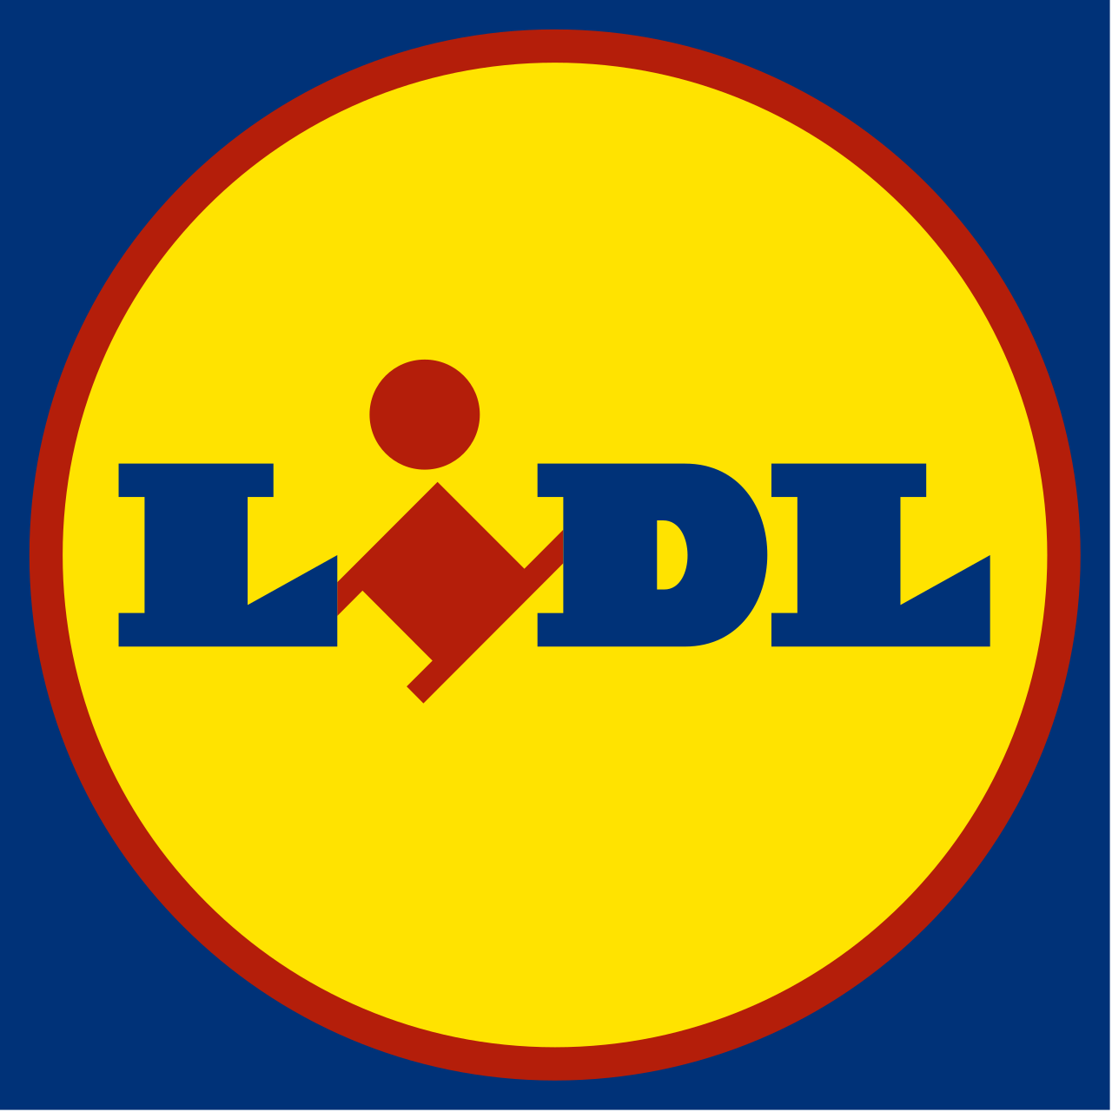

November 2019

MODULE NAME: Strategic Managemnet and sustaninability
Name: Zhuoer tan
Student Number: 1901688

Table of Contents
1.0 Executive Summary 1
2.0 Introduction 4
2.1 Objectives 4
2.2 Company Background 4
2.3 Major Concepts 5
2.3.1 Strategy 5
2.3.2 Business-level Strategy 6
2.3.3 Competitive Advantage 6
2.4 Porter's Generic Strategies 7
3. 0 Main Body 9
3.1 Cost Leadership Strategy 9
3.2 Lidl's Cost Leadership Strategy 10
3.2.1 Branding 10
3.2.2 Reduce Costs 11
3.2.2.1 Reduce Labour Costs 12
3.2.2.2 Improve Store Utilisation 13
3.2.2.3 Reduce Others Costs 14
3.3 Evaluation 14
3.3.1 Advantages of Cost Leadership Strategy 14
3.3.2 Disadvantage of Cost Leadership Strategy 16
4.0 Conclusion 17
5.0 Recommendation 18
6.0 References 19

List of Figure
Figure 1: Porter's Generic Strategies (tutor2u, 2018) 8

1.0 Executive Summary
This report first identifies the competitive strategy Lidl uses to build a competitive advantage. Second, rigorously evaluate the competitive strategy used by Lidl and explain the main advantages and limitations. Finally, Lidl is provided with some appropriate advice to help them maintain their competitive position.

Founded in Germany in 1930, Lidl was originally a general food wholesaler and later led by Dieter Schwarz to focus on large supermarkets, discounts, cash and carry wholesale markets. The first discount store opened in 1973 and opened its first store in the UK in 1994 and has continued to grow since then.

Sources used in this report include magazine, some academic books and website. Through these resources, it gives a description of Lidl’s use of the cost leadership. Includes: branding and cost reduction. A detailed analysis of how Lidl reduced costs illustrates how Lidl uses the firm leadership strategy. Lidl builds its own brand, reducing labor costs, increasing store utilization, reducing lighting costs and reducing large-scale advertising media campaigns.

Lidl uses the advantage of the cost leadership strategy to have the ability to outperform rivals and resist the five forces.
• Ability to surpass competitors: 90% of Lidl's products are self-owned brands, reducing the number of middlemen, saving the cost of cooperation with intermediaries, and ensuring the quality of the goods. In addition, to attract more consumers by providing some low-cost necessities, such as household appliances (small appliances or kitchen appliances) toys, home furnishing and gardening supplies.
• Resistance to five forces: With very low pricing, Lidl can satisfy the needs of consumers for product quality. It is unnecessary for Lidl to compete in the industry as the consumer group is huge. Lidl opens stores in different regions every year, forming a high barrier in the industry. Since most of the products are owned by its brand, Lidl is not under the control of suppliers without needing more costs to gain a trade advantage. Attracting consumers through low-priced products and small scale, Lidl is not affected by customers and lowers the price of products. Finally, Lidl is not faced with the threat of alternatives which is well resisted by the establishment of its own brand. In short, Lidl uses price leadership to effectively resist the five forces.

On the other hand, using the cost leadership strategy will also generate some disadvantage, price wars and lower customer loyalty.
• Price war: If Lidl wants to maintain market position, then it is necessary to participate in the price war and sell the goods at a lower price or even below the cost. But even if you win in the price war, Lidl's situation may be worse than before.
• Lower customer loyalty: The general consumption and the quality of products that are low-cost and low-priced are not good enough, and they can consider their loyalty brand as loyalty to product quality. Consumers will continue to buy high quality products. For example, the number of consumers will see a decline when customer loyalty is lowered, resulting resulting in a drop in market share and turnover. As a consequence, corporate income will experience a decline, which leads to a financial deficit.

The report makes a three recommendations that can help Lidl maintain a competitive advantage:
• In order to maintain Lidl's market share in the UK, Lidl can work with other discount stores of the same type to avoid price wars of the same type of store through market segmentation.
• Expanding the influence of Lidl in the UK market, increasing the usage of its website, accepting or collecting customer orders and deliver goods will provide convenience for consumers and attract more consumers.
• It can develop and produce high-end branded products targeted at different types of consumers, and compete with other supermarket retailers in a uniform environment.

2.0 Introduction

2.1 Objectives
The goals to be achieved in the report:
- To determine the strategy of Lidl Stiftung & Co. KG.
- To analyse the method of implementing the strategy and give examples.
- To evaluate the strategy and analyse its advantages and disadvantages.
- To make appropriate recommendations for the company.

2.2 Company Background
Established in Germany in 1930, Lidl Stiftung & Co. KG was jointly managed by Josef Schwarz and developed into an ordinary food wholesaler (LoveMoney, 2019). Led by Dieter Schwarz, Lidl started to focus on larger supermarkets, discount, cash and carry wholesale markets in 1977 (Aldis Erzfeind, 2019). Opened in 1973, the first discount store of Lidl replicated the philosophy of Aldi. The first Lidl in the UK was opened in 1994 since then the number of stores kept growing and exceeded 760 (Ft.com, 2015). Sven Seidel was appointed as the company’s CEO in March 2014 and resigned in February 2017 (Bloomberg.com, 2014). Currently, the company has 315,000 staff. In February 2017, Lidl had a total asset of around 28.969 billion euros (Subscribers.supermarketnews.com, 2011).

2.3 Major Concepts

2.3.1 Strategy
As an organisation’s long-term guiding scope and direction, strategy achieved stakeholder expectations through the configuration of resources and competitions (Johnson et al., 2011). The role of strategy is to determine how an organisation attains its goals. Therefore, the choice of strategy is of importance to analyse and study a company's management strategy.

Strategy management involved understanding an organisation’s strategic position, making strategic decisions for its future and managing strategies in action (Johnson et al., 2011). The strategic position was concerned with the influence of external conditions on strategy, the strategic capacity of an organisation and stakeholders’ expectations and influence (Johnson et al., 2011).

2.3.2 Business-level Strategy
In order to realise its goals, a company may set up many business units in a variety of industries. The business-level strategy analysed the life cycle and competitive position of a product, gained a customer base and sold it to make a profit (Madison, 2018). The corporate-level strategy aimed to assess the attractiveness of the portfolio of an organisation and achieve synergy through cross-department collaborative operations (Madison, 2018).

The business-level strategy mainly positioned itself on competitors and kept abreast of market trends and technological changes (Garcia, 2018). Porter held that any organisation could gain an edge over its rivals by taking three kinds of business-level strategies, including cost leadership, differentiation as well as focus (Elise, 2018).

2.3.3 Competitive Advantage
Competitive advantage refers to allowing organisations to go beyond competitors, try to determine strategic goals and attract consumers through low-priced and high-quality products or services in the target market. Porter's definition of gaining a competitive edge over competitors was cost and differentiation advantages (Porter, 1985). Cost advantage refers to providing consumers with the same products of rivals at a low cost, and a differentiation advantage meant offering higher-quality products and services than rivals (Porter, 1985). To win competitive advantage, the company took the business-level strategy to directly control the resources capable of generating competitive advantages (Rasoava, Russell and Yumiko, 2003). Competitive advantages were reflected in excellent performance and the advantages of productive resources (Ronald S, 2002).

2.4 Porter's Generic Strategies
In 1980, Porter identified three general strategies whose goal was cost leadership, differentiation or focus (Porter, 2004) and which described a company’s way of gaining competitive advantages in selected markets (Porter, 2004). Cost leadership (Porter, 1980) was a strategy of achieving profitability while reducing costs. Differentiation was a strategy of differentiating products or services to succeed in competing with rivals (Porter, 1980). The focus strategy (Porter, 1980) focused on specific customers and social members and provided them with quality service.
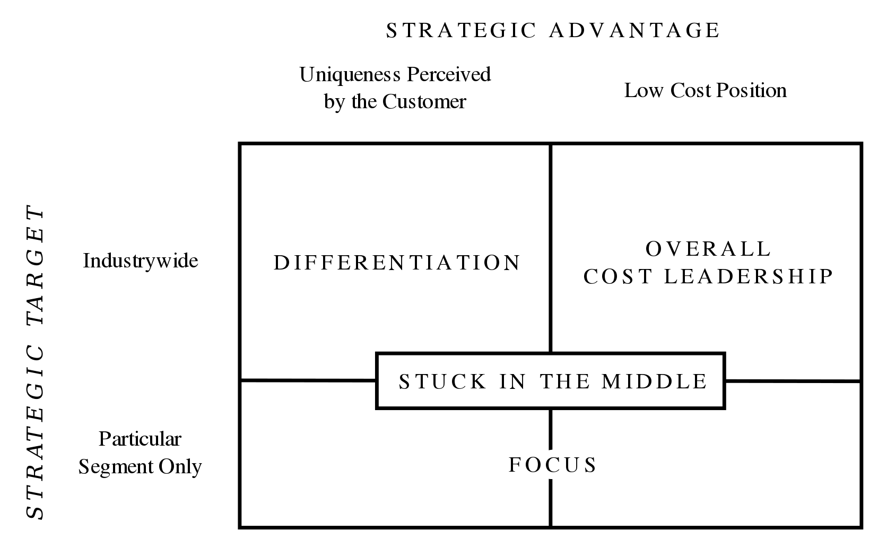
Figure 1: Porter's Generic Strategies (tutor2u, 2018)

3. 0 Main Body
Lidl is committed to selling high-quality products at the lowest possible costs, suggesting that it took the cost leadership strategy and implemented it incredibly effectively (Morschett et al., 2006). Nevertheless, Lidl may be forced to diversify its current strategy for continuous competitiveness and innovation in UK grocery markets so as to maintain its current speed of growth and expansion.

3.1 Cost Leadership Strategy
Porter proposed cost leadership in the 1908s. In business strategy, cost leadership established competitive advantages through using minimum operation costs in the industry (Grigsby and Stahl, 1997). Cost leadership strategy was aimed at producing high-standard products adopting advanced technologies by economic means like production scale and clear scope (Reid, 1993). Many companies gain leading market positions by a strategic mix, including cost and product leadership and quality customer service (Davidson, 2003).

There is a difference between cost and price leadership. A company may produce products at the lowest cost, but it cannot provide products or services of the lowest-price. In that case, its profitability is to be above average. However, cost-leading companies did have a quite effective price advantage over its rivals with low-budget structure and management (Grigsby and Stahl, 1997).

3.2 Lidl's Cost Leadership Strategy

3.2.1 Branding
Around 90% of products in Lidl stores were owned by its brand and exclusively made for Lidl (Business Insider, 2019). Selling its own products had two benefits: First, the elimination of middlemen eliminated all additional costs from suppliers (Welt.de, 2019). Second, Lidl can better control its manufacturing costs and set prices by itself. Therefore, its products made much more sales profits than other brands because of their much lower initial costs (Welt.de, 2019).

In general, own products include product diversification and price advantages. The Lidl brand is diversified and covers a wide range of product levels. For example, Okailands is the exclusive brand of Lidl's fresh fruits and vegetables, including many certified organic fruits and vegetables or selected products (lidl-ni.co.uk, 2019). As a fresh fish brand of Lidl, Lighthouse Bay was certified by MSC to ensure the quality of fresh fish (lidl-ni.co.uk, 2019). Self-operated brand products account for a relatively high proportion with relatively low price and good quality assurance. Discount supermarkets had their own brands in each product line, some of which used different self-operated brands for different types of products (Welt.de, 2019). For example, self-operated brands of eggs can cover captive, free-range and organic grades.

In addition, price advantage is a regular characteristic of self-operated brands. For retailers, self-operated brands have an advantage at a relatively cheap price because of reducing the intermediate link. The reduction of middlemen only means that manufacturers can deliver goods directly to each store while the reduction of suppliers is equivalent to saving a lot of the publicity and advertising costs. Therefore, establishing its own brand was one of the ways to reduce the costs of Lidl.

3.2.2 Reduce Costs
Cost reduction is one of the main goals of Lidl, which can be realised mainly by increasing unit area utilisation and reducing labour costs. Besides, lighting cost is reduced by reducing advertising cost.

3.2.2.1 Reduce Labour Costs
Firstly, one of the measures taken by Lidl to reduce labour costs is to reduce the number of employees which is proportional to the average traffic of stores where one person has multiple jobs. For example, cashiers could clean and organise goods after stores were closed (Lamb, 2011). In addition, discount supermarkets have a small number of manual checkout windows, in which the number of open accounts is determined according to passenger flow, usually two to three. The consumer often paid money by autonomous machines (Lamb, 2011).

The second measure is to reduce service types. Discount supermarkets generally provide no specialised services, such as on-site bakeries, cooked food windows and butcher shops in large supermarkets, which are rarely seen in Lidl’s stores and often sold in fixed specifications (Lamb, 2011). For instance, meat is packaged according to uniform specifications and refrigerated, bread is put in bags, and delicatessen is usually made into half-cooked products and packaged for refrigeration and sale.
Finally, shopping carts in supermarkets are all self-service and will not be recycled by special personnel. A coin was generally used as a deposit which could only be retrieved after the return of the trolley (Lamb, 2011).

3.2.2.2 Improve Store Utilisation
First, it increases the utilisation of unit area. The Lidl supermarket has a small store with relatively simple decoration, including simple floors and plain shelves. The placement of goods was ‘warehouse placement’ (Cheng, 2018). This way of placing this type of goods is not “casual”, but aims to reduce costs. The warehouse-style layout is able to increase more items per unit area and reduce labour costs. For example, vegetables and fruits are placed layer by layer for consumers to rummage at different levels. They can also be sold directly in boxes so that clerks only need to clean these boxes from time to time. In addition, Lidl has an average store floor area of 10,000 square feet and six aisles compared with Tesco and Wal-Mart. In spite of being larger than its European discount stores, it only accounts for about a quarter of traditional supermarkets in Europe. Although the store was small, its leasing cost was greatly reduced because of its warehouse-type layout (Business Insider, 2019).

3.2.2.3 Reduce Others Costs
In order to reduce costs, Lidl generally uses natural light during the day and turn on lights after dark. Not very bright, most of these lights are energy-saving lamps. It showed that Lidl wanted to save all unnecessary costs (Business Insider, 2019).

Second, it does not spend a lot of money on advertising. Insisting on small-scale development, Lidl has no need to release many advertisements in many places such as subway stations, buses, TVs and radio programmes according to its marketing strategy. It was very active on local radio ads and social media (Business Insider, 2019). For example, it publishes some of the latest discounts to attract a large number of consumers through leaflets or newspapers, which is much less expensive than advertising in public places.

3.3 Evaluation

3.3.1 Advantages of Cost Leadership Strategy
- Ability to outperform rivals: Since 90% of products are its own brand, Lidl reduces the middleman link, which not only saves the cost of cooperation with suppliers but also guarantees the quality and taste of goods. In addition, it offers all sorts of products to its customers, including some essentials like household appliances (small appliances or kitchen utensils), stylish equipment, toys, power tools, home décor and gardening supplies suitable for the entire family.

- Resist the five forces: Proposed by Porter in 1979, the Five Forces model (Porter, 1979) contained rivalry, substitutes, threat of new entrants, bargaining power of suppliers and buyers (JIM, 2019). With very low pricing, Lidl can satisfy the needs of consumers for product quality. It is unnecessary for Lidl to compete in the industry as the consumer group is huge. Lidl opens stores in different regions every year, forming a high barrier in the industry. Since most of the products are owned by its brand, Lidl is not under the control of suppliers without needing more costs to gain a trade advantage. Attracting consumers through low-priced products and small scale, Lidl is not affected by customers and lowers the price of products. Finally, Lidl is not faced with the threat of alternatives which is well resisted by the establishment of its own brand. In short, Lidl uses price leadership to effectively resist the five forces.

3.3.2 Disadvantage of Cost Leadership Strategy
- Price Wars: A price war referred to a competitive exchange among competing companies lowering their product prices and strategically attempting to weaken each other and seize greater market shares (Investopedia, 2019). If expecting to maintain its position in the market, Lidl must wage a price war and sell products at a price lower than the cost to achieve a monopoly market. However, offering lower prices than its competitors to retain consumers would lead to a drastic decline in profits (Harvard Business Review, 2000). Even if Lidl wins in the price war, the situation will be worse than before.

- Low Customer Loyalty: Consumers often perceive low-cost and low-priced products as not good enough, whose loyalty brands can be considered to their loyalty to the quality of products. Only high-quality products can continue to be purchased by consumers. In addition, individualised requirements may not be met, like online shopping and home delivery. For example, the number of consumers will see a decline when customer loyalty is lowered, thereby resulting in a drop in market share and turnover. As a consequence, corporate income will experience a decline, which leads to a financial deficit.

4.0 Conclusion
In brief, Lidl takes the cost leadership strategy to establish its competitive advantage with the lowest operating costs. With a market share of less than 5%, Lidl still attracts a number of consumers. It reduces some unnecessary costs by producing products of its own brand. In addition, Lidl reduces costs at every stage of production so as to offer consumers low-priced products. In order to make better use of the cost leader strategy, Lidl has taken some measures to control costs, such as establishing its own brand, lowering labour costs, and reducing the scale of stores and unnecessary costs in lighting and advertising. However, this strategy taken by the company also has some disadvantages. First of all, the company may need to start a price war of planning to make long-term development, which will pose a great threat to itself and may lead to the loss of its money. In addition, it will lose a large proportion of consumers in the long run if the quality of its products fails to meet the expectations of consumer.

5.0 Recommendation
According to the above analysis, three suggestions were made:
- To maintain competitiveness in the UK grocery sector and keep growing its market share in the UK, Lidl can work with other discount stores of the same type to avoid the price wars waged by the same type of stores through market segmentation.
- Expanding the influence of Lidl in the UK market, increasing the usage of its website, accepting or collecting customer orders and deliver goods will provide convenience for consumers and attract more consumers.
- It can develop and produce high-end branded products targeted at different types of consumers, and compete with other supermarket retailers in a uniform environment. If a high-end brand is launched, it will be different from Lidl's current business model, which may give rise to a combination of Porter's generic strategies.

6.0 References
- Bloomberg.com. (2014). German Grocer Lidl Names Replacement CEO After Holland Departure. [online] Available at: https://www.bloomberg.com/news/articles/2014-03-21/german-grocer-lidl-names-replacement-ceo-after-holland-departure [Accessed 11 Nov. 2019].
- BBC News. (2019). Lidl opens £70m distribution centre. [online]
Available at: https://www.bbc.co.uk/news/uk-scotland-scotland-business-50001158
[Accessed 11 Nov. 2019].
- Brown, G., 2015. Giant Lidl distribution hub to create 500 West Midlands jobs. [Online]
Available at: http://www.birminghampost.co.uk/business/business-news/giant-lidl-distribution-hub-create-8883111 [Accessed 06 Nov. 2019]
- Business Insider. (2019). International. [online] Available at: https://www.businessinsider.com/how-lidl-keeps-its-prices-down-2017-6/ [Accessed 5 Nov. 2019].
- Bosshart, D., 2006. Cheap: The Real Cost of Living in a Low Price, Low Wage World. London: Kogan Page Limited.
- Cleverism. (2019). Understanding the Marketing Mix Concept – 4Ps. [online] Available at: https://www.cleverism.com/understanding-marketing-mix-concept-4ps/ [Accessed 10 Nov. 2019].
- Charles Lamb (2011). Essentials of Marketing. Cengage Learning. p. 465.
- CIM, 2009. Marketing and the 7Ps, s.l. Chartered Institute of Marketing
- Cheng, B. (2018). Lidl, Aldi, these German discount supermarkets, how to achieve high quality and low price.
- Costidis, T. (2019). SWOT Analysis Helps Businesses Plan for Growth. [online] Financenewmexico.org. Available at: https://financenewmexico.org/articles/general-business-advice/swot-analysis-helps-businesses-plan-growth/ [Accessed 7 Nov. 2019].
- Dolgui, A., Proth, J. M., 2010. Pricing strategies and models. Annual Reviews in Control, 34(1), pp. 101-110.
- Davidson, W. (2003). Breakthrough. John Wiley and Sons.
- Dyson, R. G., 2004. Strategic development and SWOT analysis at the University of Warwick. European Journal of Operational Research, Volume 152, pp. 631-640.
- Elise, M. (2018). 3 Different Types of Business-Level Strategy | Fast Capital 360. [online] Fast Capital 360. Available at: https://www.fastcapital360.com/blog/business-level-strategy/
[Accessed 16 Nov. 2019].
- Ft.com. (2015). Nearly half of UK shoppers go to Aldi or Lidl each month. [online] Available at: https://www.ft.com/content/2b7f33e2-6142-11e5-9846-de406ccb37f2 [Accessed 11 Nov. 2019].
- FT. (2015). Half of UK shoppers visited Lidl, Aldi over Xmas. [Online] Available at: http://www.ft.com/fastft/260632/half-of-uk-shoppers-visited-lidl-aldi-over-xmas
[Accessed 18 Nov. 2019].
- Felsted, A., 2014. Lidl expansion to crank up pressure on big stores. [Online] Available at: http://www.ft.com/cms/s/0/2465c426-fd53-11e3-bc93-00144feab7de.html#axzz3giD80B9c
[Accessed 06 Nov. 2019].
- Glueck, W. and Jauch, L. (n.d.). Business policy and strategic management.
- Grigsby, D. and Stahl, M. (1997). Strategic management. Cambridge, MA: Blackwell Publishers.
- Harvard Business Review. (2000). How to Fight a Price War. [online] Available at: https://hbr.org/2000/03/how-to-fight-a-price-war [Accessed 11 Nov. 2019].
- Investopedia. (2019). Price Wars. [online]
Available at: https://www.investopedia.com/terms/p/price-war.asp [Accessed 8 Nov. 2019].
- Kumar, N. & Steenkamp, J. B. E. M., 2007. Private Label Strategy: How to Meet the Store Brand Challenge. Cambridge: Harvard Business Press.
- Lovemoney.com. (2019). Secrets of the German supermarkets conquering America. [online] Available at: https://www.lovemoney.com/galleries/66867/secrets-of-the-german-supermarkets-conquering-america [Accessed 11 Nov. 2019].
- lidl-ni.co.uk. (2019). 20 Years in N.I. | Big on quality, Lidl on price. [online] Available at: https://www.lidl-ni.co.uk/ [Accessed 7 Nov. 2019].
- JIM, C. (2019). Porter's 5 Forces Definition. [online] Investopedia. Available at: https://www.investopedia.com/terms/p/porter.asp [Accessed 11 Nov. 2019].
- Porter, M. (1979). How Competitive Forces Shape Strategy. 2nd ed. Boston: Harvard Business School Press, pp.137-145.
- Porter M, E. (2004). Competitive strategy. New York: Free Press.
- Poulter, S., 2014. Aldi and Lidl to force ‘big four’ supermarkets into price war to stop stampede of customers to discount chains. [Online]
Available at: http://www.dailymail.co.uk/news/article-2539064/Aldi-Lidl-force-big-four-supermarkets-price-war-stop-stampede-customers-discount-chains.html [Accessed 18 Nov. 2019]
- Rasoava, R., Russell, A. and Yumiko, F. (2003). A framework for concentric diversification through sustainable competitive advantage. Management Decision, p.362.
- Ronald S, L. (2002). Competitive factors and their relative importance in the US electronics and computer industries. International Journal of Operations & Production Management, (22), pp.125-135.
- Russell, H. (2019). Cost Leadership & Competitive Advantage. [online] smallbusiness.chron.com. Available at: https://smallbusiness.chron.com/cost-leadership-competitive-advantage-35159.html [Accessed 06 Nov. 2019].
- Reid, G. (1993). Small Business Enterprise: An Economic Analysis. Routledge.
- Simon, H., Gathen, A. V. D. & Daus, P. W., 2010. Retail Pricing – Higher Profits Through Improved Pricing Processes. In: Retailing in the 21st Century. Berlin: Springer Berlin Heidelberg, pp. 319-336.
- Siro, I., Kapolna, E., Kapolna, B. & Lugasi, A., 2008. Functional food. Product development, marketing and consumer acceptance—A review. Appetite, 51(3), pp. 456-467.
- tutor2u. (2018). Porter's Model of Generic Strategies for Competitive Advantage. [online] Available at: https://www.tutor2u.net/business/reference/porters-generic-strategies-for-competitive-advantage [Accessed 12 Nov. 2019].
- Welt.de. (2019). Der Siegeszg der Eigenmarken geht weiter. [online] Available at: https://www.welt.de/newsticker/dpa_nt/infoline_nt/wirtschaft_nt/article173723844/Der-Siegeszug-der-Eigenmarken-geht-weiter.html [Accessed 5 Nov. 2019].

