DIGITAL SKILLS AND RESEARCH METHODS
STUDENT NAME: ZOZO KAMBA
STUDENT CODE: 1712801

Executive Summary
This report highlights the modern technologies being used in the workplace like web-based emails and Tablets and smart phones to improve communication and increase the productivity of the employees. Moreover, the report also shed lights on the different social media tools being used by the organization to create an online presence, information gathering, and improve communication in the workplace. This report also explains the implications of social media on professional security and the social media tool preferred by the organizations to create connections and network with employees.
Table of Contents
Introduction 4
Use of web-based Email in the workplace 4
Improvement of the workplace because of web-based Email 4
Use of Tablets and Smartphones in the workplace 5
Comparison between the two providers 5
Social Media as a Tool for Marketing 6
Importance of Linkedin in the workplace 7
Importance of Twitter in work place 8
Importance of Face book in work place 8
Use of Social Media as Information Gathering and Communication within the Workplace 9
Facebook 9
Conclusion 10
Reference List 11

Introduction
This report explains the modern different technologies used in the workplace like web-based emails and mobile phones, smart phones and tablets and their importance in the workplace like improving formal communication between management and employees. This report also highlights the different social media marketing tools like face book, twitter and LinkedIn used in marketing and their importance in the workplace like creating online presences in the market. This report also shed lights on the different social media tools used in the workplace for collecting information and improving communication.

Use of web-based Email in the workplace
The web-based email has made the interaction between the employees of an organization or the communication within several companies faster and easier by saving time and increasing the longevity of the message sent through email. The email has been used to send official letters containing useful information and often it has been found to have important or confidential files, such as excel or word file, pictures etc. The email enables the employees to have an interaction without having a face-to-face conversation (Williams et al 2015, p.443). Through email, one message can be sent to all the employees working in several branches of a company with a single click. For example, an important notice related to payment, an event or holiday can be forwarded to one and all without any huff and puff. It not only saves the time but also saves the expenses of sending a message from one end of the country or world to the other end.

Improvement of the workplace because of web-based Email
Email has changed the definition of communication in the workplace. Email is very helpful to interact effectively with anyone, not only within the office but also within the world. Email has made the formal conversation with the clients quick and easy. One message can be sent to millions through email instantly. For example, to make an announcement regarding an official event, it is not required to print invitation letters and courier it to all employees (Cousins and Robey, 2015, p.34). The whole exercise can be done without spending much for it through mass email. Email helps the company to reduce the communication expenses since the cost of sending an email is very less compared to making a phone call or courier. Email allows the user to send a message to multiple people without letting the recipients know that the message is being sent to others along with them through the BCC option.

Use of Tablets and Smartphones in the workplace
Tablets can be used to give presentations in the workplace by reducing the pressure of carrying laptops in the workplace. The tablets can also be used to improve workforce mobility. For example, an employee can give a presentation to its clients using tablets from anywhere in the world as it is easy to carry.Moreover, tablets have been used in the workplace by employees to access information.For example, if a retail manager is out for work and not in a store he can easily use his tablet to access information and provide it to its customers (Kenna, 2015).
According to Jobber Academy (2018), the smart phones have been used in the workplace to improve communication between field workers and management.For example; field workers have can use smart phones to communicate with its seniors through video conferencing using smartphones. Additionally using smartphones in the workplace have led to an increase in productivity in the workplace. For example, the organizations allowing their employees to bring their mobiles phones in the workplace have led to an increase in their productivity. The other advantages of using smartphones in the workplace have led to flexibility in working hours. For example, the employees can work from anywhere and do not have to sit back at the office to perform tasks. Moreover, employees have been using mobile phones in improving their communication with the management which has lead to an increase in job satisfaction and company loyalty among the employees (Rauniar et al. 2016, p.150).

Comparison between the two providers

Criteria | Web-based Emails | Tablets and Smartphones
Communication | Helps informal communication. | Helps in informal communication
Evidence | Can be used as evidence in the long run | Cannot be used as evidence in the long run.
Mode of Communication | Official letters, Circulars | Face to face, Rumours
Importance | Can be sent to multiple employees at the same time to convey information, saves the time of the organization. | Has been used for effective communication in the workplace, increase productivity in the workplace, easier access to information.
Disadvantages | Increase in costs, leakage of secret information. | Creates misunderstanding, can be a distraction in the workplace.
Table 1: Comparison between web-based emails and tablets and smart phones
(Source: Colbert et al. 2016, p. 200)
The web based emails are useful in the workplace because it helps in conveying formal information the employees and clients at a faster pace. It helps in saving time in the workplace as it can be sent to many employees at the same time. It also acts as proof of evidence in case any discrepancy arises in the workplace. The tablets and smartphones are important because it helps in easier access to information. The smartphones and tablets can also be used in the workplace to gather and analyse the information (Colbert et al. 2016, p. 200). It also helps in increasing the productivity of the employees in the workplace as they can give presentations and communicate with their management any time and from anywhere. The web-based emails are useful in conveying formal information to employees whereas the tablets and smartphones are used in informal communication with employees. The web-based emails are useful in the long run in the organization whereas the smartphones and tablets are used for the short run in the organization.

Social Media as a Tool for Marketing
According to Felix et al. (2017,p.150), the different social media tools that have been used by the organizations in marketing are face book, twitter and LinkedIn to for marketing its products The different social media tools are used to create an online presence in the market. The social media tools are also used in the workplace to satisfy customers. Moreover the different social media tools like facebook, twitter and Linkedin can be used to collect information like feedback to review organizational performance and make improvement where ever required. The different social media marketing tools can be used to create brand awareness among customers.Additionally, social media tools can be used to monitor the needs and desires of their customers and create awareness among customers about the launching of new products to satisfy its customers. The social media tools can also be used by the organization for market penetration among the target audience.
The implications of social media on personal and professional security are there are chances of leakage of personal and professional information to their clients and employees. Moreover, there are chances of personal and professional profiles being hacked by the competitors or other people. Moreover, there are chances of breaching and infringement of information from social media leading to weakening of personal and professional security (Oldham and Da Silva, 2015, p.96).

Importance of Linkedin in the workplace
According to Ouirdi et al. (2015, p.156), LinkedIn can be used in the workplace to network professionally that is an organization can create formal relationships with their clients from anywhere and at any time. Linkedin can also be used in organizations to find new clients, employees and associates for the workplace. Linkedin can also be used in the workplace to increase visibility for its brands. The Linkedin is also useful in increasing the business of the organization by helping them in reaching customers.Linkedin is also helpful to the organization as it helps in researching and gathering information about its competitors and their strategies. Linkedin is also useful in creating a reputation for the company as the organization can write formal articles and blogs to gain more clients and build a reputation among the job seekers.The disadvantages of the linked are the risk of conveying wrong information about organizations are very high. The other disadvantage of Linkedin is creating misunderstanding among job seekers as the company may not update current information which in return may create a negative impression about organizations in the minds of their clients.

Importance of Twitter in work place
Twitter can be used to communicate with its employees and clients and followers updated by conveying information current information relating to the business. The other advantage of using Twitter in the workplace is it has helped in generating leads and increasing sales by attracting more customers and informing them about the new product the organization is coming up with in the future. Twitter is also useful in the workplace as it has helped in identifying trends and patterns of the competitors of an organization (Lamberton and Stephen, 2016, p.96). Moreover, Twitter has also helped in connecting with the customers and solving their queries which in turn has led to improving the company reputation. The disadvantages of using Twitter are can harm company reputation as the employees facing harassments can disclose their experience on Twitter. Moreover, there are high technical risks involved in using Twitter by the organizations like the hanging of tablets and mobile phones while using Twitter, attack by viruses on different tablets and smart phones.

Importance of Face book in work place
Facebook has helped the organizations in expanding their business by selling more products and services to its customers. Facebook has also helped in social networking that it has helped in creating connections with employees and clients. For example, Face book has created a section named Workplace by Facebook where employees of different organizations can interact with each other and share their will has helped the organization in creating a reputation. The other advantage of Facebook it requires very fewer investments which in turns help companies in reducing the costs incurred in the promotion of products. The disadvantage of using Face book is it acts as a distraction for employees which in turn lead to a decrease in productivity. The other disadvantage of Facebook is breaching of private information (Kasemsap, 2016, p.450).

Use of Social Media as Information Gathering and Communication within the Workplace

Facebook
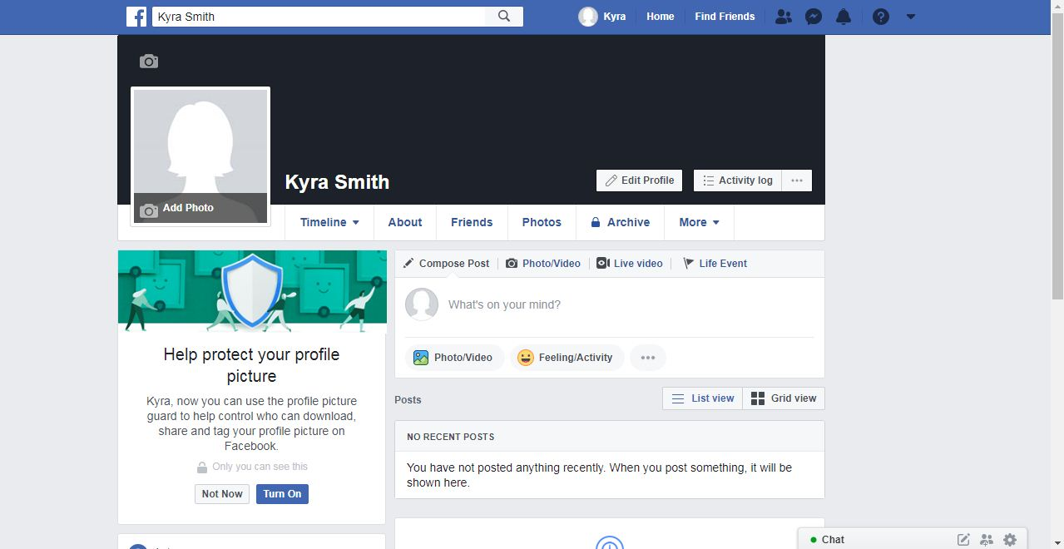
Figure 1: Facebook Account
LinkedIn
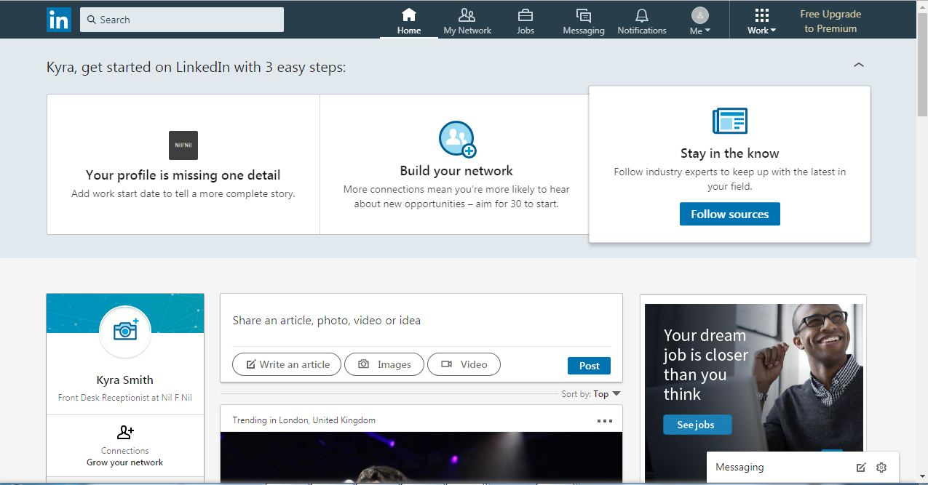
Figure 2: LinkedIn Account
(Source: https://www.linkedin.com/feed/?trk=onboarding-landing)
Twitter
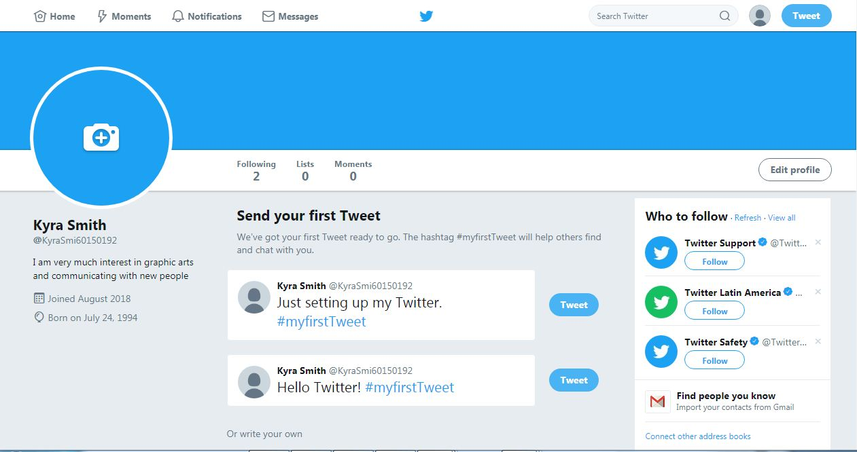
Figure 3: Twitter Account
(Source: https://twitter.com/KyraSmi60150192)

Social media has been used by the organizations in information gathering by taking feedback from its customers on different social media applications. The social media has been used to monitor and review information about its competitors and clients. The social media has been also used in improving communication in the workplace by helping them in building social networks and connections with customers (Leonardi and Vaast 2017, p.560). Moreover, social media tools have been used to interact and convey important information about their organization to their employees and customers. Facebook is preferred to create networks because it is used by all age groups and by all classes whereas linked and twitter is mainly used by professional people.

Conclusion
It can be concluded that the different technologies being used in the workplace to convey information and improve communication are web-based emails and tablets and smart phones. It can also be said that the organizations are using different social media tools like face book, twitter, LinkedIn for creating an online presence, promotion of products and creating brand loyalty. Moreover, it can also be said that the different security risks involved in using social media are privacy risk and technical risk.

Reference List
Colbert, A., Yee, N., & George, G. (2016). The digital workforce and the workplace of the future.
Cousins, K. and Robey, D., (2015). Managing work-life boundaries with mobile technologies: An interpretive study of mobile work practices. Information Technology & People, 28(1), pp.34-71.
El Ouirdi, A., El Ouirdi, M., Segers, J. and Henderickx, E., 2015. Employees' use of social media technologies: a methodological and thematic review. Behaviour & Information Technology, 34(5), pp.454-464.
Felix, R., Rauschnabel, P.A. and Hinsch, C., 2017. Elements of strategic social media marketing: A holistic framework. Journal of Business Research, 70, pp.118-126.

Frank Kenna (2015). How Smart phones and Tablets are Changing Workplace Communications.Acessed on 9 august,2018.Accessed from https ://www. Themarlin company. com/blog-articles/smartphones-tablets-changing-workplace-communications/

Jobber Academy (2018). How Tablets and Mobile Devices are Transforming Your Industry. Acessedon9august,2018.Accessedfromhttps://academy.bgetjobber.com/resources /articles /how-tablets-and-mobile-devices-are-transforming-your-industry/

Kasemsap, K., (2016). The role of social networking in global business environments. In Social media and networking: Concepts, methodologies, tools, and applications (pp. 1635-1653). IGI Global.
Lamberton, C., & Stephen, A. T. (2016). A thematic exploration of digital, social media, and mobile marketing: Research evolution from 2000 to 2015 and an agenda for future inquiry. Journal of Marketing, 80(6), 146-172.

Leonardi, P.M. and Vaast, E., (2017). Social media and their affordances for organizing: A review and agenda for research. Academy of Management Annals, 11(1), pp.150-188.
Oldham, G.R. and Da Silva, N., 2015. The impact of digital technology on the generation and implementation of creative ideas in the workplace. Computers in Human Behavior, 42, pp.5-11.
Rauniar, R., Rawski, G., Yang, J. and Johnson, B., 2014. Technology acceptance model (TAM) and social media usage: an empirical study on Facebook. Journal of Enterprise Information Management, 27(1), pp.6-30.
Williams, M.D., Rana, N.P. and Dwivedi, Y.K., (2015). The unified theory of acceptance and use of technology (UTAUT): a literature review. Journal of Enterprise Information Management, 28(3), pp.443-488.

