Contents Page
Part A
Part B
Part C
Part D
Part E
Part F
Part G

Part A
Observational Analysis – Game
Physical | Technical | Tactical | Psychological
Making sure when he crosses in the ball, they get a bit physical to get to the ball | Making sure the players are looking for space not just kicking the ball around the pitch | Not having the control of the ball and not looking up who is around him
To make sure when you’ve got the ball to stay strong and make sure that you have control of the ball | Making sure you get in front of the ball not behind when the player can get the ball of you
 | Keeping there head up and keep the ball on the floor because you’ve got more control then
Overall Review and Link to Session Planner:

UWTSD Session Planner
Venue: lc2 |  |  |  | Age group:  Number Attending:
Date |  |  |  | Start time:  Finish time:
Equipment:
Bag football’s , cones

Nearest Telephone: reception |  | 1st Aid bag: reception
Risk Assessment completed:  yes |  | Additional Hazards and actions taken: yes
Learning from Observational Analysis: |  |  | Personal action points Observational Analysis:
Goals for the session:
Passing the ball on the floor making sure they have there heads up and looking where the ball is going finding the right time to pass the ball to the team mates

.
Introduction and warm-up
Find a space by a wall / partner pass the ball right foot first then left foot then pass the ball with both feet right then left continues movement.

Main Content/Game  Passing the ball on the floor and looking who is available around you and see if there is any opportunity |  |  | Organisation/diagram
Ideas for Development (progression / regression):  Setup  Lots of small cones gates  Players work in pairs with one ball  Base drill  - Pass through as many gate’s as possible in 60 sec  Progression  - 1 touch only  - Weak foot only  - Pass move to different gates  - Add a passive defence  Regression  - 2+ touches allowed  - Larger gates  - Static partner |  |  | Diagram for activity  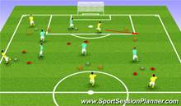
5Cs to be included in this session | Select 2 of the 5 and apply to session  HOW?
Competence

Confidence:

Connection: | The connection of the players are good they need to make sure the keep pushing up the scale to get stronger as a team but they make the right choices
Character and caring:

Creativity:

Observational Analysis – Game
Physical | Technical | Tactical | Psychological
 | Finding the space to shoot in the right location | Finding the right distance and making sure they are looking around for players
 | First touch needs to be controlled better | Making sure they don’t all stand in one place
 | Shooting needs to get stronger
Overall Review and Link to Session Planner:

UWTSD Session Planner
Venue: lc2 |  |  | Age group:  Number Attending:
Date |  |  | Start time:  Finish time:
Equipment: bag footballs , cones

Nearest Telephone: reception | 1st Aid bag: reception
Risk Assessment completed:  Yes | Additional Hazards and actions taken: yes
Learning from Observational Analysis: |  | Personal action points Observational Analysis:  A match  The players  The people performance
Goals for the session:
Shooting the ball into the goals

Introduction and warm-up

Players in pairs
One ball per pair
Small goals or cones for goals

Main Content/Game  Pass – move - receive - light shot/pass into target area  Both feet encouraged  Coaching points such as  Head up before striking  Side-foot accuracy  Good body shape  Follow through |  | Organisation/diagram  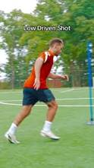
Ideas for Development (progression / regression):  Shooting accuracy  Passing under pressure  Defending 1v1  Decision-making in attack  Progression  Add pressure  Passive-active defence  Reduce time/space  Small area  Touch limit  Increase realism  Go from drill – game situation  Condition rules  One touch finish  Weak foot only  Score constraints  Extra points for certain action  Examples  Defender closes down  2v1 decision before shot  Game with finishing zones |  | Diagram for activity  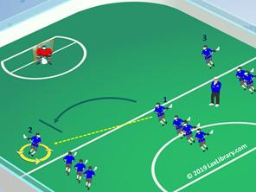  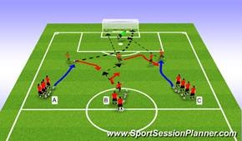

5Cs to be included in this session | Select 2 of the 5 and apply to session  HOW?
Competence

Confidence: | Having the confidence in shooting the ball not pulling back to pass the ball making sure when you receive the ball head up and looking for the space and the Strick
Connection:

Character and caring:

Creativity:

Cool-down:

Observational Analysis – Game
Physical | Technical | Tactical | Psychological
Overall Review and Link to Session Planner:

UWTSD Session Planner
Venue: |  |  |  | Age group:  Number Attending:
Date |  |  |  | Start time:  Finish time:
Equipment:

Nearest Telephone: |  |  |  | 1st Aid bag:
Risk Assessment completed: |  |  |  | Additional Hazards and actions taken:
Learning from Observational Analysis: |  |  |  | Personal action points Observational Analysis:
Goals for the session:

.
Introduction and warm-up

Main Content/Game |  |  |  | Organisation/diagram
Ideas for Development (progression / regression): |  |  |  | Diagram for activity
5Cs to be included in this session |  |  |  | Select 2 of the 5 and apply to session  HOW?
Competence

Confidence:

Connection:

Character and caring:

Creativity:

Cool-down:

Part B
Academic Journal Review – Sports Management
Student Name:
Title of Work:
Author:
Reference:
Date of Article:
PERSONAL REVIEW
Review Suggestions
- Give an overview of the article.
- What are the key points in this article?
- Who is intended audience – academics/ practitioners – why do you come to that conclusion?
- Does the author define any terms? Are the definitions specific, useful, circular?
- What are the key findings?
- What did I find striking or interesting about these key points?
- How has this article influenced me in thinking deeply about my values, beliefs and assumptions?
- Does the author suggest areas for further research or discussion?
Personal Review (300 words)
Fundamental Movement Skills (FMS) serve as essential learned movement patterns which enable individuals to perform advanced physical activities. The article by Barnett and his co-authors (2016) addresses criticism of their proposal to maintain FMS as the primary focus of physical education (PE) programs. The authors argue that FMS—typically categorized into locomotor, object-control, and stability skills—are essential for promoting lifelong engagement in physical activity. One major critique addressed is that not all FMS are truly “fundamental.” The authors explain that while definitions and assessment tools exist in different contexts and cultures the main function of FMS is to teach children basic coordination skills that enable them to take part in various physical activities. Another criticism suggests that each FMS transfers only to limited sports. The authors defend their argument by explaining that advanced movement patterns which include throwing and kicking lead to the development of essential neuromuscular coordination skills and balance abilities and timing competencies and control functions which athletes need to succeed in multiple sports. The article contests the belief that children acquire skills through unstructured play activities which require no teaching. The research shows that structured teaching methods which provide feedback to students produce better results than unstructured playtime activities for skill development. The authors demonstrate that FMS promotion exists as a compatible method which supports learning through a constraints-based approach. Effective FMS instruction needs to assess three different factors which include individual needs and environmental conditions and task requirements. The authors disprove the assertion that FMS instruction depends entirely on "skills and drills" ground. They show that expert educators implement multiple teaching methods which encompass game-based and play-practice methods to develop students' movement abilities.
The authors assert that FMS instruction must remain a permanent component of PE because it develops three essential skills of physical competence and confidence and ongoing physical activity engagement.
References
Barnett, L. M., Stodden, D., Cohen, K. E., et al. (2016). Fundamental movement skills: An important focus. Journal of Teaching in Physical Education, 35(3), 219–225. https://doi.org/10.1123/jtpe.2014-0209
Logan, S. W., Robinson, L. E., Wilson, A. E., & Lucas, W. A. (2012). Getting the fundamentals of movement: A meta-analysis of the effectiveness of motor skill interventions in children. Child: Care, Health and Development, 38(3), 305–315.
Stodden, D. F., Gao, Z., Langendorfer, S. J., & Goodway, J. D. (2014). Dynamic relationships between motor skill competence and health-related fitness in youth. Pediatric Exercise Science, 26(3), 231–241.*

Part C
UWTSD Session Planner
Venue: Lc2 |  |  | Age group: Year 3 - 5  Number Attending: 15
Date: 3/11/25 |  |  | Start time: 12.15  Finish time: 2.30
Equipment: cones, tennis rackets, balls, net

Nearest Telephone: Reception | 1st Aid bag: Reception
Risk Assessment completed: Yes | Additional Hazards and actions taken:  N/A
Learning from previous session:  From the previous session I learned to break down tasks into smaller, step by step instructions. This makes it easier for children, especially those with less experience to understand the task.  To avoid participants becoming bored split the group up and each coach take a smaller group |  | Personal action points from previous session:  Work on timing and accuracy in the players  Stay relaxed and confident, show you are an authority figure  Analyse your performance or examples throughout, make sure you are technically correct
Goals for the session:
To develop mobility through tennis.
Learn different shots
Racket control with balancing a ball
Introduction and warm-up
All learners will walk around the area of two badminton courts with a ball balanced on a tennis racket. If they drop their ball they must move to the inside of other learners, do five star jumps then put the ball back on the racket and join back in.

Main Content/Game  Around the world  How to hit forehands and  backhands |  | Organisation/diagram
  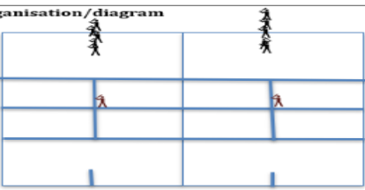
Ideas for Development (progression / regression):  Progression – Feed the ball on the other side of the court with more aggressive feed.  Regression – drop feed balls up close to make it easier to hit |  | Diagram for activity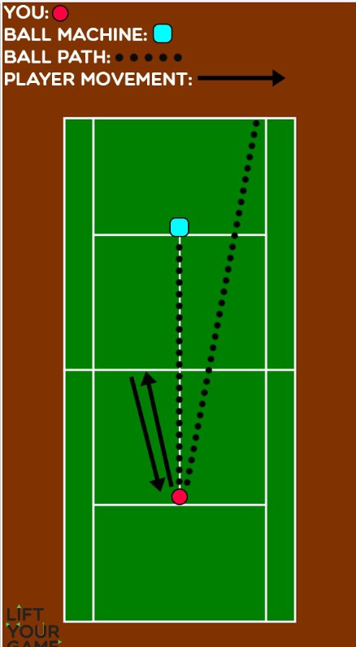

Part D
Academic Journal Review – Sports Management
Student Name:
Title of Work:
Author:
Reference:
Date of Article:
PERSONAL REVIEW
Review Suggestions
- Give an overview of the article.
- What are the key points in this article?
- Who is intended audience – academics/ practitioners – why do you come to that conclusion?
- Does the author define any terms? Are the definitions specific, useful, circular?
- What are the key findings?
- What did I find striking or interesting about these key points?
- How has this article influenced me in thinking deeply about my values, beliefs and assumptions?
- Does the author suggest areas for further research or discussion?
Personal Review (300 words)

Scaffolding in sport coaching can be understood as a socio-pedagogical process through which coaches intentionally structure, adapt, and gradually withdraw support to develop athlete agency in preparation for competition. The practice of scaffolding enables athletes to learn because Vygotsky's Zone of Proximal Development (ZPD) requires instructors to create learning environments where students can perform better through instructor support than they can through self-directed learning (Vygotsky, 1978). The research conducted by Thomas, Bailey, and Engeness (2021) through their examination of a year-long preparation period with an elite gymnast shows that scaffolding functions as an educational tool designed to support learning which develops into a deep bonding experience that unites teaching methods with understanding of student needs. At the macro level, the coach established clear performance benchmarks and long-term goals; at the meso and micro levels, he used questioning, simulated pressure scenarios, and adaptive feedback to create productive challenge. The learning process experienced its fastest progress when the coach used "insecurity" as a method to create competitive stress, which demonstrated that effective scaffolding needs both challenge elements and relationship trust to succeed (Jones & Thomas, 2015). The study demonstrates that challenges without common understanding between parties lead to trust problems which show the ethical and relationship aspects of coach intervention. The athlete demonstrated internalised learning through his performance under pressure which showed he had reached independence from coach support, according to scaffolding theory, through the diminishing support he received (Wood, Bruner, & Ross, 1976). Scaffolding in coaching goes beyond technical assistance because it creates an interactive process which needs coaches to support athletes while they take risks and build trust with their coaches. The process develops performers who can handle demanding competition situations while maintaining control over their actions. The athlete achieved successful performance through independent execution under pressure, which proved his ability to learn through internalization. Scaffolding in coaching needs more than technical correction because it establishes a system that needs all three elements, which includes either support and risk or relational security, to create performers who can succeed in high-pressure situations.
References
Jones, R., & Thomas, G. L. (2015). Coaching as scaffolded practice: A socio-pedagogical perspective. Sports Coaching Review, 4(2), 123–142.
Thomas, G. L., Bailey, J., & Engeness, I. (2021). Scaffolding athlete learning in preparation for competition: What matters. Sports Coaching Review. https://doi.org/10.1080/21640629.2021.1991713
Wood, D., Bruner, J. S., & Ross, G. (1976). The role of tutoring in problem-solving. Journal of Child Psychology and Psychiatry, 17(2), 89–100.

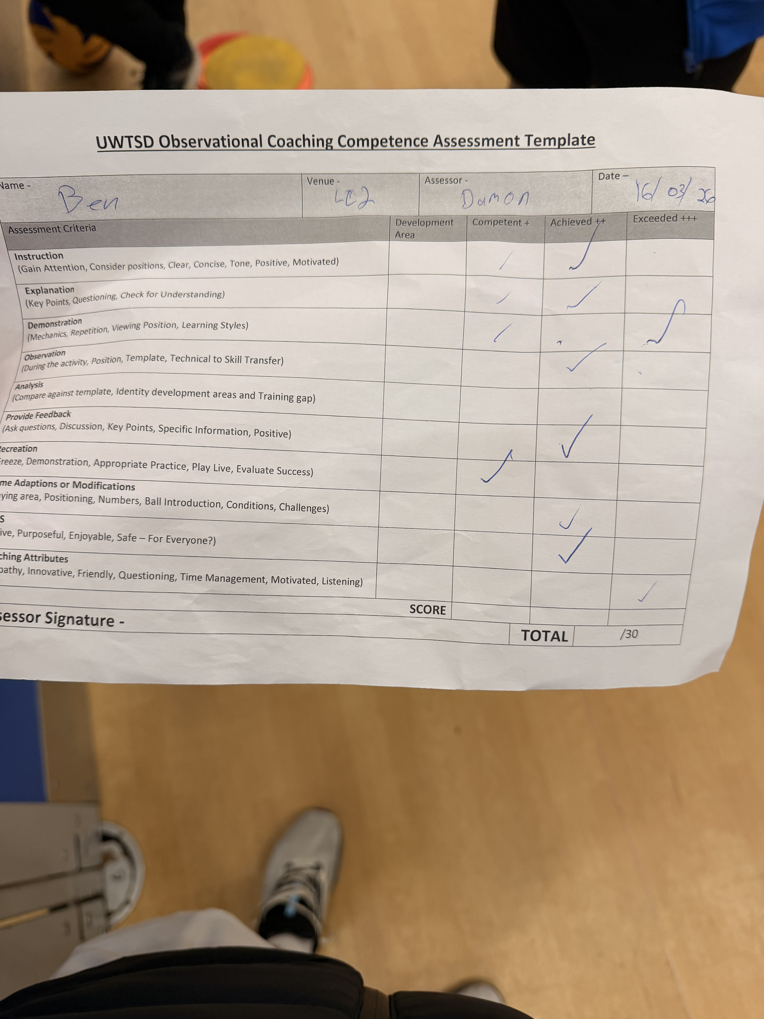
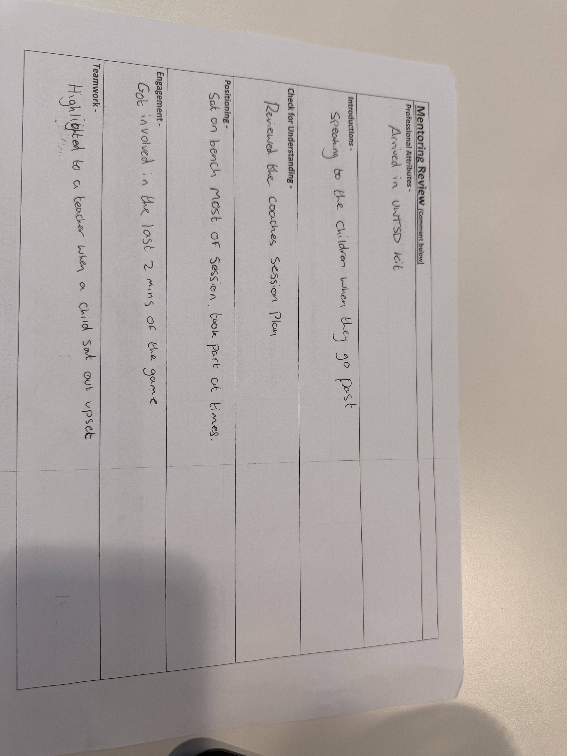
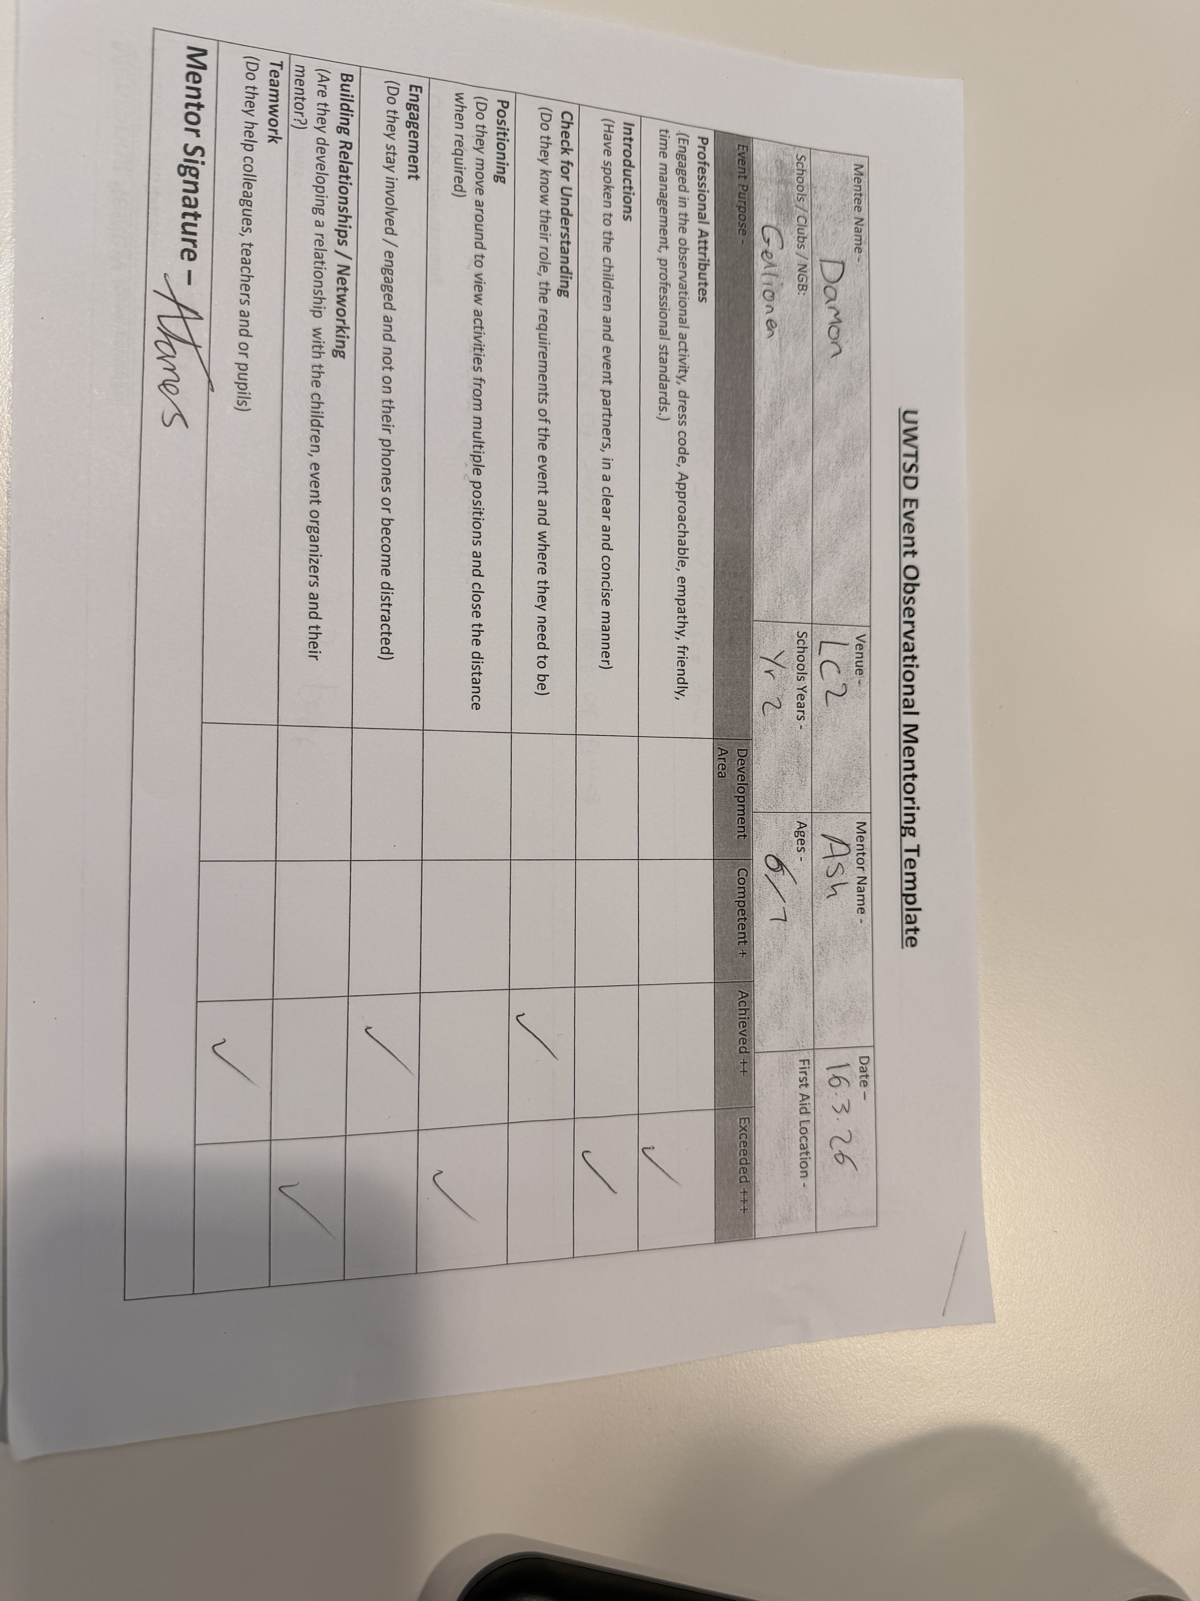
Part E

]

Part F

Part G

Contents page

- Introduction
- First Aid (prices)
- Football Coaching Pathway Overview
- 5-Year Development Plan
Year 1: Foundation Phase
Year 2: Development Phase
Year 3: Advanced Coaching Phase
Year 4: Performance Pathway Phase
Year 5: Elite Coaching Phase
- Key Skills and Competencies in Football Coaching
- Evaluation and Reflection
- Conclusion
- References

- Introduction
The report presents a five-year development plan which aims to help a coach achieve elite football coaching status. To become an elite coach, an individual needs to follow a structured path that includes obtaining certifications and gaining real-world experience and participating in ongoing professional development activities. The Football Association serves as the governing body for football coaching in the United Kingdom with support from UK Coaching and UK Sport organizations.

First aid
Requirement, Cost (£)
Emergency First Aid in Sport, £50 – £100
Safeguarding Children Course, £30 – £50
DBS Check (Enhanced), £25 – £40
FA License Registration (annually), ~£10
Travel (UK-based courses), £100 – £500
Equipment (cones, bibs, balls), £50 – £200

Qualification, Typical UK Cost (£), Year in Plan
FA Introduction to Coaching Football, £80 – £120, Year 1
C License, £600 – £800, Year 2
B License, £900 – £1,200, Year 3
A License, £3,000 – £4,000, Year 4–5
Pro License (Elite Level), £10,000 – £14,000, post-5 years

Total Estimated UK Investment
✅ Up to UEFA A License (within 5 years):
➡️ £4,700 – £6,700
✅ Full Elite Level (UEFA Pro License):
➡️ £15,000 – £20,000+

Activity / year | Year 1 | Year 2 | Year 3 | Year 4 | Year 5
FA into Course | ████
C License |  | ████
B License |  |  | ████
A License |  |  |  | ████ | ████
Coaching Experience | ████ | ████ | ████ | ████ | ████
CPD & Workshops | ░░░░ | ░░░░ | ░░░░ | ░░░░ | ░░░░
Estimated Cost (£) | £150 | £700 | £1,000 | £2,000 | £2,000

████ (solid shaded boxes) = the activity is actively taking place in that year.
░░░░ (lighter shaded boxes) = the activity is ongoing or continuous across multiple years.
Activity / Year | Year 1 | Year 2 | Year 3 | Year 4 | Year 5
 | FA Intro to Coaching Football | C license | B license | A license | A license
Grassroots Coaching Experience
Independent Team Coaching
Academy / Club Coaching
Elite / Professional Coaching
CPD (Courses, Workshops, Learning)
Mentoring & Networking
Performance Analysis Skills
Leadership & Management Skills

Key skills and Competencies in football coaching
To reach elite coaching status, a football coach must develop a wide range of skills:
- Technical knowledge – advanced understanding of football techniques and tactics
- Leadership – ability to manage players and coaching staff
- Communication – delivering clear instructions and constructive feedback
- Game understanding – analysing and adapting to match situations
- Psychological awareness – motivating players and managing pressure
Elite coaching also requires adaptability, decision-making under pressure, and strong interpersonal skills.

Evaluation and Reflection
Progress should be evaluated through:
- Player performance improvements
- Feedback from mentors, peers, and players
- Match outcomes and team development
- Personal reflective logs
The use of reflective models such as Gibbs’ Reflective Cycle supports continuous improvement by encouraging coaches to analyse their experiences and adapt their practice accordingly.

