ECEY6005
Regaining Paradise? Sustainability in the early years.
2006557

JOHN MUIR EXPERIENCE.

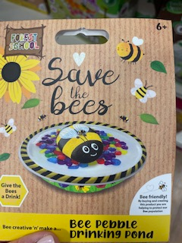
For this assignment and the john muir award, I was inspired to make a bee drinking pond. I took the idea from an item I saw in a shop which was promoting saving bees by providing them with a water source they could easily access in hot weather.

I thought about buying the product from a shop but thought it would be more sustainable to use items I could easily find in my garden. I decided to find natural materials to encourage the bees to use the pond.

According to Slatkin (2017) bees need a source of water to keep them hydrated and to help with production of honey, without water their honey can crystalise and their hive temperature can become overheated leading to health effects for the bees.
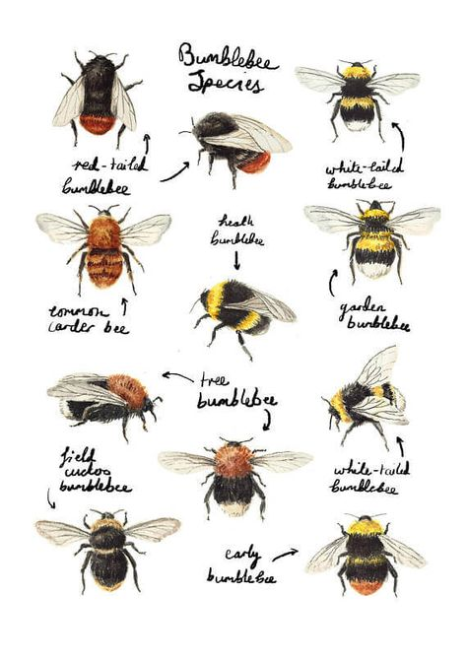
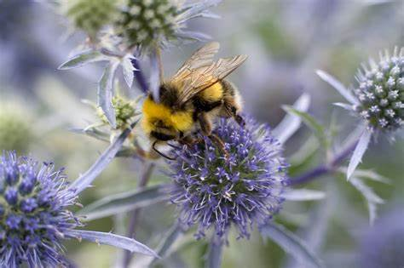
BBC Garden World (no date).

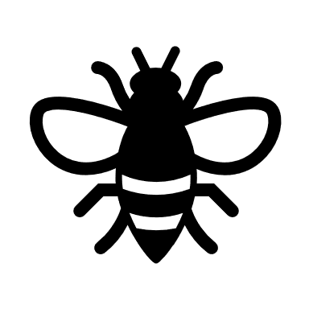
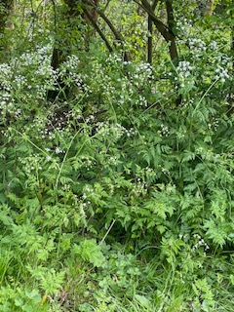
Explore

While exploring in my garden I found there were lots of these white flowers where I see bees on every year.
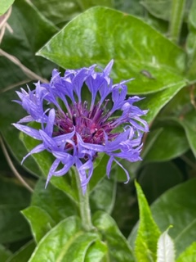
In addition to this, there were some vibrant purple flowers and also some yellow. These flowers tend to grow back every year and always bring wildlife into the garden, from bees to butterflies and birds.

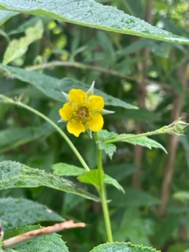

As I live in a built up area, there are limited places that wildlife can thrive. There are lots of houses and shops with regular traffic going through the area which leads to air pollution. The bee conservancy (2023) suggest planting native flowers, not using pesticides and planting trees. Bees get most of their nectar from trees as they provide a high volume of blossom which bees feed on.
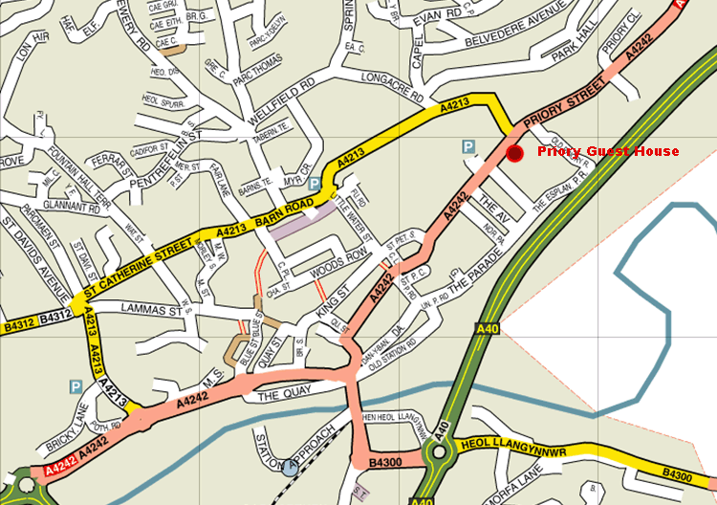
Here is a map of my local town, this shows how many roads are around. According to Rambo (2019) cars produce benzene which can cause cancerous cells for wildlife and make it hard for plants to photosynthesise, therefore making it hard for insects and plants to thrive in these areas.
Despite this, there are places in the surrounding areas where wildlife is flourishing including many beaches and fields with people making more effort recently to grow more plants and swap to electric cars helping with the air pollution.

I went on a walk around a local reservoir.
Here are some pictures which show the greenery and some of the wildlife there.

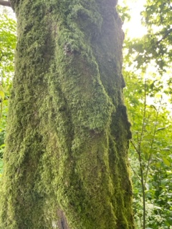
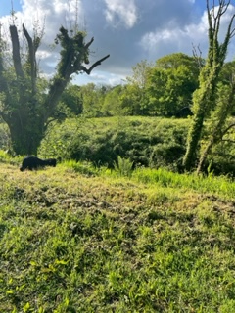
There was moss growing on the trees.
Moss is a way to absorb pollutants and improve air quality.

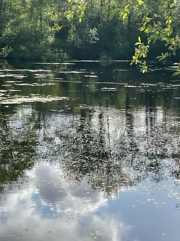

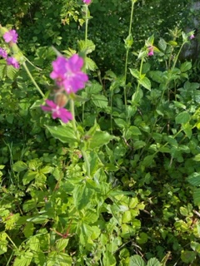
We also came across some ducklings on the water.

And some pink flowers.

We could also hear lots of different birds in the trees, here are some of the birds we saw hiding in the branches….

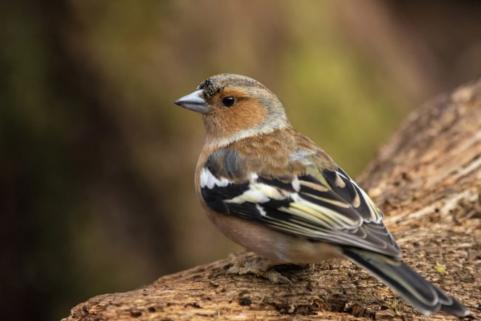
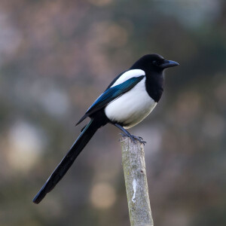

A magpie.

A sparrow

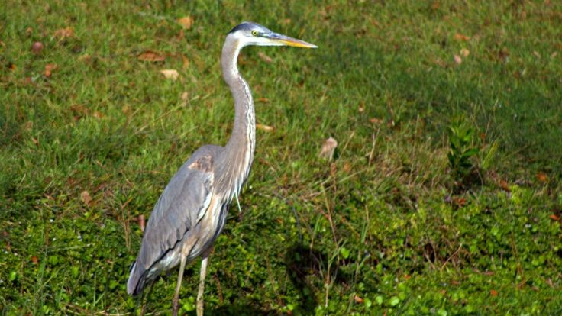

There was even a Herron on the water.

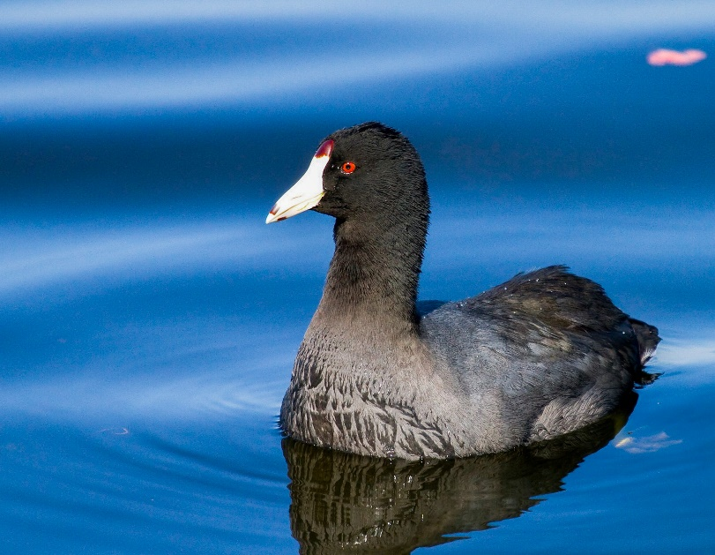

And a coot with some baby ducklings following closely behind.

Discover

While looking and exploring in the garden finding bees and their natural habitats, there was snail enjoying the damp weather. My daughter was worried the snail would get hurt so we decided to put it onto the grass to join the other insects. This brought on conversation about what habitats insects and creatures like to live in. We spoke about how insects like to live in dark and damp places so we looked under some stones and found woodlouse and ants.

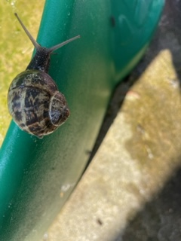
Finding the snail took us onto some further learning about them, we looked at the patterns on their shells and we looked up some other types of snails who had swirly shells and some had different colour shells, then we came across a poem:
I am a snail,
Don’t rush me, please.
I’m heading for
those cherry trees.
I have no place
I have to be,
No pressing thing,
I have to see.

I like this speed;
I like being slow;
It gives me time to get to know;
All the flowers
that I pass,
every blade
of every grass.
I am a snail,
This is my way
Don’t rush me please,
We’ve got all day.
Vance, (n.d).

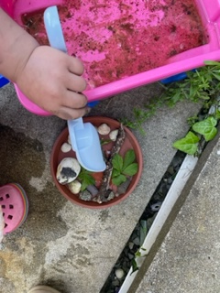
Having discovered that the garden has multiple plants which bees like to visit, I continued with the idea of making a drinking pool for them. After researching what makes a good drinking pond for bees I discovered that bees are attracted to stagnant water, they are drawn to the smell of it more than the appearance. I decided that we would look for some water which may have collected in the garden instead of using water from the tap.
Conserve
We came across a plastic toy which had been out in the rain for some time collecting water so we decided this water would be ideal for the bees to find.
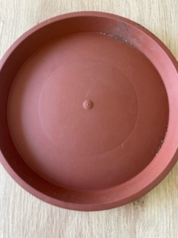
Using a spade, we collected the water and placed it into the saucer, which we also found in the garden.

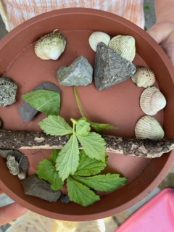

Before we put the water in, we used some stones, sticks and leaves to provide the bees with surfaces to sit on. This can allow them to collect the water without getting their wings and legs wet as this can way them down.

We used all natural materials which we found in the garden in order to reuse items and not fill the bowl with unnatural materials such as plastics.

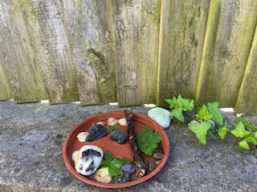
We decided to place the drinking pond up high to avoid getting stepped on and knocked over. We also placed it in a shaded area in close range of the flowers in the garden.

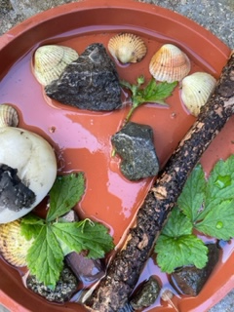

Here is the finished item, which will hopefully provide bees with a safe drinking space when they come to visit out garden.

In the future I am hoping to plant some more flowers which will encourage wildlife in the garden such as wild flowers and herbs.
Reflecting on this, I recognise the importance of taking care of all living things. The insects and plants need water just as much as we do and the plants and creatures need us to help them look after their environment so they can help us in return by providing fresh air to breathe and food to eat.
The small efforts we each make can lead to a big difference in the future.

References:
BBC Garden world, (no date). [image] available at: bees - Bing images (Accessed: 4th May 2023).
Rambo, c., (2019) How Does Car Exhaust Affect Earth's Plants & Animals? Available at: How Does Car Exhaust Affect Earth's Plants & Animals? | It Still Runs (Accessed: 8th May 2023).
Slatkin, B. (2017). How to help bees when its hot outside. Available at: How to Help Bees When It's Hot Out - (baynature.org) (Accessed: 5th May 2023).
The bee conservancy (2023). 10 ways to save the bees. Available at: 10 Ways to Save the Bees - The Bee Conservancy (Accessed: 10th May 2023).
Vance, B., (n.d) Suzie Bitner Was Afraid of the Drain. Available at: Pin on Children's Poetry (pinterest.co.uk) (Accessed: 8th May 2923).

