

A study into the effects of the COVID-19 pandemic restrictions on victims of domestic violence in England & Wales.

Alexander Pelling
1815873
BSc (Hons) Professional Policing Practice
Word Count: 8,389

Acknowledgements

I would like to thank my supervisor Steven Hill for all the help and guidance he has given me throughout this project with his knowledge and insight into professional policing. I would also like to thank my friends, family and colleagues for their support and understanding, and particularly my partner whose patience has been paramount in completing this project, especially with the new addition to our family.
Finally, I would like to thank all those who have participated in my research, it is thanks to them that this project could be completed at all. It is unfortunate that research such as this needs to be undertaken however a special thanks must be given to those victims who have found courage and understanding in assisting with project such as this one.

Declaration
This work has not previously been accepted in substance for any degree and is not being concurrently submitted in candidature for any degree.
Signed: A. Pelling
Date: 16th November 2021

STATEMENT 1
This dissertation is being submitted in partial fulfilment of the requirements for the degree of BA.
Signed: A. Pelling
Date: 16th November 2021

STATEMENT 2
This dissertation is the result of my own independent work/investigation, except where otherwise stated.
Other sources are acknowledged by footnotes giving explicit references. A bibliography is appended.
Signed: A. Pelling
Date: 16th November 2021

STATEMENT 3
I hereby give consent for my dissertation, if accepted, to be available for photocopying and for interlibrary loan, and for the title and summary to be made available to outside organisations.
Signed: A. Pelling
Date: 16th November 2021

STATEMENT 4
I hereby give consent for my dissertation, if accepted, to be available on the university’s IT system to those who have consent to use the system.
Signed: A. Pelling
Date: 16th November 2021

Abstract
This dissertation aims to examine the effects of the COVID-19 pandemic lockdown restrictions on both the victims of domestic violence, and front-line police. The researcher carried out critical analysis into the UK government’s response to domestic violence during the restrictions and finds failings in the ability to safeguard victims when faced with a pandemic. The government piloted semi-successful schemes, however, falls short in maintaining and funding existing support services which suffered immense pressure due to increased demand.

The study utilises a mixed method approach focusing on quantitative questionnaires but incorporating open qualitative questions. This paper uses grounded theory (Glaser & Strauss 1967) to analysis the data to support existing theory.
The findings in this study support the existing literature, demonstrating a gender-inequality in domestic violence and reinforces the need to tackle the social stigmas that come with it. Furthermore, the key findings show a theme in the requirement to increase victim support services across the UK. It was concluded that domestic violence during lockdown was made worse by factors which caused more exposure opportunities due to isolation with the abuser. Their ability and willingness to access support was diminished and the level of abuse remained constant or got worse. Findings also suggested police could improve upon their willingness and ability to offer different levels of support to victims including through the criminal justice system and referrals to support services.

Table of Contents
1.1 Introduction 7
1.2 Background 7
1.3 Aims and Objectives 8
1.4 Methodology 8
Chapter 2: Literature Review 10
2.1 Introduction 10
2.2 The Cycle of Abuse 12
2.3 Domestic Abuse during the COVID-19 Pandemic 13
2.4 The Government Response to Domestic Violence 17
2.5 Conclusion 18
Chapter 3: Research Methodology 20
3.1 Aims & Objectives 20
3.2 Ethics and Limitations 21
3.3 Method & Design 22
3.4 Quantitative Research 22
3.5 Qualitative Research 24
3.6 Analysis of Results 25
Chapter 4: Analysis of Results 26
4.1 Introduction 26
4.2 Demographic statistics 26
4.2.1 Victim Survey 26
4.2.2 Police Survey 28
4.3 Victim Analysis 28
4.4 Domestic Violence during the pandemic 29
4.5 Accessing support 30
4.6 A police perspective 32
4.7 Policing pandemic domestics 34
Chapter 5: Findings and Conclusion 35
5.1 Introduction 35
5.2 Interpretation of findings 35
5.3 Limitations 38
5.4 Further Research 38
5.5 Conclusion and Evaluation 39
5.6 Recommendations 40
Bibliography 42
Appendix 51
Appendix A – Copy of Victim Questionnaire 51
Appendix B – Copy of police questionnaire 56
Appendix C – Why has a victim not supported police action? (Answers) 61
Appendix D – Open question answers: Trends in policing domestic violence. 62
Appendix E – Signed declaration page of ethical approval form. 64

Chapter 1: Introduction

1.1 Introduction
This chapter will provide a background into the study and explain why it is necessary. It will outline the aims and objectives the researcher intends to address. Research of this nature is sensitive and often thought provoking for those who have experienced domestic violence. Nevertheless, this further stresses the importance of this type of research so issues can be identified, addressed, and victims safeguarded.

1.2 Background
There is a wealth of pre-existing theories into the causes and effects of domestic violence. It is widely covered throughout academic due to its complex nature and the vulnerability of the victims. Anyone can experience domestic violence regardless of their gender, age, sexuality, ethnicity, or socio-economic status and the abuse is not limited to their intimate partners. In the Home Office (2012) definition of domestic violence it describes it as being “a pattern of incidents of controlling, coercive or threatening behaviour, violence or abuse between those aged 16 and over.” This included family members and intimate partners.
A global study on homicide concluded that 80% of victims were male, and 90% of homicides were committed by males. However, when it came to intimate partner homicide, 82% of victims were female (United Nations Office on Drugs and Crime 2019). This further demonstrates the need for further research, and in this study, the researcher will aim to address the gender disparity.

In March 2020, the UK Government announced a national lockdown to ease the infection rate of the COVID-119 virus. This resulted in restrictions being imposed upon the population which lasted for an extended period. Domestic violence is a ‘hidden crime’ (Office of National Statistics, 2019) and it is easy to understand that lockdown measures would be detrimental to the lives of domestic abuse victims, who would now find it more difficult to escape the abuse and access support.

1.3 Aims and Objectives
- Analyse the links between the COVID-19 pandemic and the reported domestic violence incidents.
The researcher will aim to understand the correlations between the two, in order to understand which areas have seen increased demand, and which have decreased. The study will examine the public perception and the statistical information in order to determine the impact.
- Critically Evaluate the government’s response to domestic violence during the COVID-19 pandemic.
The researcher will examine and critique the response from the government in the early stages of the lockdown and the legislative impacts on domestic violence.
- Synthesis the effects on victims and front-line police in relation to domestic violence during the COVID-19 pandemic.
The researcher will seek the views of both victims of domestic violence, and the police that respond to it, correlating the information to identify key themes.

1.4 Methodology
The researcher will utilise a mixed methods approach, focusing on quantitative information gathering through the use of questionnaires, but these will contain some qualitative techniques in the form of open questions. The questionnaire will be designed using Gendall’s (1998) framework, starting with open questions and filtering into specific ones.
The data will be examined to identify trends through comparative analysis (Pattyn, et al. 2017) and utilised the grounded theory to allow the formation of new theory (Glaser and Strauss, 1967).

Chapter 2: Literature Review

2.1 Introduction
It is important to establish and understand the basic facts into domestic violence and the gender disparity. According to the Office for National Statistics (ONS), in the year ending March 2016 36% of victims were male while 64% were female (ONS, 2019). However, this research will seek to better understand the links between the COVID-19 Pandemic and reported domestic violence incidents. To evaluate the government’s response, and to understand the effects it has had on the victims and on front-line policing.
The causes and effects of domestic violence have been widely studied throughout academia to better understand the ‘who, how and why’. Modern research into domestic violence began in the 1970’s and 1980’s, generated by feminists on behalf of women who had been severely beaten by their partners (Woods, 2007). The general basis of the research determined that most domestic violence was at the hands of a male abuser for the purpose of gaining control over the victim. This was first described in Walker’s 1979 book ‘The Battered Woman’ and thereafter this view dominated most of the research into domestic abuse.
Domestic violence is not a gender-neutral issue (Pence and Paymar, 1993). Consequently, the focus of this review is not about the gender disparity, nor the potential cultural factors, but to better understand the overall effects on all victims when they are subject to isolation during a public health crisis. The researcher will examine the wider scope of domestic violence models and theories and the specific concerns in relation to social isolation, while reviewing available statistics and government policy relating to the handling of domestic violence during the COVID-19 pandemic.

In March 2020 the UK government announced a national lockdown to ease the effects of the ‘coronavirus’ and to slow the rate of infection amongst the population (Diver, 2020). As part of this strategy social distancing measures were implemented for long periods requiring families to remain in their homes in isolation and only being allowed to leave for essential purposes. This resulted in the depletion of social and community support networks for people at risk (Usher et al. 2020). Usher et al go on to state that social isolation is an effective way to manage infection but leads to significant social, economic, and psychological factors which are often catalysts for stress which in turn leads to violence. Isolation is not a new concept to victims of domestic abuse, and it is one tool the abuser will use to maintain control and prevent the victim getting support. The UK Government’s definition of domestic abuse detailed behavioural abuse such as psychological, sexual, financial, and emotional (Home Office 2012). Astonishingly, there was no offence for this type of abuse until 3 years later, in the Serious Crime Act 2015. Section 76 of this act created the offence of ‘Controlling or Coercive Behaviour in an Intimate or Family Relationship’, which details the offence of continually or repeatedly engaging in coercive or controlling behaviour which has a serious effect on that person (Serious Crime Act 2015). In the prosecution guidelines for this offence, it describes the relevant behaviours, which includes isolating a person from their friends and family, depriving them access to support services, and depriving them of their basic needs (Crown Prosecution Service, 2017).

It would be logical to assume that controlling and coercive behaviour would become more problematic during a national lockdown where the victims are trapped with their abusers. However, it could also be argued that this isolation is not as a direct result of the abuse they are receiving but rather the social requirements, and therefore it would not build upon this offence.

2.2 The Cycle of Abuse
Lenore Walker’s book ‘The Battered Woman’ (1979) developed a social cycle theory which depicts the cycle of abuse within an abusive relationship. This consists of four phases which will repeat itself until it is stopped, either by the victim leaving the relationship or by a third-party intervention. The stages are tension building, incident, reconciliation, and calm. Walker further describes the ‘battered woman syndrome’ whereby the women are trapped in abusive relationships due to a ‘learned helplessness’ in which they become passive and submissive, which made it impossible for them to escape (1979).

Walker’s findings were well received as an early theory into patterns of domestic violence. She proposed the cycle of abuse as being “a patriarchal behaviour of men who felt entitled to abuse their wives to maintain control”. In her research, Walker interviewed 1,500 ‘battered women’ and found they each described a similar pattern of abuse (Fisher and Lab, 2010). Fisher and Lab describe arguments among researchers as to whether victims are genuinely helpless in these scenarios as they do reach out for support. They argue that the helplessness is more of a reflection on their situation than as a response which is learnt (2010).

As an early theory, ‘The Battered Woman’ underlines key development in domestic violence research, however Walker focuses entirely on heterosexual relationships and machismo partners being the ones responsible with a typical desire to dominate women. It could be argued that research conducted in 1979 would not have the foresight to account for same-sex relationships as they may not be as prominent at the time. Walker also theorises the ‘incident’ phase in which the tension has built to such a stage that the outlet is some form of physical aggression. However, we now have the benefit of realising that domestic abuse comes in a variety of behaviours which can include emotional and financial abuse. In 2018 one quarter of domestic abuse victims sustained a physical injury, and most abuse was described as “mental or emotional”. Furthermore, male victims reported higher levels of force used against them than female victims (Office for National Statistics, 2020).
Dutton argues that the concept of ‘battered women syndrome’ fails to account for the strengths of a battered woman in their resilience and merely creates a stereotyped pathology focusing primarily on the negative effects on the victims. This syndrome is being used as a defence in court, however, is not accounting for the individual and their response to the battering as some victims can become reclusive and experience symptoms of post-traumatic stress disorder, while others gain strength from the experience and should be referred to as ‘survivors’ (Dutton, 2020).

The researcher believes that when factors relating to gender, sexuality, culture, race, and economics are removed from the equation, the cyclically based theory still holds up as a generic framework to help us understand why victims stay in these abusive relationships, provided we account for the whole spectrum of abusive behaviours. It is however crucial that we maintain the understanding that domestic violence is not gender neutral and most of the research is directed towards female victims which fairly addresses this unbalance. In a report by the United Nations Office on Drugs and Crime, they explain that the home is the most dangerous place for women who are subject to continued victimisation due to inequality and gender stereotypes (UNODC, 2019).

2.3 Domestic Abuse during the COVID-19 Pandemic
The March 2020 lockdown announcement likely came as a shock for victims of domestic violence as they would now be trapped at home with the perpetrator with minimal support as critical agencies considered ‘non-essential’ were forced to cease operations or begin the challenge of working from home. Victims would potentially fear they would now be prosecuted for leaving their homes without reasonable excuse, or they could themselves use this as an excuse to stay due to their ‘learned helplessness’ and thus continuing the cycle of abuse (Walker 1979). Prior to the lockdown, domestic abuse services in the UK had been substantially cut and defunded due to years of austerity measures (Women’s Aid, 2020; Davidge, 2019) this also led to increased demand on these services who were now unable to provide the same level of care and support. Naturally, this would cause adverse reaction to the victims who would now be either less likely to report the incident, or more likely to seek support from police.
There has been an increased demand on domestic abuse services during the pandemic (Office for National Statistics, 2020) however, they state it does not indicate an increase in victims, but likely an increase in the severity of the abuse with a lack of available coping mechanisms. However, the ONS is self-aware that the statistics relating to domestic violence can only provide a partial insight, as the data provided by police only accounts for matters which have been reported. They state that as a result, there are many cases that will not end up within the criminal justice system. Research prior to the pandemic states that official assessments of global domestic abuse rates have been grossly underestimated as victims are not reporting the abuse (Buzawa & Buzawa, 2017). It is imperative to understand these effects on victims that prevent them from reporting incidents and how it has been exacerbated by the COVID-19 pandemic.

In the US it was expected by law enforcement groups that there would be a rise in domestic violence due to stay at home rules, but they became concerned when they noticed they had received fewer reports in largely populated cities compared to previous years (Stone et al, 2020). These concerns can also be reflected in England and Wales through statistics provided by ONS. The figures show that in previous years, there has been a general increase in the reporting of domestic violence which has been aided by police campaigns such as the promotion of the domestic abuse bill (Home Office 2019), and new legislation implemented by the government (Domestic Abuse Act 2021). However, it is concerning that between the months of April and November 2020 there was no obvious trend or increase in reports (ONS, 2020). Alternatively, UK media has been reporting sharp increases in the use of domestic violence helplines, one charity called ‘Refuge’ state their calls rose by nearly 80% and they saw an increase of 54% in women seeking refuge to escape the abuse. (BBC, 2020).

In August 2020, the ‘Women’s Aid’ charity conducted research into the effects of lockdown on victims of domestic abuse and the services that support them (Davidge, 2020). They found that 90% of respondents who experienced domestic abuse were negatively impacted by COVID-19 and 61% said the abuse had worsened. Furthermore, 10% of victims stated the abuser had used lockdown restrictions as a method to prevent them leaving whilst 20.3% claim they had tried to leave but were unable to access housing or refuge (Davidge, 2020). Davidge found that the abusers had been using anxiety about the virus as a method to control their victims and that coercive and controlling behaviour was the central issue throughout lockdown as they’ve been provided easy methods of manipulation likely causing a feeling of hopelessness within the victims.

Gregory and Williamson (2021) conducting qualitative research found the pandemic had changed people’s ability to read into situations and assess risk. Furthermore, providing support proved challenging except for the victim’s informal supporters such as neighbours and friends who found ways to stay in touch and offer that support. Their research focused around interviewing these support networks to learn how to better support the victims. 18 cases were studies and of these, 17 were female victims further supporting the gender-inequality of domestic abuse. Interestingly one interviewee comments upon having to be careful when offering support as the abuser was prone to monitoring the victim’s phone (Gregory & Williamson, 2021).

This could suggest a reason into why victims are less likely to report incidents, out of fear of reprisals, however Gregory and Williamson do not go into detail so further research may be required to explore this as it could provide evidence into coercive and controlling behaviour (Serious Crime Act 2015). They suggest equipping these informal supporters with more skills and knowledge to offer help; however, it could be argued that imposing this formality upon them would create an unnecessary burden on their own lives which could affect the support they are willing to provide. It is important to maintain this link to the victim, in 2015 71% of victims had told someone personally close to them, whereas only 33% had informed a public official such as the police (Parker, 2015).

This research does produce further questions in relation to third-party reporting of domestic violence, how it is managed and recorded by police and how victims react to it being reported. Home Office guidance suggests third-party reporting does not get counted as a crime unless further verifiable information is provided, or the crime confirmed by the victim (Home Office 2021). This is likely to have some impact on the statistics by ONS and could suggest that even when the incident is reported and police make contact, the victim is still unwilling to disclose information out of fear, especially when locked in with their abuser.

2.4 The Government Response to Domestic Violence
Due to restrictions imposed to control the infection rate, many people who were not considered ‘key workers’ were required to work from home, if this was not possible the government had implemented a furlough scheme to supplement people’s income and prevent job loss (Bruce & Fisher, 2020). This would result in victims and abusers spending more time together which can increase ‘exposure opportunities’ for violence (Dugan et al 2003). Similarly, job loss could upset the ‘power balance’ within a relationship in which the patriarchal desire of the male abuser could result in manifestations of tension ultimately resulting in an incident as described in the cycle of abuse (Walker 1979).

Despite the obvious nature of domestic violence, the government’s implementation of lockdown measures in March 2020 failed to address domestic violence during the planning and the importance had to be highlighted by charities such as Woman’s Aid (UK Parliament, 2021). It wasn’t until April 2020 the Home Secretary announced a £2m investment to bolster domestic abuse helplines, and by July 2020 only £1.2m of the funding had been allocated to successful applicants. Furthermore, in May 2020 £76m of a £750m fund for charities was provided to government departments specialising in supporting victims including domestic violence (UK Parliament, 2020). It could be argued that the government’s response is more reactive than proactive and due to hurdles with bureaucracy in allocating these funds, the victims are not receiving the immediate support they require.

The government launched domestic violence schemes such as partnering with UK pharmacies in the ‘Ask for ANI’ initiative which aims to provide victims with a safe place to disclose information to staff who are trained in safeguarding (Home Office 2020). This scheme was well received by some survivors and victims of domestic violence (SafeLives 2021) however, has been criticised by Woman’s Aid as being unfair and unsafe to expect staff members to know how to effectively deal with this disclosure once reported to them and presents an unnecessary burden (Woman’s Aid 2021). Furthermore, they state the first response a victim receives is crucial in their next step and maintaining their confidence.

2.5 Conclusion
There is a wealth of statistical information available in relation to domestic violence during the pandemic provided by the Office for National Statistics and further enhanced by Davidge (2020). This information further supports the research’s initial questioning of official recorded data showing little to no trends because of lockdown restrictions (ONS 2020) but evidences a clear increase on demand from charities and how victims are experiencing worse levels of abuse since before the pandemic. It is clear that victims are less inclined to officially report abuse to police, perhaps out of fear of reprisal or not wanting their abuser to be prosecuted. Lenore Walker’s (1979) cycle of abuse provides us with a simple framework to understand the stages in a relationship which may prevent a victim from leaving their abuser prior to intervention. However, further research is needed to provide recommendations into why victims aren’t seeking formal action over their abusers and what services can do to enhance support to the victim allowing them to gain the trust of public services including police.

The government response has primarily come in the form of further funding for the services however the researcher believes more schemes such as the ‘Ask for ANI’ codeword would be crucial in getting these victim’s support. As suggested by Woman’s Aid, this support needs to come from a professional source who have received the training needed to adequately support a victim or risk failing them and losing them into the cycle of abuse.

Chapter 3: Research Methodology

3.1 Aims & Objectives
This section explores how the researcher intends to address the initial aims & objectives set out in the research proposal and addresses the limitations in obtaining credible research data. As explored in the literature review chapter, the researcher concluded there were no notable trends in official recorded data for domestic violence, however, there was a notable increase in demand on domestic violence charities. In this research it is intended to address the original objectives which have been further highlighted by the existing literature and attempt to fill in those knowledge gaps. The goal is to provide an insight into why victims aren’t reporting domestic violence to police, the effects it has on them, and the effects it has on frontline policing.

This chapter will justify the steps taken throughout the research and why the chosen methods were the most suitable to meet each objective. One of the three objectives have been addressed in the literature review chapter in which the government’s response was critically analysed by the researcher. However, it would also be suitable to allow the research subjects to provide their viewpoint on this topic to allow further insight from their own perspective, without intruding on the main aims. The researcher has identified the pragmatic paradigm for an ontological approach, and the interpretivism ideology for an epistemological approach. This will provide results based both on realistic explanations, which are also based upon examples of truth. (Creswell 2013).
Aims
Analyse the links between the COVID-19 pandemic and the reported domestic violence incidents.
The researcher identified a gap in the current research, there was a perceived increase in incidents however statistical information suggested there had been no correlation.
Synthesis the effects on victims and front-line police in relation to domestic violence during the COVID-19 pandemic.
The researcher will obtain the views of the public and the frontline police and then correlate the information into useable data in order to suggest improvements on victim support.
To aid with the research, the researcher will utilise Saunders, et al’s research onion model (2007) as a guide by working through the layers. This will allow the research to be conducted holistically and remain specific to the topic.

3.2 Ethics and Limitations
Due to the sensitive nature of this research topic, there are several ethical concerns and limitations in obtaining information. The primary limitation is access to victims of domestic violence. Access to victims through police systems would be unethical due to a lack of prior consent on the victim’s part. It could also mean that should any disclosure of offences be made; the researcher is liable to report these to the relevant authorities which would contradict any anonymity of the participant. Due to this limitation, it would be more suitable to obtain a larger sample from the public to gauge their experiences with domestic violence during the pandemic.
Additionally, this research relates to the health of the participants due to the pandemic. Restrictions implemented to combat the virus restrict the face-to-face contact the researcher can have with participants. This can affect the interview process as it would be more impersonal and responses harder to read as they would likely take place through digital means.

3.3 Method & Design
A pragmatic philosophy has been adopted for this research as the researcher intends to use mix methods to obtain results. Mix method research is a synthesis that includes ideas from qualitative and quantitative research, it considers multiple viewpoints and perspectives (Burke Johnson et al 2007). Pragmatism offers an approach which is not limited by other specific philosophy such as ‘positivism’ in which personal viewpoints cannot be considered. Pragmatism utilises the best tools available to investigate a phenomenon and approaching it from a practical point of view (Crossley & Jansen, 2021).
This research intends to obtain the viewpoint from police and their experiences with domestic violence during the pandemic, and similarly the viewpoint of the public and potential victims of domestic violence. Realistically these will be two drastically varied perspectives, therefore, questions will be tailored to these groups accordingly. Due to the ethical concerns, the researcher will not directly target victims of domestic violence for research but rather seek support from domestic violence charities. However, it is possible to receive relevant answers through probability sampling. According to the Office for National Statistics, in the year ending March 2020 4% of men and 8.1% of women had experienced domestic violence (2020). Therefore, it is likely the participants will either have some experience themselves or know someone who has.

3.4 Quantitative Research
The primary research method will be through online surveying; two alternative questionnaires will be designed for the public/victims and for police and the researcher will draw upon the statistical trends in answers. Robson (2007) states this approach is advantageous as it is inexpensive and utilises a fixed design which can be easily replicated. Participants will be informed of the purpose of the research and will provide their consent for the information to be collected and disseminated whilst ensuring their anonymity. The researcher believes anonymity is crucial in this research as it will ensure truthful, accurate information is obtained.
Questionnaire
The survey will be designed following guidance from Gendall’s Framework of Questionnaire Design (1998). Gendall builds upon Labaw’s (1980) original framework and focuses more on the question writing itself. As suggested by Gendall, these questions will be layered, beginning with open questions and filter down to specific questions. It is imperative that the questions do not influence their mindset in anyway and the researcher’s values or perceptions cannot be identified within the questions. In order to retain the participants attention, the questions will be limited between 15-20. This will allow for this framework to be followed while retaining participant interest. The questionnaires will combine several multiple-choice questions with statement questions in which the participant indicates the level they agree with it. This will allow the researcher to gain an idea on specific circumstances and the participant’s overall perspective.
Sampling
This research must consider its limitations regarding the ethics of obtaining specific participants, therefore the researcher will use probability sampling (QuestionPro, 2021) for public surveying. This will consist of random sampling by promoting the survey online through networking strategies. This will ensure the data is collected ethically and cannot be used to identify any victims of abuse. The researcher will aim to obtain opinions from at least 30 victims to provide an insight into their lives during the pandemic.
Alternatively, the questionnaire for Police will utilise non-probability sampling as the researcher will have an ease of access to this profession and will be directed specifically at them. It is likely there will be a form of unintended probability sampling due to the variety of departments within police organisation, some of which may have very little experience with domestic violence. As this questionnaire is non-probability based at least fifteen participants will be obtained to ensure a response which is representative of varied opinion.

3.5 Qualitative Research
Following the mixed method pragmatic design of this research, the researcher aims to incorporate open ended questions within the structure of the questionnaire. Due to the limitations this will likely occur through digital means through use of modern questionnaire design websites and be shared internally within a policing organisation. Thody (2007) states the purpose of this type of research is to describe to the reader, the direct experiences of the participants and provide an atmospheric context to the findings. It would be desirable for all participants to answer these questions, however they will be optional to ensure the quantitative data is not impeded, this should allow the researcher to establish opinions within this section. This will consist of limited open-ended questions where participants can use their own words to respond.
Sampling
These questions will be directed specifically to police officers and staff within the specialist domestic violence units, with a view of gaining a further understanding based on opinion. The design of the open questions will ensure anonymity for the participants and ensure questions are not so specific that victims of domestic violence can be identified. The researcher will look to seek an understanding of the trends of domestic violence cases during the pandemic which include the severity of the violence, the support being offered to victims, and the referrals being submitted to them.
Objective
The purpose of this section of the questionnaire is to provide the research with that insight from the police perspective but will also act as a foundation to assist with the analysing of the questionnaire data. The researcher will be able to identify trends and similarities in the data and compare it with the existing literature to allow for a better understanding of the situation.

3.6 Analysis of Results
The mix methods of this research will likely show similar trends through comparative analysis. The researcher will compile the results using the grounded theory (Glaser & Strauss 1967) to ensure the data has been systematically collected and assist in identifying any conflicting information to form a basis of knowledge on this subject matter. This approach is beneficial as it will allow the collected data to speak for itself and allow the researcher to form a conclusion that is not pre-determined.

Chapter 4: Analysis of Results

4.1 Introduction
This chapter will present the statistical data that has been collected through the main research methods using quantitative research techniques. The researcher will also present themes which were identified in the qualitative questions asked within the questionnaires. The goal of this chapter is to address two of the research objectives:
- Analyse the links between the COVID-19 pandemic and the reported domestic violence incidents.
- Synthesis the effects on victims and front-line police in relation to domestic violence during the COVID-19 pandemic.
The researcher designed two independent questionnaires, one targeting victims of domestic abuse and one obtaining the views of front-line police. Thirty-five participants completed the victim questionnaire whilst forty-three participants completed the police questionnaire. Gendall’s (1998) questionnaire framework was used in the design, starting at generic open questions, and closing into more specific detail. Due to the lower volume of participants the researcher has not used systematic analysis tools such as Chi-Square as suggested by McHugh (2013), this would not be effective.

4.2 Demographic statistics

4.2.1 Victim Survey
As discussed in the literature review, domestic violence is not a gender-neutral issue (Pence and Paymar 1993). Therefore, there is a focus on gender in this questionnaire, both for the victim and the abuser. The researcher will address the differences in responses from each gender to identify patterns in the statistics which could aid in providing recommendations. This question was included to gain an insight into the gender disparity in the researcher’s own study.
Of the thirty-five victim respondents, a staggering 87.5% were female and 14.3% were male. Whereas the gender of the abuser shows a slight variation with 77.1% being male and 22.9% female. While the sample size may not be fully representative of the populace, it will allow some insight into the opinions of victims and the effect upon them.

Figure 1. Gender comparison of victims and abusers.
 | Male n (%) | Female n (%) |  | Total
Victim | 5 (14.3) | 30 (87.5) |  | 35
Abuser | 27 (77.1) | 8 (22.9) |  | 35

Further to this, the research obtained the age of the victims. The results demonstrated more experience of domestic abuse within the age range of 25 - 44, whereas no participants were recorded being over 65. These results show an interesting curve as shown below.

4.2.2 Police Survey
Demographics within the police survey focus on profession and experience as there are a wide variety of departmental roles. Furthermore, the length of service was obtained to analyse links in officer experience. 79.1% of participants were police officers, police staff accounted for 18.6% while only 2.3% were police community support officers. The below figure visualises their length of service, showing 51.2% of participants have just two to five years of service within the police.

4.3 Victim Analysis
Victim participants were asked a series of questions designed to gauge their engagement with police and domestic abuse support services. The abuse was reported to police by 65.6% of participants, however, 37.1% state they did not wish to pursue it further and 11.4% state nothing was done for them.
Participants were then asked about the types of abuse they experienced to provide an overview for the research. The most common abuse experienced was emotional, physical, and coercive/controlling behaviour. Following this, participants were asked about the drivers of the abuse, these heavily favoured alcohol consumption (44.2%) and mental health conditions (34.6%). Furthermore, 68.6% of participants state the abuser was their current partner, whilst 14.3% were ex-partners and 14.3% were family members.
Figure 4: Types of abuse being experienced by victims
 | Emotional Abuse  n (%) | Physical Abuse  n (%) | Sexual Abuse  n (%) |  | Financial Abuse  n (%) | Coercive/ Controlling Behaviour  n (%)
Victims | 25 (31.3) | 24 (30) |  | 4 (5) | 7 (8.8) | 20 (25)
Note: No definitions were provided, and answers were subjective to participant opinion
Figure 5: Drivers of abuse according to victims
 | Alcohol n (%) | Drugs  n (%) | Mental Health n (%) | Gambling  n (%) | None  n (%)
Victims | 23 (44.2) | 8 (15.4) | 18 (34.6) | 1 (2.85) | 1 (2.85)

4.4 Domestic Violence during the pandemic
The focus of this research was to correlate the effects of the pandemic upon victims, 94.3% state they experienced domestic abuse during the pandemic, only 5.7% did not. Of the participants, 77.1% state they were isolating with the abuser due to lockdown restrictions while 22.9% were not.
Result totals also show that the abuser would have been home more often, with a combined number of 68.6%. This included unemployment, job loss, furlough and working from home (see Figure 6 below for breakdown).

Participants were then asked how the restrictions impacted upon the abuse itself. While predictably this would be worse for victims, the result significantly reflected the same story. 41.8% state the abuse was more frequent, 32.7% state the level of abuse was worse and 21.8% state it remained the same. One participant stated the abuse stopped and another that it was less frequent which only accounted for 3.7% of participants. Neither of these respondents were isolating with the abuser.

4.5 Accessing support
A series of questions were asked about the victim’s use of support services. Figure 7 demonstrates the lack of victim’s accessing support in general, 42.9% of which have never used support services and 37.1% hardly ever use them. Figure 8 demonstrates their use of services during the pandemic, interestingly 54.3% now state they’ve never used them and 31.4% stopped using them as a result. This anomaly could be because of participants giving answers deemed ‘socially desirable’ (Patten, 1998)

Figure 7: How often do victims use support services or charities?
 | Daily  n (%) | Weekly  n (%) | Monthly  n (%) | Yearly  n (%) | Hardly ever n (%) | Never  n (%)
Victims | 0 (0) | 3 (8.6) | 3 (8.6) | 1 (2.85) | 13 (37.1) | 15 (42.9)

Figure 8: How often did victims access support during the pandemic?
 | Daily  n (%) | Weekly  n (%) | Monthly  n (%) | Stopped using them  n (%) | Never used them before  n (%)
Victims | 0 (0) | 3 (8.6) | 2 (5.7) | 11 (31.4) | 19 (54.3)

Already, there is a clear trend in victim’s willingness to access support during the pandemic. 62.9% state restrictions prevented them from gaining support. Of the participants 57.1% found it difficult to access support services, 42.9% have never used them previously, and nobody believed they were easy to access. Of the five male participants, none have used support services previously.
Participants on average preferred to receive support via the telephone (28.2%), online (25.6%), and in person or via text message (17.9%).

Figures 9 & 10 demonstrate similarities in a victim’s ability to leave the relationship and access support. 23.1% state they were too afraid to access support and 20.5% couldn’t access it due to the abuser (figure 9). Similarly, 19.4% state they couldn’t leave the abuser as they were too scared and had nowhere else to go (figure 10).
Overall, 28.5% would not involve the police or leave the partner as they had children together, 67.7% were afraid of further abuse and 59.8% did not want anybody finding out about the abuse.

4.6 A police perspective
Using non-probability sampling forty-three police officers and staff took part in the police survey which provides an insight that online crime statistics may not fully represent. Of those surveyed, 93% regularly deal in domestic violence matters, 86% of these have regular contact with victims or perpetrators of the abuse.
These results show a higher proportion of victims not engaging with police and supporting action against the abuser. 55.8% state victims ‘sometimes’ engage, while 30.2% state ‘rarely’, and only 14% believe victims ‘mostly’ engage with police.

Figure 11 demonstrates police experiences on why victims aren’t engaging, overwhelmingly 93% of participants state the victims did not wish to attend court. Contrasting to the victim’s 28.5%, 86% of police participants believed it was due to them having children together. The ‘other’ category (figure 11) revealed a theme in which delays in the criminal justice system resulted in time for victims to heal and withdraw their support, this was reported as being let down by the courts and Crown Prosecution Service. 85% of participants actively tried to gain the victim’s support to attend court.

4.7 Policing pandemic domestics
Participants were asked what effects the lockdown restrictions had on the domestic incidents they dealt with in terms of volume and severity. The below figure (12) illustrates these percentages. The results show these factors have both increased on average, although the severity slightly less so.

Figure 12 | Significantly more | More | Same amount | Less | Significantly less
Volume | 17.5% | 50% | 25% | 7.5% | 0%
Severity | 5% | 32.5% | 57.5% | 5% | 0%

Victim engagement with police decreased slightly on average with 30% of participants stating they were less willing, 65% same amount and only 5% more willing.
As suggested by Miller (1999), open ended survey questions were utilised to form part of a qualitative data set to identify any themes arising from the answers of the participants. This anonymous survey allowed for more honest answers than a one-to-one interview. This research identified some common themes through the answers, most notably, police found that the quantity of domestic incidents had increased whereas the severity had not necessarily changed. This would correlate to the results from figure 12 and support those statistics. Furthermore, police found that there was increased alcohol and drug usage, particularly within domestic settings as people were staying home with their abusers more which naturally resulted in more domestic arguments. One participant noted victims had lost their daily break and safe space so had less opportunity to access support services. There was also an increase in concern calls as family hadn’t heard from the victims in some time due to isolation with the abuser.

Chapter 5: Findings and Conclusion

5.1 Introduction
The previous chapter focused solely on the analysis of the results produced from the research methods. In this chapter, the researcher will aim to answer the remaining research objectives by interpreting the data into meaningful context for comparison with the existing literature. The researcher will also provide recommendations based on this research and suggests for further research to benefit the topic area. In the literature review chapter, the second research objective was answered whereby the researcher critically evaluated the government’s response to domestic violence during the COVID-19 pandemic.
This chapter will focus on achieving the following research objectives:
- Analyse the links between the COVID-19 pandemic and the reported domestic violence incidents.
- Synthesis the effects on victims and front-line police in relation to domestic violence during the COVID-19 pandemic.
To effectively evaluate the findings, the researcher will be utilising the ‘grounded theory’ which allows the construction of theory from data, by allowing the results to speak for themselves (Glaser & Strauss 1967).

5.2 Interpretation of findings
Within this study an overwhelming portion of the victim participants identified themselves as female, which correlates to all of the literature review findings relating to the gender disparity. Pence and Paymar (1993) explained how domestic violence is not a gender-neutral issue, and this is consistent with this research project. Furthermore, figure 1 shows how 77% of the abusers were male, this correlates with Walker’s (1979) proposal of the cycle of abuse being a ‘patriarchal behaviour of men who felt entitled to abuse their wives’. However, this also suggests non-heterosexual or familial relationships being identified as abusive as 87.5% of victims within this study were female. Within the demographics there was a correlation within the age ranges which suggests young adults are more likely to experience abuse, this declined with age which could be due to the victim’s escaping the cycle of abuse, or possibly accepting their position. The latter could be explained by learned helplessness theory (Maier, et al 1976) however, further research is required.

The research found that two thirds of victims had reported the abuse to police previously, however over half of these did not wish to pursue any form of prosecution against their abuser. The types of abuse also favoured emotional, physical, and coercive/controlling behaviour; however, no definitions were provided to victims, so these answers were subjective to opinion. The Home Office statistics show that 24,856 incidents of controlling or coercive behaviour were reported to police, however only 1,112 people were prosecuted. 85% of these cases were finalised due to evidential difficulties including victim withdrawal (Home Office 2021). This could be explained by the interpretation of the offence in accordance with crime integrity standards and a lack of supporting evidence.

As expected, the main driver in abuse was alcohol followed closely by mental health, this becomes more impactful as lockdown restrictions come in and over two-thirds of abusers stayed home due to furlough, or unemployment (figure 6). Abusers who suffer with mental ill health may have also been under increased stress due to a closure of their own mental health services which had a knock-on effect on the victim. Victims had reported a significant increase in the level of abuse and its frequency, only two participants stated the abuse lessened, and neither of these were isolating with their abuser. This should have been easily predicted and makes the government’s slow response appear somewhat negligent. The increased levels of abuse could be explained by the tension building stage of the cycle of abuse (Walker 1979) as more opportunities for tension presented themselves due to more time spent together. This also correlates to the UNODC 2019 report which states the home is the most dangerous place for a woman due to continued victimisation and inequality, and also Dugan et al’s (2003) description of exposure opportunities.

The main finding within this research relates to support for victims which was increasingly problematic for them. The majority prefer to receive their support by electronic means rather than in person, this is likely due to the feeling of anonymity and perhaps a need to vent to a sympathetic ear. Victims reported difficulties in accessing the support, both out of fear of the abuser, and as the services were too busy, not one participant finding them more easily accessible. This is easily explained by the lockdown period where less people were able to work due to the pandemic, having a knock-on effect on services. Interestingly, none of the male participants had ever used support services before, likely due to social stigma’s relating to masculinity, and little awareness around male support services. There was also a decrease in willingness to report to police, as they did not want people finding out about the abuse, and they were afraid of the repercussions of reporting it which explains the desire to remain anonymous.

The view of the police in this research further demonstrated a victim’s unwillingness to engage with police which reduced significantly during the pandemic. Police also found an increase in the use of alcohol and drugs, and found they were attending more domestic incidents as a result which increased in frequency and severity. 93% of officers lacked support from the victim due to them not wanting to attend court (figure 11) while only 85% of officers tried to encourage them to attend court. The researcher believes officers may be less likely to engage with victims due to a variety of factors as they wouldn’t be immune to being ‘put off’ by the attitudes of the victim or their own prejudices.

5.3 Limitations
Due to ethical considerations, victim participants needed to be located anonymously as their right to privacy was paramount and naturally, their identifies need protecting. This resulted in a lower sample size as the researcher found domestic charities are often contacted for research opportunities and do not wish to subject their users to constant questioning. There is also a wealth of statistical information available when sampling two groups which can make it more difficult to identify trends in the data. Should the time horizon have been extended more participants could have been identified to produce more representative results.

5.4 Further Research
The researcher believes further research could be conducted with each sample group to allow it to go more in-depth on their views. Particularly, this would include officer’s knowledge of support and willingness to take this time with victims, and what factors prevent them from providing that information. Furthermore, victims can provide a wealth of additional knowledge relating to their accessibility of support which would be further enhanced through interviewing in a qualitative research methodology. It could be beneficial for internal studies to take place similar to Davidge’s (2020) Woman’s Aid report. This would allow them access to a larger sample size of victims.
The researcher had intended to conduct interviews with domestic violence experts within the police who could provide a wealth of information on the matter. However, due to time restrains and COVID-19 restrictions, this has not been possible. Therefore, future research would benefit greatly by incorporating such interviews. Lenore Walker (1979) claimed to have interviewed a vast number of victims about their experiences in general. However, since then society has come a long way in supporting victims and further interviews could be conducted in relation to victim support services during the pandemic.

5.5 Conclusion and Evaluation
This study has identified further need for enhanced victim’s support services, this can further reduce the demand on police and could result in savings in the public purse. The researcher has established how the government’s response to domestic violence during the start of the pandemic was inadequate and should have been easily predicted. Further support schemes should be tested by the government in an evidence-based strategy.
This chapter has also achieved the remaining two research objectives. By analysing the links between the COVID-19 pandemic and reported domestic violence the researcher has been able to identify an increased requirement for support services for both females and males. There has been a clear increase in the frequency and severity of the abuse across the demographic board which has come directly as a result of the pandemic lockdown restrictions. This is due to a variety of factors including unemployment, increase alcohol usage and mental ill-health, combined with a reduction of support, this created more ‘exposure opportunities’ triggering the effects of the cycle of abuse.

Furthermore, front-line police found a reduction in support from victims but also an increase in the severity of the abuse which syntheses with the victim’s experiences and demonstrates a requirement for police to provide them with further support. Figure 11 shows how victims won’t engage for a wide variety of reasons, and as such there is no single problem-solving theory that can be implemented as no victim is the same and each case should be treated individually.

5.6 Recommendations
This research has identified a key issue relating to domestic violence during the COVID-19 pandemic, which was the availability of support for victims of domestic violence. The researcher believes the response from the government needs be addressed, as without critique there are no learning opportunities. Much of the government’s response came as a result of pressure from domestic abuse charities who were under great duress during the pandemic (UK Parliament, 2021), placing victims at risk. Additionally, casting these victims into these circumstances without warning could be considered reckless and it is strongly recommended that victims are communicated with more effectively should future lockdowns occur. During lockdown one charity saw a 61% increase in demand resulting in 4,481 referrals for refuge being made (Refuge, 2021). Going forward plans could be put in place to utilise unused hotel space as refuge for victims, in the same manner that homelessness was addressed (Gibbs 2021). It is also recommended that the government invest more in these services as they can reduce the impact upon victims and allow them an outlet from the abuse. For many this was a huge loss during the pandemic as they were subject to more abuse, and no support. The government can work with agencies to determine what works, and trial further schemes to enhance support to victim, such as the somewhat successful ‘Ask for ANI’ (Home Office 2020).
Further attention and funding should also be given to male victim support services as there exists a strong stigma and efforts should be made to break it (Eckstein 2016).

This study also found that victims were reluctant to attend court, as demonstrated by results from both victims and police. Whilst there is a wealth of ‘special measures’ (Crown Prosecution Service, 2021) which can aid victims in giving evidence in court, more attention should be given to guiding them through the process. There is a strong social stigma putting many in fear of going to court due to the formalities, and likely the media representation of courts during dramatisations. Victims should be made to feel at ease in order to gain their support. There are existing witness care services whose role is to provide this support (Home Office 2021) however; reviews could be conducted into the effectiveness of these services and further funding supplied to increase their abilities.
Finally, it’s recommended that police officers should also be upskilled in their knowledge of special measures as there is room for improvement based on these results. By explaining special measures effectively to victims, they may feel more supported and feel more inclined to engage going forward. This would also be the case with victim referrals made by police. Under the Crown Prosecution Service’s victim code (2021), all victims should be offered the chance to have a referral made, however this may not be offered in every instance due to a variety of reasons.

Bibliography

BBC (2020) Coronavirus: Domestic abuse offences increased during pandemic. 25th November. Available at: https://www.bbc.co.uk/news/uk-55073229 .
(Accessed 29th April 2021)

BBC (2020 Coronavirus: Domestic abuse helpline sees lockdown surge, 23rd July. Available at https://www.bbc.co.uk/news/uk-53498675
(Accessed 29th April 2021)

Bradbury-Jones, C. and Isham, L. (2020) ‘The pandemic paradox: The consequences of COVID-19 on domestic violence’. Journal of Clinical Nursing. 29 (13-14), pp.2047-2049

Bruce, M. and Fisher, C. (2020) ‘UK Government announces employee “furlough” scheme’. Available at: https://www.mayerbrown.com/en/perspectives-events/blogs/2020/03/uk-government-announces-employee-furlough-scheme
(Accessed 26th July 2021)

Burke Johnson, R., Onwuegbuzie, A. and Turner, L. (2007) ‘Toward a Definition of Mixed Methods Research’, Journal of Mixed Methods Research. 1(2), pp.112-129.

Buzawa, E.S. and Buzawa, C.G. (2017) Global Responsesto Domestic Violence. Policing: A Journal of Policy and Practice, 14(2). pp.565-566

Creswell, J.W. (2013). Qualitative Inquiry & Research Design: Choosing among Five Approaches. 3rd Edition. Thousand Oaks, California: Sage.

Crossley, J. and Jansen, D. (2021) Saunders’ Research Onion: Explained Simply. Available at: https://gradcoach.com/saunders-research-onion/
(Accessed 19th August 2021)

Crown Prosecution Service (2017) Controlling or Coercive Behaviour in an intimate or Family Relationship. Available at: https://www.cps.gov.uk/legal-guidance/controlling-or-coercive-behaviour-intimate-or-family-relationship
(Accessed 29th June 2021)

Crown Prosecution Service (2021) Special Measures. Available at: https://www.cps.gov.uk/legal-guidance/special-measures
(Accessed 24th October 2021)

Crown Prosecution Service (2021) Victims and Witnesses: Care and treatment. Available at: https://www.cps.gov.uk/legal-guidance/victims-and-witnesses-care-and-treatment
(Accessed 17th November 2021)

Data Protection Act 2018. Available at:
https://www.legislation.gov.uk/ukpga/2018/12/contents/enacted
(Accessed 19th August 2021)

Davidge, S. (2020) A Perfect Storm: The impact of the Covid-19 pandemic on domestic abuse survivors and the services supporting them. Bristol: Women’s Aid.

Diver, T. (2020) ‘Boris Johnson announces UK lockdown’, The Independent, 23rd March. Available at: https://www.telegraph.co.uk/news/2020/03/23/boris-johnson-announces-uk-lockdown-speech-full/
(Accessed 29th June 2021)

Domestic Abuse Act 2015. Available at: https://www.legislation.gov.uk/ukpga/2021/17/contents/enacted
(Accessed 9th July 2021)

Dugan, L., Rosenfeld, R. and Nagin, D.S. (2003) ‘Exposure Reduction or Retaliation? The effects of Domestic Violence Resources on Intimate Partner Homicide”. Law and Society, 37(1) pp.169-198.

Dutton, M. (2020) Critique of the “Battered Woman Syndrome” model. American Academy of Experts in Traumatic Stress. Available at: https://www.aaets.org/traumatic-stress-library/critique-of-the-battered-woman-syndrome-model
(Accessed 9th July 2021).

Eckstein, J.J. (2016) IPV Stigma and its Social Management: The Roles of Relationship-Type, Abuse-Type, and Victims’ Sex. Journal of Family Violence, 31(1), pp.215-225.

Fisher, B. S. and Lab, S. P. (2010) Encyclopaedia of Victimology and Crime Prevention, 1(1). Thousand Oaks, California: Sage Publications.

Gendall, P. (1998) A framework for Questionnaire Design: Lawbaw Revisited. Marketing Bulletin, 9(3), pp. 28-39.

Glaser, B. and Strauss, A. (1967) The discovery of Grounded Theory: Strategies for Qualitative Research. Chicago: Aldine.

Gregory, A. and Williamson, E. (2021) ‘I think it just made everything very much more intense’: A Qualitative secondary analysis exploring the role of friends and family providing support to survivors of domestic abuse during the COVID-19 pandemic.’ Journal of Family Violence, 36 (5).

Home Office (2012) New definition of domestic violence. Available at:
https://www.gov.uk/government/news/new-definition-of-domestic-violence
(Accessed 29th June 2021)

Home Office (2019) Domestic Abuse Bill. Available at: https://www.gov.uk/government/collections/domestic-abuse-bill
(Accessed 9th July 2021.)

Home Office (2020) Ask for ANI and safe spaces schemes: training toolkit. Available at: https://www.gov.uk/government/publications/ask-for-ani-and-safe-spaces-schemes-training-toolkit
(Accessed 26th July 2021)

Home Office (2021) Review of the controlling or coercive behaviour offence. Available at: https://www.gov.uk/government/publications/review-of-the-controlling-or-coercive-behaviour-offence/review-of-the-controlling-or-coercive-behaviour-offence
(Accessed 29th June 2021)

Home Office (2021) Home Office Counting Rules for Recorded Crime: Violence against the person. Available at: https://assets.publishing.service.gov.uk/government/uploads/system/uploads/attachment_data/file/992839/count-violence-jun-2021.pdf
(Accessed 26th July 2021)

Home Office (2021) Witness care and services. Available at: https://assets.publishing.service.gov.uk/government/uploads/system/uploads/attachment_data/file/1015214/witness-care-services-v5.0ext.pdf
(Accessed 17th November 2021)

Kheng Goh, K., Mong-Liang L. and Jou, S. (2020) ‘Impact of COVID-19 pandemic: Social distancing and the vulnerability to domestic violence’. Psychiatry and Clinical Neurosciences. 74(11), pp.612-613

Lawbaw, P.J. (1980) Advanced Questionnaire Design. Cambridge, MA: Abt Books.

Maier, S. F., and Seligman, M. E. (1976). Learned helplessness: Theory and evidence. Journal of Experimental Psychology: General, 105(1), pp.3–46.

McHugh, M. (2013) The Chi-Square Test of Independence. Biochemical Medical, 23(2), pp.143-149.

Miller, K.W. (1999) Teaching Computer Ethics Using the World Wide Web, Frontiers in Education Conference, 29th Annual Conference.

Office for National Statistics (2019) Domestic Abuse Prevalence and Trends, England, and Wales: year ending March 2019. Available at: https://www.ons.gov.uk/peoplepopulationandcommunity/crimeandjustice/articles/domesticabuseprevalenceandtrendsenglandandwales/yearendingmarch2019
(Accessed 29th June 2021)

Office of National Statistics (2020) Domestic abuse and the criminal justice system, England, and Wales: November 2020. Available at: https://www.ons.gov.uk/peoplepopulationandcommunity/crimeandjustice/articles/domesticabuseandthecriminaljusticesystemenglandandwales/november2020#prosecution-and-conviction-outcomes
(Accessed 29th June 2021)

Office of National Statistics (2020) Domestic abuse in England and Wales overview: November 2020. Available at: https://www.ons.gov.uk/peoplepopulationandcommunity/crimeandjustice/bulletins/domesticabuseinenglandandwalesoverview/november2020
(Accessed 19th August 2021)

Office of National Statistics (2020) Partner abuse in detail, England and Wales year ending March 2018. Available at:
https://www.ons.gov.uk/peoplepopulationandcommunity/crimeandjustice/articles/partnerabuseindetailenglandandwales/yearendingmarch2018
(Accessed 9th July 2021)

Office for National Statistics (2020) Domestic abuse during the coronavirus (COVID-19) pandemic, England, and Wales: November 2020. Available at: https://www.ons.gov.uk/peoplepopulationandcommunity/crimeandjustice/articles/domesticabuseduringthecoronaviruscovid19pandemicenglandandwales/november2020
(Accessed 29th April 2021)

Parker, I. (2015) A link in the chain: The role of friends and family in tackling domestic abuse. Available at: https://www.citizensadvice.org.uk/Global/CitizensAdvice/Crime%20and%20Justice%20Publications/Linkinthechain.pdf
(Accessed 26th July 2021)

Patten, M. (1998) Questionnaire Research: A Practical Guide. New York, NY: Routledge.
Pence, E. and Paymar, M. (1993) Education Groups for Men who Batter: The Duluth Model. London: Springer Publishing Company.

Pattyn, V., Molenveld, B.B. (2017) Qualitative Comparative Analysis as an Evaluation Tool: Lessons from an Application in Development Cooperation. American Journal of Evaluation, 40 (1), pp.55-74.

Robson, C. (2007) How to do a Research Project. Oxford: Blackwell

QuestionPro (2021) Probability sampling: definition, types, examples, steps and advantages. Available at: https://www.questionpro.com/blog/probability-sampling/
(Accessed 19th August 2021)

SafeLives (2021) SafeLives comments on the new Ask for ANI codeword launch. Available at: https://safelives.org.uk/Ask-for-ANI-launch
(Accessed 26th July 2021)

Saunders, M., Lewis, P. and Thornhill, A. (2007) Research Methods for Business Students, 5th Edition, Essex: Pearson Education Limited

Serious Crime Act 2015, c.76. Available at: https://www.legislation.gov.uk/ukpga/2015/9/section/76/enacted
(Accessed 9th July 2021.)

Stone, A., Mallin, A. and Gutman, M. (2020) ‘Fewer domestic violence calls during COVID-19 outbreak has California officials concerned’, ABC News, 25th April 2020. Available at: https://abcnews.go.com/US/fewer-domestic-violence-calls-covid-19-outbreak-california/story?id=70336388
(Accessed 9th July 2021)

Thody, A. (2007) Writing and Presenting Research. London: Sage

UK Parliament (2020) Home Office preparedness for Covid-19 (coronavirus): domestic abuse and risks of harm: Government Response to the Committee’s Second Report. Available at:
https://publications.parliament.uk/pa/cm5801/cmselect/cmhaff/661/66102.htm
(Accessed 26th July 2021)

UK Parliament (2021) Domestic abuse and Covid-19: a year into the pandemic. Available at:
https://commonslibrary.parliament.uk/domestic-abuse-and-covid-19-a-year-into-the-pandemic/
(Accessed 26th July 2021)

UK Parliament (2020) Health Secretary gives update on new ‘lockdown’ measures announced to tackle coronavirus. Available at: https://www.parliament.uk/business/news/2020/march/update-on-coronavirus-24-march-2020/
(Accessed 29th April 2021).

United Nations Office on Drugs and Crime (2019) Global Study on Homicide. Available at: https://www.unodc.org/documents/data-and-analysis/gsh/Booklet_5.pdf
(Accessed 9th July 2021)

Usher, K., Bhullar, N., Durkin, J., Gyamfi, N. and Jackson, D. (2020) Family violence and COVID-19: Increased vulnerability and reduced options for support. ‘International Journal of Mental Health Nursing’, 29(4) pp.549-552

Walker, L. (1979) The Battered Woman. New York, NY: Harper and Row.

Woman’s Aid (2021) Woman’s Aid responds to Ask for ANI codeword launch. Available at: https://www.womensaid.org.uk/womens-aid-responds-to-launch-of-ask-for-ani-codeword-scheme/
(Accessed 26th July 2021)

Woods, M. (2007) ‘The Rhetoric and Reality of Men and Violence’. National Men’s Health Conference. Adelaide, Australia

Appendix

Appendix A – Copy of Victim Questionnaire

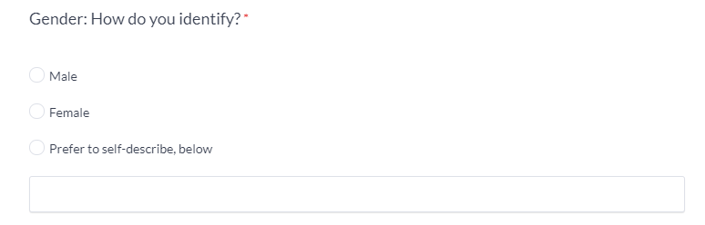
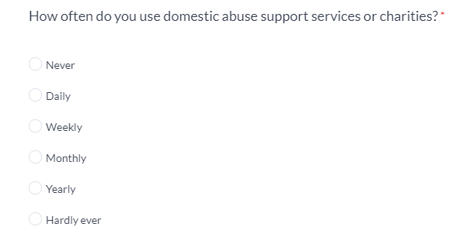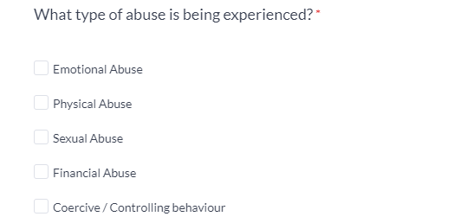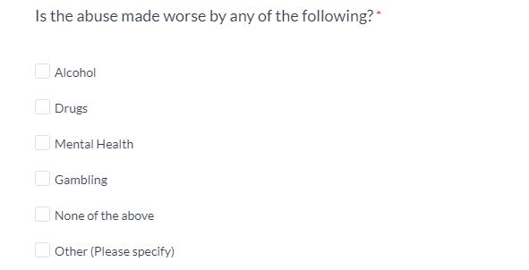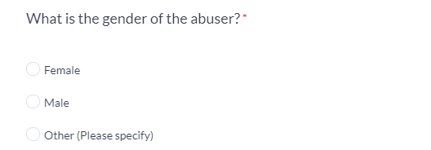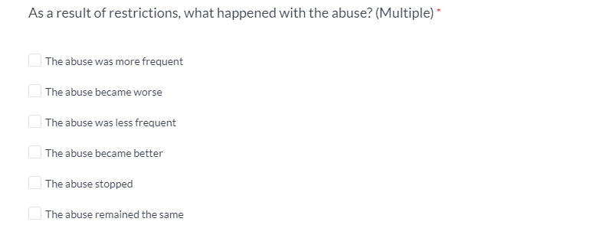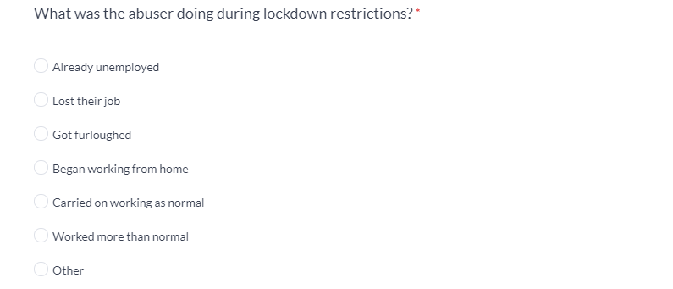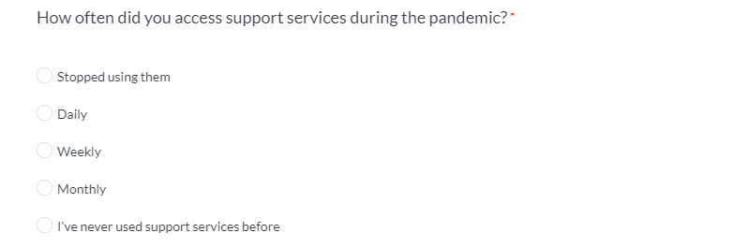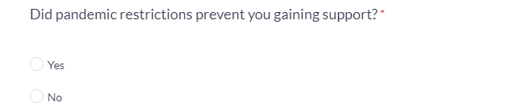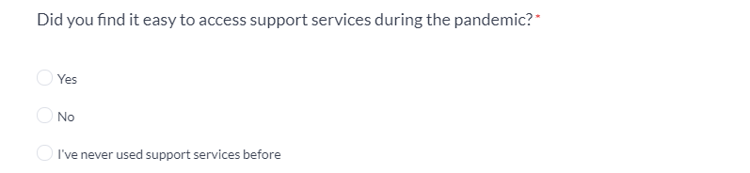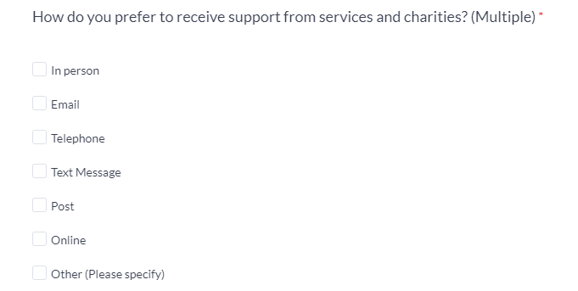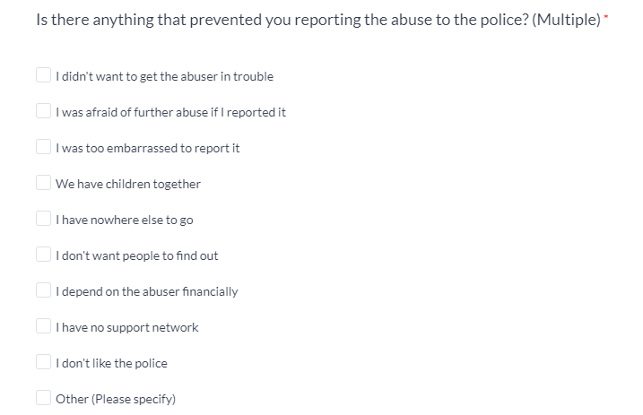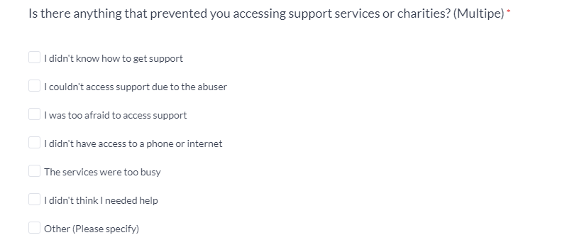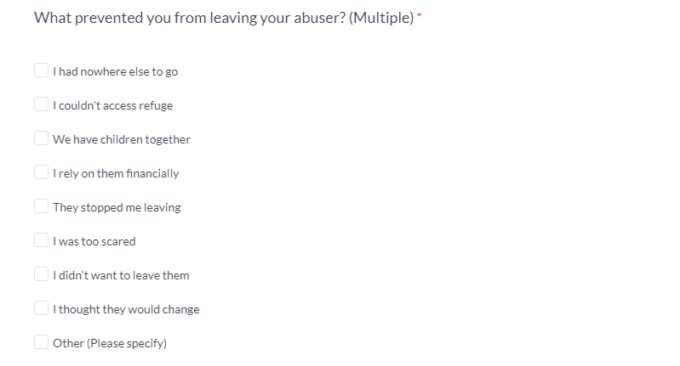

Appendix B – Copy of police questionnaire
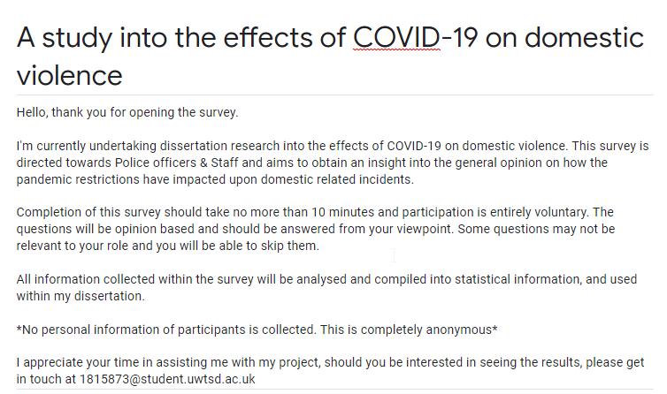


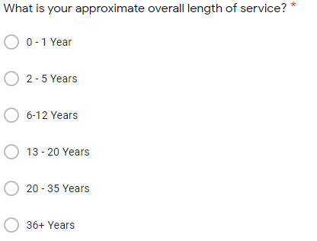
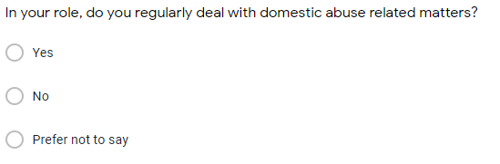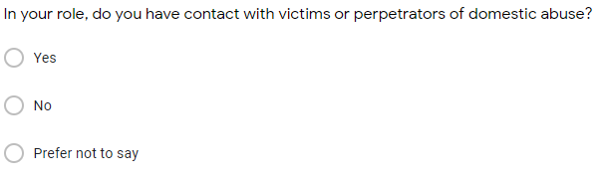
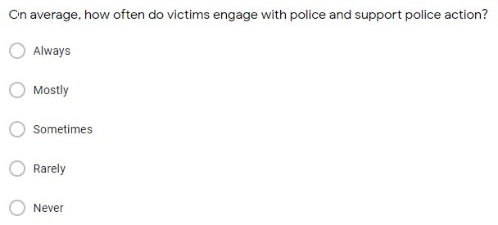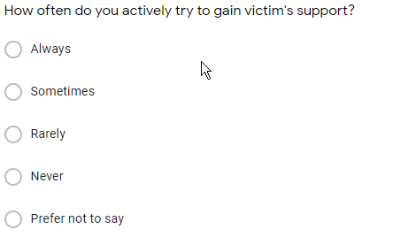
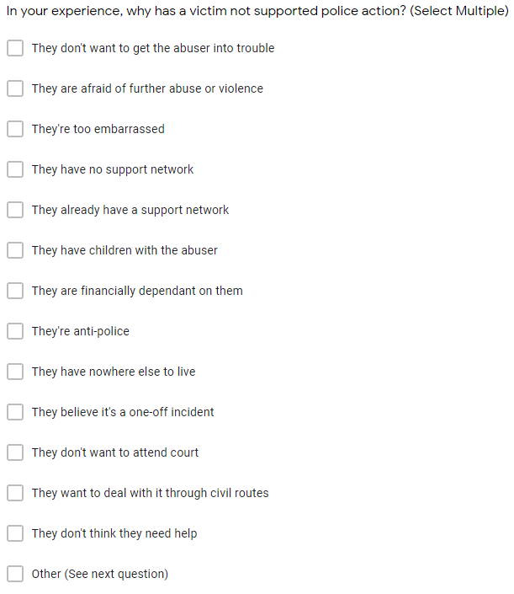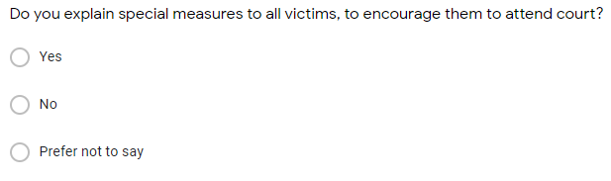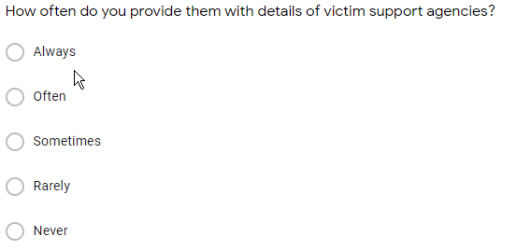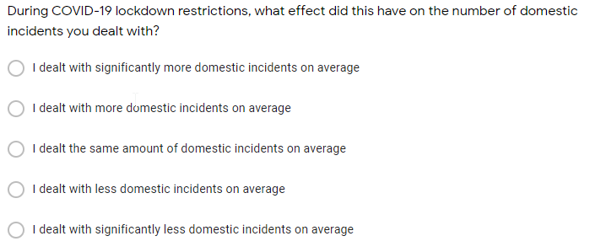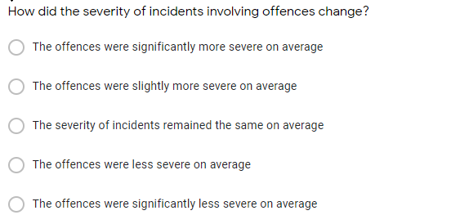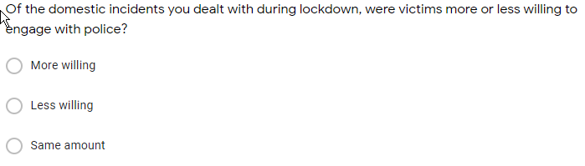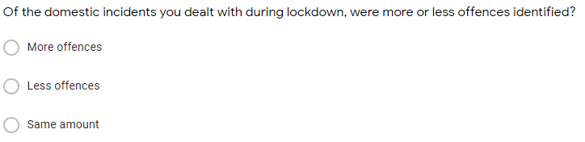
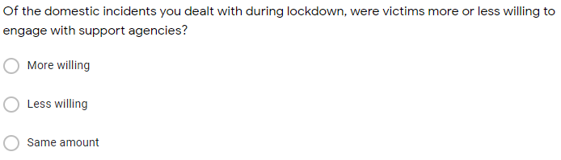
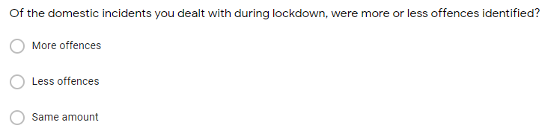
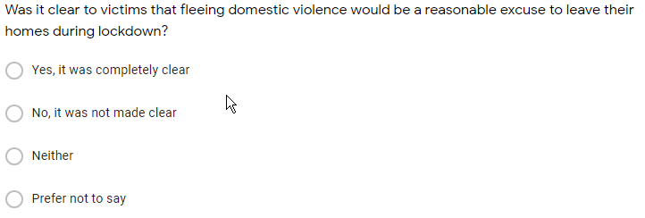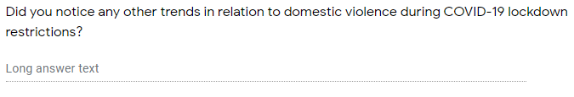

Appendix C – Why has a victim not supported police action? (Answers) 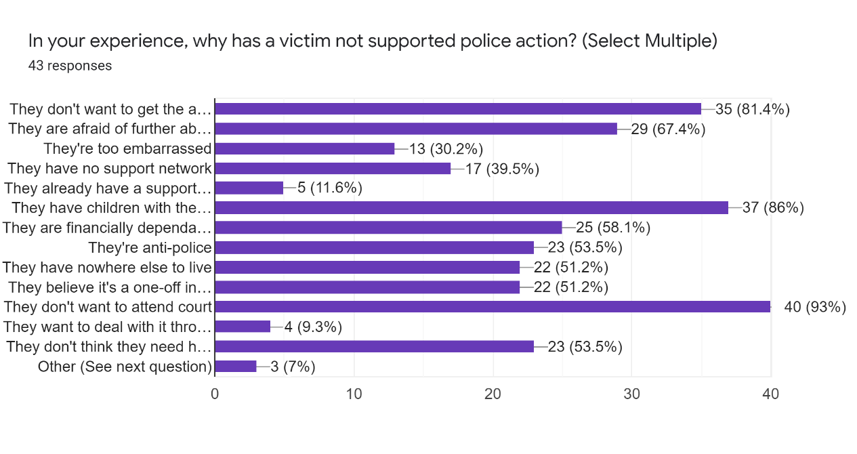
Other:
1 - Some victims are just so “beaten down” it’s the norm for them and they feel like they don’t deserve anything else

2 - When they support, there's often too much time lapsed before a result, and they almost always end up withdrawing their statement. Takes over a month to get a response from CPS

3 - Not thinking they would be believed due to an allegation being one person’s word against another

4 -Time consuming some don’t want to give a statement due to the length of time an investigation can take, and time literally is a great healer they may give a statement in the heat of the moment but 3-5 days later their anger and upset has changed and they wish to withdraw their support.
5 - Let down by the courts and they can’t separate that the police and courts work separately, and police do not have any input in sentences so blame us for the verdicts and then refuse to support and go through the processes again.

Appendix D – Open question answers: Trends in policing domestic violence.
- People spending more time at home causing more domestic arguments during COVID pandemic.

- I noticed an increase in perpetrators breaching bail conditions as a result of lockdown/working from home restrictions.

- Increased time together in an enclosed environment coupled with boredom and increasing levels of alcohol consumption seemed to fuel incidents attended.

- Some questions difficult to answer as I am a custody sergeant who dealt mostly with suspects, alcohol and drugs misuse were at a greater level due to covid, possibly mental health of people involved had increased

- Alcohol and drug use increase

- I did notice that we attended less domestic related calls, whether this was because they were not reported for whatever reason or because of the lockdown restrictions prevented persons from meeting or drinking excessive amounts of alcohol is left to the jury to decide!

- Particularly working within Rhondda, the rate of DVA cases is high so without the use of stats unable to tell if there is a clear correlation for the rise if there is any as it has always been high and the severity much the same, but the lockdown (s) has definitely become more of a factor that’s puts a strain on relationships which leads to the abuse / incidents reported.

- It’s worsened for sure

- Working from home, children not in school. Places persons at higher risk, more contact with abuser, no daily 'save space or break'

- Increased alcohol involvement

- There was more concern for welfare calls when people could not visit in person to see friends/family. Also, it was trickier to speak with victims during lockdown if they worked from home or were furloughed or their partner was at home more often - so phone contact or meeting the victim elsewhere such as a police station had to be more sensitively and carefully planned for victim support and safety.

- Some victims don't want the help because they can't accept the stigma that comes with it and won’t admit they need help.
- The frequency of DV calls shot up, however intensity remained largely constant. We also saw repeated offenses by people who were previously convicted for DV and common assault.

- An increase in online domestics (e.g., stalking/harassment/malicious communications offences committed through social media)

- Arrests were more common for unsupported domestic violence incidents (where the victim will not provide a statement) with no injury as the other party the accused offender had no other place to stay therefore custody was normally the only available open to separate and safeguard both parties from potential further incidents.

- There was simply for of it. The cases were neither less severe nor more severe - the quantity increased.

Appendix E – Signed declaration page of ethical approval form.
The information which I have provided is correct and complete to the best of my knowledge. I have attempted to identify any risks and issues related to the research activity and acknowledge my obligations and the rights of the participants.
In submitting this application I hereby confirm that I undertake to ensure that the above named research activity will meet the University’s Research Ethics and Integrity Code of Practice which is published on the website: https://www.uwtsd.ac.uk/research/research-ethics/
Signature of applicant: | A.PELLING | Date:  14/05/2021
For STUDENT Submissions:
Director of Studies/Supervisor: |  | Steven Hill | Date:
Signature: |  |  | Date:
For STAFF Submissions:
Academic Director/ Assistant Dean: |  | Date:
Signature: |  | Date:
Checklist: Please complete the checklist below to ensure that you have completed the form according to the guidelines and attached any required documentation:
☒ | I have read the guidance notes supplied before completing the form.
☒ | I have completed ALL RELEVANT sections of the form in full.
☒ | I confirm that the research activity has received approval in principle
☒ | I have attached a copy of final/interim approval from external organisation (where appropriate)
☐ | I have attached a full risk assessment (and have NOT completed Section H of this form) (where appropriate) ONLY TICK IF YOU HAVE ATTACHED A FULL RISK ASSESSMENT
☒ | I understand that it is my responsibility to ensure that the above-named research activity will meet the University’s Research Ethics and Integrity Code of Practice.
☒ | I understand that before commencing data collection all documents aimed at respondents (including information sheets, consent forms, questionnaires, interview schedules etc.) must be confirmed by the DoS/Supervisor, module tutor or Academic Director.
☒ | I have deleted the guidance notes before submitting the PG2 for consideration

